GAN Lab activity handout

[0] Open the ‘GAN_lab_activity.ipynb’ file, and run the first 8 cells (import modules and define functions)

[1] Define the hyper-parameters
Run the cell
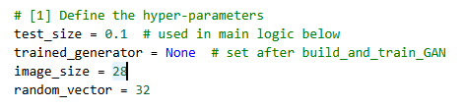

[2] Obtain the dataset ‘0’ (100 images) and ‘1’ (1,000 images) from Mnist
Run the cell
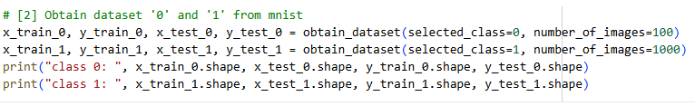

To get the following output

[3] Create imbalanced dataset from step #2
Run the cell
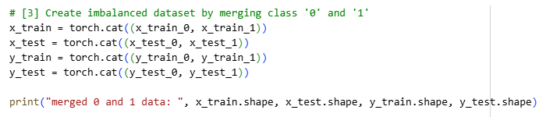

To get the following output

[4] Build, train, and test a classifier using the imbalanced data (result: ROC, AUC)
Complete the code and run the cell
To get the following output
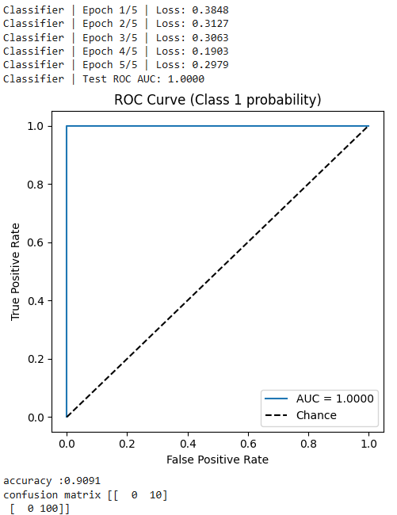

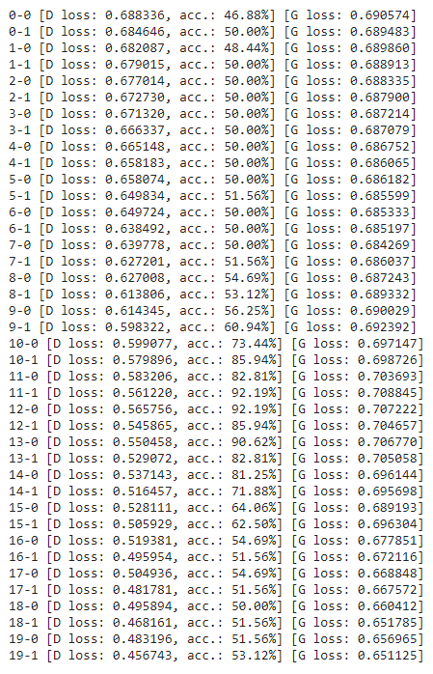
[5] Build and train GAN
Complete the code and run the cell

To get the following output
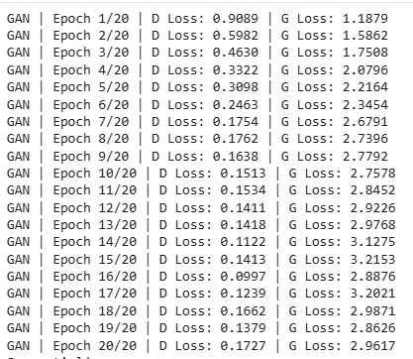

[6] Create fake data using GAN for class ‘0’

Complete the code and run the cell
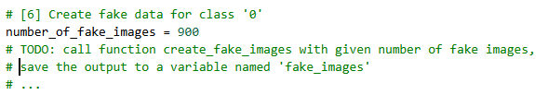
To get the following output
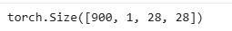

[7] Merge fake data with the original data
Complete the code and run the cell
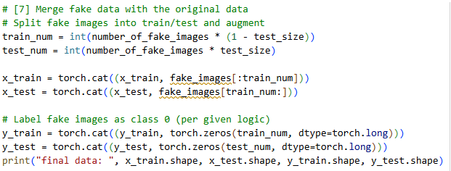
To get the following output

[8] Build, train, and test a classifier using the balanced data (result: ROC, AUC)
Complete the code and run the cell
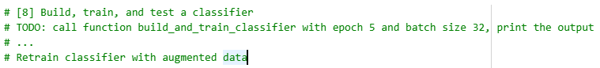
How does the output look like?
Is there any difference with the output of step number 4?

Please create a report to briefly explain the results. Attach the code that you wrote and the screenshots of the outputs. Submit the report before 03/12 (today) 23:59:59.

