**Design Document for:**

# The Attacking Dead

**The Ultimate Zombie Tower Defense Game**

“Don’t Die!”™

All work Copyright ©1999 by Sharp Steel Games

Written by Muhammad Ahmad

Version # 1.00

Friday, April 27, 2018Table of Contents

Name of Game 1

Game Overview 3

Feature Set 5

The Game World 6

The World Layout 7

Game Characters 7

USER INTERFACE 8

WEAPONS 9

Obstacles 9

Collectables 10

Musical Scores and Sound Effects 11

Art Assets 12

Single-Player Game 13

# Game Overview

## Philosophy

### Philosophical point #1

This game tower defense game where the player must defend his base by tapping on zombies or placing towers and defenses to fight against hordes of zombies.

### Philosophical point #2

Unlike a lot of other zombie games this game is very fast passed and most zombies die with very few hits

## Common Questions

### What is the game?

The game is a tower defense zombie game where the player must defend against waves of zombies to protect his base.

### Why create this game?

I am creating this game because mostly I love zombie games like Dead Rising 2 where the zombie are relatively easy to kill but there are a lot of them.

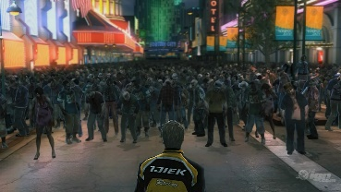

### Where does the game take place?

The game takes place in a small patch of land green land.

### What do I control?

The player controls where he can place his defenses and he also can hurt the zombies by taping on them.

### 

### What is the main focus?

The main focus of the game is to survive agents the zombies. The player has to keep the zombies out of his base if the get through he loses health and if to many get through the player loses.

### What’s different?

The main difference between this game and others is that there a lot of zombie games in which they always try to make the zombies hard to kill. I want to make a game where it easy and fun to kill zombies and it’s a bit relaxing instead trying very hard too hard to survive.

# Feature Set

## General Features

Tower Defense

Zombies

Multiple Different ways to stop or kill the zombies

## Gameplay

Fast paced gameplay

Player starts with 100 coins and he can earn more coins by killing the zombies

If the player has enough coins he can buy a tower to shoot at the zombies or buy defenses like a wall to try to keep the zombies away

The towers and walls have a health and if the zombies are close to the tower or wall the zombies will attack and try to destroy the object in their way

The turrets have a range and wont target targets outside the turret range

If the zombies get into the base the player loses health and if its health is below 0 he dies.

# The Game World

## Overview

The map is an is a small piece of green land where the zombies spawn on the right side of the map and move towards the left

## Objects

The world can objects like walls or the turrets that player choses where to place

## The Physical World

### Overview

The world is piece of green land with some grass

### Travel

The player doesn’t move the zombies come to him

### Scale

The world is the size of player screen

### Weather

The weather will be a clear day

### Day and Night

The game is set in day time. There is no day or night cycle

## Rendering System

### 2D/3D Rendering

The game will be a 2d game and will be redder using xcode default renderer

## Camera

### Overview

The camera is a bird’s eye view camera and has no other special functions.

## Game Engine

### 

### Overview

The game engine I will use is unity3d

### Water

No water in game

### Collision Detection

The collision is done by checking if the frame of 2 objects intercepts and if it does there is collision

## Lighting Models

### Overview

The world will be lit fully and there will be no shadows

# The World Layout

## Overview

The world has 2 section one is where I put the selectable turret and the wall which the player can tap to select.

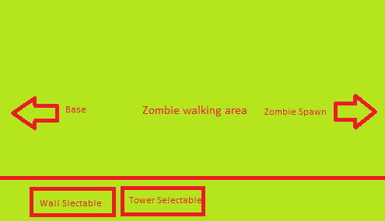

# Game Characters

## Overview

The characters are human zombies.

## Creating a Character

Character is not customizable

## Enemies and Monsters

There are 3 different types of enemies in the game. All 3 are zombies but they have different properties.

**Zombie 1: Normal**

This zombie movement speed is normal and so is health. It takes 3 shots the body to take him down.

**Zombie 2: Fast & weak**

This zombie move faster than normal zombie but lower health and it takes only 1 shot to the body or head to take him down.

**Zombie 3: Slow and Strong**

This zombie moves slower than normal zombies but it takes 5 body shots or 2 head shots to take him down.

# User Interface

## Overview

The user interface provides the player with his coins amount, score and health at the top. At the bottom are the 2 selectable items that the player can chose to palace in the world

## User Interface Detail #1

The score and coins will increase as the player kills more zombies

## User Interface Detail #2

The coins will decrease if the play buys a turret or a wall

## User Interface Detail #3

The health will go down as more zombies make it to the player base

# Weapons

## Overview

The game contains 2 ways of hurting the zombies

## Weapons Details #1

The first way to hurt the zombies is to tap on them which causes their health to go down

## Weapons Details #2

The second way to hurt the enemy is to place turrets that will shoot at the enemy

# Obstacles

## Overview

The game contains walls the player can place

## Obstacle #1

The player can place walls anywhere on the map and if the wall is in the way of the zombie, the zombie will attack the wall until it is destroyed

# Collectables

## Overview

There are 2 thing the player can collect, coins and score.

## Collectable #1

When the player kills the zombie he earns a score based on how to kill the zombie was

## Collectable #2

The player also earns coins for killing the zombie and is giving more coins if the zombie is harder to kill.

# 

# Musical Scores and Sound Effects

## Overview

The game has background sound, menu music and gun sounds. It also has footsteps sound and zombie’s sounds

## Rocket sounds

The rocket will have a scound when it hits a zombie

https://freesound.org/people/OwlStorm/sounds/404754/

## Music sounds

There will be background music that plays at the menu, game and end screen

https://freesound.org/people/DRFX/sounds/338986/

## Source

I plan on getting most of the sounds from freesound.org

# Art Assets

## Overview

The game has background, a rocket launched, rocket, and 3 different zombie images

## Background

The background will be green background with some grass effect

https://opengameart.org/sites/default/files/grass_template2_0.jpg

## Rocket and Rocket launcher

This will a be 2d image of a rocket and a rocket launcher

## [opengameart.org/sites/default/files/Rocket_Launcher_0.png](https://opengameart.org/sites/default/files/Rocket_Launcher_0.png)

## Wall Image

The wall will be image of a wall from top down

www.ludumdare.com/compo/wp-content/uploads/2009/04/wallsheet.png

## Zombie 1 sprite

The zombie will have a walking and attacking sprite sheet

https://opengameart.org/sites/default/files/zombie_2.gif

## Zombie 2 sprite

The zombie will have a walking and attacking sprite sheet

https://opengameart.org/content/the-zombie-free-sprites

## Zombie 3 sprite

The zombie will have a walking and attacking sprite sheet

https://opengameart.org/content/the-zombie-free-sprites

## Source

I am getting all of my art assets from opengameart.org

# Single-Player Game

## Story

The player is trying to defend his base from zombies who want to get in and kill his family

## Hours of Gameplay

The time of gameplay will be around 2 to 3 minutes depending on the skill of the player

## Victory Conditions

The games goes on until the player is dead and when he does die his score is displayed at the end