HIPPOCRATES

User manual
Version 1.1.4

HIPPOCRATES is an application for anonymizing and visualizing DICOM files that also supports generating user specified image masks.
DICOM is a standard for storing and transmitting medical images. Besides image related data DICOM files also contain a set of tags that represent additional information, such as date of the conducted study, device specification, facts about patient, and other. Since DICOM files contain private information about the patient in order to appropriately handle the data it is mandatory to remove all sensitive data from the file. HIPPOCRATES is primarily designed to perform this operation.
During the course of studying visual data often it is necessary to highlight a part of image where a region of interest is located. HIPPOCRATES allows user to investigate visual data stored in DICOM files, perform simple transformations, create masks, and save desired images.

Requirements
- OS: Windows 7,8 or 10
- Java virtual machine: 1.8.0

- Quick start
- Launch
Launch the Hippocrates.exe from the application, folder
- Import files
Import some images stored in a directory by specifying its path by either selecting From directory menu (File → Import → From directory), or by clicking the Import directory button on the toolbar. Importing procedure will take some time, since the application checks if it is possible to parse selected DICOM files and extracts all
DICOM tags required for further processing.
- Anonymize files
Perform anonymization of the imported files by selecting Anonymize data menu
(Run → Anonymize data) or clicking the Anonymize button located on the toolbar.
You will need to select the folder where the anonymized data will be stored. During the anonymization process all sensitive data in DICOM files will be swapped with asterisks, and then the file is saved as a DICOM file and a BMP file, that represents visual information. The name of the anonymized file is changed and becomes [Unique Patient ID]-[Study date]-[File index], the name of subdirectories also is changed to their index in the internal directory structures. The conversion tables for both patient IDs and directory names are stored alongside in files log-dir.txt and log-pid.txt. The information about location of all anonymized files is stored in the database file database.txt.
- Import anonymized dataset
It is suggested to perform mask selection on the anonymized dataset, thus to do so first, remove all previously imported files by selecting the menu New (File → New).
Then import the anonymized files by loading by selecting the saved database file database.txt. through the File → Import → From database file menu option. This operation will take significantly less time than importing anonymized files via previously used import procedure.
- Image masking
To mask a desired area of the image select the paintbrush tool and paint over the displayed image. The quickest and easiest method to save the created mask is to click the Save mask button, located in the toolbar. This saves the mask image as a PNG file to the same location as the currently displayed file, with the same name as the DICOM file concatenated with the ‘-mask’ suffix. The other way to save the mask is to select the Save image → Image mask. With this method it is possible to manually specify the name of the output file.
- Saving progress
To save the information about imported files and masks before closing the application it is necessary to export the database file. This could be done by selecting the Export → Database file from the menu and specifying the name of the output file.

2. GUI
The graphical interface consist of 5 main panels: menu, toolbar, file selection, image transformation, image display. The menu panel has three sub menus – File, Run, View – that allow to select DICOM files, directories, images to be imported or exported; launch anonymization procedure; change the view of the displayed image. The toolbar provides the user with easy access to the most used functions. The description of all buttons located in the toolbar can be found in the Table 1.

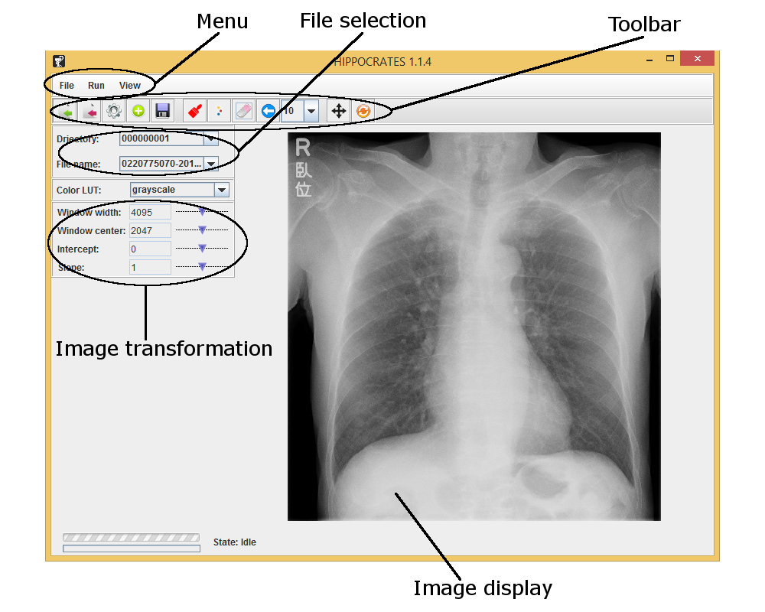
The File selection panel allows to select a particular image from all imported DICOM files. To do so, the name of the directory where the file is located has to be chosen from those available in the Directory combobox, then the file name can be selected form the File name combobox by its name.
The pixel data stored in the DICOM files requires processing to be correctly visualized. A set of tags is responsible for transformation of the visual data, and by changing these
tags it is possible to make areas of interest more visible on the image. The value of the
tags can be controlled by altering the sliders located in the Image transformation panel.
The Image display panel displays the currently selected image. By scrolling the mouse wheel the image can be zoomed in or out. The image can be also moved by clicking the Move (see Table 1) button and, then dragging the mouse cursor across the Image display.

3. Core functionality

- Importing DICOM files
DICOM files can be imported into the HIPPOCRATES application individually one by one, from a directory, or from all sub-directories located in a directory specified by path. The core element of the internal structure of files is a directory. At the GUI user need to choose a directory first, then find a name of the desired file in the combobox in order to display it. All individually imported files are added to the dummy directory UNKNOWN. Since the process of importing DICOM files extracts necessary tags from each added individual instance it could take a significant amount of time to import all files located in a single or multiple directories. To eliminate this hindrance it is possible import a database file, that contains all information about previously used files.

  - Importing individual DICOM files
Menu: File → Import → DCM file
Toolbar button: Import file
  - Importing all DICOM files from a directory
Menu: File → Import → From directory
Toolbar button: Import directory
  - Importing all DICOM files from all sub-directories, located in a directory
Menu: File →Import → From dataset
1.4 Import DICOM files using information stored in a database file
Button | Name | Description
 | Import directory | Imports all files located in the specified directory.
 | Import file | Imports a single file. The file is added to UNKNOWN element of the directory list.
 | Anonymize | Initializes the anonymization procedure
 | Get next task | Display an image for which a mask has not been selected
 | Save mask | Saves the created mask in PNG format into the same location as the imported file, which is currently displayed
 | Paintbrush | Turns on the mask selection
 | Palette | Allows to change the color of the displayed mask
 | Eraser | Clears the created mask
 | Undo | Removes the latest change of the mask
 | Move | Allows to move the image
 | Reset view | Positions the image in the center of the view screen
Menu: File →Import → From database file

If during the import stage some of the selected files could not be imported, the absolute path of all these files is stored into error log file (log-error.txt), located in the same folder as the HIPPOCRATES application.

- Anonymizing DICOM files
First the anonymization procedure creates in the specified a location a directory tree. Each newly created directory represents an imported directory, or the dummy directory which stores individually imported DICOM files. The conversion table between newly assigned directory names and original ones is stored in the log file log-dir.txt, stored alongside the created folders. Next the algorithm parses each previously imported DICOM file, fills the sensitive information with asterisks, and then saves the DICOM file and corresponding BMP image file in the appropriate location. During this process the name of the file is changed. The new name consists of newly assigned patient id, date of the study and file index.

[new file name] = [new patient id] – [date DICOM file taken] – [index]

The conversion table between original patient id-s log-pid.txt and newly assigned ones log-pid.txt is stored in the same location as the other logs.
The anonymization process can be launch by using the Anonymize button, or selecting the Run → Anonymize data menu.

- Image transformation and visualization
HIPPOCRATES supports various transformations that allows to investigate the displayed images in details. It is possible to change the values of the DICOM tags
such as window width, window center, intercept and slope via the transformation panel, which provides access to sliders, associated with the variables.
The main image display panel allows to zoom in and out the picture by scrolling the mouse wheel. It is also possible to move the image by switching into move mode (by clicking the Move toolbar button) and dragging the mouse across the panel.
To reset the view to default click the Reset view button or select the View → Reset transform.
The original image intensity levels can be transformed to other range of colors. That may help to spot intricate details of the displayed picture. Currently two LUT tables are supported: Fire and 16 colors. An example of the LUT transformations is given in the table below.

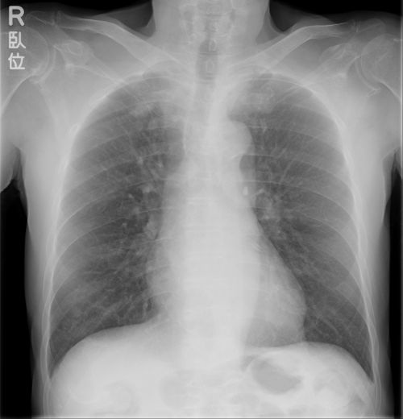 | 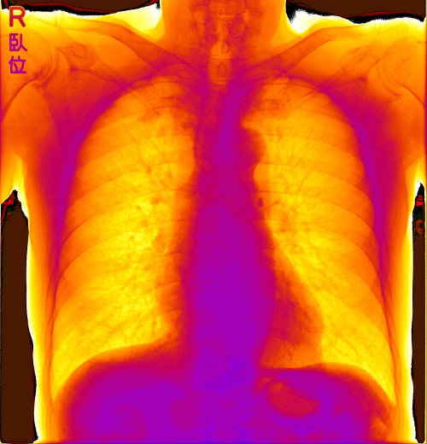 | 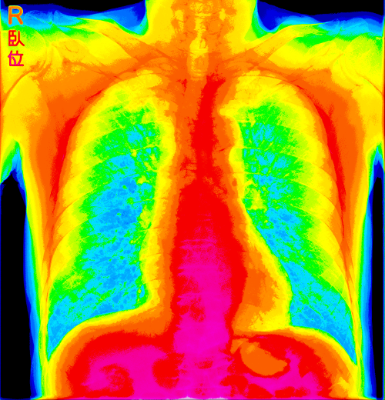
Original | LUT: fire | LUT: 16 colors

The original image and transformed image can be saved by selecting Original image and Transformed image from the File → Save image submenu.

- Creating and saving image masks
To create a mask select the Paintbrush tool from the toolbar menu. The displayed color of the mask can be changed by picking a new color for the Palette. The size of the paintbrush is altered by choosing a radius of the brush form the drop down menu, located in the toolbar. The previously added strokes can be removed by clicking the Undo button, and if it is necessary to remove the whole mask, it could be done by using the Eraser tool.
The mask can be quickly saved in the same location as the displayed DICOM file by clicking the Save mask button. The name of the output mask file is generated automatically and is the same as the DICOM file plus the ‘-mask’ suffix. To manually assign the name of the mask use the select the File → Save image → Image mask.
When a significant number of images is imported it is useful to automatically select the next image that does not have a mask. It can be done by clicking the Get next task button which will switch the image.

- Saving progress and removing all imported files
The information about all imported images, transformation tags, masks, can be stored in a separate file – database file. That file can be used during the importing stage to reduce time required for importing files into the application. This files also contains flags representing whether a mask has been saved or not. To save progress during the mask creation step save a database file before closing the application.
All previously added files can be removed by choosing File → New option.

