_{Zoom Windows Electron SDK}

Modification History

Revision | Date | Originator | Comments
2 | 06/08/2017 | Zoom custom engineering | First Draft

Note that the windows Electron SDK from Zoom is distributed under a separate SDK agreement. Please make sure that you read the terms and conditions of the SDK agreement before using the SDK.
- Introduction and Pre-Requisite
In order to use the SDK, you need to make sure that the RETS API and the mobile SDK is enabled in your account. If not, please contact your account rep or contact Zoom support.

Note that our SDK support meeting services and do not support messaging currently.

- Login https://zoom.us/developer and click Windows SDK. Get the SDK key and secret from your zoom account. This key/sec is same as the one used for mobile SDK:
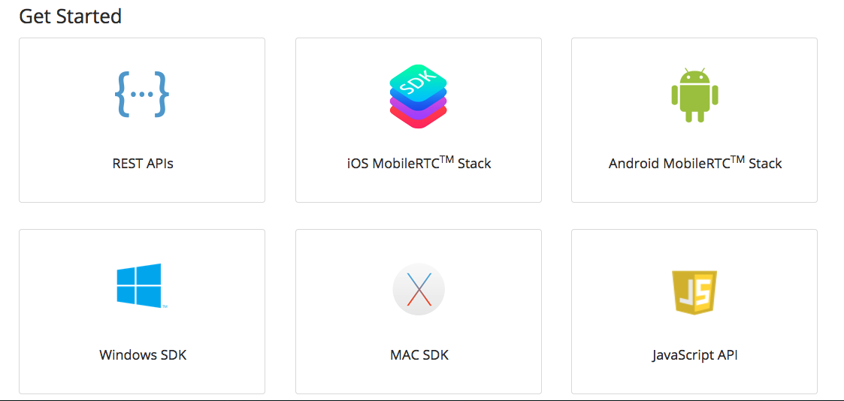
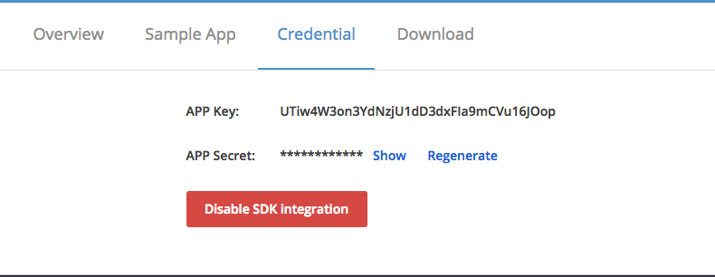
- SDK Architecture and Workflow
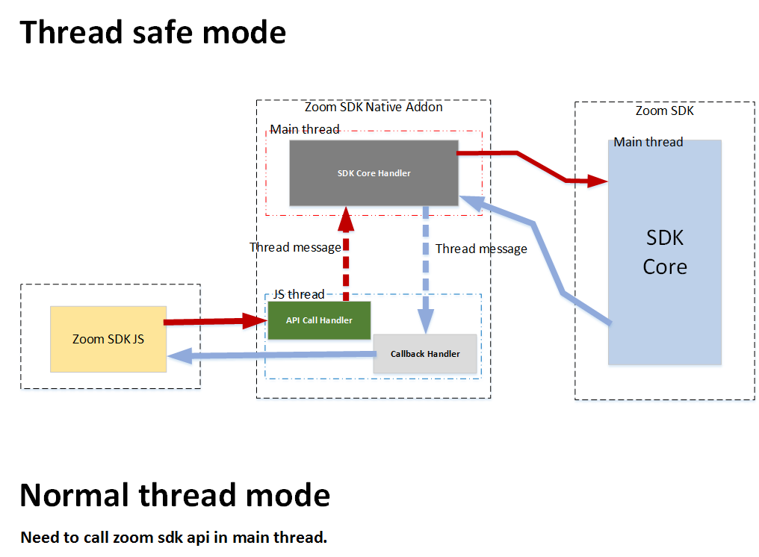
Zoom SDK supports two options for user authentication.
In this sample, we provide sample code in main.js. You can take a look on how the main.js calls functions in zoom_sdk.js.
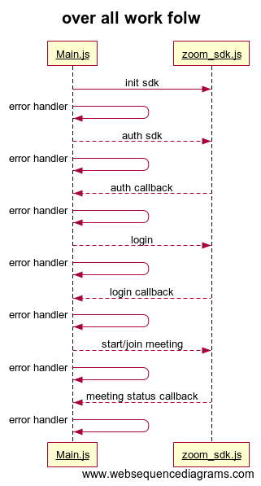

- SDK Functions

Initialization
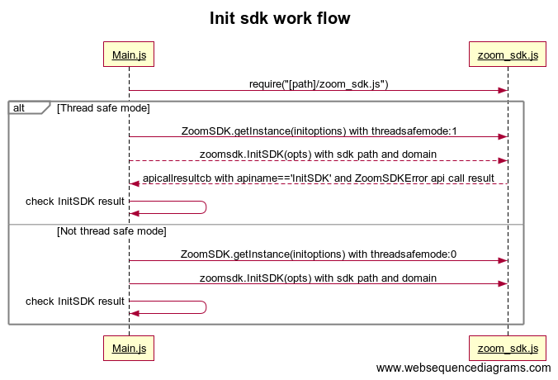
You can find these APIs in zoom_sdk.js and main.js. Zoom Electron SDK supports both Thread Safe mode and not thread safe mode. We recommend you call zoom sdk APIs in main UI thread for thread safe operation.

Initialize zoom sdk:
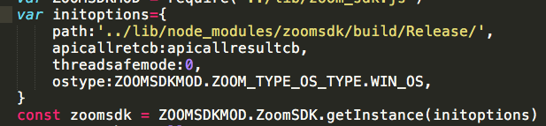
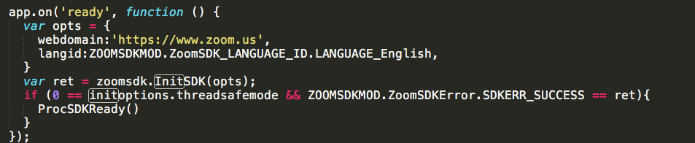

Cleanup zoom sdk before you exit your application.
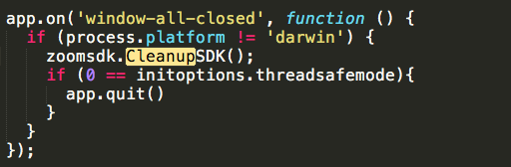

Authentication Service
You should do authentication first when you start to use zoom sdk and zoom_auth.js is included zoom_sdk.js
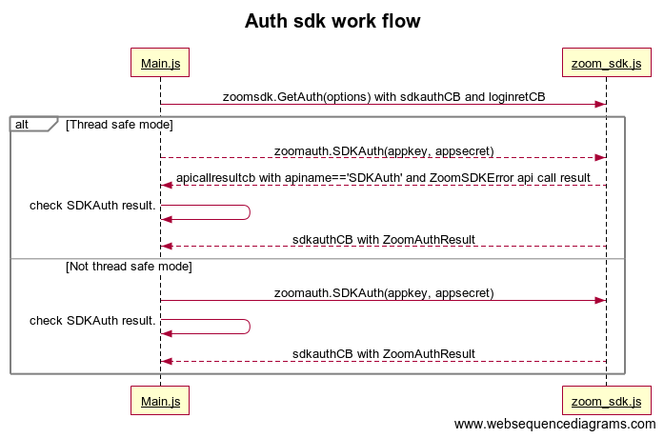

- Create authentication service after SDK is ready
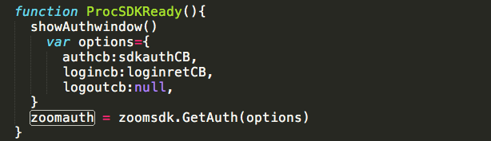
- Auth SDK
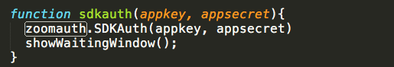
- Check for call back result
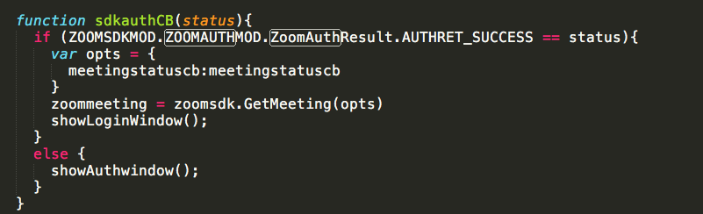

Login Service
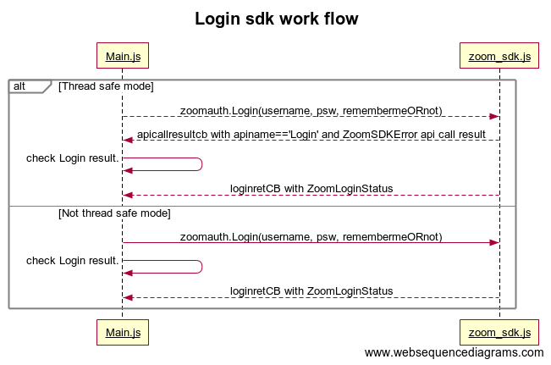
- Login end user
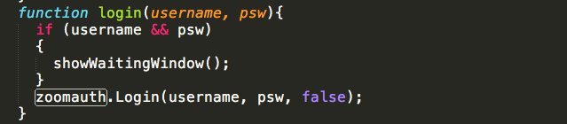

- Check login return call back value:

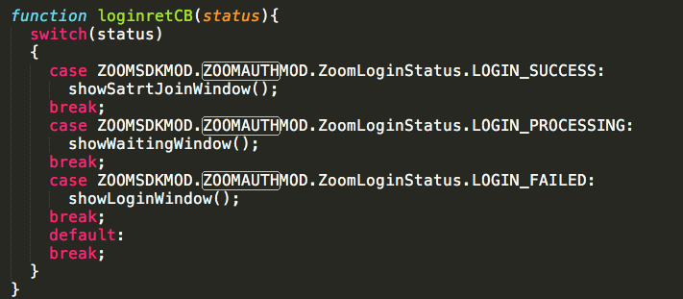

Meeting Service

Zoom meeting service let you start and join meetings. If you want to use this service, include zoom_meeting.js. In the sample, we included for you in zoom_sdk.js. The overall work flow is following:
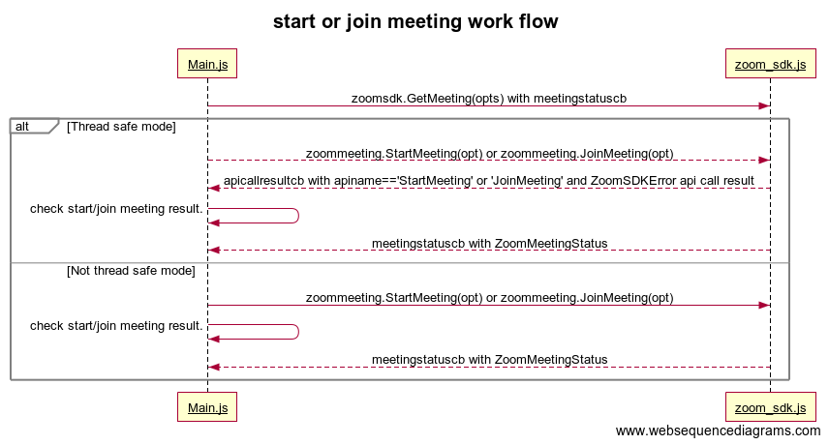

- Get meeting service after authentication success
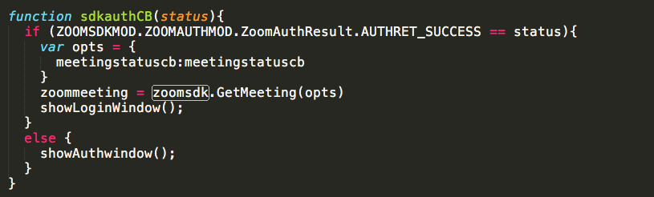

- Start the meeting:
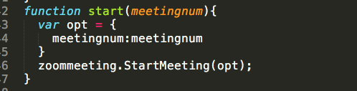

- Join the meeting:
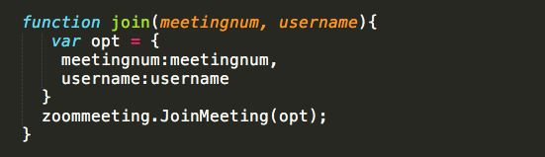
- Leave the meeting:
