Mobile App Reverse Engineering Tutorial Static Analysis of Android APKs using JADX & Radare2
Isabella Sunderman

This tutorial is a continuation of Mobile App Security Tutorial – Part 1, expanding into deeper static analysis techniques used in Android application reverse engineering. We build on previously used tools such as Android Studio and Frida, and introduce two new essential tools:

JADX for Java decompilation

Radare2 for native code analysis

All analysis here is performed on the OWASP Uncrackable Level 3 APK, a vetted target intended for educational use. Performing these techniques on unauthorized applications is illegal and unethical.

Java code Analysis with JADX
JADX is a powerful open source decompiler that transforms Android bytecode (DEX) into readable Java source code. It allows analysis to:
- Browse package structures and classes.
- Search strings, functions, and suspicious logic.
- Understand application flow without running the application.
JADX parses the app’s DEXX classes inside the APK and reconstructs human-readable java. While not perfectly, it is still widely used in Android security analysis because it requires no device, returns clean code and cross-references and IDE like navigation. This tool is effective in identifying Root detection, Anti-debugging checks, hardcoded keys, and native methods.
  - First, for this tutorial we will be using fried to do a preliminary investigation of the APK at its runtime by conducting a Dynamic analysis using Frida.
Set up your working environment, you can use the same emulated device created in the prior tutorial and install the new APKs.
Try starting the application or getting a PID using Frida.
Here is the output of the enum3.js script from the repository.

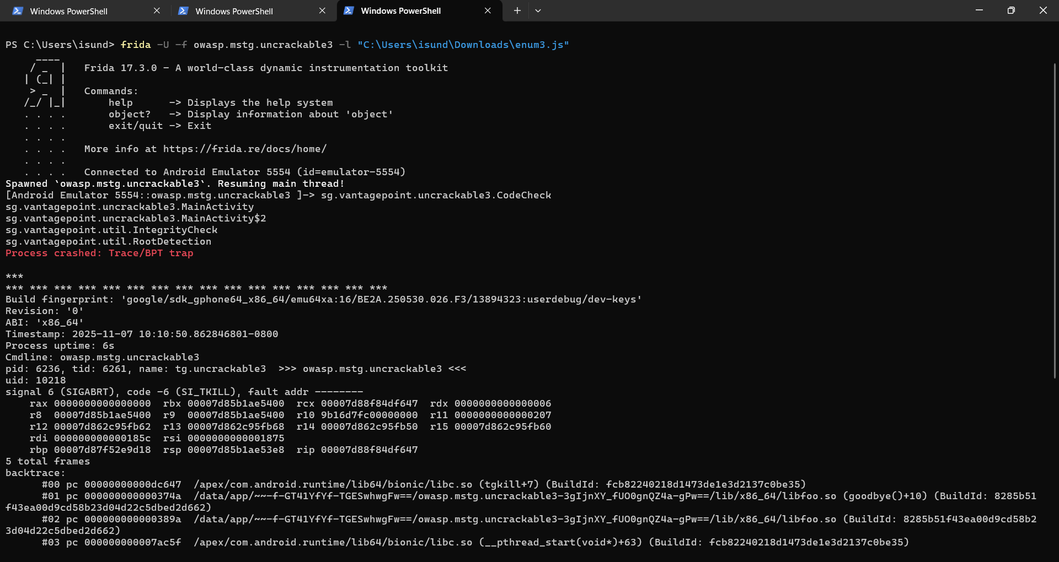

Notice the process terminates meaning the application has security measures in place to prevent execution in root namely the sg.vantagepoint.util.RootDetection. The output also provides clues as to functions to investigate further. Such as 2 MainActivity returned in the output before the app crashes.

  - JADX
We will need to investigate the code of the application, JADX can decompile the java code from the APK. The tool reads the APK and shows the readable Java code and can be used to locate suspicious functions and strings.
To install follow the link to the latest version: https://github.com/skylot/jadx/releases/tag/v1.5.3
Download the folder and run the executable.

  - Activity 1: Functions and phrase analysis
Open the Uncrackable 3 file in JADX and search the following phrases:
- System.loadLibrary
- isDebuggerConnected
- System.exit
- Sg.vantagepoint.a.b
- CodeCheck

  - Challenge 1:
Go through each phrase and answer the following questions:
- What does each phrase return?
- Do any of the phrases tell us anything notable to obtain the phrase?
- What does each line mean to the app’s security?

  - Activity 2:
Scanning the MainActivity we can also see an xor key with the string “pizzapizzapizzapizzapizz” there is also a native void (initbyte[]) and native long baz().
Look at the logic for the root and tempering detection done in the MainActivity. Find the native methods declared , we will look at them in the next section.

Native Code analysis with Radare2
Java analysis alone is often not enough, requiring further digging and looking into the native libraries for the hidden logic. Radare2 allows us to disassemble, inspect, and even emulate native code.
Radare2 is an advanced reverse engineering framework specialized for:
- Disassembly
- Binary inspection
- String extraction
- Control Flow Graph Exploration.
- Native Function analysis
Radare2 is useful in reversing symbol tables from JNI-exported functions, identifying tampering and root detection scans and recovering hidden logic.
2.1 Installing Radare2
The tutorial is made using Windows and windows PowerShell used for the commands there may be syntax differences between Linux and Windows.
The following commands can be used for Linux.
For Windows you can use scoop to install:
2.2 Activity 3: Application extraction and preliminary:
Once Radare2 is installed we need to extract the APK file for inspection. We will be extracting the files straight from the emulated device to get the exact package.
This will be extracting the application from the emulated device and setting up the file to be analyzed with radare2 in putting the following commands with the ADB shell:
In a new terminal:
The output should resemble this: 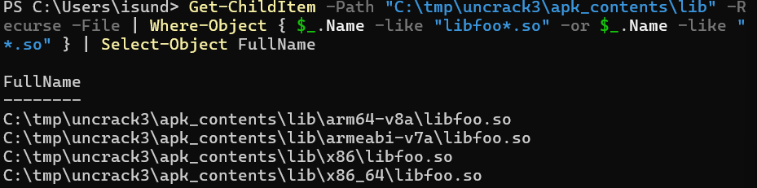
The following commands are using radare2 package rabin2 to obtain some information form the native code about the application functions. You will need to know that ABI for the device we are using, this tutorial is conducted on a Pixel 5 AVD which is x86_64.
2.3 Challenge 2:
Using the output of the above command you should be able to answer the following questions:
- What are the global functions found in the -s command and do they correspond to a function found in the JADX analysis? What are the mappings?
- What are the memory addresses for the Java class functions?
- What function is at address 0x00003740?
2.4 Activity 4:
Useful interactive commands:
aa — analyze all | afl — list functions
iz — list strings | axt <addr> — show cross-references to an address (useful to find who references detector strings)
axt sym.imp.strstr — find calls to strstr import (common pattern for /proc/self/maps scan) | pdf @ <addr> — print function disassembly at address <addr>
pdd @ <addr> — decompile function to pseudo-C (if r2dec available)

Try using the commands to understand the logic of the native code of the application.

2.5 Challenge 3:
1. What Strings were found during the exploration using the ‘iz’ command?
2. Which functions are the JNI exports?
3. what is the address for the strings “Frida” and “xposed”?

Appendix
Challenge 1:
- - System.loadLibrary("foo"): loads native library (libfoo.so). Native code may run checks before Java code.
- Debug.isDebuggerConnected() inside AsyncTask: a loop that waits for debugger attach and then shows "Debugger detected!" dialog.
- if (b.a() || b.b() || b.c()) a("Root detected!"): three root detection functions.
- System.exit(0) on OK. If any sg.vantagepoint returns true, the app shows a blocking alert which calls.
- if (a.a(getApplicationContext())) a("App is debuggable!"): debuggable flag check - shows blocking dialog.
- CodeCheck.a(String): verification routine called from verify(View). This is the function students will target for forced success or extraction.
Challenge2:
- • Java_sg_vantagepoint_uncrackable3_CodeCheck_bar
Maps to: CodeCheck.bar(...) native method (Java native declaration in class sg.vantagepoint.uncrackable3.CodeCheck).
• Java_sg_vantagepoint_uncrackable3_MainActivity_baz
Maps to: MainActivity.baz() native method.
• Java_sg_vantagepoint_uncrackable3_MainActivity_init
Maps to: MainActivity.init(byte[]) native method.
- 0x00003a70 sym.Java_sg_vantagepoint_uncrackable3_CodeCheck_bar 0x00003a60 sym.Java_sg_vantagepoint_uncrackable3_MainActivity_baz
- Sym.goodbye is at 0x00003470.
Challenge 3:
- 0 ascii /proc/self/maps.
1 frida
2 xposed
3 ascii UnCrackable3
4 Tampering detected! Terminating...
- Error opening /proc/self/maps! Terminating...

- Java_sg_vantagepoint_uncrackable3_CodeCheck_bar
Java_sg_vantagepoint_uncrackable3_MainActivity_baz
Java_sg_vantagepoint_uncrackable3_MainActivity_init

- "frida” 0x00003b62 (vaddr)
"xposed” 0x00003b68 (vaddr)

References
https://github.com/skylot/jadx/releases/tag/v1.5.3

