Mobile App Security Tutorial 1

Static and Dynamic Analysis
Isabella Sunderman
Introduction
This tutorial introduces the fundamentals of mobile application security, focusing on both static and dynamic analysis techniques. Using tools like the Mobile Security Framework (MobSF) and Frida, readers will learn how to analyze iOS and Android apps for vulnerabilities, permissions, and insecure practices. The exercises and challenges aim to simulate real-world scenarios that ethical hackers and developers face when securing mobile software.
The tutorial is divided into two main sections:
Static Analysis: Understanding permissions, vulnerabilities, and insecure configurations by examining APK and IPA files.
Dynamic Analysis: Monitoring app behavior at runtime using instrumentation and debugging tools.
Each section includes a hands-on activity and challenge to reinforce key concepts and techniques.

Static Analysis

1.1 Objectives:
The purpose of this lab is to introduce static analysis of Android and iOS applications using the Mobile Security Framework (MobSF). The tutorial users will learn how to set a containerized environment, analyze sample IPA and APK files and interpret findings of potential vulnerabilities, API usage and dangerous permissions.
  - Environment Setup
Environment setup instructions are compatible with Linux OS and Windows OS with commands and tools required being the same.

1.2.1 Docker
MobSF requires Python 3.13 or newer, using Docker is recommended to avoid compatibility issues found in Linux OS
For Windows just follow the steps provided on the Docker website:
https://docs.docker.com/get-started/get-docker/
For Linux Docker commands:

Running MobSF
Once Docker installed running the following commands in the terminal:

With the application running open a browser
Linux: http:// 127.0.0.1:8000
Windows: http://localhost:8000

Default login credentials are
Username: mobsf
Password: mobsf

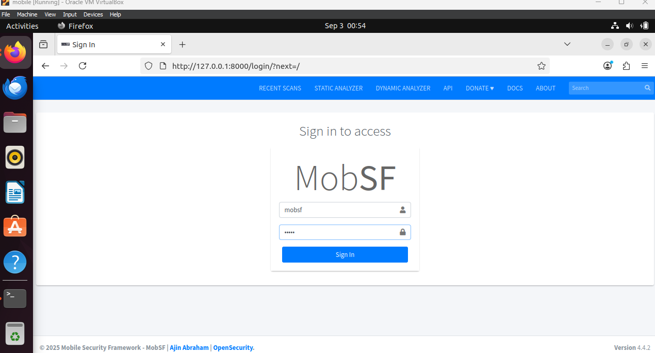

1.3 Static analysis
There are two application files provided with the tutorial and IPA and APK. These and sample applications for this tutorial and both files will be analyzed in this portion.

1.3.1 Activity 1 iOS IPA report
Upload the IPA file into the MobSF and generate the report. The key findings of the report in that the application is a helloworld and grade is 100/100 and low risk. ThIPA files, although outdated, can be observed to not have any vulnerabilities.
The generated reports include File, App and Binary information, App Transport Security, IPA Binary Code Analysis, Domain Malware check and Scan Logs. Each section provides new context of the ipa file, and the test conducted on the file.

1. 3.2 Challenge 1
This Challenge will be performing an analysis on APK file.
- Upload the APK file to MobSF.
- Record the reported if there are any detected vulnerabilities.
- Identify differences in the generated reports.
1: Locate three dangerous permissions requested by the Android app. Explain why these are risky.
2: Search the APK report for hardcoded API keys, tokens, or secrets. Explain why this practice is insecure.
3: Based on the APK and IPA reports, which platform’s sample app shows a higher attack surface? Justify your reasoning with report evidence.

Dynamic Analysis

2.1 Objectives:
The goal of this portion of the tutorial is to perform a dynamic analysis of an Android application by intercepting and modifying their behavior during runtime using Frida. This lab will require setting up and running an Android emulator, deploying Frida to capture data and bypass protections.

2.2 Environment Setup:

2.2.1 Install Frida
Frida requires python 3 and Node.js. the following link can but used to for download: https://nodejs.org/en/download
In terminal run the following commands to install Frida:

You also need to install the server binary to be pushed to the Android client device appropriate to the Frida version installed using the following link https://github.com/frida/frida/releases
used in tutorial: frida-server-17.3.0-android-x86_64

2.2.2 Install Android Studio
Android Studio will be used for compiling the application and an android emulated device for the Frida server client.
Download link: https://developer.android.com/studio
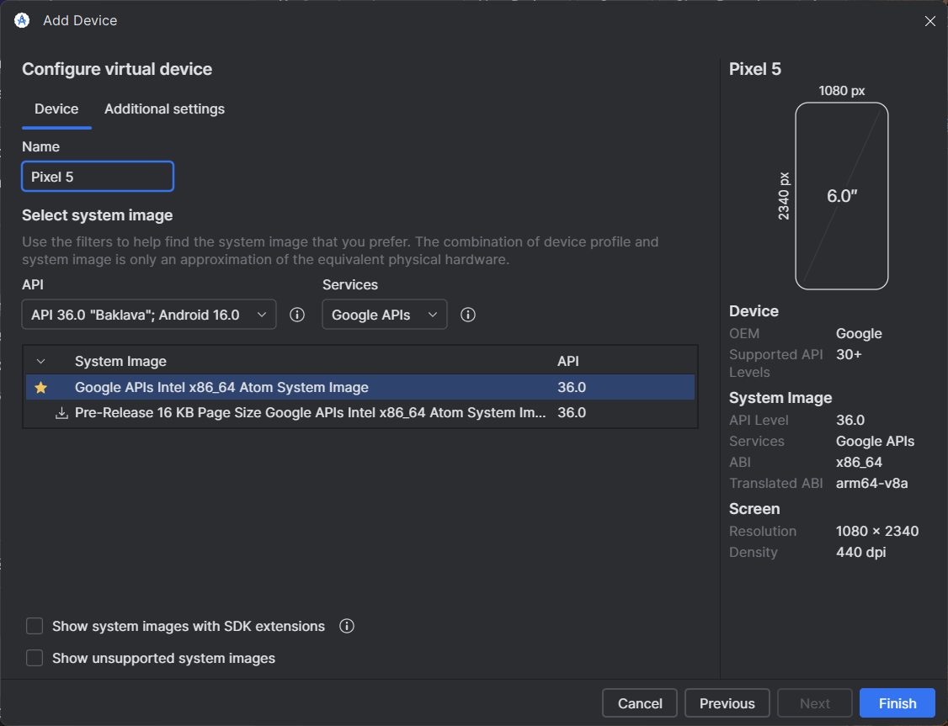
Start Android studio and navigate to the device manager and create a new android device. For this tutorial I made a Pixel 5 and used the default settings and turned the device on the device needs to be running to install the server binary.
Using the terminal note the data path addresses of the Android studio and the server binary or execute the following commands in the android studio directory:
*Note the full file paths for your adb.exe file and Frida server binary
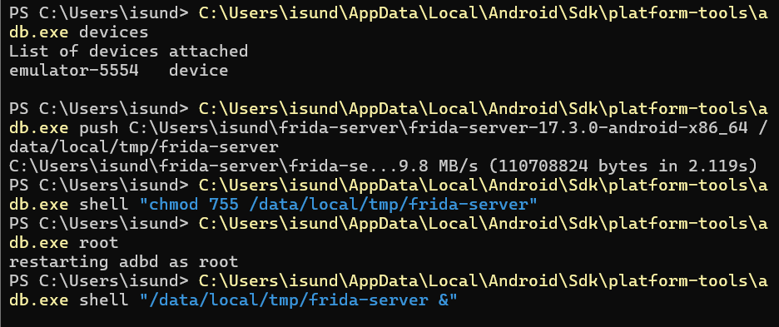
Open a new terminal verify to the connection is established between your Frida client and the server on the android device by listing all the processes on the android device run the command:
Frida-ps -U
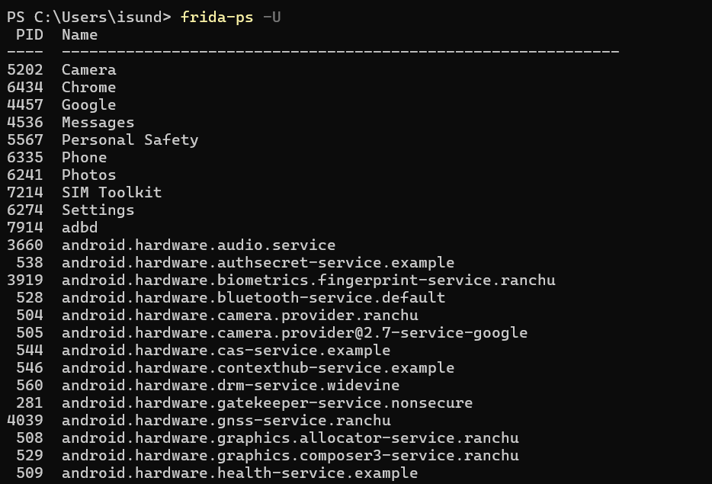

2.3 Dynamic Analysis

2.3.1 Now that the server is running on the android device and connection is set up, we can explore Frida’s capabilities and a few of the commands:
- Frida-discover finds internal functions of the program.
- Frida-kill: end processes using PID’s (Frida-ps will list the PID and process)
- Frida-ls-devices: lists devices
- Frida-trace: trace functions call dynamically, and very versatile in capabilities of launching applications and tracing java methods, API, certificates. (Frida-trace -h is a full list of options)

2.3.2 Activity 2: This required some more set up, using the provided UnCrackable1 application. This will also require the full file path of the APK file should be something like:
"C:\...\Downloads\UnCrackable-Level1.apk"
Install the APK and run the app.
Adb install -r <file path of the app-debug.apk>
run the run app on the virtual device GUI.
run Frida-ps -U to see the Frida server and Uncrackable 1 process running and Frida server.
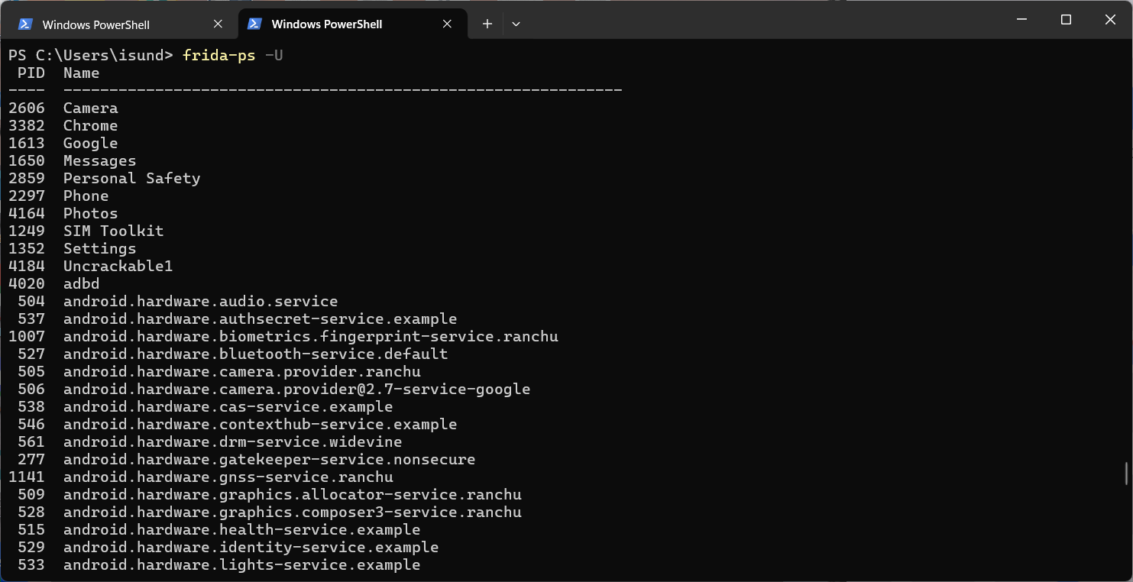

Using the Frida discover command attaching it to the Uncrackable1 PID. After initiating the command will abort itself but will give us a function name to aid in getting the secret phrase.
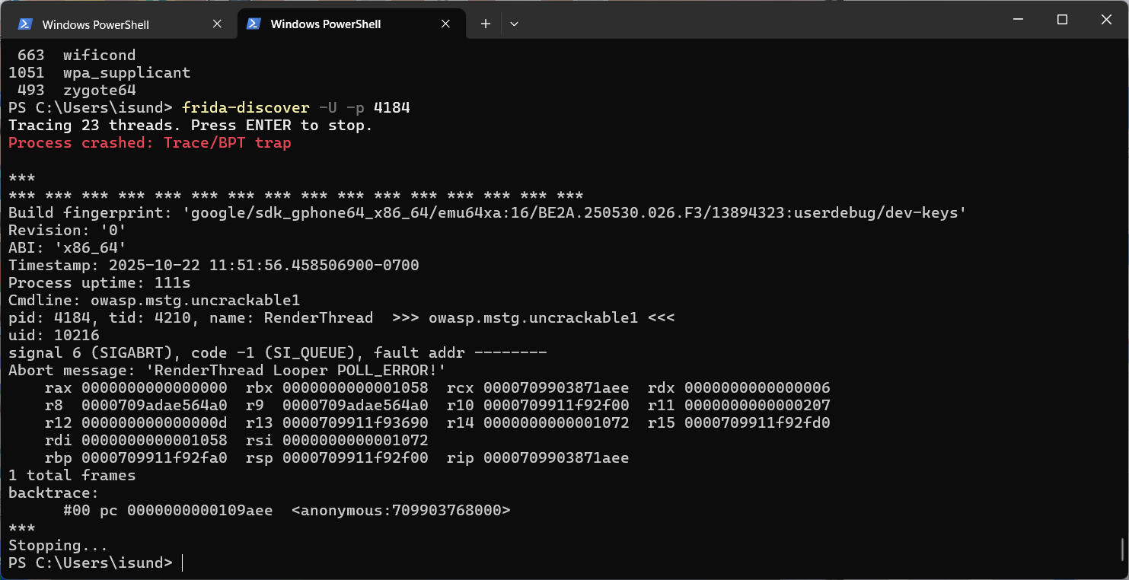

2.3.3 Challenge 2: Using the provide java scripts enum-hook and capture-verify.js to obtain the Uncrackable 1 pass phrase and answer the following questions.
- What classes did the enum-hook.js print?
- Which class would be the most relevant for hooking to in order to obtain the passphrase?
- What is the type of encryption used for the passphrase?

Conclusion
Through hands-on exercises with MobSF and Frida, this tutorial provided a practical introduction to mobile app security. Readers explored static and dynamic analysis of Android and iOS apps, discovered how to uncover dangerous permissions, and learned how runtime instrumentation can expose hidden behavior. These skills form the foundation for more advanced security testing and highlight the importance of secure coding and responsible reverse engineering practices.

Appendix
Challenge 1:
1. APK requested ACCESS_FINE_LOCATION, WRITE_EXTERNAL_STORAGE, READ_SMS. These are considered dangerous because they can expose sensitive user data (GPS, files, SMS content).
2. MobSF flagged string values in the APK resources containing API tokens. Developers should store their server-side, not inside the app.
3. The APK presented more risks (permissions, potential secrets). The IPA was low risk but outdated. Android apps are generally more exposed to reverse engineering due to APK packaging.
Challenge 2:
1.
public static boolean sg.vantagepoint.a.b.a(android.content.Context)
public static boolean sg.vantagepoint.a.c.a()
public static boolean sg.vantagepoint.a.c.b()
public static boolean sg.vantagepoint.a.c.c()
=== sg.vantagepoint.uncrackable1.MainActivity ===
private void sg.vantagepoint.uncrackable1.MainActivity.a(java.lang.String)
protected void sg.vantagepoint.uncrackable1.MainActivity.onCreate(android.os.Bundle)
public void sg.vantagepoint.uncrackable1.MainActivity.verify(android.view.View)
2. sg,vantagepoint.uncrackable1.MainActivity will be relevant to hook to obtain the passphrase. The private display lang string function means direct access to verification flow.
3. AES encryption is used
Passphrase: I want to believe

References
https://frida.re/docs/home
https://mobsf.github.io/docs/#
https://mas.owasp.org/crackmes/Android/#android-uncrackable-l2
Through hands-on exercises with MobSF and Frida, this tutorial provided a practical introduction to mobile app security. Readers explored static and dynamic analysis of Android and iOS apps, discovered how to uncover dangerous permissions, and learned how runtime instrumentation can expose hidden behavior. These skills form the foundation for more advanced security testing and highlight the importance of secure coding and responsible reverse engineering practices.
To continue your learning journey, consider exploring:
- OWASP Mobile Security Testing Guide (MSTG)
- OWASP Mobile Application Security Verification Standard (MASVS)
- Android and iOS security best practices
Always ensure that these techniques are used in an ethical and legal context.

