Introduction
The Student Results System demonstrates a small education application using Python object-oriented programming. It creates students with a name, ID, age, course and score. A parent Person class holds shared personal attributes, while a child Student class adds the education details and result calculation. One list stores the student objects.

Problem and purpose
A tutor may need to organise sample learner details, update a score and display an understandable result. This program shows how related data and behaviour can stay together in objects. It avoids repeating personal-information methods in each class by using inheritance. All names, IDs and scores supplied in the demonstration are fictional.

Scope and features
The program creates two records, adds them to a list, updates the first student and displays both results. It validates scores and ages, rejects duplicate stored IDs and counts successfully created Student objects. It uses no imports, no keyboard-input menu and no permanent storage. The sample statements run directly at the bottom of the file, without a main guard.

Class relationship
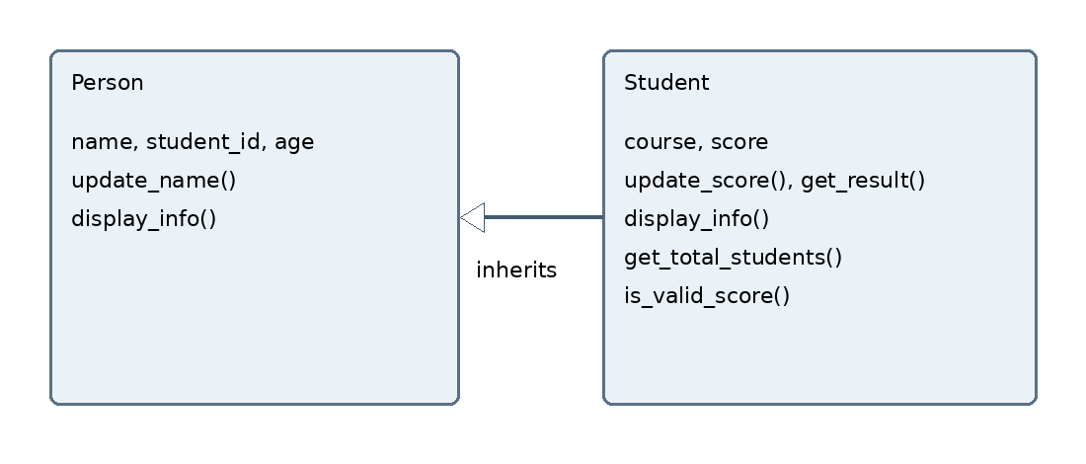
Figure 1 Student inherits shared attributes and methods from Person. The arrow points to the parent. Student adds course information and score-related behaviour.

Design and implementation

Constructor parameters and objects
student1 = Student("Alieu Kamara", "S001", 21, "Python OOP", 45)
student2 = Student("Hawa Conteh", "S002", 20, "Networking", 82)
The name, student_id and age values go to Person through super().__init__(). Student stores course and score after validating them. A blank name, student ID or course is rejected. Age must be a non-negative whole number. A score must be an int or float between 0 and 100; Boolean values are rejected.

Inheritance and method overriding
class Student(Person) declares the inheritance relationship. Student inherits update_name(). Its display_info() method overrides the parent method and uses super().display_info() before printing the course, score and result. This extends the parent behaviour without copying it (Python Software Foundation, n.d.).
Method type | Implementation | Role
Instance | update_name(), update_score() | Changes a particular student object.
Instance | get_result(), display_info() | Calculates a result and displays the record.
Class | get_total_students() | Returns the shared count through cls.
Static | is_valid_score(score) | Checks a score without self or cls.

List storage and functions
students is the only collection used to store records. add_student() checks the object type, loops through existing IDs and appends an accepted Student. display_students() checks whether the list is empty and otherwise calls each student’s display_info() method. Two different objects can hold different courses and scores while sharing the same class definition.

Result rule and updates
The demonstration labels scores of 50 or more as Pass and lower scores as Needs improvement. This is a teaching rule, not an official Limkokwing grading policy. The first student starts at 45, then update_score(68) changes the result to Pass. update_name() changes the first name to Alieu A. Kamara.
total_students counts successfully constructed Student objects. It does not count only records in the list. If a new object is constructed and later rejected because its ID is already stored, the creation count can exceed the list length.

Running the program and actual output

How to run
Install Python 3, save student_results.py in a folder and open a terminal in that folder. Run the command below. On some Windows installations, py can be used in place of python. No packages need to be installed.
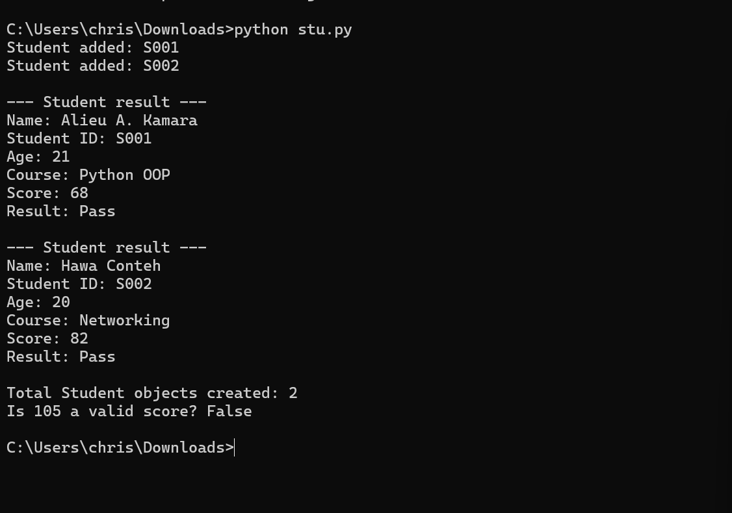
Figure 2 Actual standard output captured from running the source file. The image shows the program output, rather than a separate desktop terminal interface.
Both updated results are Pass. The class method reports two objects, and is_valid_score(105) returns False. The original score of 45 does not appear because the program updates that object before displaying the records.

Verification and requirements

Executed checks
The existing classes and functions were checked separately from the submitted source. All checks below passed. The source file itself still uses no imports.

Mapping to the assignment
Required feature | Evidence
Two classes and inheritance | Person is the parent and Student is the child.
Attributes and objects | Two objects have name, ID, age, course and score.
One record collection | students is a list of Student objects.
Add and display functions | add_student() and display_students().
Instance and class methods | Object updates and get_total_students().
Static method | is_valid_score() checks scores.
Documentation and execution evidence | This report includes explanations, code and captured output.

Digital Public Goods alignment and submission

Privacy and reuse
The example uses fictional identities and marks. It should not be used to publish real student information. Records stay in memory and disappear when the program ends. This version provides no login, access controls or encryption. Those limitations make it a demonstration rather than a production student information system.
The source is readable and has no paid dependency. It can be reused for teaching, and the text interface provides labelled results. It does not include language options or a graphical interface; accessibility would need evaluation with intended users.

Open source publication
The assignment requires GitHub publication and a README. Add an appropriate open-source licence, such as MIT, when preparing the repository. A public repository alone does not establish open licensing. The Digital Public Goods Standard covers licensing, documentation, privacy and other requirements; this exercise demonstrates selected principles and is not a claim of formal DPG recognition (Digital Public Goods Alliance, n.d.).

Limitations and improvements
The program has fixed demonstration values, one course per student, no persistence and a simplified result rule. It does not restrict IDs to a particular institutional format. An interactive menu, additional validation and authorised storage could be considered later. They are not included in this version.

Conclusion
This system uses inheritance to share personal details while keeping student-specific behaviour in Student. The constructor accepts the requested name, ID and age along with course and score. The list functions, score validation and method types demonstrate the main practical requirements of the brief.

References
Limkokwing University of Creative Technology (2026) PROG211 Object-Oriented Programming 1: Real-World Solutions under DPG Standards. Individual assignment brief.
Python Software Foundation (n.d.) Classes. Available at: https://docs.python.org/3/tutorial/classes.html (Accessed: 28 October 2026).
Digital Public Goods Alliance (n.d.) Digital Public Goods Standard. Available at: https://www.digitalpublicgoods.net/standard (Accessed: 28 October 2026).

