QUOTATION |  | No: ZGC-EVN-QTN-260826000001  Date: 26 August 2026  Valid Until: 01 September 2026  Account ID: ZGC-ORG-000001

Client / Company | MI TECHNICAL TRADING CO. W.L.L. (MIT Group)
Address | Flat/Shop 11, Building 1225, Road 2325, Block 623, Al Akr Al Sharqi, Kingdom of Bahrain
Contact | Mr. Muhammed, CEO
Reference | AWC Branded Notebook & Pen Sets

1. Quotation Scope

This quotation covers the supply and custom branding of notebook and pen sets with the AWC logo, based on the selected model and approved artwork. Two branding options are available: Option 1 featuring a single blue color print as per the MIT brand guide, and Option 2 featuring a black print.

*Following payment confirmation, orders will be ready and delivered within 10 to 15 working days.

Option 1 - Blue Branding Option 2 - Black Branding
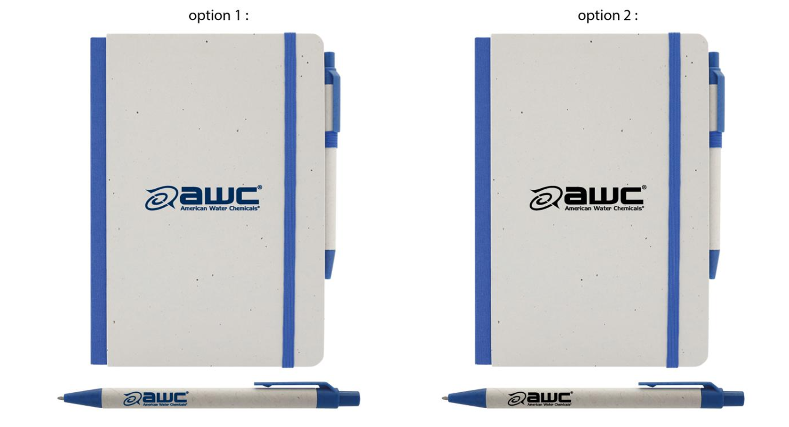

2. Commercial Items:
No. | Description | Qty | Rate (BHD) | Amount (BHD)
1 | Custom-branded notebook and pen set with AWC logo, as per approved artwork/sample | 200 | 1.⁸⁰⁰ | 360.⁰⁰⁰

Total Amount Quoted: | 360.⁰⁰⁰
In words: THREE HUNDRED AND SIXTY / BHD ONLY

3. Terms & Conditions:
- Upon approval of this quotation, Zoom Group of Companies will issue the corresponding Tax Invoice for payment processing.
- Applicable VAT will be added upon issuance of the Tax Invoice.
- Full payment of the Tax Invoice and approval of the final artwork / mock-up are required to confirm the order and commence production.
- Delivery will be made to the client's confirmed address in Bahrain within 10 to 15 working days following payment and artwork approval.
- Changes requested after artwork approval or commencement of production may result in additional charges and revised delivery timelines.
- Custom-branded goods cannot be cancelled, returned or refunded once production has commenced.
- Minor variations in colour, print positioning and material finish may occur within normal manufacturing and printing tolerances.
- Approval of this quotation confirms acceptance of the quoted scope, pricing and above terms and conditions.

4. Quotation Acceptance & Approval:
By signing below, the client accepts this quotation and agrees to the terms and conditions outlined above.

Approved By (Client Signature) | Company Stamp / Seal
Name: | Date:
Title / Designation: | Signature:

