Title

NeoNet dataset. Radiocarbon dates from Late Mesolithic/Early Neolithic transition in the North Central-Western Mediterranean watershed

Paper Authors

1. Huet, Thomas

2. Miriam, Cubas

3. Juan F.,Gibaja

4. F. Xavier,Oms

5. Mazzucco, Niccolò (corresponding author)

Paper Author Roles and Affiliations

1. UMR 5140, ASM-CNRS, thomashuet7@gmail.com

2.Universidad de Alcalá. Facultad de Filosofía y Letras. Departamento de Historia y Filosofía. Área, C/Colegios, 2. E-28801. Alcalá de Henares. Madrid. Spain, miriam.cubas@uah.es. ORCID: 0000-0002-2386-8473

3. Escuela Española de Historia y Arqueología en Roma (EEHAR-CSIC). Via di Sant’Eufemia 13, 00187, Rome (Italia), [juan.gibaja@eehar.csic.es](mailto:juan.gibaja@eehar.csic.es) ORCID: 0000-0002-0830-3570

4. SERP, Seminarid’Estudis i Recerques Prehistòriques, Secció de Prehistòria i Arqueologia. Universitat de Barcelona, oms@ub.edu ORCID: 0000-0002-1642-548X

5. Università di Pisa, Dipartimento di Civiltà e Forme del Sapere, niccolo.mazzucco@unipi.itORCID: 0000-0002-9315-3625

Abstract

The NeoNet dataset aims to contribute to model the pioneer farming front (i.e. Neolithisation) in the North Central and North Western Mediterranean watershed by focusing on the co-existence period of last hunter-gathers and first farmers (ca. 8000 to 5000 uncal BP). The complete dataset is composed of the *c14_dataset.tsv* file, a dataframe with tab-separated values, and a connex dataframe: *c14_material_life.tsv*. The dataset counts 2446 radiocarbon dates coming from 522 archaeological sites, and 1752 different archaeological records (stratigraphic units, structures, negative features, hearths, etc.). To ensure and facilitate the reuse of the radiocarbon dates, NeoNet's data structure is based on the Euroevol database layout. Among other fields, particular attentions have been paid on the homogenisation of the laboratory code, the archaeological context, and the references, in order to facilitate further data extractions. Indeed, the dataset is linked to an opensource RShiny interactive web app (NeoNet app), and a getter function (R package c14bazAAr, R function get_neonet).

Keywords

Radiocarbon dates, Mesolithic, Neolithic, Mediterranean archaeology

**(1) Overview**

Context

The Neolithisation of the Central and Western Mediterranean represents a fundamental step in the process of Europe Neolithisation. From the Aegean Neolithic, two main ways of diffusion spread towards West: a continental one, via the Central and Eastern Balkans, and a coastal one, via the Mediterranean shores []. This latter is mainly associated to the groups bearing Impressed Ware pottery, which in a few centuries moved from western Greece to the southern façade of the Iberian Peninsula, along the Adriatic and Tyrrhenian coasts. During this expansive process, several transformations occurred simultaneously with the sedentarisation, including the emerging of new pottery decorative style [], the adoption of new types of stone tools [], the domestication of new plants and animals [], the creation of new interaction zones and exchange networks [**,** ], changes in the symbolic sphere [], etc. The contact with groups of local hunter-gatherers might have played a role in this process of change [, ]. Despite that, the study of the interactions between Neolithic and Mesolithic populations remains a complex subject of research that, first of all, needs a solid chronological framework. During the last decades, hundreds of radiocarbon dates have been published as outcome of the research on the Mesolithic-Neolithic transition. Several recent papers have provided analysis of radiocarbon datasets for this chronological and geographical area [-]. However, raw radiocarbon data is often presented in form of large datasheet and exploring the data is not trivial. In addition, published dataset are often biased, as radiocarbon dates are previously filtered by authors on the basis of different criteria (type of dated sample, standard deviation of the sample, data reliability, etc.). In order to overcome such limitations and to provide a user friendly, open access, and updated tool for exploring the radiocarbon data we built NeoNet app. NeoNet is an online geospatial dataset of radiocarbon dates for the Mesolithic-Neolithic transition in the Central and Western Mediterranean, built to facilitate the selection of absolute dates (c14 dates) by providing selection tools at spatial, chronological and cultural level.

This dataset is born as part of NeoNet, a thematic research network funded by the Spanish *Plan Estatal de Investigación Científica y Técnica y de Innovación 2017-2020: Acciones de dinamización "Redes de Investigación"* in the framework of the Spanish Program for the Generation of Knowledge and Scientific and Technological development for the Spanish System of Research, Development and Innovation of the Ministry of Science, Innovation and Universities (ref. RED2018-102382-Tand PID2020-112513RB-I00). The project (<https://redneonet.com/en/home-en/>) reunites scholars from different institutions across the entire Mediterranean area in order to create a space for discussion about the origin, development and consolidation of Neolithic communities along the Mediterranean basin. To create common practices in the publication, selection, and interpretation of radiocarbon dates was one of the goals of NeoNet network.

The dataset integrates datasets of radiocarbon dates already published in the web [, -15], including online datasets as Euroevol and Radon [, ], but as well data from the personal archives of the authors. All radiocarbon dates have been individually revised, and many missing or erroneous information have been corrected. NeoNet integrates and complete recent geospatial dataset for other regions and/or chronological periods, contributing to create open access repository for radiocarbon dates [-].

*Spatial coverage*

The spatial coverage concerns the North Central-Western Mediterranean watershed (main rivers: Ebro, Rhône, Po, etc.). This area attests the diffusion of the Impresso-Cardial Complex (ICC). However, in future versions the dataset will be enlarged to the entire Mediterranean Basin, including from the Eastern Mediterranean to the Atlantic coasts of Portugal.

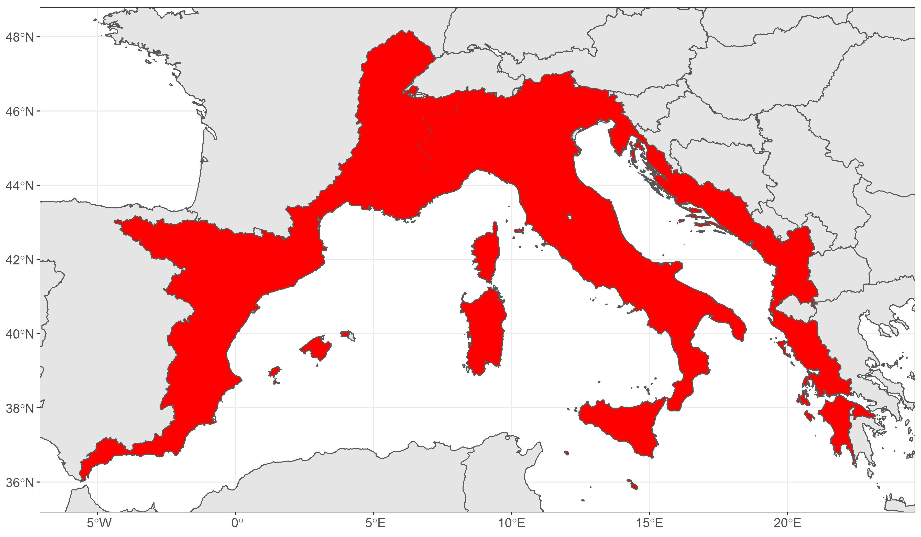

Figure 1. Region of interest (in red): watersheds of the Central and West North Mediterranean

The minimum bounding box of the region of interest is:

Northern boundary:+48.2N

Southern boundary: +35.8N

Eastern boundary: +5.7E

Western boundary: +23.2E

*Temporal coverage*

The temporal coverage starts from 8000 BP and stops at 5000 BP (uncalibrated) in order to cover the latest hunter-gatherers live style (i.e. Late Mesolithic and its regional *facies*) to the first testimonies of farming economy (i.e. Early Neolithic and its regional *facies*).

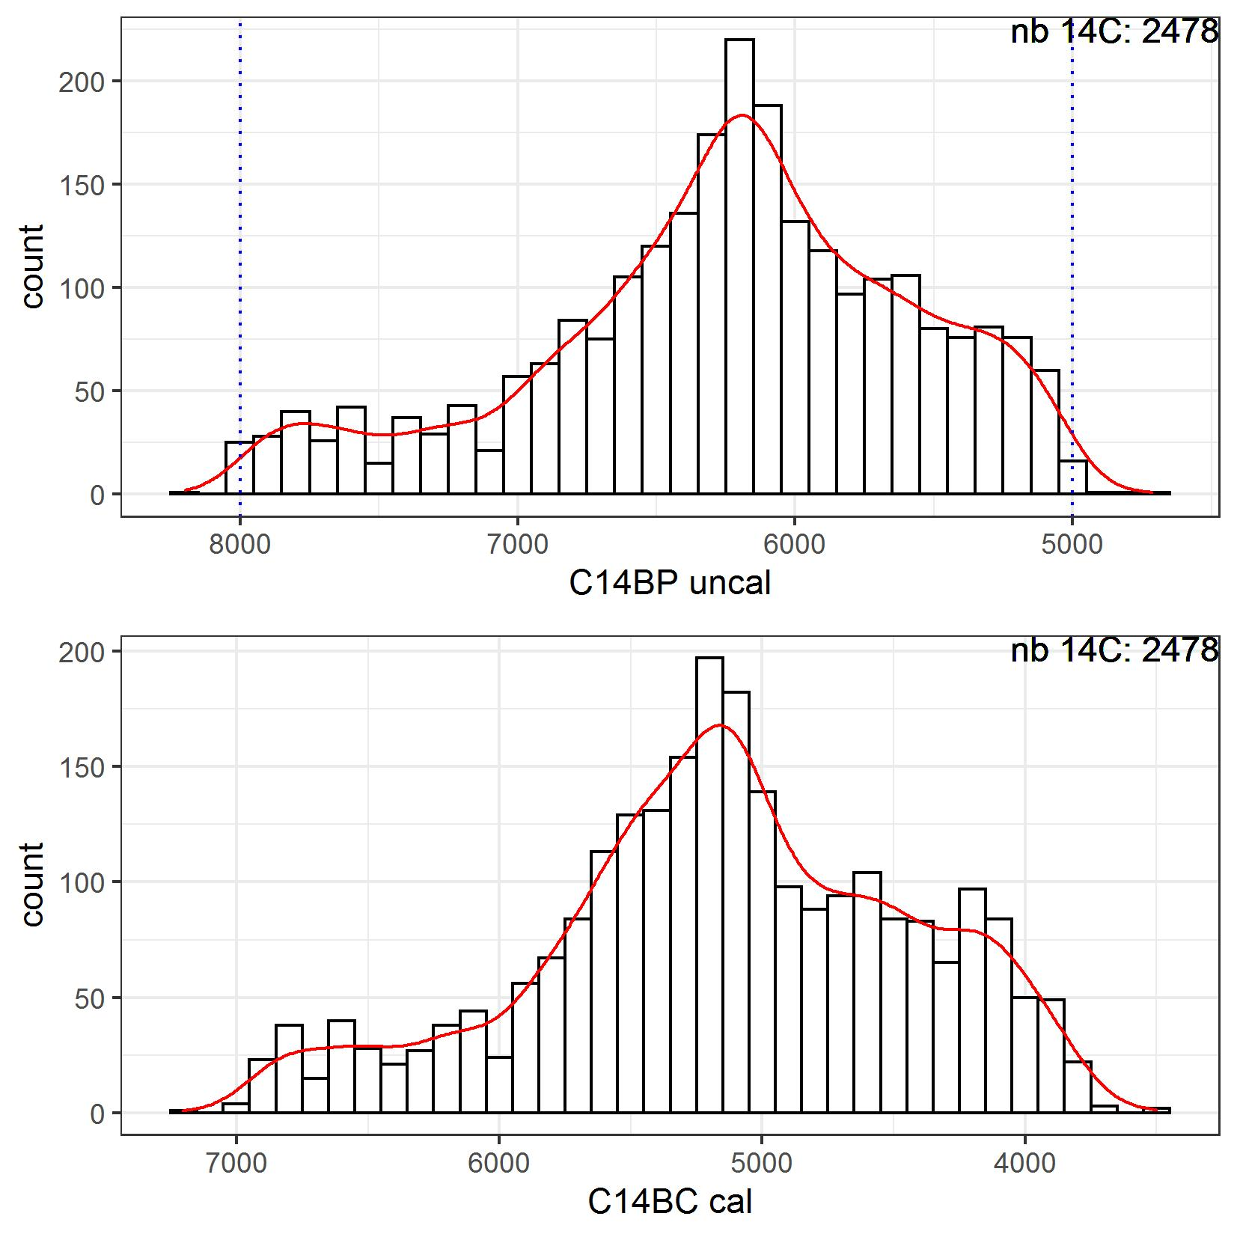

Figure 2. Chronological distribution of C14 uncal BP ages with bounding limits (top) and means on C14 cal BC ages (bottom)

(2) Methods

The creation of the NeoNet dataset was enabled by a collaborative synthesis of published radiocarbon dates between the East Adriatic and the Levantine Coast of the Iberian Peninsula. Each author has taken in charge a part of the whole dataset: Adriatic western Balkans and Italy (NM), South of France (TH), and eastern Spain (MC, JFG, XO). The dataset has been focused on information with a high reuse potential (conventional naming, URIs, etc.). The data structure has been thought to be reused in NoSQL databases where columns "SiteName" and "LabCode" could be used as unique keys. Further addition of presence/absence data about major cultural traits and contextual information (layers, structures, etc.).

***Steps***

Desk-based data integration from various radiocarbon publications (site monographs, radiocarbon inventories, online databases, etc.)

***Quality Control***

Cross verifications between different publications, standardisation of columns names and values according to current standards, duplicate suppression, etc. Scripting routines (R language) have been applied to verify, modify and summarize the dataset.

***Constraints***

The dataset structure has been voluntarily reduced to radiocarbon core fields in order to have the less possible non available (n/a) data. All fields, and all cells have been checked. When no values were available (n/a), we fill the cells with this value. Currently, the n/a values represent 2% of the whole dataset and are largely concentred in the "PhaseCode", the "Material", and the "Material Species" fields.

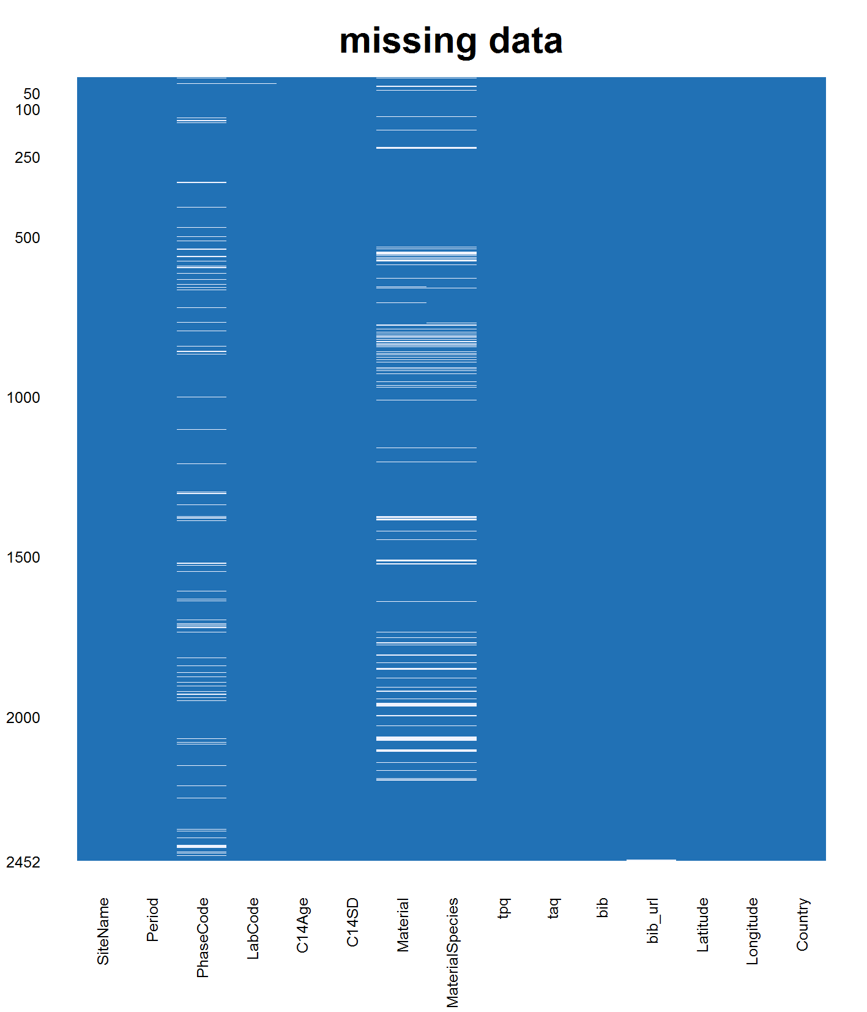

Figure 3. Missing values (blank cells) in the c14_dataset.tsv dataset

**(3) Dataset description**

***Object name***

The dataset is composed of the *c14_dataset.tsv* file listing all the radiocarbon dates; the file *c14_material_life.tsv* for equivalences between material ("Material" and "MaterialSpecies") and material life duration; the file *references.bib* for bibliographical references.

**Radiocarbon dataset (c14data.tsv)**

The NeoNet dataset reuses part of the Euroevol layout to register the main information of radiocarbon dates, since Euroevol was one of the first, and most complete open access database ever published []. The file is a dataframe with tab-separated values (.tsv)

Each radiocarbon date has a:

- unique site name("SiteName");

- cultural period associated to the radiocarbon date ("Period"). Periods abbreviations are defined as following: LM (Late Mesolithic), UM (Undefined Mesolithic), LMEN (Late Mesolithic/Early Neolithic), EN (Early Neolithic), MN (Middle Neolithic), LN (Late Neolithic), UN (Undefined Neolithic).

- stratigraphical or structural context of sample provenance ("PhaseCode");

- unique identifier based on the standard laboratory identifiers ("LabCode") in respect to the conventional naming of laboratory codes and sample notation [];

- conventional radiocarbon age ("C14Age");

- standard deviation associated error ("C14SD");

- type of material from where the date has been extract ("Material");

- specification of this material ("MaterialSpecies");

- calculated time rank in cal BC *terminus post quem* ("tpq") and *terminus ante quem* ("taq");

- bibliographical references with a short title ("bib");

- DOI or a BibTeX key refering to the an entry in c14refs.tsv ("bib_url");

- site's coordinates in decimal degrees ("Longitude", "Latitude");

- site's country ("Country")

**Material life (c14_material_life.tsv)**

Material life duration arestored in the *c14_material_life.tsv* file. The two fields show the material type ("material.type") and the material life duration ("life.duration"). The former has been aligned to the Euroevol values (cereal, fauna, wood charcoal, etc.). Material life abbreviation are defined as following: CE (Cereal charred seed); F (Faunal material); H (Human bone); OR (Organic sediment); SD (Sediment); SE (Charred seed); SH (Shell); WC (Wood Charcoal).

**Bibliographical references (reference.bib)**

Bibliographical references of each radiocarbon date are stored in the *reference.bib* file. It is a BibTeX file format. If only a BibTeX key is given, and no DOI, this file result of the join between the "bib_url" field of the C14 spreadsheet and the *references.bib*. If the DOI exists, the full bibliographical reference is given.

***Datatype***

Secondary data

***Format names and versions***

TSV UTF-8, BibTex

***Creation dates***

Records created from February 2020 to September 2021 as part of the NeoNet work group.

*Dataset Creators*

The primary researcher responsible for the data collation was Niccolò Mazzucco.The respective contributions of each authors have been detailed in the Methods section.

***Language***

English

***License***

CC BY 4.0

***Repository location***

NeoNet dataset is available on the University of Pisa repository: XXXXXXXXXXX (all versions doi).

***Publication date***

XXXXXXXXXXX September 2021

(4) Reuse potential

Regarding the spread of farming in the Mediterranean region, the NeoNet dataset completes radiocarbon datasets such as BDA [], Piberia [], Euroevol [], MediCarbon[], and Katsianis [].

The NeoNet dataset will be linked to the function get_neonet() from the R package c14bazAAR []. This function is part of the package getter function that allows browsing more than twenty different radiocarbon databases or datasets and homogenised their formats.

The NeoNet dataset is also embedded in the NeoNet app (<http://shinyserver.cfs.unipi.it:3838/C14/>) hosted by the University of Pisa. This interactive web app facilitates the selection of dates by providing selection tools for spatial, chronology, date accuracy. The map interface facilitates the multi-scalar study of the mobile border between the Last Hunter-Gathers and the Early farmers. The development version of the app is stored on GitHub (<https://github.com/zoometh/neonet>) and will enable contributions (<https://github.com/zoometh/neonet/blob/master/.github/CONTRIBUTING.md>). Finally, a web tutorial has also been created for the app and the dataset (<https://zoometh.github.io/neonet/>)

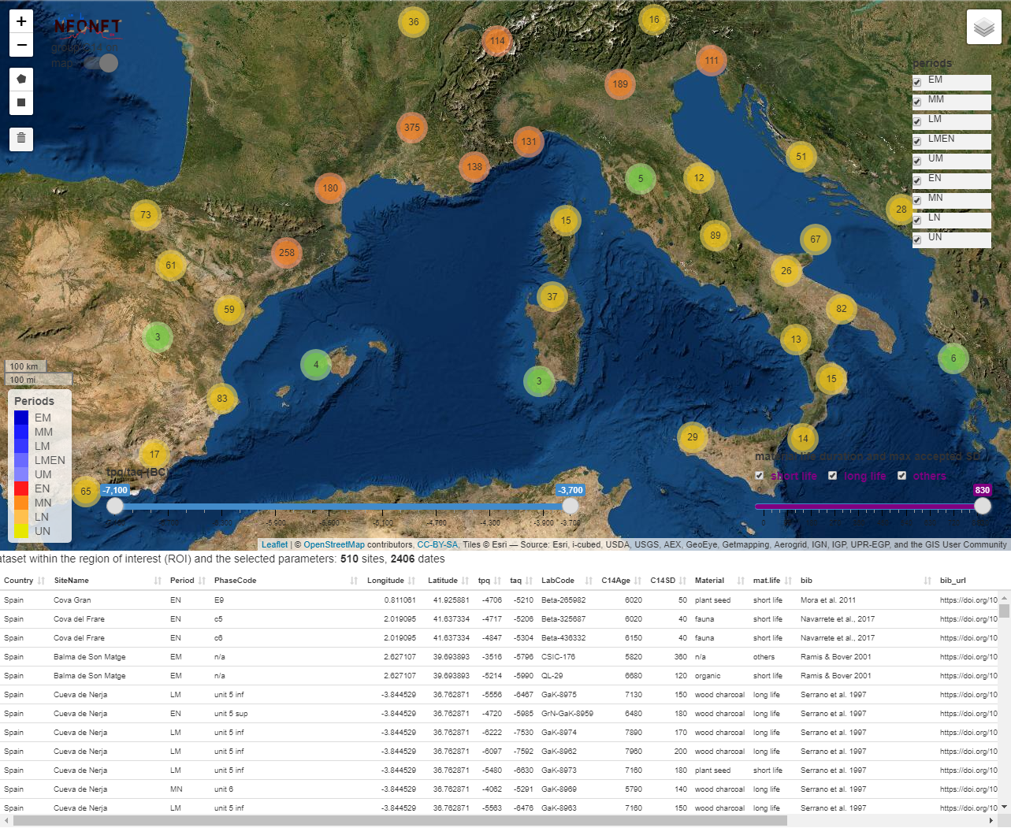

Figure 4. Screen capture of the NeoNet app (RShiny)

Acknowledgements

We are especially thankful to Federico Bianchi of the University of Pisa for the technical support.

Funding statement

This article is part two research projects funded by the Ministry of Science, Innovation and Universities*: ‘Origen, desarrollo y consolidación del neolítico en el ámbito Mediterráneo’* (RED2018-102382-T) and ‘*Tools, Techniques and Specialists: the keys to understand the Mesolithic-Neolithic transition in Mediterranean Europe’* (PID2020-112513RB-I00). Also is part of the ‘*AGER.Crescita agricola nell'Europa preistorica. Un approccio al cambio tecnologico, economico e sociale’* project funded by the Italian Ministry of Education, University and Research in the framework of the Rita Levi Montalcini.

References

1. Guilaine, J., 2009 La difusión de la agricultura en Europa: una difusión aritmética, *Zephyrvs*, 530, p- 267-272. Available at: <https://revistas.usal.es/index.php/0514-7336/article/view/4987> (Accessed: 25 August 2021).
2. Guilaine, J., 2018. A personal view of the neolithisation of the Western Mediterranean. *Quaternary International*, 470, p. 211-225. DOI: [10.1016/j.quaint.2017.06.019](https://doi.org/10.1016/j.quaint.2017.06.019)
3. Mazzucco, N., Ibáñez, J. J., Capuzzo, G., Gassin, B., Mineo, M., Gibaja, J. F., 2020. Migration, adaptation, innovation: The spread of Neolithic harvesting technologies in the Mediterranean. *PloSone*, 15(4), e0232455. DOI: [10.1371/journal.pone.0232455](https://doi.org/10.1371/journal.pone.0232455)
4. Salavert, A., Martin, L., Antolín, F., &Zazzo, A., 2018. The opium poppy in Europe: exploring its origin and dispersal during the Neolithic. *Antiquity*, 92(364), e1. DOI: [10.15184/aqy.2018.154](https://doi.org/10.15184/aqy.2018.154)
5. Tykot, R.H., 1996. Obsidian Procurement and Distribution in the Central and Western Mediterranean. Journal of Mediterranean Archaeology, 9(1), p. 39-82. DOI: [10.1558/jmea.v9i1.39](https://doi.org/10.1558/jmea.v9i1.39)
6. Gabriele, M., Convertini, F., Verati, C., Gratuze, B., Jacomet, S., Boschian, G., Durrenmath, G., Guilain, J., Lardeaux, J-M., Gomart, L., Manen, C., Binder, D., 2019. Long-distance mobility in the North-Western Mediterranean during the Neolithic transition using high resolution pottery sourcing. *Journal of Archaeological Science: Reports*, 28, 102050. DOI: [10.1016/j.jasrep.2019.102050](https://doi.org/10.1016/j.jasrep.2019.102050)
7. Skeates, R., 1994. Ritual, Context, and Gender in Neolithic South-Eastern Italy. *Journal of European Archaeology*, 2(2), p. 199–214. DOI: [10.1179/096576694800719102](https://doi.org/10.1179/096576694800719102)
8. Perrin, T., 2003. Mesolithic and Neolithic cultures co-existing in the upper Rhône valley. *Antiquity*, 77(298), p. 732-739. DOI: [10.1017/S0003598X00061676](https://doi.org/10.1017/S0003598X00061676)
9. Juan-Cabanilles J., Martí Oliver B., 2017. New Approaches to the Neolithic Transition: The Last Hunters and First Farmers of the Western Mediterranean. In: García-Puchol O., Salazar-García D. (eds.), Times of Neolithic Transition along the Western Mediterranean. Fundamental Issues in Archaeology. Springer, Cham, p. 33-65. DOI: [10.1007/978-3-319-52939-4_3](https://doi.org/10.1007/978-3-319-52939-4_3)
10. Bocquet-Appel, J. P., Naji, S., Vander Linden, M., & Kozlowski, J. K., 2009. Detection of diffusion and contact zones of early farming in Europe from the space-time distribution of 14C dates. Journal of Archaeological Science, 36(3), p. 807-820. DOI: [10.1016/j.jas.2008.11.004](https://doi.org/10.1016/j.jas.2008.11.004)
11. Binder, D., Lanos, P., Angeli, L., Gomart, L., Guilaine, J., Manen, C., Maggi R., Muntoni, I.M., Panelli, C., Radi, G., Tozzi, C., Arobba, D., Battentier, J., Brandaglia, M., Bouby, L., Briois, F., Carré, A., Delhon, C., Gourichon, L., Marinval, P., Nisbet, R., Rossi, S., Rowley-Conwy, P., Thiébault, S., 2018. Modelling the earliest north-western dispersal of Mediterranean Impressed Wares: new dates and Bayesian chronological model. *Documenta Praehistorica*, 44, p. 54-77. DOI: [10.4312/dp.44.4](https://doi.org/10.4312/dp.44.4)
12. Martínez-Grau, H., Jagher, R., Oms, F.X., Barceló, J.A., Pardo-Gordó, S., Antolín, F., 2020. Global Processes, Regional Dynamics? Radiocarbon Data as a Proxy for Social Dynamics at the End of the Mesolithic and During the Early Neolithic in the NW of the Mediterranean and Switzerland (c. 6200-4600 cal BC). *Documenta Praehistorica*, 47, p. 170-191. DOI: [10.4312/dp.47.10](https://doi.org/10.4312/dp.47.10)
13. Perrin, T., Manen, C., 2021. Potential interactions between Mesolithic hunter-gatherers and Neolithic farmers in the Western Mediterranean: The geochronological data revisited. *PloS one*, 16(3), e0246964. DOI: [10.1371/journal.pone.0246964](https://doi.org/10.1371/journal.pone.0246964)
14. Oms, X., Martín, A., Esteve, X., Mestres, J.,Morell, B., Subirà, M.E.,Gibaja, J.F., 2016. The Neolithic in North-East Iberia: Chronocultural Phases and 14C. *Radiocarbon*, 58(2),p. 291- 309. DOI: [10.1017/RDC.2015.14](https://doi.org/10.1371/journal.pone.0246964)
15. Pardo-Gordó, S., García Puchol, O., BernabeuAubán, J. and Diez Castillo, A., 2019. Timing the Mesolithic-Neolithic Transition in the Iberian Peninsula: The Radiocarbon Dataset. *Journal of Open Archaeology Data*, 7, p.4. DOI: [10.5334/joad.49](http://doi.org/10.5334/joad.49)
16. Manning, K., Colledge, S., Crema, E., Shennan, S. and Timpson, A., 2016. The Cultural Evolution of Neolithic Europe. EUROEVOL Dataset 1: Sites, Phases and Radiocarbon Data. *Journal of Open Archaeology Data*, 5, p.e2. DOI: [10.5334/joad.40](http://doi.org/10.5334/joad.40)
17. Hinz, M., Furholt, M., Müller, J., Raetzel-Fabian, D.,Rinne, C.,Sjögren, K-G.,Wotzka, H.P., 2012. RADON - Radiocarbon dates online 2012. Central European database of 14C dates for the Neolithic and Early Bronze Age. <http://www.jungsteinsite.de/>, 1-4. Available at: <https://radon.ufg.uni-kiel.de/> (Accessed: 25 August 2021).
18. Palmisano, A., Bevan, A. and Shennan, S., 2018. Regional Demographic Trends and Settlement Patterns in Central Italy: Archaeological Sites and Radiocarbon Dates. *Journal of Open Archaeology Data*, 6(1), p.2. DOI: [10.5334/joad.43](http://doi.org/10.5334/joad.43)
19. Lucarini, G., Wilkinson, T., Crema, E.R., Palombini, A., Bevan, A. and Broodbank, C., 2020. The MedAfriCarbon Radiocarbon Database and Web Application. Archaeological Dynamics in Mediterranean Africa, ca. 9600–700 BC. *Journal of Open Archaeology Data*, 8(1), p.1. DOI: [10.5334/joad.60](http://doi.org/10.5334/joad.60)
20. Katsianis, M., Bevan, A., Styliaras, G. and Maniatis, Y., 2020. An Aegean History and Archaeology Written through Radiocarbon Dates. *Journal of Open Archaeology Data*, 8(1), p.5. DOI: [10.5334/joad.65](http://doi.org/10.5334/joad.65)
21. Radiocarbon.org, Lab Codes, Available at: <http://www.radiocarbon.org/Info/labcodes.htm> (Accessed: 1 January 2021).
22. Schmid et al., (2019). c14bazAAR: An R package for downloading and preparing C14 dates from different source databases. Journal of Open Source Software, 4(43), 1914, DOI: [10.21105/joss.01914](https://doi.org/10.21105/joss.01914)

**Copyright Notice**

Authors who publish with this journal agree to the following terms:

Authors retain copyright and grant the journal right of first publication with the work simultaneously licensed under a [Creative Commons Attribution License](http://creativecommons.org/licenses/by/3.0/) that allows others to share the work with an acknowledgement of the work's authorship and initial publication in this journal.

Authors are able to enter into separate, additional contractual arrangements for the non-exclusive distribution of the journal's published version of the work (e.g., post it to an institutional repository or publish it in a book), with an acknowledgement of its initial publication in this journal.

By submitting this paper you agree to the terms of this Copyright Notice, which will apply to this submission if and when it is published by this journal.