**Laraval Blog Page Example**

Step: 1

Create Laraval Project

**composer create-project laravel/laravel blog**

Step: 2

Change Directory

**Cd blog**

Step: 3

Run Laraval Project

**php artisan serve**

Step: 4

Create Database on phpMyAdmin

Step 5

Change config

Config -> database.php

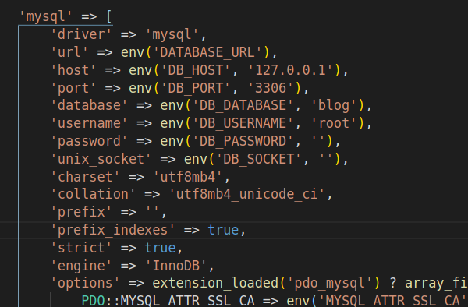

Step: 6

.env

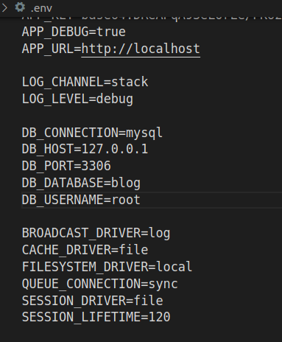

Step: 7

Create model file with migrations

**php artisan make:model Article –m**

App -> Models -> Article.php

Step: 8

Clear Cache

**php artisan config:cache**

Step: 9

Create Database with Migrate

Edit migrations file

Database -> migration ->

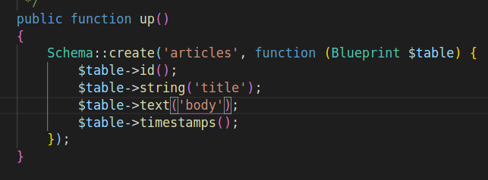

**php artisan migrate**

Step 10

Create Controller

**php artisan make:controller ArticlesController –r**

App -> Http -> Controllers-> ArticlesController

Step 11

Download a Template (If you want, author wise create with HTML)

Insert all css, js, and all support file copy to public folder

Step 12

Create a folder on

Resources -> views

Folder Name : layouts

File Name: theme.blade.php (Copy index file and paste here)

Set Content Display Area

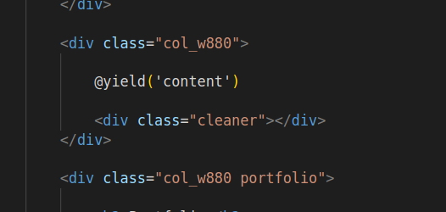

Step 13

Setup Routs

Routes -> web.php

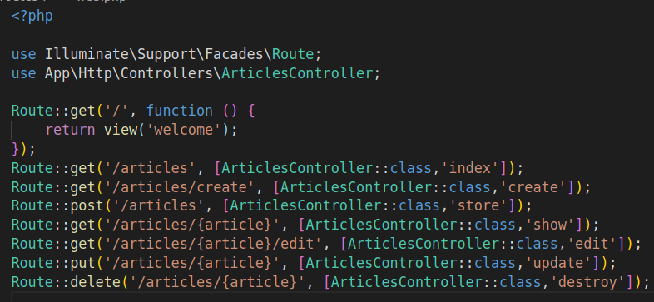

Step 14

Set Display Page

Goto

App -> Http -> Controller -> ArticlesController.php

Add top Models name

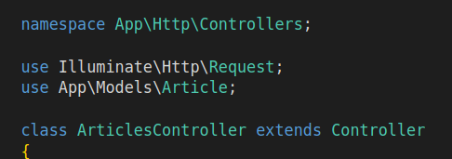

Edit index function

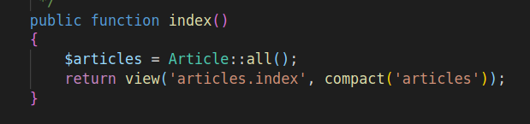

Create a folder in resource -> views

Folder Name : articles

Create Index File

File Name : index.blade.php

Code :

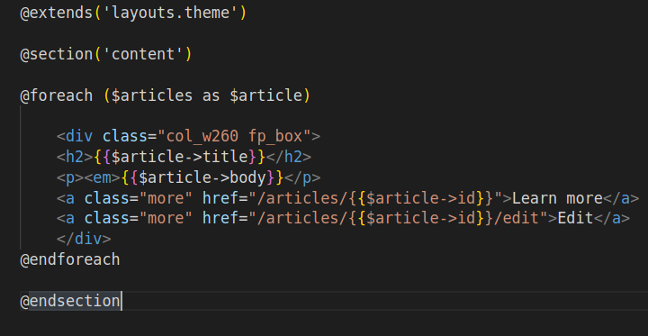

Create Post File

Add Bootstrap to theme webpage using CDM

Add a Menu to add post

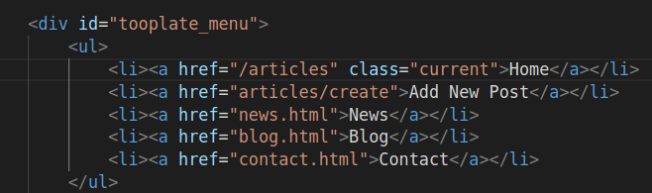

Create a File in article folder

File Name : create.blade.php

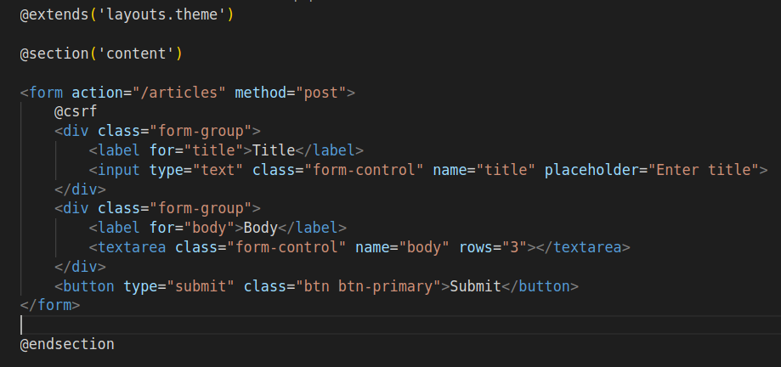

Edit ArticlesController.php

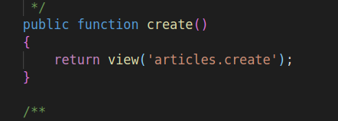

Create Store Function

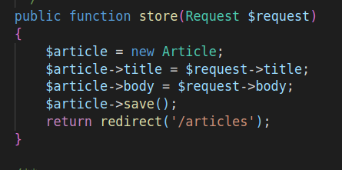

Create Open Post

Add a link in index.blade.php

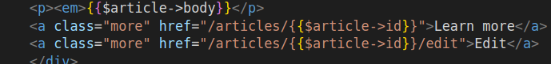

Edit ArticlesController.php

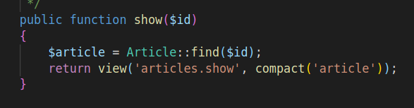

Create a File in article folder

File Name : show.blade.php

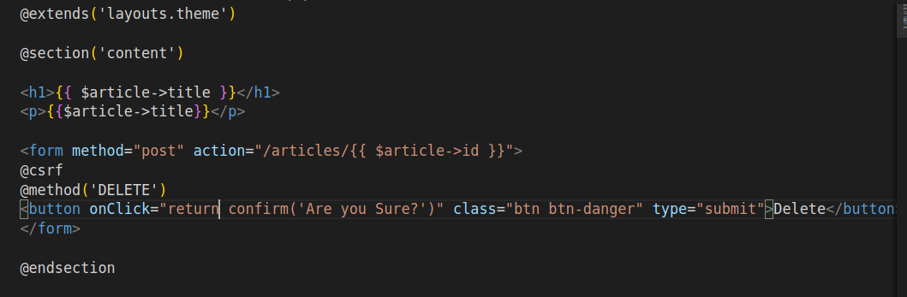

Edit Post Option

Add a button to show.blade.php



Create a File in article folder

File Name : edit.blade.php

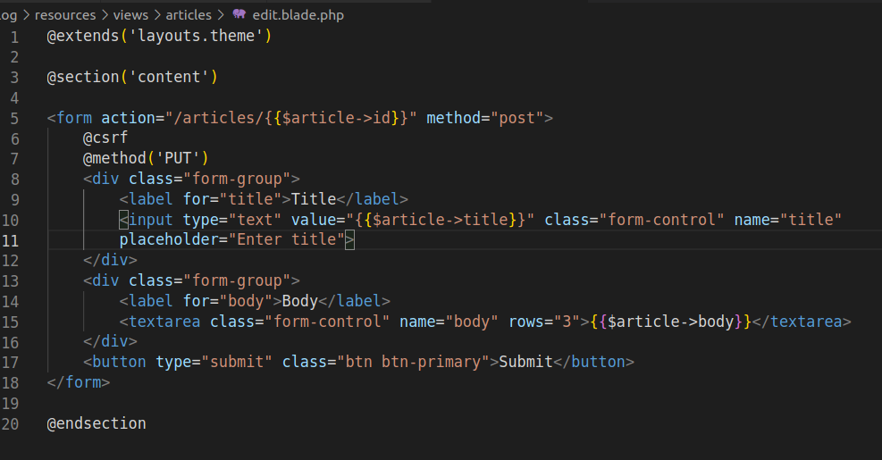

Edit ArticlesController.php

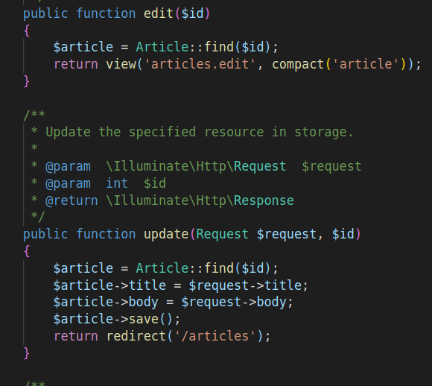

Delete Post Option

Add a form to show.blade.php

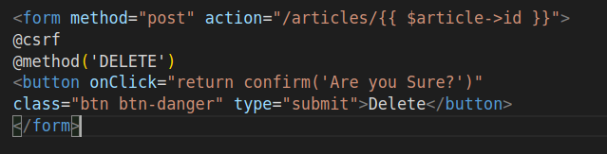

Edit ArticlesController.php

