Introduction

The purpose of this project was to implement a method for taking video of a structured scene, transforming it into voxels (volume pixels), sending it over a network to a client which recreates the original video from the voxels, camera position information, and received difference images. Illustraion 1 shows a block diagram of the method.

Illustration 1: Proposed approach.
The approach was brought to a functional state except for the registration stage, which was experimented with but deferred in order to reduce the project workload.

Gains in compression over sending the source video unprocessed were expected since the camera frequently views the same unmoving scene objects at different periods in the video. Only a few data sets were generated (and only one presented here), but on average the gains were only on the order of a 5% reduction in total data sent from the server to the client.

It is likely less ideal source video or especially non-synthesized source video would probably undermine that marginal gain and even create net increase in the amount of data sent to recreate the source video. On the other hand no real fine tuning has occurred and there could be potential for increased compression.

Video With Depth Data

This process would be used with video in a system that can produce per-pixel or nearly per-pixel depth values. Stereo camera pairs are one example, flash lidar systems are another although resolution is extremely limited currently. For this project the outputs of these systems were approximated by rendering views from a 3D polygonal scene and extracting depth from the z-buffer.

Simulated Scene

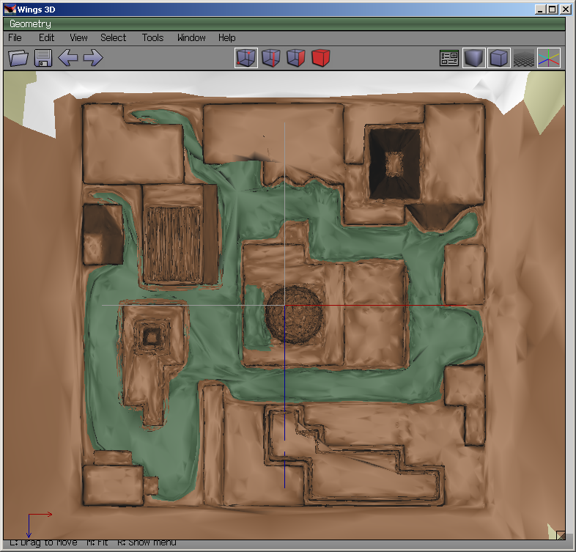Illustration 2: Orthogonal overhead view of original polygonal scene.

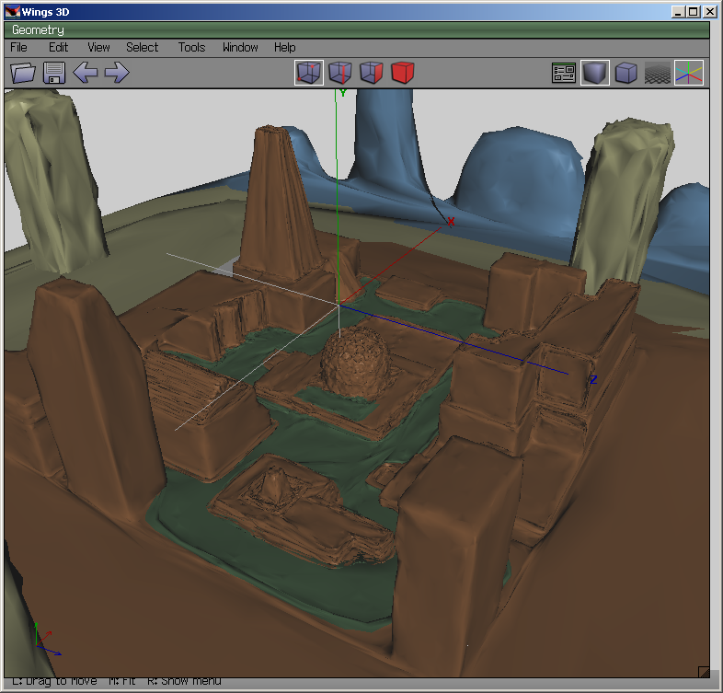Illustration 3: Angled view into original polygonal scene.
The previous two illustrations show the 3D scene that was created for the simulated camera to travel through, using the freely available Wings 3D software (http://www.wings3d.com/). The scene was exported as an ascii Wavefront Alias .obj file.

Textures were applied which resulted in a more realistic scene, and also would have presented a more difficult case for compression, but the 3d file loader did not properly support textures. Also, color coding of different parts of the scene were not properly interpreted by the file loader either, and the result is somewhat monotone video.

Processing was chosen as a development environment for all applications involved in this project, due to its ease of use and free availability (http://processing.org/). One third party library was used, the Saito .obj loader (http://users.design.ucla.edu/~tatsuyas/tools/objloader/). This library is not fully functional, but was adequate for the project.

Once loaded by the video generating processing application, the simulated camera moves through the scene to pre-defined waypoints around the central hemispherical object. For each update to the camera position, an image is saved of the conventionally rendered view (see Illustration 4), and a second image is also saved that contains a colorized view of the depth buffer (see Illustration 5).

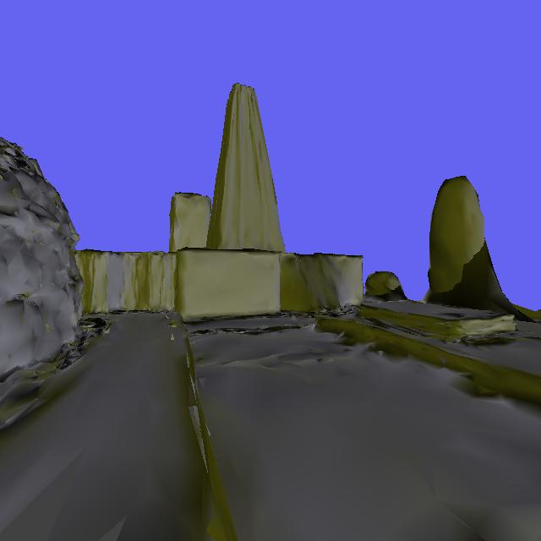Illustration 4: First frame from the source video.

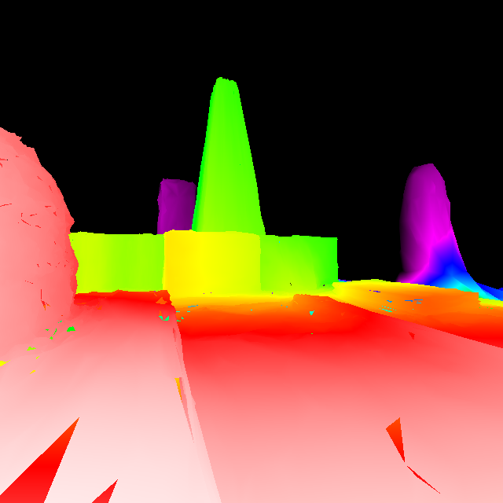Illustration 5: Colorized depth buffer for the first frame.
White corresponds to the closest range surfaces, and this transitions to yellow and green and blue to black for pixels beyond the threshold set for the maximum range. Some visual artifacts are due to polygonal holes in the source 3d scene.

Camera Position and Attitude, Image Registration

Some experiments were done to derive the relative position and angular changes between successive frames. For simplicity the source video was constrained to three degrees-of-freedom (2 translations and one rotation), rather than a full six. This drastically reduces the search space of the registration algorithm as well as simplifying it (and simplifies the voxelization process slightly). Even with those constraints, the development effort required to get this to a usable state was too large for the short schedule of this project.

Since the position and rotation were known at the source in the video generation stage, these values were stored and used in the voxelization stage. If the source video was real rather than generated, an inertial measuement unit strapped to the camera and depth finding system would be required to produce the same values.

Voxelization

The voxelization process takes the depth buffer, the source video images, and camera position, attitude, and field-of-view parameters, and derives the position in 3d space of every pixel in the 2d source image. This is simply the x and y 2d image coordinates multiplied by the depth value for that coordinate, and then the vector of x, y, and depth rotated with a rotation matrix created with the known camera rotation, and finally the camera position is added.

These points are assigned to bins in a NxNxM buffer, where their colors are averaged together with existing color values using a parallel buffer the counts the number of points that have been averaged into a each bin.

Illustration 6 shows the top view of the transformation of source image pixels back into 3D. The camera is positioned at the center bottom of the image. Black regions are out of the cameras 90 degree field-of-view or are occluded by foreground objects. Some contouring is visible near the closer range, and at even closer range the density of image pixels fills the all space at the resolution of the generated view.
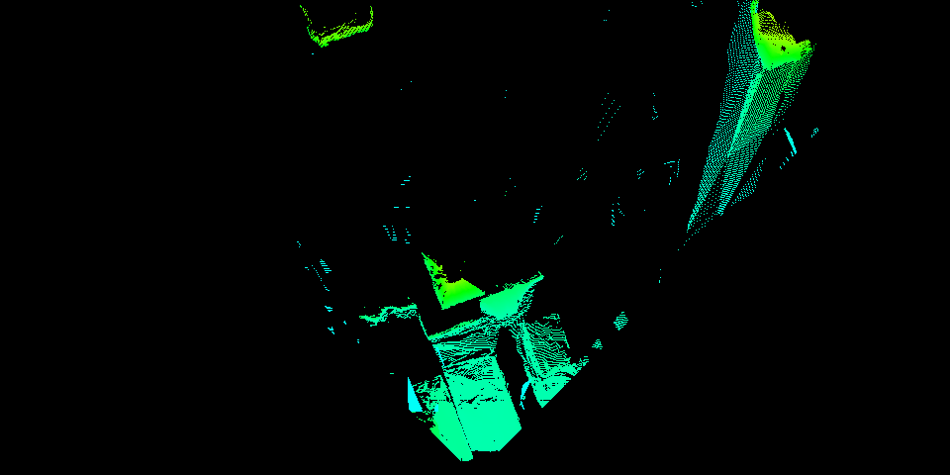Illustration 6: Colorized top view of processed first frame.

Illustration 7 shows the top view of the scene having accumulated height data from all the frames. Close to the camera path the height data is dense, and areas only seen from a distance are sparsely popluated. Some of the darker blue areas are mostly noise artifacts resulting from holes in the original 3d scene and the visualization process and should be ignored.
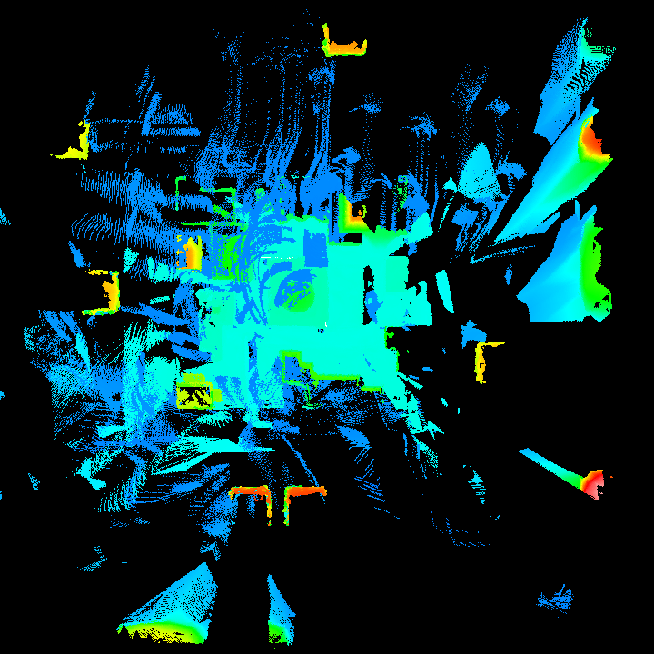Illustration 7: Colorized top view transformation of all frames.

Illustration 8 and 9 show an rendering of the contents of the bins from an elevated viewpoint, the first after only a single image has been processed and the second after the entire source video has been processed.

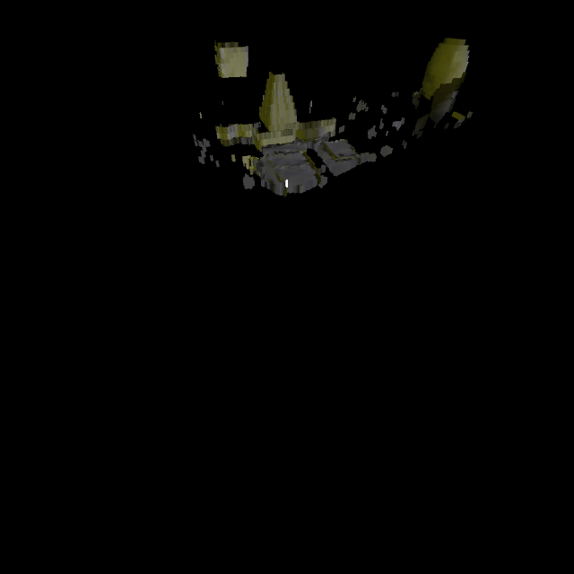Illustration 8: Voxelization afterprocessing first frame.

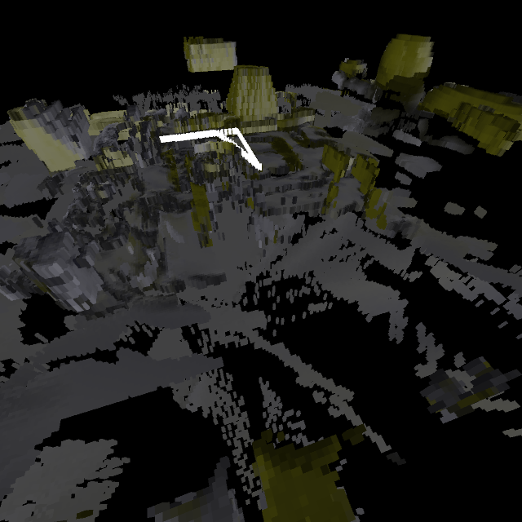Illustration 9: Voxelization after final frame. The white blocks are the path of the camera for visualization purposes only and are not stored in the scene file.
Currently there is no mechanism for removing the contents of a bin, so if a processed frame erroneously fills a bin that bin will be visible even if multiple other frames agree that it should be empty. An algorithm that computes all the bins between the viewer and visible pixels for a given frame would be necessary to enable this.

Voxel Approximation to Source Video

Once the video has been used to create a voxel representation of the scene, a new video is generated again using the stored camera position and angle. Illustration 10 shows an example.

The difference between the voxel view and the original source image is shown in figure 11. For each pixel, the difference is computed, halved, and added to a median gray color. The halving forces the difference to fit within 8-bit color channels, but throws away a bit per color channel per pixel perhaps 50% of the time.

Ideally there would be very few differences and the image would be mostly gray. It's obvious that the blocky structures are well accomodated by voxels, objects in the distance have fewer perceptible differences, but objects like the hemisphere is poorly represented. I

ncreasing the voxel resolution is one approach to reduce differences, but increased resolution increases the size of the voxel file and increases computational load for displaying the voxel scene.
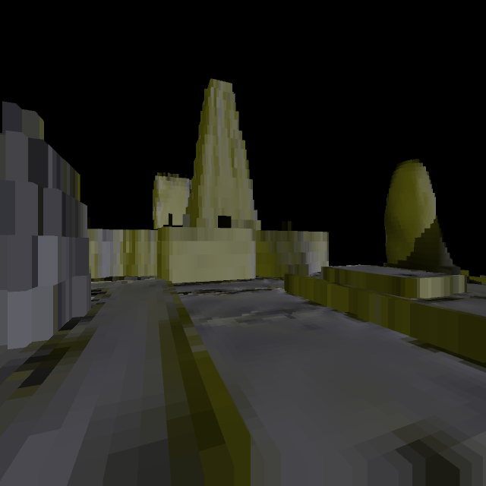Illustration 10: Approximation of first frame created with voxels.
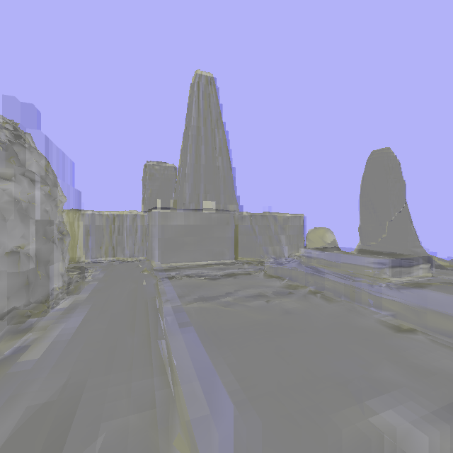Illustration 11: Difference between source video frame and voxel view.

Demonstration Software

The demonstration software consists of two applications, one is the server which has the source video and files derived from it, the other is the client which has nearly no prior knowledge about the source video.

Server

The server has a data file which contains the voxel scene description, another data file which describes the position and attitude of the camera at each frame, and a set of precomputed images which are the differences between the voxel generated view and the original source video files.

Client

The client has a priori knowledge about the camera properties for the demonstration.

The client also has a voxel scene rendering engine, and a mechanism for applying the difference image data to recreate the source video.

Client-Server Interaction

The client connects to the server, which initially sends a large data file containing the entire voxel scene. In the proposal this data was to be streamed gradually, but for simplified operation is sent in one operation at the start.

The server then sends camera position and attitude information followed by the difference image data, and the client renders the voxels from the proper vantage point and applies the difference image.

