Model tuning

This notebook details the process of tuning the model.

From this point forward, I will be modeling with a few to predicting a binary outcome - ‘intervene’ or ‘not_intervene’ and only use the ‘transformed’ data - that is, I will not be looking at the PCA dataset.

### Import libraries and datasets

import pandas as pd  
  
X_train_transformed = pd.read_csv('../../data/X_train_transformed.csv')  
#X_test_transformed = pd.read_csv('../../data/X_test_transformed.csv')  
X_val_transformed = pd.read_csv('../../data/X_val_transformed.csv')  
#X_train_pca = pd.read_csv('../../data/X_train_pca.csv')  
#X_test_pca = pd.read_csv('../../data/X_test_pca.csv')  
#X_val_pca = pd.read_csv('../../data/X_val_pca.csv')  
  
  
y_train = pd.read_csv('../../data/y_train.csv')  
#y_test = pd.read_csv('../../data/y_test.csv')  
y_val = pd.read_csv('../../data/y_val.csv')

#### Refactoring the ‘final_result’ target variable

# copy the data  
y_train_binary = y_train.copy()  
  
# map values to 'intervene' and 'no_intervene'  
y_train_binary.replace({'Pass': 'no_intervene', 'Distinction': 'no_intervene',  
 'Withdrawn': 'intervene', 'Fail': 'intervene'}, inplace=True)  
  
y_val_binary = y_val.copy()  
y_val_binary.replace({'Pass': 'no_intervene', 'Distinction': 'no_intervene',  
 'Withdrawn': 'intervene', 'Fail': 'intervene'}, inplace=True)

### Hyperparameter tuning

Because I have a validation set, I have decided to use the validation set to tune the hyperparameters of the model.

In future analyses, I will use cross-validation to tune the hyperparameters to make the analysis more robust but for this initial modelling, I will use the validation set.

from sklearn.ensemble import VotingClassifier  
from sklearn.tree import DecisionTreeClassifier  
from sklearn.neighbors import KNeighborsClassifier  
from sklearn.svm import SVC  
from sklearn.naive_bayes import GaussianNB  
from sklearn.ensemble import RandomForestClassifier  
from sklearn.linear_model import LogisticRegression  
from sklearn.model_selection import cross_val_score, RepeatedStratifiedKFold, GridSearchCV, StratifiedKFold  
from sklearn.metrics import accuracy_score  
from matplotlib import pyplot as plt  
  
  
# hyperparameter grid for each model  
lr_param_grid = {'C': [0.1, 1.0, 10.0, 100], 'penalty': ['l1', 'l2']}  
dt_param_grid = {'max_depth': [None, 2, 5, 10], 'min_samples_split': [2, 5, 10], 'min_samples_leaf': [1, 2, 4]}  
rf_param_grid = {'n_estimators': [10, 50, 100, 200, 300], 'max_depth': [None, 2, 5, 10], 'min_samples_split': [2, 5, 10], 'min_samples_leaf': [1, 2, 4]}  
svc_param_grid = {'C': [0.1, 1.0, 10.0], 'kernel': ['linear', 'poly', 'rbf'], 'gamma': ['scale', 'auto']}  
knn_param_grid = {'n_neighbors': [3, 5, 7], 'weights': ['uniform', 'distance'], 'metric': ['euclidean', 'manhattan']}  
gnb_param_grid = {} # GaussianNB has no hyperparameters  
  
# models and their parameter grids  
models = [  
 ('LR', LogisticRegression(max_iter=10000), lr_param_grid),  
 ('DT', DecisionTreeClassifier(), dt_param_grid),  
 ('RF', RandomForestClassifier(), rf_param_grid),  
 ('SVC', SVC(), svc_param_grid),  
 ('KNN', KNeighborsClassifier(), knn_param_grid),  
 ('GNB', GaussianNB(), gnb_param_grid)  
]  
  
# number of folds for k-fold cross-validation  
n_folds = 5  
  
# hyperparameter tuning and cross-validation for each model  
accuracies = []  
model_names = []  
best_models = {}   
  
# hyperparameter tuning and cross-validation for each model  
for model_name, model, param_grid in models:  
 print(f"Model: {model_name}")  
 grid_search = GridSearchCV(model, param_grid, cv=StratifiedKFold(n_splits=n_folds, shuffle=True), scoring='accuracy')  
 grid_search.fit(X_train_transformed, y_train_binary.values.ravel())   
 print("Best Parameters:", grid_search.best_params_)  
 print("Best Score:", grid_search.best_score_)  
   
 # evaluate the model on the separate validation set  
 best_model = grid_search.best_estimator_  
 y_pred = best_model.predict(X_val_transformed)  
 accuracy = accuracy_score(y_val_binary, y_pred)  
 accuracies.append(accuracy)  
 model_names.append(model_name)  
 print("Validation Set Accuracy:", accuracy)  
  
 # save the best model from each classifier  
 best_models[model_name] = best_model  
  
 print()

Model: LR

c:\Users\zoona\AppData\Local\Programs\Python\Python311\Lib\site-packages\sklearn\model_selection\_validation.py:378: FitFailedWarning:   
20 fits failed out of a total of 40.  
The score on these train-test partitions for these parameters will be set to nan.  
If these failures are not expected, you can try to debug them by setting error_score='raise'.  
  
Below are more details about the failures:  
--------------------------------------------------------------------------------  
20 fits failed with the following error:  
Traceback (most recent call last):  
 File "c:\Users\zoona\AppData\Local\Programs\Python\Python311\Lib\site-packages\sklearn\model_selection\_validation.py", line 686, in _fit_and_score  
 estimator.fit(X_train, y_train, **fit_params)  
 File "c:\Users\zoona\AppData\Local\Programs\Python\Python311\Lib\site-packages\sklearn\linear_model\_logistic.py", line 1162, in fit  
 solver = _check_solver(self.solver, self.penalty, self.dual)  
 ^^^^^^^^^^^^^^^^^^^^^^^^^^^^^^^^^^^^^^^^^^^^^^^^^^^  
 File "c:\Users\zoona\AppData\Local\Programs\Python\Python311\Lib\site-packages\sklearn\linear_model\_logistic.py", line 54, in _check_solver  
 raise ValueError(  
ValueError: Solver lbfgs supports only 'l2' or 'none' penalties, got l1 penalty.  
  
 warnings.warn(some_fits_failed_message, FitFailedWarning)  
c:\Users\zoona\AppData\Local\Programs\Python\Python311\Lib\site-packages\sklearn\model_selection\_search.py:952: UserWarning: One or more of the test scores are non-finite: [ nan 0.91925152 nan 0.91888038 nan 0.9189864  
 nan 0.91893339]  
 warnings.warn(

Best Parameters: {'C': 0.1, 'penalty': 'l2'}  
Best Score: 0.919251524548341  
Validation Set Accuracy: 0.9184160305343512  
  
Model: DT  
Best Parameters: {'max_depth': 10, 'min_samples_leaf': 4, 'min_samples_split': 2}  
Best Score: 0.923545878667397  
Validation Set Accuracy: 0.9184160305343512  
  
Model: RF  
Best Parameters: {'max_depth': None, 'min_samples_leaf': 1, 'min_samples_split': 10, 'n_estimators': 50}  
Best Score: 0.933725648472332  
Validation Set Accuracy: 0.9320928753180662  
  
Model: SVC  
Best Parameters: {'C': 10.0, 'gamma': 'scale', 'kernel': 'rbf'}  
Best Score: 0.9245002514095942  
Validation Set Accuracy: 0.9243002544529262  
  
Model: KNN  
Best Parameters: {'metric': 'manhattan', 'n_neighbors': 7, 'weights': 'distance'}  
Best Score: 0.923068959304811  
Validation Set Accuracy: 0.9212786259541985  
  
Model: GNB  
Best Parameters: {}  
Best Score: 0.9120407348186689  
Validation Set Accuracy: 0.9134860050890585

print(model_names)  
print(accuracies)

['LR', 'DT', 'RF', 'SVC', 'KNN', 'GNB']  
[0.9184160305343512, 0.9184160305343512, 0.9320928753180662, 0.9243002544529262, 0.9212786259541985, 0.9134860050890585]

# plotting the accuracies  
plt.figure(figsize=(8, 6))  
plt.bar(model_names, accuracies)  
plt.xlabel('Models')  
plt.ylabel('Accuracy')  
plt.title('Validation Set Accuracies')  
plt.ylim([0, 1])  
plt.show()

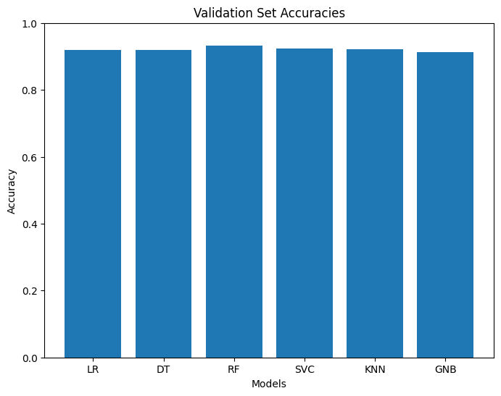

### Ensemble model from the best performing models

#### Voting classifier - Soft voting

# modify to probability True  
  
best_models['SVC'].set_params(probability=True)  
  
  
# ensemble model using the best models  
ensemble_models = [('DT', best_models['DT']),  
 ('LR', best_models['LR']),  
 ('RF', best_models['RF']),  
 ('SVC', best_models['SVC']),  
 ('KNN', best_models['KNN']),  
 ('GNB', best_models['GNB'])]  
   
  
ensemble = VotingClassifier(estimators=ensemble_models, voting='soft', weights=[1, 1, 3, 2, 2, 1])  
  
# fit the ensemble model   
ensemble.fit(X_train_transformed, y_train_binary.values.ravel())  
  
# evaluate the ensemble model on the validation set  
y_pred_ensemble = ensemble.predict(X_val_transformed)  
accuracy_ensemble = accuracy_score(y_val_binary, y_pred_ensemble)  
print("Ensemble Model Accuracy:", accuracy_ensemble)

Ensemble Model Accuracy: 0.9257315521628499

#### Voting classifier - Hard voting

from sklearn.ensemble import VotingClassifier  
from sklearn.tree import DecisionTreeClassifier  
from sklearn.neighbors import KNeighborsClassifier  
from sklearn.svm import SVC  
from sklearn.naive_bayes import GaussianNB  
from sklearn.ensemble import RandomForestClassifier  
from sklearn.linear_model import LogisticRegression  
from sklearn.model_selection import cross_val_score, GridSearchCV  
from sklearn.metrics import accuracy_score  
  
# ensemble model using the best models  
ensemble_models = [('DT', best_models['DT']),  
 ('LR', best_models['LR']),  
 ('RF', best_models['RF']),  
 ('SVC', best_models['SVC']),  
 ('KNN', best_models['KNN']),  
 ('GNB', best_models['GNB'])]  
  
ensemble = VotingClassifier(estimators=ensemble_models, voting='hard')  
  
# fit the ensemble model  
ensemble.fit(X_train_transformed, y_train_binary.values.ravel())  
  
# evaluate the ensemble model on the validation set  
y_pred_ensemble = ensemble.predict(X_val_transformed)  
accuracy_ensemble = accuracy_score(y_val_binary, y_pred_ensemble)  
print("Ensemble Model Accuracy:", accuracy_ensemble)

Ensemble Model Accuracy: 0.9274809160305344

### Stacking Classifier

from sklearn.ensemble import StackingClassifier  
from sklearn.linear_model import LogisticRegression  
from sklearn.tree import DecisionTreeClassifier  
from sklearn.ensemble import RandomForestClassifier  
from sklearn.svm import SVC  
from sklearn.neighbors import KNeighborsClassifier  
from sklearn.naive_bayes import GaussianNB  
  
# base models  
base_models = [  
 ('DT', DecisionTreeClassifier()),  
 ('LR', LogisticRegression(max_iter=10000)),  
 ('RF', RandomForestClassifier()),  
 ('SVC', SVC()),  
 ('KNN', KNeighborsClassifier()),  
 ('GNB', GaussianNB())  
]  
  
# meta-classifier  
meta_model = LogisticRegression(max_iter=10000)  
  
stacking_classifier = StackingClassifier(estimators=base_models, final_estimator=meta_model, cv=5)  
  
# fit the stacking classifier  
stacking_classifier.fit(X_train_transformed, y_train_binary.values.ravel())  
  
# evaluate the stacking classifier on the validation set  
y_pred_stacking = stacking_classifier.predict(X_val_transformed)  
accuracy_stacking = accuracy_score(y_val_binary, y_pred_stacking)  
print("Stacking Classifier Accuracy:", accuracy_stacking)

Stacking Classifier Accuracy: 0.9317748091603053

#### Decision boundary plotting

been fighting this for hours - another day, another time.

import numpy as np  
import matplotlib.pyplot as plt  
from sklearn.tree import DecisionTreeClassifier  
from sklearn.neighbors import KNeighborsClassifier  
from sklearn.svm import SVC  
from sklearn.linear_model import LogisticRegression  
from sklearn.ensemble import RandomForestClassifier  
from sklearn.naive_bayes import GaussianNB  
from itertools import product  
  
# best models  
best_models = {  
 'LR': LogisticRegression(C=0.1, max_iter=10000),  
 'DT': DecisionTreeClassifier(max_depth=10, min_samples_leaf=4),  
 'RF': RandomForestClassifier(min_samples_split=10, n_estimators=50),  
 'SVC': SVC(C=10.0, probability=True),  
 'KNN': KNeighborsClassifier(metric='manhattan', n_neighbors=7, weights='distance'),  
 'GNB': GaussianNB()  
}  
  
# fit models with transformed data  
transformed_data = []  
for features in product([0, 1], [0, 1, 2, 3, 4, 5, 6, 7, 8, 9, 10]):  
 X_train_transformed_subset = X_train_transformed.iloc[:, list(features)]  
 transformed_data.append(X_train_transformed_subset)  
  
for i, (model_name, clf) in enumerate(best_models.items()):  
 clf.fit(transformed_data[i], y_train_binary.values.ravel())  
  
# decision regions  
x_min, x_max = transformed_data[0].iloc[:, 0].min() - 1, transformed_data[0].iloc[:, 0].max() + 1  
y_min, y_max = transformed_data[0].iloc[:, 1].min() - 1, transformed_data[0].iloc[:, 1].max() + 1  
xx, yy = np.meshgrid(np.arange(x_min, x_max, 0.1), np.arange(y_min, y_max, 0.1))  
  
f, axarr = plt.subplots(2, 3, sharex='col', sharey='row', figsize=(12, 8))  
  
for idx, (model_name, clf), tt in zip(range(6), best_models.items(),  
 ['Decision Tree (depth=4)', 'KNN (k=7)',  
 'Kernel SVM', 'Logistic Regression', 'Random Forest', 'Gaussian NB']):  
 row_idx, col_idx = divmod(idx, 3) # convert the index to row and column  
  
 Z = clf.predict(np.c_[xx.ravel(), yy.ravel()])  
 Z = Z.reshape(xx.shape)  
  
 axarr[row_idx, col_idx].contourf(xx, yy, Z, alpha=0.4)  
 axarr[row_idx, col_idx].scatter(transformed_data[idx].iloc[:, 0], transformed_data[idx].iloc[:, 1],  
 c=y_train_binary, s=20, edgecolor='k')  
 axarr[row_idx, col_idx].set_title(tt)  
  
plt.tight_layout()  
plt.show()

c:\Users\zoona\AppData\Local\Programs\Python\Python311\Lib\site-packages\sklearn\base.py:420: UserWarning: X does not have valid feature names, but LogisticRegression was fitted with feature names  
 warnings.warn(

ValueError: could not convert string to float: 'intervene'

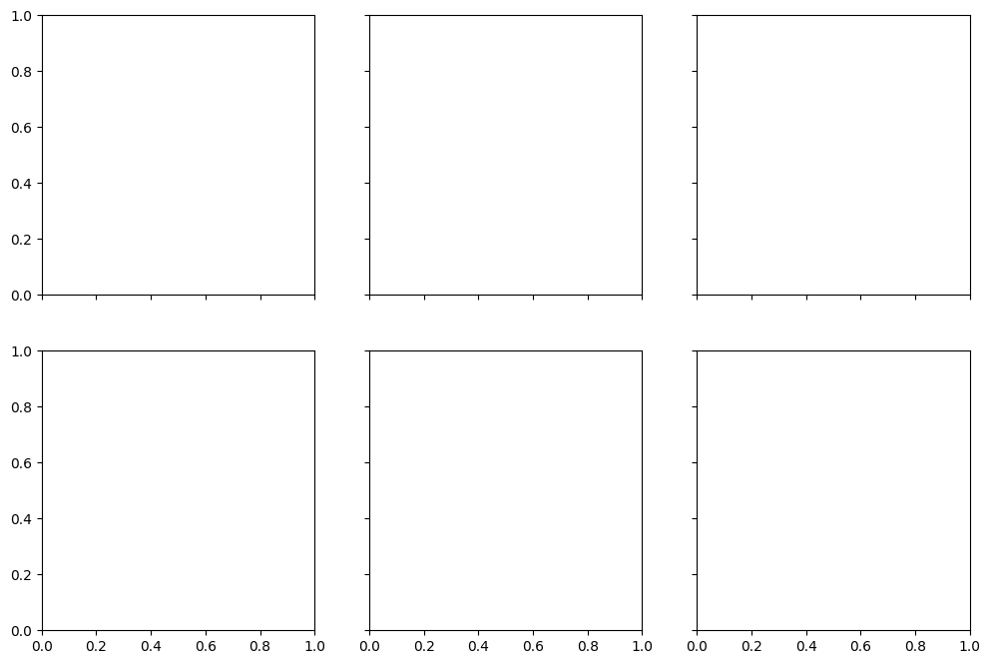

print(X_train_transformed.info())  
print(y_train_binary.shape)

<class 'pandas.core.frame.DataFrame'>  
RangeIndex: 18861 entries, 0 to 18860  
Data columns (total 11 columns):  
 # Column Non-Null Count Dtype   
--- ------ -------------- -----   
 0 subject_SocSci 18861 non-null int64   
 1 subject_Stem 18861 non-null int64   
 2 num_of_prev_attempts 18861 non-null float64  
 3 studied_credits 18861 non-null float64  
 4 prop_submissions 18861 non-null float64  
 5 avg_score 18861 non-null float64  
 6 submission_distance 18861 non-null float64  
 7 stu_activity_count 18861 non-null float64  
 8 stu_activity_type_count 18861 non-null float64  
 9 stu_total_clicks 18861 non-null float64  
 10 stu_days_active 18861 non-null float64  
dtypes: float64(9), int64(2)  
memory usage: 1.6 MB  
None  
(18861, 1)