G.H.Raisoni College of Engineering, Nagpur
(An Autonomous Institute Under Act 1956)
Department of Computer Science & Engineering

Lab Manual


Subject : Embedded with IoT

Session:-2018-2019
Semester:-VI

Course Outcomes:
Upon successful completion of the course, students will be able to
CO1: | Understand different RISC & CISC Microcontrollers and associated development tools.
CO2: | Acquainting assembly programming fundamentals and Developing Embedded C programming with 8051 resources
CO3: | Interface I/O devices and peripherals with Microcontroller for real time applications
CO4: | Use of advanced controllers & different platforms like python, OOPs, GPIO, WiFi.
CO5: | Design & Develop IoT system for different sensors and Actuators based applications.

List of Practical
Sr. No | Title of Practical | CO Mapping
1 | Write a C code for blinking of LED with Intel Galileo Gen 2 | CO1
2 | Write a C code to Fade LED using Intel Galileo Gen 2 | CO2
3 | Write a C code to vary Blinking Rate of LED using Intel Galileo Gen 2 | CO3
4 | Write a C code for Seven Segment Display using Intel Galileo Gen 2 | CO3
5 | Write a C code for Push Button using Intel Galileo Gen 2 | CO4
6 | Write a C code to control LED lightning via Array | CO4
7 | Write a C code to Interface LCD with Intel Galileo Gen 2 and display GHRCE on LCD Display | CO5
8 | Write a C code to Interface Temperature Sensor (LM35) with Intel Galileo Gen 2 and display the temperature on LCD | CO5,CO6,
9 | Write a C code to Distance sensing using ultrasonic sensor and Arduino | CO6
10 | Write a C code to detect obstacle using IR obstacle sensor and Arduino. | CO6



Experiment No. 1

AIM : Write a C code for blinking of LED with Intel Galileo Gen 2

Introduction
To help you get started with the Galileo, the SIK Galileo tutorials will take you through different basic circuits. In this tutorial, we will go over how to work with an LED.
LEDs are small, powerful lights that are used in many different applications. To start off, we will work on blinking an LED, the Hello World of microcontrollers. That’s right - it’s as simple as turning a light on and off. It might not seem like much, but establishing this important baseline will give you a solid foundation as we work toward more complex experiments.

Parts Needed
You will need the following parts:
- 1x Breadboard
- 1x Galileo
- 1x LED
- 1x 330Ω Resistor
- 2x Jumper Wires
View the SparkFun Inventor’s Kit for Galileo wishlist, to see the parts needed to go through the all the experiments.

Suggested Reading
Before continuing on with this experiment, we recommend you be familiar with the concepts in the following tutorial:
- Light-emitting Diodes - Learn more about LEDs!

Hardware Hookup
Ready to start hooking everything up? Check out the Fritzing diagram and hookup table below, to see how everything is connected. Pay special attention to the component’s markings indicating how to place it on the breadboard. Polarized components are highlighted with a yellow warning triangle, in the table. Polarized components can only be connected to a circuit in one direction.
Please note: Pay close attention to the LED. The negative side of the LED is the short leg, marked with a flat edge.

Components like resistors need to have their legs bent into 90° angles in order to correctly fit the breadboard sockets. You can also cut the legs shorter to make them easier to work with on the breadboard.

Hookup Table
Component | Galileo | Breadboard | Breadboard
LED |  | c2 ( + ) | c3 ( - )
330 Resistor |  | a3 | ( - )
Jumper Wire | GND | ( - )
Jumper Wire | PIN 13 | e2

Program
BLINKING A LED

Turn an LED on for one second, off for one second,
and repeat forever.

Hardware connections:

Most Arduinos already have an LED and resistor connected to
pin 13, so you may not need any additional circuitry.

But if you'd like to connect a second LED to pin 13, or use
a different pin, follow these steps:

Connect the positive side of your LED (longer leg) to Galileo
digital pin 13 (or another digital pin, don't forget to change
the code to match).

Connect the negative side of your LED (shorter leg) to a
330 Ohm resistor (orange-orange-brown). Connect the other side
of the resistor to ground.

pin 13 _____ + LED - _____ 330 Ohm _____ GND

(We always use resistors between the Galileo and and LEDs
to keep the LEDs from burning out due to too much current.)

This sketch was written by SparkFun Electronics,
with lots of help from the Arduino community.
This code is completely free for any use.
Visit http://www.arduino.cc to learn about the Arduino.

Version 2.0 6/2012 MDG
*/

// Welcome to the Galileo!

// If you're brand-new to this, there will be some new things to
// learn, but we'll jump right in and explain things as we go.

// The Galileo is a tiny computer that runs programs called
// "sketches". These are text files written using instructions
// the computer understances. You're reading a sketch right now.

// Sketches have computer code in them, but also (hopefully)
// "comments" that explain what the code does. Comments and code
// will have different colors in the editor so you can tell them
// apart.

// This is a comment - anything on a line after "//" is ignored
// by the computer.

/* This is also a comment - this one can be multi-line, but it
must start and end with these characters */

// A "function" is a named block of code, that performs a specific,
// well, function. Many useful functions are already built-in to
// the Galileo; others you'll name and write yourself for your
// own purposes.

// All Galileo sketches MUST have two specific functions, named
// "setup()" and "loop()". The Galileo runs these functions
// automatically when it starts up or if you press the reset
// button. You'll typically fill these function "shells" with your
// own code. Let's get started!

// The setup() function runs once when the sketch starts.
// You'll use it for things you need to do first, or only once:

void setup()
{
// The Galileo has 13 digital input/output pins. These pins
// can be configured as either inputs or outputs. We set this
// up with a built-in function called pinMode().

// The pinMode() function takes two values, which you type in
// the parenthesis after the function name. The first value is
// a pin number, the second value is the word INPUT or OUTPUT.

// Here we'll set up pin 13 (the one connected to a LED) to be
// an output. We're doing this because we need to send voltage
// "out" of the Galileo to the LED.

pinMode(13, OUTPUT);

// By the way, the Galileo offers many useful built-in functions
// like this one. You can find information on all of them at the
// Galileo website: http://arduino.cc/en/Reference
}

// After setup() finishes, the loop() function runs over and over
// again, forever (or until you turn off or reset the Galileo).
// This is usually where the bulk of your program lives:

void loop()
{
// The 13 digital pins on your Galileo are great at inputting
// and outputting on/off, or "digital" signals. These signals
// will always be either 5 Volts (which we call "HIGH"), or
// 0 Volts (which we call "LOW").

// Because we have an LED connected to pin 13, if we make that
// output HIGH, the LED will get voltage and light up. If we make
// that output LOW, the LED will have no voltage and turn off.

// digitalWrite() is the built-in function we use to make an
// output pin HIGH or LOW. It takes two values; a pin number,
// followed by the word HIGH or LOW:

digitalWrite(13, HIGH); // Turn on the LED

// delay() is a function that pauses for a given amount of time.
// It takes one value, the amount of time to wait, measured in
// milliseconds. There are 1000 milliseconds in a second, so if
// you delay(1000), it will pause for exactly one second:

delay(1000); // Wait for one second

digitalWrite(13, LOW); // Turn off the LED

delay(1000); // Wait for one second

// All together, the above code turns the LED on, waits one
// second, turns it off, and waits another second.

// When the computer gets to the end of the loop() function,
// it starts loop() over again. So this program will continue
// blinking the LED on and off!

// Try changing the 1000 in the above delay() functions to
// different numbers and see how it affects the timing. Smaller
// values will make the loop run faster. (Why?)
}

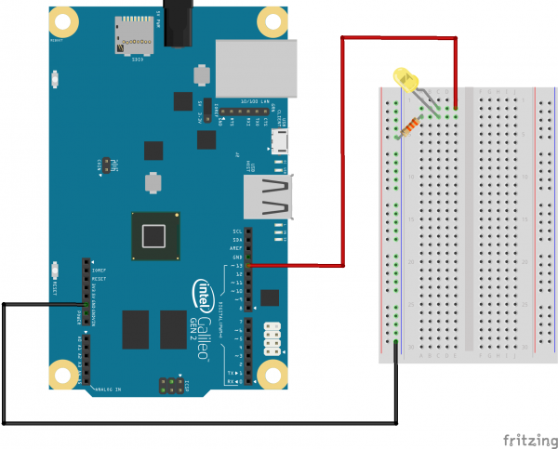
Result: C code for blinking of LED with Intel Galileo Gen 2

Experiment No. 2
Aim : Write a C code to Fade LED using Intel Galileo Gen 2
Theory:
This example demonstrates the use of the analogWrite() function in fading an LED off and on. AnalogWrite uses pulse width modulation (PWM), turning a digital pin on and off very quickly with different ratio between on and off, to create a fading effect.

Hardware Required
- Arduino or Genuino board
- LED
- 220 ohm resistor
- hook-up wires
- breadboard
Connect the anode (the longer, positive leg) of your LED to digital output pin 9 on your board through a 220 ohm resistor. Connect the cathode (the shorter, negative leg) directly to ground
Program: /*
Fade
This example shows how to fade an LED on pin 9
using the analogWrite() function.
The analogWrite() function uses PWM, so if
you want to change the pin you're using, be
sure to use another PWM capable pin. On most
Arduino, the PWM pins are identified with
a "~" sign, like ~3, ~5, ~6, ~9, ~10 and ~11.
This example code is in the public domain.
*/
int led = 9; // the PWM pin the LED is attached to
int brightness = 0; // how bright the LED is
int fadeAmount = 5; // how many points to fade the LED by
// the setup routine runs once when you press reset:
void setup() {
// declare pin 9 to be an output:
pinMode(led, OUTPUT);
}
// the loop routine runs over and over again forever:
void loop() {
// set the brightness of pin 9:
analogWrite(led, brightness);
// change the brightness for next time through the loop:
brightness = brightness + fadeAmount;
// reverse the direction of the fading at the ends of the fade:
if (brightness <= 0 || brightness >= 255) {
fadeAmount = -fadeAmount;
}
// wait for 30 milliseconds to see the dimming effect
delay(30);
}

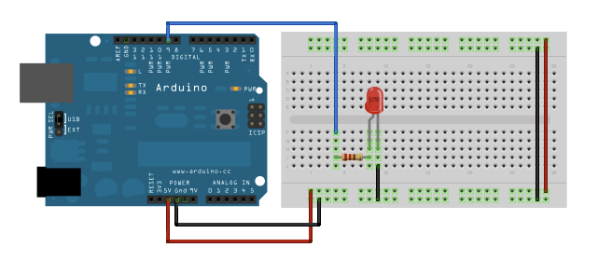

Experiment No. 3
Aim : Write a C code to vary Blinking Rate of LED using Intel Galileo Gen 2

Now that you’ve gotten your LED to blink on and off, it’s time to up the stakes a little bit – by connecting eight LEDs at once. We’ll also give our Galileo a little test by creating various lighting sequences. This circuit is a great setup to start practicing writing your own programs and getting a feel for the way Galileo works.
Along with controlling the LEDs, you’ll learn about a couple programming tricks that keep your code neat and tidy:
for() loops - used when you want to run a piece of code several times
arrays[ ] - used to make managing variables easier by grouping them together
Parts Needed
You will need the following parts:
- 1x Breadboard
- 1x Galileo
- 8x LEDs
- 8x 330Ω Resistors
- 9x Jumper Wires
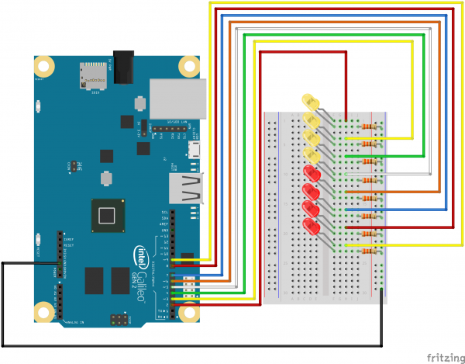

Code To Note
int ledPins[] = {2,3,4,5,6,7,8,9};
When you have to manage a lot of variables, an “array” is a handy way to group them together. Here we’re creating an array of integers, called ledPins, with eight elements.
digitalWrite(ledPins[0], HIGH);
You refer to the elements in an array by their position. The first element is at position 0, the second is at position 1, etc. You refer to an element using “ledPins[x]” where x is the position. Here we’re making digital pin 2 HIGH, since the array element at position 0 is “2”.
index = random(8);
Computers like to do the same things each time they run. But sometimes you want to do things randomly, such as simulating the roll of a dice. The random() function is a great way to do this. See http://arduino.cc/en/reference/random for more information.
MULTIPLE LEDs

Make eight LEDs dance. Dance LEDs, dance!

Hardware connections:

You'll need eight LEDs, and eight 330 Ohm resistors
(orange-orange-brown).

For each LED, connect the negative side (shorter leg)
to a 330 Ohm resistor.

Connect the other side of the resistors to GND.

Connect the positive side (longer leg) of the LEDs
to Arduino digital pins 2 through 9.

This sketch was written by SparkFun Electronics,
with lots of help from the Arduino community.
This code is completely free for any use.
Visit http://learn.sparkfun.com/products/2 for SIK information.
Visit http://www.arduino.cc to learn about the Arduino.

Version 2.0 6/2012 MDG
*/

// To keep track of all the LED pins, we'll use an "array".
// An array lets you store a group of variables, and refer to them
// by their position, or "index". Here we're creating an array of
// eight integers, and initializing them to a set of values:

int ledPins[] = {2,3,4,5,6,7,8,9};

// The first element of an array is index 0.
// We've put the value "2" in index 0, "3" in index 1, etc.
// The final index in the above array is 7, which contains
// the value "9".

// We're using the values in this array to specify the pin numbers
// that the eight LEDs are connected to. LED 0 is connected to
// pin 2, LED 1 is connected to pin 3, etc.

void setup()
{
int index;

// In this sketch, we'll use "for() loops" to step variables from
// one value to another, and perform a set of instructions for
// each step. For() loops are a very handy way to get numbers to
// count up or down.

// Every for() loop has three statements separated by
// semicolons (;):

// 1. Something to do before starting
// 2. A test to perform; as long as it's true, keep looping
// 3. Something to do after each loop (increase a variable)

// For the for() loop below, these are the three statements:

// 1. index = 0; Before starting, make index = 0.
// 2. index <= 7; If index is less or equal to 7,
// run the following code.
// (When index = 8, continue with the sketch.)
// 3. index++ Putting "++" after a variable means
// "add one to it".
// (You can also use "index = index + 1".)

// Every time you go through the loop, the statements following
// the for() (within the brackets) will run.

// When the test in statement 2 is finally false, the sketch
// will continue.

// Here we'll use a for() loop to initialize all the LED pins
// to outputs. This is much easier than writing eight separate
// statements to do the same thing.

// This for() loop will make index = 0, then run the pinMode()
// statement within the brackets. It will then do the same thing
// for index = 2, index = 3, etc. all the way to index = 7.

for(index = 0; index <= 7; index++)
{
pinMode(ledPins[index],OUTPUT);
// ledPins[index] is replaced by the value in the array.
// For example, ledPins[0] is 2
}
}

void loop()
{
// This loop() calls functions that we've written further below.
// We've disabled some of these by commenting them out (putting
// "//" in front of them). To try different LED displays, remove
// the "//" in front of the ones you'd like to run, and add "//"
// in front of those you don't to comment out (and disable) those
// lines.

oneAfterAnotherNoLoop(); // Light up all the LEDs in turn

//oneAfterAnotherLoop(); // Same as oneAfterAnotherNoLoop,
// but with much less typing

//oneOnAtATime(); // Turn on one LED at a time,
// scrolling down the line

//pingPong(); // Light the LEDs middle to the edges

//marquee(); // Chase lights like you see on signs

//randomLED(); // Blink LEDs randomly
}

/*
oneAfterAnotherNoLoop()

This function will light one LED, delay for delayTime, then light
the next LED, and repeat until all the LEDs are on. It will then
turn them off in the reverse order.

This function does NOT use a for() loop. We've done it the hard way
to show you how much easier life can be when you use for() loops.
Take a look at oneAfterAnotherLoop() further down, which does
exactly the same thing with much less typing.
*/

void oneAfterAnotherNoLoop()
{
int delayTime = 100; // time (milliseconds) to pause between LEDs
// make this smaller for faster switching

// turn all the LEDs on:

digitalWrite(ledPins[0], HIGH); //Turns on LED #0 (pin 2)
delay(delayTime); //wait delayTime milliseconds
digitalWrite(ledPins[1], HIGH); //Turns on LED #1 (pin 3)
delay(delayTime); //wait delayTime milliseconds
digitalWrite(ledPins[2], HIGH); //Turns on LED #2 (pin 4)
delay(delayTime); //wait delayTime milliseconds
digitalWrite(ledPins[3], HIGH); //Turns on LED #3 (pin 5)
delay(delayTime); //wait delayTime milliseconds
digitalWrite(ledPins[4], HIGH); //Turns on LED #4 (pin 6)
delay(delayTime); //wait delayTime milliseconds
digitalWrite(ledPins[5], HIGH); //Turns on LED #5 (pin 7)
delay(delayTime); //wait delayTime milliseconds
digitalWrite(ledPins[6], HIGH); //Turns on LED #6 (pin 8)
delay(delayTime); //wait delayTime milliseconds
digitalWrite(ledPins[7], HIGH); //Turns on LED #7 (pin 9)
delay(delayTime); //wait delayTime milliseconds

// turn all the LEDs off:

digitalWrite(ledPins[7], LOW); //Turn off LED #7 (pin 9)
delay(delayTime); //wait delayTime milliseconds
digitalWrite(ledPins[6], LOW); //Turn off LED #6 (pin 8)
delay(delayTime); //wait delayTime milliseconds
digitalWrite(ledPins[5], LOW); //Turn off LED #5 (pin 7)
delay(delayTime); //wait delayTime milliseconds
digitalWrite(ledPins[4], LOW); //Turn off LED #4 (pin 6)
delay(delayTime); //wait delayTime milliseconds
digitalWrite(ledPins[3], LOW); //Turn off LED #3 (pin 5)
delay(delayTime); //wait delayTime milliseconds
digitalWrite(ledPins[2], LOW); //Turn off LED #2 (pin 4)
delay(delayTime); //wait delayTime milliseconds
digitalWrite(ledPins[1], LOW); //Turn off LED #1 (pin 3)
delay(delayTime); //wait delayTime milliseconds
digitalWrite(ledPins[0], LOW); //Turn off LED #0 (pin 2)
delay(delayTime); //wait delayTime milliseconds
}

/*
oneAfterAnotherLoop()

This function does exactly the same thing as oneAfterAnotherNoLoop(),
but it takes advantage of for() loops and the array to do it with
much less typing.
*/

void oneAfterAnotherLoop()
{
int index;
int delayTime = 100; // milliseconds to pause between LEDs
// make this smaller for faster switching

// Turn all the LEDs on:

// This for() loop will step index from 0 to 7
// (putting "++" after a variable means add one to it)
// and will then use digitalWrite() to turn that LED on.

for(index = 0; index <= 7; index++)
{
digitalWrite(ledPins[index], HIGH);
delay(delayTime);
}

// Turn all the LEDs off:

// This for() loop will step index from 7 to 0
// (putting "--" after a variable means subtract one from it)
// and will then use digitalWrite() to turn that LED off.

for(index = 7; index >= 0; index--)
{
digitalWrite(ledPins[index], LOW);
delay(delayTime);
}
}

/*
oneOnAtATime()

This function will step through the LEDs,
lighting only one at at time.
*/

void oneOnAtATime()
{
int index;
int delayTime = 100; // milliseconds to pause between LEDs
// make this smaller for faster switching

// step through the LEDs, from 0 to 7

for(index = 0; index <= 7; index++)
{
digitalWrite(ledPins[index], HIGH); // turn LED on
delay(delayTime); // pause to slow down
digitalWrite(ledPins[index], LOW); // turn LED off
}
}

/*
pingPong()

This function will step through the LEDs,
lighting one at at time in both directions.
*/

void pingPong()
{
int index;
int delayTime = 100; // milliseconds to pause between LEDs
// make this smaller for faster switching

// step through the LEDs, from 0 to 7

for(index = 0; index <= 7; index++)
{
digitalWrite(ledPins[index], HIGH); // turn LED on
delay(delayTime); // pause to slow down
digitalWrite(ledPins[index], LOW); // turn LED off
}

// step through the LEDs, from 7 to 0

for(index = 7; index >= 0; index--)
{
digitalWrite(ledPins[index], HIGH); // turn LED on
delay(delayTime); // pause to slow down
digitalWrite(ledPins[index], LOW); // turn LED off
}
}

/*
marquee()

This function will mimic "chase lights" like those around signs.
*/

void marquee()
{
int index;
int delayTime = 200; // milliseconds to pause between LEDs
// Make this smaller for faster switching

// Step through the first four LEDs
// (We'll light up one in the lower 4 and one in the upper 4)

for(index = 0; index <= 3; index++) // Step from 0 to 3
{
digitalWrite(ledPins[index], HIGH); // Turn a LED on
digitalWrite(ledPins[index+4], HIGH); // Skip four, and turn that LED on
delay(delayTime); // Pause to slow down the sequence
digitalWrite(ledPins[index], LOW); // Turn the LED off
digitalWrite(ledPins[index+4], LOW); // Skip four, and turn that LED off
}
}

/*
randomLED()

This function will turn on random LEDs. Can you modify it so it
also lights them for random times?
*/

void randomLED()
{
int index;
int delayTime;

// The random() function will return a semi-random number each
// time it is called. See http://arduino.cc/en/Reference/Random
// for tips on how to make random() even more random.

index = random(8); // pick a random number between 0 and 7
delayTime = 100;

digitalWrite(ledPins[index], HIGH); // turn LED on
delay(delayTime); // pause to slow down
digitalWrite(ledPins[index], LOW); // turn LED off
}
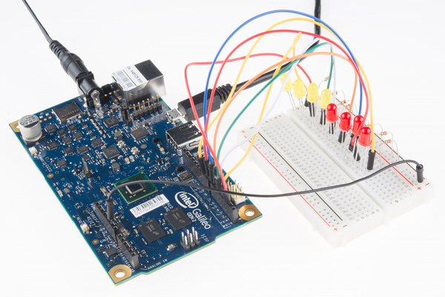
RESULT:C code to Fade LED using Intel Galileo Gen 2

Experiment No. 4

Aim : Write a C code for Seven Segment Display using Intel Galileo Gen 2
Theory:
This is a simple 0 to 9 counter circuit constructed using Arduino! Here, a common cathode 7-segment LED display is connected to Arduino for displaying the digits.
The code (Arduino sketch) allows push button increment of the counter from 0 to 9.
The whole circuit can be powered from a standard 9V PP3/6F22 battery, or from any suitable Arduino power adaptor.
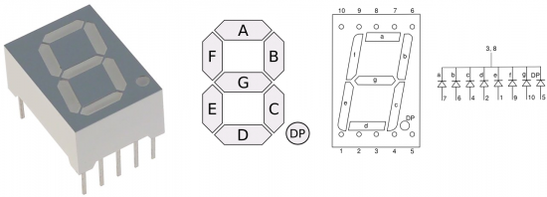
The seven segment display is infact a very simple device. It is a combination of 8 LEDs (the decimal point -DP- is the 8th), which can be arranged so that different combinations can be used to make numerical digits.
Related Products: Displays
Details of a common cathode type 7 segment LED display is shown here. Note that pins 3 and 8 of the display is the cathode terminals.
Arduino Schematic
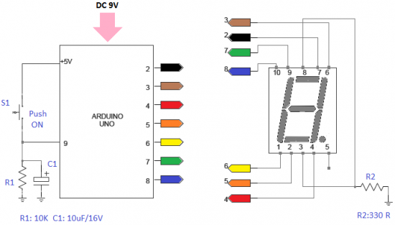
Just follow the schematic circuit diagram to make the entire project.
Arduino pins 2, 3, 4, 5, 6, 7 and 8 should go to Display pins 7, 6, 4, 2, 1, 9 and 10 in correct order. In case of any doubt refer this table. Push Switch (S1) input point is at pin 9 of the Arduino.
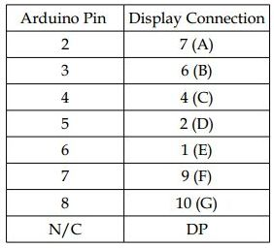
Connecting the display pins directly to Arduino I/O pins is not a good practice. For testing purpose only one 330 Ohm resistor (R2) is added between ground rail (0V) and the common cathode pins (3 & 8). It is better to directly connect pins 3 & 8 of the display to ground rail. Next add a 330 Ohm resistor between each of the other connections to the Arduino.
Program:
/*
Arduino 7-Segment LED Display for Common Cathode Displays
Arduino Pins: 2,3,4,5,6,7,8
Display Pins: 7,6,4,2,1,9,10
Display Pins 3&amp;8 should go to GND
Switch Input is at Pin 9
Source: http://www.electroschematics.com/9636/arduino-segment-display-counter/
*/
byte numbers[10] = {
B11111100, B01100000, B11011010, B11110010, B01100110,
B10110110, B10111110, B11100000, B11111110, B11100110
};
void setup() {
for(int i = 2; i &lt;= 8; i++) {
pinMode(i, OUTPUT);
}
pinMode(9, INPUT);
}

int counter = 0;
bool go_by_switch = true;
int last_input_value = LOW;

void loop() {
if(go_by_switch) {
int switch_input_value = digitalRead(9);
if(last_input_value == LOW &amp;&amp; switch_input_value == HIGH) {
counter = (counter + 1) % 10;
}
last_input_value = switch_input_value;
} else {
delay(500);
counter = (counter + 1) % 10;
}
writeNumber(counter);
}

void writeNumber(int number) {
if(number &lt; 0 || number &gt; 9) {
return;
}
byte mask = numbers[number];
byte currentPinMask = B10000000;
for(int i = 2; i &lt;= 8; i++) { if(mask &amp; currentPinMask) digitalWrite(i,HIGH); else digitalWrite(i,LOW); currentPinMask = currentPinMask &gt;&gt; 1;
}
}
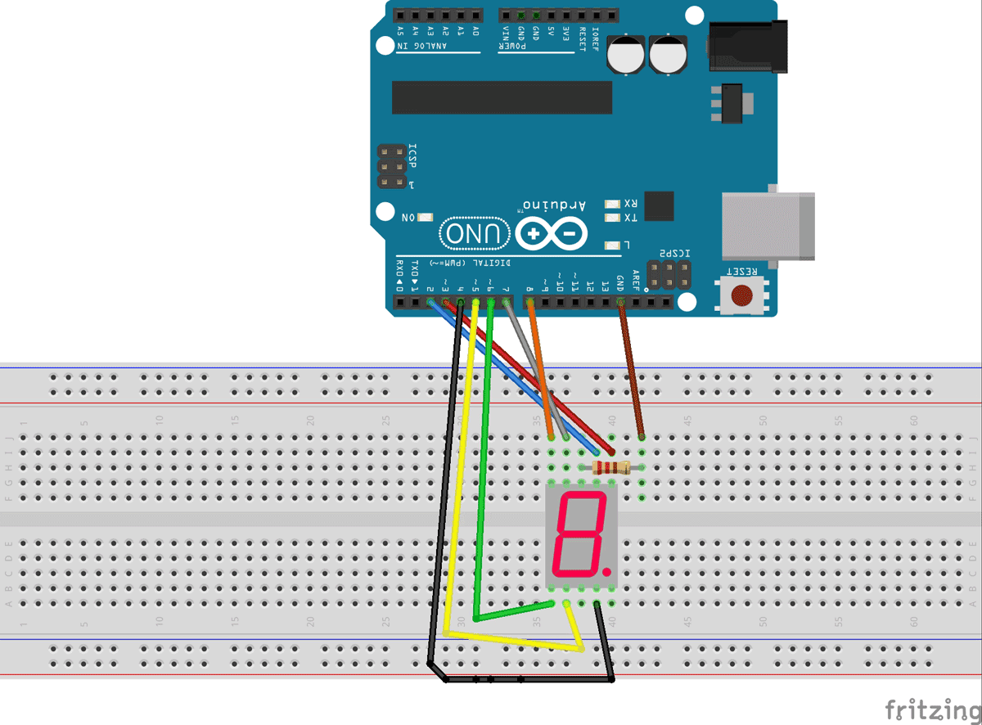

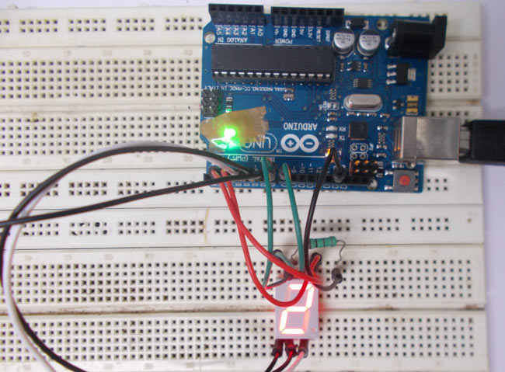

RESULT: Write a C code to control LED lightning via Array

Experiment No. 5

Aim: Write a C code for Push Button using Intel Galileo Gen 2
Theory:
Up until now, we’ve focused mostly on outputs. Now we’re going to go to the other end of spectrum and play around with inputs. In Circuit 2, we used an analog input to read the potentiometer. In this circuit, we’ll be reading in one of the most common and simple inputs – a push button – by using a digital input. The way a push button works with Galileo is that when the button is pushed, the voltage goes LOW. The Galileo reads this and reacts accordingly.
In this circuit, you will also use a pull-up resistor, which keeps the voltage HIGH when you’re not pressing the button.

Parts Needed
You will need the following parts:
- 1x Breadboard
- 1x Galileo
- 1x LED
- 1x 330Ω Resistor
- 7x Jumper Wires
- 2x Push Buttons
- 2x 10k Resistors
View the SparkFun Inventor’s Kit for Galileo wishlist, to see the parts needed to go through the all the experiments.

Suggested Reading
Before continuing on with this tutorial, we recommend you be somewhat familiar with the concepts in these tutorials:
- Switch Basics
- Analog vs. Digital

Hardware Hookup
Ready to start hooking everything up? Check out the Fritzing diagram below, to see how everything is connected. Pay special attention to the component’s markings indicating how to place it on the breadboard. Polarized components can only be connected to a circuit in one direction.

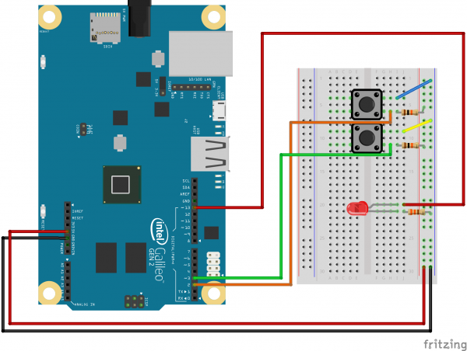
PUSH BUTTONS
Program:
Use pushbuttons for digital input

Previously we've used the analog pins for input, now we'll use
the digital pins for input as well. Because digital pins only
know about HIGH and LOW signals, they're perfect for interfacing
to pushbuttons and switches that also only have "on" and "off"
states.

We'll connect one side of the pushbutton to GND, and the other
side to a digital pin. When we press down on the pushbutton,
the pin will be connected to GND, and therefore will be read
as "LOW" by the Arduino.

But wait - what happens when you're not pushing the button?
In this state, the pin is disconnected from everything, which
we call "floating". What will the pin read as then, HIGH or LOW?
It's hard to say, because there's no solid connection to either
5 Volts or GND. The pin could read as either one.

To deal with this issue, we'll connect a small (10K, or 10,000 Ohm)
resistance between the pin and 5 Volts. This "pullup" resistor
will ensure that when you're NOT pushing the button, the pin will
still have a weak connection to 5 Volts, and therefore read as
HIGH.

(Advanced: when you get used to pullup resistors and know when
they're required, you can activate internal pullup resistors
on the ATmega processor in the Arduino. See
http://arduino.cc/en/Tutorial/DigitalPins for information.)

Hardware connections:

Pushbuttons:

Pushbuttons have two contacts that are connected if you're
pushing the button, and disconnected if you're not.

The pushbuttons we're using have four pins, but two pairs
of these are connected together. The easiest way to hook up
the pushbutton is to connect two wires to any opposite corners.

Connect any pin on pushbutton 1 to ground (GND).
Connect the opposite diagonal pin of the pushbutton to
digital pin 2.

Connect any pin on pushbutton 2 to ground (GND).
Connect the opposite diagonal pin of the pushbutton to
digital pin 3.

Also connect 10K resistors (brown/black/red) between
digital pins 2 and 3 and GND. These are called "pullup"
resistors. They ensure that the input pin will be either
5V (unpushed) or GND (pushed), and not somewhere in between.
(Remember that unlike analog inputs, digital inputs are only
HIGH or LOW.)

LED:

Most Arduinos, including the Uno, already have an LED
and resistor connected to pin 13, so you don't need any
additional circuitry.

But if you'd like to connect a second LED to pin 13,

Connect the positive side of your LED to Arduino digital pin 13
Connect the negative side of your LED to a 330 Ohm resistor
Connect the other side of the resistor to ground

This sketch was written by SparkFun Electronics,
with lots of help from the Arduino community.
This code is completely free for any use.
Visit http://learn.sparkfun.com/products/2 for SIK information.
Visit http://www.arduino.cc to learn about the Arduino.

Program:

Version 2.0 6/2012 MDG
*/

// First we'll set up constants for the pin numbers.
// This will make it easier to follow the code below.

const int button1Pin = 2; // pushbutton 1 pin
const int button2Pin = 3; // pushbutton 2 pin
const int ledPin = 13; // LED pin

void setup()
{
// Set up the pushbutton pins to be an input:
pinMode(button1Pin, INPUT);
pinMode(button2Pin, INPUT);

// Set up the LED pin to be an output:
pinMode(ledPin, OUTPUT);
}

void loop()
{
int button1State, button2State; // variables to hold the pushbutton states

// Since a pushbutton has only two states (pushed or not pushed),
// we've run them into digital inputs. To read an input, we'll
// use the digitalRead() function. This function takes one
// parameter, the pin number, and returns either HIGH (5V)
// or LOW (GND).

// Here we'll read the current pushbutton states into
// two variables:

button1State = digitalRead(button1Pin);
button2State = digitalRead(button2Pin);

// Remember that if the button is being pressed, it will be
// connected to GND. If the button is not being pressed,
// the pullup resistor will connect it to 5 Volts.

// So the state will be LOW when it is being pressed,
// and HIGH when it is not being pressed.

// Now we'll use those states to control the LED.
// Here's what we want to do:

// "If either button is being pressed, light up the LED"
// "But, if BOTH buttons are being pressed, DON'T light up the LED"

// Let's translate that into computer code. The Arduino gives you
// special logic functions to deal with true/false logic:

// A == B means "EQUIVALENT". This is true if both sides are the same.
// A && B means "AND". This is true if both sides are true.
// A || B means "OR". This is true if either side is true.
// !A means "NOT". This makes anything after it the opposite (true or false).

// We can use these operators to translate the above sentences
// into logic statements (Remember that LOW means the button is
// being pressed)

// "If either button is being pressed, light up the LED"
// becomes:
// if ((button1State == LOW) || (button2State == LOW)) // light the LED

// "If BOTH buttons are being pressed, DON'T light up the LED"
// becomes:
// if ((button1State == LOW) && (button2State == LOW)) // don't light the LED

// Now let's use the above functions to combine them into one statement:

if (((button1State == LOW) || (button2State == LOW)) // if we're pushing button 1 OR button 2
&& ! // AND we're NOT
((button1State == LOW) && (button2State == LOW))) // pushing button 1 AND button 2
// then...
{
digitalWrite(ledPin, HIGH); // turn the LED on
}
else
{
digitalWrite(ledPin, LOW); // turn the LED off
}

// As you can see, logic operators can be combined to make
// complex decisions!

// Don't forget that we use = when we're assigning a value,
// and use == when we're testing a value for equivalence.
}

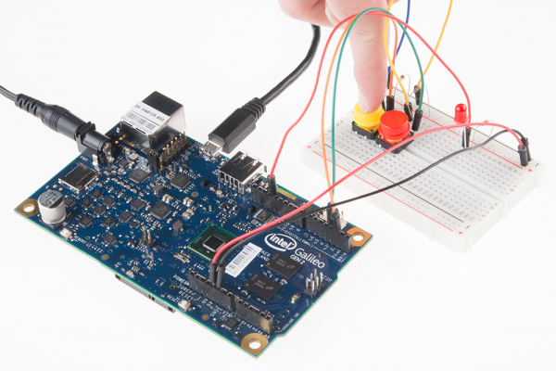
Result: C code for Push Button using Intel Galileo Gen 2 is implemented

Experiment No. 6

Aim : Write a C code to control LED lightning via Array

Theory:
For this project you will need:Wires Arduino board 1-12 leds (im using 10) usb adapter solderless breadboard Take your leds and put them in a row on the breadboard. Make sure you know which side of the led is positive and which side is negative. I like to point the positive side of the led towards the right. Also, keep a one hole spacing in between each led Now, plug in a medium sized wire into the first hole on the negative row on the top of the breadboard. Now insert wires in front of every positive side of each led. Now insert wires in the negative row that you put the medium wire in. now plug those wires into the negative sides of the leds. Now we have to plug the wires in. Position the arduino board so that you can plug the wires in from arduino pin 1 to arduino pin 12 but it doesnt matter what pin you go up to. Now plug the negative wire into GND.
The LEDs I used were slow changing RGB LEDs. This means they slowly cycle through all the colors of the rainbow. They start out red and move along the spectrum. This project would work with single color LEDs but the results looks so much better with colors that change. The code to make this work is available at github.
Program:
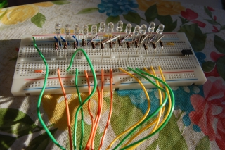
Program:
// Blinking RGB LEDs
// Written by Scott Pustay
//
// This is a really simple example of how to make some fun LED patterns
// with your Arduino.
//
// I have LEDs being powered by output pins 1 through 13. This program
// cycles these LEDs on and off to make the pattern.
// Don't forget to add your resistors to the simple circuit. I'm calling
// LED13 the top and LED1 the bottom. This made sense for how I wired the
// LEDs to the breadboard.

#define LED13 13 // LED connected to digitial pin 13
#define LED12 12
#define LED11 11
#define LED10 10
#define LED9 9
#define LED8 8
#define LED7 7
#define LED6 6
#define LED5 5
#define LED4 4
#define LED3 3
#define LED2 2
#define LED1 1

void setup()
{
pinMode(LED13, OUTPUT); // sets the digital pin as output
pinMode(LED12, OUTPUT);
pinMode(LED11, OUTPUT);
pinMode(LED10, OUTPUT);
pinMode(LED9, OUTPUT);
pinMode(LED8, OUTPUT);
pinMode(LED7, OUTPUT);
pinMode(LED6, OUTPUT);
pinMode(LED5, OUTPUT);
pinMode(LED4, OUTPUT);
pinMode(LED3, OUTPUT);
pinMode(LED2, OUTPUT);
pinMode(LED1, OUTPUT);
}

void loop(){
// all off
digitalWrite(LED13, LOW);
digitalWrite(LED12, LOW);
digitalWrite(LED11, LOW);
digitalWrite(LED10, LOW);
digitalWrite(LED9, LOW);
digitalWrite(LED8, LOW);
digitalWrite(LED7, LOW);
digitalWrite(LED6, LOW);
digitalWrite(LED5, LOW);
digitalWrite(LED4, LOW);
digitalWrite(LED3, LOW);
digitalWrite(LED2, LOW);
digitalWrite(LED1, LOW);

// doubles skipping
digitalWrite(LED1, HIGH);
delay(500);
digitalWrite(LED1, LOW);
digitalWrite(LED2, HIGH);
digitalWrite(LED3, HIGH);
delay(500);
digitalWrite(LED2, LOW);
digitalWrite(LED3, LOW);
digitalWrite(LED4, HIGH);
digitalWrite(LED5, HIGH);
delay(500);
digitalWrite(LED4, LOW);
digitalWrite(LED5, LOW);
digitalWrite(LED6, HIGH);
digitalWrite(LED7, HIGH);
delay(500);
digitalWrite(LED6, LOW);
digitalWrite(LED7, LOW);
digitalWrite(LED8, HIGH);
digitalWrite(LED9, HIGH);
delay(500);
digitalWrite(LED8, LOW);
digitalWrite(LED9, LOW);
digitalWrite(LED10, HIGH);
digitalWrite(LED11, HIGH);
delay(500);
digitalWrite(LED10, LOW);
digitalWrite(LED11, LOW);
digitalWrite(LED12, HIGH);
digitalWrite(LED13, HIGH);
delay(500);
digitalWrite(LED12, LOW);
digitalWrite(LED13, LOW);
digitalWrite(LED10, HIGH);
digitalWrite(LED11, HIGH);
delay(500);
digitalWrite(LED10, LOW);
digitalWrite(LED11, LOW);
digitalWrite(LED8, HIGH);
digitalWrite(LED9, HIGH);
delay(500);
digitalWrite(LED8, LOW);
digitalWrite(LED9, LOW);
digitalWrite(LED6, HIGH);
digitalWrite(LED7, HIGH);
delay(500);
digitalWrite(LED6, LOW);
digitalWrite(LED7, LOW);
digitalWrite(LED4, HIGH);
digitalWrite(LED5, HIGH);
delay(500);
digitalWrite(LED4, LOW);
digitalWrite(LED5, LOW);
digitalWrite(LED2, HIGH);
digitalWrite(LED3, HIGH);
delay(500);
digitalWrite(LED2, LOW);
digitalWrite(LED3, LOW);
digitalWrite(LED1, HIGH);
delay(500);
digitalWrite(LED1, LOW);

// in to out
digitalWrite(LED7, HIGH);
delay(500);
digitalWrite(LED8, HIGH);
digitalWrite(LED6, HIGH);
delay(500);
digitalWrite(LED9, HIGH);
digitalWrite(LED5, HIGH);
delay(500);
digitalWrite(LED10, HIGH);
digitalWrite(LED4, HIGH);
delay(500);
digitalWrite(LED11, HIGH);
digitalWrite(LED3, HIGH);
delay(500);
digitalWrite(LED12, HIGH);
digitalWrite(LED2, HIGH);
delay(500);
digitalWrite(LED13, HIGH);
digitalWrite(LED1, HIGH);
delay(500);

// all off
digitalWrite(LED13, LOW);
digitalWrite(LED12, LOW);
digitalWrite(LED11, LOW);
digitalWrite(LED10, LOW);
digitalWrite(LED9, LOW);
digitalWrite(LED8, LOW);
digitalWrite(LED7, LOW);
digitalWrite(LED6, LOW);
digitalWrite(LED5, LOW);
digitalWrite(LED4, LOW);
digitalWrite(LED3, LOW);
digitalWrite(LED2, LOW);
digitalWrite(LED1, LOW);

// out to in
digitalWrite(LED13, HIGH);
digitalWrite(LED1, HIGH);
delay(500);
digitalWrite(LED12, HIGH);
digitalWrite(LED2, HIGH);
delay(500);
digitalWrite(LED11, HIGH);
digitalWrite(LED3, HIGH);
delay(500);
digitalWrite(LED10, HIGH);
digitalWrite(LED4, HIGH);
delay(500);
digitalWrite(LED9, HIGH);
digitalWrite(LED5, HIGH);
delay(500);
digitalWrite(LED8, HIGH);
digitalWrite(LED6, HIGH);
delay(500);
digitalWrite(LED7, HIGH);
delay(500);

// all off
digitalWrite(LED13, LOW);
digitalWrite(LED12, LOW);
digitalWrite(LED11, LOW);
digitalWrite(LED10, LOW);
digitalWrite(LED9, LOW);
digitalWrite(LED8, LOW);
digitalWrite(LED7, LOW);
digitalWrite(LED6, LOW);
digitalWrite(LED5, LOW);
digitalWrite(LED4, LOW);
digitalWrite(LED3, LOW);
digitalWrite(LED2, LOW);
digitalWrite(LED1, LOW);

// fast line top to bottom
digitalWrite(LED13, HIGH);
delay(500);
digitalWrite(LED12, HIGH);
delay(500);
digitalWrite(LED11, HIGH);
delay(500);
digitalWrite(LED10, HIGH);
delay(500);
digitalWrite(LED9, HIGH);
delay(500);
digitalWrite(LED8, HIGH);
delay(500);
digitalWrite(LED7, HIGH);
delay(500);
digitalWrite(LED6, HIGH);
delay(500);
digitalWrite(LED5, HIGH);
delay(500);
digitalWrite(LED4, HIGH);
delay(500);
digitalWrite(LED3, HIGH);
delay(500);
digitalWrite(LED2, HIGH);
delay(500);
digitalWrite(LED1, HIGH);
digitalWrite(LED13, LOW);
delay(500);
digitalWrite(LED12, LOW);
delay(500);
digitalWrite(LED11, LOW);
delay(500);
digitalWrite(LED10, LOW);
delay(500);
digitalWrite(LED9, LOW);
delay(500);
digitalWrite(LED8, LOW);
delay(500);
digitalWrite(LED7, LOW);
delay(500);
digitalWrite(LED6, LOW);
delay(500);
digitalWrite(LED5, LOW);
delay(500);
digitalWrite(LED4, LOW);
delay(500);
digitalWrite(LED3, LOW);
delay(500);
digitalWrite(LED2, LOW);
delay(500);
digitalWrite(LED1, LOW);
delay(500);

// slow line top to bottom
digitalWrite(LED13, HIGH);
delay(1000);
digitalWrite(LED12, HIGH);
delay(1000);
digitalWrite(LED11, HIGH);
delay(1000);
digitalWrite(LED10, HIGH);
delay(1000);
digitalWrite(LED9, HIGH);
delay(1000);
digitalWrite(LED8, HIGH);
delay(1000);
digitalWrite(LED7, HIGH);
delay(1000);
digitalWrite(LED6, HIGH);
delay(1000);
digitalWrite(LED5, HIGH);
delay(1000);
digitalWrite(LED4, HIGH);
delay(1000);
digitalWrite(LED3, HIGH);
delay(1000);
digitalWrite(LED2, HIGH);
delay(1000);
digitalWrite(LED1, HIGH);
digitalWrite(LED13, LOW);
delay(1000);
digitalWrite(LED12, LOW);
delay(1000);
digitalWrite(LED11, LOW);
delay(1000);
digitalWrite(LED10, LOW);
delay(1000);
digitalWrite(LED9, LOW);
delay(1000);
digitalWrite(LED8, LOW);
delay(1000);
digitalWrite(LED7, LOW);
delay(1000);
digitalWrite(LED6, LOW);
delay(1000);
digitalWrite(LED5, LOW);
delay(1000);
digitalWrite(LED4, LOW);
delay(1000);
digitalWrite(LED3, LOW);
delay(1000);
digitalWrite(LED2, LOW);
delay(1000);
digitalWrite(LED1, LOW);
delay(1000);

}

Result: C code to control LED lightning via Array is implemented

Experiment No. 7

Aim :To write C source code to Interface LCD with Intel Galileo Gen 2 and display GHRCE on LCD Display

Software Requirement: Arduino IDE for Galileo Gen2
Hardware Requirement: Target board Intel Galileo Gen2, USB Cable, LCD, Connecting wires,
adapter
Procedure:
1. Write desired C source code
2. Compile the code as described in experiment1.
Pin Connection Diagram:
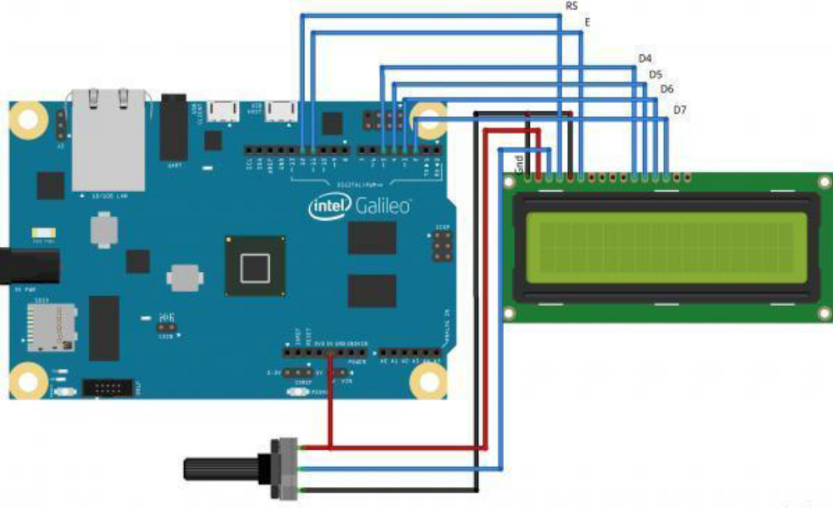
Source Code 1: Table 2.1
#include <LiquidCrystal.h> void loop()
{
// initialize the library with the numbers of the // Turn off the cursor:
interface pins
LiquidCrystal lcd(12, 11, 5, 4, 3, 2); lcd.noCursor();
delay(500);
void setup() {
// set up the LCD's number of columns and rows: // Turn on the cursor:
lcd.begin(16, 2); lcd.cursor();
// Print a message to the LCD. delay(500);
lcd.print("GHRCE");
} }
Snapshot:-
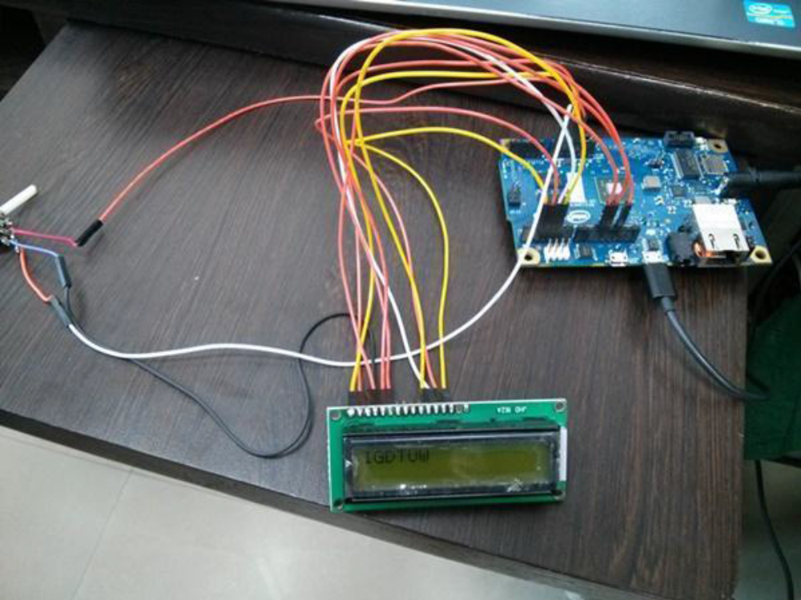
Result:- Output observed at LCD, as per compiled C source code

Experiment No. 8

Aim :To write C source code to Interface Temperature Sensor (LM35) with Intel Galileo Gen 2 and display the temperature on LCD

Software Requirement: Arduino IDE for Galileo Gen2
Hardware Requirement: Target board Intel Galileo Gen2, USB Cable, LCD, LM35, Connecting
wires, adapter
Procedure:
1. Write desired C source code
2. Compile the code as described in experiment1.
Pin Connection Diagram:
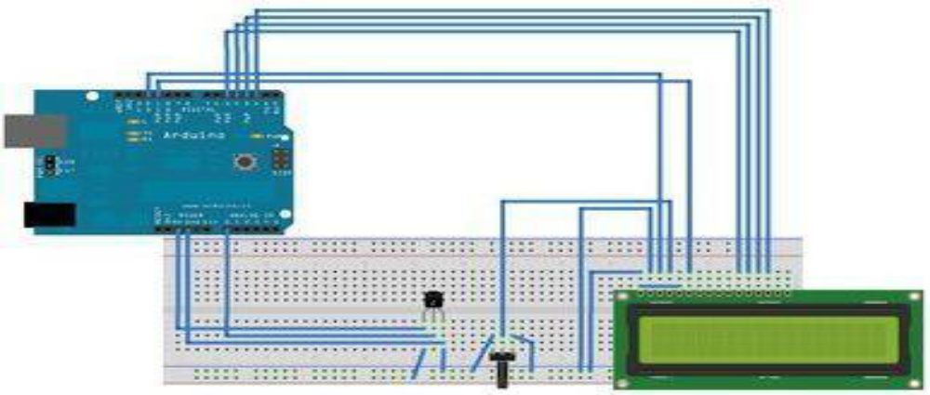
Source Code 1: Table 3.1
#include <LiquidCrystal.h> void loop()
//initializes/defines the output pin of the LM35 {
temperature sensor
int rawvoltage= analogRead(outputpin);
int outputpin= 0;
float millivolts= (rawvoltage/1024.0) * 5000;
//this sets the ground pin to LOW and the input
voltage pin to high float celsius= millivolts/10;
// BS E D4 D5 D6 D7 lcd.setCursor(0, 0);
LiquidCrystal lcd(12, 11, 5, 4, 3, 2); lcd.print(" BY IGDTUW:ESENS,");
void setup() lcd.setCursor(0, 1);
{
lcd.print(celsius);
lcd.begin(16,2);
lcd.print("C");
}
delay(1000);
//main loop
}
}
Snapshot:-
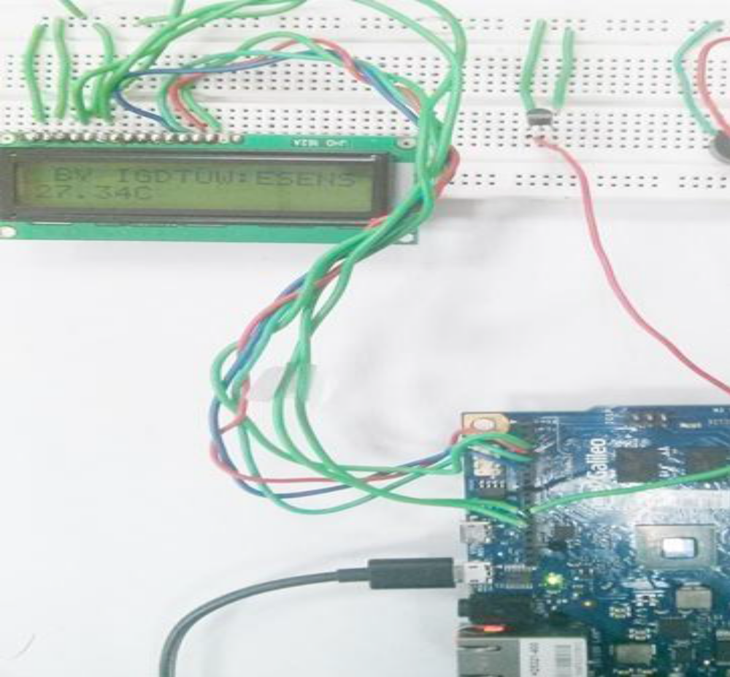
Result:- Output observed at LCD, as per compiled C source code. Temperature Sensor senses the room temperature and the value is shown at LCD.

Experiment No. 9
Aim : Write a C code to Distance sensing using ultrasonic sensor and Arduino

Software Requirement: Arduino 1.6.0
Hardware Requirement: Target board Arduino UNO, USB Cable, Arduino Ultrasound sensor

Procedure:
1. Write desired C source code
2. Compile the code.
The circuit:

1. VCC connection of the sensor attached to +5V

2. GND connection of the sensor attached to ground

3. TRIG connection of the sensor attached to digital pin 2
4. ECHO connection of the sensor attached to digital pin 4

Source Code:
const int trigPin = 2;

const int echoPin = 4;

void setup() {

Serial.begin(9600);

}

void loop()

{

long duration, inches, cm;

pinMode(trigPin, OUTPUT);

digitalWrite(trigPin, LOW);

delayMicroseconds(2);

digitalWrite(trigPin, HIGH);

delayMicroseconds(10);

digitalWrite(trigPin, LOW);

pinMode(echoPin, INPUT);

duration = pulseIn(echoPin, HIGH);

inches = microsecondsToInches(duration);

cm = microsecondsToCentimeters(duration);

Serial.print(inches);

Serial.print("in, ");

Serial.print(cm);

Serial.print("cm");

Serial.println();

delay(100);

}

long microsecondsToInches(long microseconds)

{

return microseconds / 74 / 2;

}

long microsecondsToCentimeters(long microseconds)

{

return microseconds / 29 / 2;
}

Snapshot:-
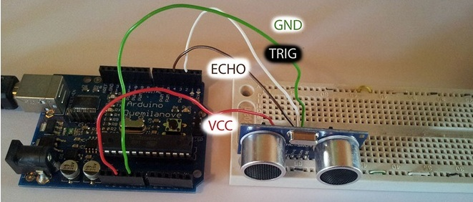

Result:- Distance calculated and display on monitor.

Experiment No. 10

Aim: Write a C code to detect obstacle using IR obstacle sensor and Arduino.

Software Requirement: Arduino IDE for Galileo Gen2
Hardware Requirement: Target board Arduino UNO, USB Cable, Arduino IR sensor

Procedure:
1. Write desired C source code
2. Compile the code.

Source Code :
int LED = 13; // Use the onboard Uno LED
int obstaclePin = 7; // This is our input pin
int hasObstacle = HIGH; // HIGH MEANS NO OBSTACLE

void setup() {
pinMode(LED, OUTPUT);
pinMode(obstaclePin, INPUT);
Serial.begin(9600);
}
void loop() {
hasObstacle = digitalRead(obstaclePin); //Reads the output of the obstacle sensor from the 7th PIN of the Digital section of the arduino
if (hasObstacle == LOW) //LOW means something is ahead, so illuminates the 13th Port connected LED
{
Serial.println("Stop something is ahead!!");
digitalWrite(LED, HIGH);//Illuminates the 13th Port LED
}
else
{
Serial.println("Path is clear");
digitalWrite(LED, LOW);
}
delay(200);
}

Snapshot:-
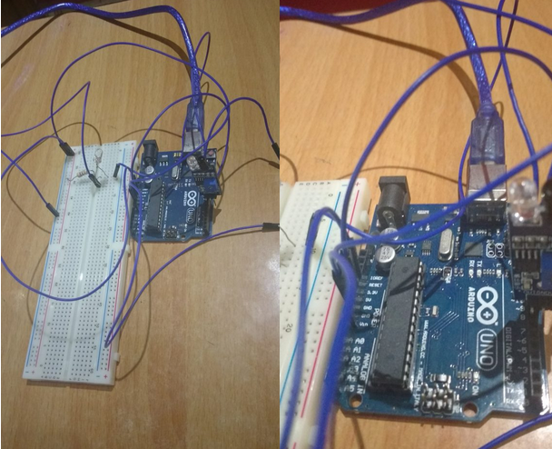

Result:- Output observed as per compiled C source code. Output is correlated with the IR sensor to check whether obstacle is present or path is clear.

