

**National University of Sciences & Technology Islamabad**

**School of Mechanical and Manufacturing**

**Engineering Islamabad**

**Fundamental of Programming Lab**

Lab Manual 5

**Submitted by:**

Muhammad Shahzeb Khan

**Registration #:**

479677

**Submitted to:**

Lab Instructor Muhammad Saqib

**Due Date:**

November 1, 2023

**Code1:**

#include<iostream>

using namespace std;

int main(){

int num1,num2,LCM,i;

int HCF=0;

cout<<"enter first number"<<endl;

cin>>num1;

cout<<"enter second number"<<endl;

cin>>num2;

for(i=1;i<=num1||i<=num2;i++){

if(num1%i==0&&num2%i==0){

HCF=i;

}

}

LCM=(num1*num2)/HCF;

cout<<"LCM of two numbers is "<<LCM<<endl;

}

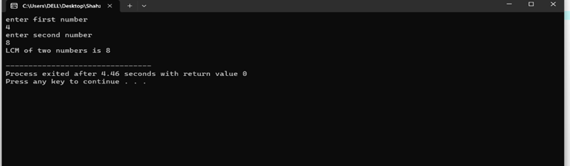

**Code2:**

using namespace std;

int main(){

int sum,num1,n,d;

cout<<"enter first term of sequence"<<endl;

cin>>num1;

cout<<"enter total number of terms"<<endl;

cin>>n;

cout<<"enter common difference of series"<<endl;

cin>>d;

sum=(n*(2*num1+(n-1)*d))/2;

cout<<”sum of arithmetic series is”<<sum<<endl;

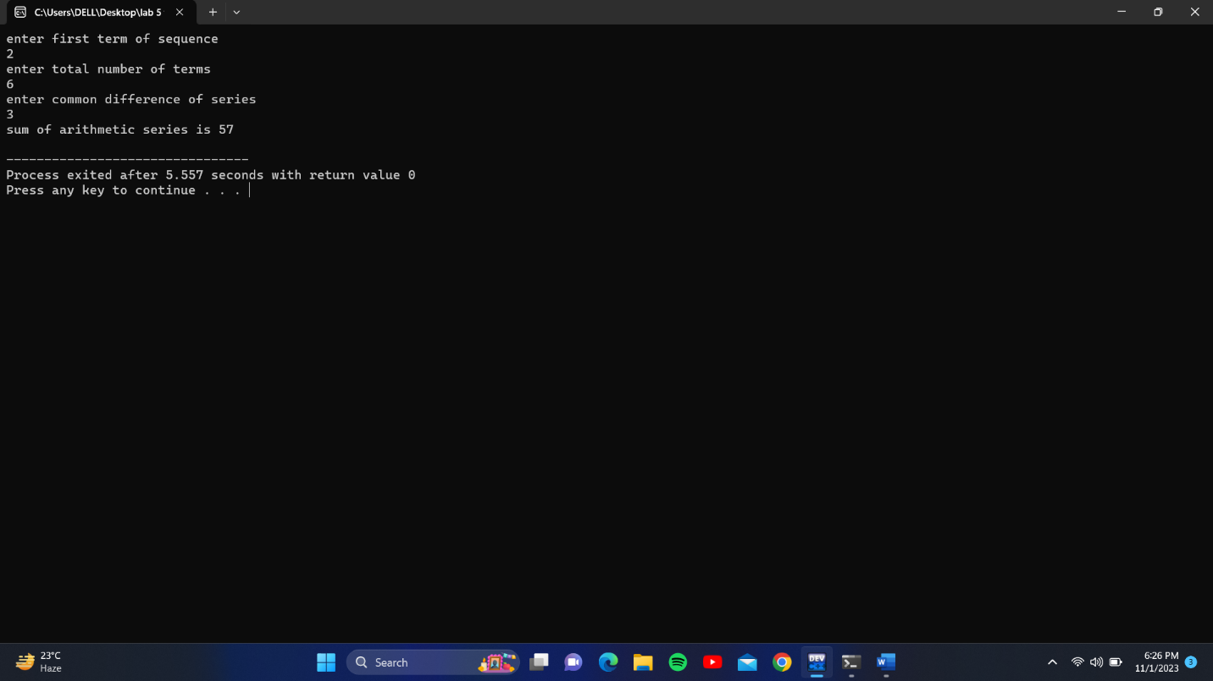

**Code3:**

#include<iostream>

using namespace std;

int main(){

int a;

cout<<"enter the number of rows ";

cin>>a;

if(a%2==0){

cout<<"enter an odd number for proper shape ";

return 1;

}

for(int i=0;i<=a/2+1;i++){

for(int j=0;j<a/2-i;j++){

cout<<" ";

}

for(int k=0;k<2*i+1;k++){

cout<<"*";

}cout<<endl;

}

for(int i=a/2-1;i>=0;i--){

for(int j=0;j<a/2-i;j++){

cout<<" ";

}

for(int k=0;k<2*i+1;k++){

cout<<"*";

}cout<<endl;

}return 0;}

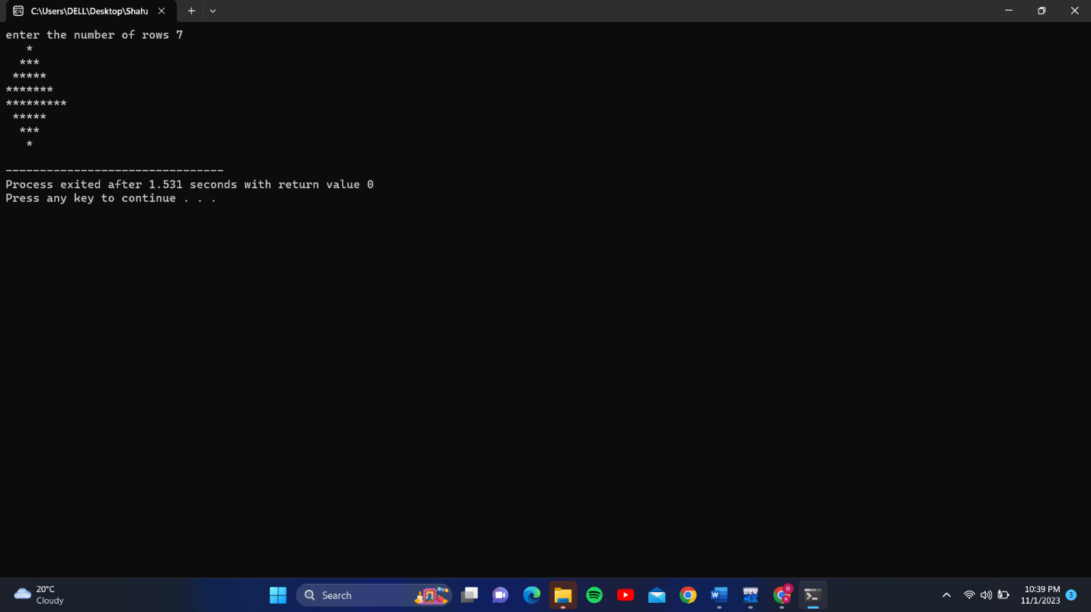

**Code4:**

#include<iostream>

using namespace std;

int main(){

int numbinary,numdecimal,remainder;

int b=1;

cout<<"enter the decimal number to be converted to binary"<<endl;

cin>>numdecimal;

while(numdecimal>0){

remainder=numdecimal%2;

numbinary=numbinary+(remainder*b);

numdecimal=numdecimal/2;

b=b*10;

}

cout<<"required binary number is"<<numbinary<<endl;

}

