National University of Sciences and Technology
islamabad
FUNDAMENTALS OF PROGRAMMING LAB
MECHANICAL ENGINEERING 15
SECTION B
Lab Manual 8

Muhammad Shahzeb Khan
479677

Lab Tasks
code 1:
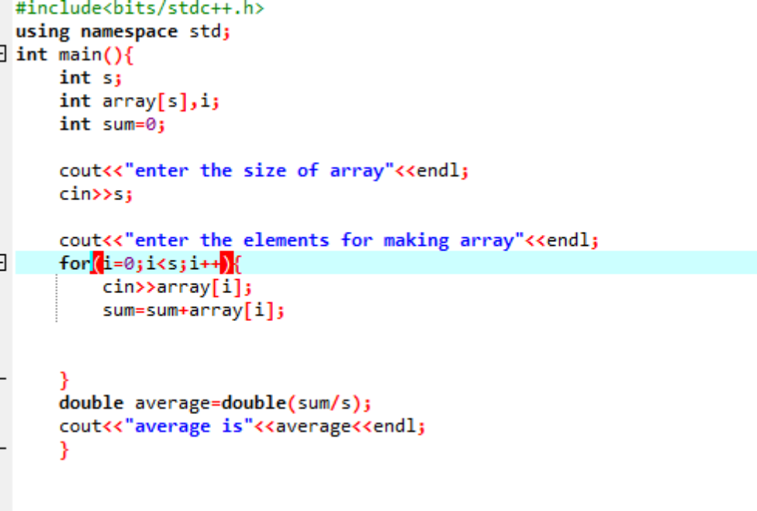
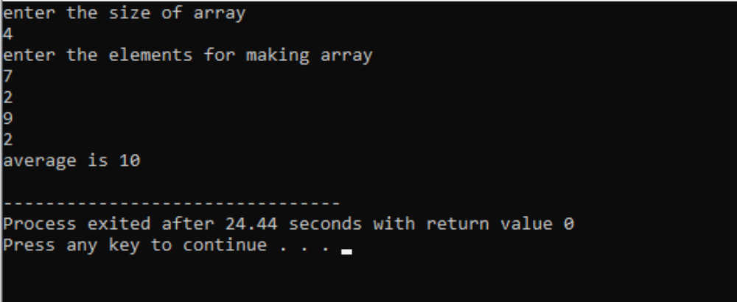

code 2:
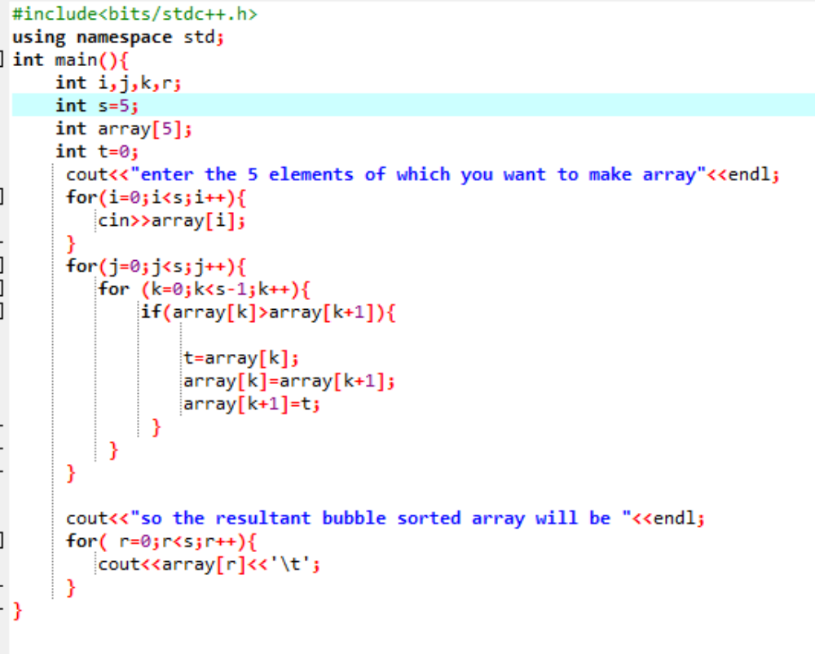

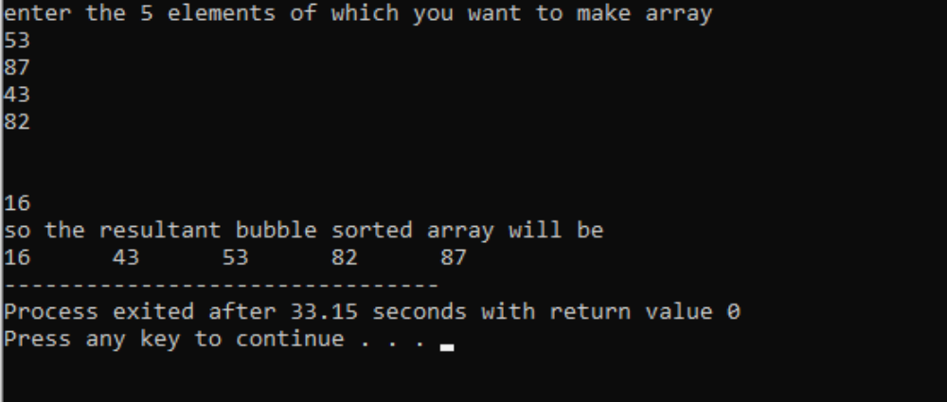

code 3:
