VISOKA ŠKOLA STRUKOVNIH STUDIJA ZA INFORMACIONE I KOMUNIKACIONE TEHNOLOGIJE
DOKUMANTACIJA – WEB PROGRAMIRANJE 1

https://zoranakondic.github.io/lattes-master/
Zorana Kondic 104/22 12.01.2026.
Contents
1. Uvod 3
1.1 Korišćeni programski jezici 3
1.2 Opis funkcionalnosti 3
1.3 Template 3
1.4 Izgled sajta 4
2. Organizacija 7
2.1 Organizaciona šema 7
3. Kodovi 12
3.1 HTML- index.html 12
3.2 HTML – autor.html 19
3.3 CSS 22
3.4 Main.js 38
3.5 Forma.js 43

1. Uvod

1.1 Korišćeni programski jezici
Za izradu sajta korišćeni su HTML, CSS, JavaScript, Bootstrap i XML.
-Radno okruženje: Visual Studio Code

1.2 Opis funkcionalnosti
• Dinamički ispasana sekcija u kojoj se menjaju slike u vidu slajdera
• Dinamički ispisan tekst, umesto preko HTML-a, unet dinamički preko JS-a
• Brojač dinamički kreiran preko JS-a
• Galerija dinamički kreirana
• Vrši se validacija formi uz regularne izraze
• Dugme toTop za povratak na vrh stranice

1.3 Template
Za izradu sajta korišćen je template preuzet sa sajta: https://themewagon.com/themes/free-html5-agency-website-template-lattes/
Menjan je originalni HTML kod, originalan CSS kod dopunjen, dodat fajl moj Main.js i Forma.js koji sadrže funkcionalnosti sajta. Takođe je napisan i sitemap.xml, sajt je jednostraničan(single-page), postoji stranica index.html i autor.html.

1.4 Izgled sajta
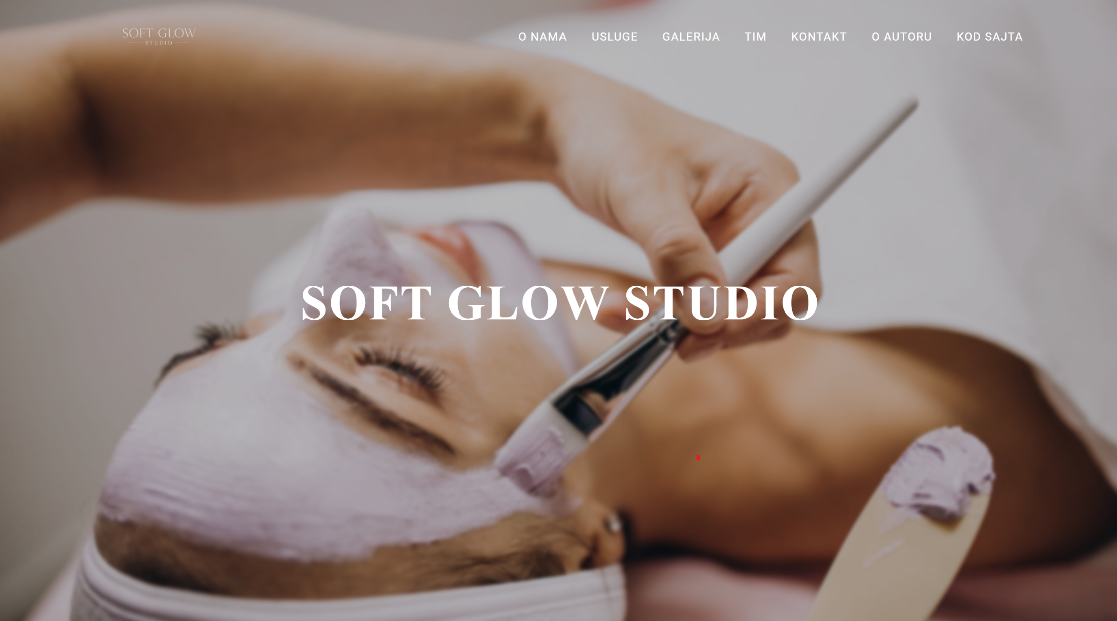

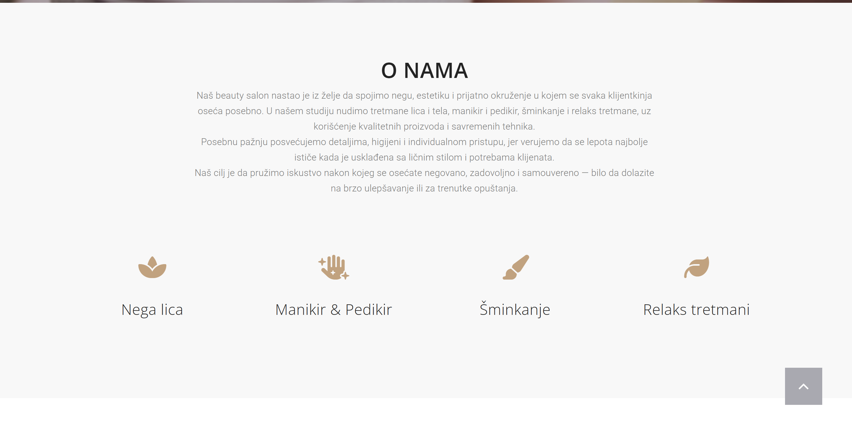

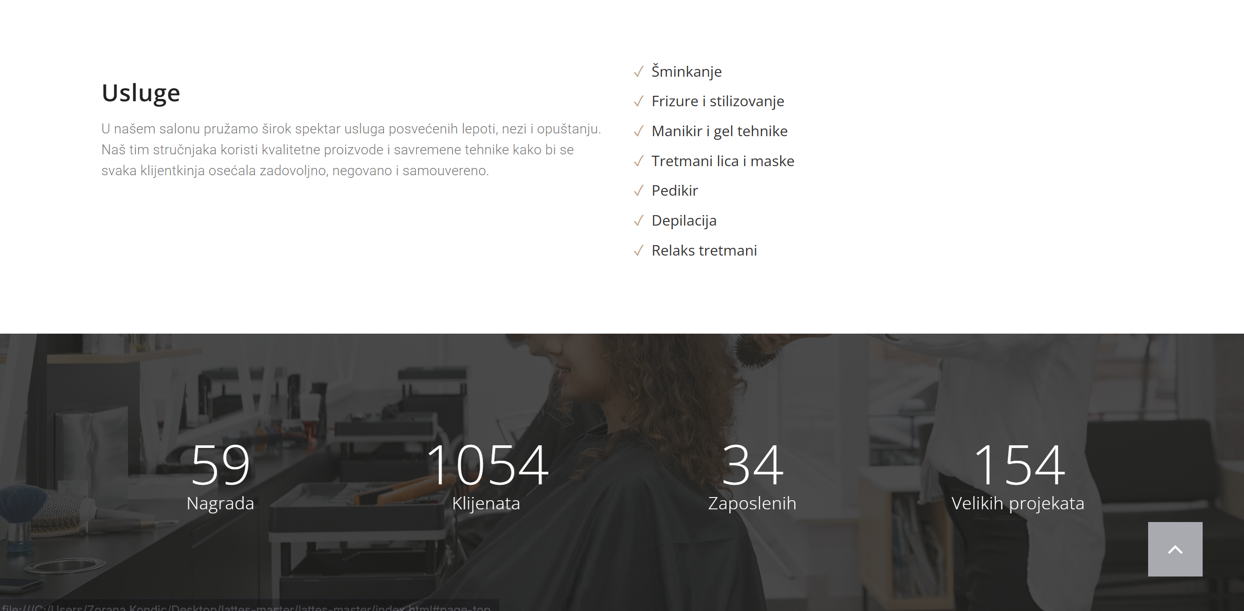

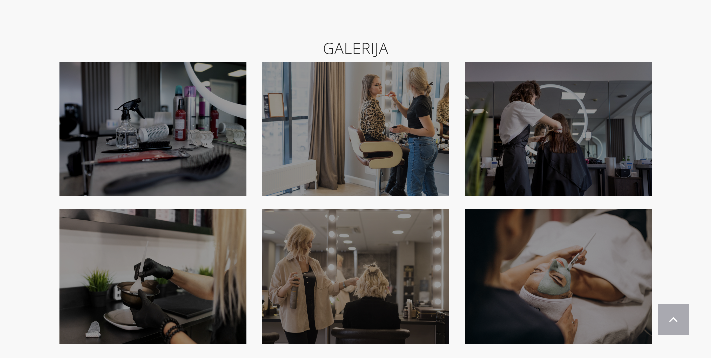

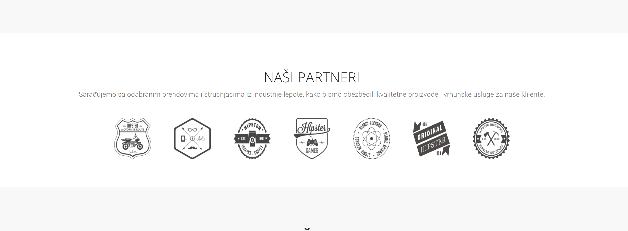
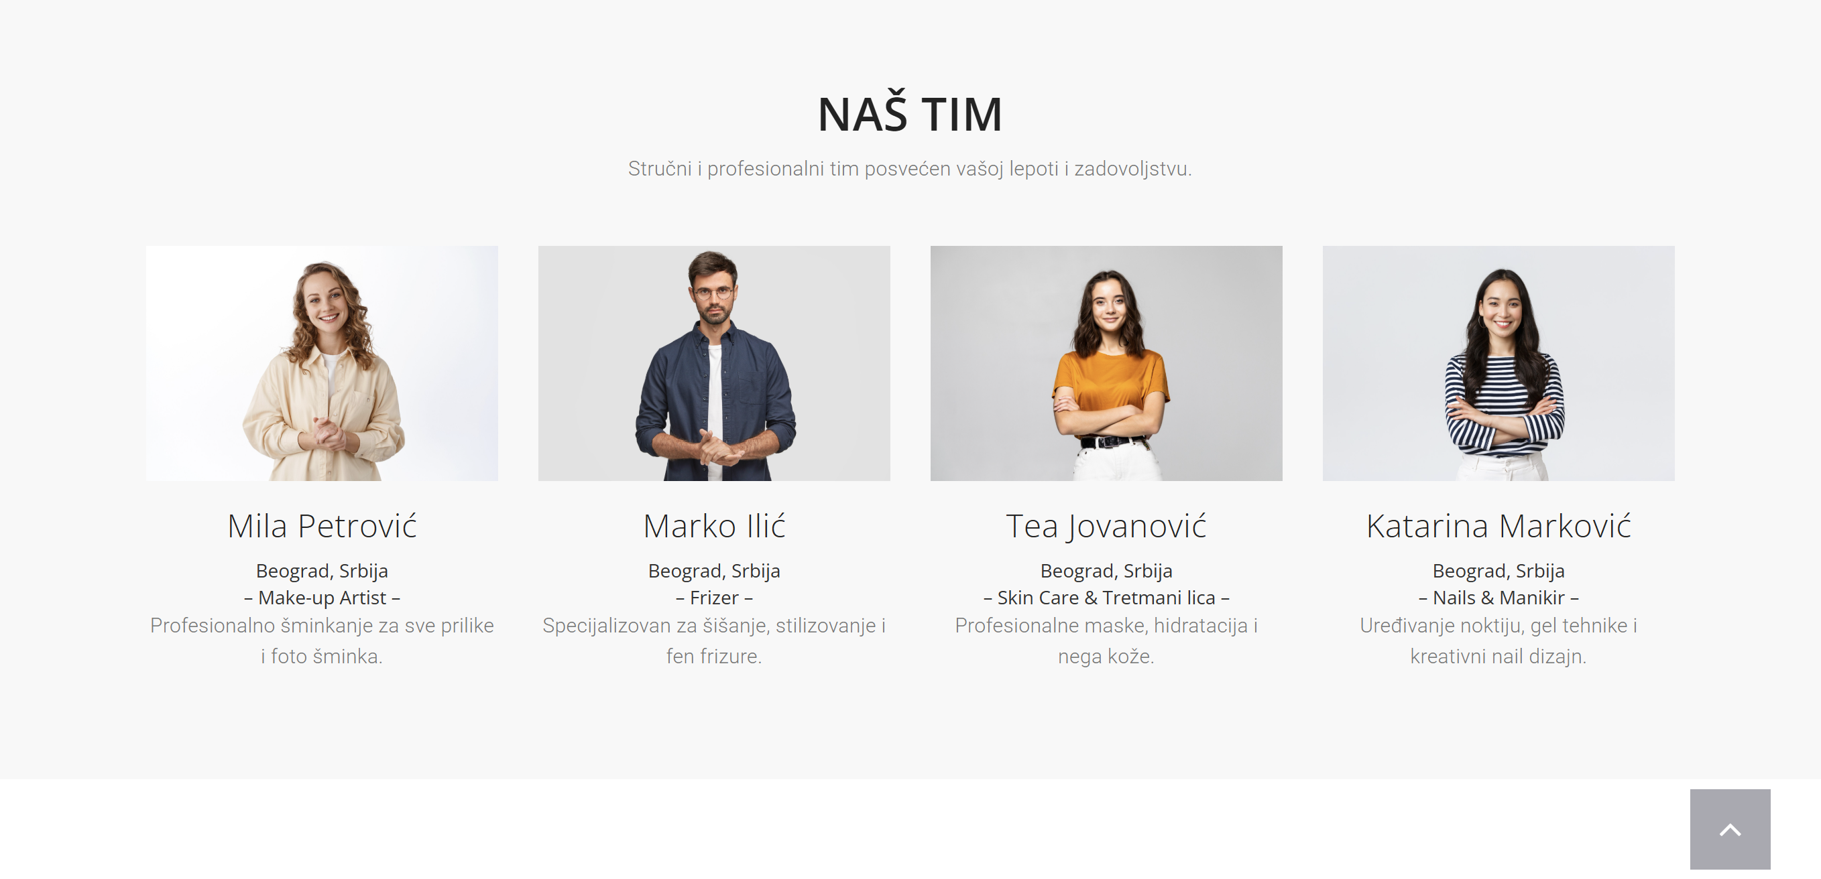

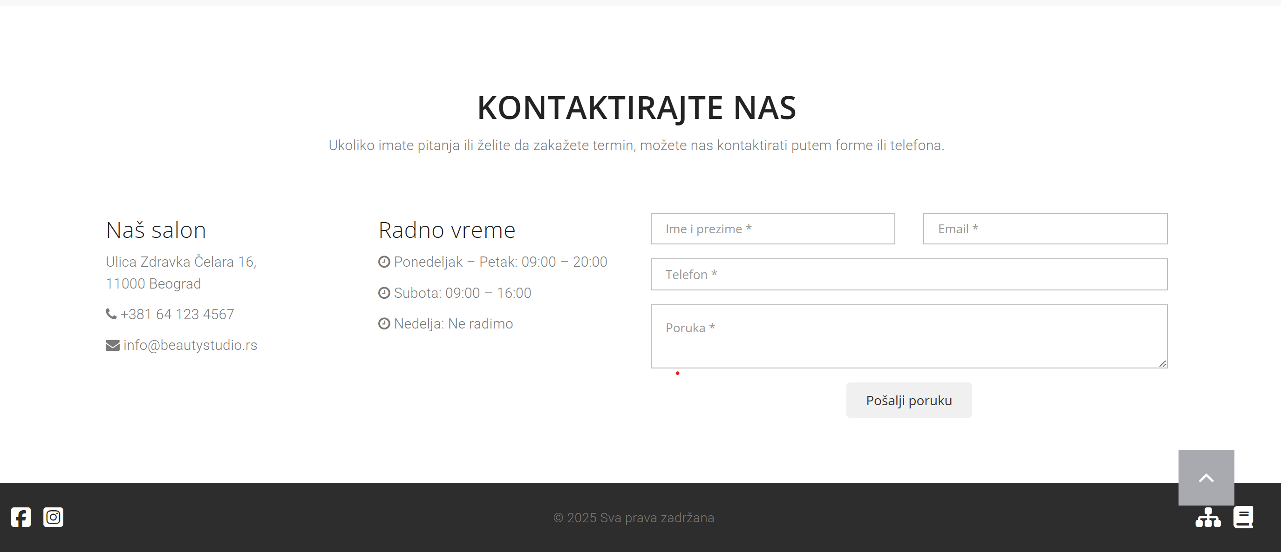

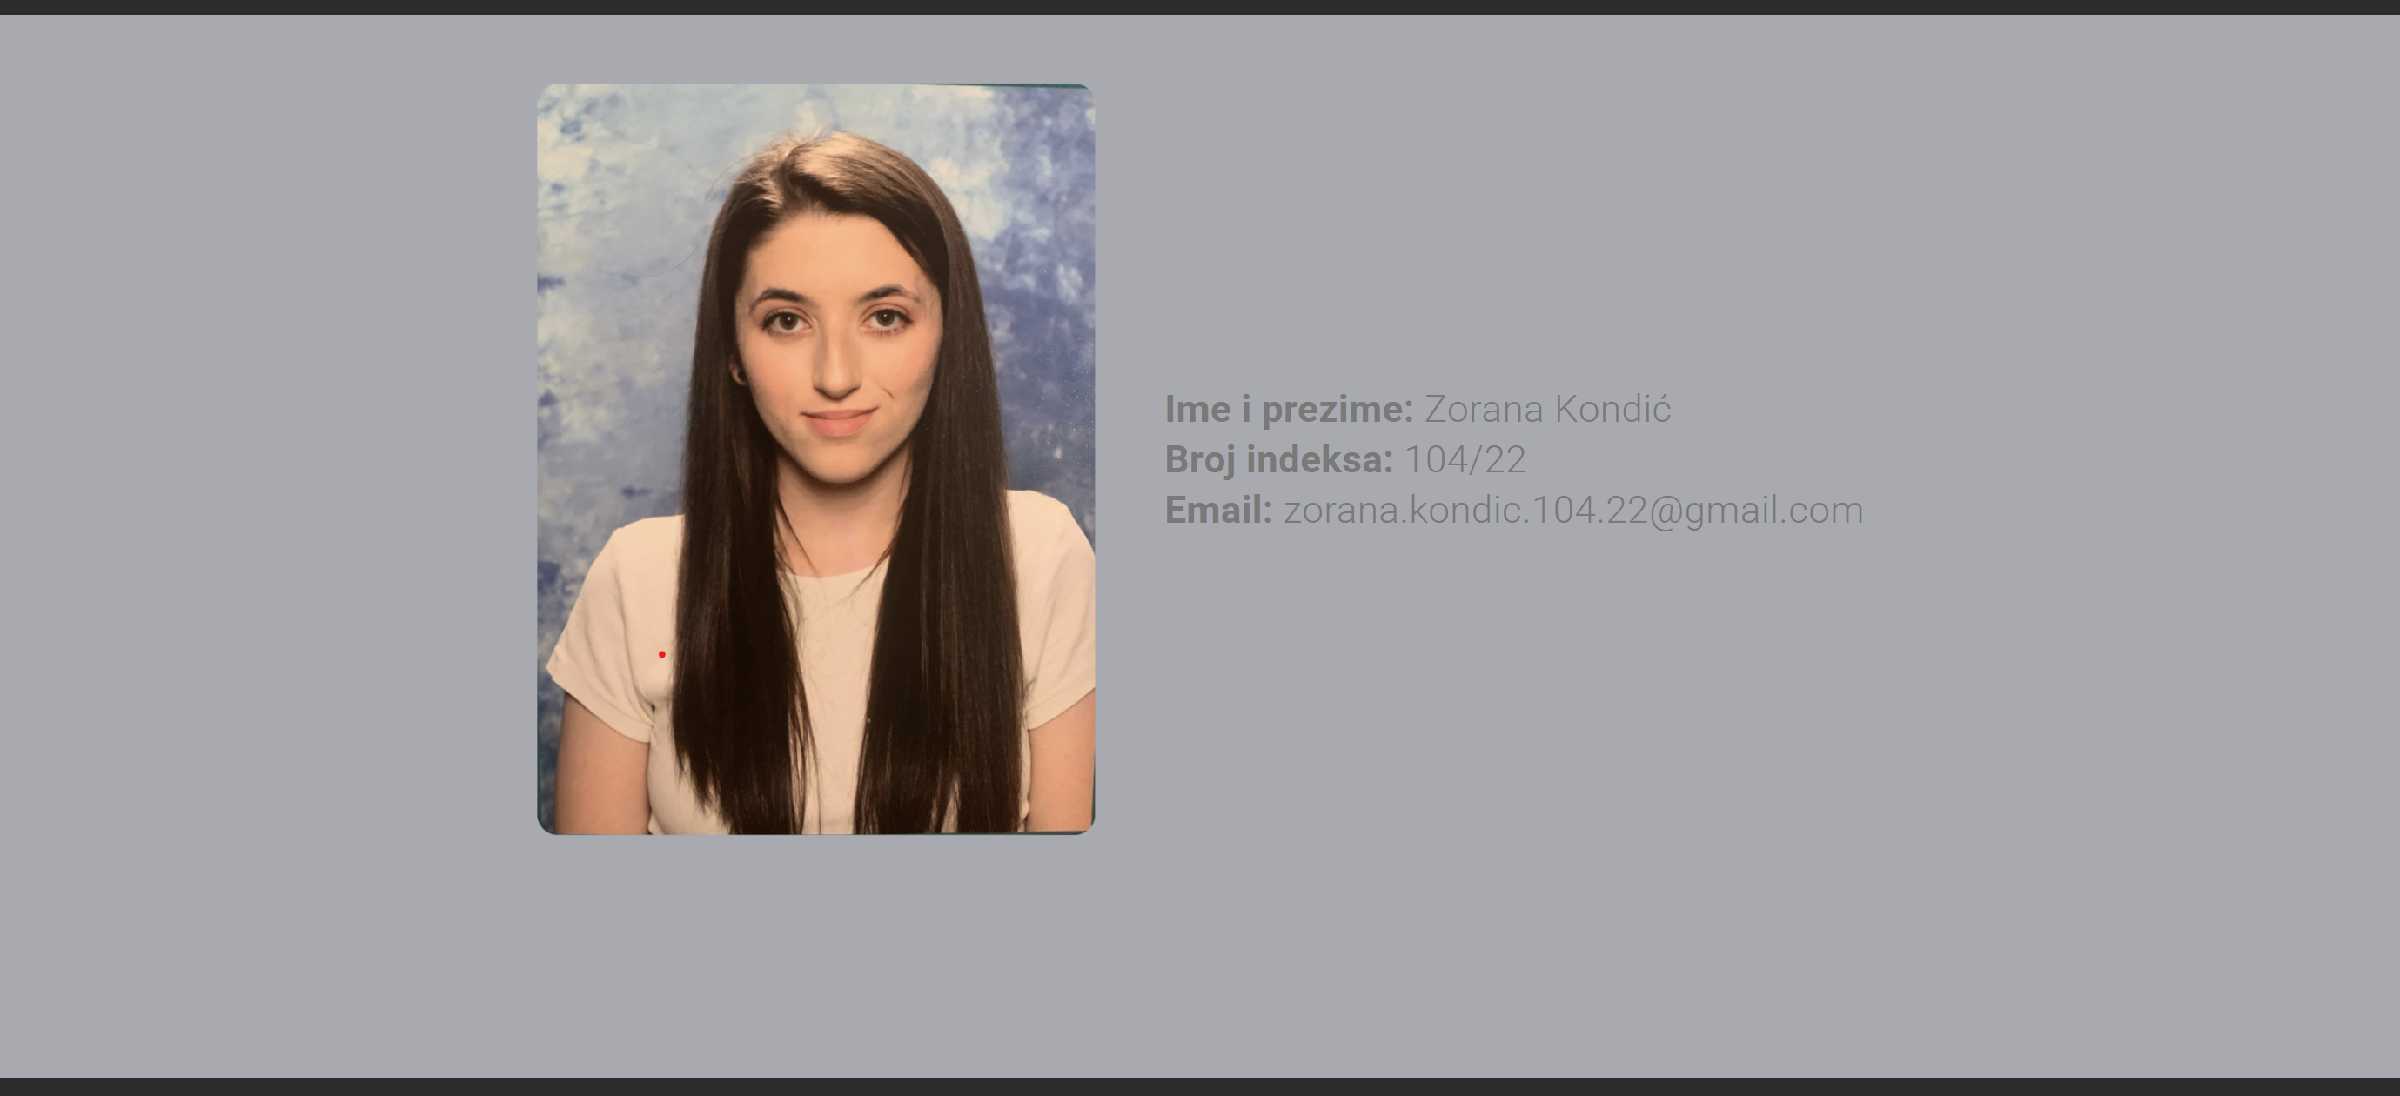

2. Organizacija

2.1 Organizaciona šema
Autor.html
Index.html

2.2 Sitemap
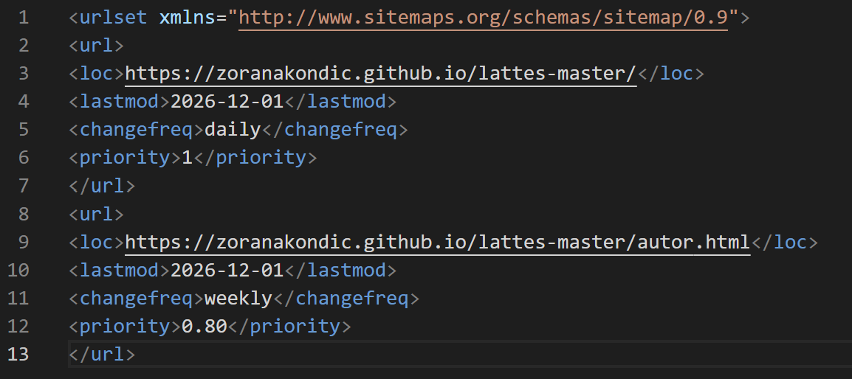

2.3 Slike stranice i opis funkcionalnosti
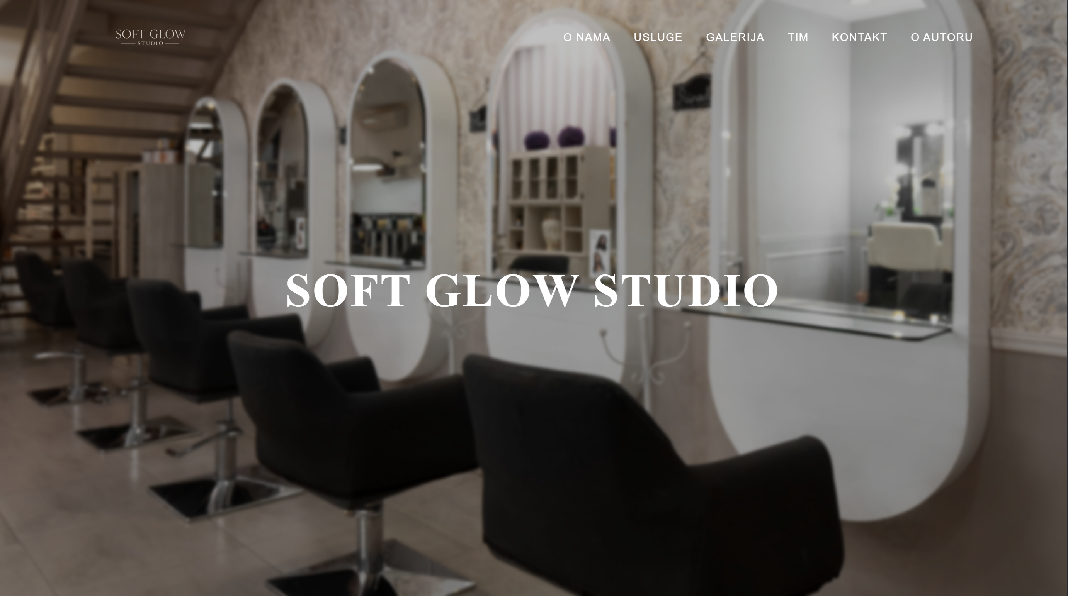
U pozadini se nalaze slike koje se menjaju nakon određenog vremenskog intervala. Slike su unete dinamički. Blok na sredini se ispisuje kad se stranica učita. U gornjem desnom uglu se nalazi meni, koji sadrži linkove koji nas šalju na određeni deo stranice.
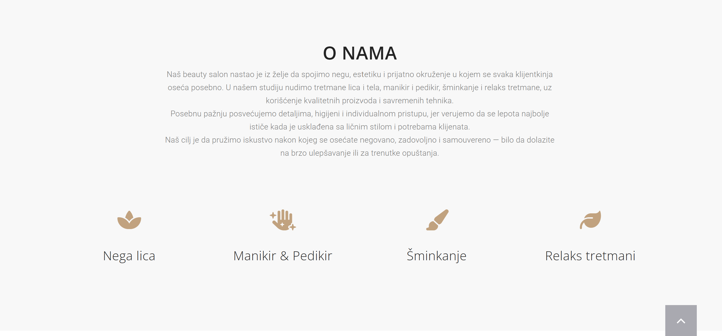
Sekcija O nama je dinamički kreirana, tekst se dinamički ispisuje kroz niz u JS-u kao i ikonice.


Usluge su ispisane u html i css-u.

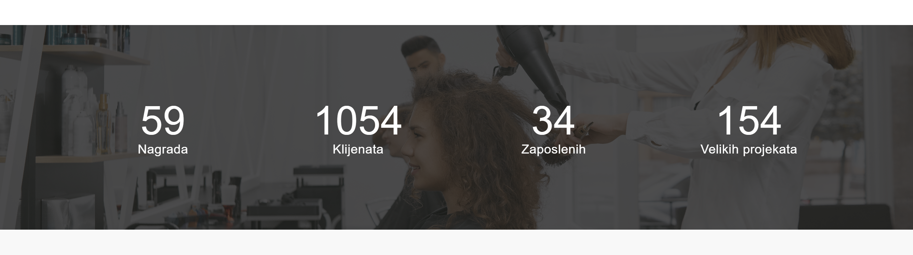
Sajt takođe sadrži brojače(countere) koji kroz animaciju prikazuju određene podatke.(npr. broj nagrada.).

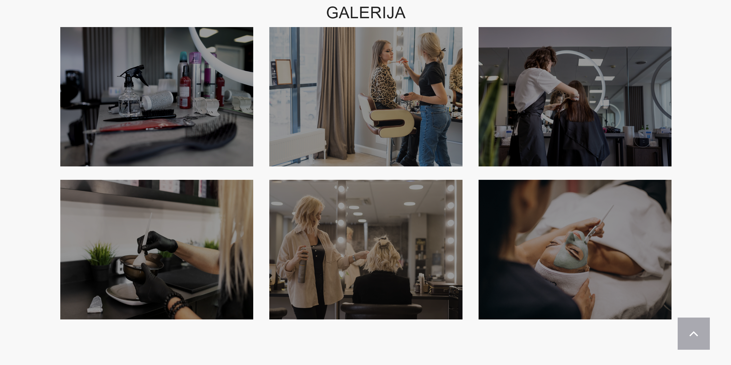
Galerija je ispisana dinamicki, preko css su takodje napravljeni vizuelni efekti.

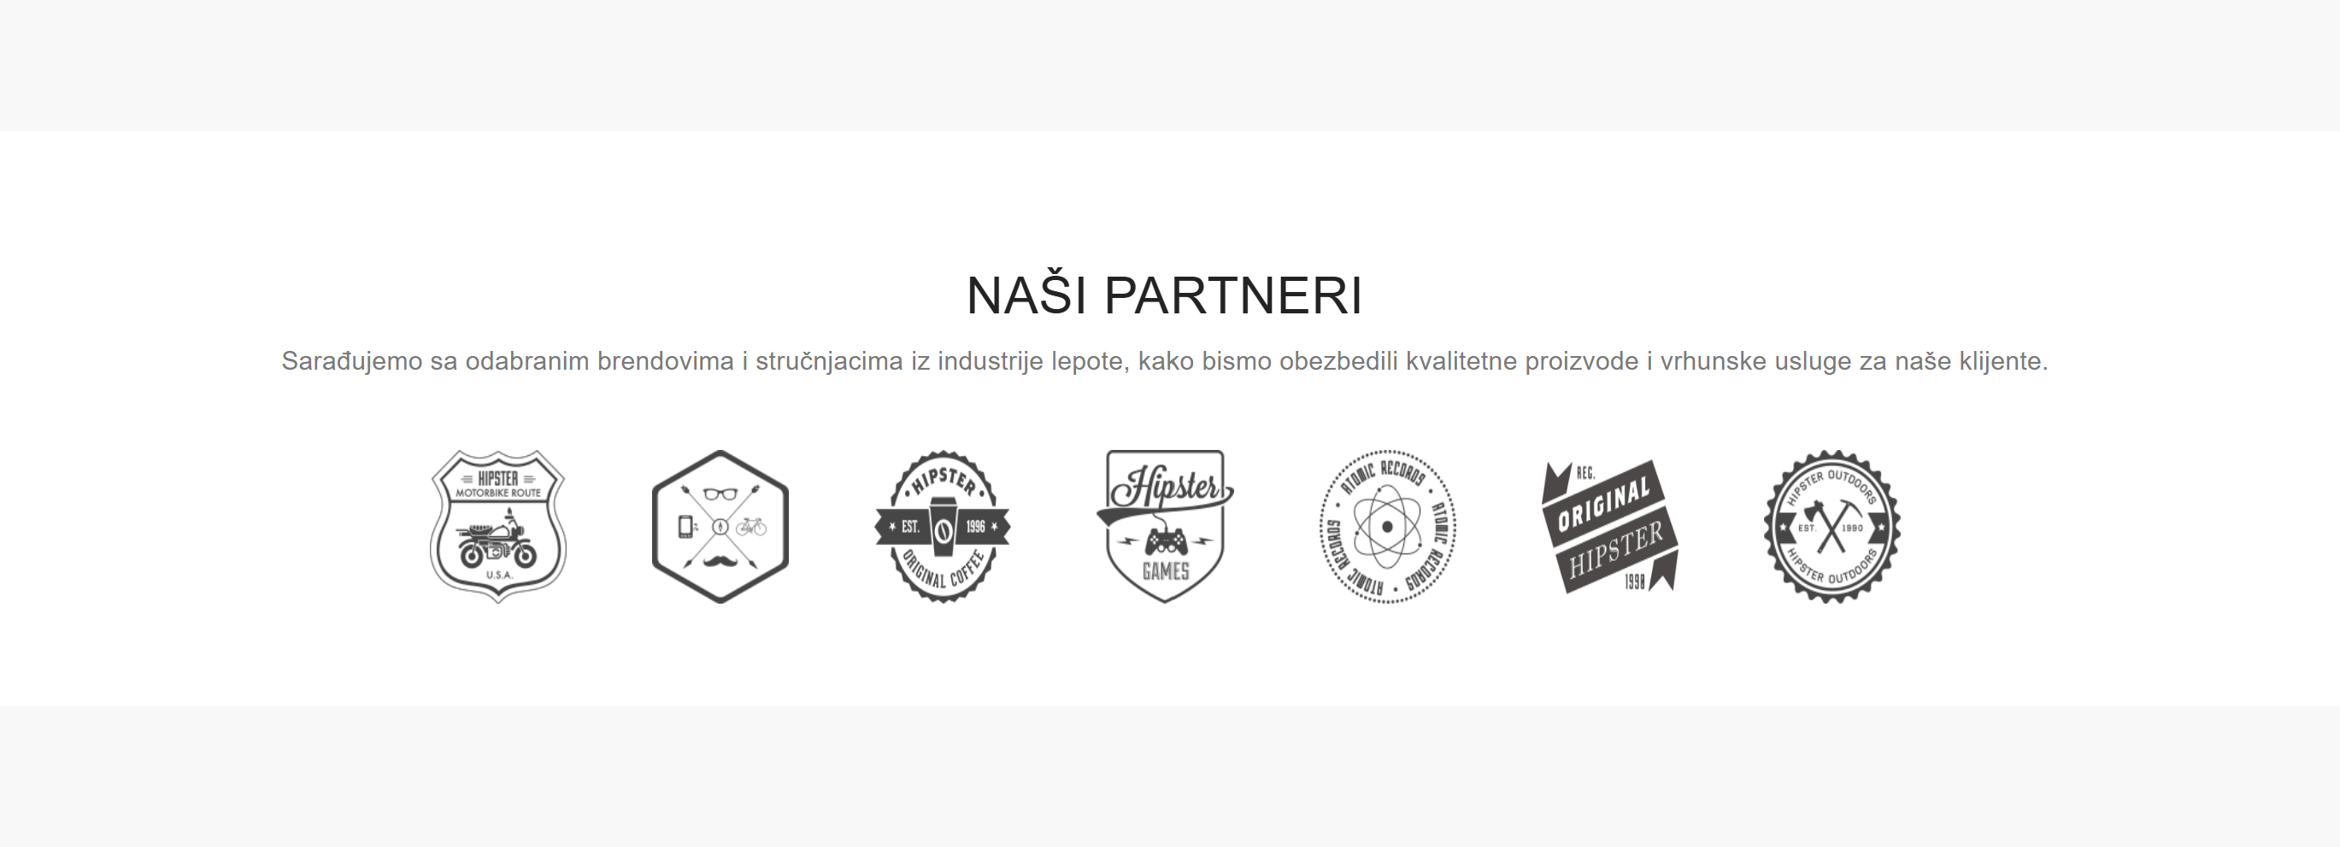
Deo nasi partneri, su takodje ispisani preko JS, i takodje su stavljeni vizuelni efekti(hover).

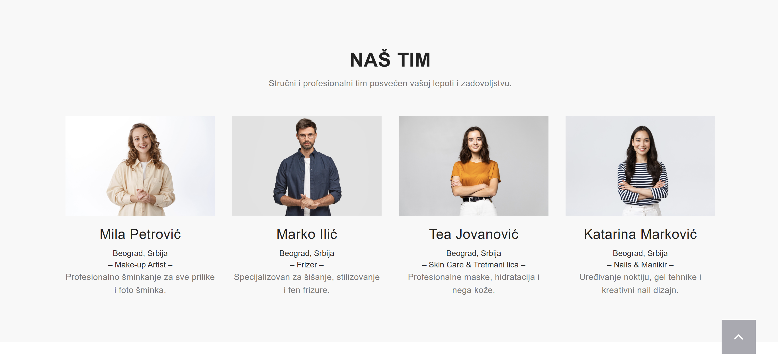
Tim je takodje ispisan dinamicki i imaju vizuelni efekti.

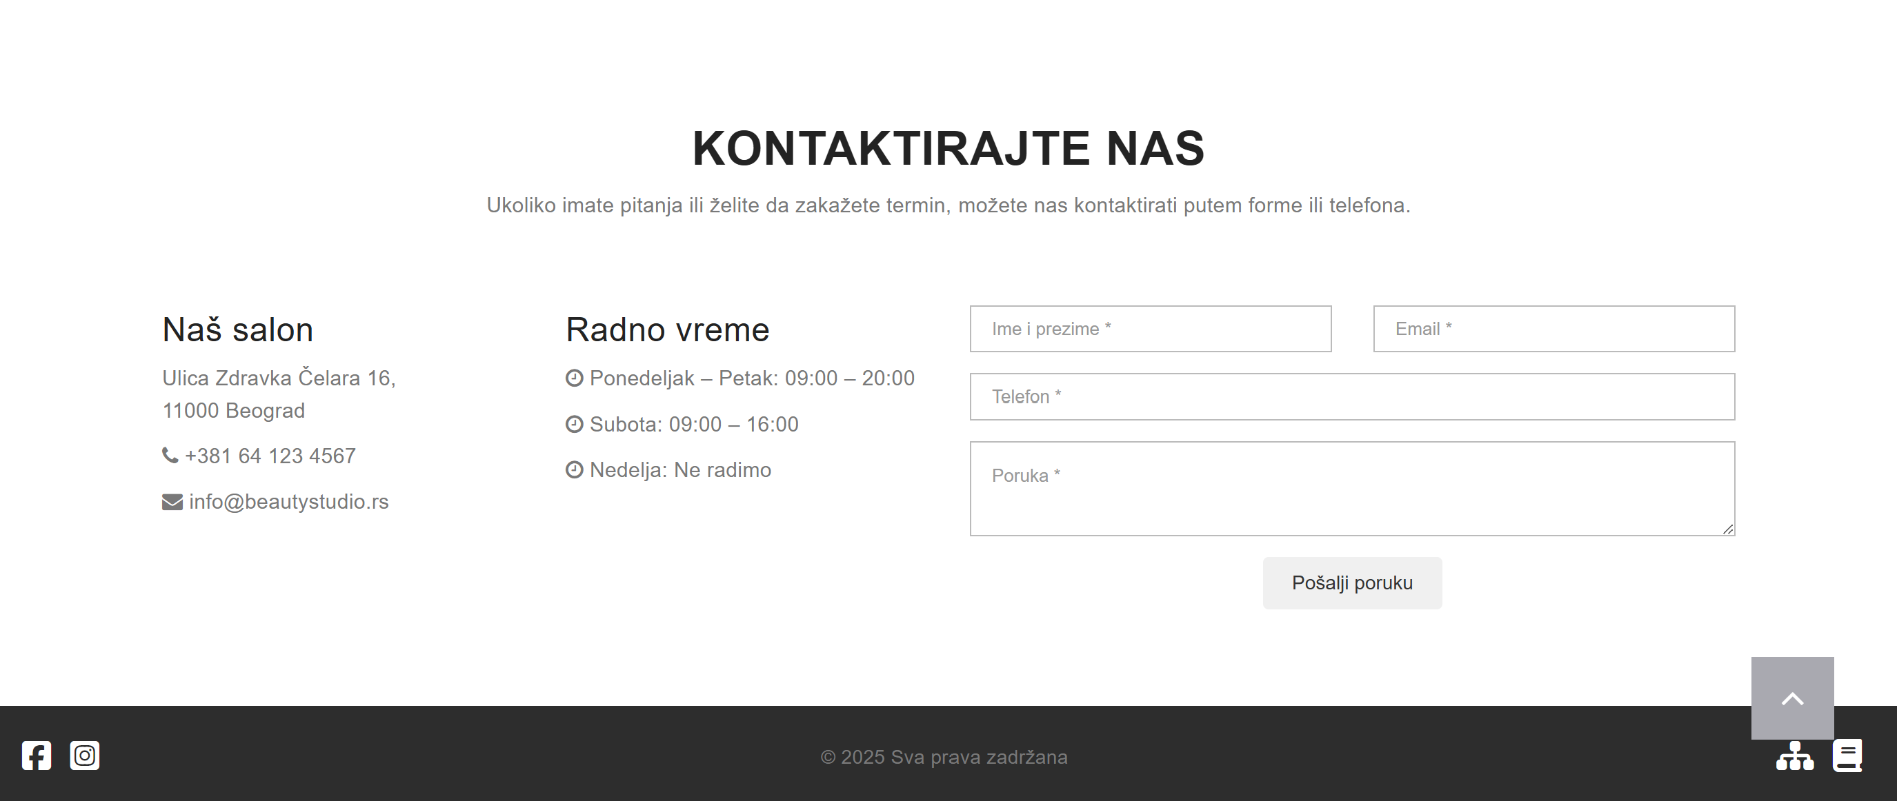
U kontaktu imamodeo gde primamo unose od korisnika, vrsimo validaciju putem JS, koristimo Regex, prikazujemo greske , sprecavamo slanje forme sve dok ne ispunjava uslov, po uspesnom slanju imamo poruku, I nakon toga polja su ponovo prazna za novi upis.

Ispis preko html I css.

3. Kodovi

3.1 HTML- index.html
<!DOCTYPE html>
<html lang="en">

<head>
<meta charset="utf-8">
<meta http-equiv="X-UA-Compatible" content="IE=edge">
<meta name="viewport" content="width=device-width, initial-scale=1">
<meta name="author" content="Zorana Kondic">
<meta name="description"
content="Soft Glow Studio nastao je iz želje da pružimo mesto gde lepota i nega dolaze zajedno — posetite nas i zablistajte sa stilom.">
<meta name="copyright" content="Soft Glow Studio. Sva prava zadrzana." />
<meta name="keywords" content="Soft, Glow, Studio, frizura, sminka, lepota, " />
<meta name="author" content="">
<title>Soft Glow Studio</title>
<link rel="icon" href="favicon.ico">
<link rel="stylesheet" href="https://cdnjs.cloudflare.com/ajax/libs/font-awesome/6.5.1/css/all.min.css">
<title>Lattes - Onepage Multipurpose Bootstrap HTML</title>
<link href="css/bootstrap.min.css" rel="stylesheet">
<link rel="stylesheet" href="https://maxcdn.bootstrapcdn.com/font-awesome/4.4.0/css/font-awesome.min.css">
<link href="css/owl.carousel.css" rel="stylesheet">
<link href="css/owl.theme.default.min.css" rel="stylesheet">
<link href="css/style.css" rel="stylesheet">
<link rel="shortcut icon" href="images/icon.ico" type="image/x-icon" />
<script src="js/ie-emulation-modes-warning.js"></script>
</head>

<body id="page-top">
<!--Navigacija-->
<nav class="navbar navbar-default navbar-fixed-top">
<div class="container">
<div class="navbar-header page-scroll">
<button type="button" class="navbar-toggle" data-toggle="collapse"
data-target="#bs-example-navbar-collapse-1">
<span class="sr-only">Toggle navigation</span>
<span class="icon-bar"></span>
<span class="icon-bar"></span>
<span class="icon-bar"></span>
</button>
<a class="navbar-brand page-scroll" href="#page-top"><img src="images/logo.png"
alt="Lattes theme logo"></a>
</div>
<div class="collapse navbar-collapse" id="bs-example-navbar-collapse-1">
<ul class="nav navbar-nav navbar-right">
<li class="hidden">
<a href="#page-top"></a>
</li>
<li>
<a class="page-scroll" href="#about">O nama</a>
</li>
<li>
<a class="page-scroll" href="#services">Usluge</a>
</li>
<li>
<a class="page-scroll" href="#portfolio">Galerija</a>
</li>
<li>
<a class="page-scroll" href="#team">Tim</a>
</li>
<li>
<a class="page-scroll" href="#contact">Kontakt</a>
</li>
<li><a class="page-scroll" href="autor.html">O autoru</a>
</li>
<li><a class="page-scroll" href="autor.html">Kod sajta</a>
</li>
</ul>
</div>
</div>
</nav>
<header>
<div class="container">
<div class="slider-container">
<div class="intro-text">
<div class="intro-heading">Soft Glow Studio</div>
</div>
</div>
</div>
</header>
<section id="about" class="light-bg">
<div class="container">

<!-- O NAMA -->
<div class="row">
<div class="col-lg-12 text-center">
<div class="section-title">
<h2>O nama</h2>
<p>
Naš beauty salon nastao je iz želje da spojimo negu, estetiku i prijatno okruženje u kojem
se svaka klijentkinja oseća posebno. U našem studiju nudimo tretmane lica i tela, manikir i
pedikir, šminkanje i relaks tretmane, uz korišćenje kvalitetnih proizvoda i savremenih
tehnika.
</br>
Posebnu pažnju posvećujemo detaljima, higijeni i individualnom pristupu, jer verujemo da se
lepota najbolje ističe kada je usklađena sa ličnim stilom i potrebama klijenata.
</br>
Naš cilj je da pružimo iskustvo nakon kojeg se osećate negovano, zadovoljno i samouvereno —
bilo da dolazite na brzo ulepšavanje ili za trenutke opuštanja.
</p>
</div>
</div>
</div>
<div class="services" id="services"></div>
<div id="usluga-opis"></div>

</div>
</section>

<!-- Usluge opis -->
</section>
<section id="services-info">
<div class="container">
<div class="row">

<div class="col-md-6">
<h2>Usluge</h2>
<p>
U našem salonu pružamo širok spektar usluga posvećenih lepoti, nezi i opuštanju.
Naš tim stručnjaka koristi kvalitetne proizvode i savremene tehnike kako bi se svaka
klijentkinja osećala zadovoljno, negovano i samouvereno.
</p>
</div>

<div class="col-md-6">
<ul class="salon-services">
<li>Šminkanje</li>
<li>Frizure i stilizovanje</li>
<li>Manikir i gel tehnike</li>
<li>Tretmani lica i maske</li>
<li>Pedikir</li>
<li>Depilacija</li>
<li>Relaks tretmani</li>
</ul>
</div>

</div>
</div>
</section>

<!--Nabrajanje -->
<section class="overlay-dark bg-img1 dark-bg short-section">
<div class="container text-center">
<div class="row">
<div class="col-md-3 mb-sm-30">
<div class="counter-item">
<h2 data-count="59">59</h2>
<h6>Nagrada</h6>
</div>
</div>
<div class="col-md-3 mb-sm-30">
<div class="counter-item">
<h2 data-count="1054">1054</h2>
<h6>Klijenata</h6>
</div>
</div>
<div class="col-md-3 mb-sm-30">
<div class="counter-item">
<h2 data-count="34">34</h2>
<h6>Zaposlenih</h6>
</div>
</div>
<div class="col-md-3 mb-sm-30">
<div class="counter-item">
<h2 data-count="154">154</h2>
<h6>Velikih projekata</h6>
</div>
</div>
</div>
</div>
</section>

<!--Galerija-->
<section id="portfolio" class="light-bg">
<div class="container">
<h2 class="text-center">GALERIJA</h2>
<div class="row" id="portfolio-container"></div>
</div>
</section>

<!--Partneri-->
<section id="partneri">
<div class="container">
<div class="row">
<div class="col-lg-12 text-center">
<h2>NAŠI PARTNERI</h2>
<p>Sarađujemo sa odabranim brendovima i stručnjacima iz industrije lepote, kako bismo obezbedili
kvalitetne proizvode i vrhunske usluge za naše klijente.</p>
</div>
</div>

<div class="row justify-content-center" id="partner-wrapper">
</div>
</div>
</section>

<!--Tim-->
<section id="team" class="light-bg">
<div class="container">
<div class="row">
<div class="col-lg-12 text-center">
<div class="section-title">
<h2>NAŠ TIM</h2>
<p>Stručni i profesionalni tim posvećen vašoj lepoti i zadovoljstvu.</p>
</div>
</div>
</div>
<div class="row" id="team-container"></div>
</div>
</section>

<!--Kontakt-->
<section id="contact">
<div class="container">
<div class="row">
<div class="col-lg-12 text-center">
<div class="section-title">
<h2>Kontaktirajte nas</h2>
<p>Ukoliko imate pitanja ili želite da zakažete termin, možete nas kontaktirati putem forme ili
telefona.</p>
</div>
</div>
</div>

<div class="row">
<div class="col-md-3">
<h3>Naš salon</h3>
<p>Ulica Zdravka Čelara 16,<br>11000 Beograd</p>
<p><i class="fa fa-phone"></i> +381 64 123 4567</p>
<p><i class="fa fa-envelope"></i> info@beautystudio.rs</p>
</div>

<div class="col-md-3">
<h3>Radno vreme</h3>
<p><i class="fa fa-clock-o"></i> <span>Ponedeljak – Petak:</span> 09:00 – 20:00</p>
<p><i class="fa fa-clock-o"></i> <span>Subota:</span> 09:00 – 16:00</p>
<p><i class="fa fa-clock-o"></i> <span>Nedelja:</span> Ne radimo</p>
</div>

<div class="col-md-6">
<form id="contactForm">
<div class="row">
<div class="col-md-6">
<div class="form-group">
<input type="text" class="form-control" placeholder="Ime i prezime *" id="name">
<p class="help-block text-danger" id="nameError"></p>
</div>
</div>

<div class="col-md-6">
<div class="form-group">
<input type="email" class="form-control" placeholder="Email *" id="email">
<p class="help-block text-danger" id="emailError"></p>
</div>
</div>
</div>
<div class="row">
<div class="col-md-12">
<div class="form-group">
<input type="text" class="form-control" placeholder="Telefon *" id="phone"
maxlength="10">
<p class="help-block text-danger" id="phoneError"></p>
</div>
</div>
</div>
<div class="row">
<div class="col-md-12">
<div class="form-group">
<textarea class="form-control" placeholder="Poruka *" id="message"></textarea>
<p class="help-block text-danger" id="messageError"></p>
</div>
</div>
</div>
<div class="row">
<div class="col-lg-12 text-center">
<div id="formOutput"></div>
<button type="submit" class="btn">Pošalji poruku</button>
</div>
</div>

</form>
</div>
</div>
</div>
</section>
<p id="back-top">
<a href="#top"><i class="fa fa-angle-up"></i></a>
</p>

<!--Footer-->
<footer>
<div class="footer-wrapper">

<div class="footer-left">
<a href="https://www.facebook.com/" target="_blank"><i class="fab fa-facebook-square"></i></a>
<a href="https://www.instagram.com/" target="_blank"><i class="fab fa-instagram-square"></i></a>
</div>

<div class="footer-center">
<p>© 2025 Sva prava zadržana</p>
</div>

<div class="footer-right">
<a href="sitemap.xml" target="_blank"><i class="fas fa-sitemap"></i></a>
<a href="Dokumentacija.pdf" target="_blank"><i class="fa-solid fa-book"></i></a>
</div>

</div>
</footer>

<!--JS fajlovi-->
<script src="https://ajax.googleapis.com/ajax/libs/jquery/1.11.3/jquery.min.js"></script>
<script src="http://cdnjs.cloudflare.com/ajax/libs/jquery-easing/1.3/jquery.easing.min.js"></script>
<script src="js/bootstrap.min.js"></script>
<script src="js/owl.carousel.min.js"></script>
<script src="js/cbpAnimatedHeader.js"></script>
<script src="js/theme-scripts.js"></script>
<script src="js/ie10-viewport-bug-workaround.js"></script>

<!-- Moji JS fajlovi -->
<script src="js/main.js"></script>
<script src="js/forma.js"></script>
</body>

</html>

3.2 HTML – autor.html
<!DOCTYPE html>
<html lang="en">

<head>
<meta charset="utf-8">
<meta http-equiv="X-UA-Compatible" content="IE=edge">
<meta name="viewport" content="width=device-width, initial-scale=1">
<meta name="author" content="Zorana Kondic">
<meta name="description"
content="Soft Glow Studio nastao je iz želje da pružimo mesto gde lepota i nega dolaze zajedno — posetite nas i zablistajte sa stilom.">
<meta name="copyright" content="Soft Glow Studio. Sva prava zadrzana." />
<meta name="keywords" content="Soft, Glow, Studio, frizura, sminka, lepota, " />
<meta name="author" content="">
<title>Soft Glow Studio</title>
<link rel="icon" href="favicon.ico">
<link rel="stylesheet" href="https://cdnjs.cloudflare.com/ajax/libs/font-awesome/6.5.1/css/all.min.css">
<title>Lattes - Onepage Multipurpose Bootstrap HTML</title>
<link href="css/bootstrap.min.css" rel="stylesheet">
<link rel="stylesheet" href="https://maxcdn.bootstrapcdn.com/font-awesome/4.4.0/css/font-awesome.min.css">
<link href="css/owl.carousel.css" rel="stylesheet">
<link href="css/owl.theme.default.min.css" rel="stylesheet">
<link href="css/style.css" rel="stylesheet">
<link rel="shortcut icon" href="images/icon.ico" type="image/x-icon" />
<script src="js/ie-emulation-modes-warning.js"></script>
</head>

<body>
<nav class="navbar navbar-default navbar-fixed-top autor-nav">
<div class="container">
<div class="navbar-header page-scroll">
<button type="button" class="navbar-toggle" data-toggle="collapse"
data-target="#bs-example-navbar-collapse-1">
<span class="sr-only">Toggle navigation</span>
<span class="icon-bar"></span>
<span class="icon-bar"></span>
<span class="icon-bar"></span>
</button>

<a class="navbar-brand page-scroll" href="index.html#page-top">
<a class="navbar-brand page-scroll" href="index.html"><img src="images/logo.png"
alt="Lattes theme logo"></a>
</a>
</div>

<div class="collapse navbar-collapse" id="bs-example-navbar-collapse-1">
<ul class="nav navbar-nav navbar-right">

<li><a class="page-scroll" href="index.html#about">O nama</a></li>
<li><a class="page-scroll" href="index.html#services">Usluge</a></li>
<li><a class="page-scroll" href="index.html#portfolio">Galerija</a></li>
<li><a class="page-scroll" href="index.html#team">Tim</a></li>
<li><a class="page-scroll" href="index.html#contact">Kontakt</a></li>
<li><a class="page-scroll" href="autor.html">O autoru</a></li>
<li><a class="page-scroll" href="autor.html">Kod sajta</a></li>

</ul>
</div>

</div>
</nav>
<section id="autor">
<div class="autor-container">

<div class="autor-slika-div">
<img src="images/demo/autor.jpeg" alt="Autor" class="autor-slika">
</div>

<div class="autor-tekst">
<p><strong>Ime i prezime:</strong> Zorana Kondić</p>
<p><strong>Broj indeksa:</strong> 104/22</p>
<p><strong>Email:</strong> zorana.kondic.104.22@gmail.com</p>
</div>

</div>
</section>

<footer>
<div class="footer-wrapper">

<div class="footer-left">
<a href="https://www.facebook.com/" target="_blank"><i class="fab fa-facebook-square"></i></a>
<a href="https://www.instagram.com/" target="_blank"><i class="fab fa-instagram-square"></i></a>
</div>

<div class="footer-center">
<p>© 2025 Sva prava zadržana</p>
</div>

<div class="footer-right">
<a href="sitemap.xml" target="_blank"><i class="fas fa-sitemap"></i></a>
<a href="Dokumentacija.pdf" target="_blank"><i class="fa-solid fa-book"></i></a>
</div>

</div>
</footer>

<script src="https://ajax.googleapis.com/ajax/libs/jquery/1.11.3/jquery.min.js"></script>
<script src="http://cdnjs.cloudflare.com/ajax/libs/jquery-easing/1.3/jquery.easing.min.js"></script>
<script src="js/bootstrap.min.js"></script>
<script src="js/owl.carousel.min.js"></script>
<script src="js/cbpAnimatedHeader.js"></script>
<script src="js/theme-scripts.js"></script>
<script src="js/ie10-viewport-bug-workaround.js"></script>

<!-- Moji JS fajlovi -->
<script src="https://code.jquery.com/jquery-3.6.0.min.js"></script>
<script src="js/main.js"></script>
<script src="js/forma.js"></script>
</body>

</html>

3.3 CSS

/*------------------------------------------------------------------
[Master Stylesheet]

Project: Lattes - One page multi purpose page
Version: 1.0
Last change: 17/08/2015 [...]
Designed by: MOOZ Themes / www.MOOZthemes.com
Primary use: One page

[Table of contents]

1. General
2. Header
3. Navigation
4. Sections
5. Footer
6. Components

[Color codes]

Buttons, etc: #726FB9 (blue)
hover color: #fed136 (yellow)
-------------------------------------------------------------------*/

/*--------------------
Import Google Fonts
--------------------*/

/* main font for menu. */
@import url(http://fonts.googleapis.com/css?family=Roboto:100,300,400,500,700,900);
/* font for headings, text, tags */
@import url(http://fonts.googleapis.com/css?family=Open+Sans:300,400,500,600,700,800);
@import url(http://fonts.googleapis.com/css?family=Playfair+Display:400italic&subset=latin,latin-ext);

/*--------------------
1. General
--------------------*/

body {
margin: 0px;
font-family: "Open Sans", Sans-serif;
}

h1,
h2,
h3,
h4,
h5,
h6 {
font-weight: 300;
letter-spacing: 0.4px;
font-family: "Open Sans", Sans-serif;
color: #232323;
}

p {
font-family: 'Roboto', sans-serif;
font-size: 15px;
font-weight: 300;
line-height: 23px;
letter-spacing: 0.2px;
color: #797979;
}

a:hover,
a:focus,
a:active,
a.active {
color: #c7a17a;
}

a,
a:hover,
a:focus,
a:active,
a.active {
outline: 0;
}

::selection {
text-shadow: none;
background: #c7a17a;
}

@media (min-width: 768px) {
section {
padding: 150px 0;
}
}

section {
padding: 70px 0;
}

/*--------------------
2. Navigation
--------------------*/

.navbar-default {
background-color: #222;
border-color: transparent
}

.navbar-default .navbar-brand {
color: #fff;
font-family: "Montserrat", sans-serif;
padding: 0px;
}

.navbar-default .navbar-brand:hover,
.navbar-default .navbar-brand:focus,
.navbar-default .navbar-brand:active,
.navbar-default .navbar-brand.active {
color: #fec503
}

.navbar-default .navbar-collapse {
border-color: rgba(255, 255, 255, .02)
}

.navbar-default .navbar-toggle {
background-color: #c7a17a;
border-color: #c7a17a
}

.navbar-default .navbar-toggle .icon-bar {
background-color: #fff
}

.navbar-default .navbar-toggle:hover,
.navbar-default .navbar-toggle:focus {
background-color: #c7a17a
}

.navbar-default .nav li a {
font-family: "Roboto", sans-serif;
text-transform: uppercase;
font-weight: 400;
letter-spacing: 1px;
color: #fff
}

.navbar-default .nav li a:hover,
.navbar-default .nav li a:focus {
color: #c7a17a;
outline: 0
}

.navbar-default .navbar-nav>.active>a {
border-radius: 0;
color: #fff;
background-color: #fed136
}

.navbar-default .navbar-nav>.active>a:hover,
.navbar-default .navbar-nav>.active>a:focus {
color: #fff;
background-color: #fec503
}

@media (min-width:768px) {
.navbar-default {
background-color: transparent;
padding: 25px 0;
-webkit-transition: padding .3s;
-moz-transition: padding .3s;
transition: padding .3s;
border: 0
}

.navbar-default .navbar-brand {
font-size: 2em;
-webkit-transition: all .3s;
-moz-transition: all .3s;
transition: all .3s
}

.navbar-default .navbar-nav>.active>a {
border-radius: 3px
}

.navbar-default.navbar-shrink {
background-color: #222;
padding: 10px 0
}

.navbar-default.navbar-shrink .navbar-brand {
font-size: 1.5em
}
}

/*--------------------
3. Header
--------------------*/

header {
background-size: cover;
background-position: center;
background-repeat: no-repeat;
transition: background-image 0.7s ease-in-out;
min-height: 100vh;
}

header::after {
content: "";
position: absolute;
top: 0;
left: 0;
right: 0;
bottom: 0;
backdrop-filter: blur(2px);
background: rgba(0, 0, 0, 0.25);
}

.intro-heading,
.intro-lead-in,
.intro-text {
position: relative;
z-index: 2;
}

header {
display: flex;
justify-content: center;
align-items: center;
text-align: center;
}

.intro-heading {
font-size: 60px;
font-weight: 800;
text-transform: uppercase;
color: white;
letter-spacing: 2px;
margin-bottom: 20px;
position: relative;
z-index: 2;
font-family: serif;
}

/*4. Sections*/

.section-title h2 {
font-size: 34px;
text-transform: uppercase;
}

.section-title p {
font-size: 15px;
font-weight: 300;
line-height: 25px;
margin: 20px 100px 60px 100px;
}

/*4.1. About*/

.section-title {
margin-bottom: 45px;
}

.section-title h2 {
font-weight: 600;
}

.section-title p {
max-width: 750px;
margin: 0 auto;
}

.services {
display: flex;
justify-content: space-between;
text-align: center;
margin: 50px 0;
gap: 20px;
flex-wrap: wrap;
}

.service {
width: 23%;
cursor: pointer;
}

.service i {
font-size: 40px;
color: #c7a17a;
margin-bottom: 15px;
}

#usluga-opis {
text-align: center;
margin-top: 20px;
font-size: 17px;
font-weight: 500;
}

#services-info h2 {
font-size: 26px;
font-weight: 600;
margin-bottom: 15px;
}

.salon-services {
list-style: none;
font-size: 16px;
padding: 0;
}

.salon-services li {
margin-bottom: 10px;
position: relative;
padding-left: 20px;
}

.salon-services li::before {
content: "✓";
position: absolute;
left: 0;
top: 0;
color: #c7a17a;
}

/*4.3. Galerija*/

.portfolio-item {
position: relative;
overflow: hidden;
cursor: pointer;
}

.portfolio-item img {
width: 100%;
display: block;
filter: brightness(60%);
transition: transform 0.4s ease, filter 0.4s ease;
}

.portfolio-item:hover img {
filter: brightness(100%);
transform: scale(1.08);
}

.portfolio-item img {
width: 100%;
height: 260px;
object-fit: cover;
}

.portfolio-item:hover {
transform: scale(1.05);
transition: .4s ease;
}

.mb-4 {
margin-bottom: 25px;
}

/*4.4. Deo nabrajanje*/

.dark-bg {
background: #323232;
color: #fff;
}

.bg-img1 {
background-image: url(../images/demo/pozadina.jpg);
background-size: cover !important;
background-position: center center;
background-repeat: no-repeat;
background-attachment: fixed;
}

.light-bg {
background-color: #f8f8f8;
}

.overlay-dark:before,
.overlay-light:before {
background-color: rgba(32, 32, 32, 0.8);
left: 0;
top: 0;
position: absolute;
width: 100%;
height: 100%;
content: "";
z-index: -1;
}

.overlay-dark,
.overlay-light {
position: relative;
z-index: 1;
}

.short-section {
padding-top: 110px;
padding-bottom: 110px;
}

.counter-item h2 {
color: #fff;
font-size: 60px;
margin: 0;
}

.counter-item h6 {
color: #fff;
font-size: 19px;
margin: 0;
}

/*4.5. Partneri */

#partneri {
padding: 60px 0;
}

#partner-wrapper {
display: flex;
justify-content: center;
flex-wrap: wrap;
gap: 50px;
margin-top: 30px;
}

.partner-logo {
width: 80px;
opacity: 0.9;
transition: transform .3s ease, opacity .3s ease;
}

.partner-logo:hover {
transform: scale(1.1);
opacity: 1;
}

/*4.6. Tim*/

.team-item {
transition: transform 0.3s ease, box-shadow 0.3s ease;
border-radius: 10px;
text-align: center;
}

.team-item:hover {
transform: scale(1.05);
box-shadow: 0px 10px 25px rgba(0, 0, 0, 0.15);
}

/*4.7. Contacts*/

section#contact form {
margin-top: 15px;
}

section#contact.form-group {
margin-bottom: 25px;
}

section#contact .form-group input,
section#contact .form-group textarea {
padding: 15px;
border: 1px solid #BBBBBB;
border-radius: 0;
-webkit-box-shadow: inset 0 1px 1px rgba(0, 0, 0, .075);
box-shadow: inset 0 0px 0px rgba(0, 0, 0, .075);
font-size: 13px;
}

.contact h3 {
margin-bottom: 30px;
}

.contact p {
font-size: 13px;
}

.contact .day {
display: inline-block;
width: 80px;
}

.contact i {
margin-right: 5px;
}

/*5. Footer*/

footer {
background: #2D2D2D;
color: white;
padding: 20px 0;
}

.footer-wrapper {
display: flex;
justify-content: space-between;
align-items: center;
}

.footer-left a,
.footer-right a {
color: white;
margin-right: 10px;
font-size: 24px;
transition: .3s;
}

.footer-center p {
margin: 0;
font-size: 14px;
}

footer a:hover {
color: #c7a17a;
}

.footer-left {
margin-left: 20px;
}

.footer-right {
margin-right: 20px;
}

.navbar-brand img {
width: 180px;
height: auto;
margin-left: 10px;
margin-top: -5px;
margin-top: -35px;
}

/*--------------------
6. Modal
--------------------*/

.modal-content {
border-radius: 0;
}

.modal-header .close {
font-size: 30px;
}

.modal-title {
text-transform: uppercase;
font-size: 23px;
}

.modal-body {
padding: 0;
}

.modal-body p {
margin: 30px 20px;
color: #2D2D2D;
}

.modal-works {
font-size: 11px;
letter-spacing: 1px;
text-transform: uppercase;
font-weight: 500;
color: #fff;
margin: 25px 20px;
}

.modal-works span {
background-color: #FED136;
margin-right: 15px;
padding: 5px 10px;
}

/*--------------------
7. Components
--------------------*/

.btn-xl:hover,
.btn-xl:focus,
.btn-xl:active,
.btn-xl.active,
.open .dropdown-toggle.btn-xl {
color: #fff;
background-color: #fec503;
border-color: #f6bf01;
}

.btn:hover,
.btn:focus,
.btn:active,
.btn.active,
.open .dropdown-toggle.btn {
color: #fff;
background-color: #c7a17a;
border-color: #c7a17a;
}

.btn {
display: inline-block;
padding: 8px 20px;
margin-bottom: 0;
font-size: 14px;
font-weight: 400;
line-height: 1.42857143;
text-align: center;
white-space: nowrap;
vertical-align: middle;
-ms-touch-action: manipulation;
touch-action: manipulation;
cursor: pointer;
-webkit-user-select: none;
-moz-user-select: none;
-ms-user-select: none;
user-select: none;
background-image: none;
border: 1px solid transparent;
border-radius: 4px;
}

.btn-xl {
color: #fff;
background-color: #726FB9;
border-color: #726FB9;
font-family: "Robot", sans-serif;
text-transform: uppercase;
font-weight: 700;
border-radius: 3px;
font-size: 18px;
padding: 20px 40px;
}

/* Back to top button
---------------------------------- */
#back-top {
position: fixed;
z-index: 1000;
bottom: 40px;
right: 50px;
}

#back-top a {
width: 60px;
height: 60px;
display: block;
text-align: center;
font: 11px/100% Arial, Helvetica, sans-serif;
text-transform: uppercase;
text-decoration: none;
color: #FFFFFF;
background: #A9A9B1;
-webkit-transition: 1s;
-moz-transition: 1s;
transition: 1s;
}

#back-top a:hover {
background: #c7a17a;
}

#back-top i {
margin-top: 15px;
font-size: 28px;
}

@media only screen and (min-width : 320px) and (max-width : 480px) {
#back-top {
position: fixed;
bottom: 10px;
right: 30px;
}

#back-top a {
width: 40px;
height: 40px;
}

#back-top i {
margin-top: 7px;
font-size: 20px;
}
}

/* Autor */
#autor {
background: #A9A9B1;
padding: 120px 0;
}

.autor-container {
display: flex;
align-items: center;
justify-content: center;
gap: 40px;
}

.autor-slika {
width: 260px;
border-radius: 12px;
}

.autor-tekst p {
font-size: 18px;
margin: 6px 0;
}

.autor-tekst strong {
font-weight: 600;
}

@media (max-width: 768px) {
.autor-container {
flex-direction: column;
text-align: center;
}
}

.autor-nav {
background: #333 !important;
}

3.4 Main.js

// NIZ SLIKA KOJE SE SMENJUJU
const slike = [
"images/demo/slika1.jpg",
"images/demo/slika2.jpg",
"images/demo/slika3.jpg"
];

let index = 0;

const header = document.querySelector("header");

header.style.backgroundImage = `url(${slike[index]})`;

setInterval(() => {
index = (index + 1) % slike.length;
header.style.backgroundImage = `url(${slike[index]})`;
}, 4000);

const textElement = document.querySelector(".intro-heading");
const text = textElement.textContent;
textElement.textContent = "";

let indexText = 0;

function type() {
if (indexText < text.length) {
textElement.textContent += text.charAt(indexText);
indexText++;
setTimeout(type, 100);
}
}

type();

if (indexText === text.length) {
setTimeout(() => {
textElement.textContent = "";
indexText = 0;
type();
}, 2000);
}

// DINAMICKI ISPIS MENIJA

const usluge = [
{ naziv: "Nega lica", ikona: "fa-solid fa-spa" },
{ naziv: "Manikir & Pedikir", ikona: "fa-solid fa-hand-sparkles" },
{ naziv: "Šminkanje", ikona: "fa-solid fa-paintbrush" },
{ naziv: "Relaks tretmani", ikona: "fa-solid fa-leaf" }
];

const servicesDiv = document.getElementById("services");

usluge.forEach(usluga => {
const div = document.createElement("div");
div.className = "service";

div.innerHTML = `
<i class="${usluga.ikona}"></i>
<h3>${usluga.naziv}</h3>
`;

div.addEventListener("click", function () {
document.getElementById("usluga-opis").innerHTML = `<strong>${usluga.naziv}</strong>: ${usluga.opis}`;
});

servicesDiv.appendChild(div);
});

// DINAMICKO ANIMIRANJE BROJEVA (COUNTER) PRILIKOM SKROLOVANJA DO SEKCIJE
const counters = document.querySelectorAll(".counter-item h2");

function animateCounter(counter) {
const target = +counter.getAttribute("data-count");
let value = 0;
const speed = target / 100;

const update = () => {
value += Math.ceil(speed);
counter.textContent = value;
if (value < target) {
requestAnimationFrame(update);
} else {
counter.textContent = target;
}
};

update();
}

const observer = new IntersectionObserver(entries => {
entries.forEach(entry => {
if (entry.isIntersecting && !entry.target.classList.contains("done")) {
animateCounter(entry.target.querySelector("h2"));
entry.target.classList.add("done");
}
});
}, { threshold: 0.5 });

counters.forEach(c => observer.observe(c.parentElement));

//GALERIJA ISPIS
const galerija = [
"images/demo/galerija1.jpg",
"images/demo/galerija2.jpg",
"images/demo/galerija3.jpg",
"images/demo/galerija4.jpg",
"images/demo/galerija5.jpg",
"images/demo/galerija6.jpg"
];

const portfolioDiv = document.getElementById("portfolio-container");

galerija.forEach(slika => {
const col = document.createElement("div");
col.className = "col-md-4 mb-4";

const div = document.createElement("div");
div.className = "portfolio-item";

const img = document.createElement("img");
img.src = slika;

div.appendChild(img);
col.appendChild(div);
portfolioDiv.appendChild(col);
});

//PARTNERI ISPIS
const partneri = [
"images/demo/partners-1.png",
"images/demo/partners-2.png",
"images/demo/partners-3.png",
"images/demo/partners-4.png",
"images/demo/partners-5.png",
"images/demo/partners-6.png",
"images/demo/partners-7.png"
];

const partnerDiv = document.getElementById("partner-wrapper");

partneri.forEach(src => {
const img = document.createElement("img");
img.src = src;
img.className = "partner-logo";
partnerDiv.appendChild(img);
});

//DINAMICKO ISPISIVANJE TIMA
const tim = [
{
ime: "Mila Petrović",
grad: "Beograd, Srbija",
uloga: "Make-up Artist",
opis: "Profesionalno šminkanje za sve prilike i foto šminka.",
slika: "images/demo/radnik1.jpg"
},
{
ime: "Marko Ilić",
grad: "Beograd, Srbija",
uloga: "Frizer",
opis: "Specijalizovan za šišanje, stilizovanje i fen frizure.",
slika: "images/demo/radnik2.jpg"
},
{
ime: "Tea Jovanović",
grad: "Beograd, Srbija",
uloga: "Skin Care & Tretmani lica",
opis: "Profesionalne maske, hidratacija i nega kože.",
slika: "images/demo/radnik3.jpg"
},
{
ime: "Katarina Marković",
grad: "Beograd, Srbija",
uloga: "Nails & Manikir",
opis: "Uređivanje noktiju, gel tehnike i kreativni nail dizajn.",
slika: "images/demo/radnik4.jpg"
}
];

const teamContainer = document.getElementById("team-container");

tim.forEach(osoba => {
const div = document.createElement("div");
div.className = "col-md-3";

div.innerHTML = `
<div class="team-item">
<div class="team-image">
<img src="${osoba.slika}" class="img-responsive" alt="${osoba.ime}">
</div>
<div class="team-text">
<h3>${osoba.ime}</h3>
<div class="team-location">${osoba.grad}</div>
<div class="team-position">– ${osoba.uloga} –</div>
<p>${osoba.opis}</p>
</div>
</div>
`;

teamContainer.appendChild(div);
});

//AUTOR
const btn = document.getElementById("btnVise");
const infoBox = document.getElementById("autor-info");

let otvoreno = false;

btn.addEventListener("click", function () {
if (!otvoreno) {
// dinamicko kreiranje ispisa
infoBox.innerHTML = `
<p>Email: zorana.kondic.104.22@gmail.com</p>
<p>Broj indeksa: 104/22</p>
`;
btn.textContent = "Manje";
otvoreno = true;
} else {
// ciscenje (hide)
infoBox.innerHTML = "";
btn.textContent = "Više";
otvoreno = false;
}
});

3.5 Forma.js

// OBRADA KONTAKT FORME SA VALIDACIJOM, REGEX PROVEROM, ISPISIVANJEM GRESAKA I PORUKE O USPESNOM SLANJU
const form = document.getElementById("contactForm");

const nameInput = document.getElementById("name");
const emailInput = document.getElementById("email");
const phoneInput = document.getElementById("phone");
const messageInput = document.getElementById("message");

const output = document.getElementById("formOutput");

// Regex
const nameRegex = /^[A-Za-zČĆŠĐŽčćšđž\s]{3,}$/;
const emailRegex = /^[^\s@]+@[^\s@]+\.[^\s@]+$/;
const phoneRegex = /^[0-9]{8,10}$/;

form.addEventListener("submit", function (e) {
e.preventDefault();

let errors = 0;

document.getElementById("nameError").textContent = "";
document.getElementById("emailError").textContent = "";
document.getElementById("phoneError").textContent = "";
document.getElementById("messageError").textContent = "";
output.textContent = "";

// VALIDACIJA IMENA
if (!nameRegex.test(nameInput.value.trim())) {
document.getElementById("nameError").textContent = "Ime mora imati bar 3 slova.";
errors++;
}

// VALIDACIJA EMAIL-a
if (!emailRegex.test(emailInput.value.trim())) {
document.getElementById("emailError").textContent = "Email nije validan.";
errors++;
}

// VALIDACIJA TELEFONA
if (!phoneRegex.test(phoneInput.value.trim())) {
document.getElementById("phoneError").textContent = "Telefon mora sadržati 8-10 cifara.";
errors++;
}

// VALIDACIJA PORUKE
if (messageInput.value.trim().length < 5) {
document.getElementById("messageError").textContent = "Poruka treba da ima bar 5 karaktera.";
errors++;
}

if (errors > 0) return;

output.style.color = "green";
output.style.fontWeight = "500";
output.textContent = "Hvala, vaša poruka je poslata!";

nameInput.value = "";
emailInput.value = "";
phoneInput.value = "";
messageInput.value = "";
});

