UCSB cs240b project Fall 1999

PTMPI

Threaded MPI execution on cluster of SMP machines

Zoran Dimitrijevic

Department of Computer Science
University of California at Santa Barbara

E-mail: zoran@cs.ucsb.edu

Introduction

- Cluster of SMP machines
  - Each cluster node is SMP machine
  - Communication between the nodes is through etherenet TCP/IP
- Current MPI implementation for shared memory machines:
  - TMPI – threaded MPI execution – each MPI node is a thread inside one process
    - Fast
    - Not scalable – regular OS process can be running on just one machine
  - MPICH – each MPI node is a process – communication between nodes involve
operating system activity
    - Slow
    - Scalable – each node can be running on different machine
Problem Statement

System consists of several processes
  - Scalability – each process can run on different machine
  - Communication between the processes is through sockets
  - Processes can be running anywhere on the Net

Each MPI node is a thread inside a process
  - Fast communication between the MPI nodes inside the same process –
through shared memory
  - During the startup the nodes are created –
each process can have different number of MPI nodes running inside it

Proposed Solution

- PTMPI Startup:
  - Configuration is in the resource file
  - Each process is started with single initialization argument – process ID
  - Each process gets its IP and listenning port number
  - There are p processes in the system
  - Complete sockets graph is created – p(p-1)/2 sockets
  - Each process creates local_MPI_count receiver queues
  - Each process creates a thread for each MPI node running on it
  - Each process creates two communication threads:
    - In communicator – read from the sockets and dispatches messages
    - Out communicator – read from its queues (one per each MPI thread) and
writes to sockets
- MPI Node Thread Startup:
  - Each MPI node is an instance of class MPI_Node
  - PTMPI main creates thread for each MPI node and passes the local ID to them
  - Each thread creates a new instance of class MPI_Node
  - SPMD in shared memory
    - All global data for MPI program must be copied for each thread
    - This is achieved since all MPI functions are friend function to class MPI_Node or defined in class MPI_Node, and all global MPI data are members of the class MPI_Node
    - All MPI global data can be placed in mpi_global_data.h which is included in
MPI_Node class
  - Each thread calls method mpi_main(int argc, char **argv)
    - Arguments are passed from PTMPI main function exept first one
(and the name is set to mpi_program)
- PTMPI System Layout:
Process 0: IP0

output
daemon
input
daemon
MPI
thread
node
MPI
thread
node
MPI
thread
node
output
daemon
input
daemon
MPI
thread
node
MPI
thread
node
MPI
thread
node
output
daemon
input
daemon
MPI
thread
node
MPI
thread
node
MPI
thread
node
MPI
thread
node
MPI
thread
node
Process 1: IP1
Process 2: IP2
Sockets

- Process node layout:

Local MPI node threads

Read sockets

MPI_Node::mpi_main

recv_queue[0]

In Communicator
p-1

MPI_Node::mpi_main

recv_queue[0]

MPI_Node::mpi_main

recv_queue[0]
.
.
.

Out Communicator
p-1
Write sockets
Out_comm._queue[0]
.
.
.

.
.
.

Out_comm._queue[0]
Out_comm._queue[0]
Out_comm._queue[0]
.
.
.

.
.
.

Each thread writes and reads to recv_queues in shared memory

- Receiver Queues

use_mutex
recv_cond
recv_buffer
recv_request
MPI_QueueElem
mutex
cond
MPI_QueueElem
mutex
cond
MPI_QueueElem
mutex
cond
MPI_QueueElem
mutex
cond

MPI_QueueElem
mutex
cond
MPI_QueueElem
mutex
cond

- Messages: MPI_QueueElem
  - Goal: minimize the number of memory copy in system
  - All queues in the system are using the same class for elements
  - Broadcast does not copy the message
  - Threads are using mutex and condition members of MPI_QueueElem
  - Last waiter free the message if the message is buffered and deletes the element

- MPI functions implemented:
  - MPI_Init
  - MPI_Comm_rank
  - MPI_Comm_size
  - MPI_Finalize
  - MPI_Send
  - MPI_Isend
  - MPI_Recv
  - MPI_Irecv
  - MPI_Wait
  - MPI_Broadcast

Initial Performance Evaluation

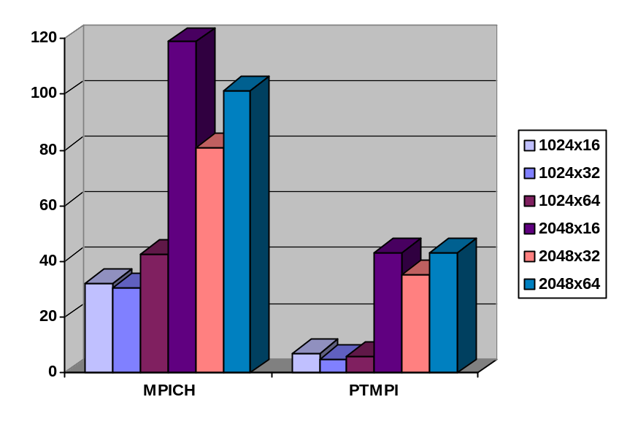
Figure 3: Block-based matrix multiplication execution time in seconds for 16 MPI nodes running on four two-processor SMP nodes.
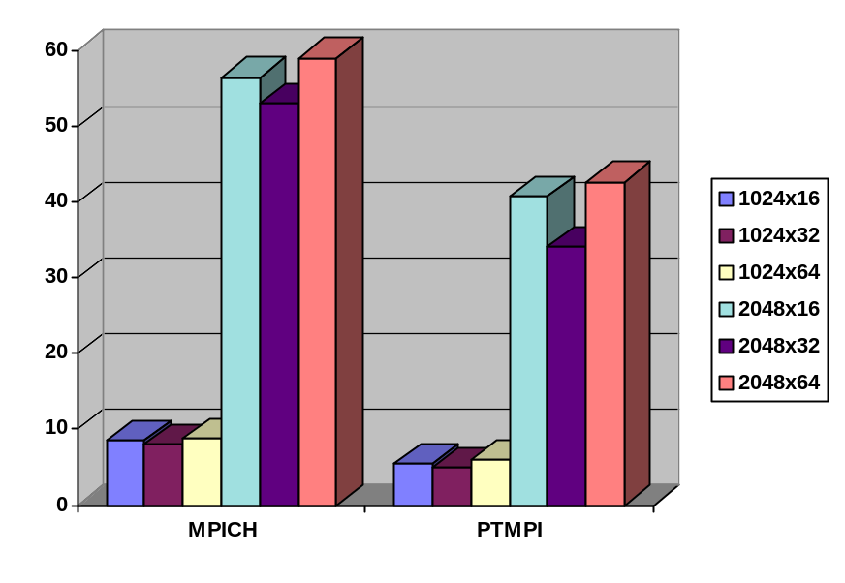Figure 4: Block-based matrix multiplication execution time in seconds for 8 MPI nodes running on four two-processor SMP nodes.

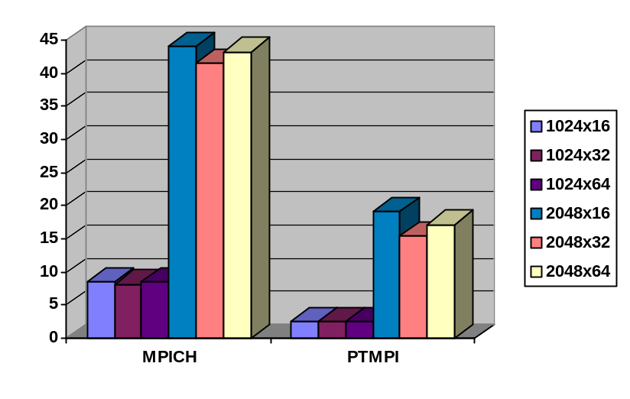
Figure 6: Block-based matrix multiplication execution time in seconds for 16 MPI nodes running on four four-processor SMP nodes.
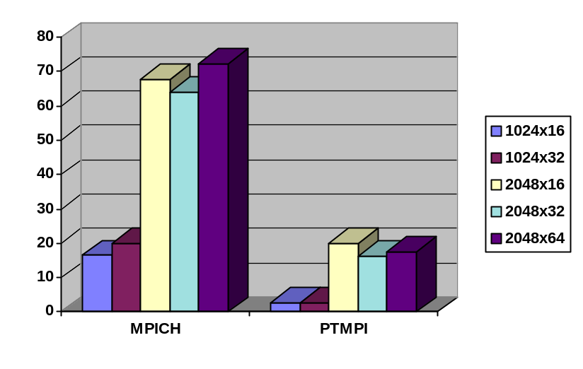
Figure 5: Block-based matrix multiplication execution time in seconds for 32 MPI nodes running on four four-processor SMP nodes.

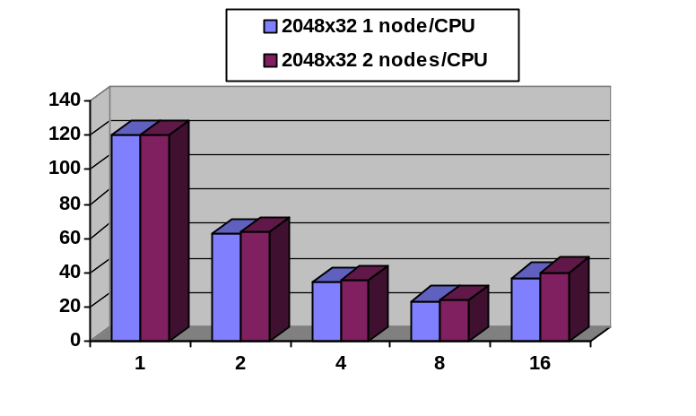
Figure 7: PTMPI block-based matrix multiplication execution time in seconds as function of number of two-processor SMP nodes.

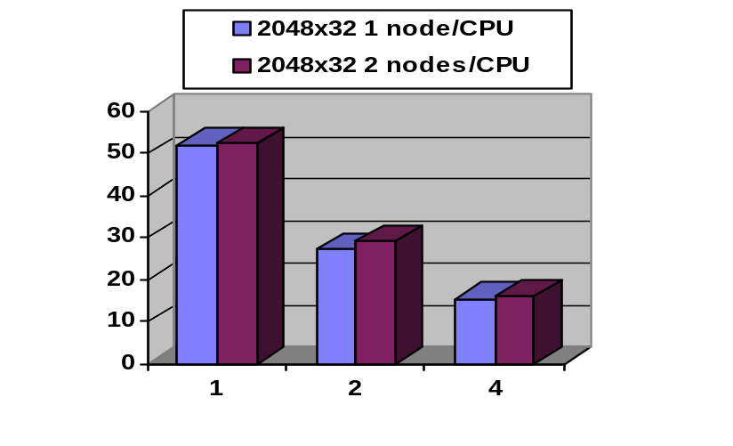
Figure 8: PTMPI block-based matrix multiplication execution time in seconds as function of number of four-processor SMP nodes.

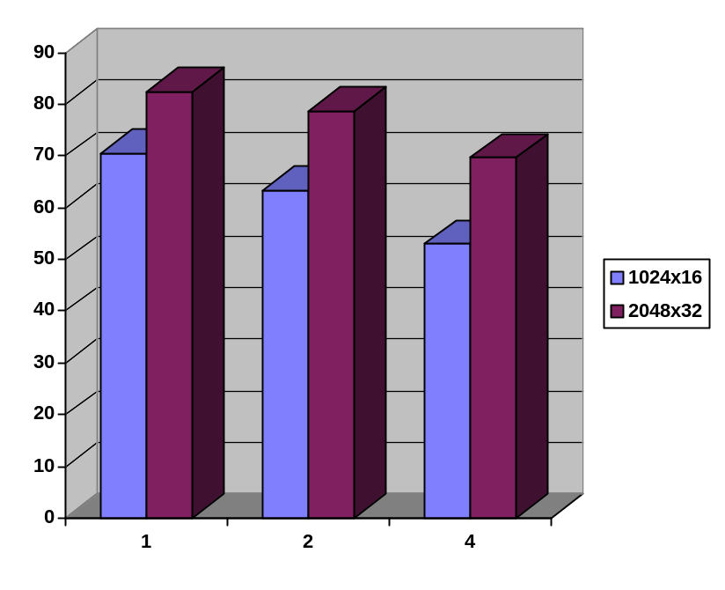
Figure 10: PTMPI block-based matrix multiplication MFLOPS rate per processor as function of number of four-processor SMP nodes (one thread per processor).
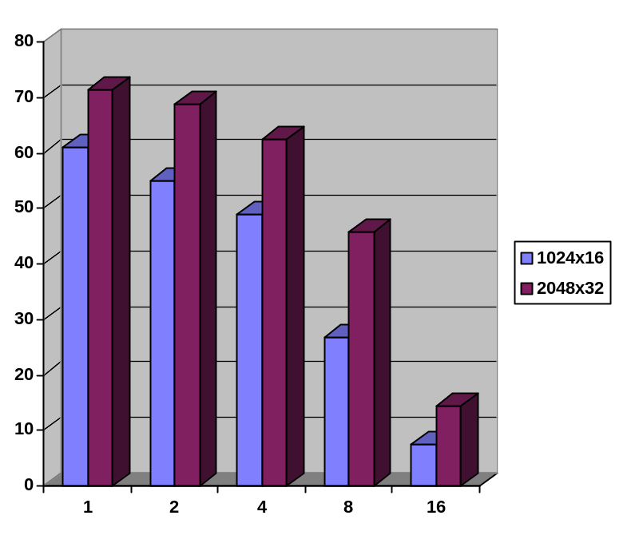
Figure 9: PTMPI block-based matrix multiplication MFLOPS rate as function of number of two-processor SMP nodes (one thread per processor).

Conclusions and Future Improvements

- Basic MPI functions are implemented
- Current MPI_node to process is basic one, it is expected that smart mapping can
significantly improve execution speedup for some applications
- Since the communication between the threads is faster than through sockets,
MPI gathering function need to be implemented
- Spin waiting for send and receive inside the process if running on real SMP
- Sending only message header through the socket if the message is big,
and waiting for message data request when the receiver is ready

