Assignment - Week 8: Final Project Documentation

Saroj Kumar Niraula
AVILA University
CY 611: Network Security
Prof. Clifton Krahenbill
Mar 1, 2025

Lab Objective
The objective of this lab is to assess the understanding and proficiency we students have gained from the Computer Networking course. The topics covered include:
- Designing and implementing IP schemes
- Configuring VLANs and dynamic routing
- Implementing security solutions
- Configuring fundamental network devices
Lab Mission
Establishing a Wide Area Network (WAN) for a simulated educational institution, consisting of three Local Area Networks (LANs), one of which is subdivided into three Virtual LANs (VLANs). Additionally, configure all network devices and endpoints to enable seamless communication across the WAN.
Requirements
- Knowledge of networking concepts and the Cisco IOS
- Cisco Packet Tracer 7.2.2 or later
- Provided file: "Final Project.pkt"
Scenario
As a junior network administrator, me and my team are responsible for designing and configuring a network for a newly established educational institution in Tucson. Our task includes properly setting up the network and applying fundamental security measures.
Step 1: Design an IP Address Scheme
Divided the 172.16.20.0/24 network into eight subnets.
- Subnet Mask: 255.255.255.224 /27
- Usable Host Addresses per Subnet: 30

Subnet Number | Network Address | Usable Host Address Range | Broadcast Address
1 | 172.16.20.0 /27 | 1-30 | 172.16.20.31
2 | 172.16.20.32/27 | 33-62 | 172.16.20.63
3 | 172.16.20.64/27 | 65-94 | 172.16.20.95
4 | 172.16.20.96 /27 | 97-126 | 172.16.20.127
5 | 172.16.20.128/27 | 129-158 | 172.16.20.159
6 | 172.16.20.160/27 | 161-190 | 172.16.20.191
7 | 172.16.20.192/27 | 193-222 | 172.16.20.223
8 | 172.16.20.224/27 | 225-254 | 172.16.20.255

Step 2: Implement VLANs and Trunking
Created and configured VLANs:
- VLAN 10 – Management
- VLAN 20 – Marketing
- VLAN 30 – Accounting
- VLAN 100 – Native VLAN
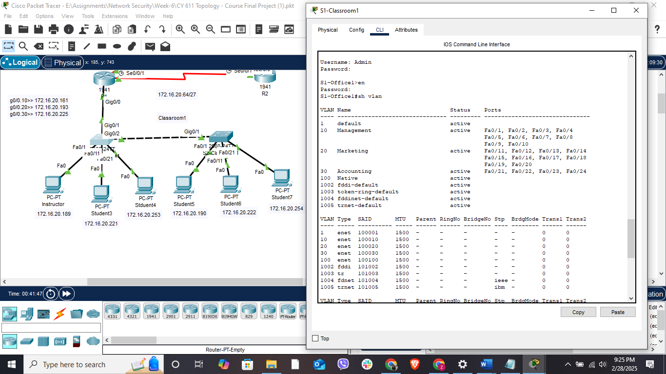
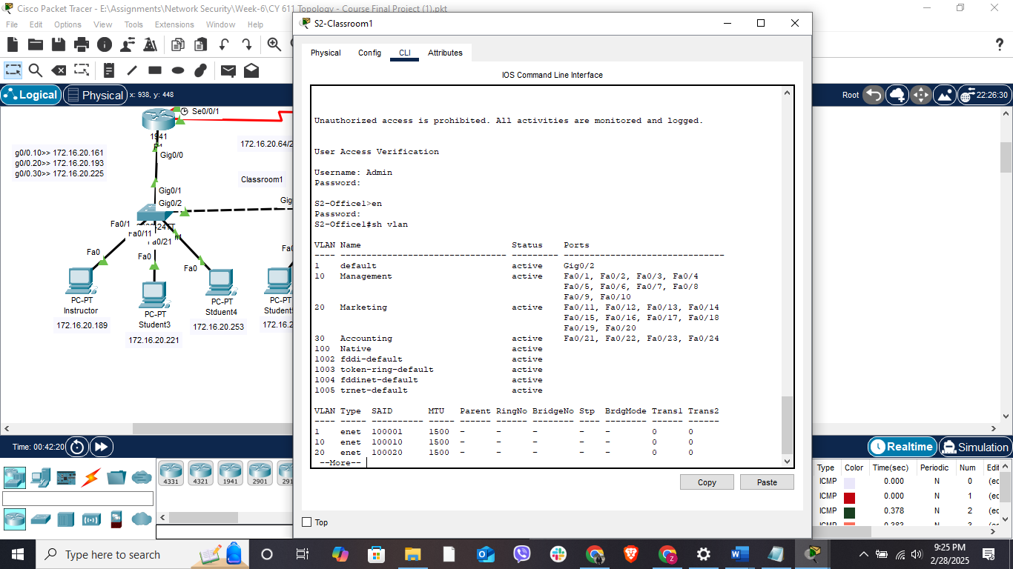
Assigned VLANs on S1-Classroom1 and S2-Classroom1:
- VLAN 10: FastEthernet0/1-10
- VLAN 20: FastEthernet0/11-20
- VLAN 30: FastEthernet0/21-24
- Set the S1-Classroom1 to S2-Classroom1 interconnecting link as **Trunk** on both switches.
- Disabled DTP on all access ports.
Verified configurations using appropriate show commands.
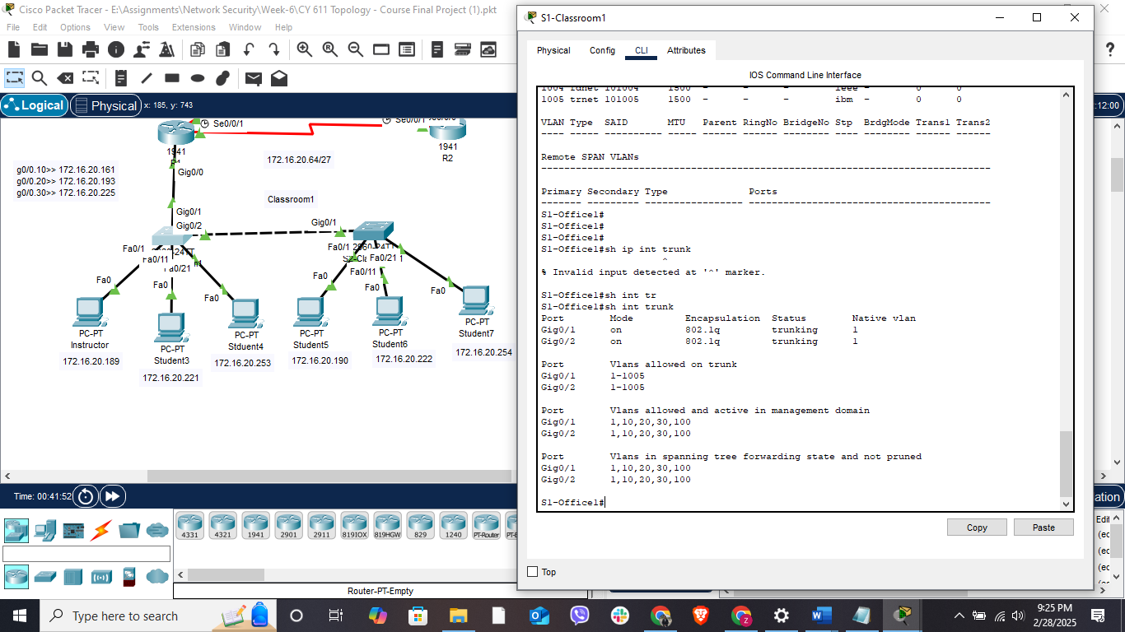
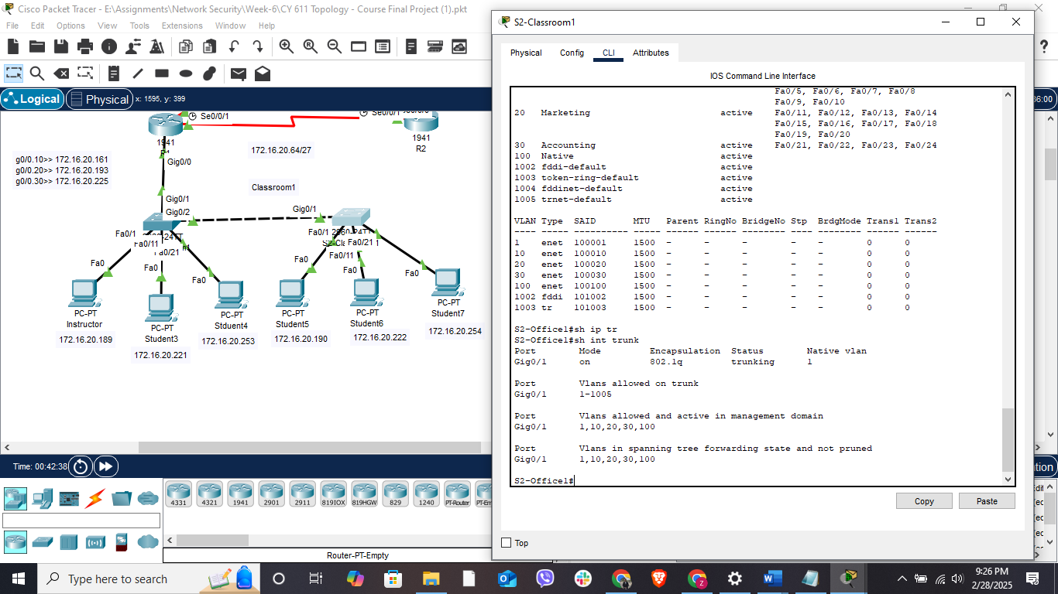
Step 3: Assign IP Addresses
Assigned IP addresses based on the subnet table. Configured default gateways for VLANs and ensured interconnectivity.
Step 4: Configure Inter-VLAN Routing
- Enabled GigabitEthernet 0/0 on R1.
- Created three sub-interfaces for VLANs on R1.
- Assigned the appropriate IP addresses and subnet masks.
- Configured GigabitEthernet 0/1 on S1-Classroom1 as Trunk with the correct Native VLAN.
- Verifed routing and test connectivity.
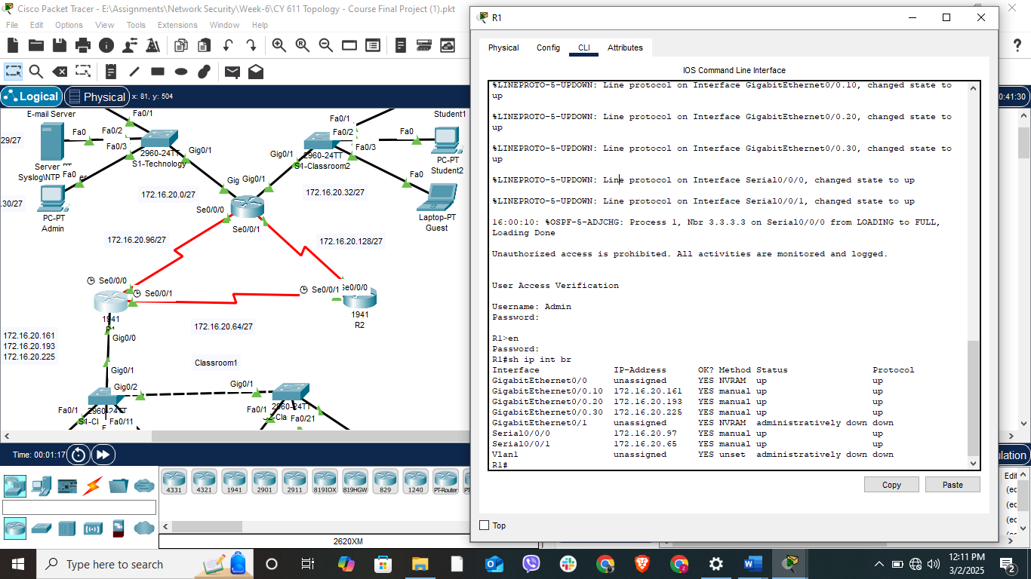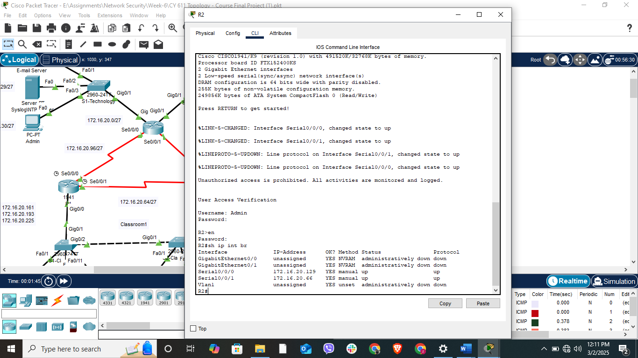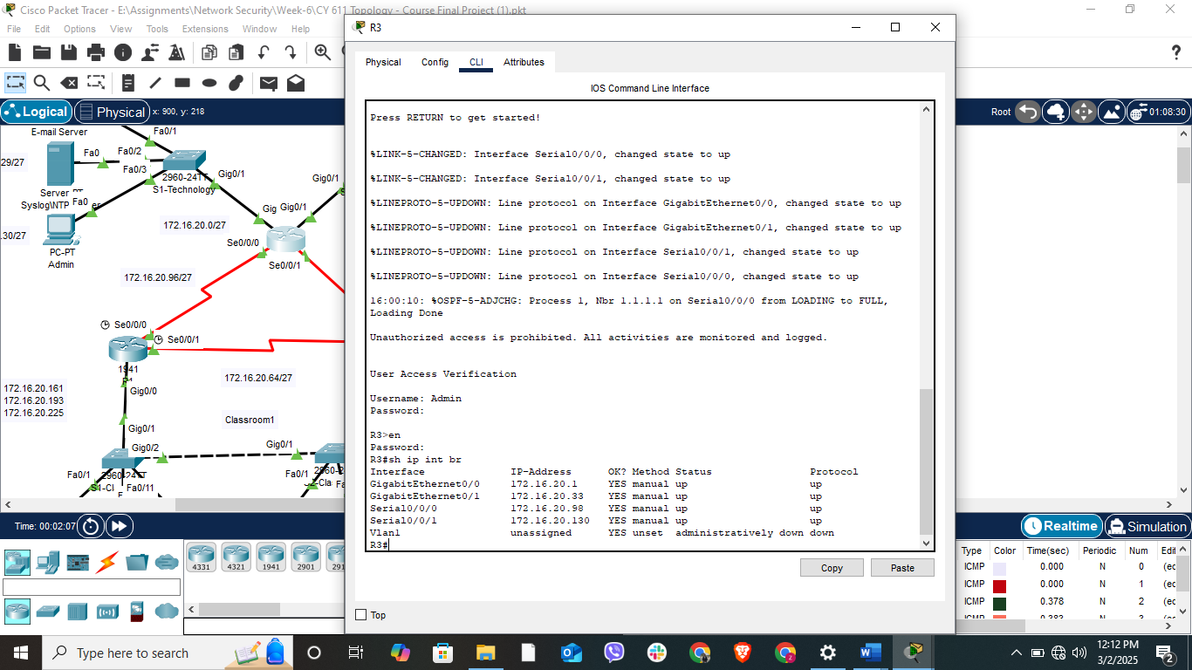
Step 5: Secure Switch Ports
- Enabled Port Security on all access ports.
- Set violation mode to Restrict.
- Enabled sticky MAC learning.
- Disabled all unused ports.
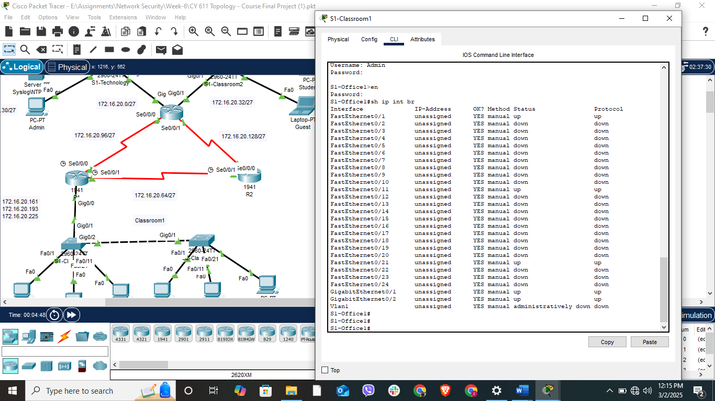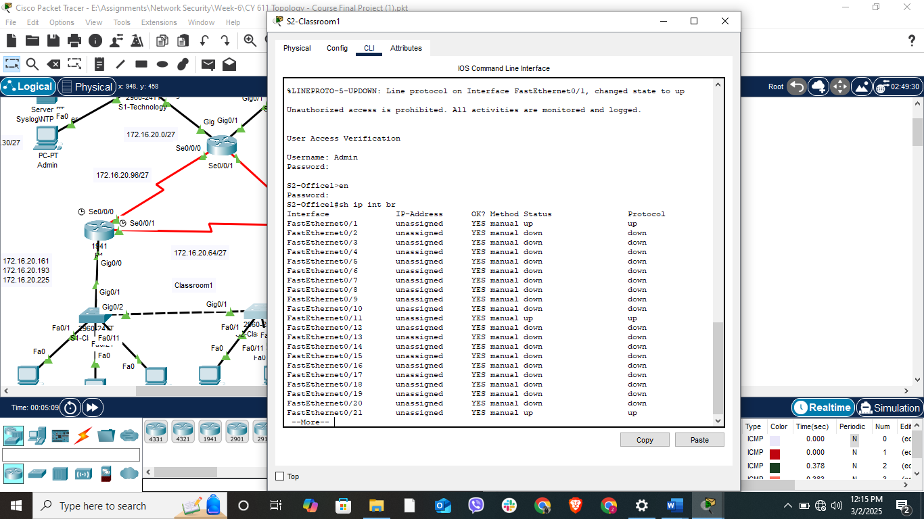
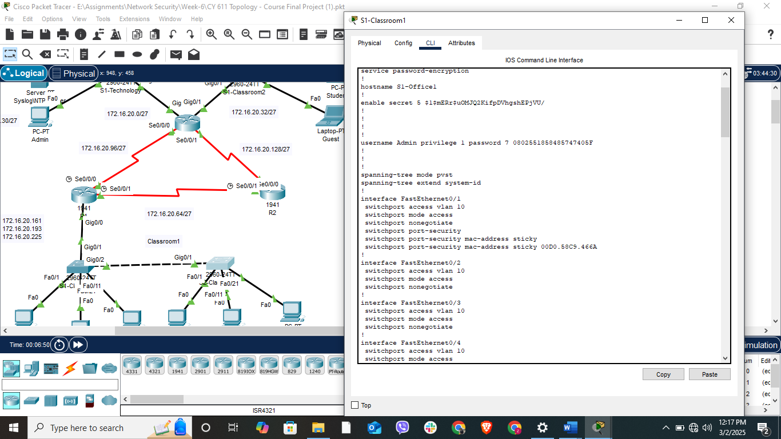
Step 6: Configure OSPF
Configured OSPF on R1, R2, and R3:
- Process ID: 1
- Router IDs:
- R1: 1.1.1.1
- R2: 2.2.2.2
- R3: 3.3.3.3
- Set LAN ports as Passive.
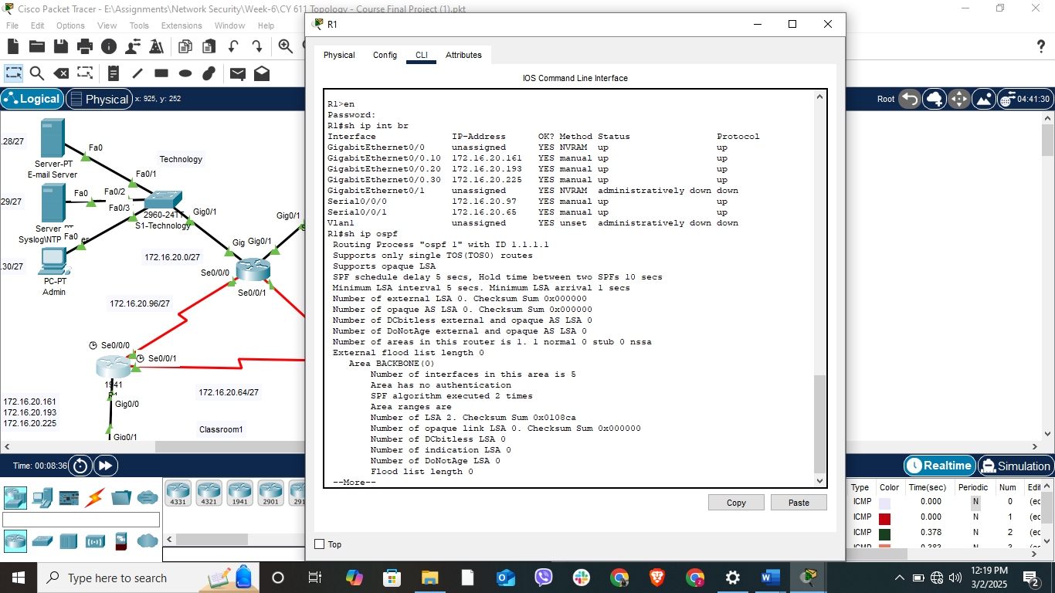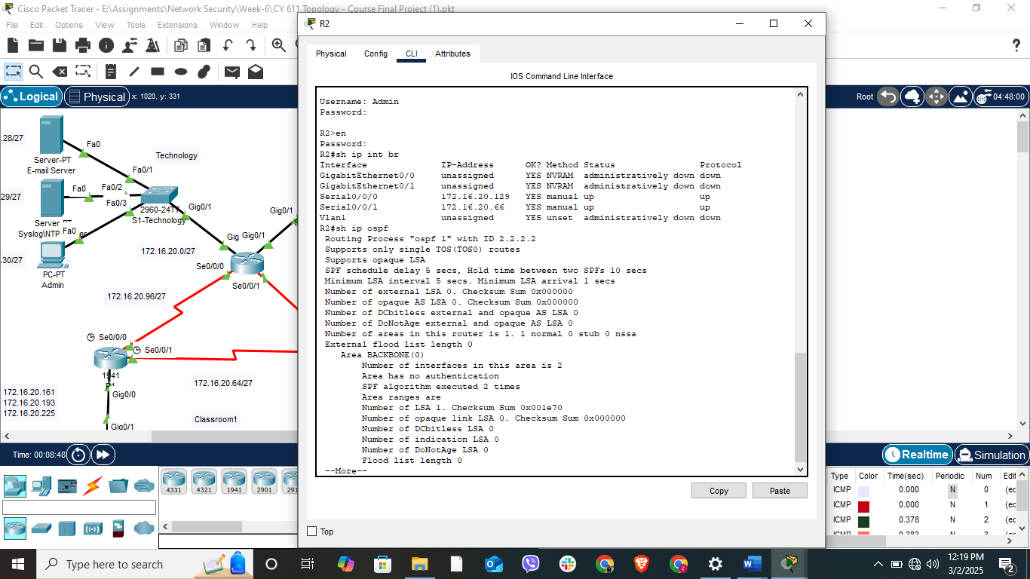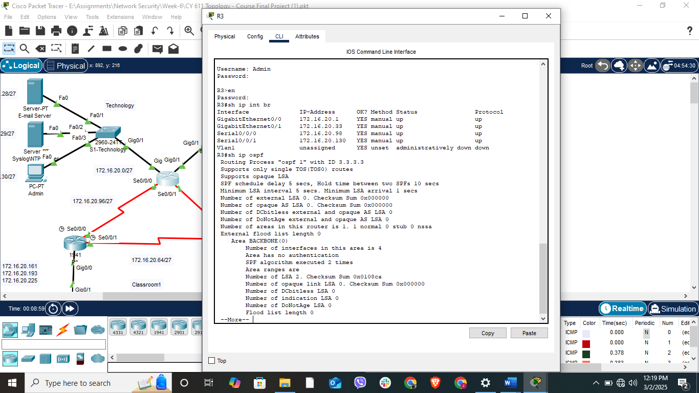

Step 7: Implement Initial Security Settings
- Created a user account on all Routers and Switches with the below
- Username: Admin
- Password: Cy6112024
- Secured console and privileged mode access with secret “letmein”
- Encrypted all passwords.
- Configured a MOTD banner.
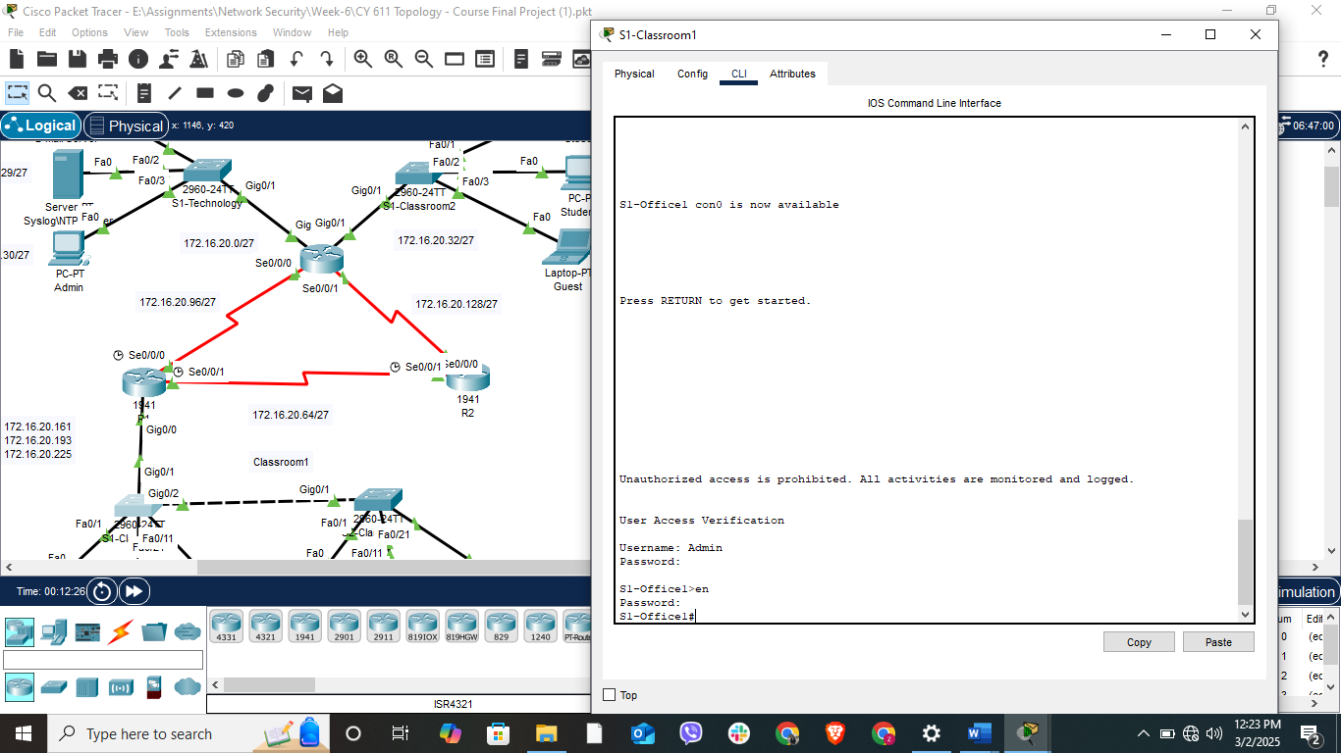
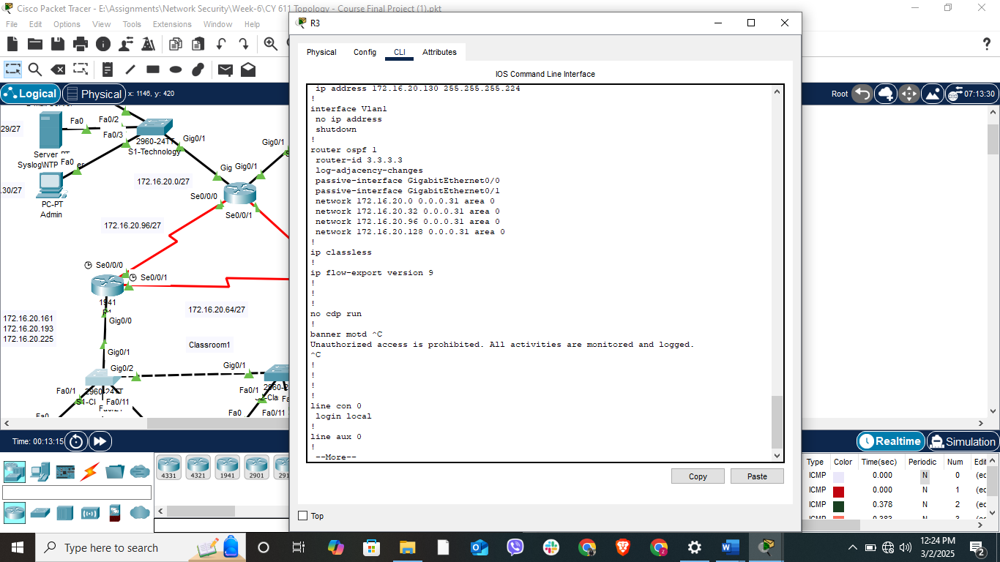

Step 8: Secure Remote Access
- Configured SSHv2 on all routers.
- Set domain name: simulated.edu.
- Generated secure SSH keys (1024-bit minimum).
- Restricted VTY access to SSH only.
- Tested SSH connectivity from the Admin PC.
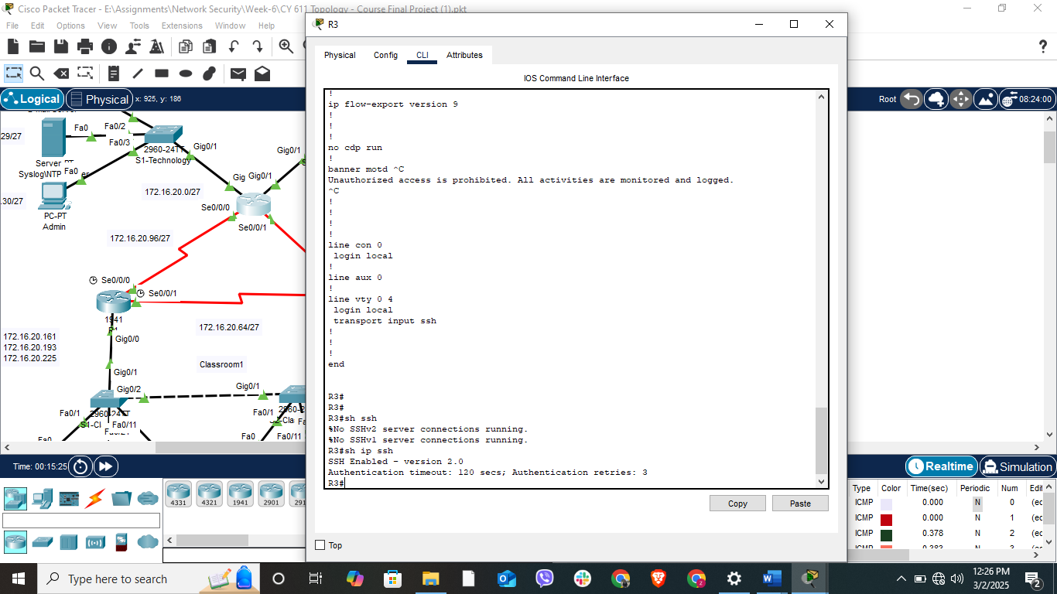
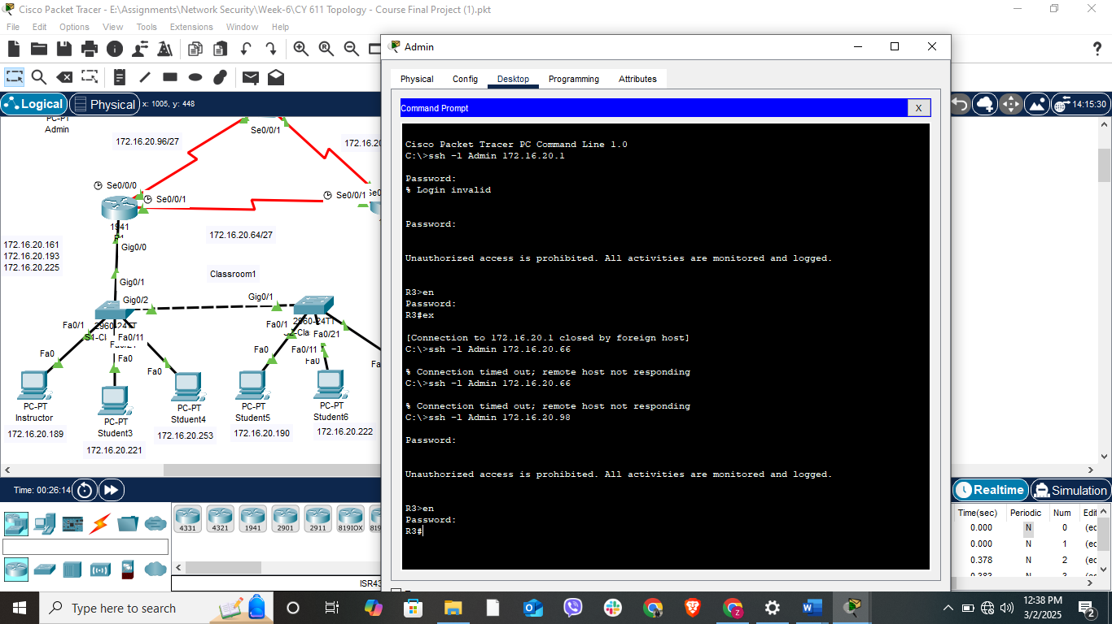

Step 9: Network Connectivity Testing & Troubleshooting
- Verified correct IP configuration on all devices.
- Used ping and traceroute for connectivity testing.
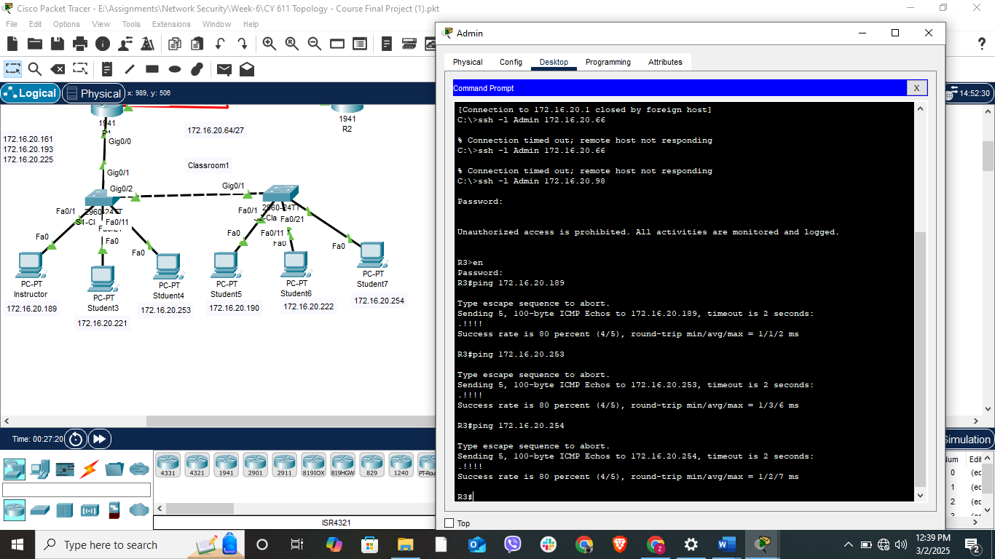

Conclusion
This project successfully demonstrates proficiency in network design, VLAN configuration, routing, security implementation, and remote access management. The configured network is scalable, secure, and fully operational for an educational institution.

