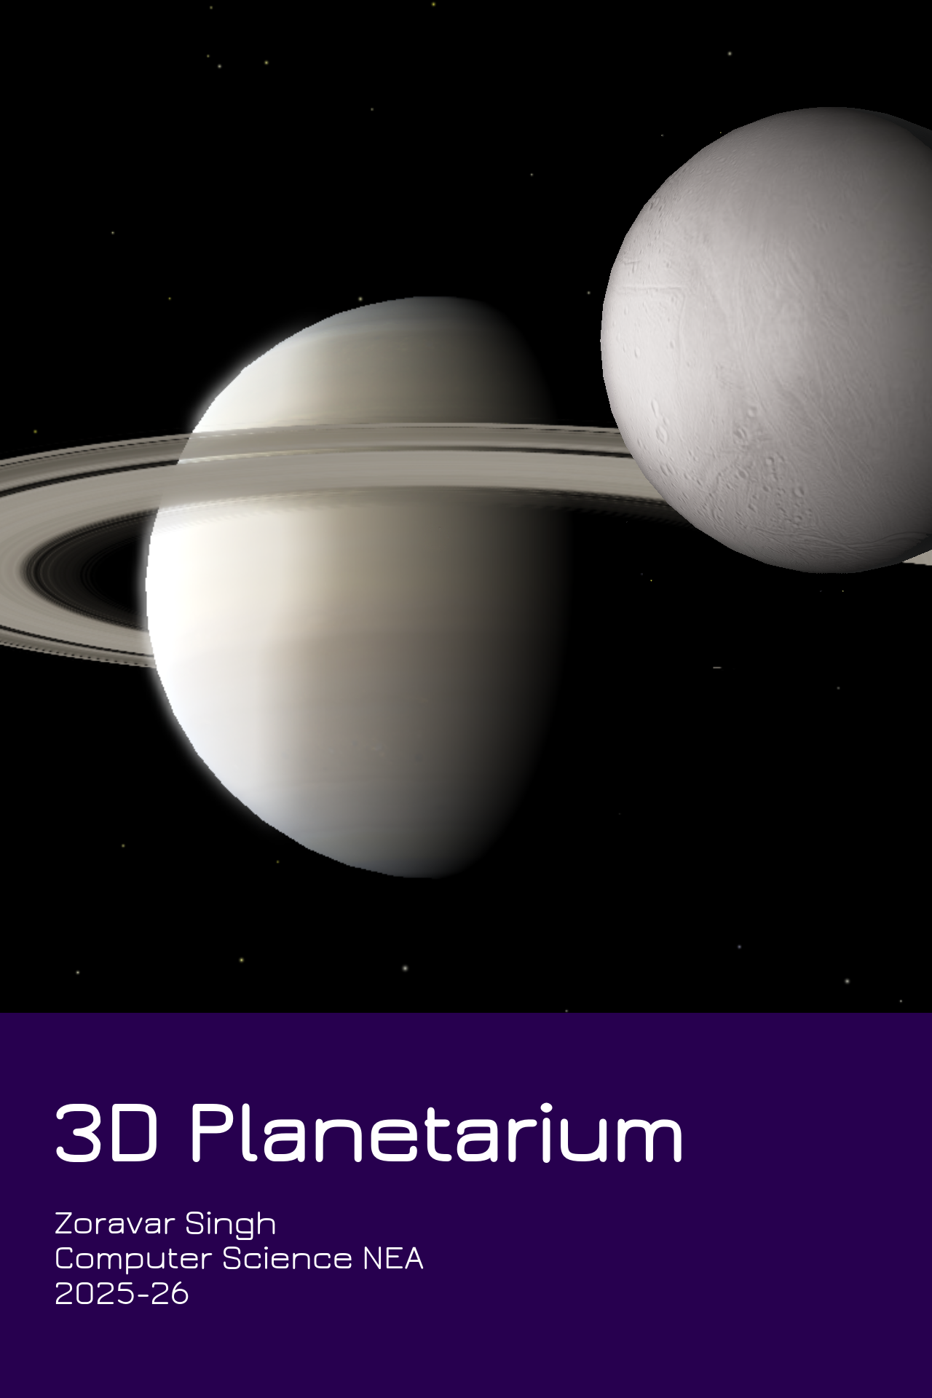

ANALYSIS

1.1 Problem Definition
Astronomy is a fascinating field to all, but for most can remain mystifying and convoluted - I experienced this first-hand with other students in our Astrophysics component of OCR Physics.
Considering this, I wanted to create an accessible, visually appealing, powerful and informative program to assist those studying, working in fields related to, or showing an interest in Astronomy. I want to allow this program to assist both beginners and those with more expertise.
This project will be a lightweight, 3D-rendered ‘Planetarium’ program which will display the most prominent objects in the Solar System, as well as our local stellar system, and allow for the user to read info on selected objects through a UI as well as the 3D viewport.
The visual aspect can enable students or hobbyists to gain an intuitive understanding of our Universe, and the ability to read information on celestial objects can be useful to those with an advanced understanding of Astronomy.
There are programs that achieve a similar concept (With varying degrees of complexity) such as SpaceEngine, GAIA Sky and Celestia. My project will be a lighter, more abstracted version of these programs’ concepts. Similarities may include an information UI for selected objects, a free camera to navigate through the map, and (possibly) the ability to change the date and time – and to have Solar System bodies change positions in orbit to reflect it.

1.2 Stakeholders

My client is my Physics teacher, Luke. He expresses interest in being able to have a program which can help teach his students Astronomy and provide data to carry out Astrophysics calculations in-class. He’d be able to also use this program in his Astronomy Club.
My stakeholders consist of those interested in, researching, learning or teaching Astronomy. My program aims to be applicable to everyone of varying knowledge in the field, from students to researchers. I will focus on the needs of a student to allow the program to be easily accessible but also be able to provide additional data on celestial objects for more advanced users.
Astronomers (or stargazing enthusiasts) may make use of this program to gather useful information of celestial objects (Such as absolute magnitude, distance from us, diameter of objects etc). Teachers may use this program for visualization to assist learners in a classroom environment.

1.3 Computational Methods

Justification of Computational Methods

Visualising the Universe around us in a 3D space is practically impossible in reality, as we only have one vantage point – Earth. As a result, students may become easily confused on how objects in space are arranged and interact with each other. For example, Alnitak – a star in Orion’s Belt – is nearly 1,000 lightyears away from Alnilam – another star in the same constellation. However, with a traditional 2D sky map, these two stars can appear right next to one-another (as the stars are simply projected onto the sky map as seen from Earth – like how two trees in a distant park may appear to be in the same spot from our perspective, but are actually far apart.)
Limitations like these, in my opinion, make it crucial to have an interactive 3D space when trying to understand the cosmos. This technology is only achievable through computational methods of 3D rendering.

Abstraction

Creating a program of this scale requires heavy abstraction. Multiple celestial objects (Nebulae, Asteroids, Comets, Spacecraft and other Galaxies) will be exempt from this program due to performance and programming constraints, as well as a vast amount of these objects (Such as the millions of asteroids in the Asteroid Belt) not being relevant to most users.
Celestial objects will have a clear and identifiable, but heavily simplified appearance. For example – Earth will have a clear surface map, but this will only be in a standard texture size. Intricate details of mountains, seas etc. For planets are not necessary for the user, as the main usage of this program is for visualizing at a much larger scale, and more general details should be considered, such as star glare or displaying orbit paths.

Decomposition

This program displays a vast number of objects and offers a large amount of data to the user. For this reason, I’ll be breaking down the project logically into smaller, more manageable tasks:
- Database management, storing and being able to fetch information from stellar catalogues.
- Planetary-scale features, such as displaying planets, moons, and orbit paths.
- Displaying data on a UI, retrieving it from the database.
- Interstellar features. A star map of the nearest ~10,000 stars (or more) to be stored via spatial hashing to allow for quick rendering and lookup.

Thinking ahead

Initial research and planning will be needed for this project.
Displaying planets in our Solar System in their accurate orbits will require knowledge on Keplerian equations (to display eccentricity and inclination)
This project relies on lots of pre-recorded data and is mainly a program to display this data into something intuitive, interactive and easy to navigate. Catalogues will be needed to have the celestial characteristics required to accurately display objects in this program (such as the GAIA/HYG catalogue).

1.4 Research

To create a program that adequately balances having wide array of features and content, while being lightweight and intuitive, I have surveyed similar programs which are similar in output to my desired program and have taken note of which features will benefit my project, and which features may be erroneous/out of bounds for implementation.

SpaceEngine

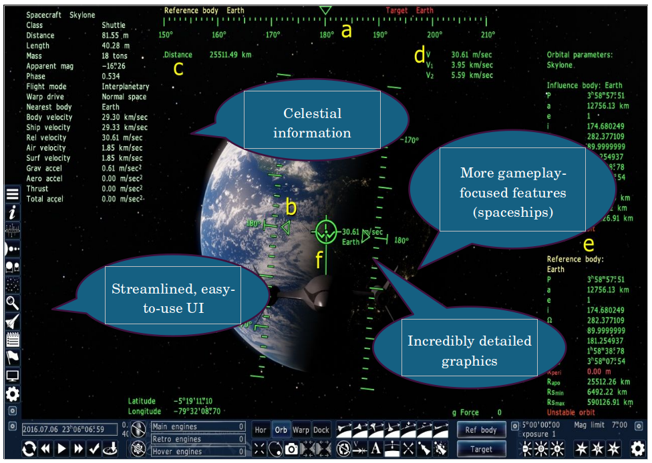

SpaceEngine is a paid, interactive 3D planetarium and astronomy software. SpaceEngine creates a 1:1 scale 3D planetarium representing the entire observable universe, combining real astronomical data with scientifically accurate procedural generation algorithms.

What may be useful:  - This program is incredibly versatile, user friendly, and visually appealing. It has a clear, illustrated UI and easy-to-use controls with a free-cam feature.  - This program intelligently balances visual appeal with a lot of useful data for more advanced users, which can be seen on the side-view panels.  - This program can handle both small and large-scale bodies. It can display objects as small as a house to entire galaxy clusters.  - This program performs decently on lower-end devices. It is very well optimized for the detailed graphics it contains. | What may be erroneous:  - This program is incredibly complex, displaying virtually the entire Universe within the planetarium, with unmapped regions being procedurally generated. This is far too complicated to implement in this coursework, and more difficult-to-implement features should be sacrificed for a more feasible project.  - The program is very visually detailed, generating terrain and surface scatter for planets, as well as complex shaders for stars and other celestial objects. These features are appealing, and make the program more engaging, but are not completely necessary for a strictly educational project.  - This program also implements more “video game”- esque features, such as adding fictional spaceships and a planet creation tool. These features are mainly for entertainment purposes, and don’t align with the goals of this project.

GAIA Sky
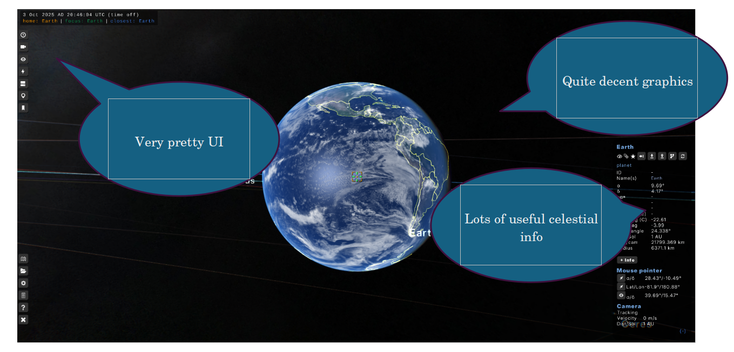
Gaia Sky is an open-source astronomy visualisation desktop and VR program in the framework of ESA's Gaia mission to create a billion-star 3D map of our Milky Way Galaxy.

What may be useful:  - I particularly liked the UI in this program. It’s very simplistic, clear and involves little-to-no menu diving. Very easy to use.  - This program balances out good graphics with simplicity very well. It gives enough visual clarity for the user, but is not as difficult to replicate as SpaceEngine.  - This program allows importing custom catalogues, and allows portions of the supported catalogues to be installed/uninstalled. This makes it very easy to manage stored catalogues, and prevent large file-sizes from importing entire catalogues at once.  - This application’s scope is similar to our own. It only displays the Milky Way galaxy (If you don’t include galaxy catalogues), which is much more feasible than the scope of SpaceEngine. | What may be erroneous:  - This program is fairly unstable at times. This may be from poor optimization of rendering the celestial objects. Our program should try and take optimization into account.  - I found the free-cam system unintuitive, which could be changed slightly with settings, but would probably be better off being well-polished by default.

Celestia
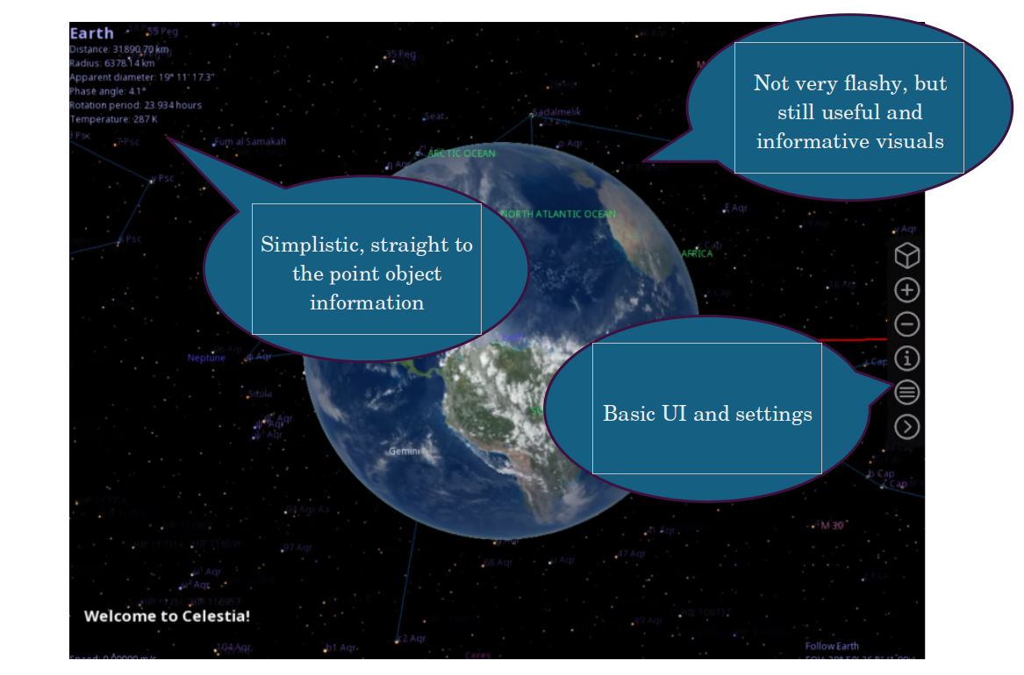
Celestia is a real-time 3D astronomy software program that was created in 2001 by Chris Laurel. The program allows users to virtually travel through the universe and explore celestial objects that have been catalogued. Celestia also doubles as a planetarium.

What may be useful:  - I found the control system, especially movement, to be very easy to use.  - This program offers a decently-sized catalogue (though it is not manageable) of various celestial objects. Other catalogues can be installed through mods.  - This program is particularly useful for stargazers. It has useful data for objects, such as distance to Earth. It also has a “Planetarium” view, which lets you browse a traditional 2D skymap.  - Well optimized, a good balance of detail and being lightweight. | What may be erroneous:  - Due to the scale of the program, and the camera not being the origin, floating-point precision becomes a problem as objects are added further away.  - Shading features are limited, with little-to-no effects or filters and a lack of shadows (for eclipses) when it comes to irregular-shaped objects.  - Some data is outdated, despite the program being updated to this day. For example, objects may have very old, low-quality textures which have since been improved through mapping. Models for spacecraft are very outdated and not very detailed.

Stellarium
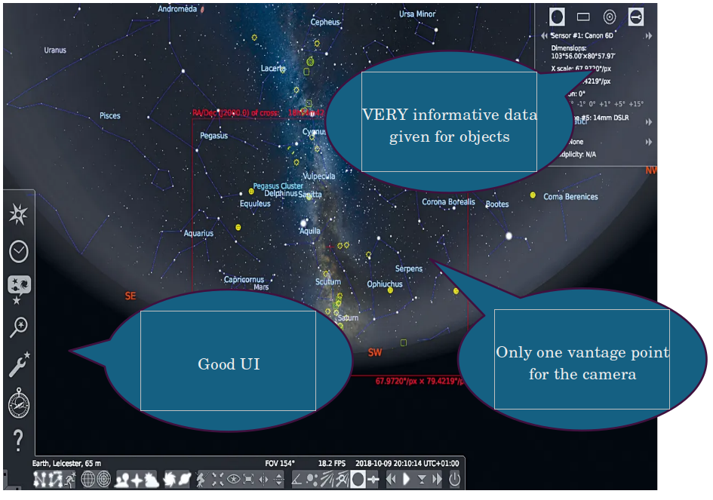
What may be useful:  - This program is especially useful for stargazers, as it gives the same vantage point a stargazer would have looking at the night sky, in a 2D skymap.  - Very easy to run, not much 3D rendering going on.  - Very useful information is given (magnitude, coordinates in the night sky) | What may be erroneous:  - Only one vantage point is given – this can cause issues for those learning astronomy due to an inability to grasp 3D space, as previously discussed.

1.5 Survey

1. General Information
Name (Optional):

Role (Student, Educator, Other…):

Results:

This survey was composed of mostly students, which is a good middle ground for those unfamiliar with the subject of Astronomy and those who specialize in the field.

What is your current understanding on Astronomy and/or Astrophysics?

Some of the results:
- “I have basic knowledge of astronomy (I only know the common constellations), and my knowledge of astrophysics is mid - I've read only a little bit outside of the spec about black/white holes for my physics presentation.”
- “I don't understand it other than common knowledge / the basis as I've never had a class revolving around it.”
- “A level physics”
- “i like it but i dont know how to do the math stuff”
- “GCSE Level”
We have a range of answers, ranging from people completely new to the subject to those with an A Level understanding of astrophysics. This will allow us to gather information that is both accessible for less experienced users and useful for those with a deeper understanding of Astrophysics.

2. Current Challenges
What are the main challenges you face when studying Astronomy?
Open ended question to gather general thoughts and opinions
Some of the results:
- “Anything mathematics involved.”
- “Finding Reliable information”
- “How the theory of astrophysics affect planets in the real world.”
- “visualising the stuff in astrophysics, its a bit hard to comprehend how massive some of the objects are”
- “Being able to picture where the planets in our solar system are and the scale”
It seems our program can tackle a lot of general problems when it comes to astrophysics. People may not be able to find reliable sources – which is where our database visualisation will come into use. Catalogues are the most viable method to accurately look up data on Celestial objects, but they can be incredibly inconvenient to go through when looking up info and are certainly not engaging for new learners. A 3D visualisation will make data both easy to read and search for, and fun to browse and learn from.
This program being to-scale can also help with being able to picture the size of objects and their distance from one another. This is mostly for visual understanding, and allows for students to understand the placements of objects in space and how they interact.

3. Preferences
How important is visual appeal and graphics to you for an information/learning software?
- Not important
- Somewhat unimportant
- Neutral
- Somewhat important
- Very important

Results:

From this data, it seems visual appeal will be very important for this program, so a significant portion of programming should go to developing graphics and visuals.

What information would you like to be available when looking up objects in this program?

Some of the results:
- “Mass, Gravity, other components that make up planets and stars”
- “The radius of planets, the mass, the names of various stars and planets that are well known”
- “Distance from Earth”
- “Luminosity, mass, distance from earth”
- “Brief history. More in depth view option. Preferably physics related values such as mass, surface temp, luminosity etc”

Luckily for us, most of these properties are standard to have in catalogues. However, non-numerical data (Such as history of the object) will have to be written manually. Distance from Earth may have to be calculated manually if we are using coordinate data (Most likely with 3D Pythagorean theorem).

What celestial bodies would you like to be able to view/visit?

Some of the results:
- “Far away planets and well known named stars.”
- “Proxima Centauri”
- “Our moon”
- “Saturn”
- “Stars, Black Holes, Planets, Dwarf Planets, Moons, Comets, Basically just everything you can”
A lot of these objects are also stored in catalogues (albeit different ones). Certain objects which are very far away from us (such as black holes) may not be added, since they are currently not in the scope of the program.

What sort of method of travel (Freecam, point-and-click etc) would be most useful to move through space?

Results:

It seems Freecam is the most popular option (Those who specified multiple camera modes fell under “other”). Being able to switch between different camera modes easily may be a challenge (especially since I’ll be using a custom camera system) so I’ll primarily be using a single camera system.

What settings would you like to be able to adjust?

Some of the results:
- “Movement speed”
- “Field of view perspective”
- “Render distance, Simulation distance (if that applies), Scale, Camera sensitivity”
- “Accessibility, controls, graphics, audio.”
- “Time”

These are all fairly important in any 3D program, and a lot of these are easy to implement (apart from time, which is asked below).

Is the ability to adjust date and time (and have objects move in orbit accordingly) crucial for this program?
- Not important
- Somewhat unimportant
- Neutral
- Somewhat important
- Very important
Results:

The results here were more varied than previous questions to importance of features. It seems there is a divide on those demanding Date and Time settings, and those who are impartial to it.

Would you find documentation/a tutorial useful as a user?
- Not useful
- Somewhat useless
- Neutral
- Somewhat useful
- Very useful

Results:

It’s clear that most people favour documentation/a tutorial for new users.

4. Requirements
Do you have >4GB RAM?
- Yes
- No

Results:

An overwhelming amount of users have more than 4GB of RAM, so there’s plenty of memory for our program to allocate to for most users.

Do you have >2GHz clock speed?
- Yes
- No

Results:

An overwhelming number of users also have over 2GHz clock speed, so most users will be able to meet the demands of a 3D graphics program. (Clock speed isn’t the only factor for CPU performance, but it is a major one and the easiest to ask for in a short survey).

What Operating System do you use?
- Windows
- MacOS
- Linux

Results:

The engine I will be using can work on most major operating systems; however, it is not officially supported by MacOS. I wanted to see how many users could run into bugs or crashes because of this, and it seems most users will have the engine running stably if they are using Windows or Linux, which is much more likely than MacOS.

5. Extra input
What other suggestions may you have?

Some of the results:
- “A little informational paragraph when you hover over a object would be cool.”
- “simple descriptions of each exoplanet or celestial object”
- “Include black holes”

There were little additional suggestions sent, and the suggestions that were sent have been addressed before in previous questions, so it seems that this survey has encompassed most of the input we could gather from our users.

1.6 Client Interview

1. What type of objects would you find useful for having in the Planetarium for students? (Such as planets, moons, stars…)

“I’d obviously like to see planets implemented, as well as moons, stars, comets, meteors and possibly artificial satellites”

2. How do you want celestial bodies to look? What sort of visuals would you like to see to help create an understanding of the properties of these objects?

“I think you should be able to show traces for orbital paths of planets and moons and use a colour code for orbits on a larger scale when zoomed out on the Solar System. When zoomed in, I’d like to see accurate, detailed textures for the bodies.”

3. What information would you like to see about a body when selected? (Mass, diameter, orbital info etc…)

“I think for objects in our Solar System; object mass, the object’s physical radius, orbital radius, period of the orbit, density, and distance from Earth would all be useful information.”

4. Would you like a lot of settings and options, or lean towards a more simplistic interface?

“I think a simple interface would be better for a classroom environment.”

5. Is there anything in particular you would like to add for this program?

N/A

6. Is there anything you would like to avoid for this program?

“Avoid making it too complex, wordy and cluttered.”

Analysis Review

This interview solidified my proposal that this program should focus on accessibility over immediate access to information, as an overly extensive UI can appear cluttered and overwhelming for new users.
It’s clear that a concise UI and visually appealing graphics (such as detailed textures) are very important – especially to those in a classroom environment. However, we clearly need to implement useful visualisations of object properties, such as orbit paths, in order to balance ease of use with functionality.

1.7 Current Proposed Features

Feature | Programs needed
Ability to display multiple textured objects in a world | Python + Panda3D
Shaders to allow detailed shadows | Python + Panda3D
Atmosphere shaders | Python + Panda3D
Glare shader/effect for stars | Python + Panda3D
A camera movement system | Python + Panda3D
Ability to display orbits when given information (eccentricity, inclination etc...) | Python + Panda3D
A visual display of object properties (Name tags, Orbit paths etc...) | Python + Panda3D
Ability to select objects with mouse | Python + Panda3D
A UI to display object info | Python + Panda3D
Have object info read from a database | Python + SQLite
Stars/Stellar objects to have a different coordinate system to planets | Python + Panda3D
Solar object positions determined with time | Python
A variable scale system to avoid rendering and precision errors with large numbers | Python + Panda3D
An ability to project distant objects to avoid large coordinate values | Python + Panda3D
Origin to be at the camera to avoid floating point error | Python + Panda3D
Ability to list nearest objects when given coordinate positions by using the Octee data structure | Python
Search for objects UI (Found using a search algorithm) | Python + SQLite

1.8 Limitations
The library is loaded in instead of being linked, so I cannot ensure if this program will work for future updates.
The engine I am using is very simple to use, but also very primitive in built in shaders. This means that graphic quality may be simplistic.
I have intentionally used an engine that, though built on Python, has most performance-heavy code written in C++, so it’s efficient. Despite this, the engine may struggle with thousands of entities when playing in a particularly crowded space. A camera at origin means that all objects need to constantly have position and scale properties checked and altered. All of these factors may result in low frame rate.
The variable scale system I will be using is complicated. Some scripts may break or lag, and the program may therefore be susceptible to crashes.
Numbers start getting too big to handle, even with variable scale, when dealing with very distant objects. The map will consist of only local objects.
To avoid large file sizes and long waiting times when parsing through objects, I only want ~1000 objects at most in this program.

1.9 Requirements

Developer requirements

Languages:
Python 3.11 with Panda3D and it’s dependancies

Software:
Visual Studio Code (Main programming)
DBBrowser (Database viewing)

OS:
Linux (Using Debian 12 Bookworm)

Hardware:
11th Gen Intel i5-1135G7 (4.2GHz)
Iris Xe Graphics Card
8 GB RAM

Minimum System requirements

OS:
Windows 7+/MacOS 10.11+/Linux (Preferably Debian-based)

Suggested Hardware:
2GHz+ CPU
10th Gen+ Graphics Card
4+ GB RAM

Software requirements
Python 3.11+ with Panda3D + Dependencies

1.10 Success Criteria

Number | Criteria | Justification | Sources
1 | Ability to display multiple textured objects in a world | Basics of appealing graphic design for celestial bodies. | Survey question 3.1  Client question 2
2 | Shaders to allow detailed shadows | Advanced feature for allowing more intricate, appealing graphic design for celestial bodies as well as allowing eclipses to occur. | Survey question 3.1  Client question 2  Research; Program 3
3 | Atmosphere shaders | Feature for allowing more intricate appealing graphic design for celestial bodies, as well as being able to display which celestial bodies have an atmosphere visually. | Survey question 3.1  Client question 2
4 | Glare shader/effect for stars | Basics of appealing graphic design for celestial bodies. | Survey question 3.1  Client question 2
5 | A camera movement system | To allow the user to explore the map easily and intuitively. | Survey question 3.4  Research; Program 4
6 | Ability to display orbits when given information (eccentricity, inclination etc...) | To accurately display locations of celestial bodies within our Solar System | Survey question 3.2  Client question 3
7 | A visual display of object properties (Name tags, Orbit paths etc...) | Ease-of-use when trying to locate celestial bodies, as well as a quick way to view properties of objects. | Survey question 3.2  Client question 3
8 | Ability to select objects with mouse | To allow the user to interact with celestial bodies directly (and for the program to know which object the user is interested in) | Research; Programs 1+2+3
9 | A UI to display object info | To allow users to easily view object information – which is the main highlight of this program. | Survey question 3.2  Research; Programs 1+2+3
10 | Have object info read from a database | To allow data on objects to be in a database for maximum efficiency of storage (as well as making queries much easier) | Survey question 3.2
11 | Stars/Stellar objects to have a different coordinate system to planets | To allow for vastly different levels of scale (km to ly) to be stored simultaneously within the program. | Research; How Solar Systems are rendered in video games: https://www.youtube.com/watch?v=aXQw-UVmInE
12 | Solar object positions determined with time | To allow users to adjust time settings to see how objects in the Solar System orbit. | Survey question 3.6  Research; Programs 1+2+3
13 | A variable scale system | To avoid rendering and precision errors with large numbers. | Research; How Solar Systems are rendered in video games: https://www.youtube.com/watch?v=aXQw-UVmInE
14 | An ability to project distant objects to avoid large coordinate values | So objects very far away can still be viewed as a ‘viewport’ even when too far away to render directly. | Research; How Solar Systems are rendered in video games: https://www.youtube.com/watch?v=aXQw-UVmInE
15 | Origin to be at the camera | To avoid floating point error when rending | Research; How Solar Systems are rendered in video games: https://www.youtube.com/watch?v=aXQw-UVmInE
16 | Documentation / A Tutorial | To help new users understand the program. | Survey question 3.7

Design

2.1 Structure of the program

For your viewing pleasure, here is the full planned structure of this program:

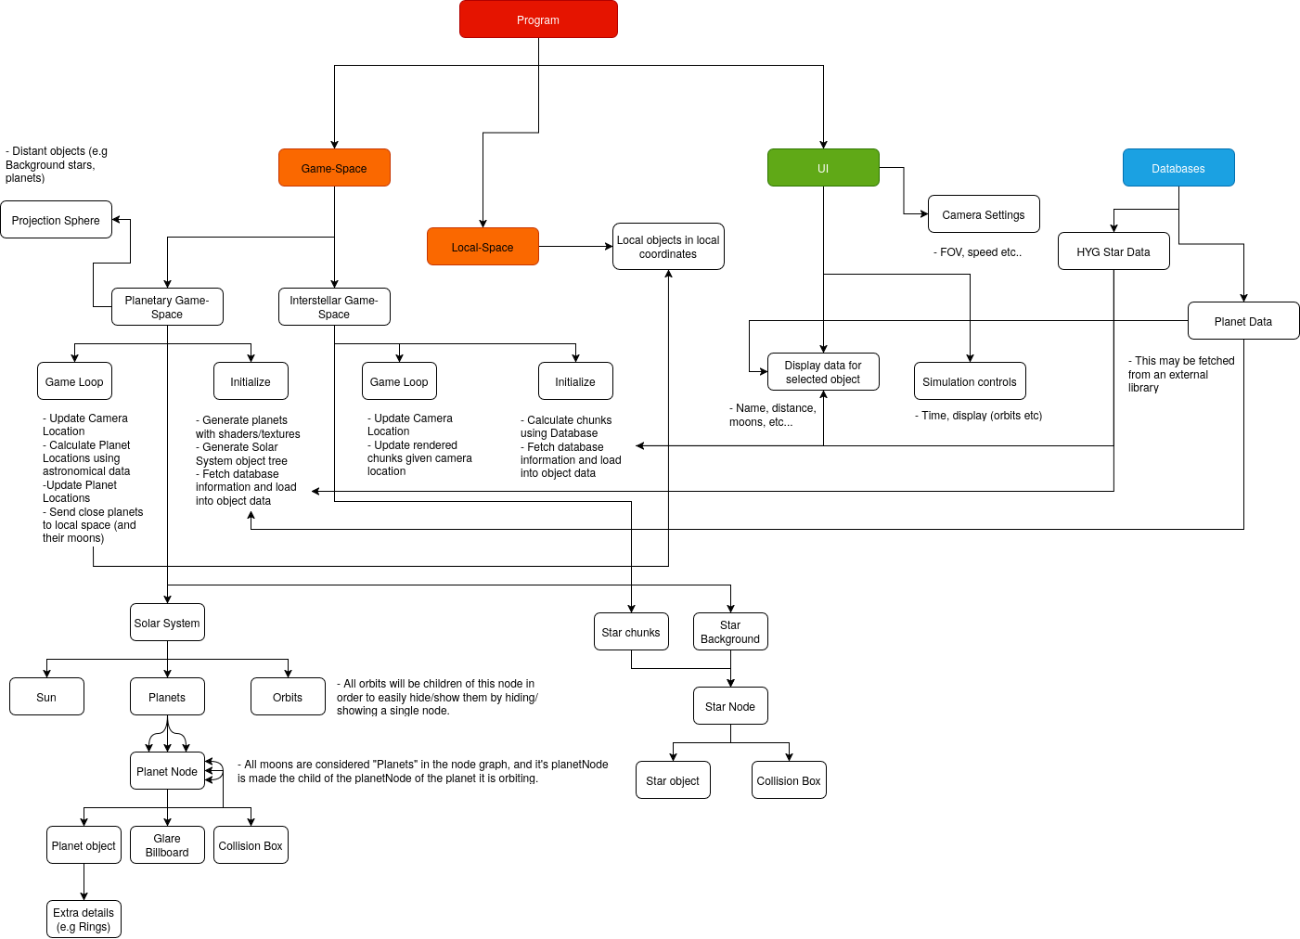
That’s a lot...
Of course, it’s only OCR standard that I’ll decompose this program down into manageable chunks – detailing each individual system which together will allow this program to run. For the Design portion, I’ll be discussing the structure of this program top-to-bottom, starting with the logical portion of implementation before diving into the more complex algorithms using pseudocode.

2.2 the game environment

Game-Spaces

To begin: Our project’s actual, physical objects are stored in “Game-spaces”.
These separate spaces are a result of the fact that our project will need to implement a very complex design in order to be able to display our local Planetary and Stellar systems. Rendering both of these in the same game-space at once will be impractical at best - and borderline impossible at worst.
The difference in scale for planetary and interstellar distances is incredibly large, and performing calculations with both magnitudes of values simultaneously will be slow and inaccurate.
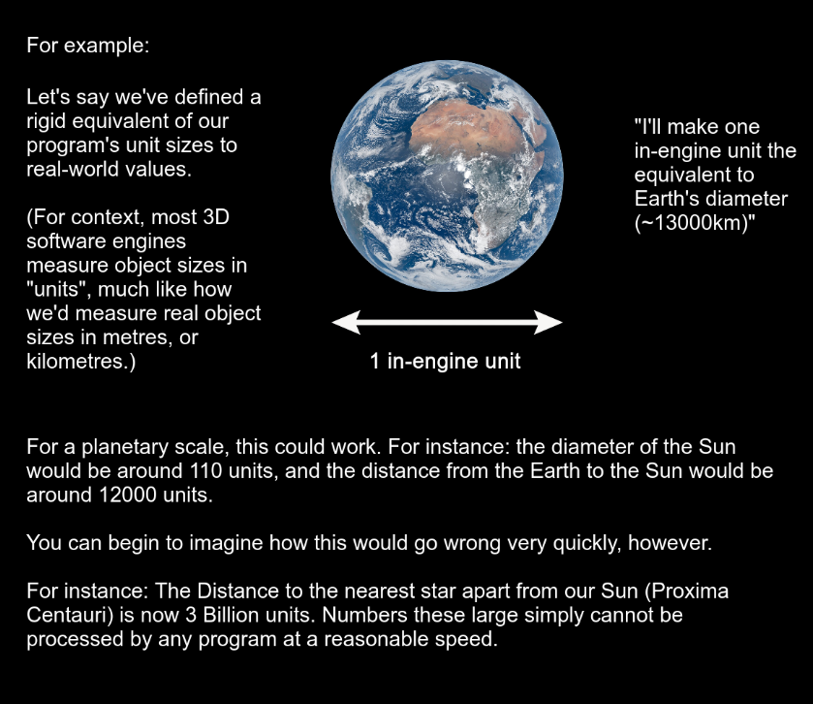
This is why it’ll be a good idea to break down this program into different, distinct game-spaces, where the engine’s unit can be assigned to a different real-world equivalent, such as light-years. (Criteria 11, 13)
A Game-Space, in the context of this program, is a distinct “world” which can be summoned into the Render (the collection of objects which are actually displayed on-screen) and removed from Render when specified.
A good example of a game-space would be in a video game.
When a character is in an outside game-space and, say, walks inside a building, the program has two choices it can make:
A: Have the interior of the building be part of the outside world’s game-space, meaning it has to be loaded in and updated even if it’s not being seen or interacted with in any way.
B: Make the interior game-space separate, and only load it in and update it when the player is inside it, and unload it once it’s stopped being interacted with, saving memory and resources.
When given these options, it’s clear which one is more suitable for a well-optimized program.

Planetary Game-Space

The Planetary game-space is where the Solar System and all of it’s objects will be contained. It is the first space loaded when started up.

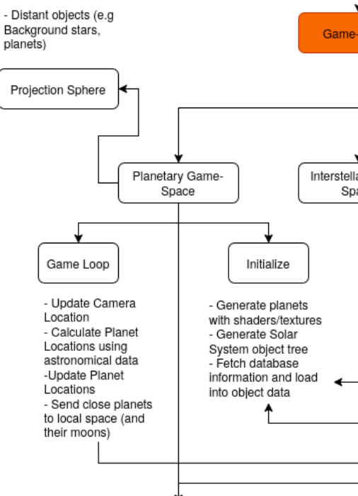
Planetary game-space
We will go over game-loop components first. The concept of a game-loop is quite simple. It’s a piece of code run fully every single frame. They’re essential to any program which requires constant user interactivity. An example of a game loop in pseudocode may be something like this:

SET BOOLEAN is_running = true
WHILE is_running:
// Changes variable “is_running”s state to false when quit
FOR event IN program.getEvents():
IF event.type = program.quit:
is_running = false
ENDWHILE
The above example runs every frame, and waits for an event in an event queue to signal the program to close, it then updates an “is_running” variable to “false”.

Camera algorithm

The first game-loop algorithm we’ll discuss is the algorithm for our free-cam (Criteria 5). This will allow the most basic interaction for the user, as it will let the user fly around the loaded scene with the most ease (as shown from our survey).
The camera (as well as all objects in the program) have distinct X, Y and Z coordinates, and XYZ rotation (or Roll, Pitch, and Yaw). These coordinates’ direction are the same for all objects, hence called “global” vectors.
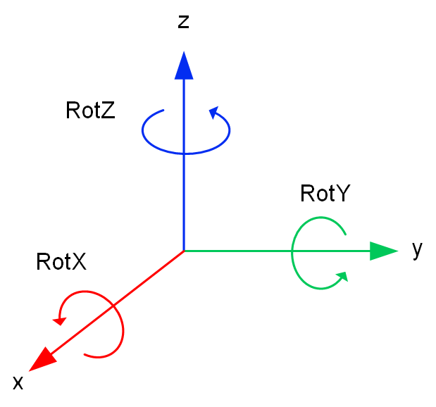
We’ll have to implement an algorithm which can take the current key being pressed, and translate it to a movement in XYZ coordinates.
Intuition first told me that I should have a direction correspond to a key input (e.g Forward -> increase Y coordinate by 1).
I quickly found out that this was unsuitable, as we’ll have to take into account the rotation of the camera itself, and translate the relative motion into global 3D vector motion.
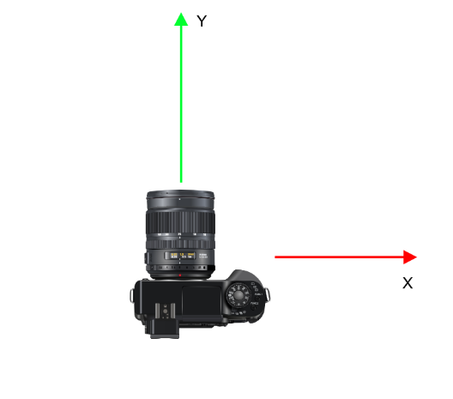
In this case, a simple script to correspond a forward input with an increase in Y would be suitable as the camera is oriented the same direction as the global vectors (In this diagram, the Z axis is ignored).
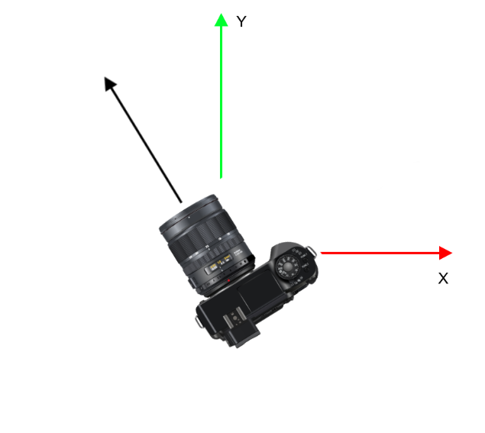
Here you can see the proposed algorithm break down, as the vector of the camera rotation is different to the global vector.
We need to translate the direction of motion from the camera’s vector into terms of the 3D game-space vectors. This can be done with trigonometry.
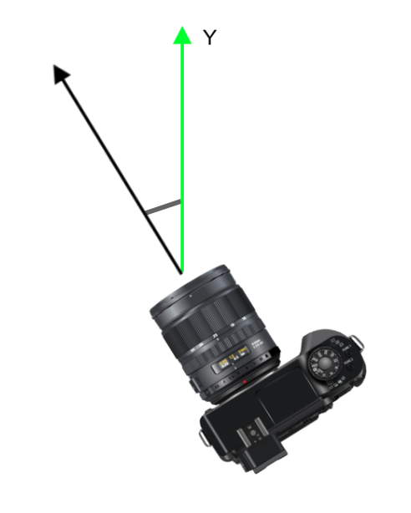
Here, the vector of the camera rotation in terms of the Y vector can be found by the formula cos(cameraZAngle), which is then multiplied by the Base movement speed.
e.g: If the angle made to the Y vector is 0 (the camera is directly facing the Y vector), the result is 1 x Movement speed, or in other words, going full speed in the Y direction. If the angle made to the Y vector is 90 degrees (or pi/2 radians), the result is 0, since it’s travelling perpendicular to the Y component and hence is not changing it’s Y position at all.
In 3D, the pitch also has to be taken into account, so it will also have to be multiplied by sin(cameraXAngle) x Movement speed, sine is used as a pitch angle of 90 degrees to the Z component (or facing forward) yields the highest possible speed in the Y direction, while a pitch angle of 0 (Or looking straight up) won’t contribute towards the Y component whatsoever.
Using this algorithm, and applying it to all possible axis of movement, I have constructed the pseudocode below. I have also created a “setting rotation” script, which translates the mouse’s x and y movements into x and y rotation on the camera object within the 3D space, to allow the camera to pan around when the mouse is moved. Z rotation is ignored for now, as a mouse cursor can only provide an input in 2D space.
Variable/Constant | Data Type | Purpose
playerMoveSpeed | float | To govern the player’s velocity – can be changed during runtime.
x_movement | float | The movement in the x component (per frame) is calculated based on user input. The x component of the camera’s position is then displaced by this variable accordingly every frame
y_movement | float | The movement in the y component (per frame) is calculated based on user input. The y component of the camera’s position is then displaced by this variable accordingly every frame
z_movement | float | The movement in the z component (per frame) is calculated based on user input. The z component of the camera’s position is then displaced by this variable accordingly every frame

DEFINE camUpdate(self):
SET FLOAT playerMoveSpeed = 10.0 // “10” here is arbitrary for the time being,
// just an example of a possible value.
SET FLOAT x_movement = 0
SET FLOAT y_movement = 0
SET FLOAT z_movement = 0 // These are all initialized to 0 since they’ll
// be calculated below
IF self.forwardButtonPressed:
SET x_movement = x_movement - playerMoveSpeed * sin(degToRad(camera.getH())) * cos(degToRad(camera.getP()));
SET y_movement = y_movement + playerMoveSpeed * cos(degToRad(camera.getH())) * cos(degToRad(camera.getP()));
SET z_movement = z_movement + playerMoveSpeed * sin(degToRad(camera.getP()));
// Here, all axis are taken into account, which gives the camera’s xyz
// rotation in terms of the global
// coordinate space. This is then multiplied by the player speed above, to
// give a final movement direction.
IF self.backwardsButtonPressed:
SET x_movement = x_movement + playerMoveSpeed * sin(degToRad(camera.getH())) * cos(degToRad(camera.getP()));
SET y_movement = y_movement - playerMoveSpeed * cos(degToRad(camera.getH())) * cos(degToRad(camera.getP()));
SET z_movement = z_movement - playerMoveSpeed * sin(degToRad(camera.getP()));
// This is almost the same as the code above for moving forward, however,
// we take the magnitude for this
// movement to be the exact opposite direction, as we’re moving backwards.
IF self.leftButtonPressed:
SET x_movement = x_movement - playerMoveSpeed * cos(degToRad(camera.getH()))
SET y_movement = y_movement - playerMoveSpeed * sin(degToRad(camera.getH()))
// You may notice z is not changed here or below. This is because it is
// not affected by x or y displacement.
IF self.rightButtonPressed:
SET x_movement = x_movement + playerMoveSpeed * cos(degToRad(camera.getH()))
SET y_movement = y_movement + playerMoveSpeed * sin(degToRad(camera.getH()))
// Opposite magnitude as left, for the same reason as the backwards
// calculation.
camera.setPosition(
camera.X - x_movement,
camera.Y - y_movement,
camera.Z - z_movement,
) // Here we update the camera position to move in the final direction
// calculated above.
camera.setRotation(
mouse.getChangeInX
mouse.getChangeInY
0
) // Here, the camera is rotated on the x and y axis depending on the
// respective change in mouse position.
END DEFINE
That was ugly, but showcased the problem with relying on more simple intuition when dealing with algorithms of this complexity. Learning how to manage relative vectors and translations with them helped pave the way to writing the algorithms we’ll see later on.
In practise, the world will actually move around the camera instead of the camera moving around the world, keeping the camera at origin (0,0,0) (explained in analysis). (Criteria 15)
Ugly as it is – this is tame in comparison to what we’ll see below.

Orbital calculations
Gone wrong – Calculus gets involved
This was the main beast I was going to encounter this program, but online resources made it surprisingly easy to understand.
When visualizing an orbit – a planet going around a star for instance – you usually picture something like this:
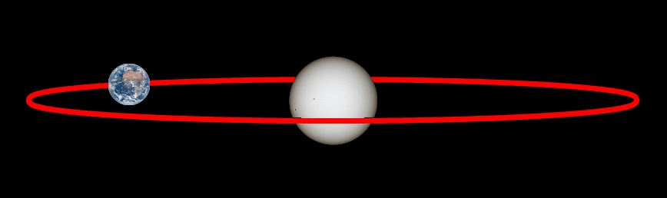
It’s not wrong to assume orbits are perfect circular paths around stars. This is what is assumed in OCR Physics, too. Assuming this, it would be easy to implement an orbit algorithm using XYZ coordinates:

DEFINE Orbit(period, radius, time): // “Period” being the time it takes to
// orbit around the Sun once, radius being the distance from the star,
// “time” being the current time.
SET FLOAT constant = time * (360/period) // This assumes period and time
// are measured in the same units, and that the trig functions are in
// degrees.
SET FLOAT x = sin(constant)*radius
SET FLOAT y = cos(constant)*radius
END DEFINE
And this would be suitable for a very basic, rudimentary program which is designed to, at most, look pretty.
However, orbiting bodies in reality have several properties – for example: orbits are rarely circular, and have eccentricity (how oval-like the orbit is), or inclination (how much the orbit is tilted from the equatorial position).
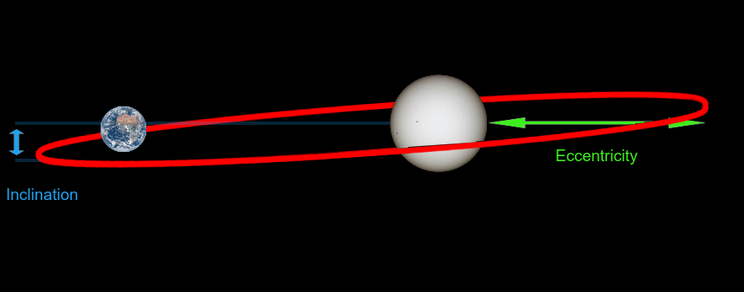
From my research, I found that 6 Keplerian constants are needed to define an object’s position in orbit:
a – Semi-major axis (the orbit diameter from the furthest point)
e – Eccentricity (How elliptical an orbit is)
i – Inclination (The tilt of an orbit to the equatorial plane)
Ω – Longitude of Ascending node (The point where an object crosses the equatorial plane)
ω – Argument of Periapsis (The orientation of the orbit)
M₀ – Mean Anomaly at Epoch (The position of the object at a certain time – an epoch)
As well as the orbital period if you want to calculate orbital position from a date:
P – Orbital period (Time taken to elapse one orbit)
We will base the “time” off of the program’s inputted time (Criteria 12)
An “Epoch” is a reference time where the position of the body was known precisely. This means that when adding a certain amount of time on from the epoch, along with the information above, you can find the object’s rough position at that given time. Epochs are measured in Astronomical Julian Date.
The Astronomical Julian Date (JD) is used to perform celestial calculations. It started at 0 on January 1, 4713 BC, and increments by 1 every day. The current time can be given with the number of days since January 1, 4713 BC + the fraction of the day passed currently.
Converting the “date” value usually stored on a computer program to Julian Date is quite easy.
The Unix time (the usual date format stored on computers) is the number of seconds since January 1, 1970. Converting these seconds to days normalizes to JD units. Then, you just add the Julian Date at the Unix epoch (2440587.5).

DEFINE UnixtoJD(time):
// Number of days since Unix epoch
SET FLOAT days_since_epoch = t / 86400.0 // 86400 seconds in
// a day
// Julian Date of Unix epoch = 2440587.5
SET FLOAT jd = 2440587.5 + days_since_epoch
RETURN jd
END DEFINE
Variable/Constant | Data Type | Purpose
days_since_epoch | float | To store the number of days elapsed from the program’s current time to the epoch time, plus a decimal for the current time of day
jd | float | The Julian Date of our current Unix time

The difficult part comes with converting the constants above to xyz coordinates using the given JD time.
We first have to find mean motion, or the average speed of the object. This is done with 2π/P.
SET FLOAT pi = 3.14159
SET FLOAT n = 2 * pi / period

Variable/Constant | Data Type | Purpose
pi | float | Approximation for the constant pi, which hopefully needs no introduction
n | float | The average tangential speed of the object in motion – named “n” to align with the scientific standard
Next, we need to find the mean anomaly (or how many radians the object has completed around the orbit) using M = M₀ + nΔt, with Δt being the difference in Julian Time between now and the Epoch.
SET FLOAT t = epoch - jd
SET FLOAT M = M0 + n*t

Variable/Constant | Data Type | Purpose
t | float | Time elapsed since epoch in JD format – named “t” to align with the scientific standard
M | float | The number of radians the object has travelled since epoch – named “M” to align with the scientific standard
This has to be in the range 0 < M < 2π, so it has to then be normalized:
SET M = M MOD (2*pi)
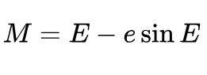
Next, we need to solve Kepler’s equation:
Coincidentally, this equation is famously “unsolvable”, which is that it cannot be expressed for E with a simple equation. However, we can get an estimate to the answer of this equation using “Newton-Raphson iteration”.
The Newton-Raphson method is this formula:
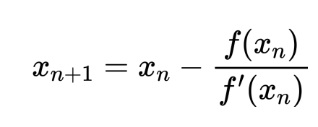
Plugging in Kepler’s equation, with the top of the fraction being the function while the bottom is the derivative with respect to E gives us this:
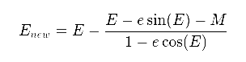
This then needs to be iterated. It would possibly make sense to use a simple “for” loop, but in mathematics, we typically want the precision to be in a certain range. e.g: |E_{new} – E| < 10⁻⁶.
Putting this iterative equation in pseudocode:
DEFINE solveKepler(M, e, tol=1e-10, max_iter=100): // Here, max_iter makes
// sure we don’t spend too much time calculating, as this method can be
// inefficient for high eccentricities
SET E = M
FOR i in range(max_iter):
SET FLOAT f = E - e * sin(E) - M
SET FLOAT f_prime = 1 - e * cos(E)
SET FLOAT delta = f / f_prime
SET E = E - delta
if abs(delta) < tol:
BREAK
RETURN E
END DEFINE

Variable/Constant | Data Type | Purpose
e | float | Eccentricity. This is assigned from the object’s orbital attributes
E | float | To put it simply: the value being refined to approximate the equation. It is set to M at the start of the function, which is usual for Newton-Raphson
Once eccentric anomaly E has been found (or estimated to a close-enough error), it can be substituted into this equation to find the True Anomaly (v):
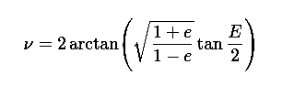
In pseudocode:
SET FLOAT nu = 2 * arctan(2*(
sqrt(1 + e) * sin(E / 2),
sqrt(1 - e) * cos(E / 2)
)) // e here being eccentricity, and E being eccentric anomaly.
Variable/Constant | Data Type | Purpose
nu | float | True Anomaly. “nu” is the name of the symbol, similar to “pi”
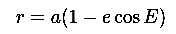
and the distance from the parent body – r – can be found with this equation:
and hence the 2d coordinates on the orbital plane can be found with this:
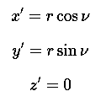
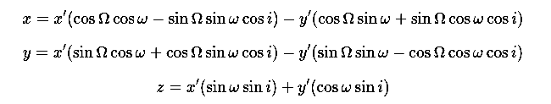
However, we need to convert these into 3d coordinates, this can be done with the following transformation:
Converting this all into pseudocode:
// Distance from focus
SET FLOAT r = a * (1 - e * cos(E))
// Position in orbital plane
SET FLOAT x_orb = r * cos(nu)
SET FLOAT y_orb = r * sin(nu)
// Precompute trig calculations (to save computing time)
SET FLOAT cosO = cos(Omega)
SET FLOAT sinO = sin(Omega)
SET FLOAT cosi = cos(i)
SET FLOAT sini = sin(i)
SET FLOAT cosw = cos(omega)
SET FLOAT sinw = sin(omega)
// Translate to 3D space
SET FLOAT x = (cosO*cosw - sinO*sinw*cosi) * x_orb + (-cosO*sinw - sinO*cosw*cosi) * y_orb
SET FLOAT y = (sinO*cosw + cosO*sinw*cosi) * x_orb + (-sinO*sinw + cosO*cosw*cosi) * y_orb
SET FLOAT z = (sinw*sini) * x_orb + (cosw*sini) * y_orb
RETURN ARRAY [x,y,z]

Variable/Constant | Data Type | Purpose
a | float | Semi-major Axis, should be given in AU.
r | float | Distance from planet body in AU.
cosO,sinO,cosi etc... | float | Precomputed trig values which are repeated heavily in the calculation below. Specified before to avoid calculating them multiple times unnecessarily
x | float | Final calculated “x” coordinate, in AU
y | float | Final calculated “y” coordinate, in AU
z | float | Final calculated “z” coordinate, in AU
[Returned values] | array | Return an array of the planet coordinates in form (x,y,z)
Having this modular code allows us to input the properties of virtually any planet or moon, and have it easily be converted into an in-game object. This will easily streamline our development and allow for a CSV database to be directly imported to spawn objects in our scene! It may also possibly allow users to easily manually add new objects into our program.
When showcasing this to my client, he clarified he’d like a visualisation of orbits in the program.
Orbits can be drawn by calculating the position of a body at intervals throughout the year, and connecting them with lines. At the end of a year (a full orbital period), the orbital path will be complete. The smaller the interval, the more detailed the orbits will be. Here’s a basic example in pseudocode:

SET INTEGER resolution = 20 // A nice number for an orbit visualization
SET FLOAT year = planet.orbitalPeriod
SET planet.pathDrawer = true
FOR i IN resolution:
SET time = JulianDate(epoch + i * (year/resolution))
planet.drawTo(calculateOrbitalPosition(time))
SET planet.pathDrawer = false

Variable/Constant | Data Type | Purpose
resolution | integer | The “resolution” of the orbits, how divided the path is into separate points. Lower resolution ⇒ Less points ⇒ Less detail
year | float | The planet’s orbital period in days
time | float | The time that would be required for the planet to be in the position of each point in the orbit path – incremented

Rotational calculations
For this program, I will be abstracting the rotational characteristics to a simple 1-axis rotation.
We simply take the current Julian Date, the Epoch, the rotation angle at Epoch (in Radians) and the rotation period in days.
The difference in time is calculated:
SET FLOAT t = epoch – jd
Then, the change in angle per day is calculated:
SET FLOAT Wdot = 2 * pi / rot_period
Then, the resulting angle after the difference in time:
SET FLOAT W = W0 + Wdot * t
Which can be MOD by 2π, as it is currently in an unnormalised format:
SET W = W MOD (2 * math.pi)
This gives a planet’s current rotation in radians (which can be converted to degrees if needed).
This is a fairly simple algorithm, however can lead to inaccuracy (e.g: Uranus rotates on a 98° angle). For the scope of our program, however, I feel this is a suitable level of abstraction, as it is satisfactory enough for the user to identify the day/night cycle of a body.

The Stellar Game-space
The stellar game-space is going to be separate, and have a different scaling system to the planetary scene. It will be around 1 unit = 1 ly.
Once a certain distance from the origin of the planetary game-space, the Planetary space is unloaded, the Stellar space is loaded in and the position and speed of the camera is adjusted to reflect the unit system of the stellar space.
e.g In planetary space:
SET FLOAT conversion_ratio = 1/63241.1 // This is how many light-years are
// in an AU.
IF distance(sun, camera) > 1000:
camera.setPosition(camera.getPosition * conversion_ratio)
camera.setSpeed(camera.getSpeed * conversion_ratio)
… Switch game-spaces …
Once the stellar space has been loaded in, it is best to use a grid-based spatial partitioning algorithm.
A grid-based spatial partitioning algorithm divides objects or points in a (in this case, 3d) space into distinct cells, which can be loaded or unloaded when needed. This is best-suitable for our program, as loading individual cells which are close to the camera instead of all objects at once can save memory and resources.
Here is how we would partition objects in a 3d space with a given cell size:
SET ARRAY gridSize = (WorldWidth / CellSize, WorldHeight / CellSize, WorldLength / CellSize)
SET ARRAY Grid = 3dArray(gridSize, []) // Here, we make an empty array for
// the objects
// Here, we calculate which cell to add the object to using it’s coordinates
FOR Object IN World:
SET INTEGER cellX = floor(Object.x / CellSize)
SET INTEGER cellY = floor(Object.y / CellSize)
SET INTEGER cellZ = floor(Object.z / CellSize)
Grid[cellX][cellY][cellZ].add(Object)

Variable/Constant | Data Type | Purpose
gridSize | array | This list (1D array) will help give the dimensions of the world in terms of cell units
cellX | integer | This points to a location on one dimension of the 3D array
cellY | integer | This points to a location on one dimension of the 3D array
cellZ | integer | This points to a location on one dimension of the 3D array. With all 3, a certain element in the array can be specified
Now that we’ve divided the objects into partitioned cells, we need an algorithm to know which cells to load in given the camera’s location.
SET INTEGER camCellX = floor(Camera.x / CellSize)
SET INTEGER camCellY = floor(Camera.y / CellSize)
SET INTEGER camCellZ = floor(Camera.z / CellSize)
FOR x FROM camCellX - renderDistance TO camCellX + renderDistance:
FOR y FROM camCellY - renderDistance TO camCellY + renderDistance:
FOR z FROM camCellZ - renderDistance TO camCellZ + renderDistance:
SET INTEGER dx = x - camCellX
SET INTEGER dy = y - camCellY
SET INTEGER dz = z - camCellZ
IF (dx*dx + dy*dy + dz*dz) <= renderDistance^2: // Sphere formula
Render cell
Variable/Constant | Data Type | Purpose
camCellX | array | This points to a location on one dimension of the 3D array
camCellY | integer | This points to a location on one dimension of the 3D array
camCellZ | integer | This points to a location on one dimension of the 3D array. With all 3, a certain element in the array can be specified
dx | integer | This is the distance in 1 axis between the camera and the cell
dy | integer | This is the distance in 1 axis between the camera and the cell
dz | integer | This is the distance in 1 axis between the camera and the cell
This algorithm essentially goes through each cell, and calculates whether the cell is in a certain spherical range from the camera.
This is a game loop function – and is also an expensive function, but only really needs to be called every second or so, since it’s unlikely the camera will be moving multiple cells a second.

The Local-Space
This is a feature which will aim to parent very distant objects (e.g other stars, distant planets) to the camera, and have it follow the camera at a set distance as to not interfere with the scene, but simultaneously give the illusion of immense distance. (Criteria 14)
Once an object is close enough to render in-scene, it is switched to the scene.
// Let’s assume we have an object which may be far enough to be in local-space.
SET FLOAT distance = object.getIntendedDistanceFromOrigin()
SET FLOAT boundary = 1000.0 // This should be changed to the maximum
// distance the engine can allow
IF distance > boundary:
object.setGameSpace(localSpace)
object.updatePosition = false // Since we want the object to appear
// stationary, it will not update it’s position.
ELSE: // If the object is close enough to be in the main game-space again:
object.setGameSpace(gameSpace)
object.updatePosition = true // Now we want the object to appear to move.

Variable/Constant | Data Type | Purpose
distance | float | The distance an object should be – the distance we want it to be faked at
boundary | float | The maximum distance an object can truly be from the camera in terms of coordinates
In practise, this will create a physical “sphere” around the camera where distant objects are stored.
Sometimes, you want an object to move, and appear to be distant at the same time whilst still being within a certain range from the camera.
In this case, position can be calculated normally, then converted to a point on the sphere with this equation:
SET FLOAT distance = object.getIntendedDistanceFromOrigin()
SET FLOAT x2 = object.getX()
SET FLOAT y2 = object.getY()
SET FLOAT z2 = object.getZ()
SET FLOAT radius = 1000.0 // Arbitrary for example
IF distance > radius: // Check if it’s too far, else it stays in place.
object.setPosition(
((radius*((x2)/distance)),
(radius*((y2)/distance)),
(radius*((z2)/distance)))) // This will move the object to our render
// sphere.

Variable/Constant | Data Type | Purpose
distance | float | The distance an object should be – the distance we want it to be faked at
radius | float | The maximum distance an object can truly be from the camera in terms of coordinates – the radius of the sphere in this case

2.3 the Node Graph
Most 3D engines use a node-graph, which is essentially a tree of classes and objects. In our program, objects will have the following node-graph:
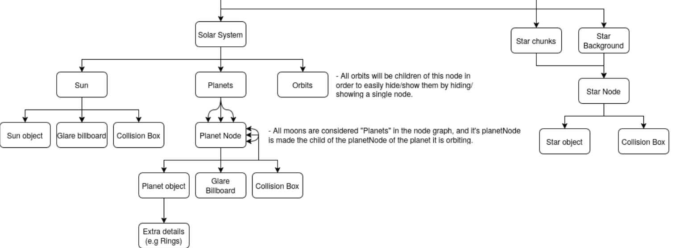
To break this down, we will have 3 distinct objects:
- The Sun Node
- Planet Nodes
- Star Nodes
The Sun Node will have these children:
- The “Sun object”, which is the actual textured sphere to convey the Sun.
- The “Glare billboard”, which is present in all objects.
- The “Collision Box”
The Planet Node will have these children:
- The Planet object, which can contain other children for planetary details (e.g Rings)
These will have shaders, to give an atmospheric appearance (Criteria 2-4)
- The Glare billboard
- The Collision Box
The Star Node will have these children:
- The Star object
- The Collision Box

What is a billboard?
The “glare” effect of an object, such as the Sun, can be achieved in a few ways.
A complex shader can be programmed to generate a glow around certain objects, which is sometimes done for more ambitious games.
However, this glare effect can easily be faked with a “billboard”.
A "billboard" object is (usually) a flat, textured plane that always faces the camera. This means that it appears 2D while the program is run, even though it’s technically a 3D object in space.
If the billboard is textured with a glow, it can be used to convincingly fake a “glare” effect if it is placed in the same 3D coordinate as the object which is meant to be glowing.
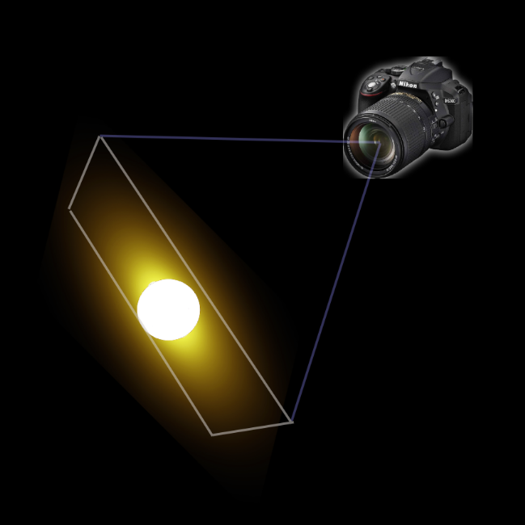
Here, the 2d “glow” billboard is facing the camera, so will appear normal in-game.
The “glare” for planets will not be visible when close to them. However, once far away, the planets can be unloaded apart from the glare node, which makes the planets appear as star-like dots in the sky, much like in real-life. This also saves on resources.

What is a Collider?
A collider object is a simple object which defines the physical shape of another object when a “collision” is made. The reason this can’t simply be the object that is being collided with is that if geometry is too complex, the object will have to do many calculations on all polygons, which may not be necessary.
In the case of our program, Criteria 8 will need us to allow a click-to-select function for the user.
If the user clicks very near to an object, but not having the cursor physically touch it, not having a collider would mean that the selection is ignored, even if it’s clear that the user means to select an object. A separate collider (e.g: an invisible box slightly bigger than the actual object) gives a boundary where the user can click near an object, and still have the game understand the intended selection. This will help with ease-of-use and user interactivity, especially when an object is far away and only a few pixels in size.

2.4 User Interface + Usability Features
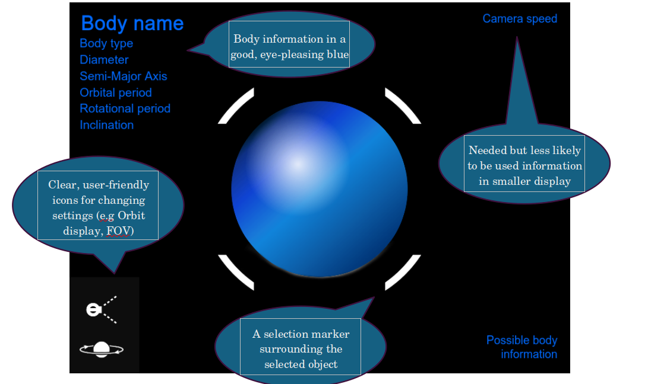
(Success Criteria 6 and 7 _{>:)} ) Object data from the currently selected object will be displayed to the user, and will be fetched from the object data (which is fetched from a database)
I want bold, stand-out colour, clear writing for the display – as well as easily understandable selectable buttons for UI/Scene settings to give the best ease of access for our user.
For ease of access to our user, I also want to possibly implement instructional UI which briefly explains navigation when starting the program. (Criteria 16)
When asking my Client, he gave the following:
“This looks good so far, but maybe we could have extra information to help my students perform calculations, maybe the mass of the body, for example.”
In this case – we may want to have brief misc. information per object. This can help with our teaching aspect and allow users who may be students to apply our information to studying planetary calculations.
All UI must be concise, informative, and consistent in theme to maximise clarity to the user.

Validation
Of course, validation of user input is required for this program.
Presence checks may be done with selection and displaying an object’s info to make sure an actual body has been selected before attempting to display it’s information – this will avoid possible errors and/or crashes when trying to fetch information from a null object.
A range check will be done for values of FOV, Camera speed etc. To ensure the input isn’t a game-breaking value (e.g a speed of -10, or an FOV of 0)
Validation will also be applied to the database when reading and importing it into the program. Data type validation needs to be carried out (e.g, the radius of an object is a float) to make sure no fatal errors occur when handling an unexpected data type.

2.5 Databases
There will be 2 databases in this program (Criteria 10). They are unrelated in contents and as such, will not be relational and be stored in a simple CSV file from which it will be read from.
- A Planetary database
This will store all information needed to calculate a body’s position, size and rotation. It will also contain extra data for the user in a string, which can be passed to the program when needed to be displayed.
Object Name (string) | Parent Body  (string) | Epoch Time  (integer) | Semi-Major Axis  (float) | Eccentricity  (float) | Inclination  (float) | Longitude of ascending node  (float) | Argument of periapsis  (float) | Mean anomaly at epoch  (float) | Orbital period  (float) | Rotational period  (float) | Misc. info  (string)

- A Stellar database
This will be significantly larger (more objects), and have all info needed to calculate a star’s position in 3D space and the night sky. It will also contain the star-type to accurately colour the star, as well as it’s magnitude to pass to the glowing filter.
Object Name (string) | Right ascention  (float) | Declination  (float) | Distance from Sun  (float) | Luminosity/Magnitude  (float) | Star type (string)
(A reliable database we could use is the HYG Database. It contains local stars to us and also has all the data we need. Extracts from it are also given in CSV format.)
When the program is launched, the databases will be read from, and used to import Solar objects linearly – in the case of the planetary database.
For the Stellar database, we may split up the database into “caches” on launch, with each individual chunk corresponding to a certain cell in the spatial partitioning algorithm. This can make loading cells incredibly fast, as we don’t need to search through the whole database per-load.

2.6 Testing
Testing is crucial to see if the proposed criteria have been met and work as intended. They will be used on each individual function in the program. Iterative testing will be done with my client’s input in order to give the desired final product for this program.
The test plans will be based off of our proposed design, and the features we will want to implement.
In-development tests will ensure our program is fundamentally working as expected, and is currently meeting our expectations without clear error.
Post-development tests will focus on our user experience, and make sure that our program is best suited for our stakeholders and our client.
Here are tests we can do to ensure that these features are present, and that the proposed design of our program has been met – generally starting from most basic, to most complex:

Development Test Plan
Number | Test | Expected result | Justification
1 | Open Python file with Panda3D startup | Panda3D can summon it’s environment | To allow for the program’s creation
2 | Request to create an object | An object can be added to the node graph with a desired mesh (shape) | To allow for basic custom object creation in the environment
3 | Set up a camera facing the object | The object is visible through a viewport | This is the most basic test – to see if we can physically spawn in objects.
4 | Input displacement from keyboard controls (WASD) | An interactive, bug-free camera movement system which can respond to user input | Here, we introduce basic user interactivity. This will also allow us to get different viewing angles and camera positions for later testing and debugging.
5 | Input rotation from mouse controls – attempt to pan the camera with a mouse | An interactive, bug-free camera rotation system which can respond to user input – the mouse is able to stay in the centre of the screen | We aim to be able to use the mouse as an input, by calculating it’s movement
6 | Input a suitable speed for the camera | Range check validation makes sure that unsuitable input values are accepted | This is to allow users to input speed in a suitable range
7 | Input an unsuitable speed for the camera | Range check validation makes sure that unsuitable input values are discarded | This is to make sure the user cannot input any game-breaking values which may cause bugs when incredibly low/high
8 | Select an object | A visual marker appears on the selected object. Nothing happens when selecting empty space | This is to allow user selection of objects
9 | Select an object with descriptive tags | A UI displays relevant information | This is to allow users to have a basic interface with the program, and allow database info to be accessible in an engaging format.  Usability Feature
10 | Select empty space | Nothing happens when selecting empty space – the selection is ignored and invalid | To make sure nothing goes wrong when the “selected object” variable is null.
11 | Input: Test data for planet calculations along with JD time | An accurate XYZ coordinate and rotation is given for the planet given the planet data and current JD time | To allow for planets in our program to be accurately positioned – small-scale test of accurate positioning at first
12 | Load Star database | The stars can be read, and it’s data used to create objects with realistic attributes | This will provide the stellar portion of our program. This is requested by our stakeholders: Survey question 3.3
13 | Load planetary database | The planets can be read, and it’s data used to create objects with realistic attributes | This will provide the planetary portion of our program. This is requested by our stakeholders: Survey question 3.3
14 | Summon star objects | They are created in the scene, are clear, correctly places/coloured and are selectable – giving the attributes fetched from the database to the user though a UI. | This allows for user interaction with our visualised stellar database
15 | Summon planet objects | They are created in the scene, are clear, have correct textures, scale, moons and shaders applied – as well as possible extra characteristics such as rings. They are selectable – giving the attributes fetched from the database to the user though a UI. | This allows for user interaction with our visualised planetary database
16 | Request orbit rendering given the same inputs as a planet summon | Orbits can be calculated – this will be achieved with having points in the orbit connected with a drawer, making an orbital path for each celestial body. | My client has specified that orbits must be implemented
17 | Toggle orbit paths from user input (UI and keyboard shortcut) | Eye-pleasing, non-buggy, accurate orbit paths for celestial objects | As per request of my client, we also want to implement orbit path generation and display
18 | Request multiple object summons from inputting database records | The objects are added to the scene and behave as expected, retain the information in the databases | To allow for automatic, database-driven generation of celestial bodies
19 | Adjust time | Object locations and rotations update accordingly | Stakeholder survey indicated that time should be adjustable for the program, to allow for viewing past/future celestial positions
20 | Input a camera position far enough where a singular coordinate system is impractical | The coordinate system is updated and the environment is scaled accordingly | This will allow our user to interact with more distant objects, where having them in the same game-space as closer objects is impossible or impractical
21 | Launch the program | Some form of intuitive documentation/a tutorial is provided | Stakeholder survey indicated that new users should have some form of tutorial for easy accessibility

Post-Development Test Plan
Number | Test | Expected result | Justification
1 | Allow user to boot up program | Program opens smoothly – possibly with a loading screen to indicate program status to the user. | ...To be able to use the program.
2 | User opens program for the first time | User is greeted with short help on using the program | To allow the user to know how to begin program interaction.  Survey question 3.7
3 | User attempts to input world movement | The camera responds as expected, in a free-cam setting. | Basic user interactivity for movement of the camera.  Survey question 3.4  Research; Program 4
4 | User attempts to adjust camera rotation with a mouse | The camera can be adjusted in rotation by using the mouse, responds as expected | Basic user interactivity for movement of the camera.  Survey question 3.4  Research; Program 4
5 | User attempts to select an object | The program can successfully identify the intended selection | Research; Programs 1+2+3
6 | User summons UI from object selection | The UI should always give concise, clear and accurate data | Survey question 3.2  Research; Programs 1+2+3  Usability Feature
7 | User selects empty space | A presence check is performed - the selection is not processed to avoid errors with a null value | This is to avoid dealing with null values, which may return errors due to no presence found.
8 | User attempts to use UI/keys to toggle orbit paths | The orbit paths appear as intended | Survey question 3.2  Client question 3
9 | User attempts to interact with distant objects | The coordinate system is updated to reflect the new scale our program is running in | To allow our user to fly to and view distant objects easily and without visual error. Discussed above.
10 | User inputs suitable values for the camera speed from keys | The camera speed is adjusted accordingly – the speed is shown in the UI | Allow the user to explore the program practically – the distances can be incredibly large
11 | User inputs unsuitable values for the camera speed | The program performs a range check to avoid game-breaking user inputs | Allow a smooth program where the user cannot accidentally (or intentionally) create errors easily from input
12 | Time is adjusted by the user | Object locations and rotations update accordingly | Survey question 3.6  Research; Programs 1+2+3
13 | User is running the program on a computer with the specified requirements (or higher) | FPS is stable, preferably 30 or above at all times in the program | To allow use of the program to be smooth, with fast response times

Development

3.1 Introduction to Panda3d

Panda3D is a free, open-source game-engine developed by Disney and CMU University. It’s back-end runs on C++ and has Python as the intended game-engine language.
Panda3D does the unpleasant work of 3D rendering for the user in an efficient, compiled environment, and exposes it’s functionality for the user to program.
Python in Panda3D requires a lot of OOP, so nearly all algorithms will be separate methods within classes.
To begin with installing Panda3D, I used pip package manager to install it on my machine:
I first create a virtual environment:
and I can see the venv files within the folder:
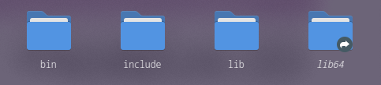
I then source from “activate” the venv python:
and install Panda3D using pip on the venv:
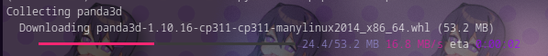
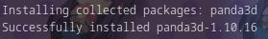
Panda3D has been succesfully installed.
Number | Test | Expected result | Achieved?
1 | Install Panda3D in a virtual environment | Panda3D source created in venv | Yes
For a basic, blank scene within Panda3D:
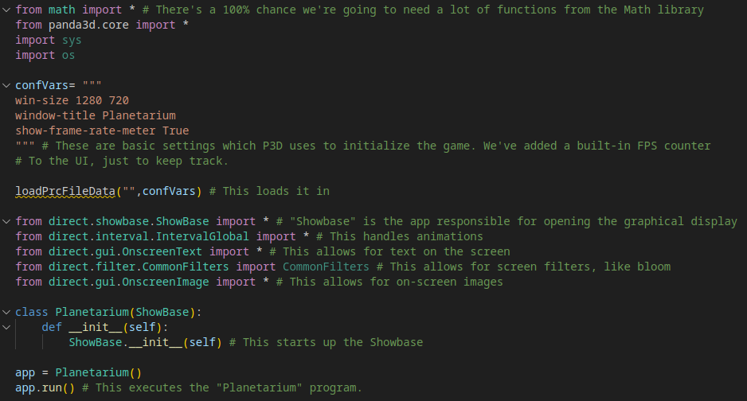
Here, we import the needed libraries, mainly Panda3D’s core, as well as math (for obvious reasons), sys and os. We feed config variables assigned at the start of the program for window size, the window title, and a visible frame-rate meter.
We import the needed Panda3D libraries for the graphical display, animation handling, onscreen text and images, and finally, a filters library for on-screen filters such as bloom.
We then create a Planetarium class, with an init method which is executed upon the creation of the program, this simply starts up the “ShowBase” – the window where all of Panda3D’s visuals will appear. The app is then run.
Then, we have life!
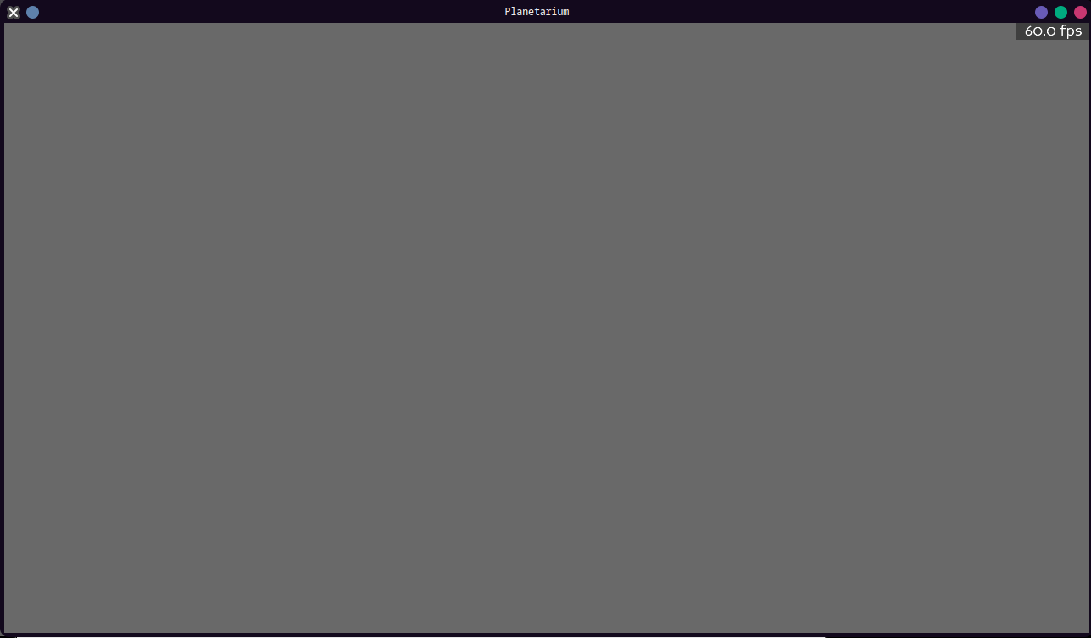
(Do you like my custom desktop colours?)
We’ve successfully called Panda3D in our Python file.
Number | Test | Expected result | Achieved?
2 | Open Panda3D’s environment from Python | Panda3D can summon it’s environment | Yes
We’ve run the window where all of our program will be seen through! It contains both a 3D space, and a 2D overlay where UI can be placed.
However, space is black, so let’s make our space black too…
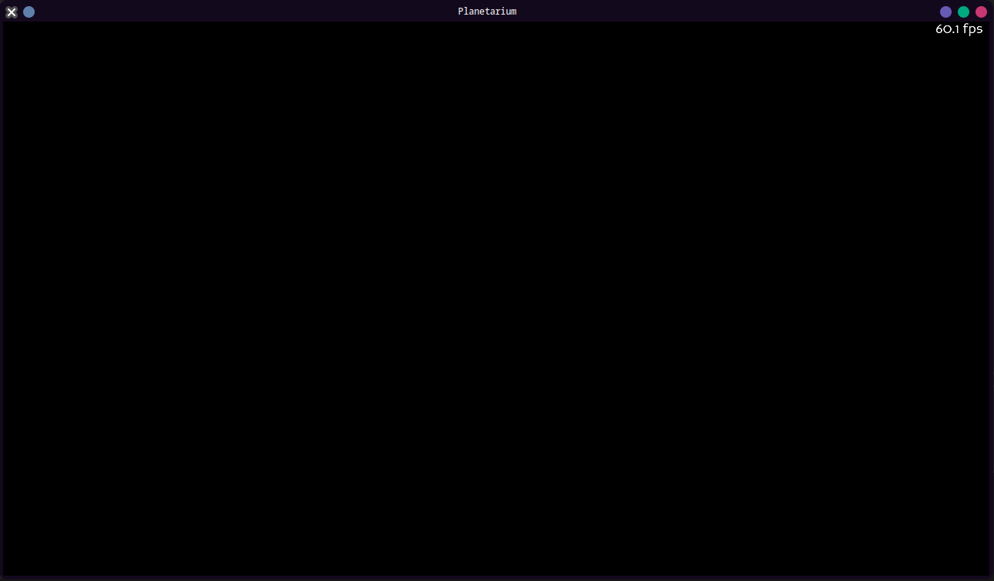
and the boring result:

3.2 A Sun
Let’s first attempt to make The Sun.
We’ll try to spawn in a sphere. Object creation in Panda3D is amazingly simple. We can use some built-in functions to spawn nodes (the concept of a “Node” was explained in Design), models and textures!
First, we need a sphere object – which has to be made manually and imported into Panda3D for it to reference.
Panda3D reads special, 3D object files called “.egg” files, and annoyingly is the only program to use this format as far as I know.
I don’t understand how they work too well, or how to create and manipulate them (even though they’re stored in a human-readable format). Luckily, the Panda3D repository supplies free .egg files for basic shapes, including a sphere!

It has a UV map too. A UV map essentially instructs how to apply a texture to an object, and where each polygon corresponds to in the texture.
For example, different projections of an Earth map can be seen as different “UV maps”, in this case applying the 2D texture of the Earth to a 3D ball in multiple unique formats:

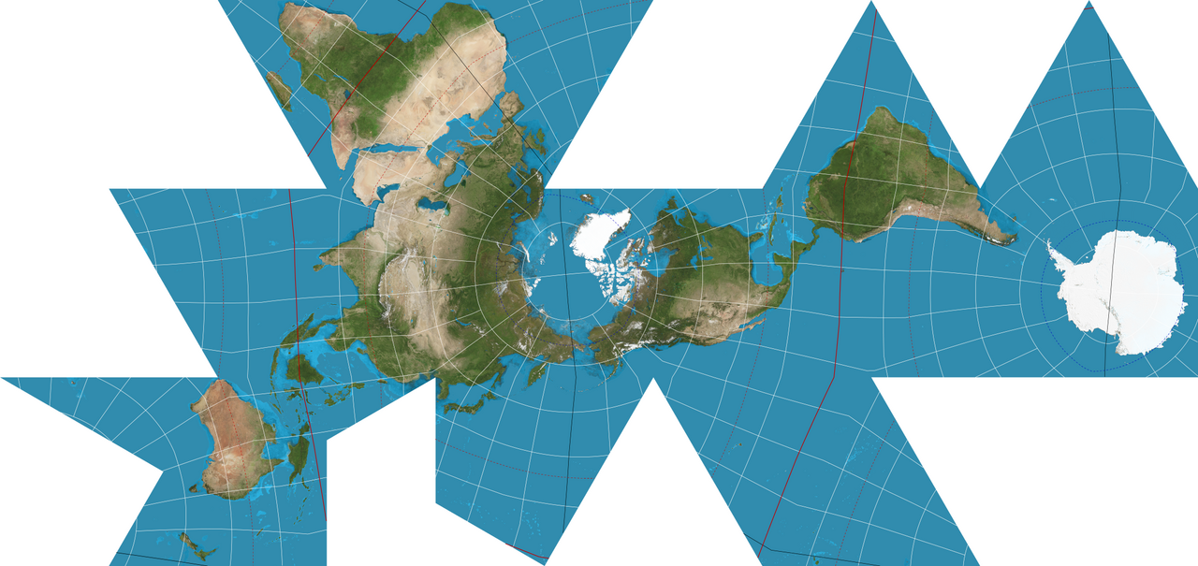
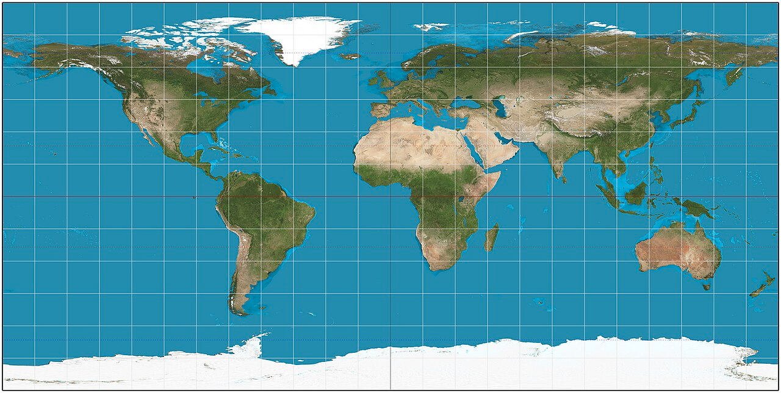
An Equirectangular projection (which is the UV projection we are using) vs a very unique “Dymaxion projection”, which though completely valid as a UV map, looks a bit strange.
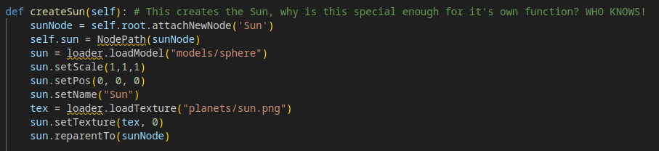
Here, I’ve created a basic function to spawn in a “Sun”. This creates the “Sun Node”, attaches a sphere object to it (from a models folder I made earlier and copied the .egg file into) and applies a texture to it. This is applied to a “root” node which is created during initialization and serves as the container for the map, so it can be easily moved around the camera.
I’ve created an easy way to refer to the node path of the Sun Node as “self.sun”, as the Sun Node will be referred to a lot in this program.
This is then called in the init along with the creation of the root:
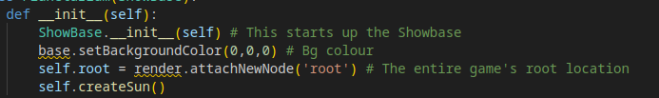
Which results in absolutely nothing, because I then realised our camera is actually inside the Sun, at (0,0,0).
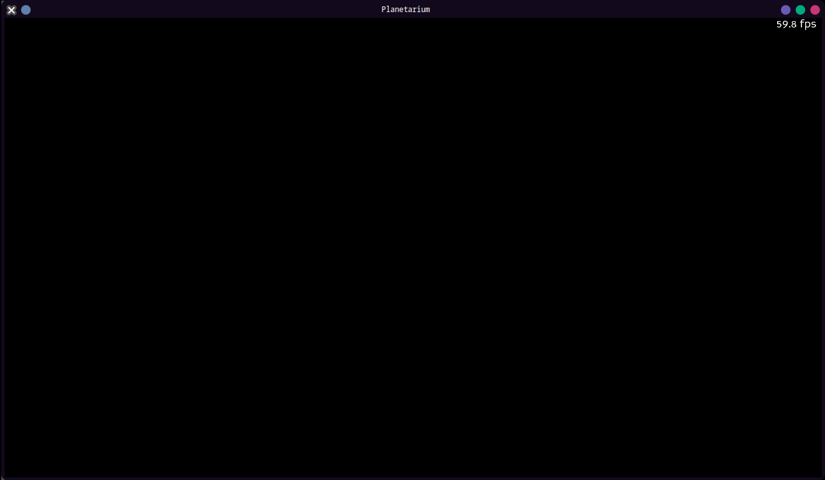
Luckily, Panda3D comes with a built-in camera system for previewing your scene just before you add your own, so we can zoom out for a good view:
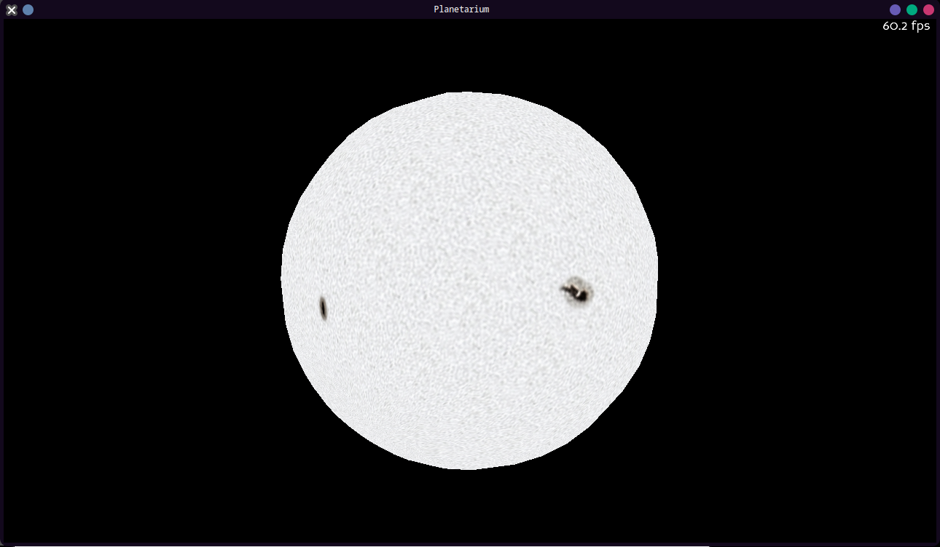
Progress!
We’ve successfully managed to 1. create an object 2. that is visible to the viewport and 3. has a custom mesh and is textured – we have achieved 3 of our tests in just a few lines of code.

Number | Test | Expected result | Achieved?
3 | Request to create an object | An object can be added to the node graph with a desired mesh (shape) | Yes
4 | Set up a camera facing the object | The object is visible through a viewport | Yes
5 | Be able to set attributes to an object (a Mesh, texture, scale...) | A textured, scaled mesh is now visible through the window/viewport | Yes
(It won’t be this easy to achieve our tests onwards)

3.3 A Camera
Next, we’ll be adding our custom camera system.
We need to first remove the current default camera system using – just an aside, the worst name for a method I have ever seen – “disableMouse()”.
Yes, the “disable mouse” method is actually for disabling the camera.
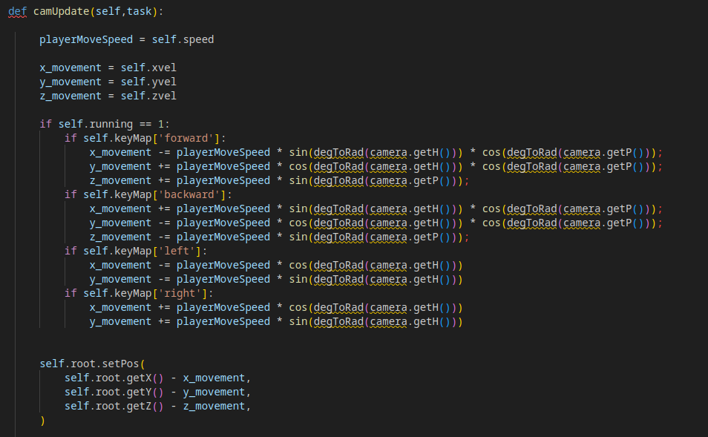
Next, we’ll implement the pseudocode from Design for our camera, at first virtually 1:1, with the “camera” object being Panda3D’s camera
The code to adjust the rotation of the camera depending on mouse movement was a bit more difficult, here’s a commented screenshot of the code:
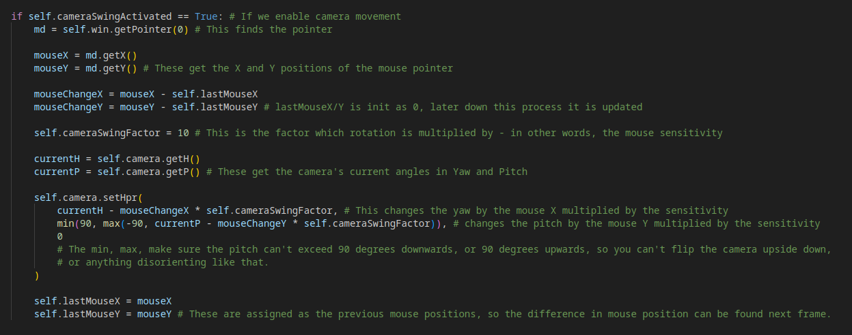
and for this to repeat every frame, it needs to be made into a “task”.

Panda3d Tasks
A bonus about Panda3D is that it has a built-in, easy-to-use Task Manager.
For a method to be added to the Task Manager, you can use this line of code:
taskMgr.add(exampleTask, 'TaskName')
Where “exampleTask” is the method’s name.
In the method itself, the line “return task.cont” should be appended at the end of the method to signal the task to be run again. This is put at the end of the camera code.
(If you want to remove a task, just use:)
taskMgr.remove('TaskName')

We simply take the camera update code and put it into a method called “camUpdate”. We add it as a task in the init and let it run:
- as well as initializing the self.lastMouseX and lastMouseY variables in the init through another function before the task is run, along with activating camera swing, and locking the mouse in-place in “relative mode”, where only it’s attempted movements are reported as the mouse is in the centre at all times. The mouse is also hidden.
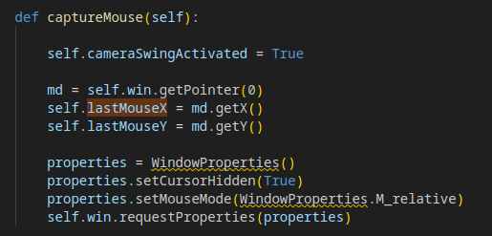
This can also be changed to a “release” function, where the mouse is free-to-move (for UI clicking or exiting the program) which can be run at a button press, if we desire.
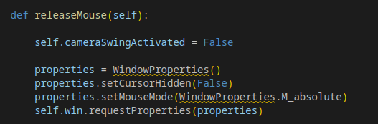
Upon running the program, it worked as expected – mostly.
My test for being able to run game-loops had succeeded:
Number | Test | Expected result | Achieved?
6 | Allow game-loops – specifically testing a moving camera for this stage of development | A game loop is created, and allows adjustment of attributes, variable values over time during the program runtime. | Yes
However, my test for a functional camera system has not yet been met – as I noticed that the speed and sensitivity of the camera was way too high. I was going to lower the variables defined for these values – until I realised a problem I would have to overcome as a programmer:
The camera movement is tied to the FPS of the program.
That means that instead of the camera moving x units per unit time – or at a constant speed – it moves x units per frame, which can be inconsistent depending on how well the program is being run.
This is a problem a lot of developers at Bethesda frequently miss, and can seriously impact the user if they’re running at a frame-rate you don’t expect as a developer.

Number | Test | Expected result | Achieved?
7 | Input any form of movement (e.g WASD), as well as keybinds for speeding up/slowing down camera speed. | An interactive, bug-free camera system which can respond to user input | No
Luckily – Panda3D, in all it’s glory – has developed an easy solution to this problem.
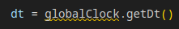
This function returns the time since the last frame was drawn. When multiplied by the speed we have originally, it gives a steady speed which remains constant no matter the frame-rate. This can be applied to the camera sensitivity too.
Our amended code:
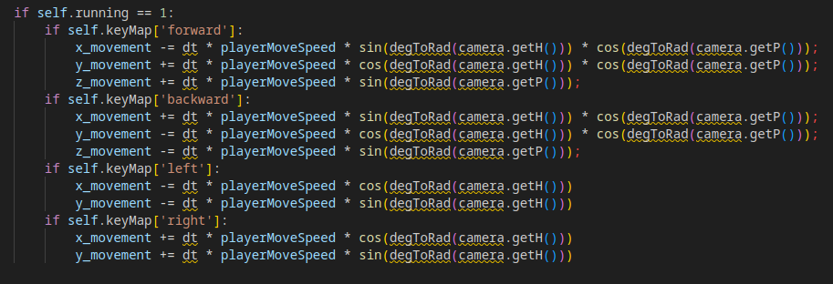
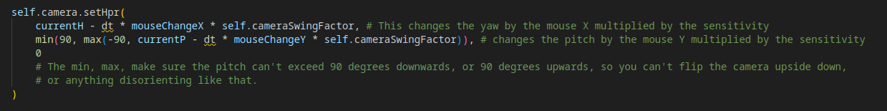
Which runs as expected, allowing a stable movement speed separate to FPS.
Number | Test | Expected result | Achieved?
7 | Input any form of movement (e.g WASD), as well as keybinds for speeding up/slowing down camera speed. | An interactive, bug-free camera system which can respond to user input | Yes
You may have also noticed “keyMap”s in our program. This is because, in a method called “setupControls”, I’ve assigned controls to instructions in a list called “keyMap”, which pairs keyboard inputs to methods.
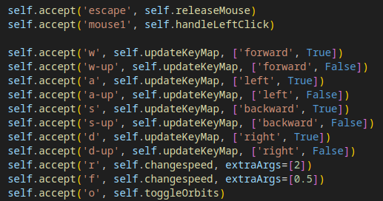
(There’s also some other keyMaps for later, which I’ve just assigned to blank methods)
Here’s the way I update Key Maps:
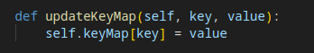
I also added a “changespeed” function which, as you expect, changes the speed:
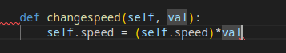
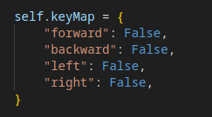
And when assigning the movement Key Maps at init, the camera now works as expected.
You may have noticed that I am using a “handleLeftClick” function. This is because “handleLeftClick” will capture the mouse, and also select an object.
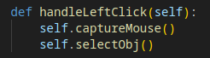

3.4 Object selection
Selecting an object will be done by “raycasting”.
Raycasting, in this context, is essentially shooting an invisible “ray”, sort of like a laser, out of the direction of the camera and seeing what it hits.
Here is the code for setting up a ray:
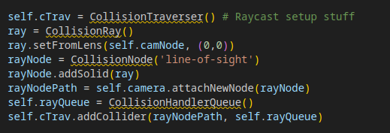
The ray is instructed to have a collider (mentioned earlier in Design), shoot from the camera, and be attached to the camera. The collider is then added to the collider handler of the program.
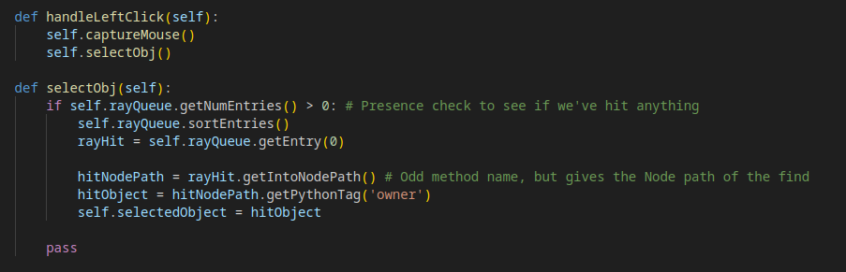
Here, we check if the ray has hit anything every left mouse click (which is a presence check for our user). We get the closest object it’s hit (the first entry in the rayQueue) and fetch it’s nodepath.
We then find the parent of the object it’s hit. In this case, it will be the parent node of the object, since we’ll attach the collider the ray will detect as a child.
The node is then identified as the “selected object”. This will allow the object’s properties to be easily fetched.
For now, I just requested the currently selected object’s name to be print.
I then attach a “collision” object to the Sun node – an invisible cube just slightly bigger than the Sun. This is mainly to keep the collision calculations simple with a lower-poly collision box (This is further discussed in Design).
Here we assign the dimensions of the box, give it an appropriate name and add this box to a collision node which is a parent of the Sun Node.
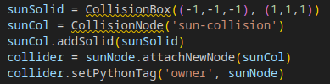
When running, it seems to be selecting objects properly – it prints out “Sun” when I click on the Sun, as expected.
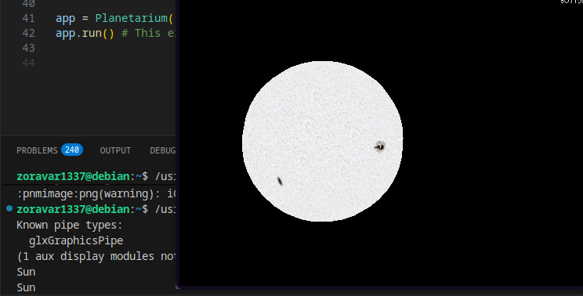
I then set up on-screen images, the crosshair (just a small cursor in the centre – nothing is particularly done with it) and the selector. (Since they’re .pngs, the transparency of the UI elements need to be specified to be the alpha data of the image)
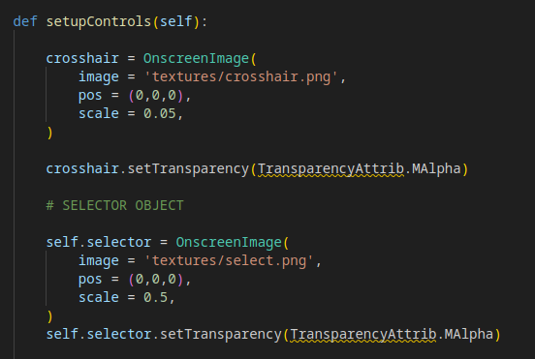
I then made a task which updates the location of the OnscreenImage for the selector to be in the 2D coordinate of the selected object’s position on-screen – if an object is selected.
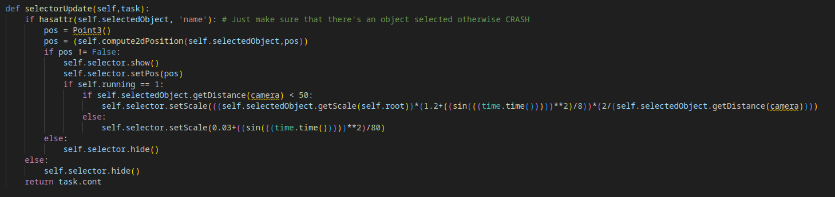
Here, we check if the selected object has a name attached to it. If not, it’s most likely blank.
If so, we compute the 2D position (algorithm shown below) and check if the position of the object is within the confines of the 2D screen (essentially, if the selected object is visible). If it is, we let the selector be visible with the same size as the object’s apparent size on-screen – plus a factor of the sin of the time elapsed in the program, and also a adding a fixed value, so it always remains at least a certain size when far away – and always visible.
In practise, the sine function makes the selector marker have a pulsing animation, which I thought was appealing for the user – and makes it clear what is being selected.
We have to convert the 3D coordinates of the object to 2D screen coordinates, however:
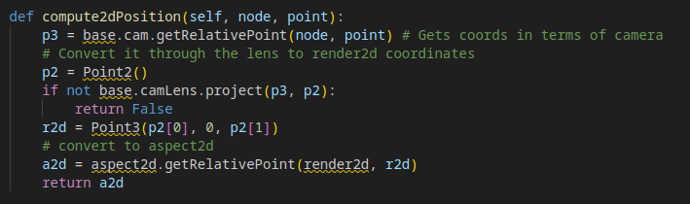
This uses the “project” function to convert the 3D vector point into a 2D one (which is specified by the formats of p3 and p2). It then converts it back into a new 3D coordinate (as for some odd reason, the 2D display takes an XYZ coordinate despite the fact that the Z will always be 0) and is passed. It returns “false” if the object is not on-screen.
This results in a pretty selection marker on the object selected.
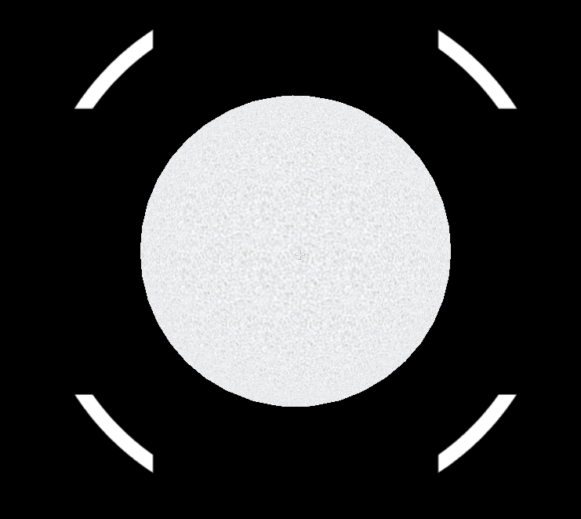
Here, the selection marker is well-scaled with the object.

Once the object is far away, however, the selector remains a fixed size to always appear visible.
This basic selection system will allow for our user interaction with the objects in the program. I was quite happy with how this system had turned out.

Number | Test | Expected result | Achieved?
12 | Select an object, or empty space | A visual marker appears on the selected object. Nothing happens when selecting empty space | Yes
We’ve skipped a few tests which we’ll come back to later, but it’s good to test the plausibility of more fundamental systems first as a programmer.
I also began to add basic UI to show the selected object’s name, and the camera’s current speed.
This was the point where I had to implement a scale factor for the program – and I decided on 1 AU = 1000 Units, or that 1 Unit = 0.001AU / 150000km.
Using a conversion function (which is imported from a custom library into the main file – code will be shown below), I scale the Sun accordingly.
Where 1.3927e6 is the Sun’s diameter in km, and self.scale is defined as the number of units to 1 AU (defined in the init):
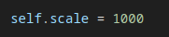
In the imported “planethandler” file (the constant is the number of AU in a km – a small value):
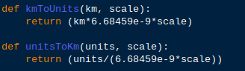
Which correctly scales the Sun Node (and hence all objects within it, as the scale of the planetnode – and others – is 1,1,1). The new size is roughly 9 units.
I then added variations of the “Arial” font’s .ttf files as reference for the program in a “fonts” folder:
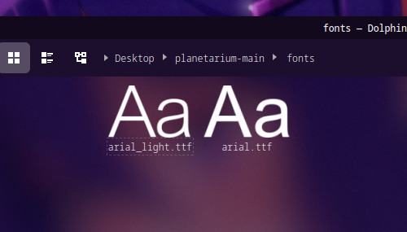
Which then allows me to create a simple UI with a nameplate, and display the current speed.
In the init:
And the method:
The Name plate for the selected object, and camera speed need to be updated every time it is changed. Here, I change the Name plate to the selected object’s name every time an new object is selected:
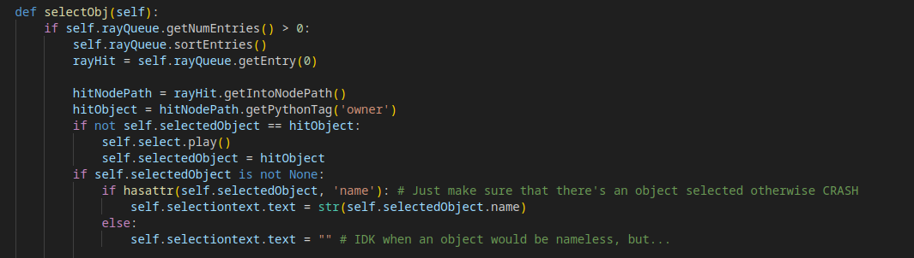
and here I update the speed UI to be the camera’s current speed in km/s, using the unitstoKm function shown earlier:
The function also implements range validation in the conditional – it makes sure the camera never updates to travel under 1000 km/s – which is an appropriate value for this scale.
Testing this, when I input a slowing-down request which would have my speed lower than 1000km/s, the program would not update my information.
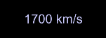
Number | Test | Expected result | Achieved?
8 | Input an unsuitable speed for the camera | Range check validation makes sure that unsuitable input values are discarded | Yes
We also have created a nice display:
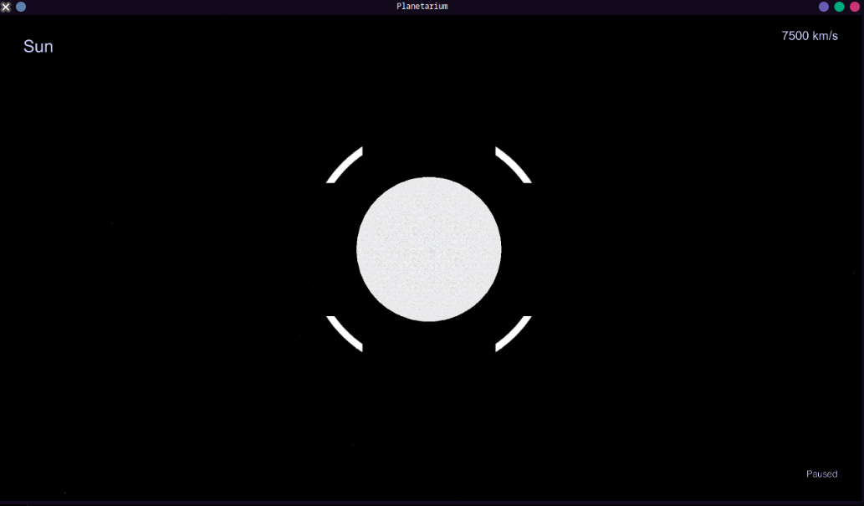
You may have noticed a “Paused” display. I then created a variable called “running”, which determines if the simulation is paused. If “running” is 0, the camera and UI/Planet updates are locked and not updated per-frame. If it is 1, they are resumed again. “Running” can be turned off or on by “esc” and clicking anywhere respectively.
This just involves putting all methods fed to tasks in an “if running == 1:” statement.
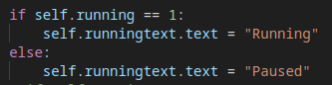
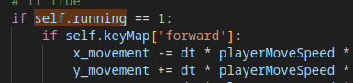
And updating the display per-frame (in a task):

And “running” being updated by inputs:
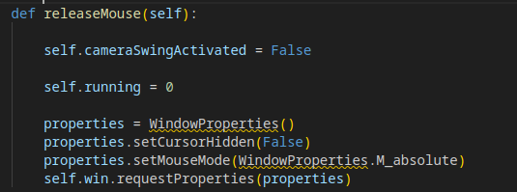
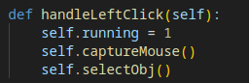

3.5 Filters and Billboard Effects
I then began to create basic filters and billboard effects to make a convincing, appealing Sun.
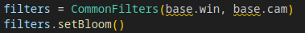
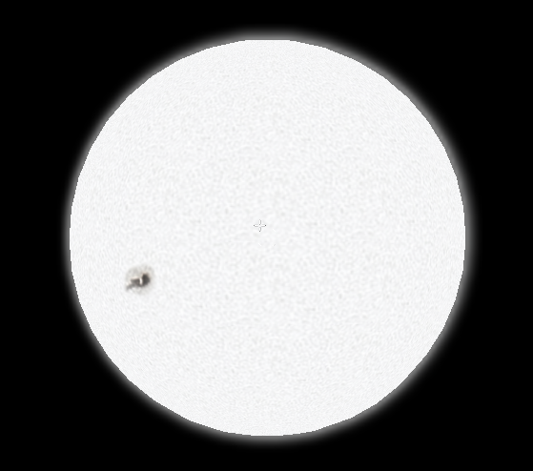
For filtering, I simply applied a bloom filter to the program, which comes pre-packaged with the CommonFilters imported earlier. I quickly managed to implement the filtering that I wanted in this program.
Number | Test | Expected result | Achieved?
9 | Allow for filter effects | Filtering should become apparent (such as bloom) – allowing for bright objects to appear “glowing”. | Yes
Then with the billboard effect – I imported a custom .egg file of a “board” for the program’s reference, and scaled it to have the “glow” texture 8x the size of the Sun. I gave it an appropriate name and used a very convenient “setBillboardPointWorld()” function, which instructs an object to always face the camera during a program’s runtime.
I then textured it, and parented it to the Sun:
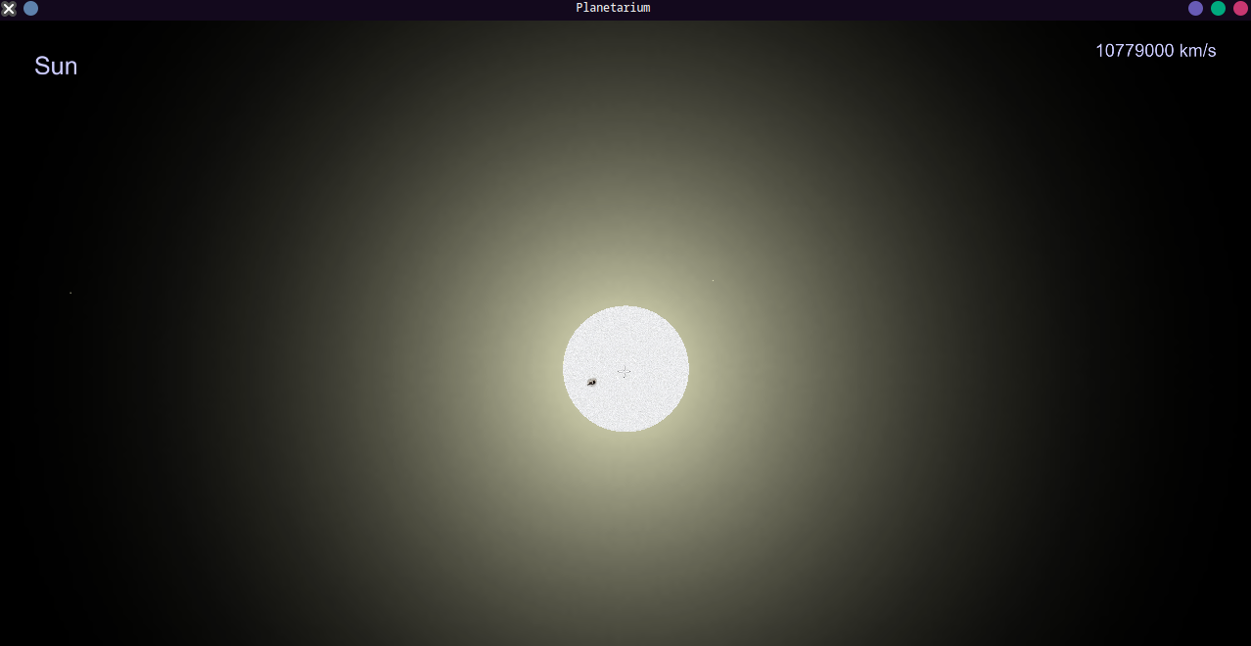
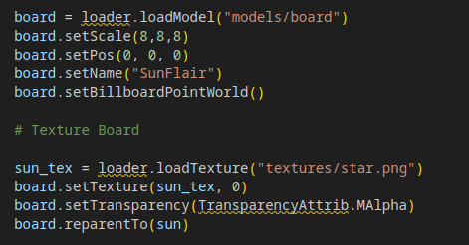
However, when far away from the Sun, I would have the glare board become barely visible.
I wanted the glare to be visible from all distances to the user, so I wanted a minimum apparent size for the Sun’s glare in the sky.
I originally thought to set the glare to be an apparent size once it’s far away enough – so the scale variable increases directly proportional to it’s distance from the camera.
However – I realised this effect can be faked using the “render-sphere” algorithm talked about in design. The glare will actually follow the camera a set distance away, and appear in the location of the Sun. This means it will have a minimum apparent size inversely proportional to it’s distance from the camera (or the render sphere radius).
Here, I created a task which performs this algorithm at the distance of 1000 units – or the scale factor.
(This is declared in the Sun creation method)
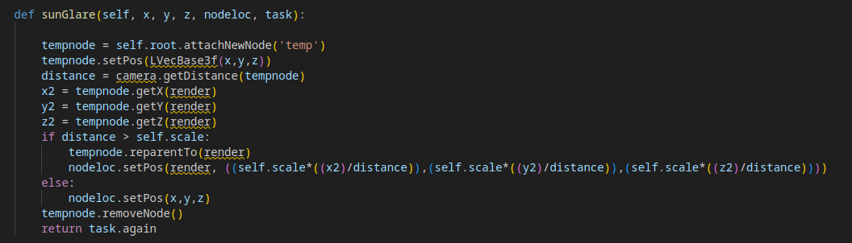
Here, I create a temporary node which attaches itself to the root node. It goes to the location the glare should appear to be in, and checks if it is too far away. If so – the sphere algorithm is computed and the glare node is sent to that location in terms of displacement from the camera (Which in this case is also the displacement from the render, as both have a global coordinate of 0,0,0). This means there is a constant minimum apparent size of the glare, which is the size it would appear 1000 units away – always.
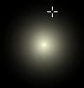
This had the exact effect I was hoping for, and allows the user to easily see the Sun at all times – even if it is very far away.
I also realised this would have to be applied to the Sun’s hitbox – as if the Sun is very far away, and the apparent size of the star itself is only a few pixels across, the user would have immense trouble selecting it. I made a similar task which performs the same calculation – however, I made it only update every .1 seconds, as it’s likely a user will be stationary when selecting an object and hence, the motion of the invisible hitbox doesn’t need to be taken into account as much.
This is achieved through the “doMethodLater” function for Task Manager. It is nearly the same as add, however, an additional argument of the delay time in seconds is added at the start – to specify the difference in time between each update.
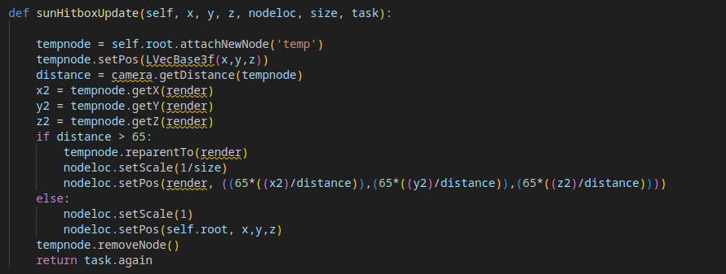
This method is virtually identical to the glare updater, however, it has a maximum draw distance of only 65 units (Though arbitrary, I felt this gave good enough selection area to the user for the Sun to be selectable from far away).
Now testing if this appears as intended:
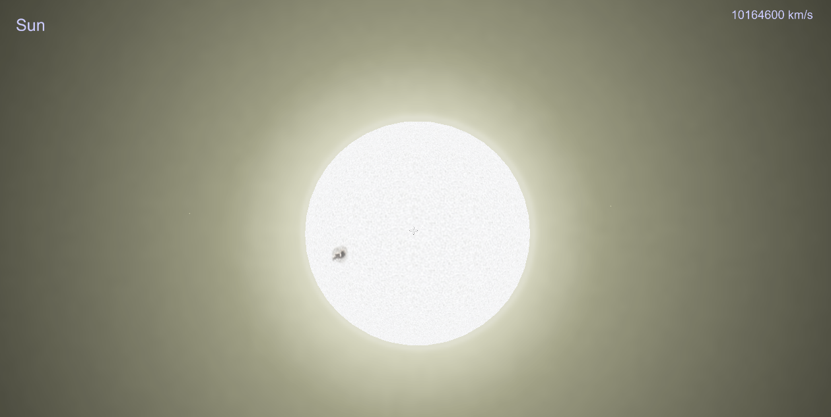
Look at that Sun.
I then also set up a point light inside the Sun – which signals to other objects that the Sun is a light source. This will be used later.
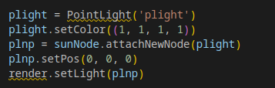
We have now created an appealing Sun – which will be the origin of our entire program.
Number | Test | Expected result | Achieved?
10 | Set up the camera facing the Sun with a bloom filter and billboard glare | A fairly pretty-looking Sun, which appears glowing from no matter the camera angle – the billboard changes size depending on the camera’s distance from the Sun. | Yes
Next, I wanted to begin with importing stars.

3.6 The Stars
I intend to use the HYG database to import stars, and after not much digging, I found a CSV for it here.
I created a simple “csvhandler” custom library which is imported at the start of the main script, and it simply returns an array of all the data needed per-star (or per record in the CSV file) using the “csv” library.
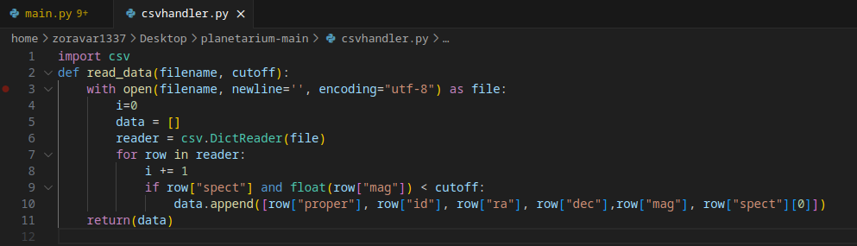
Here, since there’s thousands of stars in the database and we realistically only need a few hundred, I run through all the stars with a spectral class identified (as it is needed to render the stars’ colours) and check if it’s apparent magnitude (brightness from Earth) is above a certain threshold (all stars with a spectral class have an apparent magnitude in this database), then it only appends stars bright enough to be seen above the “cutoff” value.
I tried to test this function within the python file using this command:
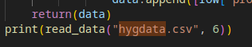
However, it couldn’t locate the csv file, even though it was in my directory – and my test had currently failed.
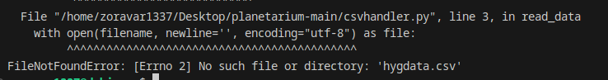
I found out that occasionally during Python executions, the main directory of the program needs to be specified using os:

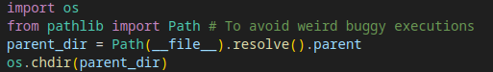
When adding these lines to point the main directory to the parent folder of the Python file, I got this output as intended:
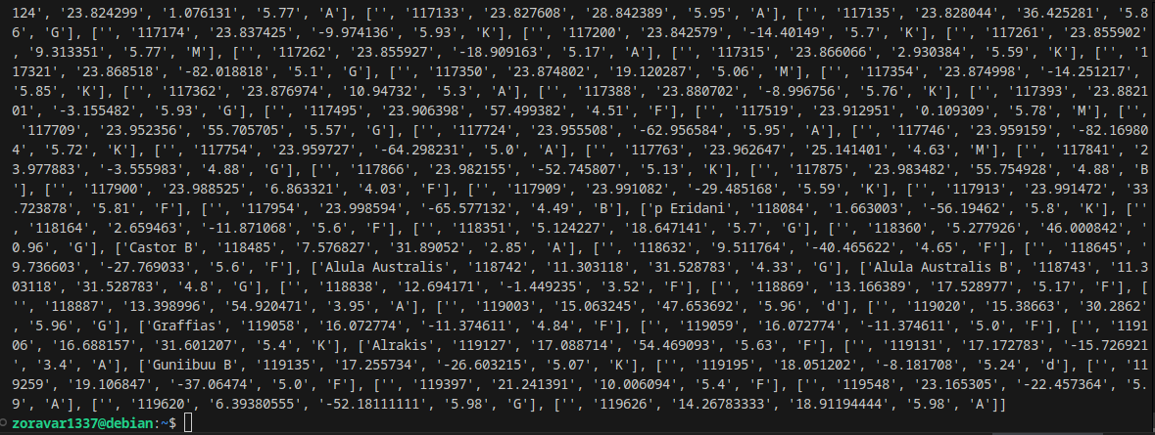
Number | Test | Expected result | Achieved?
20 | Parse through a database and create objects with the data | The objects are added to the scene and behave as expected, retain the information in the databases | Yes

Number | Test | Expected result | Achieved?
14 | Import Star database | The stars can be read, and it’s data used to create objects with realistic attributes | Yes
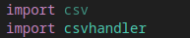
I then imported csvhandler and begun to create a method to import all stars above a certain apparent magnitude, and append them to a render sphere which follows the camera at a far distance, where they’ll appear distant and stationary.
In reality, they do move very slightly when moving across the Solar System (this is how we know their distances, we find them from the parallax they have as the Earth moves around the Sun), but this will be abstracted for the sake of minimising unneeded complexity in this program.
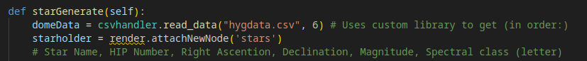
We start off with gathering all the star data we need to render each star in a realistic manner (as well as give information, like it’s HIP number). I used a threshold magnitude of 6, as I found it to be a suitable balance between having a pleasing night sky with identifiable constellations, and also not cluttering the sky or slowing down the program with so many objects.
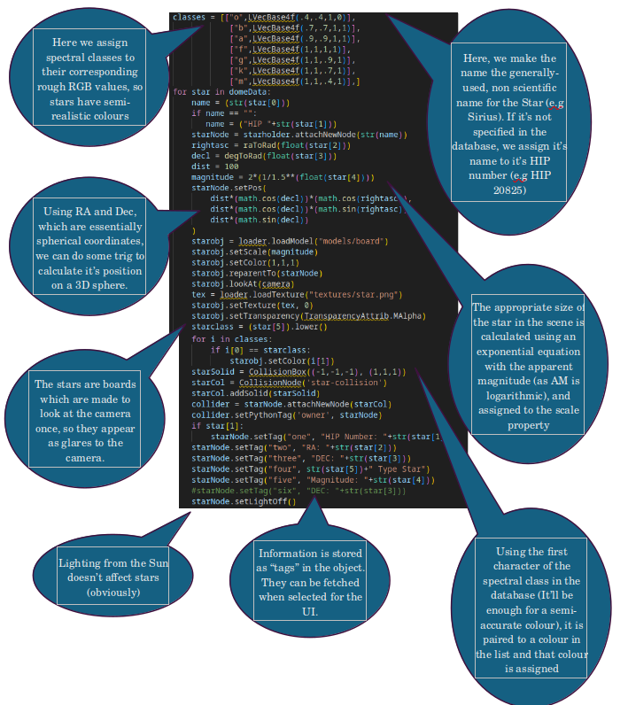
Most of the collision, texturing code is identical to the Sun’s. However, there are no updates to any of their positions – as they are attached to the camera.
I also created new UI to show object info, and update them:
(The TopLeft, Right etc… parents are present to allow UI to be anchored onto screen corners, even during screen resizing – allowing flexible UI for the user.)
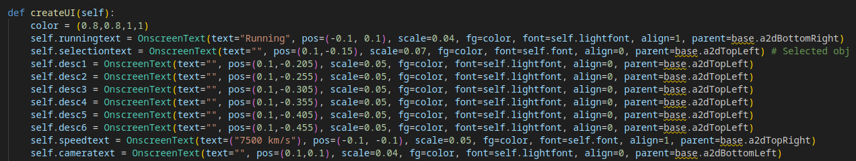
(I decided to make the camera orientation known to the user, and shown in the corner)
Object info updated every selection (within selectObj):
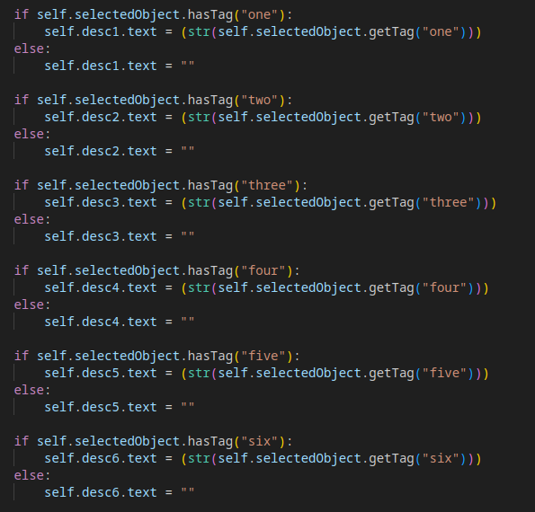
After all these calculations, and the new UI implemented, here are the results:
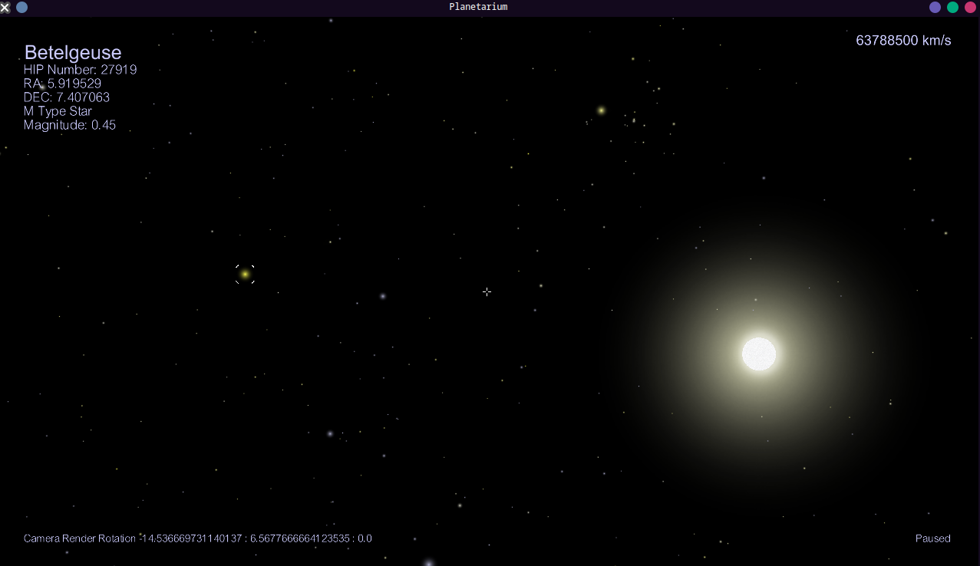
So pretty.
Every star you see has it’s real color, position and brightness as our own night sky, using our HYG database.
This was a significant leap forward for my program, and I was very pleased with the progress being made.
I had implemented an informative UI which is capable of displaying database information to the user clearly and concisely:

Number | Test | Expected result | Achieved?
13 | Select an object with descriptive tags | A UI displays relevant information | Yes
I also had managed to create star objects on the render sphere which can be selected – and appear completely as intended.

Number | Test | Expected result | Achieved?
16 | Stars objects are summoned | They are created in the scene, are clear, correctly places/coloured and are selectable – giving the attributes fetched from the database to the user though a UI. | Yes
When approaching my client on the progress of my application:
“It seems very visually appealing so far – I especially like the object info currently given for the stars.”

3.7 The Planets – First implementation
Sourcing planets’ data was a bit different. I couldn’t find a well-enough abstracted database to suit the program. Most contained much too many objects for the scope of our program – so I opted to make one myself.
This database uses planetary data simply sourced from the Wikipedia pages I copied myself:
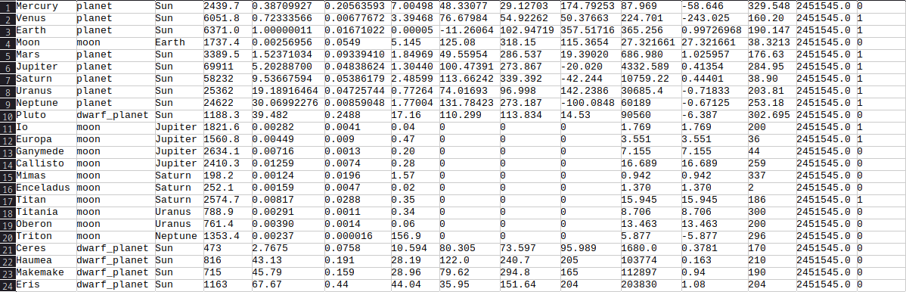
(Columns in order: Body Name, Body Type, Parent Body, Radius (km), Semi-major Axis (AU), Eccentricity, Inclination, Longitude of Ascending Node, Argument of Periapsis, Mean Anomaly at Epoch, Orbital period (Earth days), Rotational Period (Earth days), Rotation at Epoch (deg), Epoch time in JD, Atmosphere present?)
To begin with calculating XYZ coordinates given orbital characteristics, I first needed a reference time. In the planethandler, I created the function for converting Unix time to JD date – as discussed in Design. It stayed virtually identical to the proposed pseudocode.
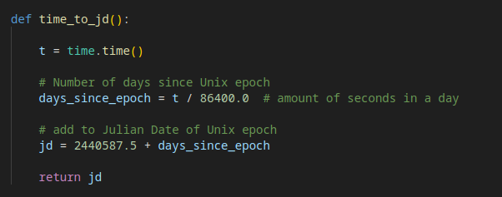
I then began to implement the XYZ calculation function. This also remains virtually identical to the discussed pseudocode in Design.
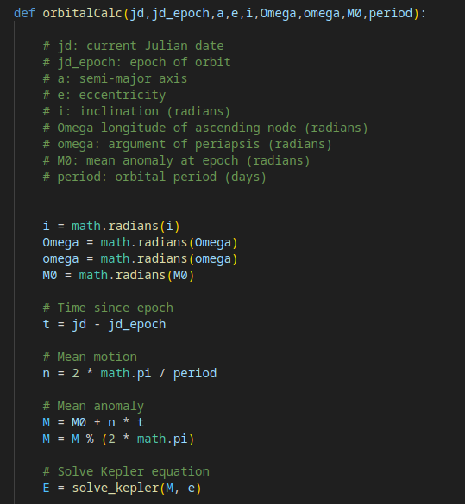
solve_kepler algorithm will be shown below
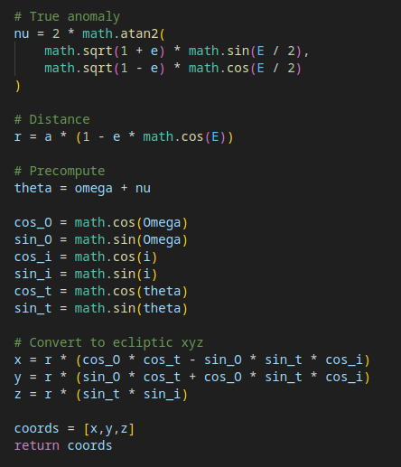
Here, we implement the algorithm needed to return the XYZ coordinates of a planet. To reiterate: we calculate the time passed in JD, the mean motion, mean anomaly, we solve the Keplerian Equation for E (shown below), we get the true anomaly, the distance from the parent body – and finally transform the otherwise plane coordinates into 3D coordinates.
The iterative solver is below:
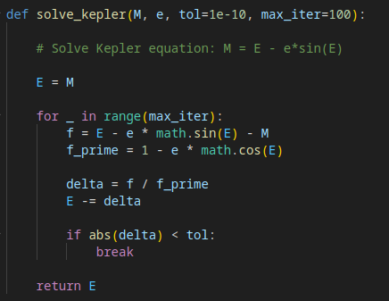
Here, we perform Newton-Raphson iteration until either the delta of the current estimate and the previous one is below a certain threshold (in this case, I chose 1e-10, as I felt it was suitable to have a low error, but prevent too long processing time) or that the number of iterations reaches 100 (for a similar reason of preventing too long processing time, slowing down interactivity for the user).
The XYZ coordinates will have 1 unit = 1 AU. This can be multiplied by our scale factor of 1000 to give it’s position in the scene (as seen below).
We also need to be able to calculate the rotation of an object.
For only one axis, this is quite simple – and was shown in Design. The code implemented is virtually identical to the pseudocode:
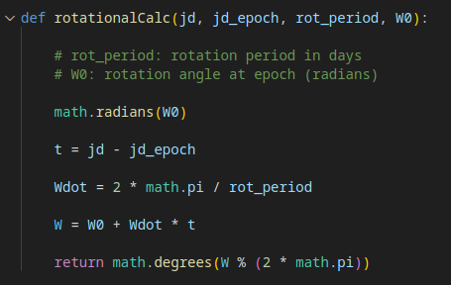
Where we take the difference in time, the angle travelled in that period and normalise it. This is contained in the planethandler library.
Now that we can determine XYZ coordinates and rotation of a body given it’s orbital/rotational characteristics – we can begin with constructing them, beginning with orbits.
I opted to take the approach discussed in Design – to have a line drawer move to each position in a segment of the object’s year, and have the circle closed once a full year has elapsed.
Here, the arguments passed are the same as what our planet-creator method will have. Some of the arguments are unused – but I felt being able to both generate an orbit and a planet when passed the same parameters allows for greater ease of creation.
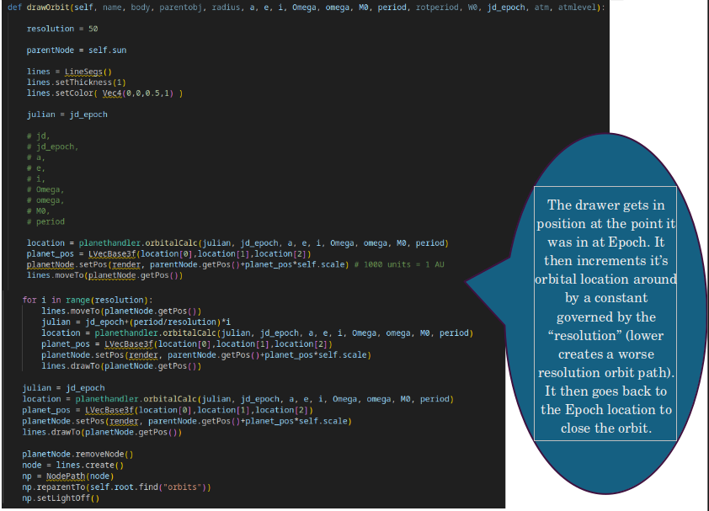
This was in-development, so I assume that the parent node is always the Sun (which will be amended later). This was simply to test the orbit renderer.
Panda3D has a built-in line renderer called “LineSegs”, which has basic draw commands, much like Turtle. This allows for the custom line rendering.
We init a node attached to root called “orbits” – for the drawings to be made a child of.
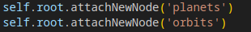
For testing, I called the orbit generation method using the data for Earth – hopefully creating a clear orbit identical to that of Earth.
And I got this as an output:
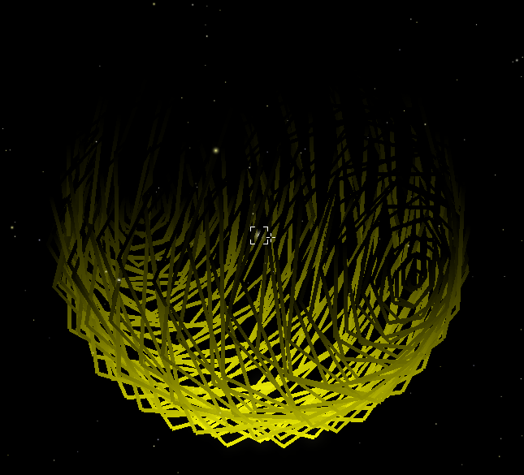
Uh…
It took me an embarrassing amount of time to realise I had accidentally used the same variable “i” for both inclination and the increment. Swapping out the increment variable for “m”:
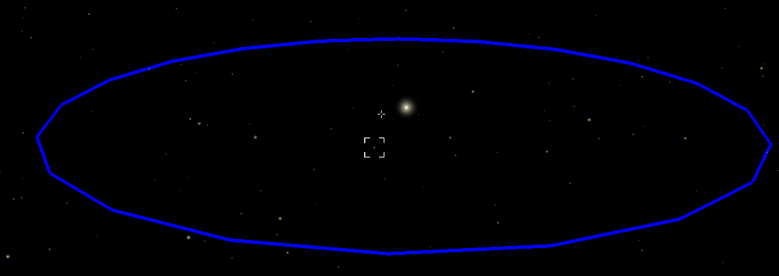
Success!
I was happy to see that my orbital calculations had worked as expected.
Number | Test | Expected result | Achieved?
18 | Implement orbit rendering | Orbits can be calculated – this will be achieved with having points in the orbit connected with a drawer, making an orbital path for each celestial body. | Yes
I then created a method called at init, which creates an orbit for every object in the Planetary Database by calling drawOrbit with each planet’s data using a “planetcsvhandler”:
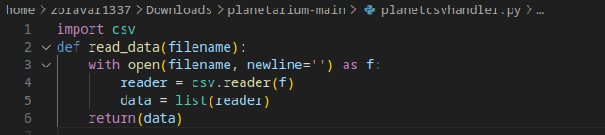
In main:
and in init:
Where the method is generating an orbit for each record given and the needed orbital characteristics are passed into the orbit renderer from the database:
and the result:
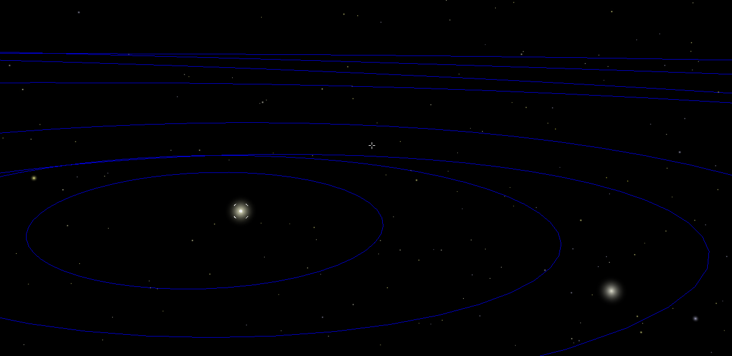
We now have the orbits of all our planets!

Number | Test | Expected result | Achieved?
15 | Import planetary database | The planets can be read, and it’s data used to create orbits/objects with realistic attributes | Yes
I also added a keyboard command to toggle the orbits by simply hiding/showing the orbit node when pressed:
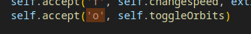
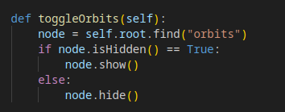
As mentioned before, I had temporarily only allowed the Sun as the possible parent when calculating orbits. I then allowed the orbits to be displaced along the parent body’s location – if the parent body is a planet.
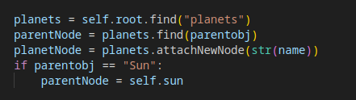
The orbits – when the program is run – can now be toggled in display by pressing “o” on the keyboard, as intended.

Number | Test | Expected result | Achieved?
19 | Toggle orbit paths | Eye-pleasing, non-buggy, accurate orbit paths for celestial objects | Yes
Next was adding the planets themselves.
I started with declaring the current Julian Time:
and with the new method:
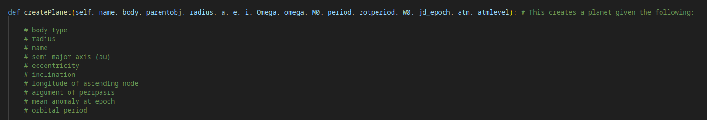
(A “planets” node is declared in the init, along with the “orbits” node)
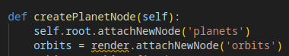
I first convert the diameter to appropriate units. Then I either parent the new PlanetNode to the new node called “planets” within the root, or to the Planet it is orbiting in the case that it is a moon. I create the actual planet object (discussed earlier), load it’s sphere model and set it’s scale to the calculated diameter. I then calculate the position the planet should be in using the arguments passed.
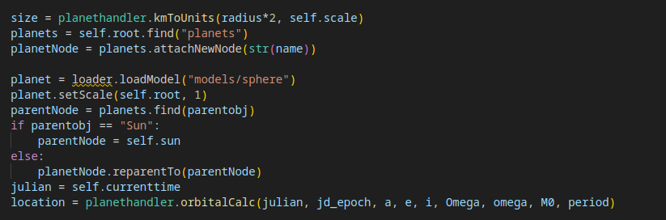
Then, rotational calculations are set:
Then the position is set (multiplied by the scale factor), and the planet is renamed to it’s name stored in the database. This will allow it to be looked up in the Node Graph easily.
The collider is added. This is the same process as with previous objects. The scales are then applied from the calculated diameter – as discussed previously, the collider box is made slightly bigger to allow easier selection. A board – similar to the Sun’s – is added and parented. It will be used for the “glare” a planet will have from far away.
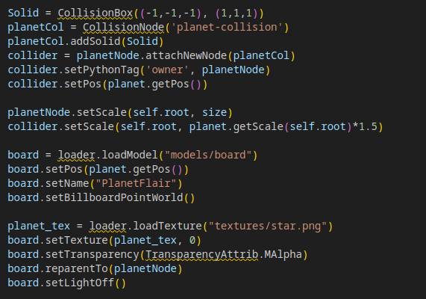
I also added tags to be fetched by the selector, so it can display planetary information to our user. Here, I simply append the data passed from the database and convert it to readable, easy-to-understand strings:
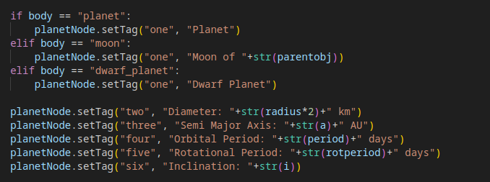
The planets are now visible and in accurate space and scale – though are blank, textureless spheres:
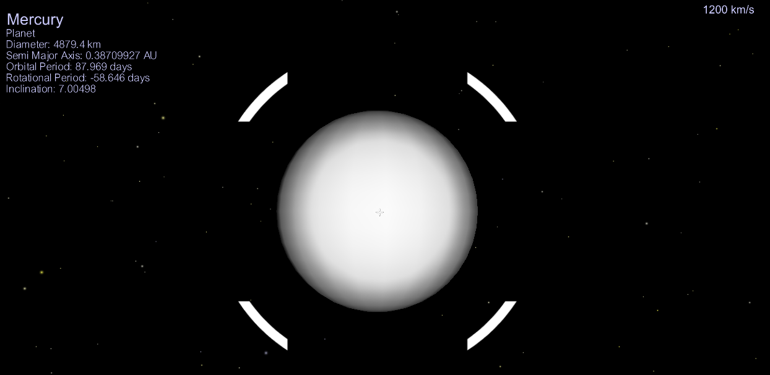
Number | Test | Expected result | Achieved?
17 | Planet objects are summoned | They are created in the scene, are clear, have correct textures, scale, moons and shaders applied – as well as possible extra characteristics such as rings. They are selectable – giving the attributes fetched from the database to the user though a UI. | Yes (Partially)
For the planets themselves, I will need to apply shaders and surface textures – which will now be explained:

Shaders
A shader is a specialized program that runs on the GPU to determine the final colour and position of pixels, vertices, and textures in (usually) 3D scenes.
In other words – it’s a program that utilizes the concurrent processing of the GPU to perform calculations on each pixel, or vertex of an object in a scene – and returns a new colour for the pixel to be, or a new location for the vertex of a mesh to be.
Shaders are usually used for rendering shadows, and other lighting effects. They’re commonly found in video games, and allow for appealing graphics to the user.
For example (and this is what we want to achieve in our program), here is a model of Earth with and without a shader applied:
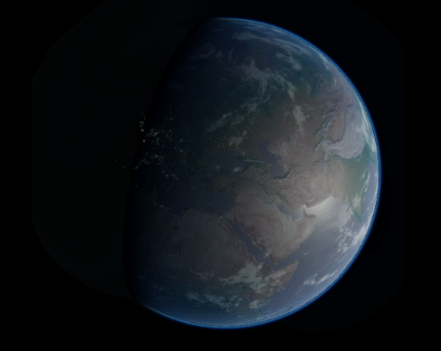
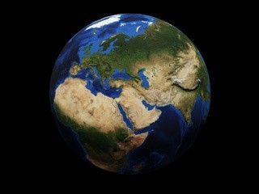
Here is where shaders come in.
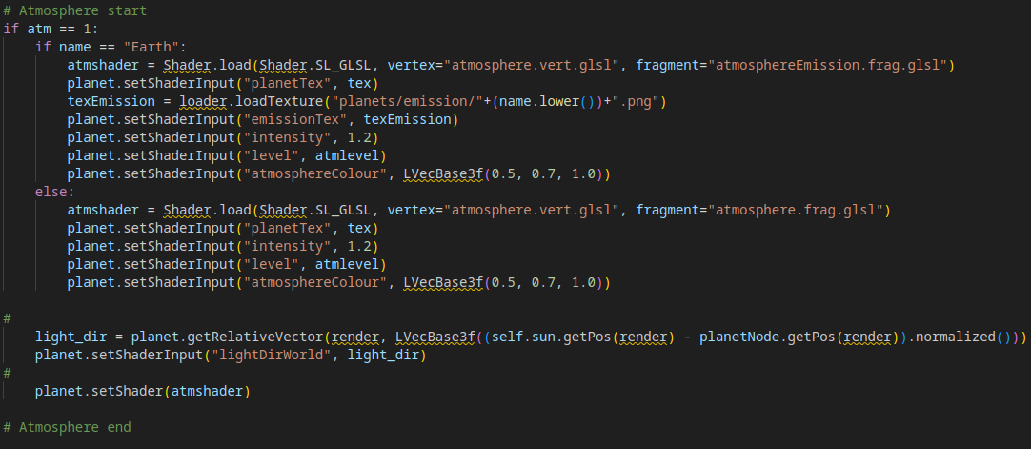
Here, we have a special shader applied to Earth, and a normal one for every other object with an atmosphere (Which the Earth shader is based on). If no atmosphere is present – a shader is not applied, and Panda3D’s built-in shadow system is used instead.
The shaders have this in common: They are atmospheric shaders which allow the object to have a halo-like tint – much like in real life.
The shader language I have used is GLSL. It’s a high level, C-like language which executes shader code directly in the GPU.
Here, we need “vertex” shaders and “fragment” shader.
A vertex shader alters a model’s vertices – or in other words alters the shape of an object. We aren’t keen on altering our spherical planets’ shapes, so this shader will essentially be a “blank” shader which simply transforms our vertices to reflect the current camera’s position.
In the context below, “normalizing” refers to converting a vector’s magnitude to 1, whilst preserving it’s direction. If only the direction is important to the program, this can allow the same output to be achieved when the vector is fed to the program, but allow the values contained in the vector to be an easily stored number, instead of a very large one (which can be the case with the large coordinate values we have stored).
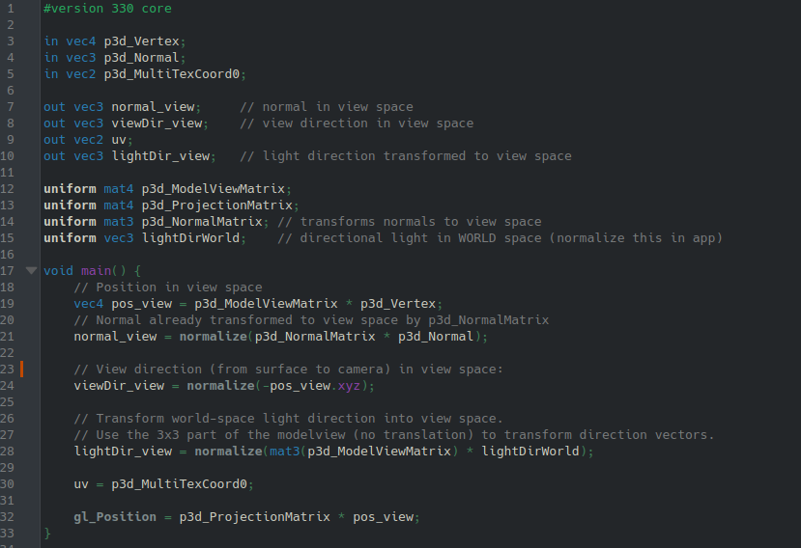
Here, we first declare the input/output variables.
The “input” variables are the variables passed from the previous stage of rendering. In our program, our shaders operate from:
Panda3D → Vertex Shader → Fragment Shader → Final Renderer
So we are passed the standard input variables Panda3D provides to imported shaders, in this case: Each vertex on the mesh, it’s normal and it’s corresponding position on the object’s texture image.
A “normal” is essentially a vector of the direction a vertex is “facing” relative to the object’s surface.
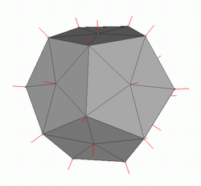
Example of vertex normals on a Dodecahedron mesh
We also declare “out” variables, which are then passed to the Fragment Shader as discussed above.
We also have “uniform” variables, which are custom variables passed by the “user” (or the user’s application). In this case – however – the first 3 are automatically passed by Panda3D, which is signalled by their names;
The model view matrix, which is the model’s current position relative to the camera.
The projection matrix – To put it in very simple terms, it is a matrix which maps a vertex’s 3D position in term of the camera-space. It is multiplied by the camera’s position to achieve the vertex’s final position to be sent to the renderer.
The normal matrix in view-space – the normal vector from earlier, but in terms of the camera’s rotational matrix.
And finally, the light direction matrix in the World space is given, which is calculated in Panda3D and passed.
The position in the view-space is calculated and used to find each vertex’s normal in terms of the camera (this is already calculated by Panda3D, so it’s simply normalised into appropriate units and passed along), the direction each vertex is facing in terms of the camera (which can be used to see whether it is facing the camera, or perpendicular to it) and the light direction vector in terms of the camera, which is found by multiplying the global light direction vector by the object’s position, which is then normalised.
The UV is passed from Panda3D, which just gives the corresponding texture coordinates per-vertex.
The vertex normals in terms of the camera, view direction, UV, and light direction vector in terms of the camera is then passed to the fragment shader:
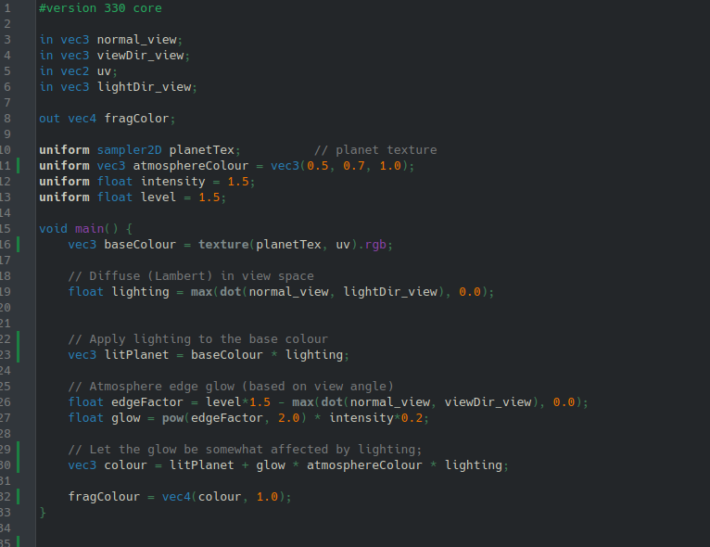
In the Fragment shader, we aim to create a halo-like atmospheric effect on spherical objects, much like how planets behave in real life:
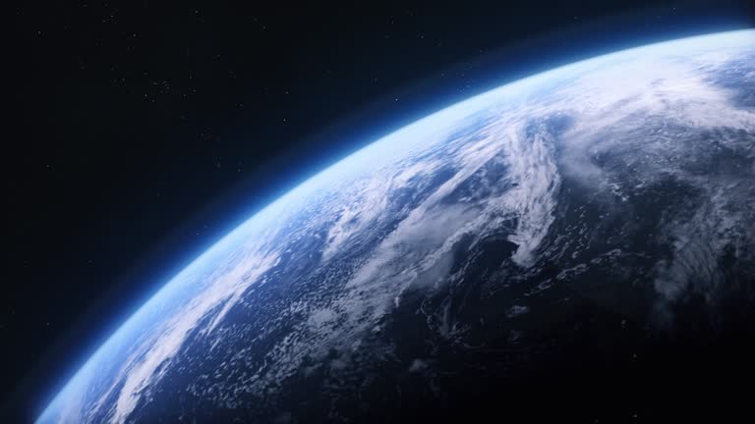
Note the halo-like glowing caused from the Earth’s atmosphere
This will make the program much more appealing to the user – and also help convey which planets have an atmosphere present.
The base colour is given by passing the planet’s regular texture (through a uniform) and applying the UV map to it.
The “lighting” is the dot product of the normal and light direction vectors, which should yield 0 or less if the vertex is facing away (if less than 0, it is then changed to 0 though the max function) and a positive value which increases the greater it is facing the Sun.
the “edgeFactor” takes the vector of each vertex’s normal in relation to the camera, and sees whether it is facing more towards or perpendicular to the camera. This makes sense, as the “edge” of an object will correspond to how perpendicular it is facing from the camera – and a halo-like edge is what we seek to achieve in this shader.
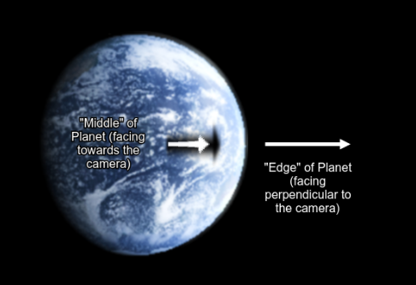
We then use this factor as the base for the atmosphere multiplier, where some colour for the atmosphere is multiplied by the factor and some constant which yields the best visual result.
This is also applied to a “glow” effect, which has a stronger but sharper multiplier which creates an outer glow.
These effects are then overlayed with the standard lighting calculated before, and passed out to the renderer.
Earth in particular has a similar custom shader, which simply also adds another texture layer for “emission”, to imitate the night-time lighting Earth has from cities and towns.
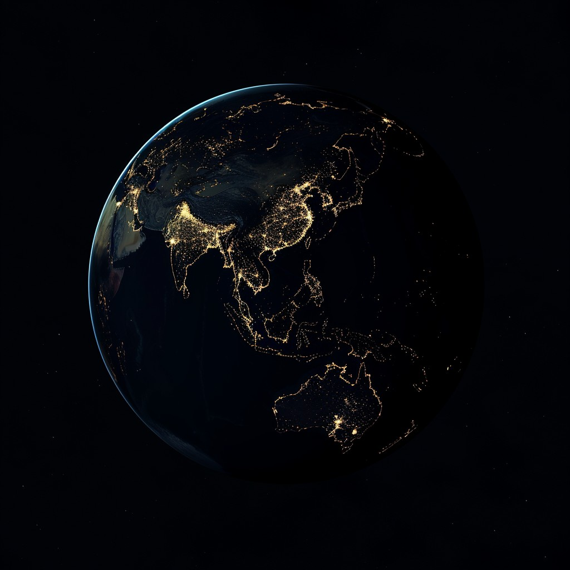
Instead of being directly multiplied by the Sun’s lighting, it’s multiplied by a factor of the linear inversion of the lighting – hence it is only visible in the dark.
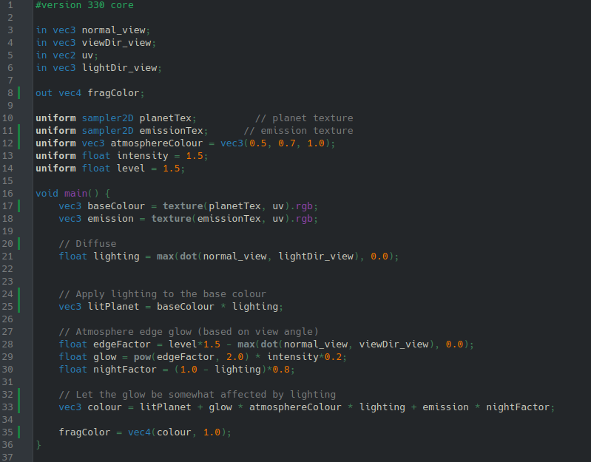
We will obviously need surface textures for all the planets to be identifiable to the user. For all planets, I’ve compiled their surface textures into a “planets” folder. The textures have to be named the exact same as the planet’s name in lowercase.
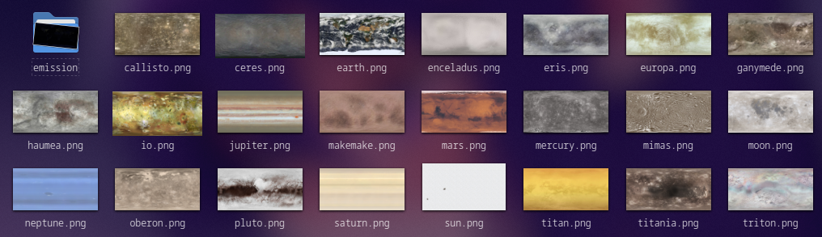
These are then textured onto the planet objects, and also passed to the “planetTex” input for shaders (as shaders override Panda3D’s built-in renderer)
I then apply an atmospheric shader to planets tagged with an atmosphere (along with a stored “intensity” value per atmospheric planet to indicate how strong the atmospheric effects should be), along with the special “emission” variant of the fragment shader shown above for Earth, where I pass along a custom emission texture.
I also use this vector calculation to get the Sun’s direction vector to the planet, which is then passed to the shader:
It gets the vector translation to travel from the Sun to the planet, and normalises it into a directional vector.
Here is Earth without and with shaders:
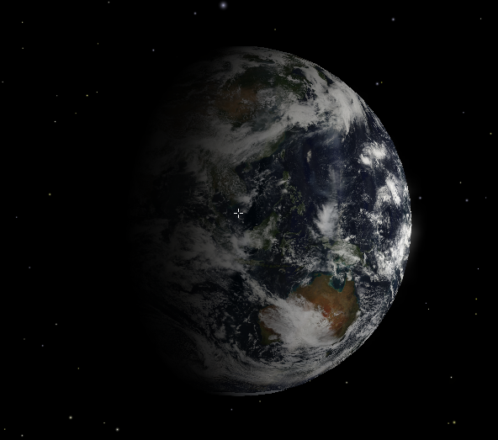
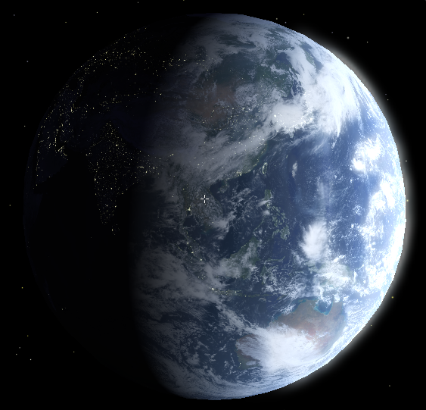
Very pretty.
When asking my client:
“It looks great so far – I like the addition of the city lights.”
We have now implemented planets into our program – along with shaders for visual appeal to the user.
Number | Test | Expected result | Achieved?
11 | Set up the camera facing an object with shaders applied | A semi-realistic, but glitch-free atmospheric shader, along with lighting and shadows. | Yes
I then created a “glare” system similar to the Sun’s: The difference being that at a certain distance from the camera, the planets stop rendering and are instead replaced with a bright light on the render-sphere, to imitate the glare planets have in the night sky (they usually look like stars, sometimes the brightest “stars” you see are actually Jupiter or Venus).
This saves on resources, since we certainly don’t want to render every single planet in the Solar System, and pass shaders through the GPU for each of them.
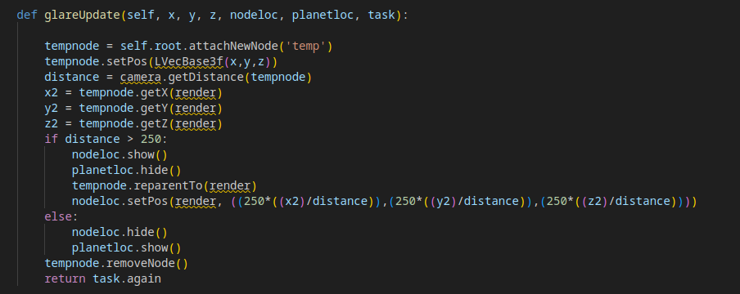
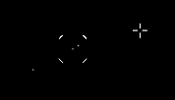
The result: The object being selected, and the object to it’s right are the Earth and Moon respectively, where they are far enough to not be rendered and instead replaced with glares, similar to a background star (bottom-left).
I also created a similar hit-box updater to that of the Sun’s, little-to-no changes:
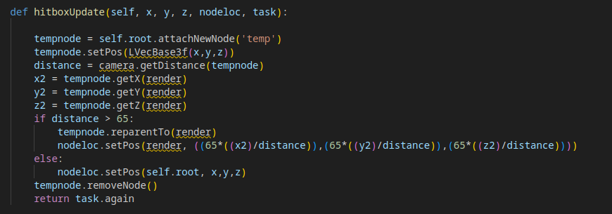
When running the program, I also noticed that Saturn had no rings. I thought it was only necessary to add them, so I made a special “ring” object for Saturn in particular:
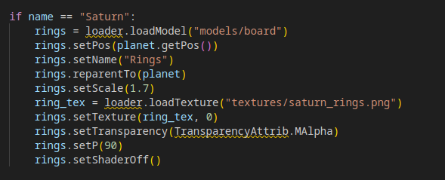
This creates a model with the “board” mesh (though it doesn’t have billboard properties), has it face the sun, then face perpendicular to it so the ring lies flat.
It is part of the “planet” node and hence automatically has shaders assigned. I disable it manually. I scale it appropriately.
Since it’s facing the sun on the Z axis, I can create a fake “shadow” by simply baking one into the texture:
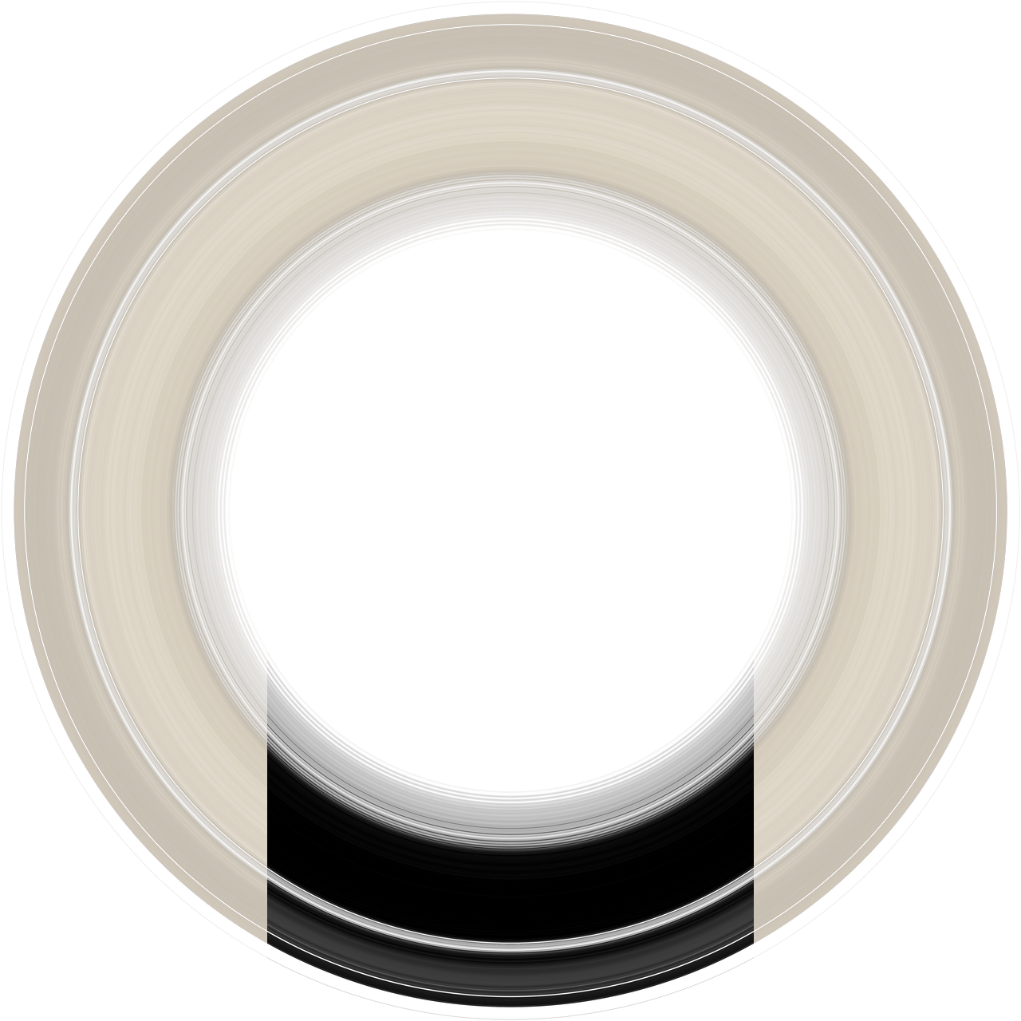
This is the result:
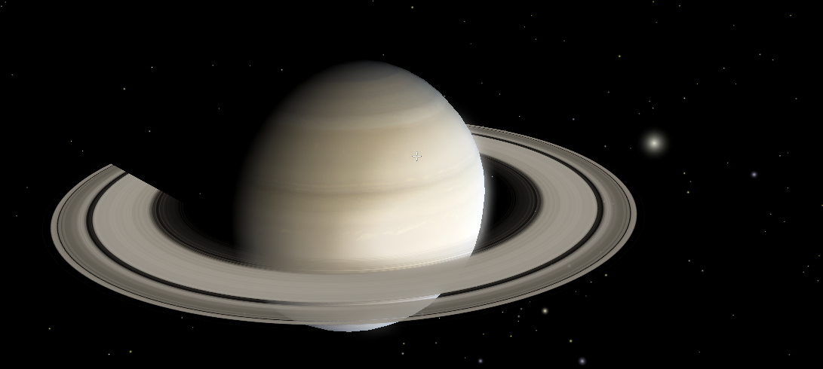
Saturn
I had successfully added detailed, accurate planets into our program, with enough realistic attributes for me to be satisfied considering planets “fully implemented”.
Number | Test | Expected result | Achieved?
17 | Planet objects are summoned | They are created in the scene, are clear, have correct textures, scale, moons and shaders applied – as well as possible extra characteristics such as rings. They are selectable – giving the attributes fetched from the database to the user though a UI. | Yes
Now that I had the planets in-scene, I began to explore the outer limits of the Solar System, only to notice my camera and the planets were sliding around and vibrating unnaturally. This is caused by a major issue for large-scale programs: Floating-Point Error.
As we know in OCR syllabus, Floating-Point values with greater range come with the expense of less precision – hence the camera and objects begin to lose precise motion and rendering when the coordinate values are far out, in the tens of thousands. How can we fix this?

3.8 The Planets 2 – Overcoming floating-point error
My solution to overcoming floating-point error was to do anything I could to make the stored coordinate values of the planets smaller.
If a planet has a great imprecision and is far away from the camera, it’s negligible enough at this scale. If it is close to the camera, the shifting and glitching becomes apparent. My solution was to have the planet’s coordinate values converted from displacement to the Sun (or root), to displacement from the camera when close enough in-range.
I adjusted the “glare” updater to not only swap between the planet object and a glare board, but also readjust the coordinate values for the planet to be in terms of the camera instead of the root node.
I also combined the collider updater into this singular method – so now only one task is added per planet. I explain this method in detail below.
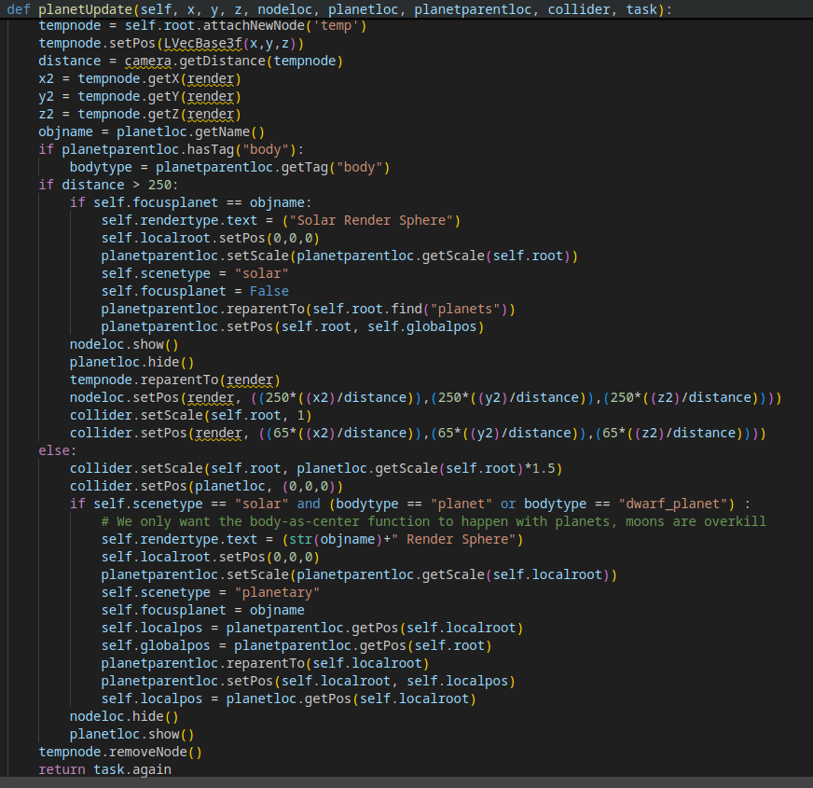
(I also gave it a more appropriate name)
Here, we alternate between parenting the Planet Node and having it’s position, scale etc in terms of the root node if the planet is far away enough to not be rendered (this is how position values have been stored thus far), or instead have position in terms of the camera once the planet is close by (or render, as both are 0,0,0).
Why does this work?
With planets far out, the coordinate values for them can get extremely large, as they are written in terms of the planet’s displacement from the Sun (or root node). Once we rewrite and reparent the Planet Node to the render, the position is written in terms of displacement from the camera (as the camera is always at 0,0,0). Since this is done when the planet is close to the camera, the resulting position coordinates are very small – which allows for greater precision and hence less floating-point error. Once the planets are far from the camera, they are reparented to the root and the original coordinate values return along with the error. However, since the planets are now far away, the visual errors are negligible and unnoticeable to the user.
If the planet is close enough to be rendered, the rendertype for the program is set to “planetary”, otherwise it is “solar”. I create a small UI to help distinguish what is being rendered.
This function only allows switching of coordinate types for planets, as moons are parented to planets anyway and hence have their coordinate types in terms of the planet.
A downside to this method is that only one planet can be rendered at a time – but since there is virtually no point in which any planets will be noticeably close to one-another, this is negligible.
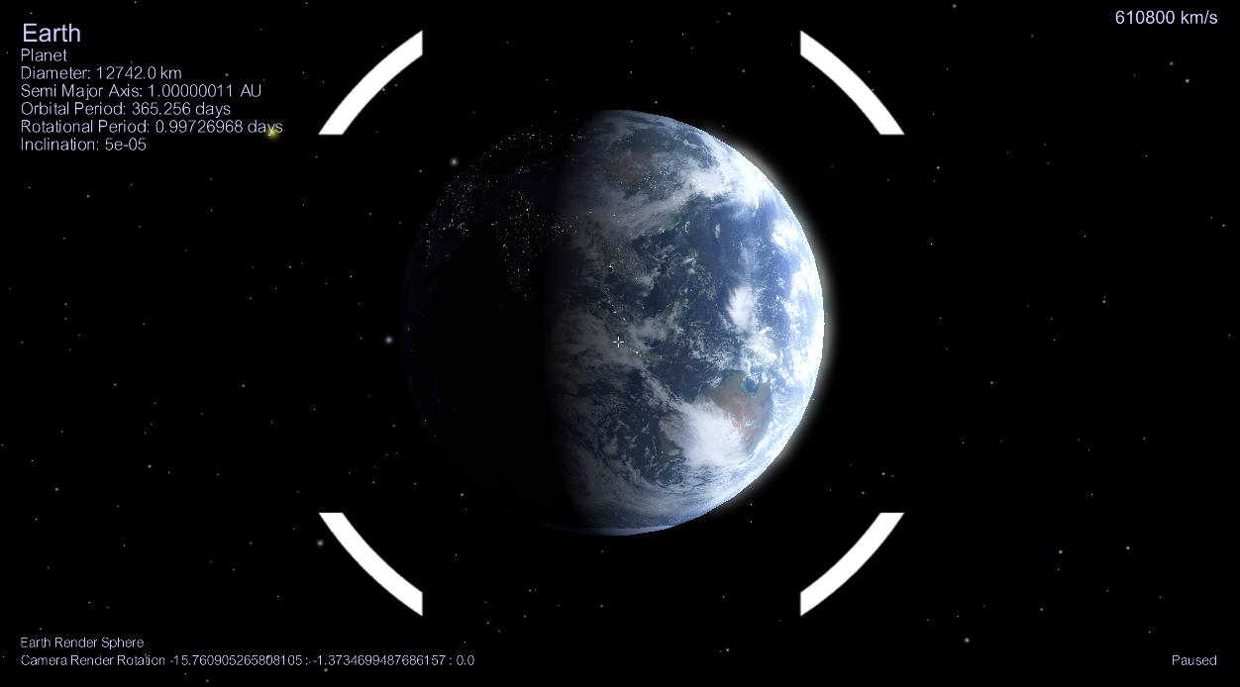
There is now a “Render area” UI indicating the loaded planetary system in the bottom-left. Here, it is Earth’s. Once I move far away enough from Earth, it becomes the Sun’s render area.
Once I travelled to distant planets, as well as getting a beautiful view, I also noticed smooth movement of the planets, and no visual bugs to distract or confuse the user.
I needed to do similar to the orbits, as they would disappear from render due to how far away they were – I decided to project the orbits into the previously discussed render-sphere.
Here, I find the points to draw the orbits as usual, but append and store it in a special “orbit cache”, instead of directly rendering.
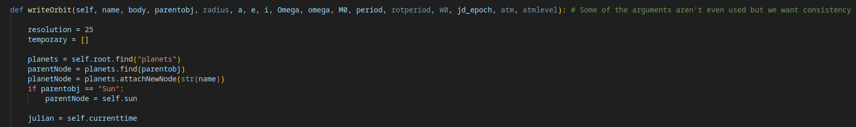
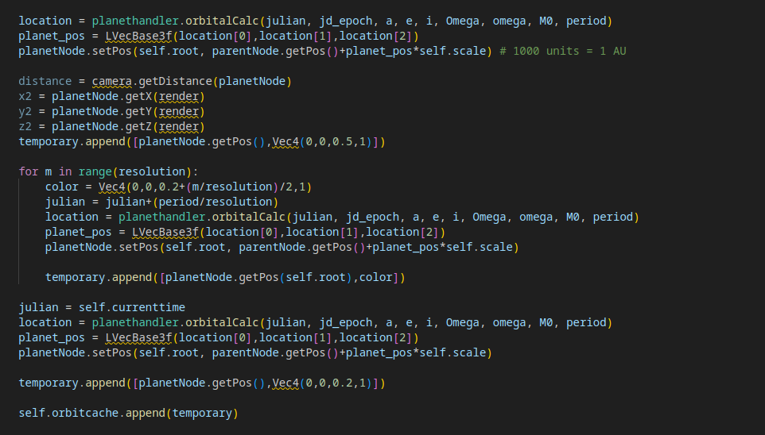
I then pass these coordinates to a renderer, which converts the coordinates in terms of the root node to coordinates in terms of the render (or camera). It then performs the “render-sphere” algorithm for each point, in order to project the orbit onto the render-sphere and have it appear full-scale from the perspective of the camera.
This has to be updated per-frame – which costs processing time, but only causes a small decrease in FPS.
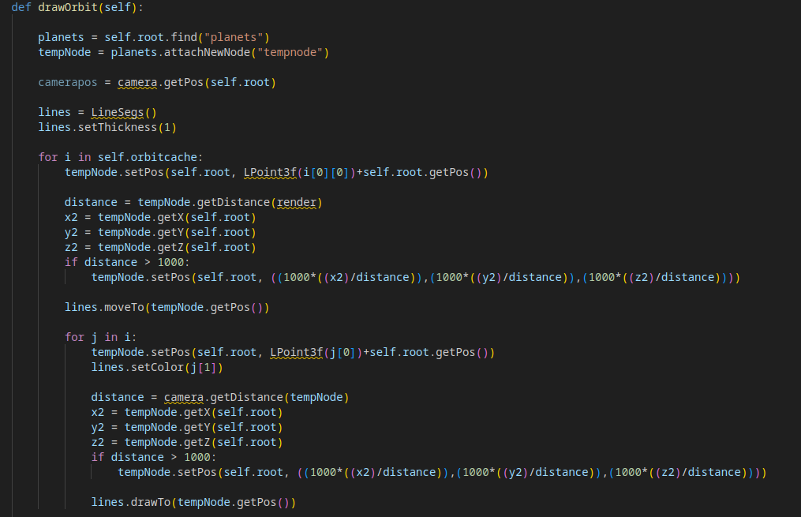
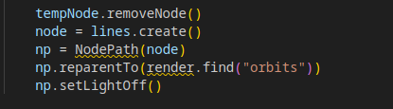
Here, instead of hiding/showing the orbit node, the orbit key enable/disables direct rendering:
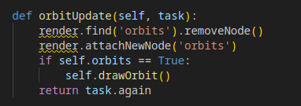
Now, we can have full view of our orbits, without running into floating-point error:
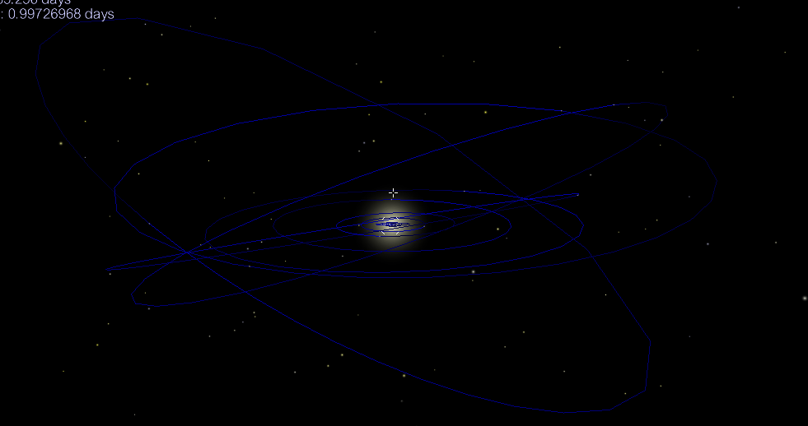
My client commented:
“This looks great, but I’d prefer colour-codes for each orbit to be able to distinguish each body.”
So I added different colours to each orbit depending on the body-type:
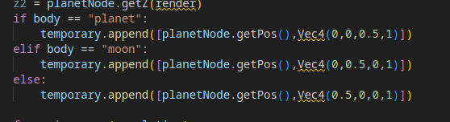

Here, I change the colours to be red, green or blue depending on whether the orbit is of a Dwarf Planet, Moon, or Planet respectively.
I also added a “trail” effect, meaning that the colour dims as the orbit goes around the body’s movement path, to show the body’s current position more clearly. This is done by slightly darkening the colour for every point in the orbit as the coordinates are drawn around it.
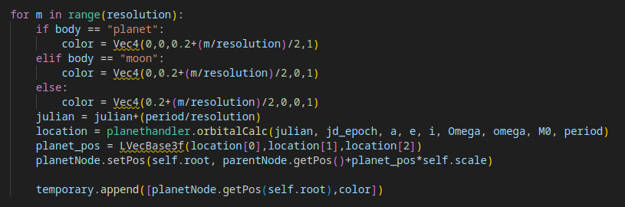
Here, colour is proportional to what iteration the point has been calculated from. Dividing the iteration by the resolution variable gives how “complete” the orbit is at that point, and can be used to dim the colour at that point.
The starting time is now not the epoch, but the current time:
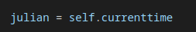
and the pretty result:
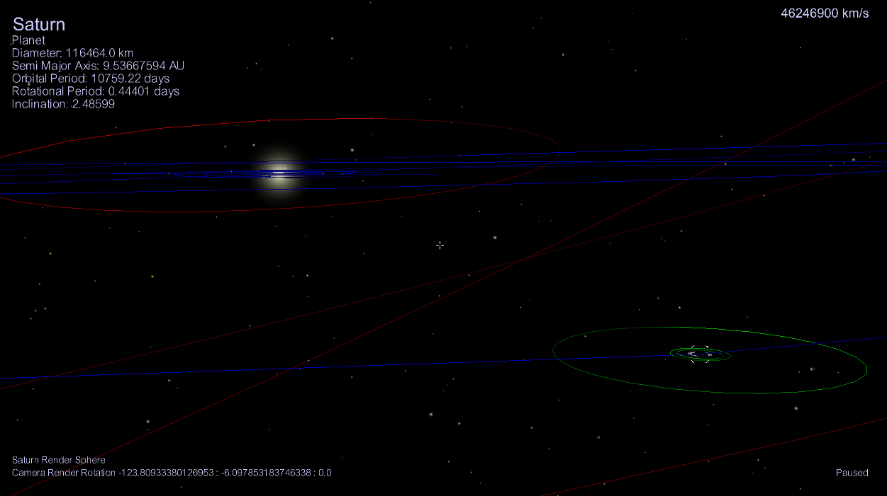
I also began to create a loading screen for the program – as I noticed database reading and object creation times were noticeably long (which is to be expected).
Here, I created an image for the loading screen – an in-program screenshot which I felt was appealing to the user:
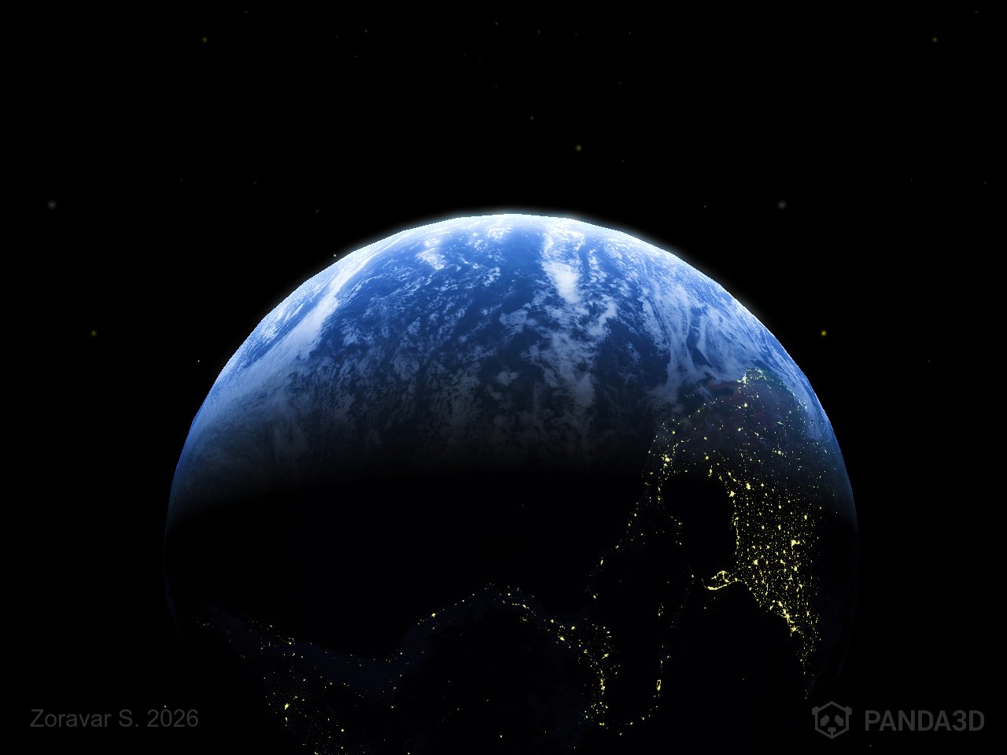
I wanted the loading screen to be a “splash screen” – a branded, stylised loading screen which maintains a smooth experience to the user.
I change the initial window size in the to match the image dimensions:
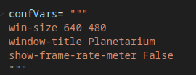
I then created an OnscreenImage at the beginning of the init, along with loading text. I then called the window to render one single frame (as otherwise, no frames will be rendered until loading is complete).
This created a visual error of a black screen. I’m unsure what causes this error, and I assume it has to do with Panda3D’s renderer, but it’s fixed by calling the frame renderer around 4 times instead of one:
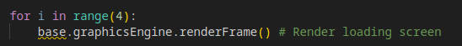
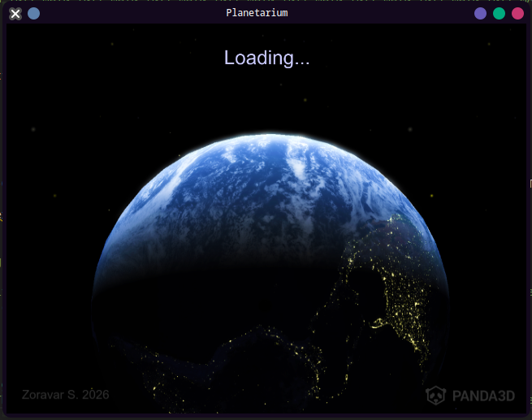
I then had the resolution change to the suitable one we had before (which can be adjusted by the user, or made fullscreen if needed) when loaded, as well as removing the loading screen nodes.
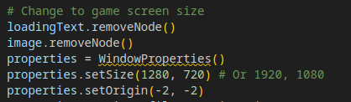
“setOrigin” allows the window to be centred in the middle of the screen on resize – Panda3D has -2,-,2 equate to the screen centre. This is placed at the end of the init.
I also had the camera be placed a set amount of units away from Earth during startup (or rather the root be moved from the camera the opposite displacement of Earth to the root, to place Earth in front of the camera) – and then have the camera face Earth.
This ensures that the camera is in a suitable place when booted up (at “Home”).
I had created a “README” file, which served to give basic information on how to use this program:
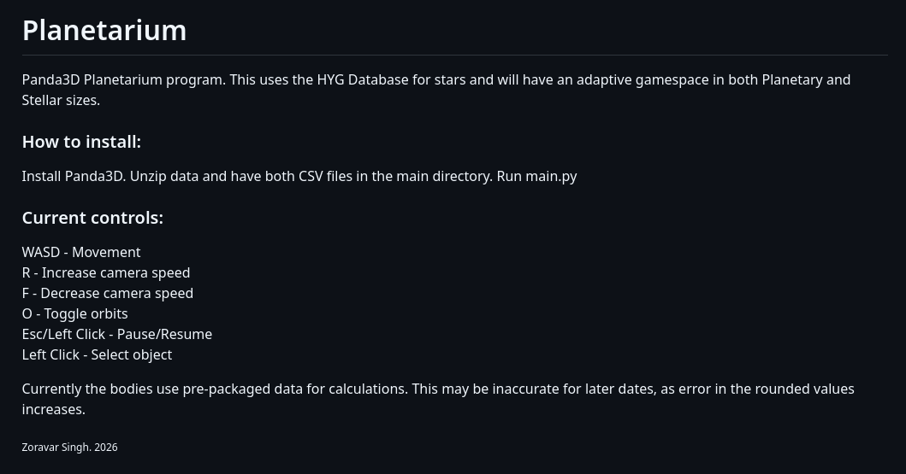
I also made a “startupdisplay” during UI creation, and a task which creates a temporary introduction text on the display which cycles before being deleted.
I use task.time to see how many seconds the task has persisted for. It binds being under a certain amount of time to a particular text, so the text is updated every time the conditional is not met for the previous text.
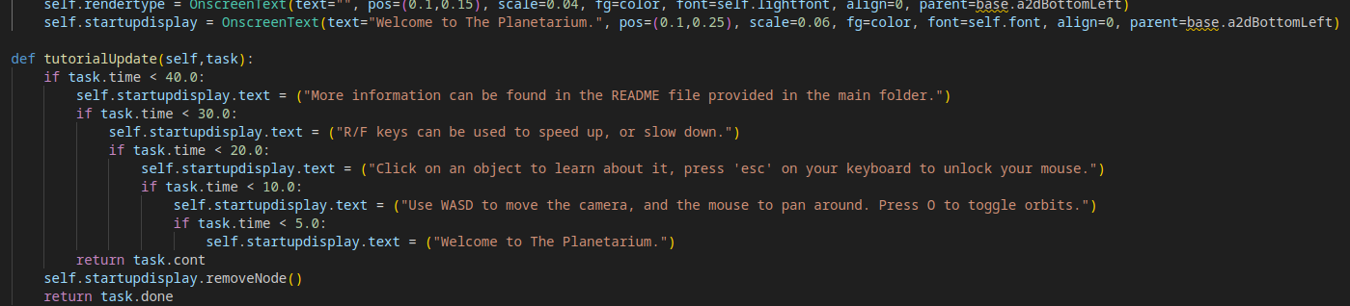
The task is then run at the end of init, only after the program has fully loaded.
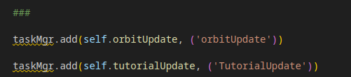
This creates a nice visual introduction for our user, as well as any extra info in the README:
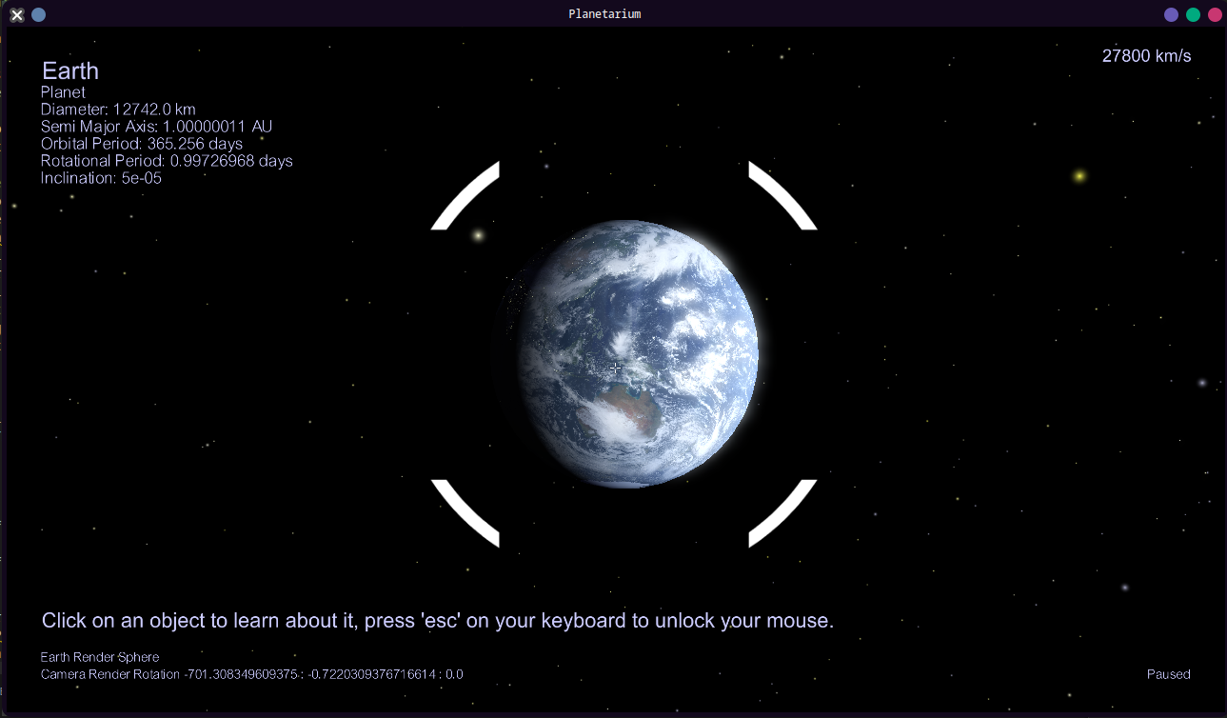
We have successfully added a user introduction to help create an accessible program.

Number | Test | Expected result | Achieved?
23 | The program is installed/launched | Some form of intuitive documentation/a tutorial is provided | Yes
I unfortunately couldn’t finalise the more ambitious features of this program, such as interstellar travel and time settings. Though the stellar neighbourhood is visible and accessible to the user – it cannot be navigated through in 3D. The time in the simulation currently boots to the computer’s current time. Though this could hypothetically be changed by the user – it isn’t as accessible as I had hoped it would be.

Number | Test | Expected result | Achieved?
21 | Time is adjusted | Object locations and rotations update accordingly | No
22 | The camera travels far enough where a singular coordinate system is impractical | The coordinate system is updated and the environment is scaled accordingly | No

Post-Dev Testing
We are now going to test the robustness and usability of our program to any user who may use it. I will be going over the Post-development tests I have created.

Basic Program Usage
Number | Test | Expected result | Justification
1 | Allow user to boot up program | Program opens smoothly – possibly with a loading screen to indicate program status to the user. | ...To be able to use the program.
This is pretty straight-forward, and behold: Our program opens without immediate errors!
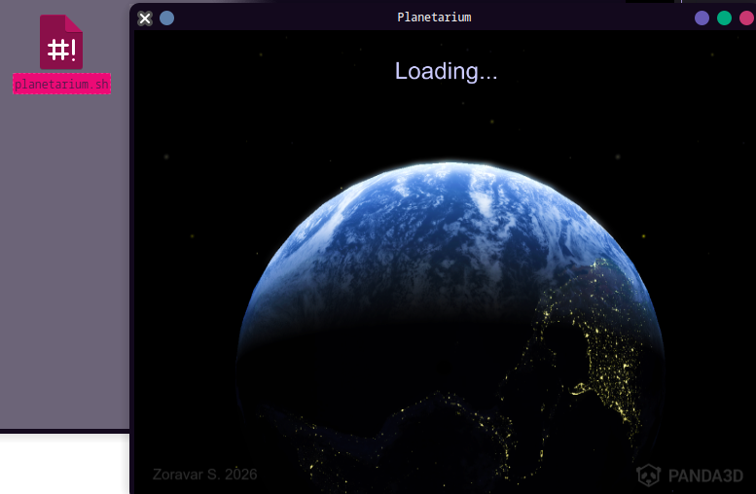
(This shell script simply executes main.py)

Number | Test | Expected result | Achieved
1 | Allow user to boot up program | Program opens smoothly – possibly with a loading screen to indicate program status to the user. | Yes

Number | Test | Expected result | Justification
2 | User opens program for the first time | User is greeted with short help on using the program | To allow the user to know how to begin program interaction.  Survey question 3.7
We are greeted with a short introduction on how to use the program:
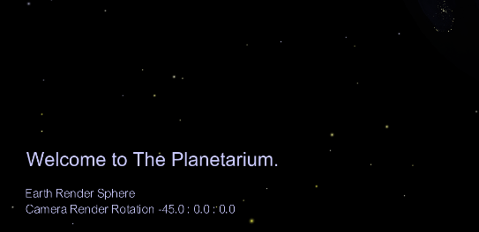
Number | Test | Expected result | Achieved
2 | User opens program for the first time | User is greeted with short help on using the program | Yes

Number | Test | Expected result | Justification
3 | User attempts to input world movement | The camera responds as expected, in a free-cam setting. | Basic user interactivity for movement of the camera.  Survey question 3.4  Research; Program 4
4 | User attempts to adjust camera rotation with a mouse | The camera can be adjusted in rotation by using the mouse, responds as expected | Basic user interactivity for movement of the camera.  Survey question 3.4  Research; Program 4
As a user, I can move around the scene by inputting WASD and turn the camera using the mouse.
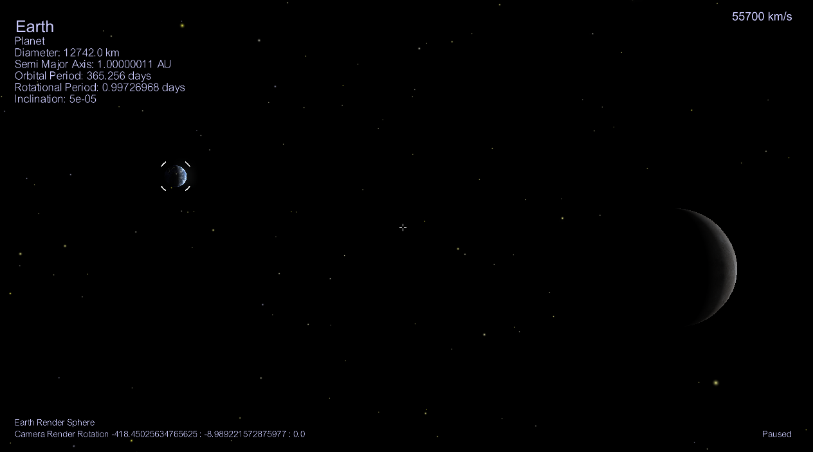
Number | Test | Expected result | Achieved
3 | User attempts to input world movement | The camera responds as expected, in a free-cam setting. | Yes
4 | User attempts to adjust camera rotation with a mouse | The camera can be adjusted in rotation by using the mouse, responds as expected | Yes

Number | Test | Expected result | Justification
5 | User attempts to select an object | The program can successfully identify the intended selection | Research; Programs 1+2+3
6 | User summons UI from object selection | The UI should always give concise, clear and accurate data | Survey question 3.2  Research; Programs 1+2+3  Usability Feature
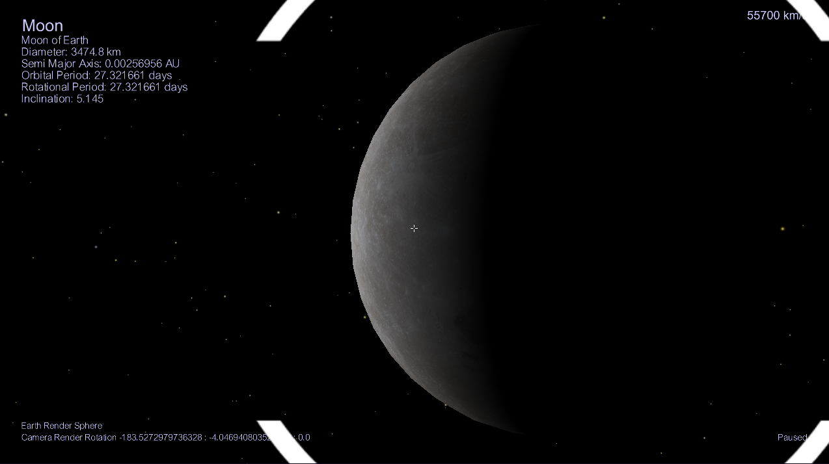
Other objects can be selected in our program – and relevant UI appears displaying body information.

Usability
Number | Test | Expected result | Achieved
5 | User attempts to select an object | The program can successfully identify the intended selection | Yes
6 | User summons UI from object selection | The UI should always give concise, clear and accurate data | Yes

Number | Test | Expected result | Justification
7 | User selects empty space | A presence check is performed - the selection is not processed to avoid errors with a null value | This is to avoid dealing with null values, which may return errors due to no presence found.
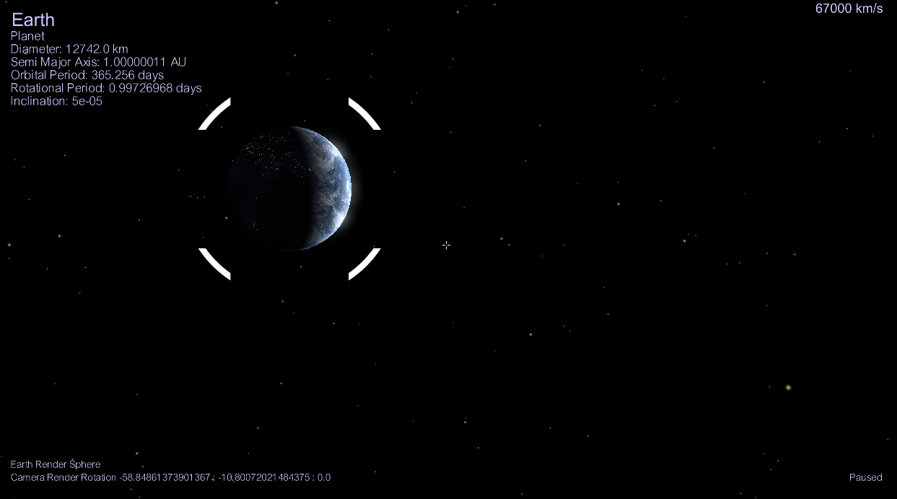
Here, when I select an empty part of the scene, my selection is not read as we have implemented a presence check – this avoids complications with null values and avoids a crash.

Number | Test | Expected result | Achieved
7 | User selects empty space | A presence check is performed - the selection is not processed to avoid errors with a null value | Yes

Number | Test | Expected result | Justification
8 | User attempts to use UI/keys to toggle orbit paths | The orbit paths appear as intended | Survey question 3.2  Client question 3
Orbits can be toggled (however without a UI button, relying on keyboard input).
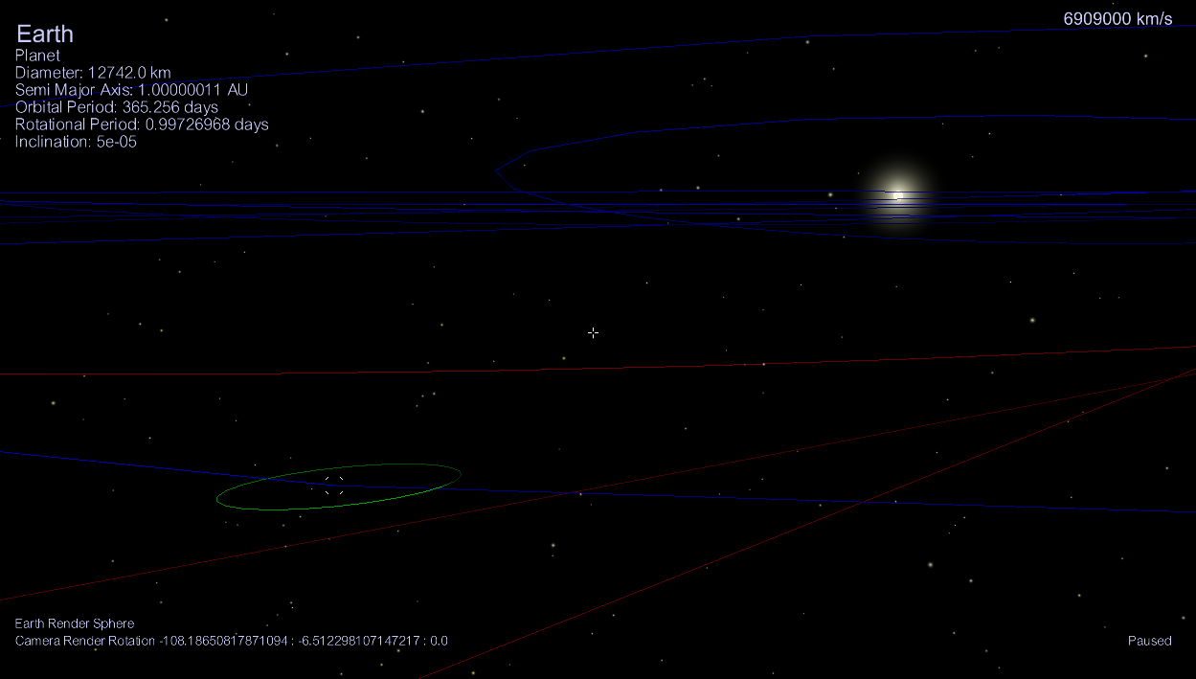
Number | Test | Expected result | Achieved
8 | User attempts to use UI/keys to toggle orbit paths | The orbit paths appear as intended | Yes (Partially)

Functionality and Robustness
Number | Test | Expected result | Justification
9 | User attempts to interact with distant objects | The coordinate system is updated to reflect the new scale our program is running in | To allow our user to fly to and view distant objects easily and without visual error. Discussed above.
We unfortunately did not implement a variable coordinate system during development, so distant objects cannot be flown to.

Number | Test | Expected result | Achieved
9 | User attempts to interact with distant objects | The coordinate system is updated to reflect the new scale our program is running in | No

Number | Test | Expected result | Justification
10 | User inputs suitable values for the camera speed from keys | The camera speed is adjusted accordingly – the speed is shown in the UI | Allow the user to explore the program practically – the distances can be incredibly large
11 | User inputs unsuitable values for the camera speed | The program performs a range check to avoid game-breaking user inputs | Allow a smooth program where the user cannot accidentally (or intentionally) create errors easily from input
I can change my speed to quickly traverse the great distances in my program, as seen here:
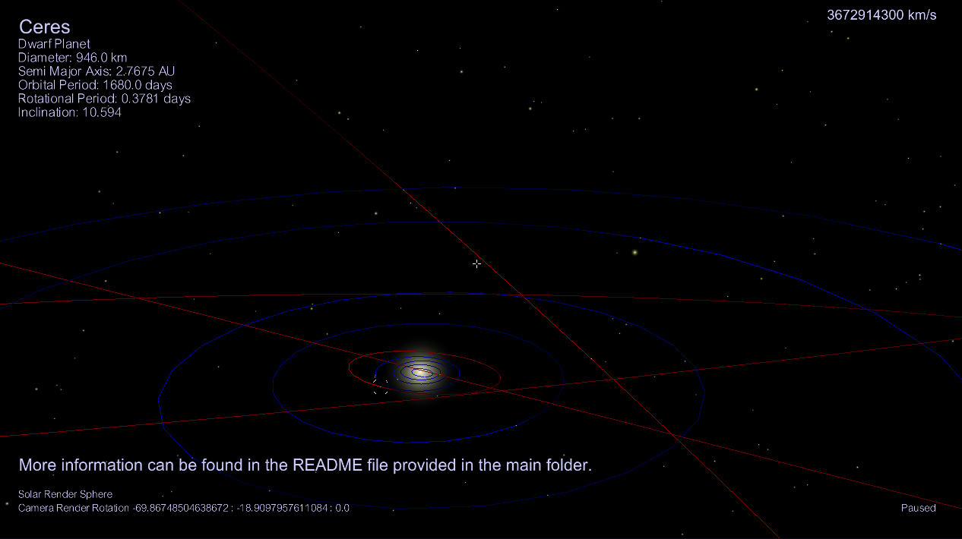
However, range validation makes sure I can’t set my speed too low (e.g 0, in which case I wouldn’t be able to move as “speeding up” multiplies my speed by a constant. 0 x anything = 0).
Minimum speed to travel at

Number | Test | Expected result | Achieved
10 | User inputs suitable values for the camera speed from keys | The camera speed is adjusted accordingly – the speed is shown in the UI | Yes
11 | User inputs unsuitable values for the camera speed | The program performs a range check to avoid game-breaking user inputs | Yes

Number | Test | Expected result | Justification
12 | Time is adjusted by the user | Object locations and rotations update accordingly | Survey question 3.6  Research; Programs 1+2+3
This is not met – though time is changeable within the program, I had not created a quick, easy way to alter it for the user in the form of a UI.

Number | Test | Expected result | Achieved
12 | Time is adjusted by the user | Object locations and rotations update accordingly | No

Number | Test | Expected result | Justification
13 | User is running the program on a computer with the specified requirements (or higher) | FPS is stable, preferably 30 or above at all times in the program | To allow use of the program to be smooth, with fast response times
Enabling FPS again, we can see a constant, steady FPS of 50 or higher:
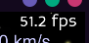
With orbits enables (and hence extra drawing time), this can sometimes go down to around 30:
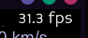
However, the FPS stays consistent and above 30, which is more than enough for this program to be smooth and responsive.
Also, note that my computer is comparatively fairly slow, and that other computers are likely to run this program much faster.
Number | Test | Expected result | Achieved
13 | User is running the program on a computer with the specified requirements (or higher) | FPS is stable, preferably 30 or above at all times in the program | Yes

EVALUATION

4.1 TEST OVERVIEW
To reiterate, here are all of our tests and their outcomes:

Development TestS
Number | Test | Expected result | Achieved
1 | Install Panda3D in a virtual environment | Panda3D source created in venv | Yes
2 | Open Panda3D’s environment from Python | Panda3D can summon it’s environment | Yes
3 | Request to create an object | An object can be added to the node graph with a desired mesh (shape) | Yes
4 | Set up a camera facing the object | The object is visible through a viewport | Yes
5 | Be able to set attributes to an object (a Mesh, texture, scale...) | A textured, scaled mesh is now visible through the window/viewport | Yes
6 | Allow game-loops – specifically testing a moving camera for this stage of development | A game loop is created, and allows adjustment of attributes, variable values over time during the program runtime. | Yes
7 | Input any form of movement (e.g WASD), as well as keybinds for speeding up/slowing down camera speed. | An interactive, bug-free camera system which can respond to user input | Yes
8 | Input an unsuitable speed for the camera | Range check validation makes sure that unsuitable input values are discarded | Yes
9 | Allow for filter effects | Filtering should become apparent (such as bloom) – allowing for bright objects to appear “glowing”. | Yes
10 | Set up the camera facing the Sun with a bloom filter and billboard glare | A fairly pretty-looking Sun, which appears glowing from no matter the camera angle – the billboard changes size depending on the camera’s distance from the Sun. | Yes
11 | Set up the camera facing an object with shaders applied | A semi-realistic, but glitch-free atmospheric shader, along with lighting and shadows. | Yes
12 | Select an object, or empty space | A visual marker appears on the selected object. Nothing happens when selecting empty space | Yes
13 | Select an object with descriptive tags | A UI displays relevant information | Yes
14 | Import Star database | The stars can be read, and it’s data used to create objects with realistic attributes | Yes
15 | Import planetary database | The planets can be read, and it’s data used to create objects with realistic attributes | Yes
16 | Stars objects are summoned | They are created in the scene, are clear, correctly places/coloured and are selectable – giving the attributes fetched from the database to the user though a UI. | Yes
17 | Planet objects are summoned | They are created in the scene, are clear, have correct textures, scale, moons and shaders applied – as well as possible extra characteristics such as rings. They are selectable – giving the attributes fetched from the database to the user though a UI. | Yes
18 | Implement orbit rendering | Orbits can be calculated – this will be achieved with having points in the orbit connected with a drawer, making an orbital path for each celestial body. | Yes
19 | Toggle orbit paths | Eye-pleasing, non-buggy, accurate orbit paths for celestial objects | Yes
20 | Parse through a database and create objects with the data | The objects are added to the scene and behave as expected, retain the information in the databases | Yes
21 | Time is adjusted | Object locations and rotations update accordingly | Yes (Partially)
22 | The camera travels far enough where a singular coordinate system is impractical | The coordinate system is updated and the environment is scaled accordingly | No
23 | The program is installed/launched | Some form of intuitive documentation/a tutorial is provided | Yes

Post-Development TestS
Number | Test | Expected result | Achieved
1 | Allow user to boot up program | Program opens smoothly – possibly with a loading screen to indicate program status to the user. | Yes
2 | User opens program for the first time | User is greeted with short help on using the program | Yes
3 | User attempts to input world movement | The camera responds as expected, in a free-cam setting. | Yes
4 | User attempts to adjust camera rotation with a mouse | The camera can be adjusted in rotation by using the mouse, responds as expected | Yes
5 | User attempts to select an object | The program can successfully identify the intended selection | Yes
6 | User summons UI from object selection | The UI should always give concise, clear and accurate data | Yes
7 | User selects empty space | A presence check is performed - the selection is not processed to avoid errors with a null value | Yes
8 | User attempts to use UI/keys to toggle orbit paths | The orbit paths appear as intended | Yes (Partially)
9 | User attempts to interact with distant objects | The coordinate system is updated to reflect the new scale our program is running in | No
10 | User inputs suitable values for the camera speed from keys | The camera speed is adjusted accordingly – the speed is shown in the UI | Yes
11 | User inputs unsuitable values for the camera speed | The program performs a range check to avoid game-breaking user inputs | Yes
12 | Time is adjusted by the user | Object locations and rotations update accordingly | No
13 | User is running the program on a computer with the specified requirements (or higher) | FPS is stable, preferably 30 or above at all times in the program | Yes

4.2 A Statement on Usability Features
The usability features proposed have been demonstrated through the clean, concise UI I have developed – along with the user introduction.
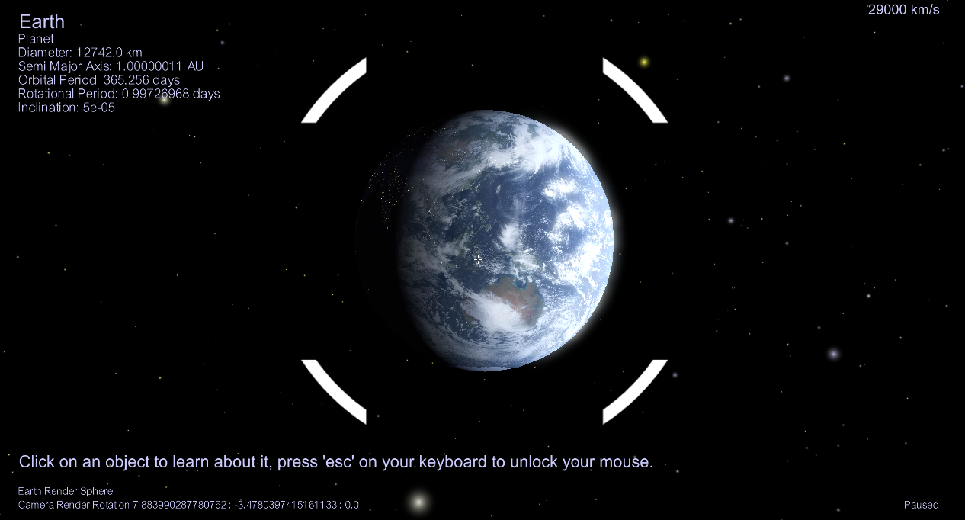
I created a UI in a clear font, stand-out but fitting colour which is also adaptive to different screen sizes, ensuring information is not lost off-screen or clutters the viewport. I also embedded a simple start-up tutorial within the UI.
More important information (Tutorial, selected object name) is in larger, bold text – to be easily noticeable to the user.
The selector object maintains a constant minimum size throughout the program to always indicate the selected object to the user – even if said object is far away.
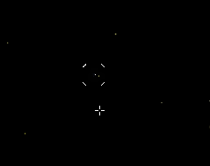
This is the same with the hitboxes, which are always a certain relative scale to the camera, in order for objects to be easily selectable to the user.
The loading screen has been implemented to provide a smooth, stylised transition between the program opening and running:
As per request of my client, we added orbits into the program to allow the user to see the paths the objects in our program take, and be able to visualise orbital concepts, such as eccentricity or inclination.
Although we have implemented a significant amount of usability features as planned, which have been very effective – I have unfortunately not been able to implement UI icons for toggling orbits, changing FOV, the simulation time etc… These would be straight-forward to implement for the UI using Onscreen Images, however, updating the positions of all objects in the scene may require a different technique than constant calculation (e.g path animations), as calculating positions per-frame for each object when having time constantly change will be incredibly expensive and impractical.
In future development, I would like to add these features into our program in order to give a cohesive, interactive application. I feel that though our UI serves it’s purpose, it is rather simplistic. I would definitely prioritise appealing icons, input boxes or drop-down menus for more complex features in the future.

4.3 Stakeholder FINAL Interview
To get general feedback on our final program, I gave this survey to our stakeholders to get their thoughts and feelings on the usability of the program.
1. Information available
How satisfied were you by the information available to the user?
- Not satisfied
- Somewhat satisfied
- Neutral
- Somewhat satisfied
- Very satisfied

Results:

From this data, it seems we implemented a suitable amount of data for the user to view through the UI.

2. User Interface
How satisfied were you by the user interface?
- Not satisfied
- Somewhat satisfied
- Neutral
- Somewhat satisfied
- Very satisfied
Results:

It seems we were very successful in creating a compact, clear and appealing user interface for our user.
3. Visual Appeal
How satisfied were you by the user interface?
- Not satisfied
- Somewhat satisfied
- Neutral
- Somewhat satisfied
- Very satisfied
Results:

It appears our complex shader code did good work, as our stakeholders found our program extremely vibrant and visually appealing.
4. Performance
Did you find the performance and response times of the program satisfactory?
- Yes
- No
- Neutral
Results:

It appears that for most machines, our program is completely satisfactory in terms of performance, and is capable of running on different OS.
What more feedback would you like to give?

Some of the results:
- “I think being able to quick-travel to objects would be nice.”
- “I liked the detail in this program”
- “I would like to travel to nearby stars in future updates”
- “i’d like more objects like asteroids or more moons”
It seems that any draw-backs of our program were merely due to time-constraints. We may also want to look into support for smaller objects in the future, as our engine currently cannot handle this.

4.4 Overview of the Success Criteria
Here is our Success Criteria, and based on the testing carried out above, I have shown which criteria I have or have not achieved:
Number | Criteria | Justification | Achieved
1 | Ability to display multiple textured objects in a world | Basics of appealing graphic design for celestial bodies. | Yes
2 | Shaders to allow detailed shadows | Advanced feature for allowing more intricate, appealing graphic design for celestial bodies as well as allowing eclipses to occur. | Yes
3 | Atmosphere shaders | Feature for allowing more intricate appealing graphic design for celestial bodies, as well as being able to display which celestial bodies have an atmosphere visually. | Yes
4 | Glare shader/effect for stars | Basics of appealing graphic design for celestial bodies. | Yes
5 | A camera movement system | To allow the user to explore the map easily and intuitively. | Yes
6 | Ability to display orbits when given information (eccentricity, inclination etc...) | To accurately display locations of celestial bodies within our Solar System | Yes
7 | A visual display of object properties (Name tags, Orbit paths etc...) | Ease-of-use when trying to locate celestial bodies, as well as a quick way to view properties of objects. | Yes
8 | Ability to select objects with mouse | To allow the user to interact with celestial bodies directly (and for the program to know which object the user is interested in) | Yes
9 | A UI to display object info | To allow users to easily view object information – which is the main highlight of this program. | Yes
10 | Have object info read from a database | To allow data on objects to be in a database for maximum efficiency of storage (as well as making queries much easier) | Yes
11 | Stars/Stellar objects to have a different coordinate system to planets | To allow for vastly different levels of scale (km to ly) to be stored simultaneously within the program. | No
12 | Solar object positions determined with time | To allow users to adjust time settings to see how objects in the Solar System orbit. | Yes (Partially)
13 | A variable scale system | To avoid rendering and precision errors with large numbers. | No
14 | An ability to project distant objects to avoid large coordinate values | So objects very far away can still be viewed as a ‘viewport’ even when too far away to render directly. | Yes
15 | Origin to be at the camera | To avoid floating point error when rending | Yes
16 | Documentation / A Tutorial | To help new users understand the program. | Yes

4.5 Future implementation, missed proposed features AND LIMITATIONS
I had significantly underestimated the work required towards this project – despite acknowledging it’s ambition. I had considered using other engines (Such as Blitz3D), but I ended up using Panda3D for it’s reliability, efficiency and being programmed in a language I am familiar in. Despite this, I have had to learn this game-engine from the ground-up, as well as wrap my head around OOP in general.
This resulted in a lot of proposed features having to be implemented in a fairly short amount of time, along with the workload of my A-Levels. This resulted in a few criteria being missed, or implemented partially.
This means virtually all missed features were a result of a lack of time.
The most glaring missed feature is interstellar objects being traversable in 3D. This would have required a variable scale system, and adjustment of coordinates when moving in/out of the Solar System. This would have also required implementing a chunk loading system, with chunks being calculated given star coordinates (This was discussed further in Design).
I also would have liked a system to update time easily for the user. Currently, it takes a lot of processing in order to calculate the positions of all objects in a single point in time. If this had been optimized, object position could have been updated in real-time – for now it is only set once during program startup.

Maintenance
Since our values for orbital calculations are rounded and inaccurate, and don’t take micro-adjustments of positions and rotations into account, as our time increases, delta time also increases – hence our error has deviation from true values increase as time goes on.
This means that as time increases, our orbits and rotations get more inaccurate. This will become more apparent as our date increases – this unfortunately cannot be maintained well, and is a downside to our positioning technique.
The Panda3D engine may cause compatibility issues if our code becomes unsupported or outdated. This can cause significant problems with our code if it is not accommodated to Panda3D updates (though updates aim to preserve older programs) – our code will need to be routinely updated in these scenarios.

Limitations
There are several limitations with both Python and my own code.
My own code is unoptimized at points – such as the orbit renderer, which renders every orbit in the Solar System, even if far away and small (e.g the moons of Jupiter will have their orbits rendered when the camera is at Mercury, despite being virtually invisible)
I have abstracted several features of objects in my program, including the following:
- Planets/moons are modelled as completely spherical – which they aren’t in reality.
- Rotation is limited to 1 axis, which doesn’t model seasons, or tilted planets like Uranus.
- Surface detail is incredibly basic, with only base colour – no bump map is present.
I am unable to simulate very small bodies (e.g comets) as their unit size is too small for Panda3D to handle – this could be circumvented through camera trickery similar to the render sphere (which made objects appear much larger and further away than they actually were) where smaller objects are made to appear smaller in a similar fashion. This may be suitable for a future update, as our stakeholders seem eager to have this feature in our program.
Python, being an interpreted language famous for being relatively slow when compared to it’s compiled counterparts, can slow down the program greatly – even if resource-heavy code is run in C++ by Panda3D.

Possible Features in the Future
I would enjoy adding as many celestial objects as I can into this program (Comets, asteroids, possibly even spacecraft) – as well as interstellar objects if interstellar features could have been successfully implemented, such as nebula.
This would shape up for a complex, ambitious program which I could possibly make open-source.
I also would like to have planet position, calculation etc… not dependant on an in-program database. NASA API allows for incredibly accurate position and rotation values to be fetched, and this has been packaged into convenient libraries such as AstroPy. Swapping our in-program calculations for far more efficient and accurate ones will allow for a much more realistic program, as well as being able to avoid abstractions (such as rotation in this program currently only being in one access).
More planets, moons etc… can be easily added through the CSV files – however, orbit rendering will need to be optimized to allow many objects at once, which is discussed above.
I would like to add multiple camera modes and features (e.g Quick-travel, focus on an object) – which would require multiple tasks being implemented for the camera, and chosen by the user.

4.6 FINAL STATEMENT
(Not to be marked or taken as part of the assessment)
This project has been very ambitious, and though I couldn’t achieve features I had planned, I am generally happy with the way it has turned out – it is very satisfying to view the Solar System and night sky stars in this program and see celestial bodies up close. I had to learn Panda3D (and 3D game development in general) for this project, and I am very pleased with the programming experience I have acquired along the way.
If I ever do make the repository for this program open-source, you will be able to find it on my GitHub.
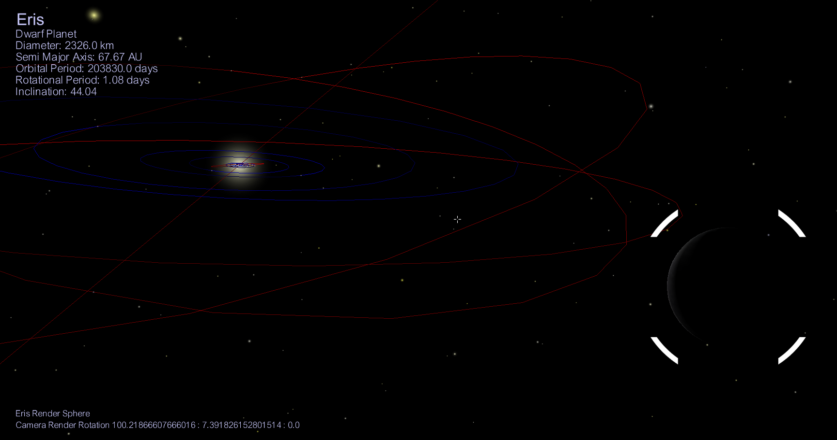
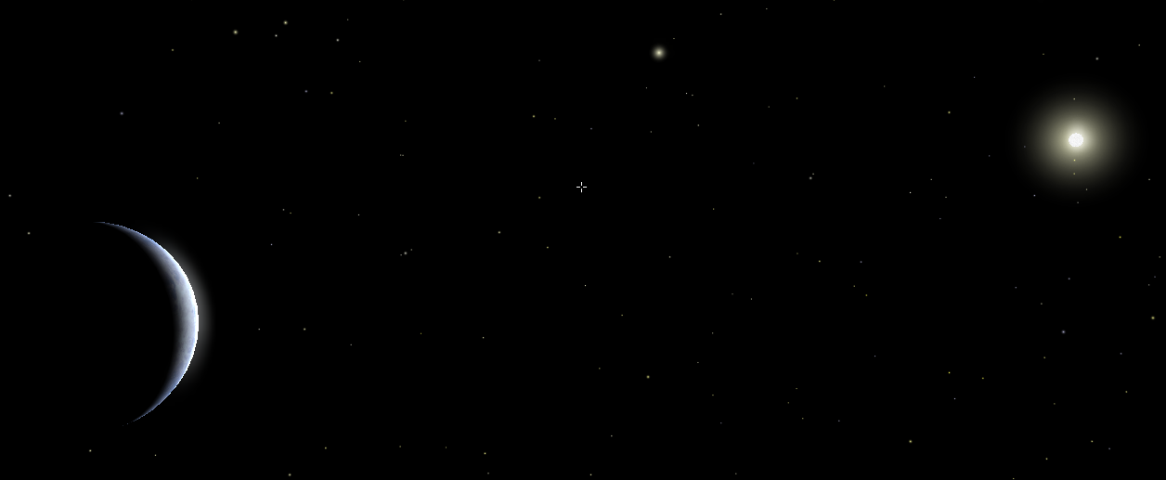
Venus
Eris
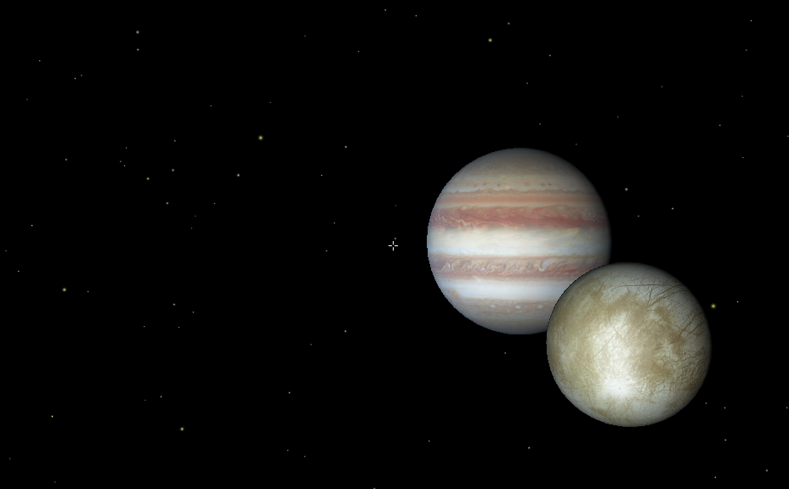
Jupiter and it’s moon, Europa
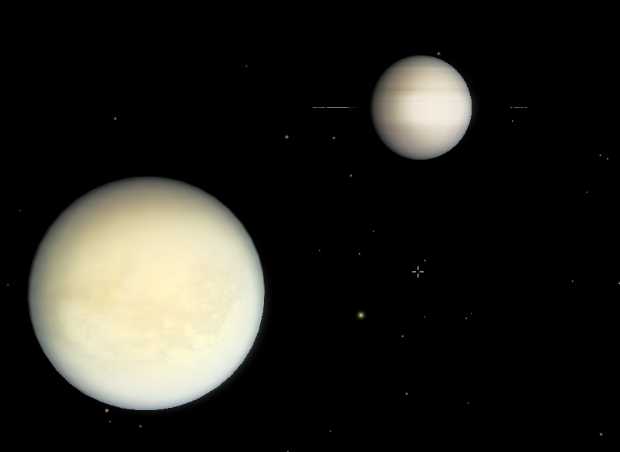
Saturn and it’s moon, Titan
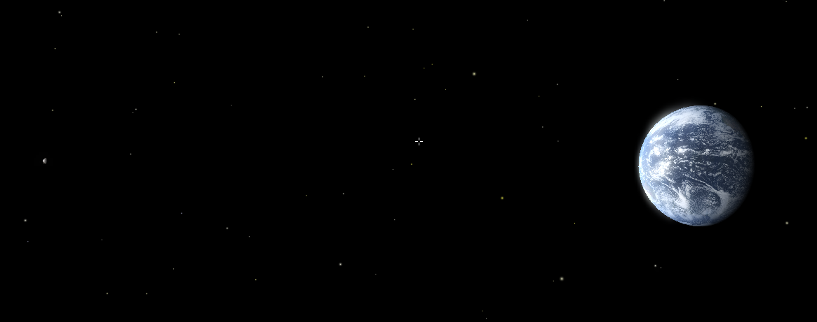
Earth and our Moon


