ANALYSIS

1.1 Problem Definition
Astronomy is a fascinating field to all, but for most can remain mystifying and convoluted - I experienced this first-hand with other students in our Astrophysics component of OCR Physics.
Considering this, I wanted to create an accessible, visually appealing, powerful and informative program to assist those studying, working in fields related to, or showing an interest in Astronomy. I want to allow this program to assist both beginners and those with more expertise.
This project will be a lightweight, 3D-rendered ‘Planetarium’ program which will display the most prominent objects in the Solar System, as well as our local stellar system, and allow for the user to read info on selected objects through a UI as well as the 3D viewport.
The visual aspect can enable students or hobbyists to gain an intuitive understanding of our Universe, and the ability to read information on celestial objects can be useful to those with an advanced understanding of Astronomy.
There are programs that achieve a similar concept (With varying degrees of complexity) such as SpaceEngine, GAIA Sky and Celestia. My project will be a lighter, more abstracted version of these programs’ concepts. Similarities may include an information UI for selected objects, a free camera to navigate through the map, and (possibly) the ability to change the date and time – and to have Solar System bodies change positions in orbit to reflect it.

1.2 Stakeholders

My client is my Physics teacher, Luke. He expresses interest in being able to have a program which can help teach his students Astronomy and provide data to carry out Astrophysics calculations in-class. He’d be able to also use this program in his Astronomy Club.
My stakeholders consist of those interested in, researching, learning or teaching Astronomy. My program aims to be applicable to everyone of varying knowledge in the field, from students to researchers. I will focus on the needs of a student to allow the program to be easily accessible but also be able to provide additional data on celestial objects for more advanced users.
Astronomers (or stargazing enthusiasts) may make use of this program to gather useful information of celestial objects (Such as absolute magnitude, distance from us, diameter of objects etc). Teachers may use this program for visualization to assist learners in a classroom environment.

1.3 Computational Methods

Justification of Computational Methods

Visualising the Universe around us in a 3D space is practically impossible in reality, as we only have one vantage point – Earth. As a result, students may become easily confused on how objects in space are arranged and interact with each other. For example, Alnitak – a star in Orion’s Belt – is nearly 1,000 lightyears away from Alnilam – another star in the same constellation. However, with a traditional 2D sky map, these two stars can appear right next to one-another (as the stars are simply projected onto the sky map as seen from Earth – like how two trees in a distant park may appear to be in the same spot from our perspective, but are actually far apart.)
Limitations like these, in my opinion, make it crucial to have an interactive 3D space when trying to understand the cosmos. This technology is only achievable through computational methods of 3D rendering.

Abstraction

Creating a program of this scale requires heavy abstraction. Multiple celestial objects (Nebulae, Asteroids, Comets, Spacecraft and other Galaxies) will be exempt from this program due to performance and programming constraints, as well as a vast amount of these objects (Such as the millions of asteroids in the Asteroid Belt) not being relevant to most users.
Celestial objects will have a clear and identifiable, but heavily simplified appearance. For example – Earth will have a clear surface map, but this will only be in a standard texture size. Intricate details of mountains, seas etc. For planets are not necessary for the user, as the main usage of this program is for visualizing at a much larger scale, and more general details should be considered, such as star glare or displaying orbit paths.

Decomposition

This program displays a vast number of objects and offers a large amount of data to the user. For this reason, I’ll be breaking down the project logically into smaller, more manageable tasks:
- Database management, storing and being able to fetch information from stellar catalogues.
- Planetary-scale features, such as displaying planets, moons, and orbit paths.
- Displaying data on a UI, retrieving it from the database.
- Interstellar features. A star map of the nearest ~10,000 stars (or more) to be stored in an octree data structure to allow for quick rendering and lookup.

Thinking ahead

Initial research and planning will be needed for this project.
Displaying planets in our Solar System in their accurate orbits will require knowledge on Keplerian equations (to display eccentricity and inclination)
This project relies on lots of pre-recorded data and is mainly a program to display this data into something intuitive, interactive and easy to navigate. Catalogues will be needed to have the celestial characteristics required to accurately display objects in this program (such as the GAIA catalogue).

1.4 Research

To create a program that adequately balances having wide array of features and content, while being lightweight and intuitive, I have surveyed similar programs which are similar in output to my desired program and have taken note of which features will benefit my project, and which features may be erroneous/out of bounds for implementation.

SpaceEngine

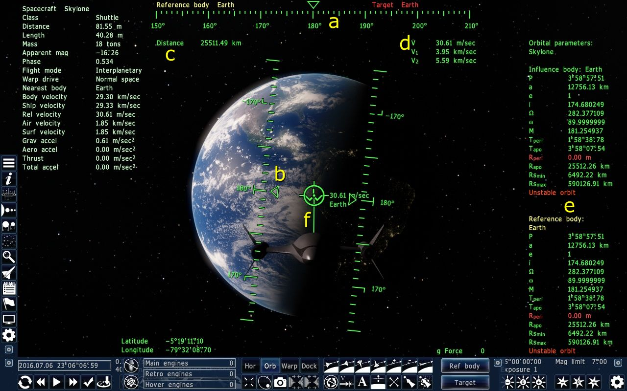
Celestial information
More gameplay-focused features (spaceships)
Streamlined, easy-to-use UI
Incredibly detailed graphics

SpaceEngine is a paid, interactive 3D planetarium and astronomy software. SpaceEngine creates a 1:1 scale 3D planetarium representing the entire observable universe, combining real astronomical data with scientifically accurate procedural generation algorithms.

What may be useful:  - This program is incredibly versatile, user friendly, and visually appealing. It has a clear, illustrated UI and easy-to-use controls with a free-cam feature.  - This program intelligently balances visual appeal with a lot of useful data for more advanced users, which can be seen on the side-view panels.  - This program can handle both small and large-scale bodies. It can display objects as small as a house to entire galaxy clusters.  - This program performs decently on lower-end devices. It is very well optimized for the detailed graphics it contains. | What may be erroneous:  - This program is incredibly complex, displaying virtually the entire Universe within the planetarium, with unmapped regions being procedurally generated. This is far too complicated to implement in this coursework, and more difficult-to-implement features should be sacrificed for a more feasible project.  - The program is very visually detailed, generating terrain and surface scatter for planets, as well as complex shaders for stars and other celestial objects. These features are appealing, and make the program more engaging, but are not completely necessary for a strictly educational project.  - This program also implements more “video game”- esque features, such as adding fictional spaceships and a planet creation tool. These features are mainly for entertainment purposes, and don’t align with the goals of this project.

GAIA Sky
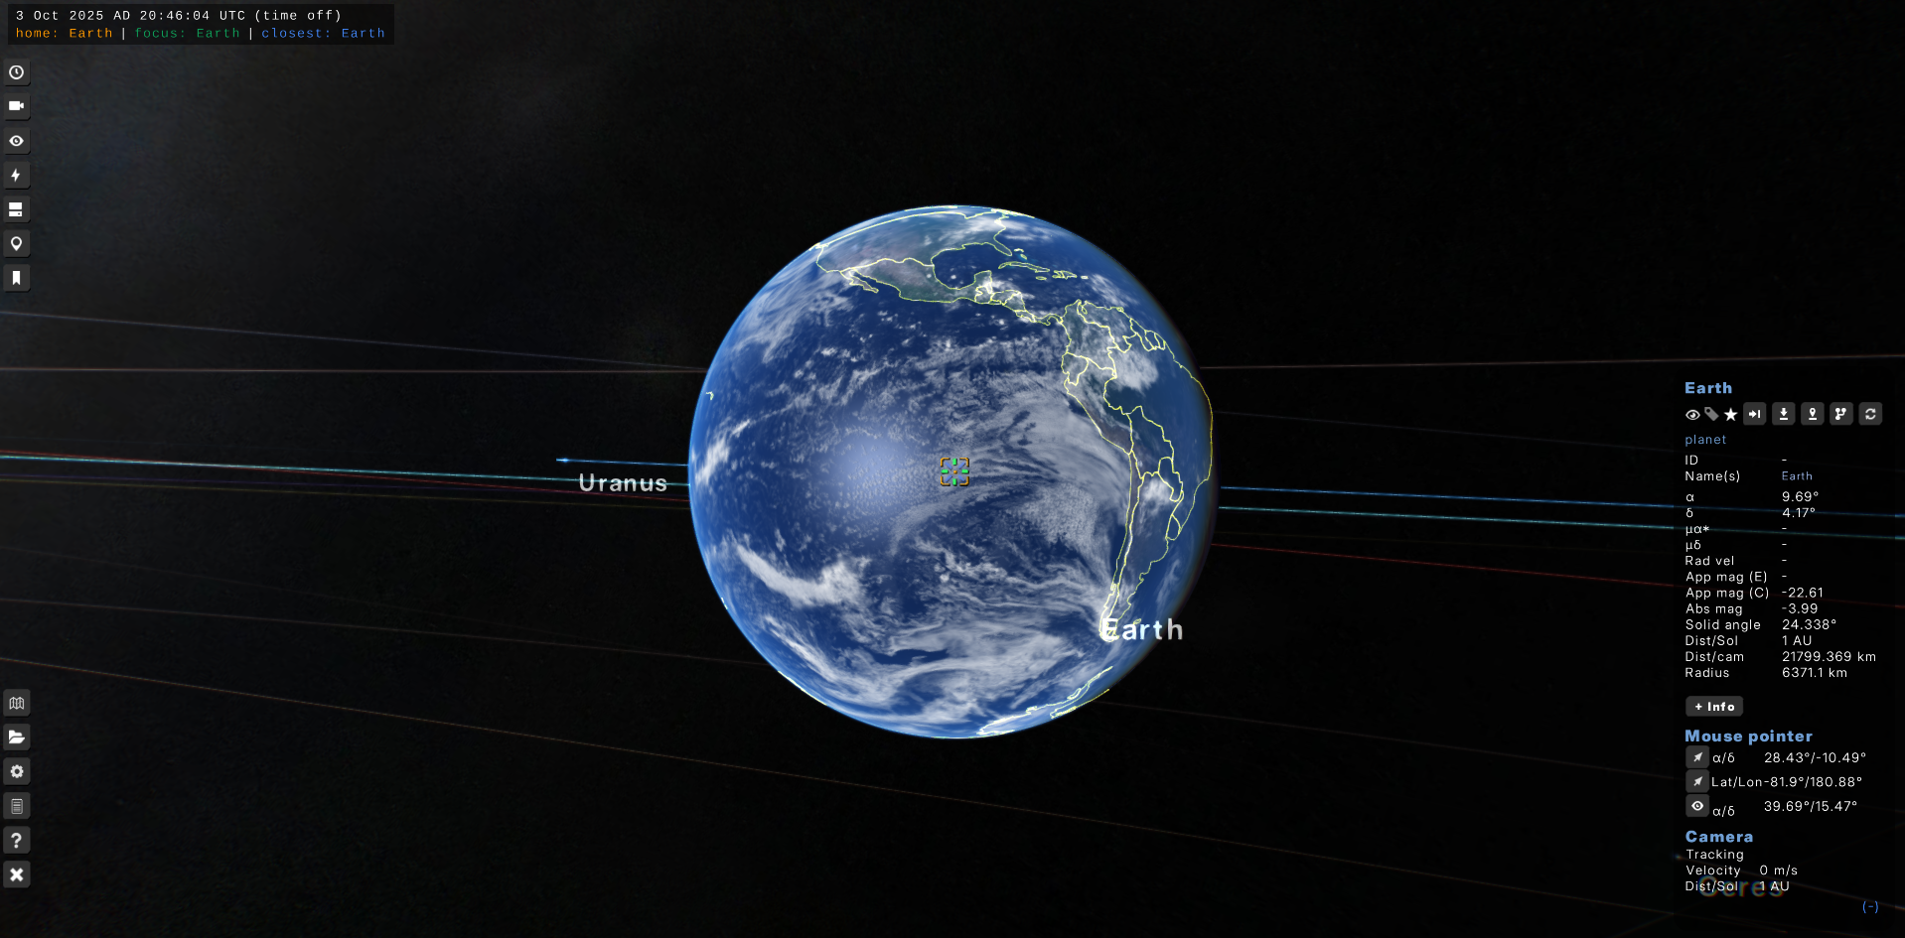
Quite decent graphics
Lots of useful celestial info
Very pretty UI
Gaia Sky is an open-source astronomy visualisation desktop and VR program in the framework of ESA's Gaia mission to create a billion-star 3D map of our Milky Way Galaxy.

What may be useful:  - I particularly liked the UI in this program. It’s very simplistic, clear and involves little-to-no menu diving. Very easy to use.  - This program balances out good graphics with simplicity very well. It gives enough visual clarity for the user, but is not as difficult to replicate as SpaceEngine.  - This program allows importing custom catalogues, and allows portions of the supported catalogues to be installed/uninstalled. This makes it very easy to manage stored catalogues, and prevent large file-sizes from importing entire catalogues at once.  - This application’s scope is similar to our own. It only displays the Milky Way galaxy (If you don’t include galaxy catalogues), which is much more feasible than the scope of SpaceEngine. | What may be erroneous:  - This program is fairly unstable at times. This may be from poor optimization of rendering the celestial objects. Our program should try and take optimization into account.  - I found the free-cam system unintuitive, which could be changed slightly with settings, but would probably be better off being well-polished by default.

Celestia
Simplistic, straight to the point object information
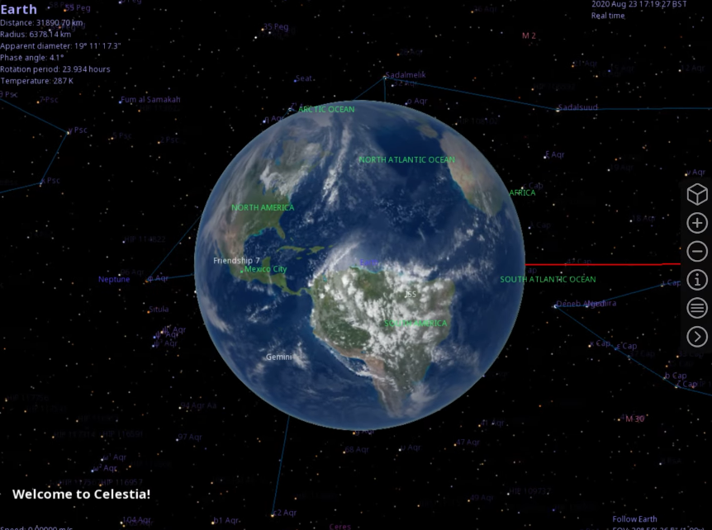
Basic UI and settings
Not very flashy, but still useful and informative visuals

Celestia is a real-time 3D astronomy software program that was created in 2001 by Chris Laurel. The program allows users to virtually travel through the universe and explore celestial objects that have been catalogued. Celestia also doubles as a planetarium.

What may be useful:  - I found the control system, especially movement, to be very easy to use.  - This program offers a decently-sized catalogue (though it is not manageable) of various celestial objects. Other catalogues can be installed through mods.  - This program is particularly useful for stargazers. It has useful data for objects, such as distance to Earth. It also has a “Planetarium” view, which lets you browse a traditional 2D skymap.  - Well optimized, a good balance of detail and being lightweight. | What may be erroneous:  - Due to the scale of the program, and the camera not being the origin, floating-point precision becomes a problem as objects are added further away.  - Shading features are limited, with little-to-no effects or filters and a lack of shadows (for eclipses) when it comes to irregular-shaped objects.  - Some data is outdated, despite the program being updated to this day. For example, objects may have very old, low-quality textures which have since been improved through mapping. Models for spacecraft are very outdated and not very detailed.

Stellarium
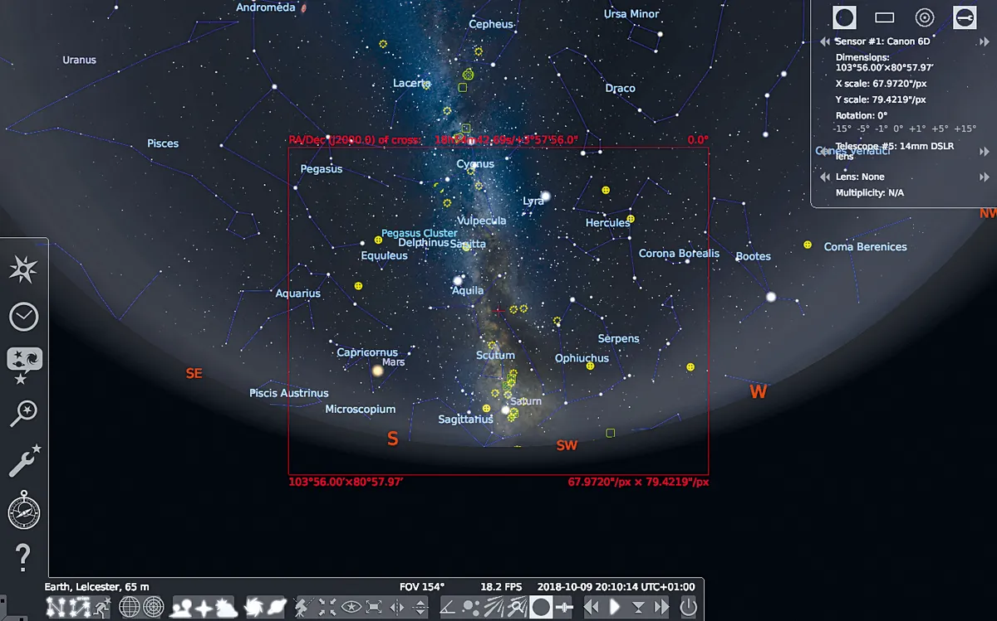
Only one vantage point for the camera
Good UI
VERY informative data given for objects
What may be useful:  - This program is especially useful for stargazers, as it gives the same vantage point a stargazer would have looking at the night sky, in a 2D skymap.  - Very easy to run, not much 3D rendering going on.  - Very useful information is given (magnitude, coordinates in the night sky) | What may be erroneous:  - Only one vantage point is given – this can cause issues for those learning astronomy due to an inability to grasp 3D space, as previously discussed.

1.5 Survey

1. General Information
Name (Optional):

Role (Student, Educator, Other…):

Results:

This survey was composed of mostly students, which is a good middle ground for those unfamiliar with the subject of Astronomy and those who specialize in the field.

What is your current understanding on Astronomy and/or Astrophysics?

Some of the results:
- “I have basic knowledge of astronomy (I only know the common constellations), and my knowledge of astrophysics is mid - I've read only a little bit outside of the spec about black/white holes for my physics presentation.”
- “I don't understand it other than common knowledge / the basis as I've never had a class revolving around it.”
- “A level physics”
- “i like it but i dont know how to do the math stuff”
- “GCSE Level”
We have a range of answers, ranging from people completely new to the subject to those with an A Level understanding of astrophysics. This will allow us to gather information that is both accessible for less experienced users and useful for those with a deeper understanding of Astrophysics.

2. Current Challenges
What are the main challenges you face when studying Astronomy?
Open ended question to gather general thoughts and opinions
Some of the results:
- “Anything mathematics involved.”
- “Finding Reliable information”
- “How the theory of astrophysics affect planets in the real world.”
- “visualising the stuff in astrophysics, its a bit hard to comprehend how massive some of the objects are”
- “Being able to picture where the planets in our solar system are and the scale”
It seems our program can tackle a lot of general problems when it comes to astrophysics. People may not be able to find reliable sources – which is where our database visualisation will come into use. Catalogues are the most viable method to accurately look up data on Celestial objects, but they can be incredibly inconvenient to go through when looking up info and are certainly not engaging for new learners. A 3D visualisation will make data both easy to read and search for, and fun to browse and learn from.
This program being to-scale can also help with being able to picture the size of objects and their distance from one another. This is mostly for visual understanding, and allows for students to understand the placements of objects in space and how they interact.

3. Preferences
How important is visual appeal and graphics to you for an information/learning software?
- Not important
- Somewhat unimportant
- Neutral
- Somewhat important
- Very important

Results:

From this data, it seems visual appeal will be very important for this program, so a significant portion of programming should go to developing graphics and visuals.

What information would you like to be available when looking up objects in this program?

Some of the results:
- “Mass, Gravity, other components that make up planets and stars”
- “The radius of planets, the mass, the names of various stars and planets that are well known”
- “Distance from Earth”
- “Luminosity, mass, distance from earth”
- “Brief history. More in depth view option. Preferably physics related values such as mass, surface temp, luminosity etc”

Luckily for us, most of these properties are standard to have in catalogues. However, non-numerical data (Such as history of the object) will have to be written manually. Distance from Earth may have to be calculated manually if we are using coordinate data (Most likely with 3D Pythagorean theorem).

What celestial bodies would you like to be able to view/visit?

Some of the results:
- “Far away planets and well known named stars.”
- “Proxima Centauri”
- “Our moon”
- “Saturn”
- “Stars, Black Holes, Planets, Dwarf Planets, Moons, Comets, Basically just everything you can”
A lot of these objects are also stored in catalogues (albeit different ones). Certain objects which are very far away from us (such as black holes) may not be added, since they are currently not in the scope of the program.

What sort of method of travel (Freecam, point-and-click etc) would be most useful to move through space?

Results:

It seems Freecam is the most popular option (Those who specified multiple camera modes fell under “other”). Being able to switch between different camera modes easily may be a challenge (especially since I’ll be using a custom camera system) so I’ll primarily be using a single camera system.

What settings would you like to be able to adjust?

Some of the results:
- “Movement speed”
- “Field of view perspective”
- “Render distance, Simulation distance (if that applies), Scale, Camera sensitivity”
- “Accessibility, controls, graphics, audio.”
- “Time”

These are all fairly important in any 3D program, and a lot of these are easy to implement (apart from time, which is asked below).

Is the ability to adjust date and time (and have objects move in orbit accordingly) crucial for this program?
- Not important
- Somewhat unimportant
- Neutral
- Somewhat important
- Very important
Results:

The results here were more varied than previous questions to importance of features. It seems there is a divide on those demanding Date and Time settings, and those who are impartial to it.

Would you find documentation/a tutorial useful as a user?
- Not useful
- Somewhat useless
- Neutral
- Somewhat useful
- Very useful

Results:

It’s clear that most people favour documentation/a tutorial for new users.

4. Requirements
Do you have >4GB RAM?
- Yes
- No

Results:

An overwhelming amount of users have more than 4GB of RAM, so there’s plenty of memory for our program to allocate to for most users.

Do you have >2GHz clock speed?
- Yes
- No

Results:

An overwhelming number of users also have over 2GHz clock speed, so most users will be able to meet the demands of a 3D graphics program. (Clock speed isn’t the only factor for CPU performance, but it is a major one and the easiest to ask for in a short survey).

What Operating System do you use?
- Windows
- MacOS
- Linux

Results:

The engine I will be using can work on most major operating systems; however, it is not officially supported by MacOS. I wanted to see how many users could run into bugs or crashes because of this, and it seems most users will have the engine running stably if they are using Windows or Linux, which is much more likely than MacOS.

5. Extra input
What other suggestions may you have?

Some of the results:
- “A little informational paragraph when you hover over a object would be cool.”
- “simple descriptions of each exoplanet or celestial object”
- “Include black holes”

There were little additional suggestions sent, and the suggestions that were sent have been addressed before in previous questions, so it seems that this survey has encompassed most of the input we could gather from our users.

1.6 Client Interview

1. What type of objects would you find useful for having in the Planetarium for students? (Such as planets, moons, stars…)

“I’d obviously like to see planets implemented, as well as moons, stars, comets, meteors and possibly artificial satellites”

2. How do you want celestial bodies to look? What sort of visuals would you like to see to help create an understanding of the properties of these objects?

“I think you should be able to show traces for orbital paths of planets and moons and use a colour code for orbits on a larger scale when zoomed out on the Solar System. When zoomed in, I’d like to see accurate, detailed textures for the bodies.”

3. What information would you like to see about a body when selected? (Mass, diameter, orbital info etc…)

“I think for objects in our Solar System; object mass, the object’s physical radius, orbital radius, period of the orbit, density, and distance from Earth would all be useful information.”

4. Would you like a lot of settings and options, or lean towards a more simplistic interface?

“I think a simple interface would be better for a classroom environment.”

5. Is there anything in particular you would like to add for this program?

N/A

6. Is there anything you would like to avoid for this program?

“Avoid making it too complex, wordy and cluttered.”

Analysis Review

This interview solidified my proposal that this program should focus on accessibility over immediate access to information, as an overly extensive UI can appear cluttered and overwhelming for new users.
It’s clear that a concise UI and visually appealing graphics (such as detailed textures) are very important – especially to those in a classroom environment. However, we clearly need to implement useful visualisations of object properties, such as orbit paths, in order to balance ease of use with functionality.

1.7 Current Proposed Features

Feature | Programs needed
Ability to display multiple textured objects in a world | Python + Panda3D
Shaders to allow detailed shadows | Python + Panda3D
Atmosphere shaders | Python + Panda3D
Glare shader/effect for stars | Python + Panda3D
A camera movement system | Python + Panda3D
Ability to display orbits when given information (eccentricity, inclination etc...) | Python + Panda3D
A visual display of object properties (Name tags, Orbit paths etc...) | Python + Panda3D
Ability to select objects with mouse | Python + Panda3D
A UI to display object info | Python + Panda3D
Have object info read from a database | Python + SQLite
Stars/Stellar objects to have a different coordinate system to planets | Python + Panda3D
Solar object positions determined with time | Python
A variable scale system to avoid rendering and precision errors with large numbers | Python + Panda3D
An ability to project distant objects to avoid large coordinate values | Python + Panda3D
Origin to be at the camera to avoid floating point error | Python + Panda3D
Ability to list nearest objects when given coordinate positions by using the Octee data structure | Python
Search for objects UI (Found using a search algorithm) | Python + SQLite

1.8 Limitations
The library is loaded in instead of being linked, so I cannot ensure if this program will work for future updates.
The engine I am using is very simple to use, but also very primitive in built in shaders. This means that graphic quality may be simplistic.
I have intentionally used an engine that, though built on Python, has most performance-heavy code written in C++, so it’s efficient. Despite this, the engine may struggle with thousands of entities when playing in a particularly crowded space. A camera at origin means that all objects need to constantly have position and scale properties checked and altered. All of these factors may result in low frame rate.
The variable scale system I will be using is complicated. Some scripts may break or lag, and the program may therefore be susceptible to crashes.
Numbers start getting too big to handle, even with variable scale, when dealing with very distant objects. The map will consist of only local objects.
To avoid large file sizes and long waiting times when parsing through objects, I only want ~5000 objects at most in this program.

1.9 Requirements

Developer requirements

Languages:
Python 3.11 with Ursina and it’s dependancies
(Python3 including SQLite)

Software:
Visual Studio Code (Main programming)
DBBrowser (Database viewing)

OS:
Linux (Using Debian 12 Bookworm)

Hardware:
11th Gen Intel i5-1135G7 (4.2GHz)
Iris Xe Graphics Card
8 GB RAM

Minimum System requirements

OS:
Windows 7+/MacOS 10.11+/Linux (Preferably Debian-based)

Suggested Hardware:
2GHz+ CPU
10th Gen+ Graphics Card
4+ GB RAM

Software requirements
Python 3.11+ with Panda3D + Dependencies

1.10 Success Criteria

Criteria | Justification | Sources
1. Ability to display multiple textured objects in a world | Basics of appealing graphic design for celestial bodies. | Survey question 3.1  Client question 2
2. Shaders to allow detailed shadows | Advanced feature for allowing more intricate, appealing graphic design for celestial bodies as well as allowing eclipses to occur. | Survey question 3.1  Client question 2  Research; Program 3
3. Atmosphere shaders | Feature for allowing more intricate appealing graphic design for celestial bodies, as well as being able to display which celestial bodies have an atmosphere visually. | Survey question 3.1  Client question 2
4. Glare shader/effect for stars | Basics of appealing graphic design for celestial bodies. | Survey question 3.1  Client question 2
5. A camera movement system | To allow the user to explore the map easily and intuitively. | Survey question 3.4  Research; Program 4
6. Ability to display orbits when given information (eccentricity, inclination etc...) | To accurately display locations of celestial bodies within our Solar System | Survey question 3.2  Client question 3
7. A visual display of object properties (Name tags, Orbit paths etc...) | Ease-of-use when trying to locate celestial bodies, as well as a quick way to view properties of objects. | Survey question 3.2  Client question 3
8. Ability to select objects with mouse | To allow the user to interact with celestial bodies directly (and for the program to know which object the user is interested in) | Research; Programs 1+2+3
9. A UI to display object info | To allow users to easily view object information – which is the main highlight of this program. | Survey question 3.2  Research; Programs 1+2+3
10. Have object info read from a database | To allow data on objects to be in a database for maximum efficiency of storage (as well as making queries much easier) | Survey question 3.2
11. Stars/Stellar objects to have a different coordinate system to planets | To allow for vastly different levels of scale (km to ly) to be stored simultaneously within the program. | Research; How Solar Systems are rendered in video games: https://www.youtube.com/watch?v=aXQw-UVmInE
12. Solar object positions determined with time | To allow users to adjust time settings to see how objects in the Solar System orbit. | Survey question 3.6  Research; Programs 1+2+3
13. A variable scale system | To avoid rendering and precision errors with large numbers. | Research; How Solar Systems are rendered in video games: https://www.youtube.com/watch?v=aXQw-UVmInE
14. An ability to project distant objects to avoid large coordinate values | So objects very far away can still be viewed as a ‘viewport’ even when too far away to render directly. | Research; How Solar Systems are rendered in video games: https://www.youtube.com/watch?v=aXQw-UVmInE
15. Origin to be at the camera | To avoid floating point error when rending | Research; How Solar Systems are rendered in video games: https://www.youtube.com/watch?v=aXQw-UVmInE
16. Ability to list nearest objects when given coordinate positions by using the Octee data structure | To be able to find the nearest objects to the camera in order to know which objects to render (instead of rendering everything at once – which is very inefficient) | Research; LOD in 3D games: https://www.youtube.com/watch?v=YO_A5w_fxRQ
17. Search for objects UI (Found using a search algorithm) | To allow users to search for objects within our map (and database) | Research; Programs 1+2+3+4
18. Documentation / A Tutorial | To help new users understand the program. | Survey question 3.7

Design
This project will need to implement a very complex design in order to be able to display our local Planetary and Stellar systems. Rendering both of these in the same game-space at once will be impractical at best - and borderline impossible at worst.
This is because the difference in scale for planetary and interstellar distances is incredibly large, and performing calculations with both magnitudes of values simultaneously will be slow and inaccurate.
This is why it’ll be a good idea to break down this program into different, distinct game-spaces.
The Planetary game-space

