맥문동 추출물의 경구 섭취가 호흡기 건강 기능 개선에 미치는 영향 분석을 위한 무작위배정, 이중맹검, 대조군 비교 예비임상연구

Statistical Analysis Results

# Note

혈액 지표 중 low intensity 값(예: “< 0.3660”)을 아래와 같이 변경

혈액 지표 중 low intensity 값(예: “< 0.3660”)을 아래와 같이 변경 mice()

본문

* IL-4: “< 3.660” $→$ 3.65
* IL-6: “< 0.360” $→$ 0.359
* IL-1β: “< 0.980” $→$ 0.979

# 분석 결과

## 인구학적 정보(demographics)

Table 1: Participant Characteristics

| **Characteristic** | **Control, N = 111** | **Treatment, N = 111** | **p-value2** |
| --- | --- | --- | --- |
| **Sex: Female, n (%)** | 9 (82%) | 10 (91%) | >0.999 |
| **Age (year)** |  |  | 0.531 |
| Mean (SD) | 51 (10) | 51 (12) |  |
| Median (IQR) | 53 (50, 56) | 55 (50, 59) |  |
| Min - Max | 25 - 64 | 21 - 60 |  |
| **Height (cm)** |  |  | 0.793 |
| Mean (SD) | 161.1 (5.2) | 161.7 (7.4) |  |
| Median (IQR) | 162.6 (157.6, 165.2) | 162.5 (155.1, 167.1) |  |
| Min - Max | 152.5 - 167.9 | 150.9 - 172.5 |  |
| **Weight (kg)** |  |  | 0.974 |
| Mean (SD) | 57 (9) | 58 (9) |  |
| Median (IQR) | 57 (50, 60) | 55 (53, 59) |  |
| Min - Max | 44 - 71 | 45 - 75 |  |
| **BMI (kg/m²)** |  |  | 0.948 |
| Mean (SD) | 21.70 (2.33) | 21.95 (2.35) |  |
| Median (IQR) | 21.70 (20.51, 22.47) | 21.30 (20.16, 22.69) |  |
| Min - Max | 17.78 - 26.07 | 19.79 - 27.08 |  |
| **Alcohol, n (%)** |  |  | 0.635 |
| none | 7 (64%) | 9 (82%) |  |
| moderate | 4 (36%) | 2 (18%) |  |
| heavy | 0 (0%) | 0 (0%) |  |
| **Smoking, n (%)** |  |  | >0.999 |
| none | 9 (82%) | 10 (91%) |  |
| previous | 1 (9.1%) | 1 (9.1%) |  |
| current | 1 (9.1%) | 0 (0%) |  |
| 1Mean (SD); Median (IQR); (Minimum, Maximum) | | | |
| 2Categorical variable: Fisher's exact test; Continuous variable: Wilcoxon's rank sum test | | | |

## 1차 유효성 평가변수: BCSS 점수

### 기저치 및 EOS 측정값 기술 통[1]계량

Table 2: Descriptive Statistics of BCSS scores according to each visit

| **BCSS score** | **Control, N = 111** | **Treatment, N = 111** | **p-value2** |
| --- | --- | --- | --- |
| **Visit 1 (Baseline)** |  |  | 0.675 |
| Mean (SD) | 3.73 (0.65) | 4.36 (1.86) |  |
| Median (IQR) | 4.00 (3.00, 4.00) | 4.00 (3.00, 5.00) |  |
| Min - Max | 3.00 - 5.00 | 3.00 - 9.00 |  |
| **Visit 2 (End of Study)** |  |  | 0.482 |
| Mean (SD) | 3.09 (1.14) | 2.82 (1.33) |  |
| Median (IQR) | 3.00 (2.50, 3.00) | 3.00 (2.00, 3.00) |  |
| Min - Max | 2.00 - 6.00 | 1.00 - 6.00 |  |
| 1Mean (SD); Median (IQR); (Minimum, Maximum) | | | |
| 2Mann-Whitney-Wilcoxon rank sum test | | | |

### BCSS 점수 프로파일

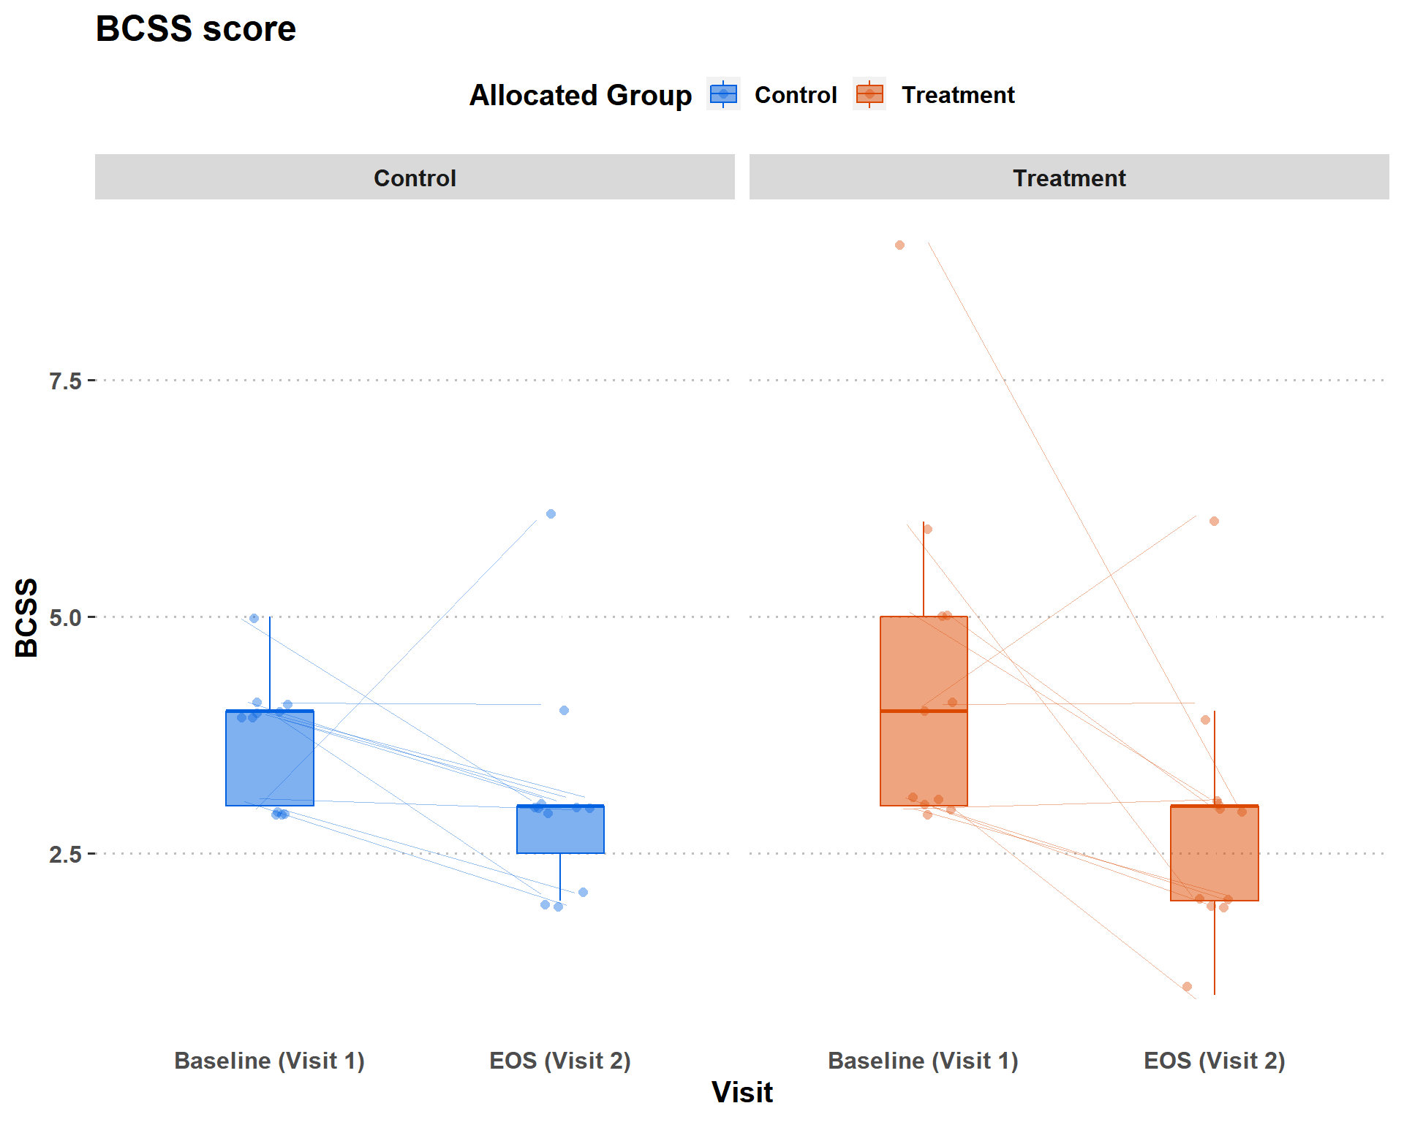

Figure 2:

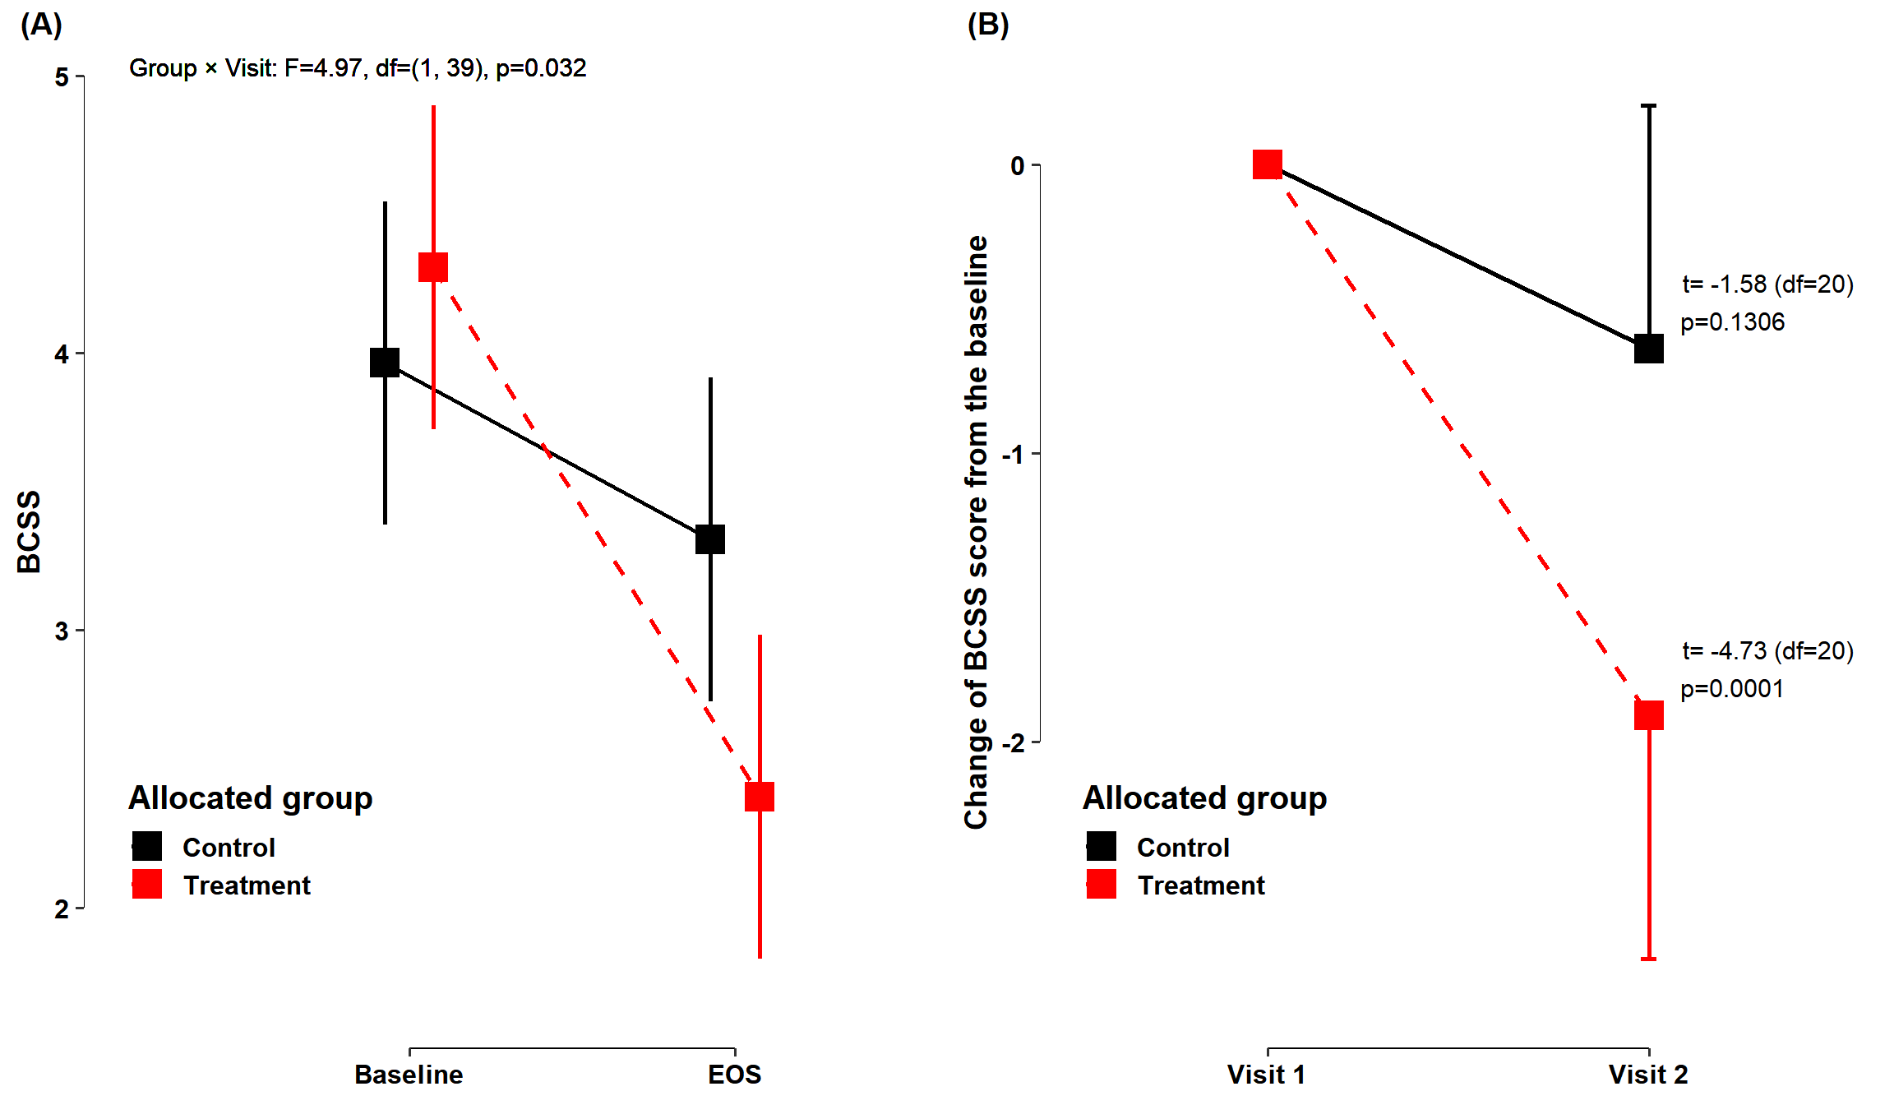

Figure 1: Figure 1: For both panels, squares represent the estimated marginal means and changes. Errorbars across the squares indicate the 95 % CI for EMM obtained from a linear mixed effects model. (A) Estimated marginal means of BCSS score at each visit according to each allocated group. (B) Mean changes of K-WOMAC score from the baseline to 4 weeks for each allocated group

1.