Item | Details
Discipline | Development of Web Applications in Java Spring
Work | Lab 7: Final Exam Project Planning and UX/UI Design
Project type | Team project (3 students)
Backend | Java 17, Spring Boot, Spring MVC, Spring Data JPA, Spring Security
Database | PostgreSQL
Team | Bekturgan Almas , Sheripov Ilyar , Nurmat Imran

Contents of this document: project description, objectives, functional requirements, UX/UI design, technology stack, system architecture, team responsibilities, development roadmap and repository links.

1. Project Description

Project title
ScentHub: Fragrance Catalog and Review Community

Description
ScentHub is a web application built with Java Spring Boot where perfume lovers can discover fragrances, read reviews and share their own opinions. The catalog contains perfumes with a brand, description, category, fragrance notes (top, heart and base) and a photo. Registered users rate each perfume by longevity, sillage and overall impression, write reviews, and keep personal lists called Favorites and Want to try. The application also shows a monthly top of the best-rated fragrances. Choosing a perfume is difficult because opinions are scattered across social networks and online stores. ScentHub collects honest reviews and average ratings in one place, with filters by brand, notes, category and rating. Moderators approve or reject new reviews, and the administrator manages the catalog and users. Data is stored in PostgreSQL and processed through a layered architecture: Controller, Service and Repository. Spring Security provides login and role-based access for the roles User, Moderator and Admin. The expected result is a tested, working application that demonstrates Spring MVC, Spring Data JPA, validation and security.

Main objectives
- Build a web application with a layered Spring Boot architecture (Controller, Service, Repository).
- Collect perfume information and honest reviews in one catalog.
- Calculate and display average ratings by criteria for every perfume.
- Provide secure registration, login and role-based access.
- Store all data in a relational database and cover the key logic with tests.

Target users
- Perfume enthusiasts who want to share opinions and track their collection.
- Beginners choosing their first fragrance.
- Gift buyers who need a trusted rating before buying.
- Moderators and administrators who keep content honest and the catalog up to date.

Problem the application solves
Opinions about perfumes are scattered across social networks, forums and stores. There is no single place to compare fragrances by longevity and sillage, and it is hard to choose a scent without trying it. ScentHub brings honest reviews, average ratings and notes together and lets users filter the catalog to find a suitable fragrance quickly.

Functional requirements
- Registration, login and logout with three roles: User, Moderator and Admin.
- Perfume catalog with brand, description, category, notes (top, heart, base) and photo.
- Search and filter perfumes by brand, notes, category and rating.
- Rate a perfume by longevity, sillage and overall score and write a review; one review per user per perfume.
- Automatic calculation of the average rating for every perfume.
- Personal lists: Favorites and Want to try.
- Monthly top of the best-rated perfumes on the home page.
- Moderator approves or rejects new reviews.
- Admin panel to add and edit perfumes, brands, notes and to manage users.
- Input validation (rating from 1 to 5, review text not empty) with clear error messages.

Expected results
A working Spring Boot web application connected to PostgreSQL with authentication and roles, a searchable perfume catalog, a review system with average ratings, personal lists, a moderation workflow, an admin panel and basic unit and API tests.

2. UX/UI Design
The interface was designed in Figma as a full-width website in a dark elegant style: black background, beige text and gold accents, Playfair Display for headings and Inter for body text. All screens share the same navigation bar, buttons, cards and form fields. The prototype is clickable and contains two user flows.
Figma design and clickable prototype: https://www.figma.com/design/jiqrXnbHaURy682ESe0YT1
# | Screen | Purpose
1 | Login | Sign in with email and password.
2 | Register | Create a new account.
3 | Home | Search, top perfumes of the month and scent families.
4 | Catalog | Perfume grid with filters by brand, family and rating.
5 | Perfume page | Notes, average rating by criteria, reviews, add to lists.
6 | Add review | Rate longevity, sillage and overall; write the review text.
7 | My profile | Favorites, Want to try and My reviews.
8 | Admin panel | Moderate reviews: approve or reject.
9 | Admin: Add perfume | Form for a new perfume: name, brand, category, notes, description and photo.

Main user flow
Register → Login → Search perfume by notes → Open perfume page → Add to Want to try → Write a review with ratings → See the updated average rating.

Admin flow
Login as Admin → Open Admin panel → Approve or reject pending reviews → Add a new perfume.

3. Technology Stack and Dependencies
Component | Technology
Programming language | Java 17
Backend framework | Spring Boot
Web layer | Spring MVC / Spring Web
Frontend | Thymeleaf, HTML, CSS, JavaScript
Database | PostgreSQL
Persistence | Spring Data JPA / Hibernate
Build tool | Maven
Version control | Git / GitHub
Testing | JUnit, Postman
Design | Figma, draw.io

Spring Boot dependencies and why they are needed
Dependency | Why it is necessary
Spring Web | Handles HTTP requests, controllers and perfume photo upload (MultipartFile).
Spring Data JPA | Works with the database through entities and repositories without writing SQL by hand.
Thymeleaf | Renders HTML pages on the server and passes model data to the views.
PostgreSQL Driver | Connects the application to the PostgreSQL database.
Lombok | Removes boilerplate code: getters, setters and constructors.
Spring Validation | Checks input: rating from 1 to 5, review text not empty, email format.
Spring Security | Login, BCrypt password hashing and role-based access (User, Moderator, Admin).
Spring Boot Starter Test | JUnit and Mockito for unit and integration tests of services and controllers.

4. System Architecture
The project follows the layered Spring architecture required by the assignment:
Frontend → Controller → Service → Repository → Database
Layer | Responsibility
Frontend | Thymeleaf pages in the browser. Shows data and sends forms and clicks as HTTP requests.
Spring Security | Checks login and role before a request reaches a controller.
Controller | Processes HTTP requests, validates input, calls the Service and returns a view. Contains no business logic.
Service | Business logic: average rating calculation, one review per user per perfume, search by notes, monthly top, moderation rules.
Repository | Database access through Spring Data JPA (save, find, delete, custom queries).
Entity / Model | JPA classes that represent data: User, Perfume, Brand, Note, Review, FavoriteList.
Database | PostgreSQL stores users, perfumes, brands, notes, reviews and personal lists.

Entities and relations
- A brand has many perfumes (one-to-many).
- A perfume has many notes and a note belongs to many perfumes (many-to-many).
- A user writes many reviews and a perfume has many reviews (one-to-many on both sides).
- A user owns many list items (Favorites or Want to try), each pointing to one perfume.
The full architecture diagram is provided as a separate draw.io file (ScentHub-architecture.drawio) and in FigJam.
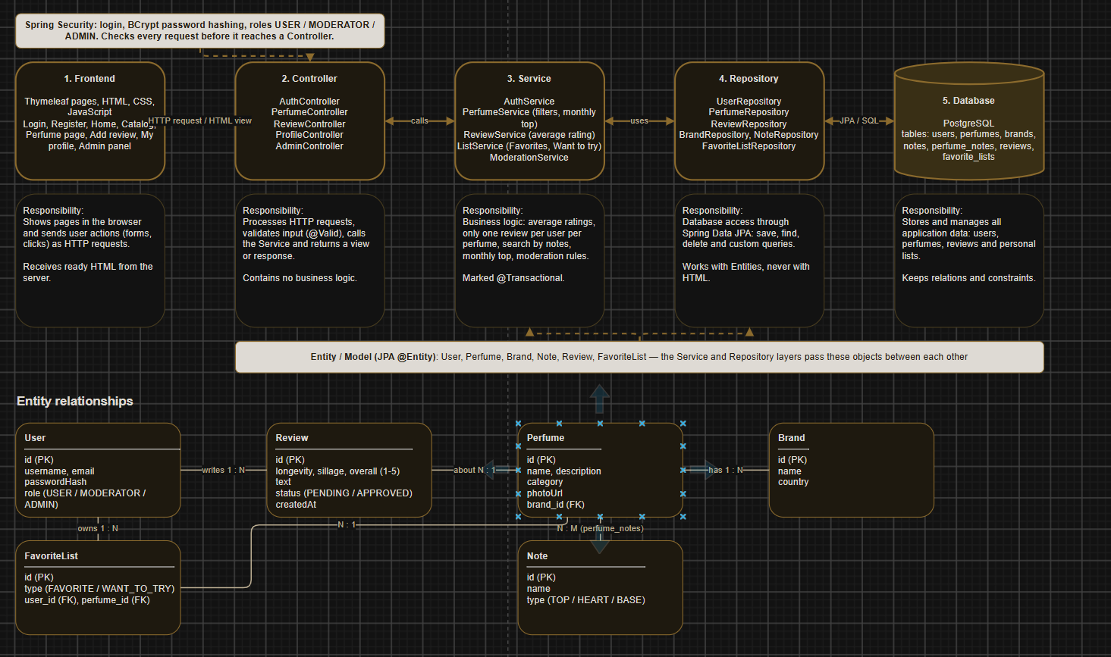

5. Team Members and Responsibilities
Student | Role | Responsibilities
Бектұрған Алмас Рүстемұлы | Backend Developer | Spring Boot project, Controllers, Services (rating calculation, review rules, moderation), Repositories, Spring Security.
Full name 2 | Frontend / UX/UI Developer | Figma (screens and clickable prototype), HTML/CSS/JS, Thymeleaf pages, catalog and perfume page interface.
Full name 3 | Database / Integration Developer | PostgreSQL schema, JPA entities and relations, catalog data, search queries, integration, JUnit and Postman tests.
All members must understand the overall architecture and take part in the Final Exam presentation.

6. Development Roadmap
Stage | Description | Responsible
1 | Project requirements and planning | All members
2 | UX/UI design | Student 2
3 | Spring Boot project setup | Student 1
4 | Database and entity development | Student 3
5 | Repository, Service, Controller implementation | Student 1
6 | Frontend development | Student 2
7 | Integration and testing | Student 3
8 | Final Exam presentation and demonstration | All members

7. Links
Figma design and prototype: https://www.figma.com/design/jiqrXnbHaURy682ESe0YT1
Architecture diagram: ScentHub-architecture.drawio (attached)
GitHub repository: [insert repository link]

