Columbia University | Department of Biomedical Engineering
ECBM E4060 – Introduction to Genomic Information Science and Technology
Instructor: Dr. Tai‑Hsien Ou Yang Student: Yanxuan Yu (UNI: yy3523, yy3523@columbia.edu)

Final Project Proposal (Individual)
Comparative Modeling of Somatic Mutation Accumulation for Age‑Dependent Cancer Risk

Goal and Scientific Background
Cancer risk increases with the accumulation of somatic mutations. Building on the September 29 lecture, the baseline model expresses the probability of malignancy as P = 1 − (1 − p^N)^M. To reflect biological heterogeneity, the project adopts a comparative design that includes: (i) a probabilistic framework with mutation‑rate variation (p ~ LogNormal), DNA repair efficiency (r), and a clonal threshold (C); and (ii) at least one alternative baseline (deterministic rate/hazard or empirical regression). In line with Tomasetti & Vogelstein (Science 2015), tissue‑specific lifetime stem cell divisions (LSCD) will be incorporated as a replicative‑risk covariate to explain cross‑tissue variation. Recent studies further motivate these extensions by documenting driver‑mutation accumulation in normal tissues and tissue/individual variability in cancer risk (Lawson et al., 2025; Imaoka, 2025).

Figure 1. Inputs upstream (LSCD per tissue; SEER age×tissue incidence; TCGA mutation burden/driver panels; 1000G±Kaggle) → parallel models (A/B/C) → model comparison & calibration → outputs (age–repair surface, calibration/discrimination/fit, external validation).
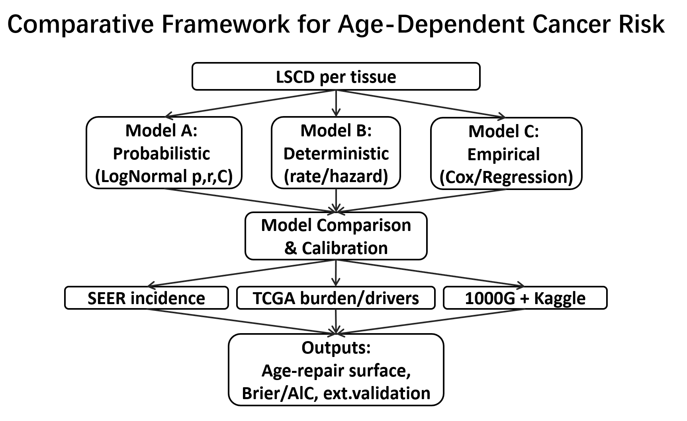

Proposed Method (multiple models & multiple validation sets)
Models:
(A) Probabilistic model with p ~ LogNormal(μ,σ), repair r ∈ [0,1] (effective p(1−r)) and clonal threshold C
(B) Replicative-risk baseline relating log-incidence to log-LSCD (Science 2015; slope estimated via log-linear regression with tissue fixed effects)
(C) Deterministic hazard model and/or empirical Cox regression. Simulation: Monte Carlo (10^6 cells, 0–80 years) to generate age‑incidence curves and examine Poisson limits for small p. Datasets & Validation: SEER incidence for population curves (SEER*Stat download); TCGA for tumor mutation burden and driver panels (GDC API); 1000 Genomes for germline background; optional Kaggle benchmarks for reproducibility. Evaluation: calibration (Brier at 10‑year intervals), discrimination (time‑dependent AUC), and fit (NLL/AIC), with external validation across SEER tissues. Ablations: remove r, fix C, or replace LogNormal p with Gamma to quantify component contributions.

Expected Outcome
Hypothesis: after accounting for LSCD, the probabilistic framework with p, r, and C will provide superior calibration and interpretable residual structure compared with LSCD‑based and deterministic baselines. Outputs include an age–repair‑efficiency surface, cross‑tissue residual plots vs LSCD, and sensitivity analyses over r and C, yielding data‑driven hypotheses that connect mutation burden and repair performance to incidence trends.

Note on computational resources: SEER, TCGA, and 1000 Genomes can be sizable; if local compute/storage limits are reached, the plan uses stratified downsampling (by age bin × tissue), sparse year grids, and staged per‑tissue processing. Any adjustments will follow the methodology and be documented during implementation.

References (recent & public data portals)
Tomasetti C., Vogelstein B. Variation in cancer risk among tissues can be explained by the number of stem cell divisions. Science. 2015;347(6217):78‑81. https://www.science.org/doi/10.1126/science.1260825
Lawson A.R.J. et al. Somatic mutation and selection at population scale. Nature. 2025. https://www.nature.com/articles/s41586-025-09584-w
Imaoka T. Trans‑Scale Insights into Variability in Radiation Cancer Risk Across Tissues, Individuals, and Species. Biology. 2025;14(8):1025. https://doi.org/10.3390/biology14081025
SEER Research Data and SEER*Stat: https://seer.cancer.gov/data/
TCGA Program (GDC): https://www.cancer.gov/tcga
1000 Genomes Project: https://www.internationalgenome.org/

