비교

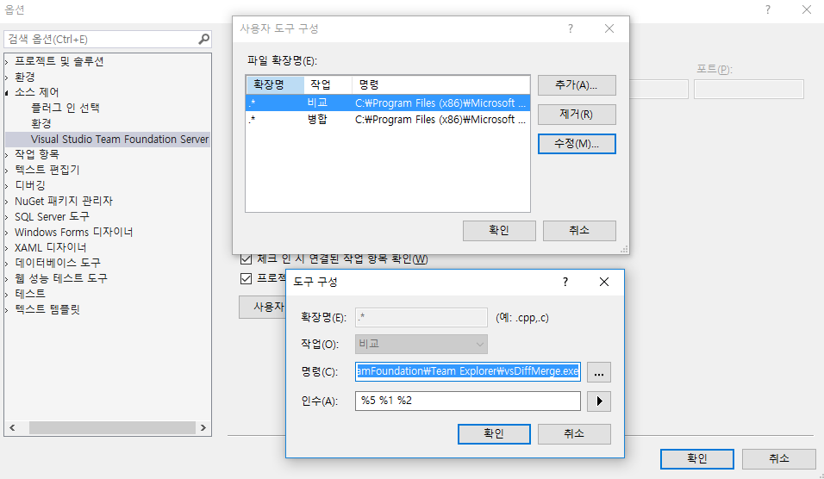

C:\Program Files (x86)\Microsoft Visual Studio\2017\WDExpress\Common7\IDE\CommonExtensions\Microsoft\TeamFoundation\Team Explorer\vsDiffMerge.exe

%5 %1 %2

병합

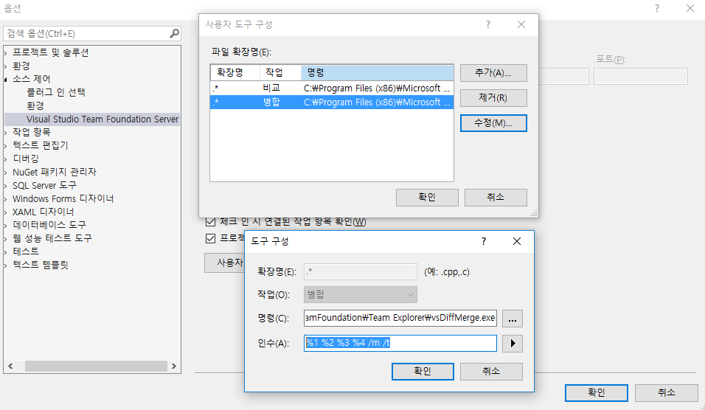

C:\Program Files (x86)\Microsoft Visual Studio\2017\WDExpress\Common7\IDE\CommonExtensions\Microsoft\TeamFoundation\Team Explorer\vsDiffMerge.exe

%1 %2 %3 %4 /m /t

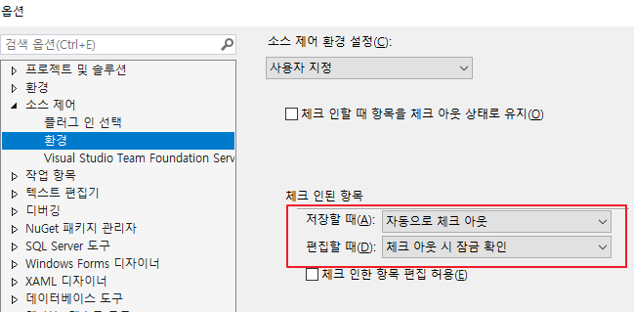

이건 편집할 때 켜야 안꼬임