**CLASS DIAGRAM:**

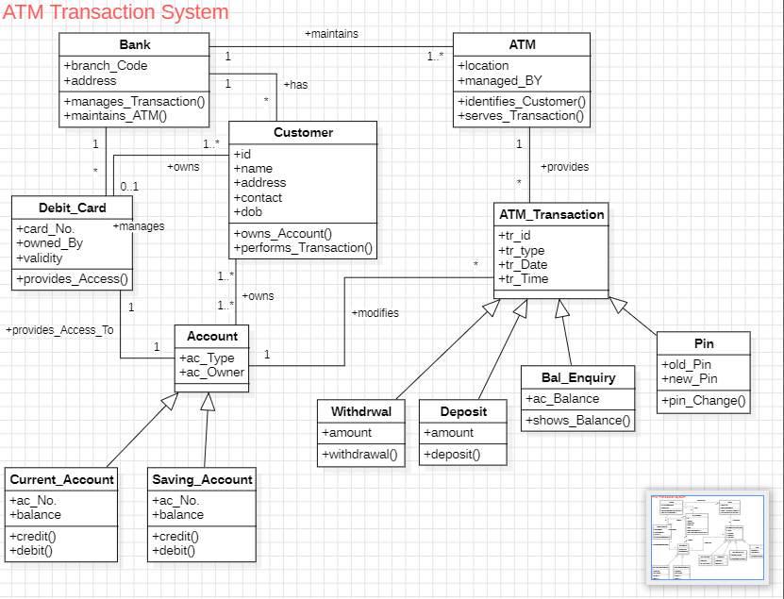

**USE CASE DIAGRAM:**

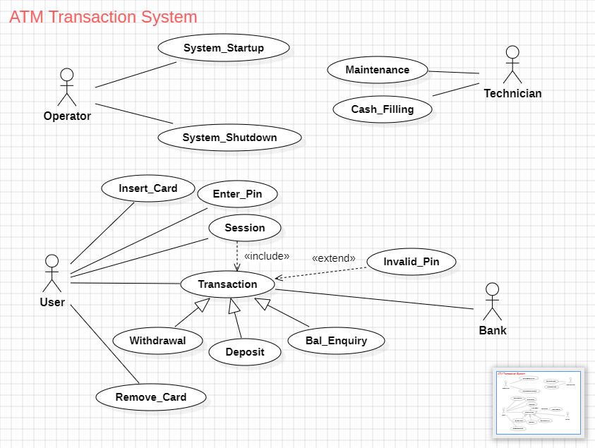

**ENTITY RELATIONSHIP DIAGRAM:**

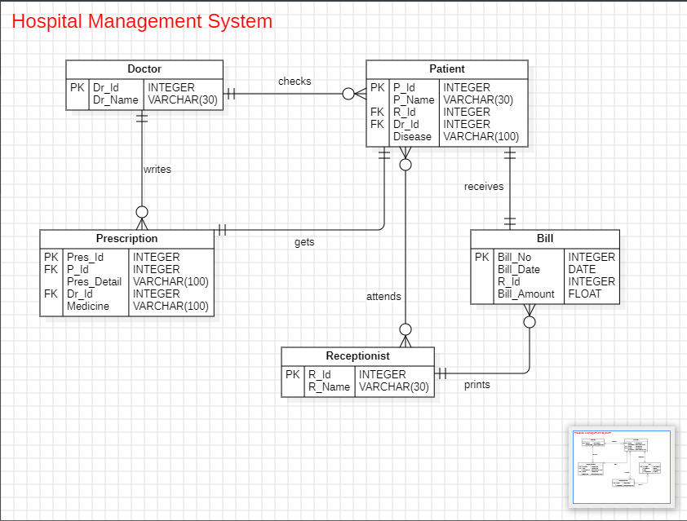

**SEQUENCE DIAGRAM:**

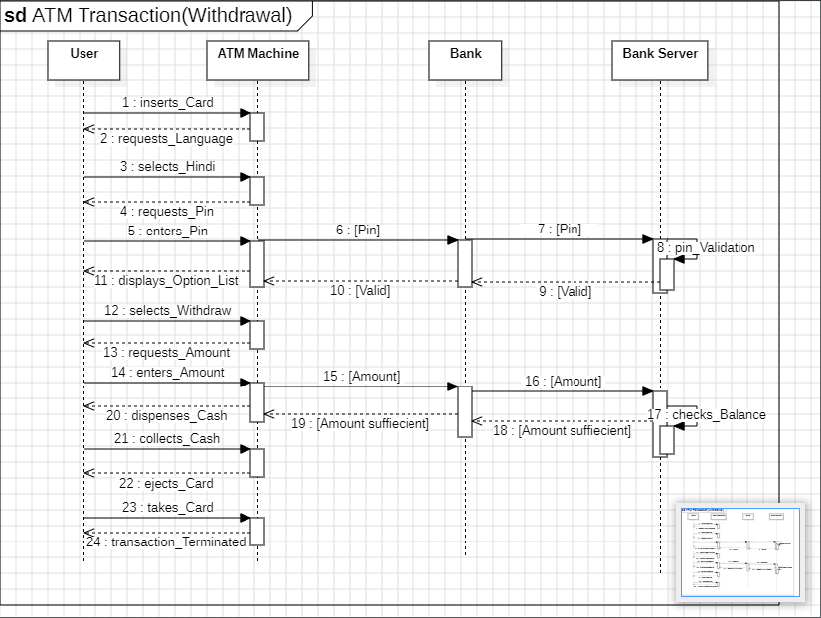

**STATE TRANSITION DIAGRAM:**

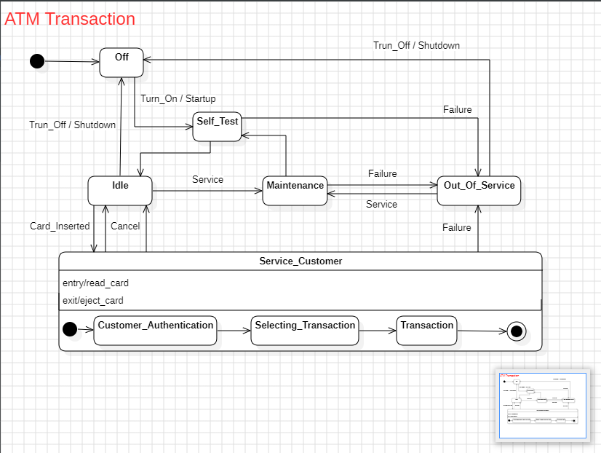

**DATA FLOW DAIGRAM:**

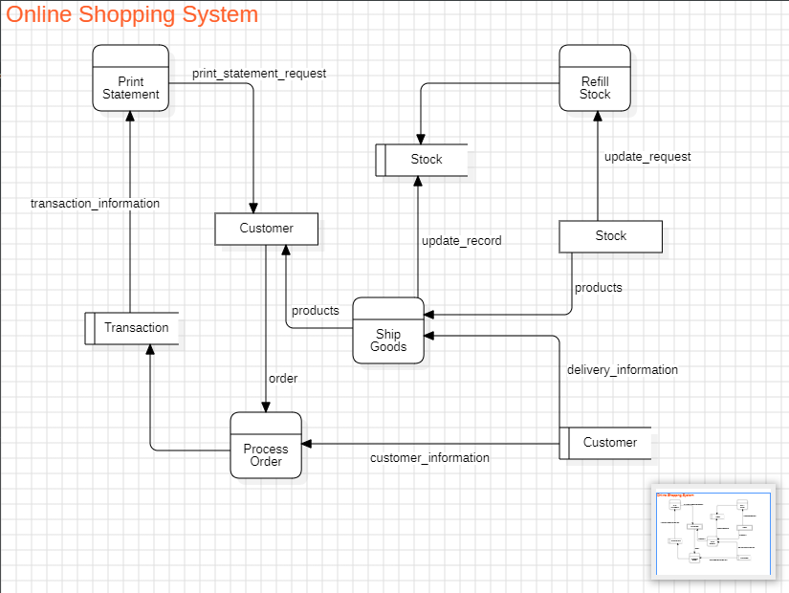

**COLLABORATION DIAGRAM:**

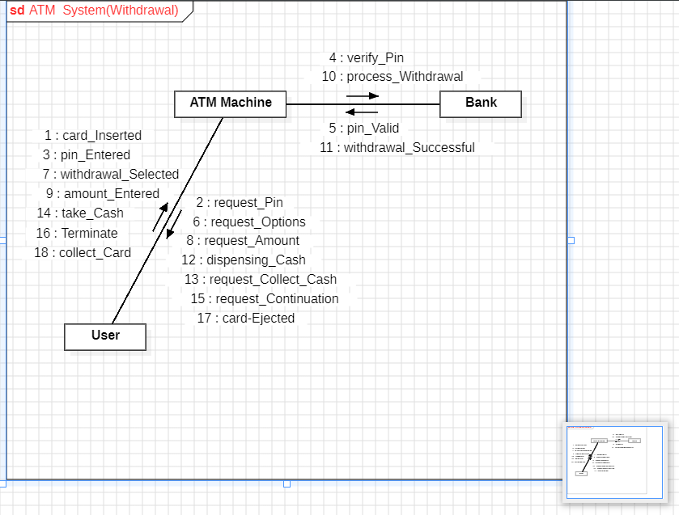

**ACTIVITY DIAGRAM:**

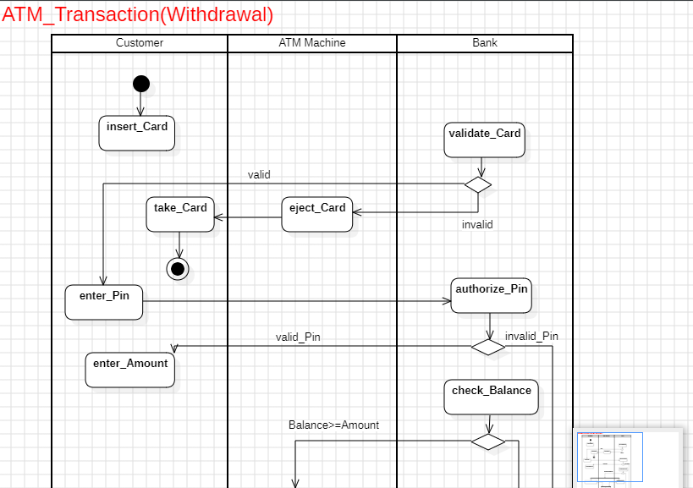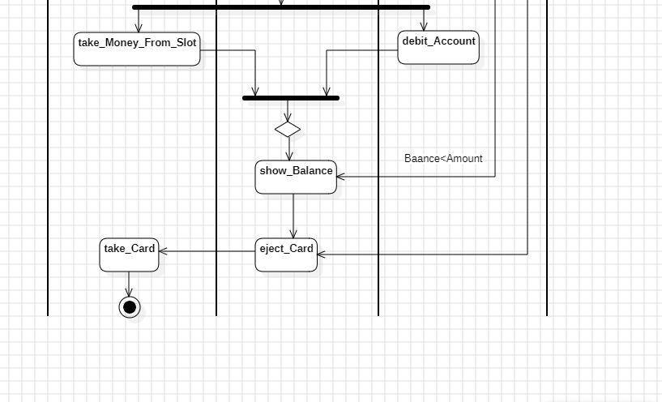

**COMPONENT DIAGRAM:**

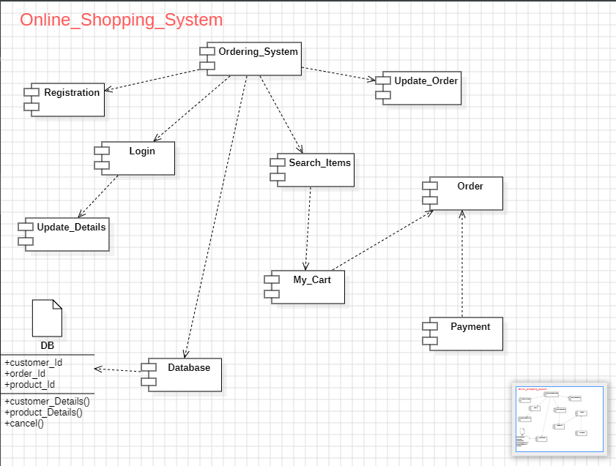

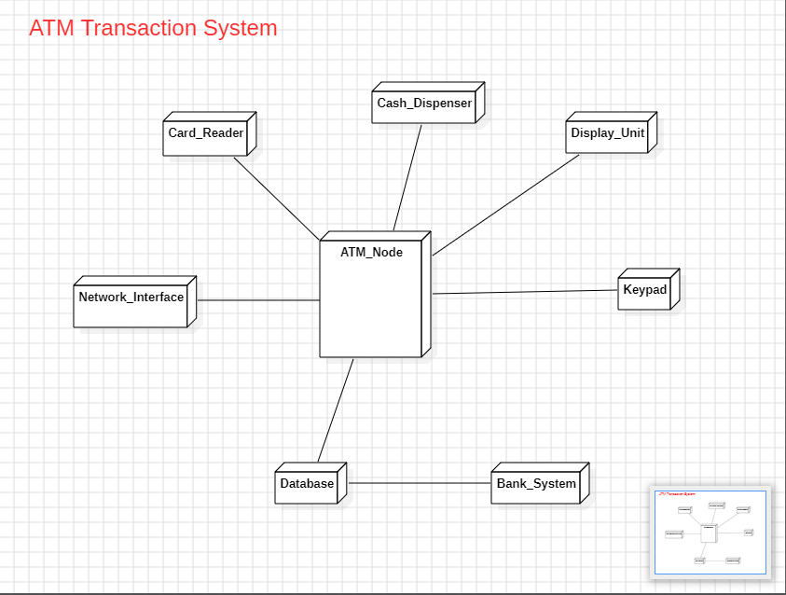**DEPLOYMENT DIAGRAM:**