**Literature Survey on Graphical User Interface**

**1.1 Introduction:**

Graphical User Interface (GUI) has transformed the way users interact with electronic devices, ranging from desktop computers to smartphones and household appliances. GUI has played an important role in making computing more accessible and user-friendly, allowing users to interact with complex systems through visual interfaces.

The evolution of GUIs has brought significant advancements in design principles, technological, and user experience. This literature survey aims to provide an overview of the Graphical User Interface, exploring its evolution, challenges, and future directions in the context of modern computing environments.

**1.1 Definition of Graphical User Interface (GUI)**

A graphical user interface (GUI) is a user interface that allows users to interact with electronic devices through graphical icons and visual indicators, text-based interfaces, typed commands and labels. GUIs are used in various electronic devices, including computers, smartphones, tablets, and household appliances, to simplify the user's interaction with the device and provide a more intuitive and user-friendly experience.

**1.2 Importance of GUI in modern computing environment**

Graphical User Interfaces (GUIs) in the modern computing environment enhances usability and increases productivity. They provide visual interfaces that simplify complex tasks, offer immediate visual feedback. GUIs contribute to a positive user experience by creating visually satisfying interfaces, ultimately allowing seamless interaction between users and electronic devices.

**2. Historic Perspective**

**2.2 Early developments**

In the early days of computing, users communicated with machines using text-based commands, which was difficult, complex and technical knowledge was required. In the 1970s, the development of Graphical User Interfaces (GUIs) evolved by introducing visual elements like icons, menus, pointers and windows.

The Xerox Alto, developed in 1973, was one of the first computers to feature a GUI with a mouse for navigation, though the system never reached commercial production.

The first commercially available computer with a GUI was the 1979 PERQ workstation, manufactured by Three Rivers Computer Corporation.

Apple Computer brought out the first Macintosh in 1984. It became the first all-in-one personal computer to be a mass-market success.

The original Macintosh computer was designed to make computing more accessible to non-technical users. The first version of Windows was released on November 20, 1985, as a graphical operating system shell for MS-DOS in response to the growing interest in graphical user interfaces (GUIs).

Since then, GUIs have continued to evolve, becoming more intuitive and feature-rich, enabling users to interact with computers in more natural and user-friendly ways. Today, GUIs are present in various electronic devices, from smartphones to smart appliances, shaping the way we interact with technology on a daily basis.

**3.Components of GUI**

**1.Visual elements:**

**1.1 Icons:** Graphical representations used to symbolize commands, files, or applications, enhancing visual recognition and ease of use.

**1.2 Windows:** Rectangular graphical areas on the screen that contain content, enabling multitasking and organizing information.

**1.3 Menus:** Lists of options or commands displayed in a hierarchical structure, providing access to various functions within an application.

**2. Interactive elements:**

**2.1. Buttons:** Graphical elements that users can click or tap to trigger actions, such as opening a file or submitting a form.

**2.2. Text fields:** Input areas where users can enter alphanumeric text or numerical values, facilitating data entry and interaction.

**2.3. Dropdown lists:** Interactive controls that display a list of options when clicked or tapped, allowing users to select from predefined choices.

**3. User input devices:**

**3.1. Mouse:** Pointing device with buttons used to interact with GUI elements by moving a cursor on the screen.

**3.2. Keyboard:** Input device with keys for typing alphanumeric characters and executing commands, providing an alternative input method to the mouse.

**3.3. Touchscreen:** Display screen that senses touch inputs, allowing users to interact directly with GUI elements using their fingers or a stylus.

**4. Principles of GUI Design**

**1. Usability principles**

Degree to which a product or system can be used by specified users to achieve specified goals with effectiveness, efficiency and satisfaction in a specified context of use. This characteristic is composed of the following sub-characteristics:

**2.Visibility:** Ensure that important features and functions are clearly visible and easily accessible to users without the need for extensive exploration.

Visual design of Graphical User Interfaces aims to contribute to their usability by manipulating their visual components (e.g., widgets, menus, contents, pictures, videos, banners) and their layout by relying on a variety of techniques borrowed such as Gestalt properties.

There are six individual principles commonly associated with gestalt theory: **similarity**, **continuation**, **closure**, **proximity**, **figure/ground**, and **symmetry & order** ([refer](https://www.toptal.com/designers/ui/gestalt-principles-of-design#:~:text=There%20are%20six%20individual%20principles,order%20(also%20called%20pr%C3%A4gnanz).))

## **3.Consistency**: This principle refers to the use of consistent visual elements, layout, and navigation throughout the product. A consistent GUI design helps users to understand and navigate the product easily, regardless of the context or section they are in. For example, using the same colour scheme and typography across a website can help users quickly identify different types of content, such as headings, paragraphs, and links .

## **4.Simplicity**: This principle refers to the use of simple and clear visual elements, language, and interactions that reduce cognitive load and confusion for users. A simple GUI design helps users to focus on the main tasks and goals, without being distracted or overwhelmed by unnecessary or complex information. For example, using icons that are easily recognizable and meaningful can help users to perform actions or access functions with minimal effort.

## **5.Feedback:** This principle refers to the use of visual or auditory cues that inform users about the status, results, or consequences of their actions or interactions. A feedback GUI design helps users to feel confident and in control of the product, as well as to correct errors or problems if they occur. For example, using progress indicators that show how much time or steps are left for a task can help users to feel reassured and motivated.

## These are some of the essential principles of GUI design that can help to create user-friendly and effective digital products. However, there are other principles and patterns that can also be considered depending on the specific context and needs of the product and the users. For example, user familiarity, recoverability, user guidance, etc. Moreover, it is important to consider accessibility and user testing aspects when designing a GUI, as they can help to ensure that the product is usable and enjoyable for all users. ([refer](https://blog.logrocket.com/ux-design/essential-gui-design-principles/))

**Appropriateness recognizability** - Degree to which users can recognize whether a product or system is appropriate for their needs.

**Learnability** - Degree to which a product or system can be used by specified users to achieve specified goals of learning to use the product or system with effectiveness, efficiency, freedom from risk and satisfaction in a specified context of use.

**Operability** - Degree to which a product or system has attributes that make it easy to operate and control.

**User error protection**. Degree to which a system protects users against making errors.

**User interface aesthetics** - Degree to which a user interface enables pleasing and satisfying interaction for the user.

**Accessibility** - Degree to which a product or system can be used by people with the widest range of characteristics and capabilities to achieve a specified goal in a specified context of use.

**1.3 Efficiency:** Design GUIs to enable users to accomplish tasks quickly and efficiently, minimizing the number of steps and interactions required to complete common actions.

**1.4 Accessibility:** Ensure that GUIs are accessible to users with diverse abilities and preferences, incorporating features such as keyboard navigation, screen reader compatibility, and adjustable font sizes.

**1.5 Backup and Error handling:** Often an operation can be cancelled before execution is completed, with the system restored to the state it was in the before the operation was started. With the ability to back up at any point, we can confidently explore the capabilities of the system, knowing that the effects of a mistake can be erased.

One of the important principles of designing a GUI application is to handle errors gracefully and provide useful feedback to the user. Errors can occur due to various reasons, such as invalid input, network failure, file not found, etc. A GUI application should be able to detect and display both terminating and non-terminating errors in a way that is consistent and informative.

One of the common ways to handle errors in a GUI application is to use a try-catch block that executes a block of code and catches any exceptions that occur. The catch block can then display an appropriate message to the user, either in a text box, a message box, or a status bar. For example, the following code tries to get a command from the user input and displays it in the output text box. If the input is empty or invalid, it catches the exception and displays an error message.

$buttonGetCommand_Click = {

try {

$cmdlet = textboxInput.Text

$textboxOutput.Text = Get-Command -Name $cmdlet | Format-Table -AutoSize | Out-String

}

catch {

$textboxOutput.Text = "Enter a valid cmdlet name."

}

}

Another way to handle errors in a GUI application is to use the $Error variable, which contains an array of error objects that occurred during the execution of the script. The $Error variable can be used to access the details of the errors, such as the error message, the error category, the error ID, etc. For example, the following code checks if the $Error variable is not empty and displays the last error message in the output text box.

$buttonGetCommand_Click = {

$cmdlet = textboxInput.Text

$textboxOutput.Text = Get-Command -Name $cmdlet | Format-Table -AutoSize | Out-String

if ($Error) {

$textboxOutput.Text = $Error[0].Exception.Message

}

}

A GUI application should also implement backup and recovery mechanisms to prevent data loss or corruption due to errors. For example, a GUI application that performs file operations should create backup copies of the files before modifying them, and restore them if an error occurs. A GUI application that interacts with a database should use transactions to ensure data integrity and consistency. A GUI application that uses network resources should handle network errors and retry or resume operations if possible.

The following are some references for more information on error handling in GUI applications:

- [Manage Errors in a GUI Application - SAPIEN Blog](https://www.sapien.com/blog/2015/01/15/manage-errors-in-a-gui-application/)

- [Handling of command line errors in a GUI app - Stack Overflow](https://stackoverflow.com/questions/77685585/handling-of-command-line-errors-in-a-gui-app)

- [gui design - Handling of command line errors in a GUI app - User Experience Stack Exchange](https://ux.stackexchange.com/questions/149356/handling-of-command-line-errors-in-a-gui-app)

**Different GUIs may have different philosophies or design principles that guide their development and use. Some common GUI philosophies are:**

- User-centered design: This philosophy focuses on understanding the needs, preferences, and goals of the users, and designing the GUI accordingly. User-centered design involves testing and evaluating the GUI with real users and incorporating their feedback into the design process.([refer](https://www.interaction-design.org/literature/topics/user-centered-design#:~:text=User%2Dcentered%20design%20(UCD),and%20accessible%20products%20for%20them.)) ([refer](https://en.wikipedia.org/wiki/User-centered_design))

- Affordance: This philosophy suggests that the GUI should indicate or suggest how the user can interact with it. Affordance means that the GUI should provide visual cues or hints that show what actions are possible and how to perform them. For example, a button should look like something that can be pressed, and a slider should look like something that can be moved. ([refer](https://www.interaction-design.org/literature/topics/affordances))

These are some of the common GUI philosophies that influence the design and development of graphical user interfaces. However, there may be other philosophies or variations depending on the context, purpose, and audience of the GUI.

**Thumb rules for GUI development**

**Visibility of System Status:**

Users should always be informed of system operations with easy-to-understand and highly visible status displayed on the screen within a reasonable amount of time1.

**Match Between System and the Real World:**

Designers should mirror the language and concepts users encounter in the real world. Presenting information logically and aligning with users’ real-world experiences reduces cognitive strain and makes systems easier to use1.

**User Control and Freedom:**

Offer users a digital space where backward steps are possible. Allow actions like undoing and redoing previous steps1.

**Consistency and Standards:**

Interface designers should maintain consistency in both graphic elements and terminology across similar platforms. For example, an icon representing a specific concept should remain consistent regardless of the screen it appears on1.

**Error Prevention:**

Design interfaces that prevent errors or guide users away from making mistakes. Clear instructions and safeguards enhance usability1.

**Recognition Rather Than Recall:**

Minimize the need for users to recall information. Present options and actions in a way that users can recognize without relying on memory1.

**Flexibility and Efficiency of Use:**

Design interfaces that cater to both novice and expert users. Provide shortcuts, accelerators, and efficient workflows for experienced users1.

**Aesthetic and Minimalist Design:**

Strive for simplicity and elegance. Remove unnecessary clutter and focus on essential elements1. ([refer](https://www.interaction-design.org/literature/article/user-interface-design-guidelines-10-rules-of-thumb))

**Application or Website Development**.

The companies need to develop more attractive, intuitive and aesthetically pleasing website or application in order to facilitate communication between device and user. To improve the software products we can use the ISO 25000 norm to get a certification about the quality of their software. Also known as SQuaRE (System and Software Quality Requirements and Evaluation), this has been developed to give guidelines to website designers. This evaluates the software quality has 3 different parts : software product quality, software data quality and operational quality of the software.The software product quality model comprises eight quality characteristics. .([refer](https://iso25000.com/index.php/en/iso-25000-standards/iso-25010))([refer](https://www.iso.org/obp/ui/#iso:std:iso-iec:25020:ed-2:v1:en))

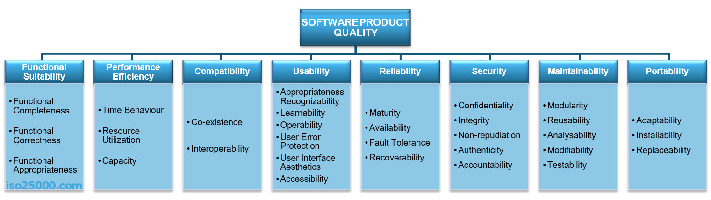

**5.Learning Curve:**

Graphical User Interfaces (GUIs) can pose a learning curve for certain users, particularly those with limited technology experience. Navigating through menus, icons, and graphical elements may require time and effort, especially for older adults or individuals with cognitive impairments. While GUIs aim to simplify interaction with computers, the transition from traditional text-based interfaces to visual ones may present challenges for users accustomed to older paradigms. Providing adequate training and support can help mitigate these challenges and empower users to leverage the full capabilities of GUIs effectively.

**6. Applications of GUI:**

a. Business applications:

- GUIs are widely used in business applications such as accounting software, customer relationship management systems, and enterprise resource platforms. These GUIs provides intuitive interfaces for managing finances, tracking sales, and analysing business data.

b. Entertainment and gaming:

- In the realm of entertainment and gaming, GUIs play a crucial role in providing immersive and interactive experiences for users. Video game interfaces feature graphical elements such as menus, buttons, and HUDs (Heads-Up Displays) to navigate game settings, control characters, and monitor game progress.

c. Educational software:

- Educational software often employs GUIs to create engaging learning environments for students. GUI-based educational tools and applications facilitate interactive learning experiences by presenting educational content in visually appealing formats, offering multimedia resources, and enabling student interaction with course materials.

d. Industrial and scientific applications:

- GUIs are utilized in industrial and scientific applications for tasks such as data analysis, simulation, and control. GUI-based software tools enable engineers, scientists, and researchers to visualize complex data, perform simulations, and control equipment through graphical interfaces, enhancing productivity and facilitating decision-making in various domains.

**7. Emerging Interfaces**

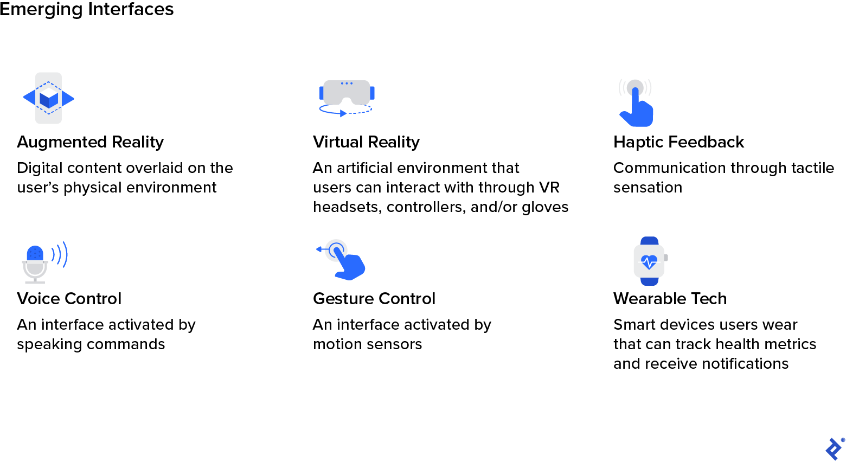

**8.Challenges in Graphical User Interface (GUI):**

1. Consistency:

Maintaining consistency in design elements, terminology, and interaction patterns across different platforms and applications poses a challenge for GUI designers, leading to confusion and cognitive load for users.

2. Accessibility: Ensuring that GUIs are accessible to users with disabilities, including those with visual, auditory, motor, or cognitive impairments, presents challenges in designing interfaces that accommodate diverse user needs and preferences.

3. Security: GUIs face security challenges related to protecting user data, preventing unauthorized access, and mitigating risks such as phishing attacks, malware, and social engineering exploits.

4. Performance: GUIs must balance aesthetic appeal with performance considerations, ensuring that interfaces are responsive, fluid, and fast-loading across different devices and network conditions.

- GUI, UI, and UX are three essential components of modern website design. While each is unique, they all play a crucial role in delivering a successful user experience.

### GUI (Graphical User Interface)

* GUI refers to the visual elements of a website that users interact with, such as buttons, icons, and menus.
* It focuses on the design of the interface and how users navigate through the website.
* A well-designed GUI can improve the user experience and make the website more intuitive and user-friendly.

### UI (User Interface)

* UI refers to the overall design of a website, including the layout, colors, fonts, and other visual elements.
* It aims to create a visually appealing, cohesive design that reflects the brand's values and style.
* A well-designed UI can enhance the user experience by creating a sense of consistency and familiarity throughout the website.

### UX (User Experience)

* UX refers to a user's overall experience while interacting with a website, including how easy it is to use, how quickly it loads, and how it makes the user feel.
* It considers the user's emotions, needs, and goals and aims to create a positive and meaningful experience.
* A well-designed UX can increase user satisfaction, loyalty, and engagement with the website.
* Refer :
* https://www.msinteractive.com/blog/tips-for-experience-design/what-is-the-difference-between-ui-gui-and-ux#:~:text=In%20summary%2C%20UI%20and%20GUI,%2C%20accessibility%2C%20and%20emotional%20response.

**Conclusion**

**Summary of key findings:**

1. Graphical User Interfaces (GUIs) have transformed the way users interact with computers and electronic devices, enhancing usability, productivity, and accessibility.

2. GUIs consists of various components, including visual elements like icons, windows, and menus, interactive elements such as buttons and text fields, and user input devices like mouse, keyboards, and touchscreens.

3. Usability principles such as visibility, feedback, consistency, efficiency, and accessibility are essential for designing effective GUIs that meet user needs and preferences.

4. GUIs find applications across various domains, including business, entertainment, education, and industrial and scientific applications, where they provide data visualization, interaction, and control.

5. Challenges in GUI design include maintaining consistency, ensuring accessibility, information overload, addressing cross-device compatibility and security concerns, and optimizing performance.

6. Future trends in GUIs include the integration of voice and natural language interaction, AI-driven interfaces, adaptive and context-aware interfaces, and support for multi-modal interaction.

Overall, GUIs play a critical role in modern computing, and addressing challenges while embracing emerging trends will be key to enhancing user experience and advancing the effectiveness and usability of GUIs in the future.

**References**

1. Computer Graphics – Donald Heran D

- This book primarily focusses on users’ model which serves as the basis of the design to manipulate and perform actions they use windows and icon graphical interface, accommodating multiple skill levels, consistency, minimizing, memorization, back up, error handling and feedback.

2. "Designing Interfaces: Patterns for Effective Interaction Design" by Jenifer Tidwell

- Focusing on interface design patterns, this book offers a collection of reusable solutions for common GUI design problems. It covers patterns for navigation, input controls, layout, data display, and social interaction.

3. "GUI Bloopers: Don'ts and Do's for Software Developers and Web Designers" by Jeff Johnson

- Jeff Johnson identifies common mistakes the developers make over and over in GUI design and provides practical advice for avoiding them and helps GUI designers and developers learn and produce better GUI’s. The book covers topics such as consistency, error handling, responsiveness, and accessibility.

4. "About Face: The Essentials of Interaction Design" by Alan Cooper, Robert Reimann, and David Cronin

- This comprehensive guide covers essential concepts and techniques in interaction design, discussions on mobile app’s, touch interfaces and tablets, including those specific to GUIs. It addresses user personas, task analysis, information architecture, and usability testing.

5. "The Visual Display of Quantitative Information" by Edward Tufte

- Although primarily focused on data visualization, this book offers valuable insights into designing effective graphical displays within GUIs. It includes 250 illustrations of the best statistical graphics, with detailed analysis of how to display data. It covers principles such as clarity, simplicity, and integrity in visual communication.

6. "Universal Principles of Design" by William Lidwell, Kritina Holden, and Jill Butler

- This reference book presents 125 laws, guidelines, design principles applicable across various design disciplines, including GUI design. It covers principles such as visibility, feedback, constraints, consistency, and discoverability.

7. "Don't Make Me Think" by Steve Krug

- Steve Krug discusses usability principles and techniques for designing interface that is human-computer interaction and web useability. The book emphasizes simplicity, clarity, and minimizing cognitive load to enhance user experience.

8. "GUI Design Handbook" by Susan L. Fowler

- This handbook provides practical guidance on GUI design principles, methodologies, and best practices to create effective graphical user interface by using object-oriented methods and tools. It covers topics such as user research, prototyping, visual design, and usability evaluation techniques.

9. "Designing for Interaction: Creating Smart Applications and Clever Devices" by Dan Saffer

- This book explores innovative approaches to interaction design for products such as the iPod and websites like Flickr, including GUIs for emerging technologies. The book covers topics such as design for Web, software, devices, gestural interfaces, tangible interactions, and designing for the Internet of Things.

10. "Programming Windows" by Charles Petzold

- Although focused on Windows GUI development, this book offers valuable insights into GUI design principles and techniques. It covers topics such as basics – input, output, dialogue boxes, text and fonts, window management, message handling, controls, and graphics programming.

11. "The Humane Interface: New Directions for Designing Interactive Systems" by Jef Raskin

- This book introduces fundamental principles and approaches for designing user-friendly interfaces, emphasizing simplicity, efficiency. It explores concepts such as direct manipulation, and incremental feedback.

DESIGNING THE USER INTERFACE

Dix, A., Finlay, J., Abowd, G., & Beale, R. (2004). Human-computer interaction. Prentice Hall.

<https://www.toptal.com/designers/ui/the-future-of-interfaces>

By referring to these resources, we can gain a comprehensive understanding of GUI design principles, techniques, and best practices, enabling them to create user-friendly and effective graphical interfaces for various applications and platforms.

Good Morning Sreeya ,

Report is fine . Need to refer the content properly..  The objective was to understand the concepts of UI.. You need to put focus on the principles of GUI. Need to further detail on usability principle and error handling .

Incorporate the basic recommended philosophies and thumb rules while doing the GUI development .

Survey and incorporate the characteristics and recommendation for user interface(UI) and user experience (UX) design exclusively for military applications. With those updation you can release the first version of the document.

Learn about the interaction diagram like **Sequence diagram** and **Collaboration diagram**.

Prepare a similar report on the same.

regards

Mirjith.

* 1. Usability – feedback,error handling,simplicity,consistency whatever we get we’ll do
  2. Incorporate the basic recommended philosophies and thumb rules while doing the GUI development .
  3. UI , UX
  4. Psychology principle under visibilty