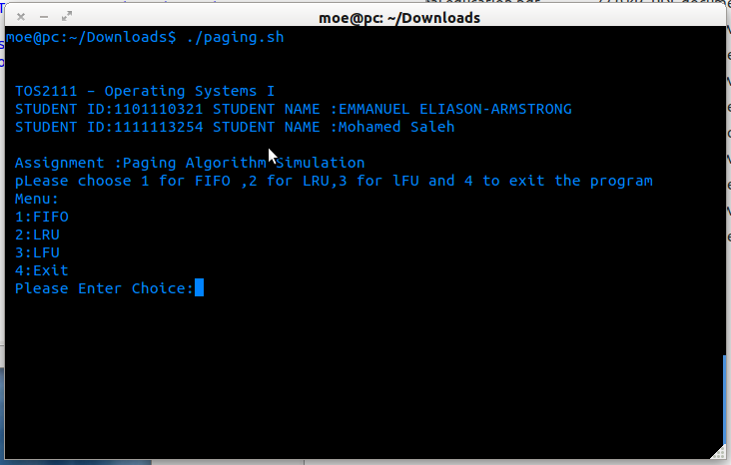
- Make the file executable by going to chmod +x paging.sh
- Run the file ./paging.sh

know you can choose the algorithm by typing its number

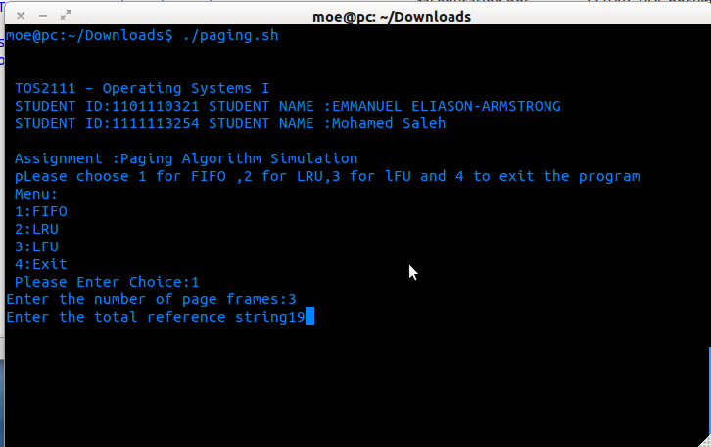

we chose FIFO as an example:
1) Enter the total reference name
2) Enter the number frame pages
- Enter the total reference sequence
- Enter the values

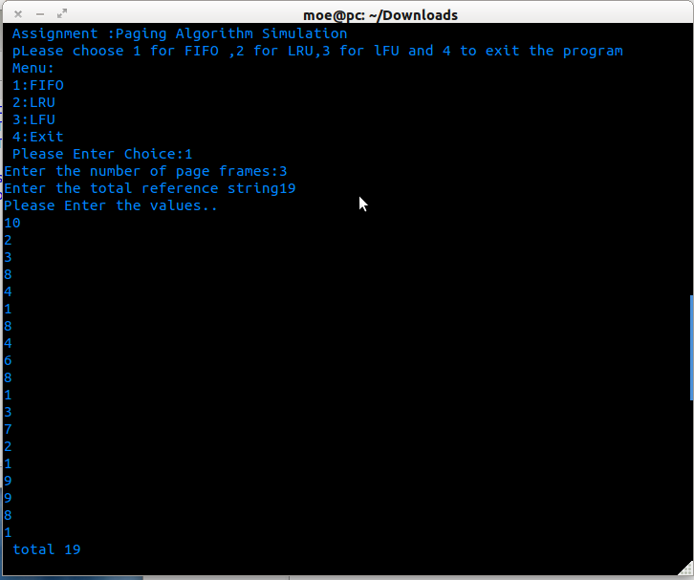

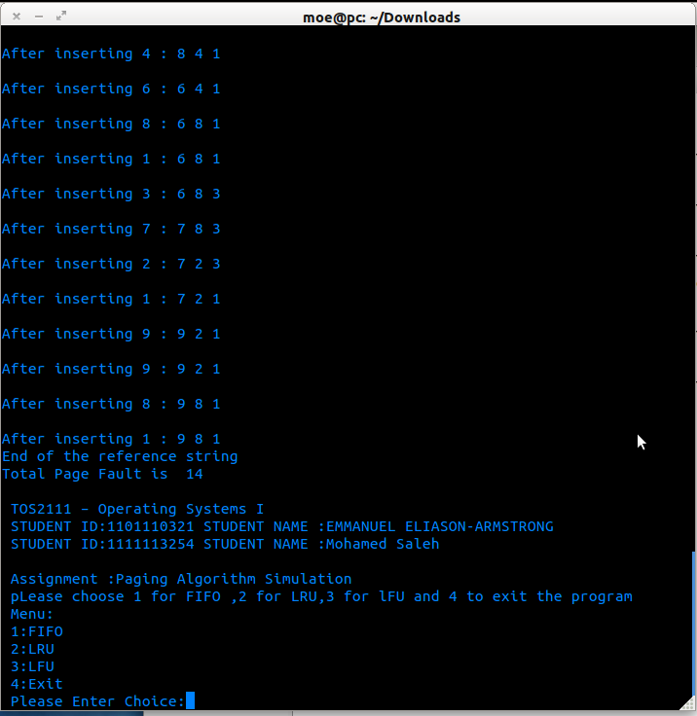
the result of the FIFO algorithm

you can choose another algorithm or press 4 to exit the program

