**Create python virtual environment**

‘python -m venv venv’

**Copy the path of the activate file and run it in the cmd**

venv\Scripts\activate.bat



Install Django - pip install Django

**Check the installation**

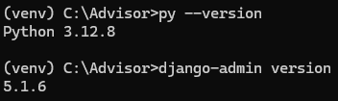

**Install Dependencies**

pip install pandas numpy scikit-learn joblib

**Create a Django Project**

django-admin startproject laptop_advisor

cd laptop_advisor

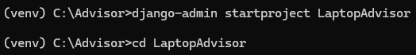

**Create a Django App**

python manage.py startapp advisor