Workflow Documentation
Smart University Management Platform
Prepared by: Bhomik Lalotra
This document describes each of the five n8n workflows that make up the platform: what triggers them, which nodes they use, and what data flows in and out. Screenshots of each workflow's n8n canvas should be inserted in the marked placeholder sections.

Workflow 1: Student Registration & Enrollment
Purpose: Automatically registers new students when they submit the registration form, stores their record, and sends a confirmation email.
Trigger: Google Sheets Trigger — New row added in the form's response sheet.
Nodes used:
- Google Sheets Trigger — Watches for new form submissions
- Edit Fields — Cleans and renames raw form data (student_name, email, roll_no, course, semester)
- Google Sheets (Append Row) — Saves the clean record to the Students tab
- Gmail (Send a message) — Sends a registration confirmation email to the student
Input / Output: Input: Google Form (name, email, roll number, course, semester). Output: new row in Students tab + confirmation email.

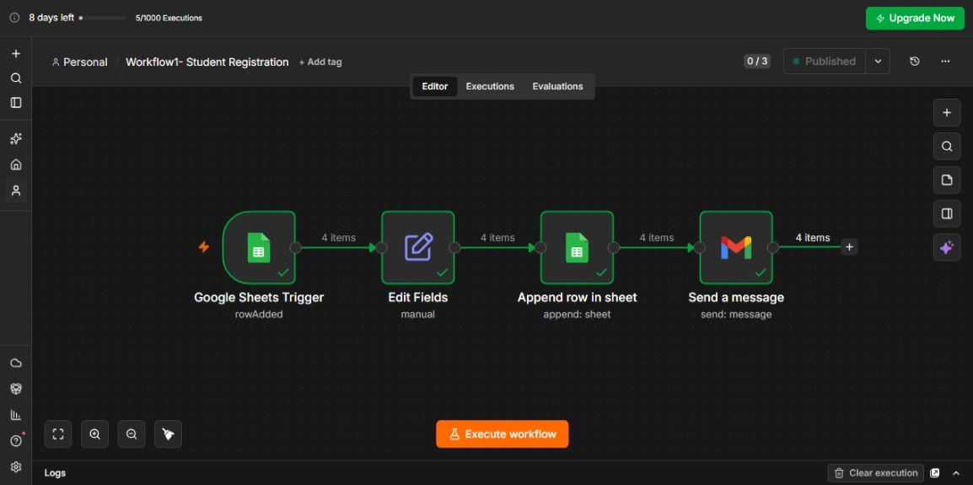

Workflow 2: Attendance Management
Purpose: Validates and logs daily attendance against the registered student database, calculates a running attendance percentage per student, and alerts students who fall below 75%.
Trigger: Google Sheets Trigger — New row added in the attendance form's response sheet.
Nodes used:
- Google Sheets Trigger — Watches for new attendance submissions
- Edit Fields — Cleans roll_no, student_name, date, status
- Google Sheets (Get Row) — Looks up the student's real record in the Students tab by Roll_No
- IF — Validates that the roll number exists and the submitted name matches the record on file
- Google Sheets (Append, true branch) — Logs the entry to Attendance_Log
- Google Sheets (Append, false branch) — Logs mismatched/invalid entries to the Errors tab
- Google Sheets (Get Row) — Retrieves the student's full attendance history
- Code (JavaScript) — Calculates total classes, present count, and attendance percentage
- Google Sheets (Append or Update) — Writes the running total to Attendance_Summary
- IF — Checks whether attendance percentage is below 75%
- Gmail (Send a message) — Emails a low-attendance alert if the threshold is breached
Input / Output: Input: Attendance Form (roll number, name, date, status). Output: rows in Attendance_Log and Attendance_Summary, low-attendance alert email, mismatch entries in Errors tab.

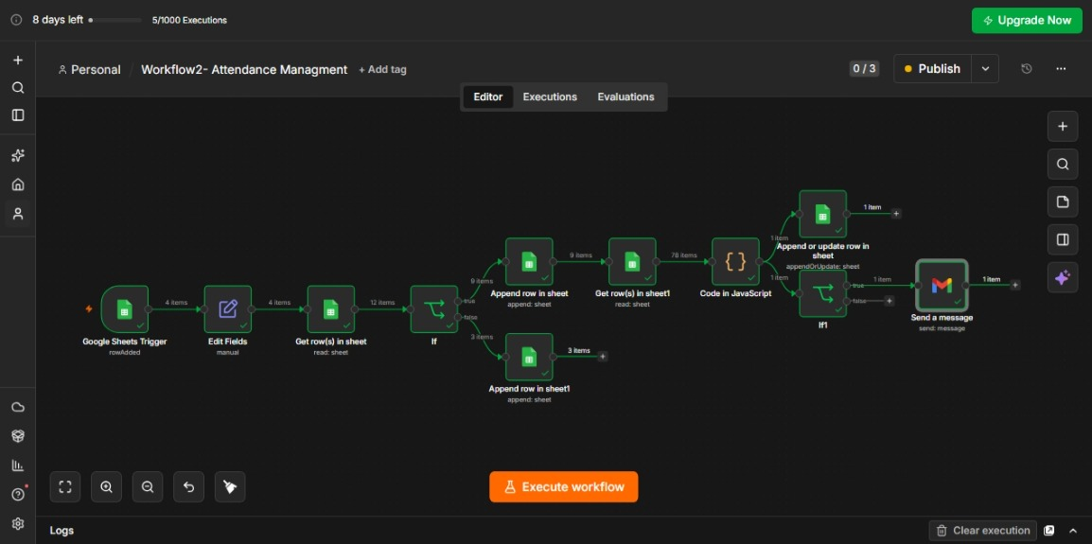

Workflow 3: Assignment Submission & AI Evaluation
Purpose: Accepts a student's assignment submission and uses OpenAI to grade it automatically, storing the score and written feedback.
Trigger: Google Sheets Trigger — New row added in the assignment form's response sheet.
Nodes used:
- Google Sheets Trigger — Watches for new assignment submissions
- Edit Fields — Cleans roll_no, student_name, assignment_title, submission_text
- OpenAI (Message a model) — Grades the submission out of 10 and returns written feedback
- Edit Fields — Extracts the numeric score and feedback text from the AI's response
- Google Sheets (Append Row) — Saves the submission, AI score, and feedback to the Assignments tab
Input / Output: Input: Assignment Form (roll number, name, title, submission text). Output: new row in Assignments tab with AI_Score and AI_Feedback.

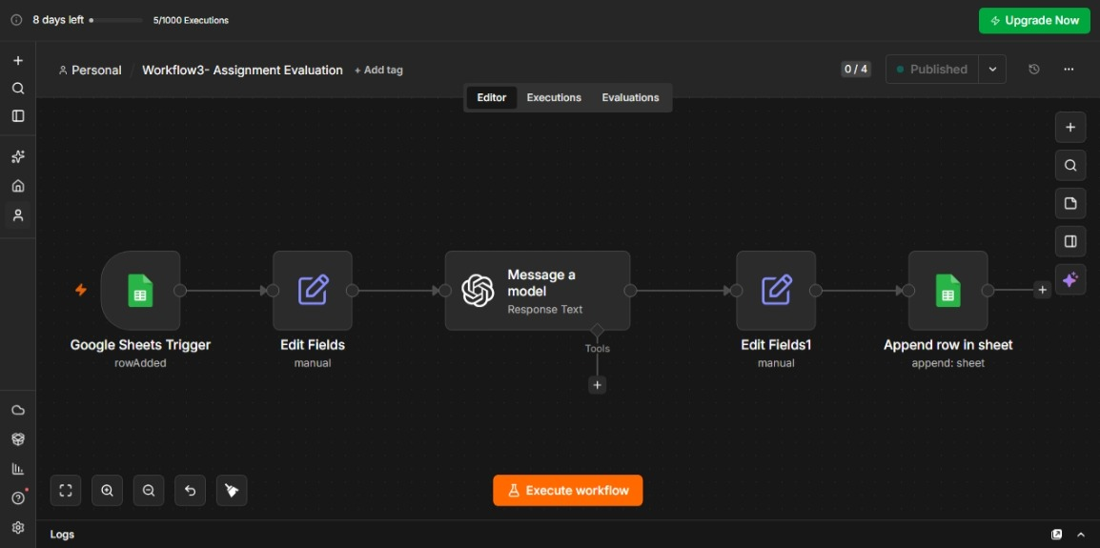

Workflow 4: Grade Processing & Result Publication
Purpose: Reads AI-graded assignments, applies a pass/fail threshold, looks up the student's email, and publishes the result by email.
Trigger: Google Sheets Trigger — New row added in the Assignments tab.
Nodes used:
- Google Sheets Trigger — Watches the Assignments tab for new AI-graded rows
- Google Sheets (Get Row) — Looks up the student's email from the Students tab using Roll_No
- IF — Checks whether AI_Score is greater than or equal to 5
- Google Sheets (Append, true branch) — Logs a Pass result to the Results tab
- Google Sheets (Append, false branch) — Logs a Fail result to the Results tab
- Gmail (Send a message) — Sends a single pass/fail email using a conditional expression to select the message
Input / Output: Input: Assignments tab row (roll number, score). Output: new row in Results tab, pass/fail email sent to the student.

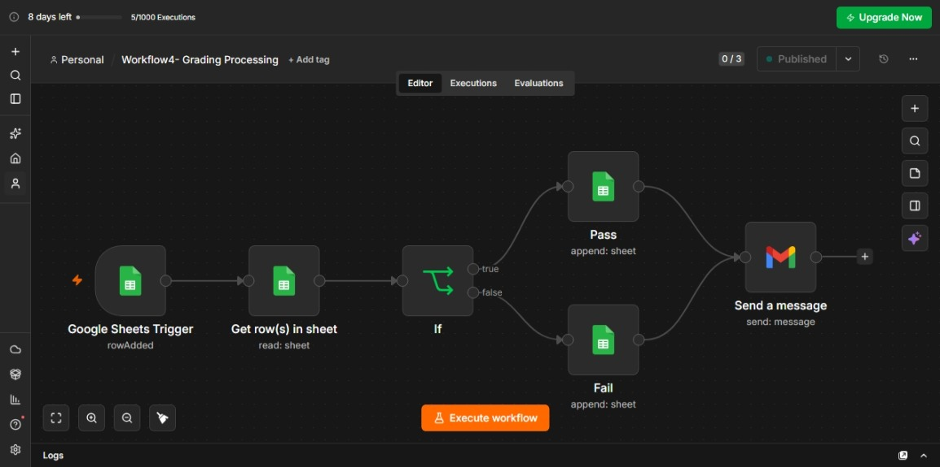

Workflow 5: Certificate Generation & Reports
Purpose: Runs automatically every week, compiles overall pass/fail statistics from the Results tab, and emails a summary report to the administrator.
Trigger: Schedule Trigger (Cron) — Runs weekly on a fixed day and time.
Nodes used:
- Schedule Trigger — Fires on a weekly schedule
- Google Sheets (Get Row(s)) — Pulls all rows from the Results tab
- Code (JavaScript) — Calculates total submissions, pass count, fail count, and pass rate
- Google Sheets (Append Row) — Saves the compiled statistics to the Reports tab
- Gmail (Send a message) — Emails the weekly summary report to the administrator
Input / Output: Input: All rows in Results tab (time-triggered, no form). Output: new row in Reports tab, summary email to admin.

