Objective Questions:
- What is the total no. of tables present in the data?
Answer
The dataset provided consists of two tables:
- A restaurant-level data table containing information such as restaurant name, city, cuisines, ratings, price range, delivery options, etc.
- A country code description table that maps country codes to their corresponding country names.

- What is the total no. of attributes present in the data?

Answer
The restaurant dataset contains 20 attributes (columns), including identifiers, location details, cuisines, pricing information, ratings, votes, and service-related features such as online delivery and table booking.
Additionally, a separate country description table with 2 attributes is provided for country code mapping.
During the data cleaning and analysis process, additional derived columns were created to support insights and dashboard requirements, increasing the total number of columns in the cleaned dataset. However, the attribute count refers to the original raw dataset.

- How many categorical columns are there in the data? [Search about categorical and continuous data, and try to answer this question]
Answer
- Guidelines:
Categorical data represents qualitative values such as names, labels, or categories, while continuous data represents numerical measurements.
- Answer:
The Raw dataset contains categorical columns such as:
- RestaurantName
- CountryCode
- Address
- City
- Locality
- LocalityVerbose
- Cuisines
- Currency
- Has_Table_booking
- Has_Online_delivery
- Is_delivering_now
- Switch_to_order_menu
- Price_range
Although CountryCode and Price_range are stored as numbers, they represent categories rather than measurable quantities. Therefore, they are treated as categorical variables. Only columns where mathematical operations are meaningful are considered continuous.
- The data consists of some inconsistent and missing values so ensure that the data used for further analysis is cleaned.
Answer
  - Guidelines:
Identify missing and inconsistent values in the dataset and apply appropriate data-cleaning techniques. Use visualizations where necessary to justify the chosen approach.
  - Issue 1: Missing values in Cuisines column
Visualization:
A Pivot Table was created showing the frequency of cuisines country-wise, specifically for the USA, to identify the most frequently occurring cuisine.
Most Frequent Cuisine in USA
CountryName | United States of America
Row Labels | Count of RestaurantID
Mexican | 25
American | 16
North Indian | 9
BBQ | 9
Chinese | 9
Grand Total | 68
Observation:
- There were 9 missing values in the Cuisines column.
- All missing entries belonged to restaurants located in the USA.
- The most frequent cuisine in the USA was identified using a pivot table.
- Missing cuisine values were replaced with this dominant cuisine to maintain consistency and minimize bias.

  - Issue 2: Zero values in Latitude and Longitude
- A total of 498 records contained zero values for latitude and longitude.
- Since geographic coordinates are unique for each restaurant, statistical imputation (mean/mode) was not appropriate.
- Instead of replacing these values, they were flagged as data errors using conditional formatting to preserve spatial accuracy.

  - Issue 3: Zero values and currency inconsistency in Average_Cost_for_two

Visualization:
Average cost for two
CountryName | (Multiple Items)
City | Average of Average_Cost_for_two_INR
Agra | INR 1,238.70
Albany | INR 1,928.09
Allahabad | INR 544.93
Columbus | INR 2,336.04
Davenport | INR 2,205.31
Dehradun | INR 765.43
Dubuque | INR 2,074.59
Kanpur | INR 1,012.70
Miller | INR 1,909.00
Pocatello | INR 1,913.57
Varanasi | INR 561.70
Grand Total | INR 1,460.35
A Pivot Table was created to calculate the average cost for two at the city level.

Observation:
While analyzing the dataset, it was observed that some restaurants had 0 recorded as the average cost for two, which is not realistic in a real-world scenario. Additionally, the Average_Cost_for_two values were originally recorded in different local currencies, making cross-country and city-level comparisons inaccurate.
To address this, all cost values were first converted into a standard currency (INR) using appropriate exchange rates to ensure consistency across countries. After standardization, zero values were handled by calculating the city-wise average cost for two (in INR) using available valid records. Each zero value was then replaced with the corresponding city average, ensuring that pricing remained realistic, comparable, and aligned with local market conditions without introducing random or extreme values.
  - Issue 4: Date format inconsistency
- The original Datekey_Opening column was not in a clean, readable date format, which made time-based analysis difficult.
- To fix this, a new date column was created by converting the original values into a proper date format.
- This made it easier to understand when restaurants were opened and ensured consistency across the dataset.
- From the new date column, useful information such as the opening year could be extracted for year-wise analysis and dashboard filtering.
  - Issue 5: City Column Inconsistencies
Problems identified:
- Same cities appeared with different spellings and special characters (e.g., SÃ£o Paulo / Sao Paulo, ÛÁstanbul / Istanbul).
- Inconsistent use of uppercase and lowercase letters.
- Extra leading and trailing spaces in city names.
- These inconsistencies caused duplicate city entries in pivot tables.
Observation
Due to inconsistent formatting, spelling variations, and special characters in the City column, the same city was treated as multiple different entries during analysis. This led to incorrect restaurant counts and distorted city-level insights, making data cleaning essential before performing any aggregation or comparison.

- Using the LookUp functions, fill up the countries in the original data using the country code.

Guidelines:
A lookup operation was required to map country codes to country names using a reference table.

Answer:
The Country Description table was used as a lookup table to populate the missing country names in the restaurant dataset. A lookup function such as VLOOKUP was applied using CountryCode as the key, which ensured accurate and consistent country information across all records.

=VLOOKUP(C2,'country description'!$A$2:$B$16,2,0)

- Create a table to represent the number of restaurants opened in each country.
Guidelines:
Aggregate the dataset by country and count the number of restaurants.

Visualization:
A Pivot Table with:
- Rows: CountryName
- Values: Count of RestaurantID
Row Labels | Count of RestaurantID
India | 8652
United States of America | 434
United Kingdom | 80
Brazil | 60
United Arab Emirates | 60
South Africa | 60
New Zealand | 40
Turkey | 34
Australia | 24
Philippines | 22
Indonesia | 21
Sri Lanka | 20
Singapore | 20
Qatar | 20
Canada | 4
Grand Total | 9551

Observation:
Some countries show a high concentration of restaurants, indicating market saturation, while others have relatively fewer restaurants, suggesting potential expansion opportunities.

- Management wants to look at the number of restaurants opened each year.

Guidelines:
Analyze the trend of restaurant openings over time.

Visualization:
A Line chart showing:
- X-axis: Opening Year
- Y-axis: Number of Restaurants

Year | Count of RestaurantID
2010 | 1080
2011 | 1098
2012 | 1022
2013 | 1061
2014 | 1051
2015 | 1024
2016 | 1027
2017 | 1086
2018 | 1102
Grand Total | 9551

Observation:
The data shows variations in restaurant openings across different years, with certain years witnessing higher growth. This trend helps identify favorable periods for expansion and market entry.

- What is the total number of restaurants in India in the price range of 4?

Formula Used:
=COUNTIFS('Working Data'!$D:$D,"India",'Working Data'!$Q:$Q,4)

Observation:
- The formula checks the CountryName column and counts only those rows where the country is India.
- At the same time, it checks the Price_range column and includes only restaurants with price range 4.
- Since COUNTIFS evaluates both conditions together, only rows satisfying both criteria are counted.
- This approach avoids manual filtering and ensures consistent and reproducible results.

- What is the average number of voters for the restaurants in each country according to the data?

Guidelines:
Group the data by country and compute the average of the Votes column.

Visualization:
A bar chart displaying:
- X-axis: Country
- Y-axis: Average Vote
Country | Average of Votes
Australia | 111.4166667
Brazil | 19.61666667
Canada | 103
India | 137.212552
Indonesia | 772.0952381
New Zealand | 243.025
Philippines | 407.4090909
Qatar | 163.8
Singapore | 31.9
South Africa | 315.1666667
Sri Lanka | 146.45
Turkey | 431.4705882
United Arab Emirates | 493.5166667
United Kingdom | 205.4875
United States of America | 428.2211982

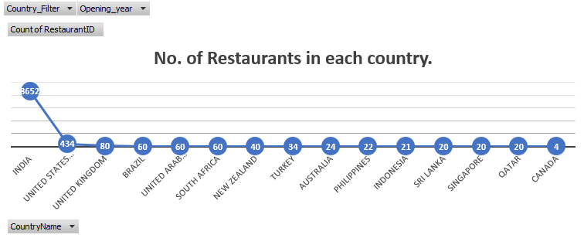

- Calculate the average rating for all the restaurants that have price_range < 4 and provide online delivery. Use only the “IF” function, Logical Operators, and Aggregation functions to solve this problem. [Note: Don’t use Conditional aggregation in this question.]

Formula Used (Array Formula):
{=AVERAGE(IF(('Working Data'!$Q:$Q<4)*('Working Data'!$N:$N="Yes"), 'Working Data'!$T:$T))}

Observation:
- The condition Price_range < 4 was applied to include only affordable restaurants.
- The condition Has_Online_delivery = "Yes" was applied to include only restaurants that offer online delivery.
- The IF function checks both conditions together and returns the rating values only for rows that satisfy them.
- Restaurants that do not meet the conditions are automatically ignored in the calculation.
- The AVERAGE function then calculates the average rating of only those valid restaurants.

- Using Conditional formatting highlight the rows of restaurants that are located in the countries or cities that you’ve suggested to the management for opening new restaurants.

Answer (Steps):

  - Selected the entire dataset containing restaurant details.
  - Went to Home → Conditional Formatting → New Rule.
  - Chose “Use a formula to determine which cells to format.”
  - Used a logical formula to check whether the CountryName or City belongs to the recommended list.
  - Example logic:
    - Match CountryName against recommended countries
    - OR match City against recommended cities
  - Applied a highlight colour (e.g., light green) to visually distinguish the selected rows.
Clicked OK, which highlighted all restaurants located in the suggested countries or cities.
Visualization
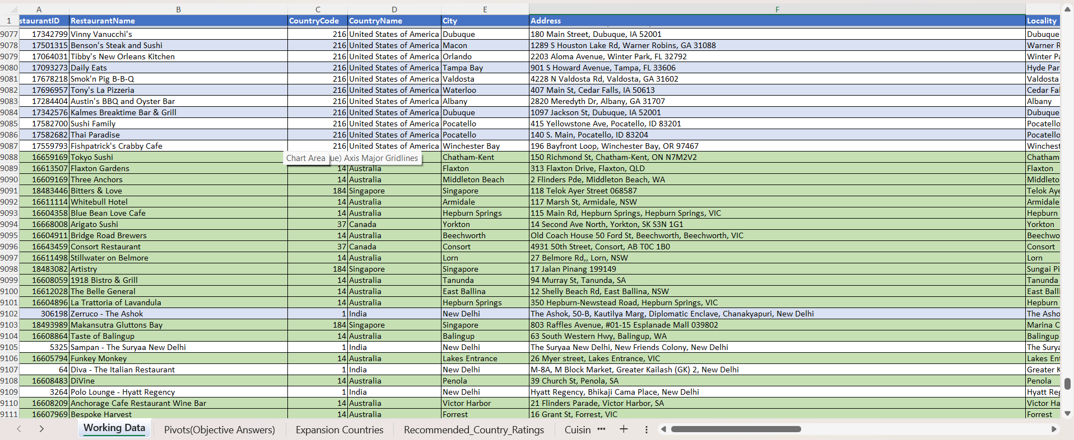

12. Create a new customized price column that consists of the abbreviation/symbol of the currency along with the Average_cost_for_two values. [Use string operations to do this task]
Guidelines:
Use string operations to concatenate values.

Answer:
A new column was created by combining the currency symbol with the Average_Cost_for_two value using string concatenation.
=MID(L2,FIND("(",L2)+1,FIND(")",L2)-FIND("(",L2)-1)&S2

13. How can you create an array formula in Excel or Google Sheets to count the number of restaurants listed that do not offer online delivery, are in the lowest price range, and have an average cost for two people less than or equal to 250 Indian Rupees?
Answer:
An array formula was used to simultaneously evaluate all conditions and count the number of restaurants meeting the criteria. This allowed multi-condition filtering without creating additional helper columns.
=SUM(IF(('Working Data'!L:L='Working Data'!$L$5)*('Working Data'!N:N="No")*('Working Data'!Q:Q<=1)*('Working Data'!S:S<=250),1,0))
(ctrl + shift + enter)

Subjective Question:

- Suggest a few countries where the team can open newer restaurants with lesser competition. Which visualization/technique will you use here to justify the suggestions?
Visualization used:
- A line / marker chart showing the Number of Restaurants in each country
Data aggregated using a Pivot Table
- Values: Count of RestaurantID
- Axis: CountryName

- A Pivot Table was used to analyse restaurant ratings country-wise.

Data was aggregated using the following Pivot configuration:

- Rows: CountryName
- Values:
- Average of Rating
- Maximum of Rating
- Minimum of Rating


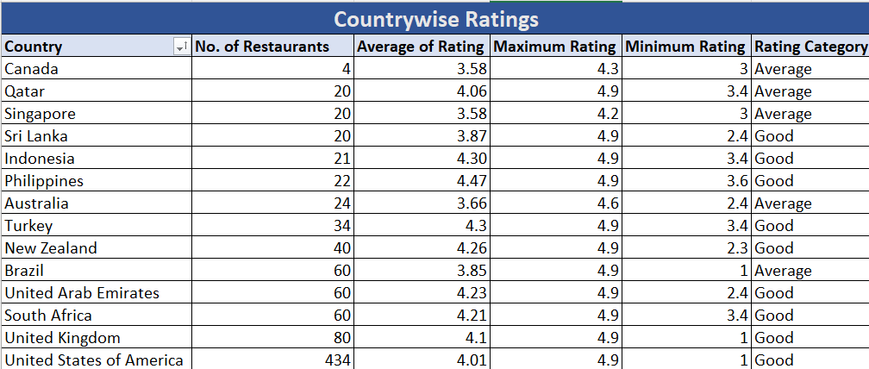

Insights:
- India (8652 restaurants) and United States (434 restaurants) are highly saturated markets, indicating very high competition.
- Countries like Canada (4), Qatar (20), Singapore (20), Sri Lanka (20), Indonesia (21), Philippines (22), and Australia (24) have a very low number of restaurants.
- Even mid-level countries such as Turkey (34) and New Zealand (40) show significantly lower competition compared to India and the USA.
- The sharp drop after the USA clearly highlights underserved markets.
- Most of the low-competition countries also have strong average ratings, which indicates good customer acceptance and market potential:
    - Indonesia – Avg rating ~4.30
    - Philippines – Avg rating ~4.47
    - Turkey – Avg rating ~4.30
    - New Zealand – Avg rating ~4.26
    - Qatar – Avg rating ~4.06
- Countries with low competition but poor ratings would be risky, but in this case, ratings remain consistently above 3.5 for most recommended countries.
- Highly saturated markets like India not only have extreme competition, but also lower average ratings (2.77), suggesting customer dissatisfaction due to overcrowding and intense competition.
Recommendations:
- Canada should be prioritized for immediate expansion as it has the lowest number of restaurants (4) while maintaining a decent average rating (~3.6), indicating low competition with acceptable customer satisfaction.
- Indonesia and Philippines are strong expansion markets as they show very high average ratings (above 4.3) along with low restaurant density (21–22 restaurants), highlighting high demand and positive customer perception.
- Turkey and New Zealand are attractive options due to their high average ratings (above 4.2) combined with moderate but still low competition, making them suitable for controlled expansion.
- Australia demonstrates a balanced opportunity, with relatively low competition (24 restaurants) and good customer ratings, suggesting scope for premium or mid-range restaurant formats.
- Qatar, Singapore, and Sri Lanka also qualify for expansion as they have low competition levels (around 20 restaurants) and consistent ratings above 3.5, indicating stable market acceptance.
- Highly saturated markets such as India and the United States should be avoided for new openings despite reasonable ratings, as extreme competition significantly increases entry barriers.
- Overall, the recommended countries offer a favourable mix of low competition and healthy ratings, making them suitable for early market entry, brand establishment, and scalable growth.

- Come up with the names of States and cities in the suggested countries suitable for opening restaurants.

Visualization:
- Country-wise city-level Pivot Tables combining number of restaurants, average converted cost for two (INR), and average ratings for each city
- Country filter used to analyze each country individually and understand city-level demand concentration and expansion potential
CountryName | Canada
Row Labels | No. of Restaurants | Average Cost for two | Average of Rating
Chatham-Kent | 1 | INR 1,550.00 | 3.7
Consort | 1 | INR 1,550.00 | 3
Vineland Station | 1 | INR 4,340.00 | 4.3
Yorkton | 1 | INR 1,550.00 | 3.3
Grand Total | 4 | 2247.5 | 3.575
CountryName | Sri Lanka
Row Labels | No. of Restaurants | Average Cost for two | Average of Rating
Colombo | 20 | INR 641.25 | 3.87
Grand Total | 20 | 641.25 | 3.87
CountryName | Qatar
Row Labels | No. of Restaurants | Average Cost for two | Average of Rating
Doha | 20 | INR 5,079.13 | 4.06
Grand Total | 20 | 5079.125 | 4.06
CountryName | Australia
Row Labels | No. of Restaurants | Average Cost for two | Average of Rating
Armidale | 1 | INR 1,100.00 | 3.5
Balingup | 1 | INR 1,100.00 | 3.2
Beechworth | 1 | INR 1,100.00 | 4.6
Dicky Beach | 1 | INR 385.00 | 3.6
East Ballina | 1 | INR 1,100.00 | 4.1
Flaxton | 1 | INR 1,650.00 | 3.5
Forrest | 1 | INR 1,100.00 | 3.7
Hepburn Springs | 2 | INR 742.50 | 3.8
Huskisson | 1 | INR 1,100.00 | 4.1
Inverloch | 1 | INR 385.00 | 3.7
Lakes Entrance | 1 | INR 385.00 | 3.8
Lorn | 1 | INR 1,100.00 | 3.6
Macedon | 1 | INR 1,100.00 | 3.5
Mayfield | 1 | INR 1,100.00 | 2.9
Middleton Beach | 1 | INR 1,650.00 | 3.8
Montville | 1 | INR 1,650.00 | 2.4
Palm Cove | 1 | INR 1,650.00 | 4.4
Paynesville | 1 | INR 6,600.00 | 2.6
Penola | 1 | INR 1,100.00 | 3.4
Phillip Island | 1 | INR 1,100.00 | 3.7
Tanunda | 1 | INR 1,650.00 | 4.4
Trentham East | 1 | INR 1,100.00 | 4.1
Victor Harbor | 1 | INR 1,100.00 | 3.6
Grand Total | 24 | 1324.583333 | 3.658333333
CountryName | Indonesia
Row Labels | No. of Restaurants | Average Cost for two | Average of Rating
Bandung | 1 | INR 795.00 | 4.2
Bogor | 2 | INR 848.00 | 3.85
Jakarta | 16 | INR 1,634.72 | 4.35625
Tangerang | 2 | INR 1,325.00 | 4.3
Grand Total | 21 | 1490.309524 | 4.295238095
CountryName | Singapore
Row Labels | No. of Restaurants | Average Cost for two | Average of Rating
Singapore | 20 | INR 9,656.50 | 3.575
Grand Total | 20 | 9656.5 | 3.575
CountryName | Turkey
Row Labels | No. of Restaurants | Average Cost for two | Average of Rating
Ankara | 20 | INR 235.58 | 4.305
Istanbul | 14 | INR 219.86 | 4.292857143
Grand Total | 34 | 229.1029412 | 4.3
CountryName | New Zealand
Row Labels | No. of Restaurants | Average Cost for two | Average of Rating
Auckland | 20 | INR 3,549.00 | 4.275
Wellington City | 20 | INR 3,705.00 | 4.25
Grand Total | 40 | 3627 | 4.2625
CountryName | Philippines
Row Labels | No. of Restaurants | Average Cost for two | Average of Rating
Makati City | 2 | INR 1,667.50 | 4.65
Mandaluyong City | 4 | INR 2,900.00 | 4.625
Pasay City | 3 | INR 4,833.33 | 4.366666667
Pasig City | 3 | INR 1,353.33 | 4.633333333
Quezon City | 1 | INR 1,160.00 | 4.8
San Juan City | 2 | INR 1,232.50 | 4.25
Santa Rosa | 2 | INR 1,196.25 | 3.8
Tagaytay City | 1 | INR 1,740.00 | 4.5
Taguig City | 4 | INR 2,501.25 | 4.525
Grand Total | 22 | 2329.886364 | 4.468181818

- Country-wise Insights & Recommendations

Canada (Total restaurants: 4)

Cities identified:
- Chatham-Kent (1)
- Consort (1)
- Vineland Station (1)
- Yorkton (1)
Insight
- All cities have only 1 restaurant each, indicating extremely low competition.
- Vineland Station has the highest avg cost and strong rating (4.3), suggesting premium demand.
- Overall ratings are moderate (~3.5), indicating scope for quality improvement.
- No clear demand leader
Recommendation:
- Since all cities have equal and very low restaurant counts, these cities represent early-stage markets.
- Opening in any of these cities would face minimal competition, but demand should be validated carefully.
- A phased approach is recommended, start with Vineland Station (premium positioning) or Yorkton (balanced cost).

- Indonesia (Total restaurants: 21)
Cities identified:
- Jakarta (16)
- Bogor (2)
- Tangerang (2)
- Bandung (1)
Insights:
- Jakarta dominates with 16 out of 21 restaurants, showing strong demand.
- Jakarta and Tangerang have high ratings (>4.3).
- Avg cost is moderate, suitable for mass-market dining.
Recommendation:
- Jakarta should be the primary entry city, as it clearly shows the highest demand.
- Bogor and Tangerang are suitable for secondary expansion due to lower competition.
- Bandung can be considered a long-term expansion option.

- Sri Lanka (Total restaurants: 20)
Cities identified:
- Colombo (20)
Insights:
- All 20 restaurants are concentrated in Colombo, showing high city concentration.
- Avg cost is moderate (INR 641) with decent rating (3.87).
- Indicates a centralized but stable market.
Recommendation:
- The entire restaurant presence is concentrated in Colombo, making it the only viable city for entry.
- This indicates a centralized market, suitable for focused competition and brand building.
- Suitable for controlled expansion with quality-focused outlets.

- Singapore (Total restaurants: 20)
Cities identified:
- Singapore (20)
Insights:
- All restaurants are located in Singapore city (20).
- Very high avg cost (INR 9,656) indicates a premium market.
- Ratings are moderate (3.57), suggesting room for differentiation.
Recommendation:
- As Singapore is a city-state, all restaurants are concentrated within the same city.
- Focus on high-quality, premium offerings.
- Strong branding is essential due to high costs and competition.

- Qatar (Total restaurants: 20)
Cities identified:
- Doha (20)
Insights:
- Entire restaurant presence is in Doha (20).
- High avg cost (INR 5,079) reflects a premium market.
- Strong avg rating (4.06) shows high acceptance of quality dining.
Recommendation:
- Doha is the sole market for restaurant activity.
- Expansion should focus on quality, not quantity.
- Ideal for premium or fine-dining concepts.

- Turkey (Total restaurants: 34)
Cities identified:
- Ankara (20)
- Istanbul (14)
Insights:
- Ankara (20) has more restaurants than Istanbul (14).
- Istanbul has higher ratings (~4.29) despite fewer outlets.
- Costs are relatively low, indicating affordable dining market.
Recommendation:
- Ankara shows slightly higher restaurant presence, indicating strong demand.
- Istanbul has fewer restaurants and offers a balance between demand and competition.
- Start in Istanbul for better quality perception.
- Expand to Ankara after initial traction.

- Australia (Total restaurants: 24)
Cities identified:
- Armidale (1)
- Balingup (1)
- Beechworth (1)
- Dicky Beach (1)
- East Ballina (1)
- Flaxton (1)
- Forrest (1)
- Hepburn Springs (2)
- Huskisson (1)
- Inverloch (1)
- Lakes Entrance (1)
- Lorn (1)
- Macedon (1)
- Mayfield (1)
- Middleton Beach (1)
- Montville (1)
- Palm Cove (1)
- Paynesville (1)
- Penola (1)
- Phillip Island (1)
- Tanunda (1)
- Trentham East (1)
- Victor Harbor (1)
Insights:
- Restaurants are highly fragmented across many cities, mostly 1 outlet per city.
- Hepburn Springs (2 restaurants) shows slightly higher demand.
- Costs range widely; ratings are moderate (~3.65).
Recommendation:
- Hepburn Springs (2 restaurants) stands out slightly in terms of demand.
- Other cities represent very low competition markets.
- Cities like Beechworth, Palm Cove, and Tanunda show high ratings with low competition, making them suitable expansion points.

- New Zealand (Total restaurants: 40)
Cities identified:
- Auckland (20)
- Wellington City (20)
Insights:
- Restaurant presence evenly split between Auckland and Wellington (20 each).
- High average cost for two (₹3,600+).
- Strong ratings (~4.26).
Recommendation:
- Both cities show equal restaurant presence.
- Entry can begin in either city, with parallel or phased expansion into the other.

- Philippines (Total restaurants: 22)
Cities identified:
- Mandaluyong City (4)
- Taguig City (4)
- Pasay City (3)
- Pasig City (3)
- Makati City (2)
- San Juan City (2)
- Santa Rosa (2)
- Quezon City (1)
- Tagaytay City (1)
Insights:
- Cities like Mandaluyong and Taguig (4 restaurants each) show strong demand signals.
- Average cost for two is moderate (₹2,500–₹2,900).
- Ratings are very high (4.5+), indicating excellent customer acceptance.
Recommendation:
- Mandaluyong City and Taguig City show the highest demand and should be prioritized.
- Pasay City and Pasig City are suitable for secondary expansion.
- Cities with 1–2 restaurants indicate long-term expansion opportunities.
- The market balances moderate competition, affordability, and high ratings, making it ideal for growth.
- According to the countries you suggested, what is the current quality regarding ratings for restaurants that are open there?

Visualization:
- Pivot table showing Average, Maximum, and Minimum Ratings by Country

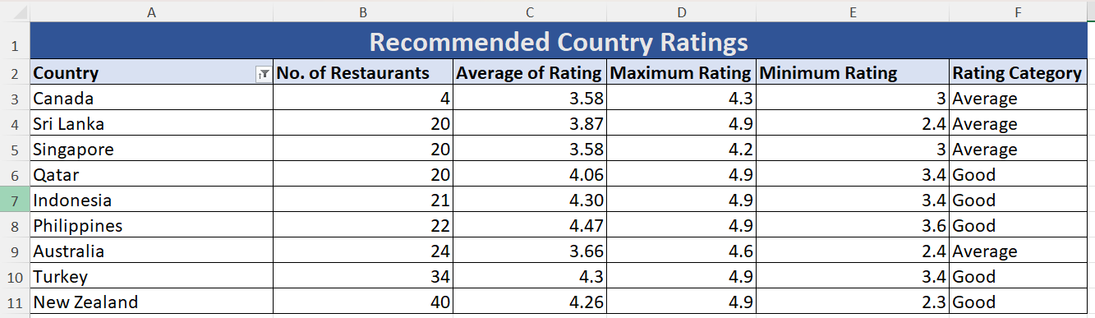

Insights:
- Countries like Qatar,Indonesia, Philippines, Turkey, and New Zealand fall under the “Good” rating category (≈4 and above).
- Canada, Sri Lanka, Singapore, and Australia fall under the “Average” rating range (3–4).
- Presence of low minimum ratings in some countries indicates inconsistent service quality.
Recommendations:
- In Good-rating countries, maintain quality consistency to match customer expectations.
- In Average-rating countries, focus on better service, hygiene, and food quality to outperform competitors.

- Also, what is the current expenditure on food in the suggested countries, so we can keep our financial expenditure in control?
Visualization:
- Pivot table showing Average Cost for Two by Country
Food Expenditure
Country | Average Cost for two
Australia | INR 1,324.58
Brazil | INR 2,154.67
Canada | INR 2,247.50
India | INR 624.28
Indonesia | INR 1,490.31
New Zealand | INR 3,627.00
Philippines | INR 2,329.89
Qatar | INR 5,079.13
Singapore | INR 9,656.50
South Africa | INR 1,846.83
Sri Lanka | INR 641.25
Turkey | INR 229.10
United Arab Emirates | INR 3,761.02
United Kingdom | INR 5,020.31
United States of America | INR 2,212.29

Insights:
- Average cost for two is recorded in local currencies, so values are not directly comparable across countries.
- Countries like Indonesia, Philippines, and Sri Lanka show large numeric values due to currency denomination, but in real-world terms they represent affordable dining.
- Canada, Australia, and New Zealand reflect moderate food expenditure.
- Singapore and Qatar indicate high food expenditure, even after considering currency context.
When I looked at the data, I realised that the numbers cannot be compared directly across countries because every country uses a different currency. For example, Indonesia and the Philippines show very large numeric values, but that does not mean food is expensive there — it’s just how their currency works. In real terms, food in these countries is quite affordable.
On the other hand, countries like Singapore and Qatar show genuinely high food expenditure even in local currency. Countries such as Canada, Australia, and New Zealand fall somewhere in between, indicating moderate spending levels.
Recommendations:
Food pricing should be decided country-wise, not by comparing numbers across countries. Menu prices should be aligned with what customers in that country usually spend and what they consider affordable.
- Come up with the names of restaurants from the recommended states that are our biggest competitors and those that are rated in the lower brackets, i.e. 1-2 or 2-3.

Visualization:
- Pivot Tables created country-wise showing:
  - Restaurant Name
  - Total Votes
  - Average Rating
- Separate identification of:
  - High-vote & high-rating restaurants (major competitors)
  - Low-rated restaurants (rating ≤ 3)

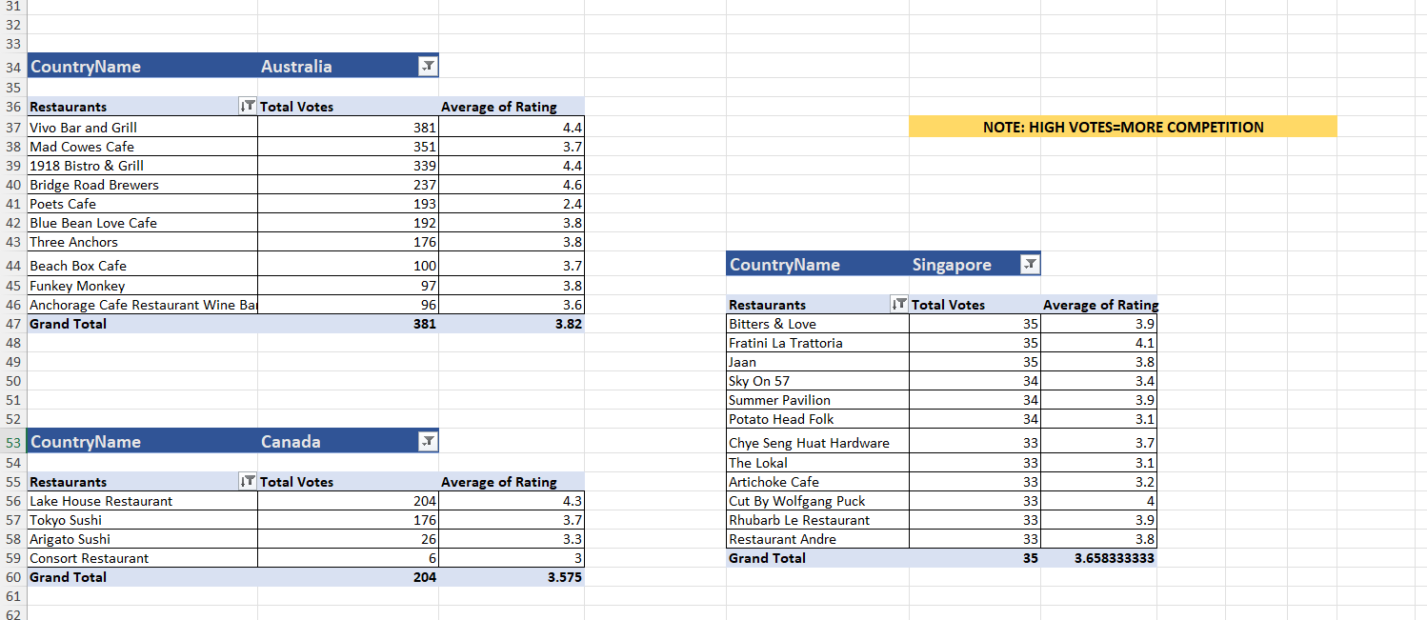

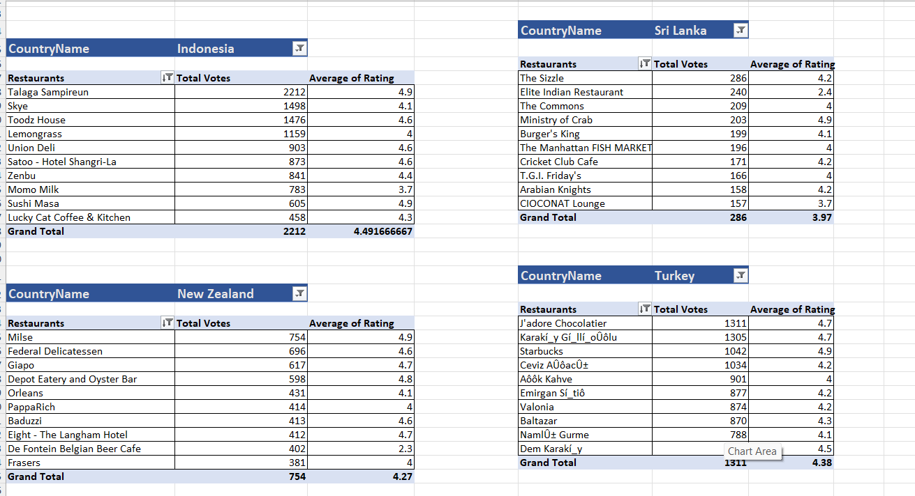

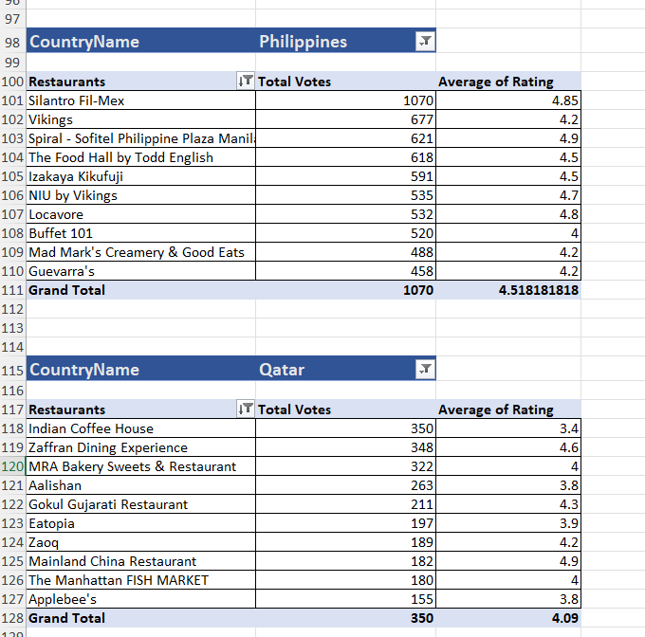

CountryName | (Multiple Items)
Low Rated Restaurants
Restaurants | Ratings
De Fontein Belgian Beer Cafe | 2.3
Elite Indian Restaurant | 2.4
Poets Cafe | 2.4
Queen's Cafe | 2.5
Pier 70 | 2.6
Star Buffet | 2.9

Insights:
Major Competitors :
- Restaurants with very high vote counts and strong ratings indicate established market leaders.
- Examples observed across countries:
  - Indonesia: Talaga Sampireun, Skyz, Toodz House
  - New Zealand: Milse, Federal Delicatessen, Giapo
  - Turkey: J’adore Chocolatier, Karaköy Güllüoğlu, Starbucks
  - Philippines: Silantro Fil-Mex, Spiral – Sofitel, Vikings
  - Australia & Canada: Viva Bar and Grill, 1918 Bistro & Grill, Lake House Restaurant
These restaurants reflect strong brand presence, customer trust, and high footfall, making them key competitors.
Low-Rated Restaurants (Opportunity Indicators):
- Restaurants rated between 1–2 or 2–3 indicate customer dissatisfaction.
- Identified low-rated restaurants include:
  - De Fontein Belgian Beer Cafe (2.3)
  - Elite Indian Restaurant (2.4)
  - Poets Cafe (2.4)
  - Queen’s Cafe (2.5)
  - Pier 70 (2.6)
  - Star Buffet (2.9)
These ratings highlight issues related to service quality, food consistency, or customer experience.
Recommendations:
Highly rated and high-vote restaurants should be treated as benchmarks to understand customer expectations and service standards. Instead of entering highly competitive zones dominated by such players, expansion should focus on areas where low-rated restaurants are present. These locations offer an opportunity to attract dissatisfied customers by providing better quality, improved service, and a more consistent dining experience.
- Which cuisines should we focus on in the newer restaurants to get better feedback? Does the choice of cuisines affect the restaurant ratings?

Visualization:
Cuisine-wise pivot table and chart showing:
  - Number of restaurants per cuisine
  - Average rating per cuisine

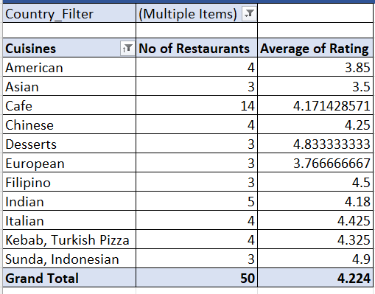

Insights:
  - Cafe cuisine has the highest presence, indicating strong customer demand.
  - Despite high competition, cafes maintain a good average rating, showing consistent acceptance.
  - Desserts, Sunda/Indonesian, and Filipino cuisines have very high average ratings even with fewer restaurants.
  - Chinese, Italian, Indian, and Turkish/Kebab cuisines show a healthy balance of restaurant count and strong ratings.
  - Asian and European cuisines have comparatively lower average ratings, indicating mixed customer feedback.
  - Differences in ratings across cuisines clearly show that cuisine choice impacts customer satisfaction.

Recommendations:

  - Prioritize Cafe cuisine for expansion due to high demand and stable performance.
  - Explore underrepresented but high-rated cuisines like Desserts and regional cuisines for differentiation.
  - Include well-performing cuisines such as Chinese, Italian, and Indian to ensure broad customer appeal.
  - Avoid overcrowding cuisines with lower ratings unless service and quality improvements are planned.
  - Use a balanced cuisine strategy combining popular and high-rated niche cuisines.
Conclusion:
Yes, the choice of cuisine significantly affects restaurant ratings. Selecting cuisines with strong customer demand and consistently high ratings increases the likelihood of better feedback for new restaurants.

- According to our current data, should we go for online delivery and table booking? Does that affect the customer’s ratings?

Visualization:

- Pie charts showing:
  - Distribution of restaurants with and without online delivery
  - Distribution of restaurants with and without table booking
- Pivot tables showing:
  - Number of restaurants vs average rating for online delivery (global data)
  - Number of restaurants vs average rating for table booking (recommended countries)

Insights:
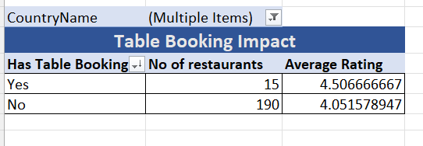
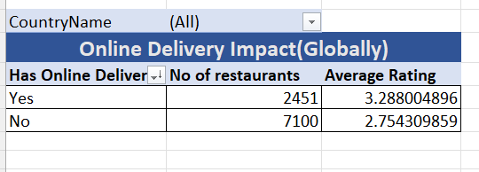

Online Delivery:
  - In the recommended countries, 100% of restaurants do not offer online delivery, indicating a clear service gap.
  - To understand the impact, global data was analysed.
  - Globally, restaurants with online delivery have a higher average rating (~3.29) compared to those without delivery (~2.75).
  - This shows that online delivery positively influences customer satisfaction and ratings.
Table Booking:
  - Only 7% of restaurants offer table booking, while 93% do not, indicating low adoption.
  - Restaurants that provide table booking have a higher average rating (~4.51) compared to those without it (~4.05).
  - This suggests that table booking improves customer experience and perceived service quality.
Recommendations:
  - Online delivery should be strongly considered for new restaurants, as global data clearly shows higher ratings where delivery is available.
  - Since recommended countries currently lack online delivery, introducing it provides a first-mover advantage.
  - Table booking should be implemented, especially in urban and high-footfall areas, to improve convenience and customer satisfaction.
  - Combining both services can help new restaurants differentiate themselves and achieve better customer feedback and higher ratings.

Conclusion:
Yes, both online delivery and table booking have a positive impact on customer ratings. Introducing these services in new restaurants can significantly enhance customer experience and improve overall performance

- Should the team keep the rate of cuisines higher? Will that affect the feedback? According to our data are the rates of cuisines and ratings, correlated?

Visualization:
- Average Cost vs Rating (Restaurant-level)
- Pivot table and chart showing Average of Converted Average Cost for Two (INR) against Average Rating across all restaurants.
- Used to calculate overall correlation between price and rating.

- Cuisine-wise Average Cost vs Rating (Country-wise)
- Country-wise pivot tables showing cuisine-level average cost (INR) and average rating.
Country_Filter | (Multiple Items)
Row Labels | Average of Average_Cost_for_two_INR
2.5 | INR 540.00
3 | INR 1,705.00
3.5 | INR 1,579.00
4 | INR 2,707.06
4.1 | INR 2,183.73
4.5 | INR 2,241.29
- Used to analyze whether pricing within specific cuisines and countries influences customer ratings.

Row Labels | Average of Average_Cost_for_two_INR | Average of Rating
Australia
Italian, Fusion, Cafe | INR 385.00 | 3.8
Coffee and Tea, Tea, Modern Australian | INR 385.00 | 3.6
Burger, Coffee and Tea, Modern Australian | INR 385.00 | 3.7
Breakfast, Coffee and Tea | INR 742.50 | 3.7
Cafe, Coffee and Tea, Modern Australian | INR 1,100.00 | 3.8
Asian | INR 1,100.00 | 2.9
Cafe, Coffee and Tea, Sandwich | INR 1,100.00 | 3.4
Breakfast, Modern Australian | INR 1,100.00 | 4.1
Breakfast, Coffee and Tea, Modern Australian | INR 1,100.00 | 3.7
Cafe, Australian | INR 1,100.00 | 3.7
Coffee and Tea, Tapas, Australian | INR 1,100.00 | 3.6
Cafe | INR 1,100.00 | 3.8
Bar Food, Steak | INR 1,100.00 | 3.5
Pizza, Bar Food | INR 1,100.00 | 4.6
Australian | INR 1,100.00 | 4.1
Coffee and Tea, Modern Australian | INR 1,650.00 | 2.4
Modern Australian, Australian | INR 1,650.00 | 4.4
Mediterranean, Seafood | INR 1,650.00 | 4.4
Bar Food, Modern Australian | INR 1,650.00 | 3.8
Tea, Modern Australian | INR 1,650.00 | 3.5
Modern Australian | INR 3,850.00 | 2.9
Canada
Chinese, Canadian | INR 1,550.00 | 3
Japanese, Sushi | INR 1,550.00 | 3.7
Asian | INR 1,550.00 | 3.3
Italian, Mediterranean, Pizza | INR 4,340.00 | 4.3
Indonesia
Cafe, Desserts, Beverages | INR 371.00 | 3.7
Seafood, Western | INR 530.00 | 3.7
Burger | INR 636.00 | 4.4
Cafe, Coffee and Tea, Western | INR 795.00 | 4.2
Cafe, Italian, Coffee and Tea, Western, Indonesian | INR 874.50 | 4.6
Desserts, Bakery, Western | INR 1,060.00 | 4.6
Korean | INR 1,060.00 | 3.9
Sunda, Indonesian | INR 1,060.00 | 4.9
Japanese, Sushi, Ramen | INR 1,060.00 | 4.4
Peranakan, Indonesian | INR 1,325.00 | 4
Western, Asian, Cafe | INR 1,325.00 | 4.2
Indonesian | INR 1,590.00 | 3.7
Cafe, Western | INR 1,590.00 | 4.3
French, Western | INR 1,855.00 | 4.3
Japanese | INR 2,385.00 | 4.2
Sushi, Japanese | INR 2,650.00 | 4.9
Italian, Continental | INR 4,240.00 | 4.1
Asian, Indonesian, Western | INR 4,240.00 | 4.6
New Zealand
Ice Cream, Desserts | INR 1,040.00 | 4.7
Fast Food | INR 1,300.00 | 4.5
Chinese | INR 1,820.00 | 4.3
Desserts | INR 1,950.00 | 4.9
Thai | INR 2,080.00 | 4.3
Vietnamese, Fish and Chips | INR 2,080.00 | 4.3
Cafe | INR 2,444.00 | 4.3
Cafe, Kiwi, Ice Cream, Desserts | INR 2,600.00 | 4
Cafe, European, Mexican | INR 2,600.00 | 4.4
Taiwanese, Street Food | INR 2,600.00 | 4.4
Cafe, Kiwi | INR 2,600.00 | 4.3
Asian, Sushi, Seafood | INR 2,860.00 | 4.5
Malaysian | INR 2,860.00 | 4.2
American | INR 3,120.00 | 4.1
Cafe, European | INR 3,120.00 | 4
Cafe, American | INR 3,120.00 | 4.6
Japanese, Asian | INR 3,640.00 | 3.7
Asian Fusion, Pub Food, Fusion, Asian, Filipino, Malaysian, Thai | INR 3,640.00 | 3.5
European, Cafe | INR 4,160.00 | 4.2
Mediterranean, Cafe, European | INR 4,160.00 | 4.2
Asian Fusion, Cafe | INR 4,680.00 | 4.2
Seafood, Kiwi | INR 4,680.00 | 4.45
Kiwi, European | INR 4,680.00 | 4.2
Italian | INR 4,940.00 | 4.55
Asian | INR 5,200.00 | 4.3
Italian, Cafe | INR 5,460.00 | 4.2
European | INR 6,933.33 | 3.766666667
French, Kiwi | INR 10,400.00 | 4.4
Philippines
Cafe, Korean, Desserts | INR 870.00 | 4.5
Korean | INR 1,015.00 | 4.3
Filipino, Mexican | INR 1,160.00 | 4.85
Cafe, American, Italian, Filipino | INR 1,160.00 | 3.6
Italian, Pizza | INR 1,232.50 | 4
American, Ice Cream, Desserts | INR 1,305.00 | 4.2
Chinese | INR 1,450.00 | 4.4
French, Japanese, Desserts | INR 1,595.00 | 4.8
Filipino | INR 1,595.00 | 4.5
Japanese | INR 1,740.00 | 4.5
Japanese, Korean | INR 2,175.00 | 4.8
Japanese, Sushi | INR 2,175.00 | 4.9
Cafe, Bakery, American, Italian | INR 2,175.00 | 4.4
American, Asian, Italian, Seafood | INR 2,610.00 | 4.5
Asian, European | INR 2,900.00 | 4
Seafood, Filipino, Asian, European | INR 2,900.00 | 4.2
Seafood, American, Mediterranean, Japanese | INR 4,350.00 | 4.7
Seafood, Asian, Filipino, Indian | INR 5,800.00 | 4.4
European, Asian, Indian | INR 8,700.00 | 4.9
Qatar
Kerala, Indian, Chinese, Bakery | INR 1,362.00 | 4
North Indian, Chinese, Turkish | INR 2,270.00 | 3.8
Steak | INR 2,497.00 | 3.6
Pakistani | INR 2,837.50 | 4
Indian, Street Food | INR 3,405.00 | 3.4
Seafood, American | INR 3,405.00 | 4
Indian | INR 3,813.60 | 4.18
European, Arabian, Japanese, Bakery, Desserts | INR 4,540.00 | 3.9
American, Tex-Mex | INR 4,994.00 | 3.8
Steak, American | INR 5,675.00 | 4
Chinese | INR 5,675.00 | 4.9
Italian | INR 9,080.00 | 4.5
Thai | INR 10,101.50 | 4.3
International | INR 11,917.50 | 4.05
Singapore
Bakery | INR 1,240.00 | 4.2
Singaporean, Chinese, Seafood, Malay, Indian | INR 1,860.00 | 3
Cafe | INR 2,480.00 | 3.7
Finger Food | INR 2,480.00 | 3.9
American, Bakery, European, Burger, Fusion | INR 3,100.00 | 3.8
Italian, French, Bakery, Cafe | INR 3,100.00 | 3.2
Western, Fusion, Fast Food | INR 3,720.00 | 3.2
Singaporean, Australian, German | INR 3,720.00 | 3.1
Cafe, Spanish, Turkish, Greek | INR 4,650.00 | 3.2
American | INR 4,960.00 | 3.1
American, Japanese, Singaporean | INR 4,960.00 | 3.2
American, Mexican | INR 5,890.00 | 3.2
Italian | INR 6,200.00 | 4.1
Asian, Continental, Seafood | INR 13,640.00 | 3.8
American, Steak | INR 16,740.00 | 4
Chinese, Continental, Singaporean | INR 18,600.00 | 3.4
Chinese, Seafood, Cantonese, Dim Sum | INR 18,600.00 | 3.9
French | INR 23,095.00 | 3.85
French, Mediterranean, European | INR 31,000.00 | 3.8
Sri Lanka
Desserts, Bakery | INR 270.00 | 4.2
Desserts, Ice Cream | INR 270.00 | 4.1
Fast Food | INR 270.00 | 4.1
Juices, Desserts | INR 351.00 | 4.5
Malaysian, North Indian, Sri Lankan | INR 405.00 | 3.5
North Indian, Chinese, Sri Lankan | INR 486.00 | 2.4
American, Chinese, North Indian | INR 540.00 | 2.5
Cafe, Italian | INR 540.00 | 3.6
Chinese | INR 540.00 | 3.4
Continental, American | INR 540.00 | 4.1
Middle Eastern, Arabian | INR 648.00 | 4.2
Cafe, Sri Lankan, Continental, American | INR 675.00 | 4
Sri Lankan | INR 675.00 | 4
Italian, Cafe, Desserts | INR 675.00 | 3.7
American, Fast Food, Steak, Beverages | INR 810.00 | 4.2
Continental, American, Seafood | INR 810.00 | 4.2
Cafe, Fast Food, Beverages | INR 945.00 | 3.8
Seafood | INR 1,080.00 | 4.9
American, Steak | INR 1,080.00 | 4
Seafood, Italian | INR 1,215.00 | 4
Turkey
Cafe, Desserts | INR 94.50 | 4.3
Pizza | INR 108.00 | 4.7
Desserts, Bí_rek | INR 108.00 | 4.7
Kebab, Turkish Pizza, Dí_ner | INR 135.00 | 4.4
Turkish Pizza | INR 135.00 | 4.3
Desserts | INR 135.00 | 4.7
Patisserie, Coffee and Tea | INR 135.00 | 3.4
Cafe | INR 153.00 | 4.266666667
Kebab, Izgara | INR 162.00 | 4.4
Kebab, Desserts, Turkish Pizza | INR 189.00 | 4.3
Kebab, Turkish Pizza | INR 202.50 | 4.325
Restaurant Cafe, Turkish, Desserts | INR 202.50 | 4.2
World Cuisine | INR 216.00 | 4.9
Turkish | INR 216.00 | 4.1
Restaurant Cafe, Desserts | INR 216.00 | 4.2
Kebab | INR 229.50 | 4.55
Burger, Izgara | INR 243.00 | 4.3
Restaurant Cafe | INR 270.00 | 3.85
World Cuisine, Patisserie, Cafe | INR 283.50 | 4.2
Bar Food | INR 351.00 | 4.9
World Cuisine, Mexican, Italian | INR 405.00 | 4.4
Italian, World Cuisine | INR 459.00 | 3.7
Steak | INR 1,080.00 | 4.1

Insights:
Average Cost vs Rating:
  - The correlation between average cost for two (INR) and rating is ~0.34, indicating a weak positive relationship.
  - This suggests that restaurants with higher prices tend to receive slightly better ratings, but the relationship is not strong.
  - Several mid-priced and low-priced restaurants still achieve high ratings, showing that higher price alone does not guarantee better feedback.
Cuisine-wise Average Cost vs Rating (Country-wise Analysis):
  - Ratings are relatively high across all price ranges.
  - The difference in average rating between price ranges is not very significant.
  - Even lower price ranges perform well in terms of ratings.
  - This suggests that in recommended countries, quality matters more than price.

Overall Insights
- In countries like Australia and Canada, higher average cost for two does not consistently result in higher ratings, showing that increasing prices alone does not improve customer feedback.
- In Indonesia, Philippines, and Turkey, several cuisines achieve high ratings even at low to mid price levels, indicating strong influence of food quality and local taste preferences over pricing.
- In New Zealand and Qatar, ratings generally improve from low to mid price ranges but tend to stabilize at higher prices, suggesting diminishing returns beyond a certain price point.
- In premium markets such as Singapore, very high prices do not translate into significantly better ratings, highlighting customer sensitivity to value for money.
- Overall, the correlation between average cost for two and ratings (~0.34) indicates a moderate positive relationship, meaning price has some impact but is not a dominant factor.
- Across most countries, cuisines in the mid-price range consistently receive better and more stable ratings than very low or very high priced cuisines.

Recommendations:
- For markets like Australia, Canada, and Singapore, focus on improving service quality, ambience, and consistency rather than increasing prices to improve ratings.
- For Indonesia, Philippines, and Turkey, maintain affordable to mid-range pricing while emphasizing taste and authenticity, as high ratings are already achieved without premium pricing.
- For New Zealand and Qatar, adopt a mid to upper-mid pricing strategy, avoiding extreme premium pricing unless it is strongly supported by the dining experience.
- Avoid a one-size-fits-all pricing approach; pricing strategies should be adjusted based on regional customer expectations and cuisine types.
- Use pricing as a positioning tool only after ensuring strong value delivery through food quality, service, and overall customer experience.

Conclusion:

Yes, the rate of cuisines does affect customer feedback to some extent. According to the data, there is a moderate positive correlation (~0.34) between the rates of cuisines (average cost for two) and customer ratings, indicating that higher-priced cuisines generally tend to receive slightly better feedback. However, this relationship is not strong or consistent across all countries and cuisines. In several markets, high ratings are achieved even at lower or mid-price levels, while in some cases higher prices do not lead to better ratings. Therefore, cuisine pricing alone does not determine customer feedback; quality, service, and overall dining experience play a more significant role.

- What is the distribution of the number of restaurants of different price ranges in all the countries?
Visualization:
  - Bar chart showing Price Range vs Number of Restaurants for all countries.
  - Price ranges categorized from 1 (lowest) to 4 (highest).

Insights:
  - Price Range 1 has the highest number of restaurants, indicating strong dominance of low-cost dining options.
  - Price Range 2 also has a large number of restaurants, showing high customer demand for affordable to mid-range pricing.
  - Price Range 3 has significantly fewer restaurants compared to price ranges 1 and 2.
  - Price Range 4 has the lowest number of restaurants, indicating that premium dining is relatively limited.
  - The overall distribution shows that the global restaurant market is heavily skewed toward budget and mid-priced segments.
Recommendations:
  - Focus expansion on Price Range 3 and 4, as these segments offer:
    - Lower competition
    - Higher average customer ratings
  - Position new restaurants as premium or upper-mid offerings with strong quality and service.
  - Avoid entering oversaturated low-price segments unless there is a clear differentiation strategy.
  - Ensure premium pricing is supported by superior food quality, ambiance, and customer experience.

Conclusion:

Although fewer restaurants exist in higher price ranges, this indicates an opportunity rather than a risk. Combined with better ratings, Price Range 3 and 4 represent the most promising segments for strategic expansion.

- Explain your approach in brief for suggesting countries/cities in order to open new restaurants, if the objective and subjective questions would have not been given to assist you. [you have to give bullet pointers in order to answer this question]
  - I first looked at how many restaurants exist in each country to understand where competition is high and where it is low.
  - Then, I checked customer ratings to see which countries maintain good quality standards.
  - I analysed price ranges to identify segments with fewer restaurants but better ratings, especially premium and mid-premium ranges.
  - I studied average cost for two (in local currency) to understand how much customers are comfortable spending in each country.
  - I compared cities within selected countries to find cities with demand but limited restaurant presence.
  - I analysed cuisine distribution to focus on cuisines that customers like the most and rate highly.
  - I checked whether services like online delivery and table booking impact ratings and customer experience.
  - I avoided markets dominated by very high-vote restaurants to reduce direct competition in the initial phase.
  - I combined all insights using dashboards and filters to validate decisions visually.
  - Finally, I shortlisted countries and cities that show low competition, good ratings, suitable pricing, and growth potential.

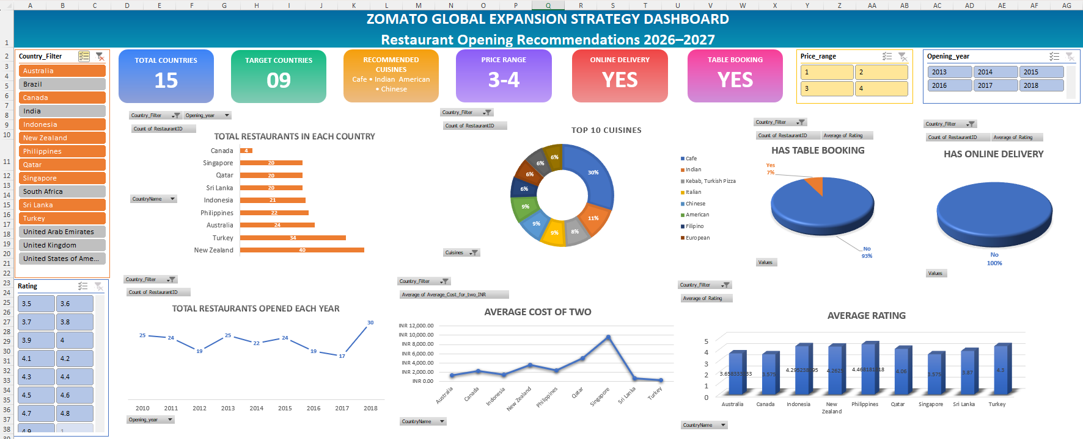
Dashboard:

