**CANDIDATE DECLARATION**

We hereby declare that the project work entitled *"*Gastro-intestinal Disease Prediction*"* has been carried out by our team as part of the requirements for the completion of Software Engineering Course (CS-5704). This project represents our collective work, except where due acknowledgment has been made. All information derived from other sources has been appropriately referenced, and we confirm that we have not plagiarized any content in this report. We also affirm that this work has not been submitted, either wholly or in part, for any degree, diploma, or other academic qualification at any other institution or for any other purpose. Any collaborative efforts, guidance, or assistance received during this project have been clearly acknowledged within the report. We accept full responsibility for the authenticity and integrity of the content presented in this document.

By submitting this declaration, we agree to abide by the academic and ethical standards set forth by Virginia Tech.

* Aayush Bagrecha
* Bhashya Seth
* Gautham Gali
* Nikilesh Madala
* Sreya Sri Lingala

**ACKNOWLEDGEMENT**

We would like to express our sincere gratitude to Professor Melissa Cameron for her invaluable guidance and support throughout the duration of our project, *"*Gastro-intestinal Disease Prediction *"* Her expertise and insightful feedback were instrumental in shaping the project's direction and ensuring its success. We also extend our heartfelt thanks to our Teaching Assistant for their prompt responses to our queries and the invaluable assistance provided during challenging phases of the project. Their contributions, along with the support and encouragement from our peers and mentors, played a vital role in helping us achieve our objectives.

* TEAM FALCON

**1 INTRODUCTION**

This section provides an overview of the challenges that motivated the development of this project and introduces the innovative solution we designed to address these issues. The problem statement highlights the gaps in current diagnostic processes for gastrointestinal disorders, while the product description offers a concise summary of the platform's key features and functionalities, showcasing its impact on improving healthcare accessibility and efficiency.

**1.1 PROBLEM STATEMENT**

Diagnosing gastrointestinal (GI) disorders is essential for ensuring timely and effective treatment, yet the process is often complicated by several challenges. Limited access to specialists, high consultation costs, and long waiting periods are common barriers that delay diagnosis and treatment, which can worsen health outcomes and increase healthcare costs. While traditional diagnostic tools are effective, they require professional interpretation, leading to additional time and expense. Furthermore, existing AI-based diagnostic tools are primarily designed for healthcare professionals, leaving patients without accessible or affordable solutions. This lack of patient-focused diagnostic tools creates a significant burden, both for individuals and the healthcare system. Delayed diagnosis not only increases the risk of complications but also places undue stress on healthcare infrastructure. There is an urgent need for an innovative solution that empowers patients with reliable preliminary diagnoses, reduces barriers to healthcare access, and enables early action to improve outcomes while alleviating the strain on healthcare providers.

**1.2 BRIEF PRODUCT DESCRIPTION**

Our project, *AI-Driven Web Application for Gastrointestinal Disorder Diagnosis*, is an innovative healthcare platform designed to improve the accessibility and efficiency of GI disorder diagnosis. Leveraging advanced deep learning models, the application analyzes endoscopic images uploaded by users to predict potential gastrointestinal conditions such as polyps, esophagitis, or ulcerative colitis. To enhance user experience and engagement, the platform integrates large language models (LLMs) to provide a chatbot feature, enabling patients to ask queries and receive instant, reliable answers about their conditions, reports, or general healthcare information. In addition to generating detailed diagnostic reports that explain the findings, severity, and suggested next steps, the application aims to bridge the gap between patients and healthcare professionals by offering a preliminary diagnostic tool. This solution reduces dependency on immediate specialist consultations, saves time and costs, and empowers users with actionable insights. With its user-friendly interface, scalable design, and advanced AI integrations, this project represents a significant step forward in utilizing AI to improve healthcare accessibility and patient outcomes.

**1.3 CONTEXT**

Healthcare systems face significant challenges in delivering timely and accurate diagnoses for gastrointestinal (GI) disorders, often hindered by limited access to specialists, high costs, and long waiting times. Traditional diagnostic methods, while effective, rely heavily on professional interpretation, making them time-consuming and expensive. This project leverages advancements in artificial intelligence (AI), deep learning models, and large language models (LLMs) to bridge this gap. By creating a user-friendly web application, the platform empowers patients to upload endoscopic images, receive accurate preliminary diagnoses, and access a chatbot for personalized queries. This innovative approach aims to enhance healthcare accessibility, reduce diagnostic delays, and provide actionable insights while maintaining ethical and user-centric standards.

Fig1: Sample Images of Gastro-Intestinal Disorders

**1.4 OBJECTIVES**

* **Preprocess Dataset and Train Deep Learning Models**: Prepare a diverse and comprehensive dataset for training deep learning models to ensure accurate and reliable diagnosis of gastrointestinal disorders.
* **Integrate Large Language Models (LLMs)**: Implement LLMs to provide an interactive chatbot feature, enabling users to ask questions and receive detailed, domain-specific responses.
* **Develop a User-Friendly Web Interface**: Design and implement an intuitive, accessible web application that allows users to upload images, view diagnostic results, and navigate seamlessly.
* **Generate Detailed Diagnostic Reports**: Create an automated system for generating comprehensive diagnostic reports that include condition descriptions, severity levels, and suggested next steps.
* **Ensure Scalability and Security**: Build a scalable and secure architecture that complies with data privacy standards such as HIPAA, ensuring user data is protected and the platform can handle future growth.

**2 PRODUCT FUNCTIONALITIES**

The *AI-Driven Web Application for Gastrointestinal Disorder Diagnosis* is designed with a user-friendly interface and advanced functionalities to ensure seamless operation. Below is a walkthrough of the platform's core functionalities using screenshots to showcase the user experience.

**2.1 User Authentication**

* **Login and Registration:** Users can securely log in or create an account through the platform. This ensures only authorized users can access sensitive features.
* **API:** /login for login validation, /register for new user registration.

2.2 **Image Upload**

* **Feature:** Users can upload endoscopic images for analysis directly from their devices.
* **Workflow:** Once uploaded, the image is processed by the system for classification.

**2.3 Disease Prediction**

* **Model Used:** DenseNet121 was utilized for classification, achieving an accuracy of 91%.
* **Process:** The uploaded image is analyzed, and the system predicts potential GI disorders, including conditions like esophagitis, polyps, and ulcerative colitis.

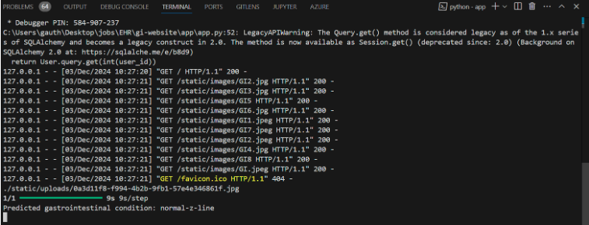

**2.4 Detailed Diagnostic Report**

* **Feature:** A comprehensive report is generated for each prediction, including:
  + - Disease description.
    - Severity levels.
    - Suggested next steps.

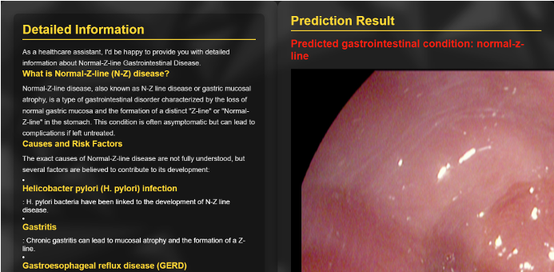

**2.5 Chatbot Integration**

* **LLM Used:** Meta-Llama-3.0.
* **Feature:** The chatbot allows users to ask questions regarding their reports, diagnoses, or general health concerns.

**2.6 Backend APIs and Data Handling**

* **Feature:** The backend is powered by Flask and Postgres DB, ensuring efficient handling of user requests and secure data management.

**3 MACHINE LEARNING & DEEP LEARNING MODELS**

**Model One - VGG16**

VGG16 is a deep convolutional neural network architecture that has proven highly effective for image recognition tasks. It is known for its simplicity and uniform architecture, consisting mainly of 3x3 convolutional layers stacked on top of each other, with increasing depth. This model has been pre-trained on the ImageNet dataset, which contains over a million images and 1,000 classes, allowing it to extract rich feature representations from images**.**

Architecture:

* Input: 224x224 RGB image
* Convolutional Blocks:
  + Multiple convolutional layers (with 3x3 filters)
  + Max-pooling layers for downsampling
* Fully Connected Layers:
  + Layers to map the extracted features to the final output classes
* Output: 1000-dimensional vector (corresponding to 1000 ImageNet classes)

Total Parameters: 33,989,210

Trainable Parameters: 6,424,840

Non-trainable Parameters: 14,714,688

Results:

**Model Two - VGG19**

VGG19, an advanced version of the VGG network family, is a deep convolutional neural network known for its uniform architecture and consistent use of 3x3 convolutional filters. With 19 layers, VGG19 builds upon the strengths of VGG16, incorporating additional layers to capture finer details in images, making it highly effective for image classification tasks. Pre-trained on the ImageNet dataset, it provides a robust foundation for extracting meaningful features.

Architecture:

* Input: 224x224 RGB image
* Convolutional Blocks:
  + Multiple convolutional layers (with 3x3 filters)
  + Max-pooling layers for downsampling
* Fully Connected Layers:
  + Flatten Layer: converts the multi-dimensional output of a convolutional or pooling layer into a one-dimensional array or vector.
  + Dense Layer: computes a weighted sum of its inputs from the previous layer, adds a bias term, and then applies an activation function.
  + Dropout: Prevents overfitting by randomly deactivating some units during training.Output: 1000-dimensional vector (corresponding to 1000 ImageNet classes)

Total Parameters: 26,449,224

Trainable Parameters: 6,424,840

Non-trainable Parameters: 20,024,384

Results:

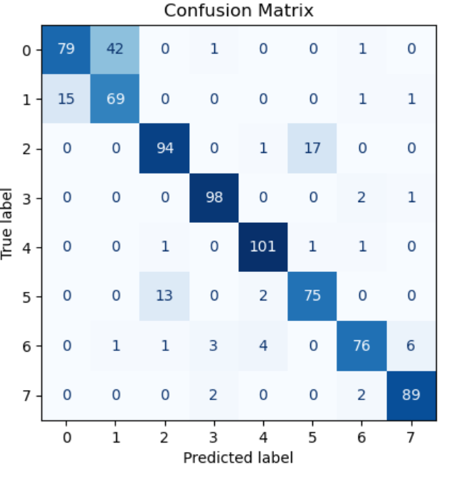

**Model Three - RESNET50**

ResNet50, short for "Residual Networks," is a pre-trained convolutional neural network that is highly effective for image classification tasks. It is designed to handle the vanishing gradient problem by using residual learning, which allows the network to train deeper architectures with improved accuracy.

Architecture:

* Input: 224x224 RGB image
* Convolutional Blocks:
  + Multiple convolutional layers (with 3x3 filters)
  + Max-pooling layers for downsampling
* Fully Connected Layers:
  + Flatten Layer: converts the multi-dimensional output of a convolutional or pooling layer into a one-dimensional array or vector.
  + Dense Layer: computes a weighted sum of its inputs from the previous layer, adds a bias term, and then applies an activation function.
  + Dropout: Prevents overfitting by randomly deactivating some units during training.

Total Parameters: 100,664,986

Trainable Parameters: 25,692,424

Non-trainable Parameters: 23,587,712

Results:

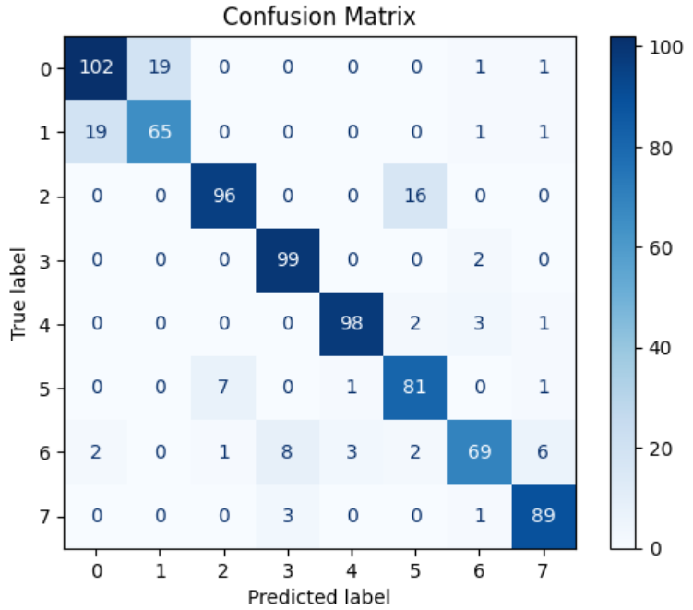

**Model Four - DENSENET121**

Unlike traditional convolutional networks, where layers only connect to their immediate predecessors and successors, DenseNet121 establishes direct connections between all layers. This approach enhances feature propagation, reduces redundancy, and improves gradient flow, making it especially effective for complex image classification tasks.

Architecture:

* Input: 224x224 RGB image
* Convolutional Blocks:
  + Multiple convolutional layers (with 3x3 filters)
  + Max-pooling layers for downsampling
* Fully Connected Layers:
  + GlobalAveragePooling2D: Reduces spatial dimensions while retaining important information.
  + Dense Layer: Adds non-linearity to the model with 256 units and ReLU activation function.
  + Dropout: Prevents overfitting by randomly deactivating some units during training.

Total Parameters: 7,830,874

Trainable Parameters: 264,456

Non-trainable Parameters: 7,037,504

Results:

**Model Five - MOBILENET**

MobileNet is a highly efficient convolutional neural network architecture specifically designed for resource-constrained environments, such as mobile devices. It balances performance and computational efficiency by employing depthwise separable convolutions, significantly reducing the number of parameters and computations while maintaining accuracy

Architecture:

* Input: 224x224 RGB image
* Convolutional Blocks:
  + Multiple convolutional layers (with 3x3 filters)
  + Max-pooling layers for downsampling
* Fully Connected Layers:
  + Global_Average_Pooling Layer:This layer reduces each of the incoming feature map's dimensions to a single value, condensing the spatial information, thus lowering the model's complexity and total parameter count.
  + Dense Layer: computes a weighted sum of its inputs from the previous layer, adds a bias term, and then applies an activation function.
  + Dropout: Prevents overfitting by randomly deactivating some units during training.

Total Parameters: 3,493,320

Trainable Parameters: 264,456

Non-trainable Parameters: 3,228,864

Results:

**Model Six - EFFICIENTNET**

EfficientNet_B2 is a state-of-the-art convolutional neural network designed to achieve high accuracy with fewer parameters. Its architecture is based on the principle of compound scaling, which uniformly scales network depth, width, and resolution. This makes it ideal for handling complex datasets while maintaining computational efficiency.

Architecture:

* Input: 224x224 RGB image
* Convolutional Blocks:
  + Multiple convolutional layers (with 3x3 filters)
  + Max-pooling layers for downsampling
* Fully Connected Layers:
  + Global_Average_Pooling Layer:This layer reduces each of the incoming feature map's dimensions to a single value, condensing the spatial information, thus lowering the model's complexity and total parameter count.
  + Dense Layer: computes a weighted sum of its inputs from the previous layer, adds a bias term, and then applies an activation function.
  + Dropout: Prevents overfitting by randomly deactivating some units during training..

Total Parameters: 8,131,329

Trainable Parameters:362,760

Non-trainable Parameters: 7,768,569

Results:

**4 ETHICAL IMPLEMENTATIONS**

This section explores the ethical considerations associated with the project, highlighting potential issues that could arise from its use and implementation. It also discusses the strategies employed to mitigate these challenges, ensuring that the platform adheres to high ethical standards while delivering a reliable and inclusive healthcare solution.

**4.1 ETHICAL ISSUES**

* Accuracy and Reliability of Diagnoses: There is a risk that the deep learning models may occasionally produce inaccurate or misleading results, which could negatively impact users' decision-making.
* User Misinterpretation: Non-specialist users might misunderstand the diagnostic reports or over-rely on the tool without consulting a healthcare professional, potentially leading to inappropriate actions.
* Liability and Accountability: The question of who is responsible for any adverse outcomes resulting from the platform's diagnostic suggestions is a critical ethical concern.

**4.2 MITIGATION STRATEGIES**

* Accuracy Verification: Conducted extensive testing and validation of the deep learning models to minimize inaccuracies, including cross-referencing predictions with medical experts to ensure reliability.
* Educational Guidance: Added clear disclaimers and step-by-step instructions to help users interpret the reports accurately. The tool explicitly recommends consulting healthcare professionals for definitive diagnosis and treatment.
* Liability Clarification: Clearly outlined the platform's purpose as a supplementary diagnostic tool in the terms of use, stating that it is not intended to replace professional medical consultations.

**5 RETROSPECTION**

This section reflects on the journey of building the project, highlighting both the achievements and the challenges encountered along the way. It provides an overview of what went well, showcasing the successes that contributed to the project\u2019s outcomes, and what went wrong, offering insights into the obstacles faced and lessons learned. This retrospection serves as a valuable guide for future improvements and project iterations.

**5.1 WHAT WENT WELL**

* Team Collaboration: The team maintained excellent communication and coordination, leveraging each member's strengths effectively to deliver key components of the product.
* Successful Model Integration: The integration of deep learning models with the web application went smoothly, resulting in accurate and reliable disease predictions.
* User-Centric Design: The frontend was developed with a strong focus on simplicity and accessibility, receiving positive feedback during user testing for its intuitive interface.
* Chatbot Implementation: The chatbot integration using LLMs exceeded expectations, offering users clear and accurate responses to their queries and enhancing overall engagement.
* Timely Completion of MVP: The Minimum Viable Product (MVP) was completed within the projected timeline, including core functionalities such as image upload, disease prediction, and report generation.

**5.2 WHAT WENT WRONG**

* Dataset Challenges: Sourcing a diverse dataset for training the deep learning models proved challenging, leading to longer training times and some limitations in model performance for rare conditions.
* Backend-Frontend Integration Delays: Initial delays were encountered during backend and frontend integration due to compatibility issues and differing technical requirements.
* Time Constraints: Limited time impacted the implementation of advanced features such as multilingual support and real-time consultations, which remain as future enhancements.
* Challenges in Training Deep Learning Models: Training deep learning models required significant computational resources and time, taking several days to achieve acceptable accuracy and performance.
* Challenges with LLM Chatbot Integration: Integrating the large language model (LLM) chatbot posed significant challenges, including ensuring the accuracy and relevance of responses to user queries.

**6 RECOMMENDATIONS FOR FUTURE**

This section outlines potential enhancements and future directions for the project to further improve its functionality, scalability, and user experience. By addressing current limitations and exploring new features, these recommendations aim to make the platform more robust, and impactful in the healthcare domain. These insights serve as a guide for continued development and innovation, ensuring the product evolves to meet user needs and industry standards.

**6.1 TABULAR FORM FOR FUTURE RECOMMENDATIONS**

|  |  |  |
| --- | --- | --- |
| S.No | Recommendation | Description |
| 1 | Enhance Dataset Diversity | Collect diverse datasets to improve model accuracy for underrepresented conditions and demographics. |
| 2 | Develop Mobile Accessibility | Build a mobile application for convenient access to the platform. |
| 3 | Improve Chatbot Functionality | Expand chatbot capabilities to handle complex queries, provide symptom-based guidance, and support multiple languages. |
| 4 | Integrate Real-Time Consultations | Add a feature for direct consultations with certified healthcare professionals. |
| 5 | Strengthen Compliance and Security | Update the platform to comply with regulations like HIPAA and GDPR to ensure data security and privacy. |
| 6 | Add Educational Resources | Include videos, articles, and FAQs to help users understand their conditions and make informed decisions. |
| 7 | Collaborate with Healthcare Organizations | Partner with medical institutions for validation and adoption of the platform in professional environments. |
| 8 | AI-Assisted Treatment Recommendations | Extend features to include AI-generated lifestyle and treatment suggestions based on diagnostic results. |
| 9 | Monitor and Maintain | Implement a system to track performance, flag inaccuracies, and keep the platform updated with medical advancements. |
| 10 | Enhance User Feedback Mechanisms | Introduce a feedback system to gather user insights and improve platform usability. |
| 11 | Integration with Healthcare Systems | Link the platform with EHR systems to enable seamless sharing of diagnostic results with healthcare providers. |

**6.2 NOTES TO SELF**

* **Aayush Bagrecha:** Enhance the chatbot's capabilities to provide meaningful, empathetic, and accurate responses. Work on integrating advanced NLP features, support for multiple languages, and a conversational flow that makes the chatbot feel like a trusted advisor.
* **Bhashya Seth:** Take charge of ensuring the system remains stable, updated, and future-proof. Monitor performance metrics, address technical debt, and proactively implement user feedback to keep the platform relevant and efficient.
* **Gautham Gali:** Build a robust and scalable backend infrastructure. Ensure APIs are efficient, secure, and well-documented. Optimize database queries and maintain modularity for future expansions and integrations. The backbone of the system lies in your hands!
* **Nikilesh Madala:** Create a user interface that is not just functional but delightful. Focus on accessibility, responsiveness, and intuitive navigation. Ensure the design adapts seamlessly across devices and prioritizes a smooth user experience for every interaction.
* **Sreya Sri Lingala:** Hone the deep learning models to perfection. Continuously improve their accuracy and generalization. Experiment with advanced architectures, fine-tune hyperparameters, and ensure the models remain at the forefront of innovation in GI diagnostics.

**6.3 CONCLUSION**

The *AI-Driven Web Application for Gastrointestinal Disorder Diagnosis* offers a transformative approach to improving healthcare accessibility and efficiency. By combining deep learning models for accurate disease prediction and a chatbot powered by large language models for personalized user interactions, the platform empowers patients with actionable insights while reducing reliance on immediate specialist consultations. Among the models evaluated, DenseNet121 achieved the highest accuracy, reaching nearly 91%, with no signs of overfitting, ensuring reliable and generalizable predictions. This project not only addresses key challenges in GI diagnostics but also lays the groundwork for future advancements in AI-driven healthcare, with the potential to revolutionize diagnostic accessibility and patient outcomes.

**7. References:**

[1] Guo, Han, et al. “Improving Image Classification of Gastrointestinal Endoscopy Using Curriculum Self-Supervised Learning.” Scientific Reports, vol. 14, no. 1, 13 Mar. 2024, p. 6100, www.nature.com/articles/s41598-024-53955-8), https://doi.org/10.1038/s41598-024-53955-8. Accessed 30 Mar. 2024.

[2] Haile, Melaku Bitew, et al. “Detection and Classification of Gastrointestinal Disease Using Convolutional Neural Network and SVM.” Cogent Engineering, vol. 9, no. 1, 6 June 2022, https://doi.org/10.1080/23311916.2022.2084878.

[3] “Kvasir Dataset.” Www.kaggle.com, www.kaggle.com/datasets/meetnagadia/kvasir-dataset. Accessed 13 Mar. 2024.

[4] Lonseko, Zenebe Markos, et al. “Gastrointestinal Disease Classification in Endoscopic Images Using Attention-Guided Convolutional Neural Networks.” Applied Sciences, vol. 11, no. 23, 1 Jan. 2021, p. 11136, www.mdpi.com/2076-3417/11/23/11136, https://doi.org/10.3390/app112311136. Accessed 30 Mar. 2024.

[5] Nouman Noor, Muhammad, et al. “Efficient Gastrointestinal Disease Classification Using Pretrained Deep Convolutional Neural Network.” Electronics, vol. 12, no. 7, 1 Jan. 2023, p. 1557, www.mdpi.com/2079-9292/12/7/1557, https://doi.org/10.3390/electronics12071557.