EMBER — Addendum: UI Mockups, LLM Prompt, API Contracts
Supplements the EMBER Project Overview Final v2. Addresses UI layout, LLM integration, API contracts, and caching implementation.

6. UI Layout — Visual Reference

6.1 Resident view (/ route)
The map occupies approximately 65% of the screen height. The briefing card sits below it. On wider screens, the briefing card moves to a right-side panel beside the map. The address input and profile flags are always visible at the top. An alert banner appears dynamically when route conditions change (e.g., a road closure triggers a re-route).
Key UI components: EMBER logo with evacuation status badge, address input with GO button, profile flag toggles (Mobility, Pets, Medical, No Vehicle) as pill-shaped buttons, alert banner for route changes, Mapbox map with fire perimeter, projection rings, road closures, shelter pins, and wind arrows, and the briefing card with threat/route/shelter summary cards.
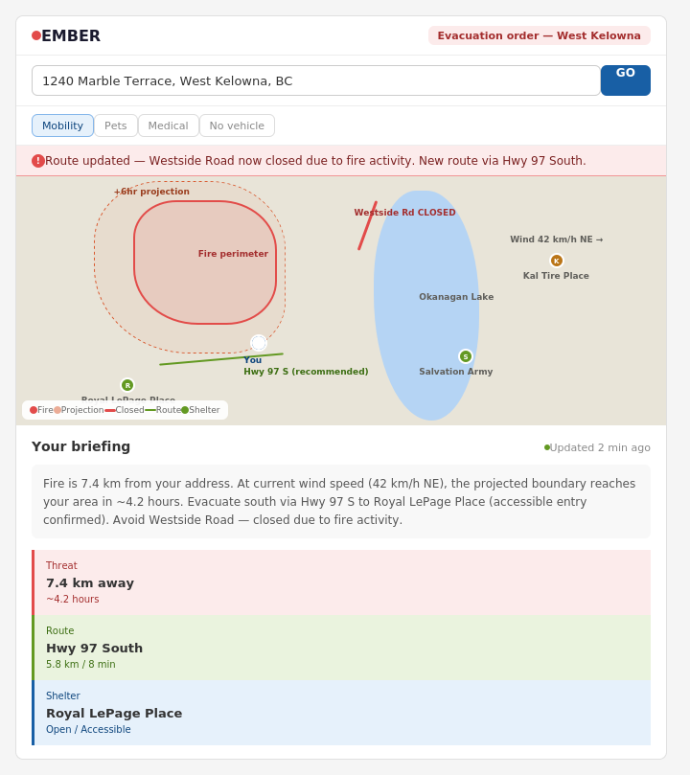

6.2 Admin / Command view (/admin route)
Split-panel layout. Map on the left (60% width), situation panels on the right (40% width). The right panel stacks three sections: situation summary with metric cards, road status with color-coded badges, and shelter panel with manual override buttons (Open / Filling / Near Full). Simulation control buttons sit at the bottom. A Demo Mode toggle and LIVE badge are in the top bar.
Key UI components: regional map with evacuation order zones (red), alert zones (orange), fire perimeter, projection overlay, road closures, shelter pins with status colors, wind arrows, and census vulnerability clusters (65+ areas shown as dashed purple regions). The shelter override buttons are inline with each shelter row — clicking one changes the shelter’s status across the entire system.
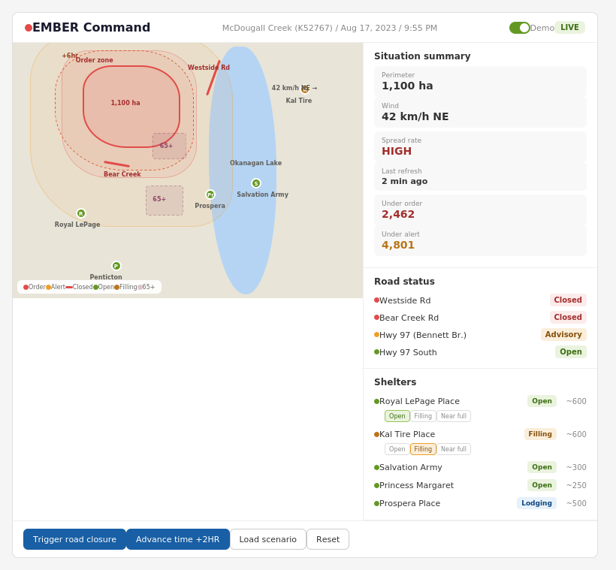

Appendix A: LLM Prompt Template
The Profile Agent assembles a structured JSON payload from the four agent outputs and sends it as a single API call to Claude Sonnet. The LLM’s only job is to synthesize this into a 3–4 sentence plain-language briefing. All decision logic (routing, ranking, filtering) happens in deterministic code before this call.
System prompt:
You are EMBER, an emergency evacuation assistant for BC wildfire
emergencies. Given structured data about a resident's situation,
generate a 3-4 sentence plain-language evacuation briefing.
Be direct, specific, and actionable. Use no jargon. Include:
distance to fire, time estimate, recommended route, shelter name,
and any road closures to avoid. If accessibility flags are set,
mention the relevant accommodation. Do not add disclaimers or
caveats — the system labels projections on the map already.
User message (structured JSON input):
{
"threat": {
"distance_km": 7.4,
"time_to_perimeter_hours": 4.2,
"spread_rate": "HIGH",
"wind_speed_kmh": 42,
"wind_direction": "NE"
},
"route": {
"primary": "Hwy 97 South via Boucherie Rd",
"distance_km": 5.8,
"duration_min": 8,
"fallback": "Hwy 97C West to Merritt"
},
"shelter": {
"name": "Royal LePage Place",
"address": "2760 Cameron Rd, West Kelowna",
"status": "Open",
"is_accessible": true,
"has_pet_area": true
},
"closures": [
"Westside Road — CLOSED (fire activity)",
"Bear Creek Road — CLOSED (evacuation zone)"
],
"profile": {
"mobility": true,
"medical": false,
"pets": false,
"no_vehicle": false
}
}
Expected LLM output (plain text, 3–4 sentences):
"Fire is 7.4 km from your address. At current wind speed (42 km/h NE), the projected boundary reaches your area in approximately 4.2 hours. Evacuate south via Hwy 97 S to Royal LePage Place — accessible entry confirmed, 5.8 km, about 8 minutes. Avoid Westside Road and Bear Creek Road, both closed due to fire activity."

Appendix B: API Response Shapes
These are the key JSON contracts between the FastAPI backend and the React frontend. Member A (frontend) and Member B (backend) should agree on these before coding begins.
GET /api/briefing?address=1240+Marble+Terrace,West+Kelowna,BC
{
"updated_at": "2023-08-17T21:55:00-07:00",
"threat": {
"distance_km": 7.4,
"time_to_perimeter_hours": 4.2,
"spread_rate": "HIGH",
"wind": { "speed_kmh": 42, "direction": "NE" }
},
"route": {
"summary": "Hwy 97 South via Boucherie Rd",
"distance_km": 5.8,
"duration_min": 8,
"polyline": "q~ioHxlwxUQo@c@sA...",
"fallback_summary": "Hwy 97C West to Merritt"
},
"shelter": {
"id": "shelter_001",
"name": "Royal LePage Place",
"address": "2760 Cameron Rd, West Kelowna",
"lat": 49.8587, "lng": -119.5827,
"status": "Open",
"is_accessible": true,
"has_pet_area": true
},
"closures": [
{ "road": "Westside Rd", "status": "CLOSED",
"lat": 50.025, "lng": -119.493 },
{ "road": "Bear Creek Rd", "status": "CLOSED",
"lat": 49.940, "lng": -119.518 }
],
"briefing_text": "Fire is 7.4 km from your address...",
"fire_perimeter_geojson": "http://api/static/perimeter.geojson",
"projections_geojson": [
"http://api/static/spread_2hr.geojson",
"http://api/static/spread_4hr.geojson",
"http://api/static/spread_6hr.geojson"
]
}
GET /api/admin/situation
{
"fire": {
"id": "K52767", "name": "McDougall Creek",
"hectares": 1100, "spread_rate": "HIGH",
"wind": { "speed_kmh": 42, "direction": "NE" },
"perimeter_url": "/static/perimeter.geojson"
},
"evacuations": {
"under_order": 2462, "under_alert": 4801
},
"roads": [ ...same as closures above... ],
"shelters": [ ...array of shelter objects with status... ],
"updated_at": "2023-08-17T21:55:00-07:00"
}
POST /api/admin/shelter/{id}/status
Request: { "status": "Filling" }
Response: { "id": "shelter_002", "status": "Filling", "updated_at": "..." }
POST /api/admin/simulate/closure
Request: { "closure_id": "closure_001" }
Response: { "active_closures": ["closure_001", "closure_004"], "updated_at": "..." }
POST /api/admin/simulate/advance
Request: { "hours": 2 }
Response: { "current_time": "2023-08-17T23:55:00-07:00", "timeline_step": 4 }

Appendix C: Caching Implementation
For a hackathon with 4 weeks and 4 people, the caching layer is a Python dictionary with timestamps. No Redis, no file cache, no external dependency. This lives in the FastAPI backend as a module-level dictionary.
# cache.py
import time

_cache = {}

TTL = {
"fire_perimeter": 900, # 15 minutes
"drivebc": 300, # 5 minutes
"weather": 900, # 15 minutes
"directions": 600, # 10 min (only refresh on input change)
}

def get(key):
entry = _cache.get(key)
if entry and time.time() - entry["ts"] < TTL.get(key.split(":")[0], 300):
return entry["data"]
return None

def set(key, data):
_cache[key] = {"data": data, "ts": time.time()}
Usage in agents:
cached = cache.get("fire_perimeter:K52767")
if cached:
return cached
data = await fetch_from_geobc(fire_id)
cache.set("fire_perimeter:K52767", data)
return data
In Demo Mode, the cache is pre-populated at startup from the scenario JSON files, so no external API calls are ever made. The cache TTLs are irrelevant in Demo Mode since the data never expires.

