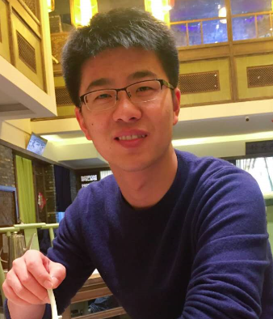**Ji Dong**

**Date of Birth: 11th. July. 1990**

**Education:**

Ph.D.: Peking University (2015-2020)

Master: East China Normal University (2012-2015)

Bachelor: Hainan University (2008-2012)

**Research Experience:**

Visiting Toronto University (2014)

**Research Interests:**

Embryonic Development, Tumor Biology, Single-Cell Omics

**E-mail:** [**zorrodong@pku.edu.cn**](mailto:zorrodong@pku.edu.cn)

**Selected Publications (* Co-First Author):**

**1.** Single-cell RNA-Seq analysis maps development of human germline cells and gonadal niche interactions

L Li, **J Dong\***, L Yan, J Yong, X Liu, Y Hu, X Fan, X Wu, H Guo, X Wang, ...

***Cell stem cell*** (2017) 20 (6), 858-873. e4

**2.** Single-cell RNA-seq analysis unveils a prevalent epithelial/mesenchymal hybrid state during mouse organogenesis

**J Dong** , Y Hu, X Fan, X Wu, Y Mao, B Hu, H Guo, L Wen, F Tang

***Genome biology*** (2018) 19 (1), 31

**3.** Spatial transcriptomic survey of human embryonic cerebral cortex by single-cell RNA-seq analysis

X Fan, **J Dong\***, S Zhong, Y Wei. ...

***Cell research*** (2018) 1

**4.** Single-cell multiomics sequencing and analyses of human colorectal cancer

S Bian, Y Hou, X Zhou, X Li, J Yong, Y Wang,..., **Ji Dong**, …

***Science*** (2018) 362(6418): 1060-1063.

**5.** A single-cell RNA-seq survey of the developmental landscape of the human prefrontal cortex

S Zhong, S Zhang, X Fan, Q Wu, L Yan, **J Dong**, H Zhang, L Li, L Sun, ...

***Nature*** (2018) 555 (7697), 524