K-NanoMFA v2.5.1

User Manual
  - Material flow analysis and nanoform resolved environmental fate
Version 2.5.1-en
Includes verified Chromium interface screenshots
19 September 2026
Prof. Younghun Kim
Kwangwoon University
MIT License

K-NanoMFA calculates material flows through the use, end-of-life, treatment and environmental stages of engineered nanomaterials. This manual describes the inputs, calculations, interpretation and reproducibility functions of v2.5.1. Define the material basis, geographic domain, time boundary and medium before interpreting a result.
Bundled values are starting assumptions. A runnable default scenario is not a measured national market inventory or environmental concentration. Successful execution, mass-balance closure and agreement with observations are separate checks.
Working sequence Define scope → Review inputs → Calculate → Check balance and convergence → Compare observations → Archive results

Contents
1 Purpose and model scope
2 Installation and launch
3 Interface architecture
4 Workflows and readiness
5 Study setup
6 Product inventory and life cycle
7 Treatment and environmental capacities
8 Nanoforms and environmental fate
9 Evidence observations and uncertainty
10 Results interpretation and export
11 Mixtures and co exposure
12 Expert tools
13 Scenario files and compatibility
14 Quality assurance and reproducibility
15 Troubleshooting
16 Scientific interpretation boundaries
A Feature directory
B Units and tracking basis
C Distribution files
D MFA terms and output fields
E Observation data columns

1 Purpose and model scope
K-NanoMFA calculates material flows through the use, end-of-life, treatment and environmental stages of engineered nanomaterials. This manual describes the inputs, calculations, interpretation and reproducibility functions of v2.5.1. Define the material basis, geographic domain, time boundary and medium before interpreting a result.
Bundled values are starting assumptions. A runnable default scenario is not a measured national market inventory or environmental concentration. Successful execution, mass-balance closure and agreement with observations are separate checks.
Layer | Purpose
Base MFA | Product and treatment flows and stocks
Product inventory | Product quantities to nanomaterial inflow
Nanoform | Form allocation of released mass
Fate 28 | Time evolution across four media and seven forms
Expert tools | Optional estimation and comparison functions

$$Initial stock + cumulative inflow = final stock + cumulative external outflow$$

2 Installation and launch
Extract the complete ZIP, then open index.html in Chrome or Edge. Keep the JavaScript, CSS and HTML files together. Moving only the HTML file prevents the calculation and chart files from loading. Normal operation requires neither Node.js nor Python. Calculations use bundled files; literature links require internet access.
Select Compact, Standard or Large under Text size. Compact uses 14 px body text. Text size does not change results. The application interface remains in English when you open the Korean manual.
Use Analysis navigator or Feature directory to locate a function. Select All workspaces under Interface view to expose the complete workspace navigation. On narrow screens, controls stack vertically. Wide tables scroll within their own containers. Focus a long input value and move the text cursor to inspect its full contents.

Launch checks
After extraction, open index.html and confirm that the displayed version is v2.5.1. Choose an example, run Calculate and check that results appear. Verify the selected material and units before saving.

3 Interface architecture
Interface example
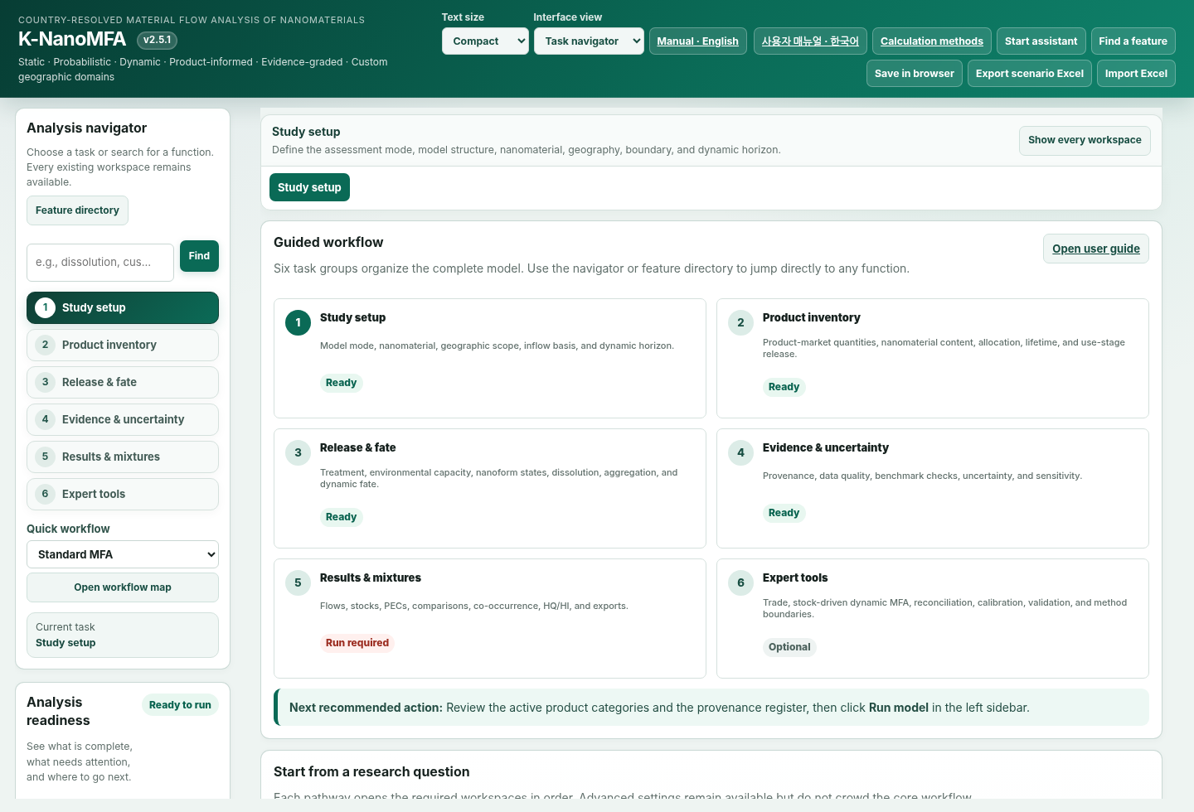
Figure 1. K-NanoMFA v2.5.1 rendered in Chromium. The interface uses a top action bar, an Analysis navigator on the left, and the active workspace in the main panel.
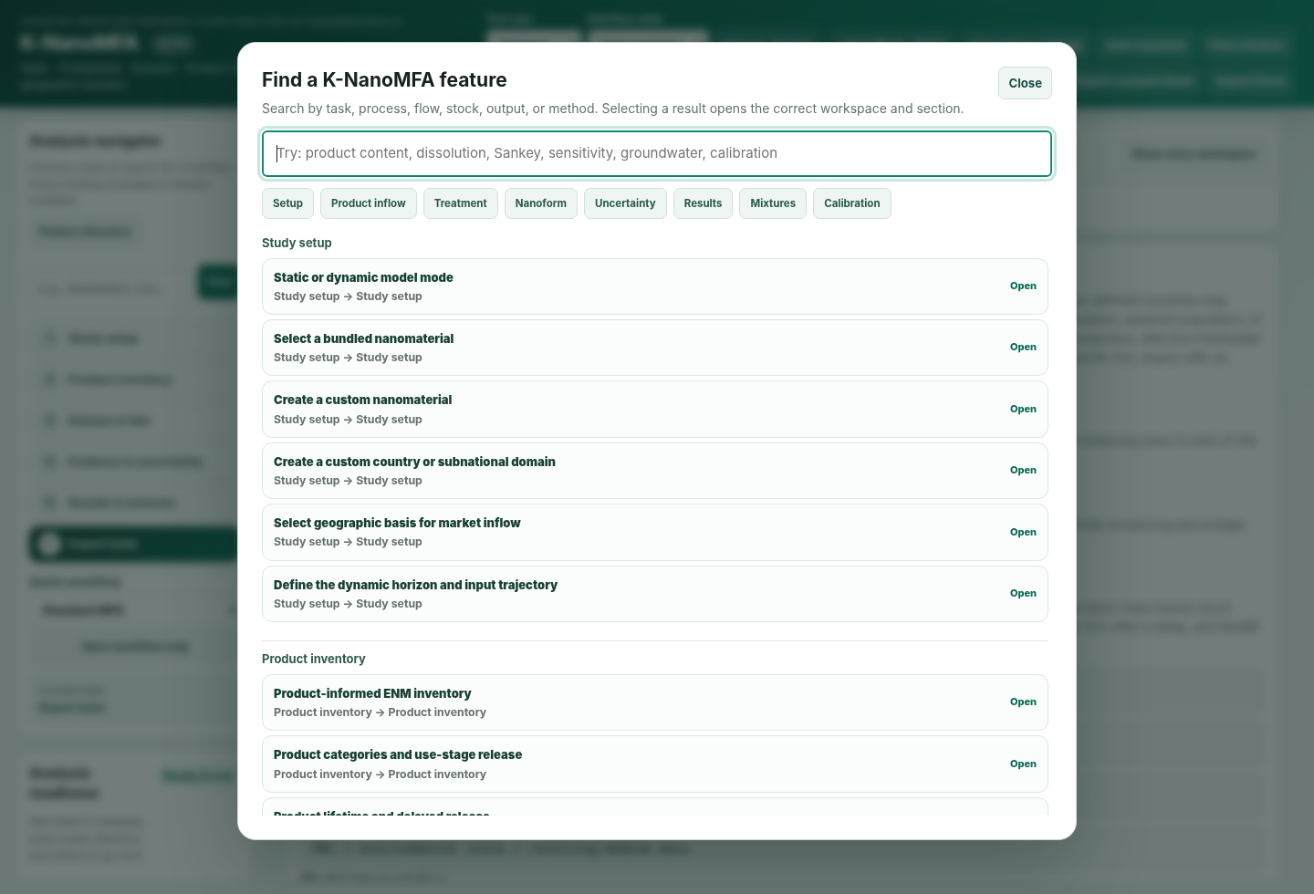
Figure 2. Find a feature overlay. Search for a function and jump directly to the relevant workspace.
Select a task in Analysis navigator. The same functions remain accessible in All workspaces. Navigation changes which tabs are shown; it does not change the numerical model.
Search Feature directory by function name or pathway. Selecting a result opens the relevant workspace and input location. Its button sits below the navigator heading and description. Wide tables scroll within their own containers.
Task group | Main inputs and outputs
Study setup | Material, domain, horizon, mode
Product inventory | Product quantity, content, lifetime, EoL
Release & fate | Treatment, capacities, forms, kinetics
Evidence & uncertainty | Sources, observations, sensitivity, uncertainty
Results & mixtures | Flows, stocks, PECs, mixtures
Expert tools | Trade, stock-driven inference, fitting, validation

4 Workflows and readiness
Interface example
Figure 3. Guided workflow organized around research tasks, from Study setup through Expert tools.
Start assistant supplies starting examples. Save any current scenario using Export scenario Excel before replacing it. After choosing an example, review inflow, product fractions and environmental capacities, then run Calculate.
Review inputs links issues to their input locations. Ready means no blocking structural input error was detected. It does not certify empirical validity. Activate optional modules only when the research question and evidence support them.
Autosave history restores scenarios from the current browser and device. Check the timestamp, material, domain and mode before restoring. Recalculate with the restored inputs. Browser storage is not a durable project archive.
Status | Meaning
Ready | No blocking structural input error
Attention | Input or documentation review needed
Calculated | A current result is available
Run required | Run the calculation after input review
Optional | Optional for the selected analysis

5 Study setup
Interface example
Figure 4. Model-structure selection. Choose static deterministic, static probabilistic, or dynamic probabilistic MFA according to the study design.
1. In Project settings, choose the material, country/domain, reference year and Model mode.
2. Check the inflow unit and time boundary. A trial input of 1,000 kg is a scenario assumption unless supported by market data.
3. Review product allocation, use-stage releases, treatment processes and end-of-life fractions. Resolve percentage-sum errors before calculation.
4. Review water discharge, receiving area, mixing depth and density. Administrative area is not automatically the actual receiving area.
5. Run Calculate. Read the mass balance, warnings and units before interpreting concentrations.
6. If required, enable Nanoform and 28-state fate, then calculate again.
A successful example run does not establish that its inputs are suitable for your study. Distinguish measured inputs from retained assumptions.
Static MFA allocates flows for the selected period. Dynamic MFA tracks annual inflow, product lifetimes and stocks. Probabilistic calculations repeatedly sample the specified input distributions.
Base MFA PECs, reduced four-compartment fate PECs and 28-state fate PECs are outputs of different models. Identify the model when reporting a concentration.
The system balance is initial stock + cumulative inflow = final stock + cumulative external outflow. Do not add internal transfers again as external losses. A 100% balance demonstrates accounting closure, not agreement with measured environmental concentrations.
Steady-state fate checks stock changes and flow residuals for every state. Sustained input into a state with no external removal path prevents steady state. Increasing the iteration horizon alone cannot resolve that condition.

6 Product inventory and life cycle
Interface example
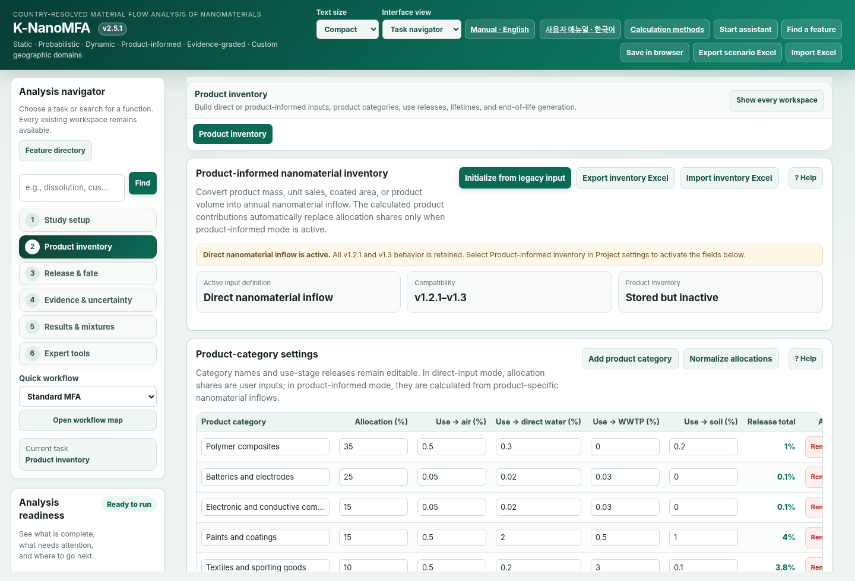
Figure 5. Product inventory workspace for product mass, nanomaterial content, allocation, lifetime, and use-stage release inputs.
Product-informed inflow converts product-market quantities into nanomaterial inflow. For each row, verify the input basis, quantity, conversion factor, nanomaterial content and nano-enabled share. The same number has different physical meanings under different input bases.
Area loading uses g/m² and therefore includes division by 1,000 to obtain kg. Volume concentration uses kg/m³. These two bases already describe nanomaterial loading or concentration; the content fraction is not multiplied a second time.
For example, 10,000 kg/year of product, 1 wt% nanomaterial content and a 50% nano-enabled share give 50 kg/year of nanomaterial. This hypothetical example checks units; it is not a measured market quantity.
In dynamic mode, review annual changes in product quantity, content and nano-enabled share. Lifetimes determine when products reach end-of-life. Inspect use-stage releases and end-of-life flows separately, then check the resulting stock changes.
Input basis | Conversion and input units
Direct nanomaterial | Q [kg/year]
Product mass | Q [kg/year] × content/100 × nano-enabled/100
Unit sales | Q [items/year] × mass [kg/item] × content/100 × nano-enabled/100
Area loading | Q [m²/year] × loading [g/m²] ÷ 1000 × nano-enabled/100
Volume concentration | Q [m³/year] × concentration [kg/m³] × nano-enabled/100

$$10 000 kg/year × 0.01 × 0.50 = 50 kg/year$$

7 Treatment and environmental capacities
Interface example
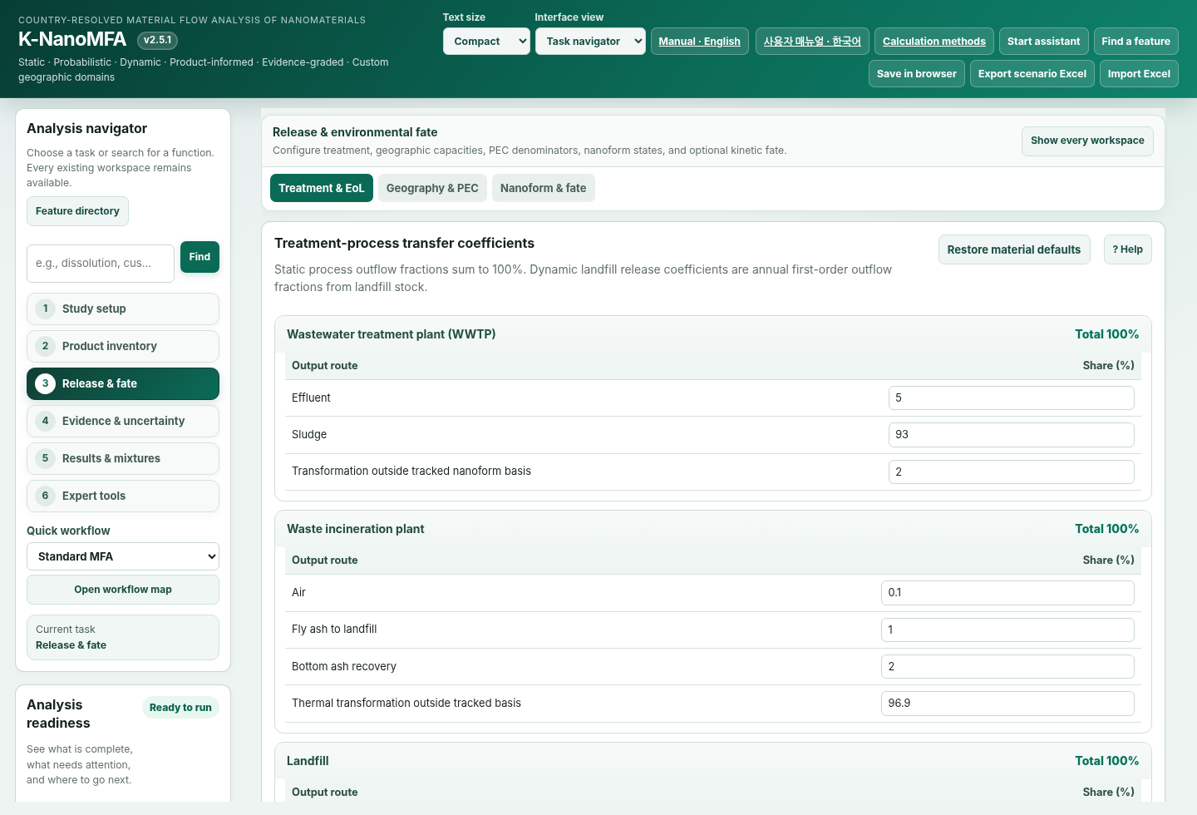
Figure 6. Treatment & EoL workspace for waste, wastewater, and sludge transfer settings.
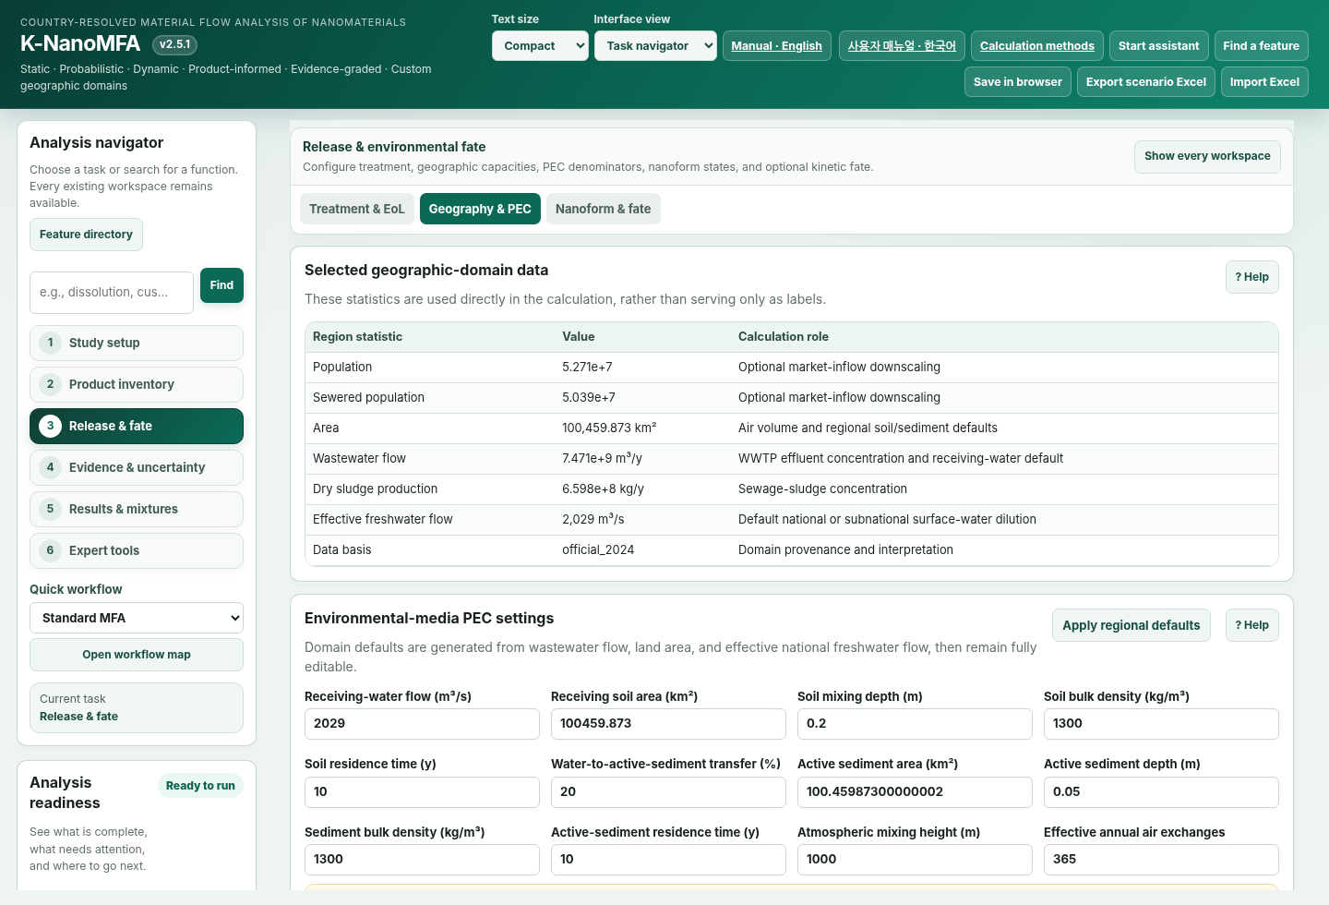
Figure 7. Geography & PEC workspace for regional data and environmental capacities used in PEC calculations.
Enter transfer coefficients for WWTP, incineration, landfill, recycling and reuse in Treatment & EoL. Each coefficient allocates a fraction of process inflow to an outflow or stock addition. Check percentage closure and units for each process.
Distinguish sludge routing to soil, incineration or landfill from WWTP effluent. Material leaving the tracking boundary is not necessarily elemental destruction. Element-based validation also requires the destinations of dissolved and transformed species.
Geographic allocation and environmental dilution are separate. Allocating regional inflow by population share does not establish the region’s actual river discharge. Record a source and reference year for each input.
Medium | Capacity | Evidence check
Water | Q × residence time | Actual discharge and residence time
Soil | Area × depth × dry density | Receiving area and mixing depth
Sediment | Area × depth × dry density | Active-layer depth and dry density
Air | Area × mixing height | Domain and mixing height

$$PEC = tracked stock / receiving capacity$$

8 Nanoforms and environmental fate
Interface example
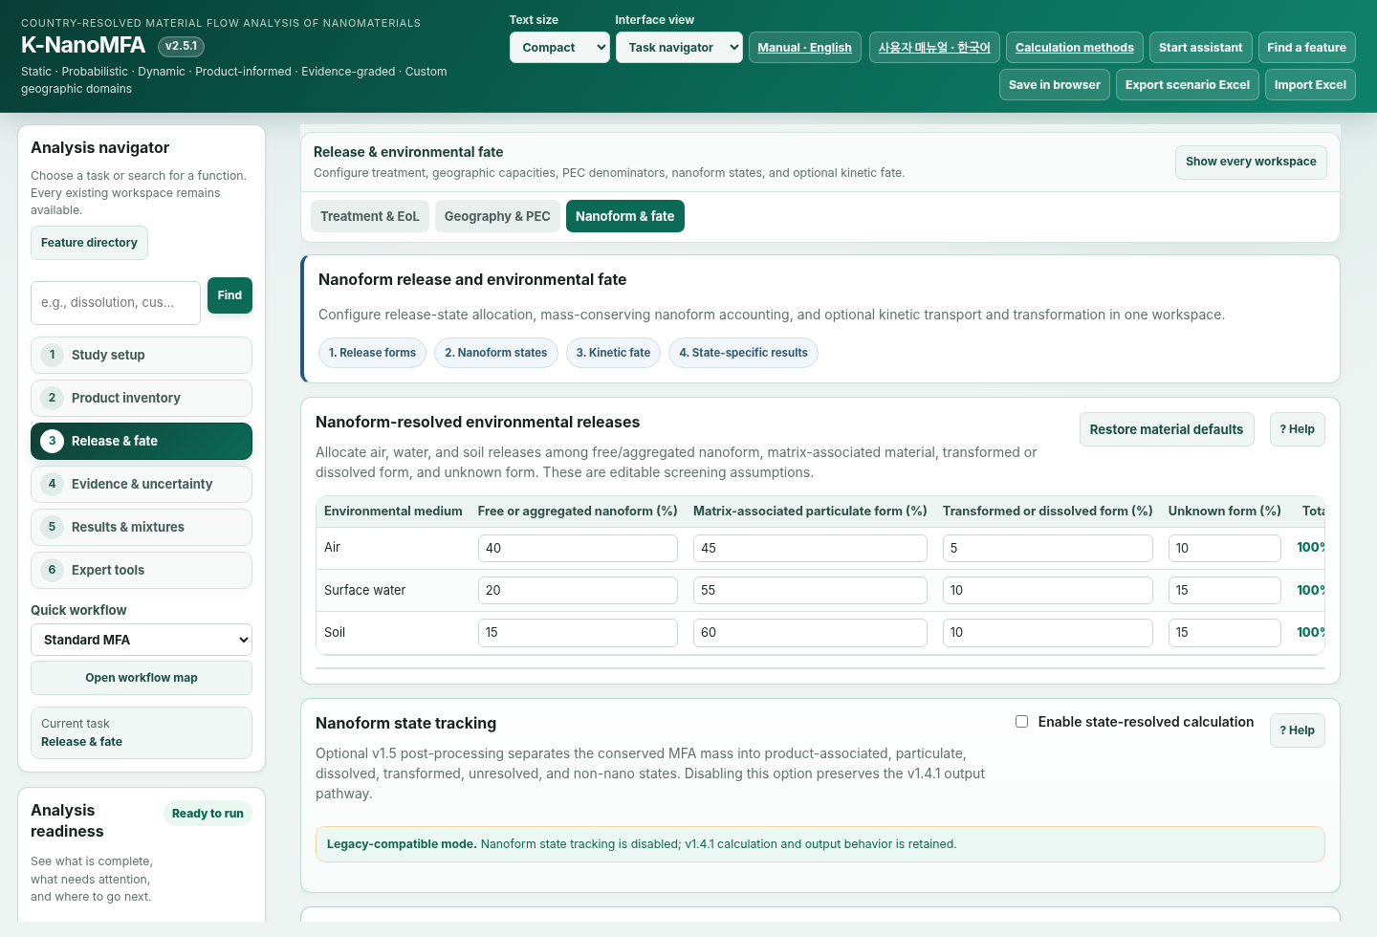
Figure 8. Nanoform & fate workspace for release forms, medium-specific allocation, dissolution, aggregation, transformation, and dynamic transport.

Tracked forms and material basis
The 28 states combine air, water, soil and sediment with seven forms: matrix-bound, free particle, small aggregate, large aggregate, dissolved, transformed particle and unresolved. These are operational model categories. They do not automatically match analytical size fractions.
Parent-material equivalent expresses mass on the original material basis. Element equivalent expresses its constituent-element mass. For pure ZnO, the Zn fraction is 65.38/81.379. Neither basis automatically represents the complete mass of a newly formed sulfide or coated particle.
Enter initial stocks on the selected basis. Changing the basis or elemental fraction automatically converts existing initial stocks. Do not convert them manually a second time. Imported inflow rows retain their declared tracking_basis and are converted during calculation.
Mixtures, coated particles and uncertain compositions require a documented element and mass fraction. Transformation outside the tracking boundary does not mean elemental mass disappears.

Transfers reactions and events
Water volume is discharge Q multiplied by residence time. Default advection uses Q/V. Soil and sediment capacities are receiving area × mixing depth × dry bulk density. Smaller capacity produces a higher PEC for the same stock.
Use Physical rates when diameter, density, viscosity, depth and aggregation inputs are available. Settling uses the Stokes relation for spheres. Applicability to nonspherical particles or real aggregates requires evidence. Dissolution is not automatically predicted from pH, ligands or saturation.
Storms are discrete year-end transfers in dynamic mode. Every transfer uses pre-event stocks. Material newly entering sediment is not resuspended again by that same event. An empty event-year list applies the pulse in every simulated dynamic year.
Overlapping soil-transfer fractions must sum to at most 100%. Storms are unavailable in steady mode. A year-end pulse does not retrospectively change the preceding annual-mean concentration.
$$dx/dt = Kx + u$$
K is the rate matrix of state transfers and external removal. u is the inflow rate. Matrix-exponential calculation solves the linear system under constant rates and forcing over each step.

External forcing and time statistics
External coupling CSV uses year, compartment, form, mass_kg_y and tracking_basis. Match material and domain_id to the active scenario. Start from the application's exported CSV format.
Missing years are rejected by default. Missing data do not imply zero inflow. Select zero-fill only when zero inflow is justified. A single annual row defaults to a one-year dynamic calculation.
Year end uses the closing stock. Annual mean integrates stock through the year. Do not use these statistics interchangeably when comparing observations. A steady-state request requires constant annual forcing and a converged solution.

9 Evidence observations and uncertainty
Interface example
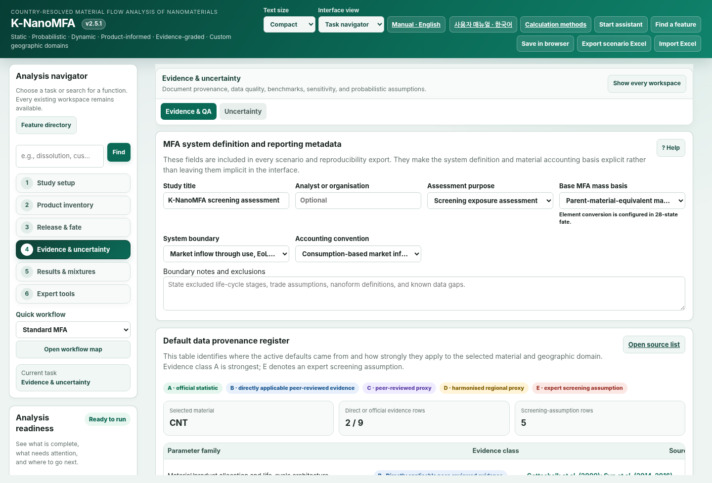
Figure 9. Evidence & QA workspace for parameter provenance, data quality, applicability, and observation comparison.
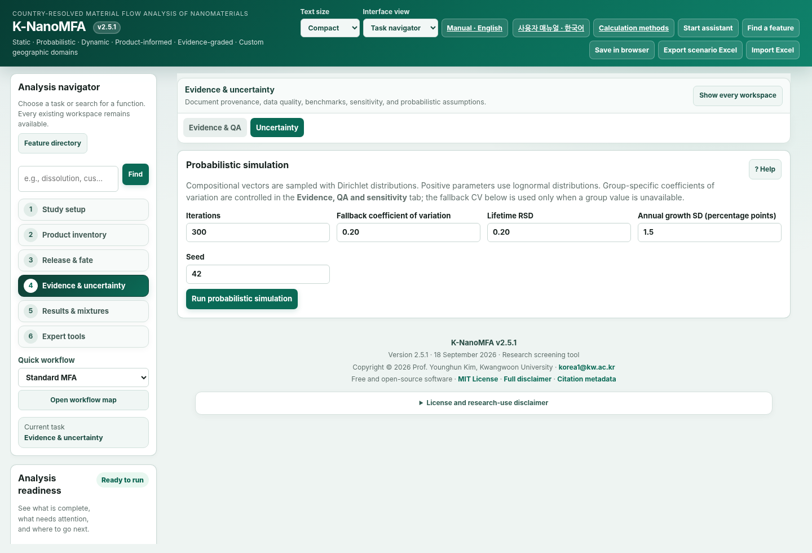
Figure 10. Uncertainty workspace for iterations, random seed, variability settings, and repeated simulation.

Parameter evidence
Open Parameter evidence editor under Evidence and numerical qualification. Select a parameter, enter its evidence type, source, material, domain ID, unit, applicable years/range and conditions, then select Save parameter evidence.
Measured denotes a measured input. Published proxy denotes a literature-derived proxy. Calibrated denotes a fitted input. Retain Screening assumption when evidence is absent. Record the relevant table, equation and conditions in addition to a DOI or report title.
Internal soil-area units are ha; rate units are 1/year. The audit flags unit and applicability mismatches. Registering a source does not certify that source or its suitability for your site.
Rate CV override changes the coefficient of variation used for that kinetic parameter. Min/max document applicability; they do not truncate Monte Carlo samples.

Observations and validation qualification
Use Template CSV or enter rows in Observed concentration comparison. Match material, domain, model_source, medium, form, tracking_basis, statistic, year, observed value, unit, role and source. Soil, sediment and sludge require dry-weight concentration units.
Independent-validation qualification also requires dataset_id, analytical_method, sampling_period, background_treatment, measurand_scope and independence. Register IDs used for fitting under Calibration dataset IDs. Matching IDs cannot count as independent validation.
Use full_year for annual means, year_end for closing-year values and steady_representative for steady observations. Select engineered_material and independent only when supported by evidence. Total metal containing natural background does not automatically match engineered-material PEC.
After Compare, inspect matched rows and exclusion reasons. Interpret RMSE and bias within comparable endpoints. Censored measurements are excluded rather than replaced with half a detection limit. Incomplete metadata may permit diagnostic comparison while disqualifying the independent-validation count.

Sensitivity and repeated simulation
Run fate sensitivity varies individual rates and capacities by ±20% and reports PEC changes. Upstream MFA emissions remain fixed. Zero-valued inputs are excluded from multiplicative perturbations. This is local sensitivity, not global sensitivity or an interaction analysis.
Kinetic-only varies rates. Linked also varies supported inflow, process, environmental and form-allocation inputs. External coupling preserves imported form proportions while varying mass scale. Stock-driven linked fate uncertainty is not supported.
Repeatability workloads are Quick 50/100/200, Research 500/1000/2000 and Extended 1000/2000/5000 draws. Enter two to five distinct seeds. The default 10% threshold is a numerical criterion selected by the user, not a permitted field-prediction error.
P5–P95 is a conditional 90% simulation interval. It is not an empirically validated prediction interval. If repeatability fails, review sample size, input distributions and convergence. Passing the bundled v2.5.0 test scenario does not certify your current scenario.

Literature benchmarking
Literature benchmarking separates applicability from concordance. Applicability assesses similarity of material, endpoint, boundary, geography, time and evidence. Concordance describes numerical distance from the comparator. Neither is a probability of validation.
The current library contains 27 comparator records from 11 studies and covers nine of the ten material classes. Multiple endpoints from one paper do not count as multiple independent studies. Nanoclay has no sufficiently compatible quantitative comparator in the bundled library.
The default Ag WWTP effluent fraction is 2% of tracked mass. The published abstract’s total-Ag effluent fraction of 5–18% is not automatically the same measurand. The default model assigns 8% to transformation outside its tracking boundary, whose destination must be resolved. This comparison does not validate regional environmental PECs.
Component | Maximum
Material / nanoform | 30
Endpoint / compartment | 25
Boundary / metric | 15
Geography | 15
Time | 10
Evidence | 5

The score is an applicability indicator, not percent accuracy. Inspect comparator records in benchmark_validation.js and source information in SOURCES.md.

10 Results interpretation and export
Interface example
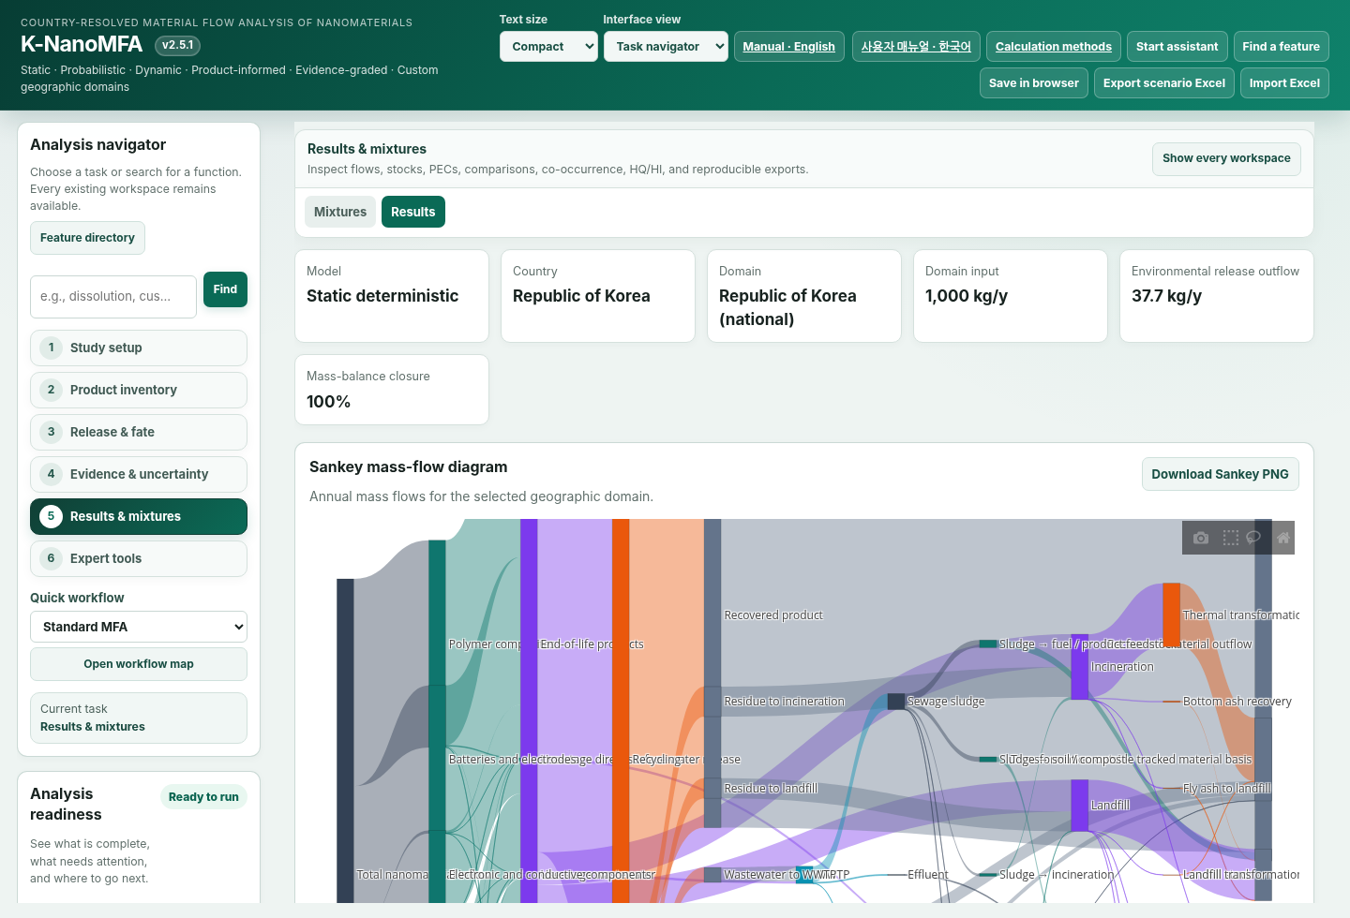
Figure 11. Results overview after a model run, showing run status and access to detailed outputs.
Figure 12. Sankey mass-flow diagram for major annual flows and stock additions.
Figure 13. Detailed results for annual flows, stocks, PECs, and the complete flow table.
Distinguish flows, stocks and PECs in Results. A Sankey link width represents the corresponding flow quantity. Do not interpret annual flows and cumulative quantities as interchangeable. A stock is the retained mass at a defined time.
Before comparing scenarios, check inflow, horizon, tracking basis and environmental capacities. A one-factor comparison differs from a comparison that changes several inputs at once. Save the inputs together with the results.
P5, P50 and P95 are quantiles of the same simulated distribution. P50 is not necessarily the mean. A narrow plotted range does not demonstrate small structural error or small field-measurement error.
Export | Contents
Export scenario Excel | Inputs and enabled modules
Results reproducibility Excel | Inputs, outputs, observations, evidence and current diagnostics
Export diagnostics Excel | Sensitivity and repeatability diagnostics
Coupling CSV | Annual state inflows with declared basis

11 Mixtures and co exposure
Interface example

Figure 14. Mixtures workspace for parallel material-specific MFA, co-occurrence, and HQ/HI screening.
In Mixtures, define each component material and inflow. Inspect component results before applying formulation and co-occurrence assumptions. Retain the tracking basis and units of every component.
HQ divides an exposure concentration by a comparable effect threshold. HI sums HQ values under the selected assumptions. Do not directly combine thresholds from incompatible receptors, durations, forms or endpoints.
Co-occurrence does not establish toxicological interaction. Record separate evidence for synergy or antagonism. Report the dependence assumptions used for joint uncertainty. A mixture indicator does not validate the environmental fate of its components.
$$HQ = exposure concentration / comparable effect threshold$$
$$HI = sum of compatible HQ values$$

12 Expert tools
Interface example
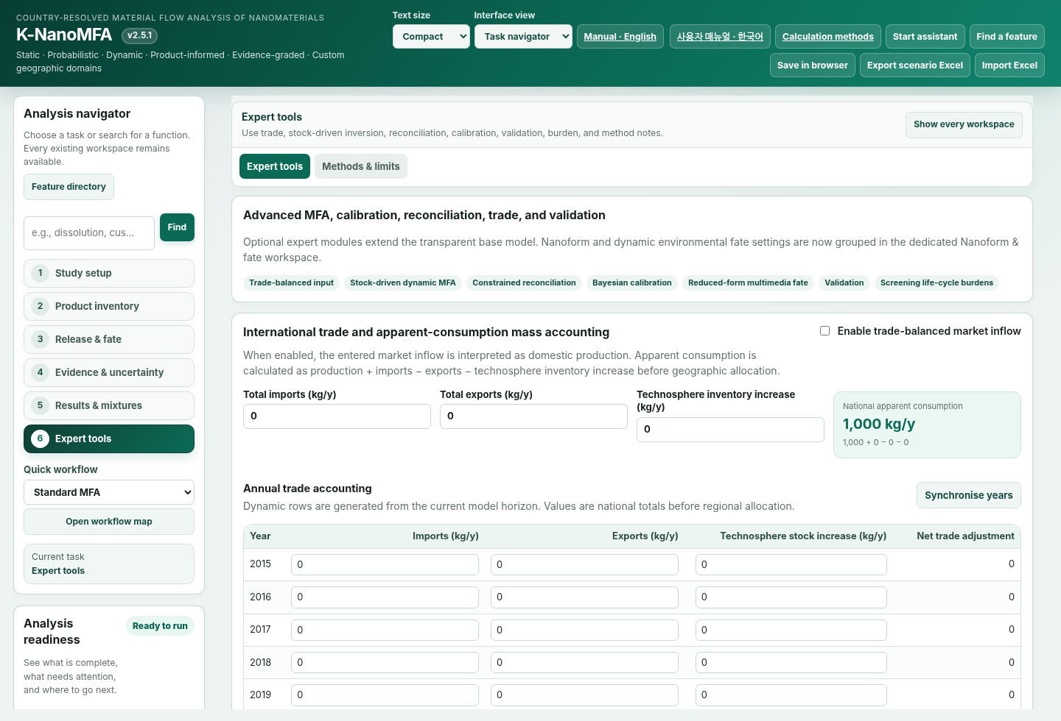
Figure 15. Expert tools for trade, stock-driven dynamic MFA, reconciliation, calibration, and validation.
Optional Expert tools answer different questions. Define the required inputs and output meaning, then activate tools individually. Outputs of different estimation problems do not automatically carry equivalent empirical support.
For calibration, record the fitted parameter and the data used. Register calibration dataset IDs and evaluate against separate data. Fitting a scalar multiplier does not establish identifiability of individual kinetic rates.
Stock-driven dynamic MFA infers the inflow required by a target stock trajectory and lifetime assumptions. Reproducing an entered stock trajectory does not validate subsequent environmental PECs. The 28-state linked uncertainty module does not support this driver mode.
Tool | Question and boundary
Trade | Apparent consumption and allocation; not a complete MRIO.
Stock-driven MFA | Inflow inferred from target stocks; depends on lifetimes.
Reconciliation | Adjust observations under constraints; review weights.
Calibration | Fit parameters; separate validation is needed.
Reduced-form fate | Four-compartment comparison; differs from 28-state fate.
Burden indicator | Screening energy/climate co-indicator; not a complete LCA.

13 Scenario files and compatibility
Import Excel restores saved scenario inputs. Export the current scenario first if it must be retained. After import, review material, domain, horizon, tracking basis and enabled modules.
Unsupported older mass-basis labels may migrate to parent-material-equivalent tracking. Review the meaning of initial values and recalculate. Numerical identity across versions is not guaranteed. Initial stocks already stored on a current scenario basis are not converted twice during import.
Distinguish browser-held results from exported files. For a publication analysis, retain the program ZIP, scenario workbook, results workbook and observations used for interpretation together.

14 Quality assurance and reproducibility
Separate input checks, conservation checks, numerical solution checks and field comparisons. Review input fractions and capacities, inspect mass balance, then assess convergence and sensitivity before comparison with independent observations.
The independent SciPy comparison in v2.5.0 found a maximum 28-state stock difference of 7.73×10⁻¹² kg. This supports numerical solution of the specified linear equations. It does not establish that those equations adequately represent environmental chemistry.
The v2.5.0 synthetic Ag test compared 500, 1,000, 2,000 and 5,000 draws across three seeds. Across 25,500 draws, the maximum quantile change was 7.47%. This passed the selected 10% criterion for that test, not for every scenario.
The v2.5.1 calculation regressions passed ten checks, and the JSDOM input/output tests passed 18 checks. JSDOM does not verify actual Chrome typography, Plotly rendering or touch behavior. Actual browser verification status is recorded separately in the distributed UI_VERIFICATION report.
Archive the software version and ZIP, input and result workbooks, seed, draw count, distributions and CVs, observations, calibration dataset IDs and reported output definitions.

15 Troubleshooting
The mobile layout reflows the same functions vertically. The examples below were verified with Chromium mobile emulation at 390 × 844 px.
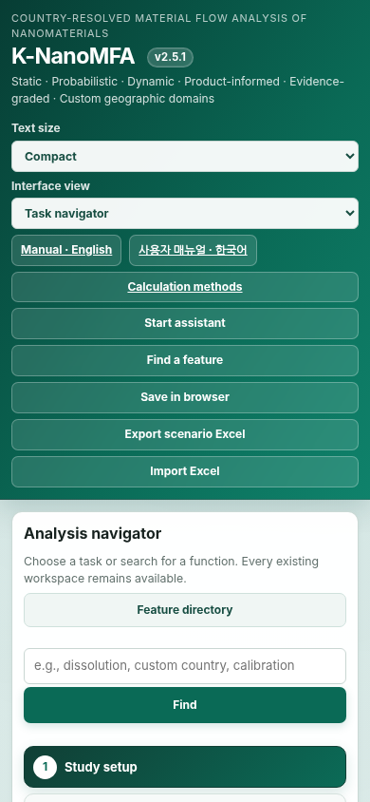  Main screen | 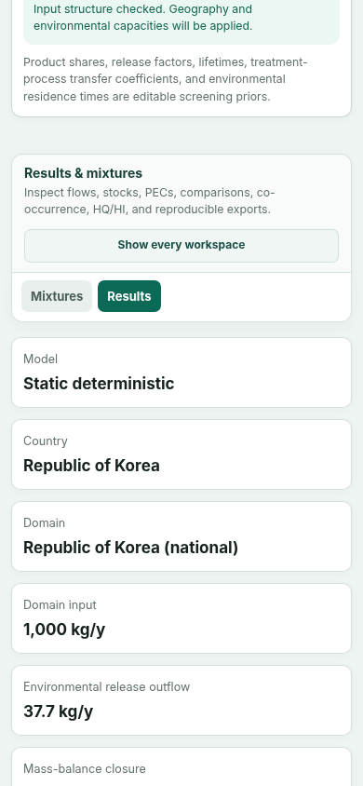  Results screen
Figure 17. Mobile layout examples. Left: main screen; right: results screen.
Export scenario Excel saves inputs. The results reproducibility package includes outputs, evidence, observation comparison and current diagnostics. Export diagnostics Excel saves sensitivity and repeatability separately. Recalculate after changing inputs.
Save in browser and autosave depend on the current browser's storage. Clearing browser data or changing computers may remove access. Use exported Excel files for durable records.
Problem | What to check
Empty chart | Extract the complete ZIP and run Calculate. Open the results tab and resize the window.
No steady convergence | Inspect continuous inputs, removal paths and retained states. Use dynamic results when removal is physically absent.
Observation excluded | Read the exclusion reason. Check medium, form, basis, year, statistic and dry-weight units.
Clipped text | Check browser zoom at 100% and Text size. Use horizontal scrolling inside wide tables.

Verification scope:Actual browser charts and mobile rendering could not be verified in the build environment because local-file access was blocked. Source/event checks are distinct from rendered-screen verification. See the methods and published-data applicability check for scientific boundaries.

16 Scientific interpretation boundaries
Interface example
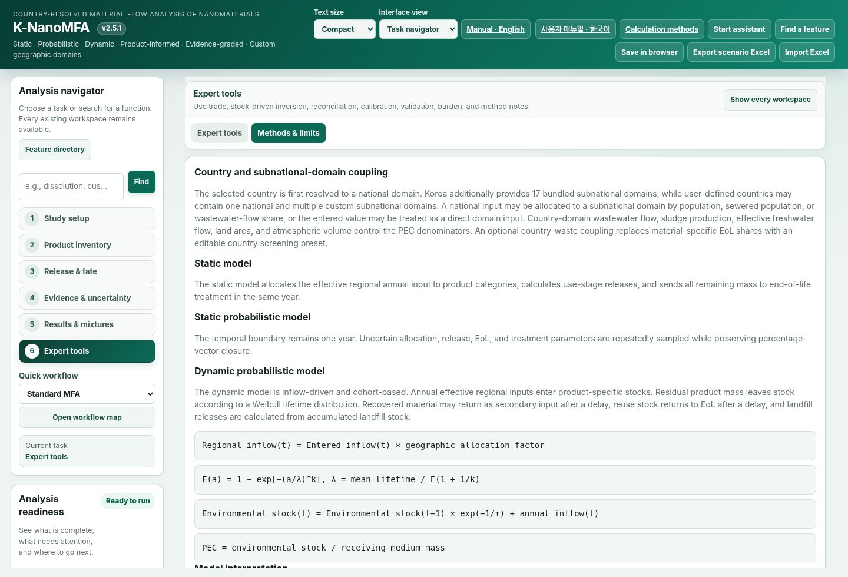
Figure 16. Methods & limits workspace describing model boundaries, equations, interpretation, and limitations.
A PEC is a prediction derived from defined material quantities and environmental capacities. Numerical precision does not remove uncertainty in inputs or model structure. Choose reported significant figures with the precision of the source data in mind.
The model uses spatial averages, operational forms and first-order rates. It does not resolve within-river concentration gradients, complete size distributions, pH-dependent speciation equilibrium or food-web transfer. Additional modeling is needed when these processes determine the research conclusion.
Do not call agreement with calibration data independent validation. Agreement in concentration scale with another model is also distinct from validation against measurements. Report model-to-model agreement, parameter fitting and field validation separately.

A Feature directory
Workspace | Functions
Study setup | Material, domain, mode, dynamic horizon
Product inventory | Product amount, content, use release, lifetime, EoL
Treatment & EoL | WWTP, incineration, landfill, recycling, reuse, sludge
Geography & PEC | Domain statistics and environmental capacities
Nanoform & fate | Forms, basis, initial stocks, rates, storms, external input
Evidence & QA | Sources, observations, benchmarks, parameter audit
Uncertainty | Base Monte Carlo and distributions
Results | Sankey, flows, stocks, PECs, scenario comparison
Mixtures | Components, co-occurrence, HQ, HI, joint uncertainty
Expert tools | Trade, stock-driven MFA, reconciliation, fitting, reduced fate
Methods & limits | Equations, boundaries and license

B Units and tracking basis
Quantity | Unit
Annual flow | kg/year
Stock | kg
Water and effluent PEC | µg/L
Soil sediment sludge PEC | µg/kg dry
Air PEC | ng/m³
First-order rate | 1/year
Water residence time | days
River discharge | m³/s
Soil receiving area | ha [1 ha = 10 000 m²]
Sediment area | km²
Mixing depth | m
Dry bulk density | kg/m³
Particle diameter | nm
Dynamic viscosity | Pa s
Collision kernel | m³/s
Background number | 1/m³
Content and nano-enabled share | %
CV | dimensionless

Dissolved form is not a separate mass unit. Tracking basis and form are different attributes. Element-equivalent selection converts the mass basis; it does not automatically change the physical form.

C Distribution files
File | Purpose
index.html / styles.css | Interface and styles
data.js / engine.js | Base data and MFA calculations
nanoform.js / dynamic_fate.js | Form allocation and dynamic fate
reliability_core.js / reliability_ui.js | Numerical diagnostics and observation comparison
research_core.js / research_ui.js | Evidence, sensitivity and repeatability
excel_io.js | Excel import and export
USER_MANUAL_EN.html / USER_MANUAL_KO.html | Quick web guides
K-NanoMFA_User_Manual_v2.5.1_EN.docx and .pdf | Detailed English manual
K-NanoMFA_User_Manual_v2.5.1_KO.docx and .pdf | Detailed Korean manual
SCIENTIFIC_METHODS_v2.5.0.md | Equations and assumptions
UI_VERIFICATION_v2.5.1.md | UI verification scope
FILE_CHECKSUMS.sha256 | File integrity manifest

D MFA terms and output fields
Term | Meaning
Process | A modeled activity such as use or treatment
Flow | Material exchanged between processes or across a boundary
Inflow / outflow | Flow entering or leaving a defined boundary
Stock | Retained mass at a specified time
Stock change | Change in retained mass over an interval
Transfer coefficient | Fraction allocating process inflow
Fate compartment | Environmental state space, not automatically an MFA process
Kinetic pathway | State transformation or intercompartment transfer

Legacy field | Interpretation
terminal | Final annual flows and stock additions
primary_input_kg_y | Primary market inflow
transformation_loss_kg_y | Transformation outflow beyond the tracking basis
cumulative_external_sinks_kg | Cumulative external outflow

E Observation data columns
Column | Meaning and check
id | Row identifier
material | Matches active material
domain_id | Matches active domain ID
model_source | base or fate28
medium / form | Medium and measured form
tracking_basis | Parent or element equivalent
statistic / year | Time statistic and year
observed / unit | Measured concentration and unit
role | calibration or validation
source_note | Source and method note
qualifier | Equality or censoring symbol
dataset_id | Dataset identifier
analytical_method | Analytical method and fraction
sampling_period | full_year / year_end / steady_representative
background_treatment | Background removal or documented negligible background
measurand_scope | Measurand such as engineered_material
independence | Independence declaration

Use the choices supplied in the form. Do not declare independent validation when the source or independence is unknown.

