1. Introduction
This project involved developing and analyzing different machine learning models to predict the cooking time of recipes on the site Food.com as quick, medium or slow.
Out of the three models Gaussian Naive Bayes (GNB), Logistic Regression (LR) and K Nearest Neighbours (KNN) assessed, it was discovered that LR performed the best and that model bias in regards to classifying recipes labeled as slow remained a considerable issue for all models despite attempts to minimize it. Hence, another model such as neural networks such as the Neural Attentive Bag-of-Entities model could be better suited to this task, which generally perform very well including on text data. This specific model uses neural networks to detect entities for a document such as “Washington” can be George Washington or Washington, D.C (Yamada & Shindo, 2019). Each document is then represented as a weighted bag-of-entities.

2. Supervised Learning
The task of classifying the recipes is a supervised classification problem where the class named duration_label is ordinal with values 1, 2 and 3 corresponding to quick, medium and slow. Moreover, the features n_steps and n_ingredients are numeric, while the other three features name, ingredients and steps are lines of text, which were converted into numeric vectors of length 50 using Doc2Vec with similar lines of texts having vectors close to each other (Shperber, 2017 & Ma, 2018). This conversion puts these features into a useful format and having all attributes as numeric requires the use of classifiers that handle continuous attributes such as LR, GNB and KNN. Overall, 152 features were used for training and testing the models with a 0.53/0.27/0.2 train/validation/test split used to reduce overfitting. Scikit-Learn was primarily used to run and analyze these models using Python.
Furthermore, 0R and 1R were used to derive baseline and lower benchmark scores of 0.506 and 0.621 respectively using 5-fold cross-validation to reduce evaluation variance.

2.1 Initial Findings and Hyperparameters
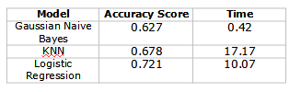
The hyperparameters that are number of nearest neighbours, distance metric and weighting metric for KNN are set to 5, Minkowski and inverse distance respectively. GNB and LR have fewer hyperparameters with GNB using no smoothing and LR using no regularizer. Figure 1 shows the accuracy scores and times of the three models under these initial settings with LR performing well and GNB scoring poorly near the lower benchmark. These results also adhere to the notion of a trade-off between speed and performance as mentioned in the lectures (Ling, 2021) with each model having differing time complexities.
Figure 1 – Accuracy scores and times for models.

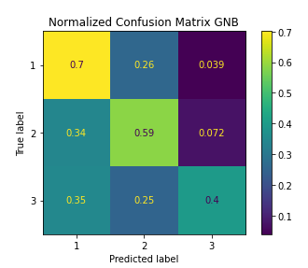

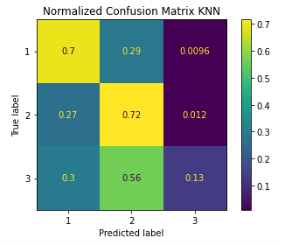

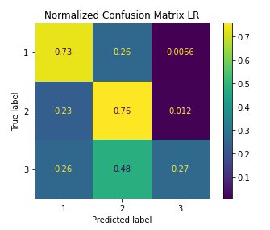

Figure 2 – Confusion matrices for classifiers.
Furthermore, Figure 2 shows the confusion matrices of these models, which reveals good overall ability to classify fast and medium recipes, but not slow ones. One had 9,502, 10,837 and 1,101 training instances of classes 1 to 3 respectively suggesting an imbalanced class distribution, which could be causing this model bias towards the majority classes. This was the most prevalent issue and the next section discusses this in regards to KNN.

3. KNN
KNN handled class 3 the most poorly with a recall of just 13%, which can be a consequence of most instances being classes 1 and 2 causing class 3 instances to play a smaller role as more k nearest neighbours are used. A higher k value reduces class 3 recall towards zero, while increasing accuracy to 0.707 as a high k value creates the situation were most neighbours are not class 3 and thus leads to them being classified as class 1 and 2 more often. This leads to really poor predictions for class 3, while improved ones for classes 1 or 2 and also highlights how the skewed class distribution lowered the impact of this increased model bias on the accuracy scores. Additionally, inverse distance voting over majority voting helps to lower this model bias moderately by prioritizing closer neighbours, which are more likely to be the same as the test instance, to reduce the impact of an imbalanced class distribution.
Conversely, reducing the value of k correspondingly improved class 3 recall, which is 0.21 when k equals one, but overall validation accuracy dropped to 0.622 near the benchmark value, which is poor, while training accuracy is around 1.0 as shown in Figure 3. This can be a consequence of the model overfitting to the training data for very low K values with potentially high model variance. However, this large gap with 100% validation accuracy could mostly be due to KNN memorizing the whole training set for prediction purposes. Overall, a trade-off for the value of k must be made with a value of 11 used for the final model where it is not divisible by 2 or 3 to avoid ties and inverse distance weighting is used as well.

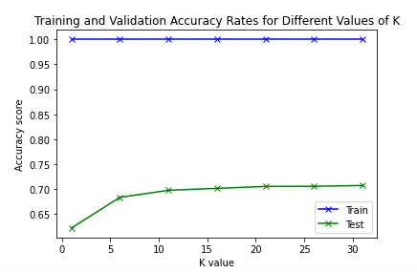
Figure 3 – KNN accuracy over varying K values.

4. Gaussian Naive Bayes and Logistic Regression
GNB had the best class 3 recall of 0.4, which may be due to the priors adjusting to the fewer instances of class 3 while the other models possess no such adjustment mechanism. Moreover, the class distribution did not seem to exhibit such a clear large negative impact on LR or GNB as it did for KNN. This can explain why LR had a moderately higher class 3 recall of 0.27 compared to 0.13 for KNN.
Further, GNB had the lowest accuracy score of 0.627 among the three models, which can be due to it making more assumptions than the other models. LR does not make the assumptions that the features are independent conditional on class and normally distributed unlike GNB. It only assumes classes are linearly separable (Deb, 2016). In addition, it is hypothesized by Andrew Pg and Micheal Jordan in their paper that LR as a discriminative model performs asymptotically better than GNB as a generative model (Pg, A 2001). Although, linear separability may also be violated, especially in the case for class 3, which may explain some of the incorrect classifications and low class 3 recall of 0.27 for LR.
In regards to the assumptions made by GNB mentioned before, when constructing several QQ plots for each feature it appears that only the steps feature appears to be normally distributed. Normally distributed random variables are independent when they have zero covariance, which occurs with zero Pearson correlation, which is low for most features with 152 out of 11,628 having an absolute value above 0.4 for each class. However, the model obtained a lower accuracy score and class 3 recall when trained over the steps feature only. Possible explanations include the Doc2Vec vector components are not really independent as they come from the same text, information loss from using fewer features and floating point underflow from multiplying many small numbers together, which could be fixed by taking logarithms.
Moreover, regularisation for LR reduces overfitting by lowering the number of features with sizeable weights and this is suitable when one has few instances relative to features, which is not the case for this data set. This could explain why using a regularizer for LR had marginal impact on the accuracy score for small C values.

4.1 Feature Selection
When one uses feature filtering via mutual information (MI) to select the K best features for each model over different values of K we find that this only improves the performance of GNB, while the other two lower in performance, which is greater at lower values. This reflects the impact of performance loss of using fewer features with PCA feature reduction leading to large drops in performance below the benchmark for each model. In contrast to the other models, GNB may improve in performance due to fewer features leading to less floating point underflow, reduced sparsity of important features that have greater predictive power and features with fewer complex relationships that might adhere to the assumptions more. GNB performs best for values around 10 to 30, so filtering filtering via MI using k equal to 30 is used in the final model.

5. Learning Curves for Final Models
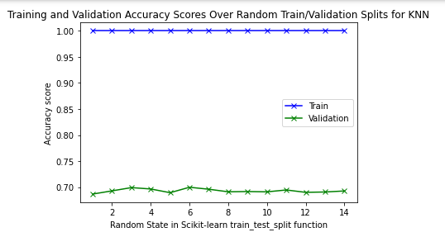
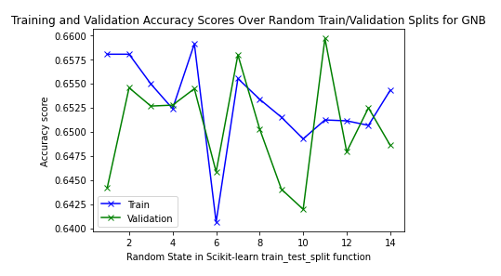
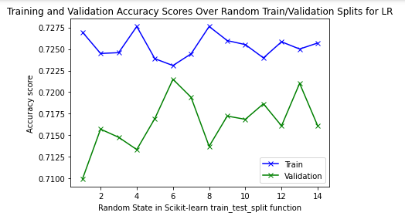
Figure 4 – Learning curves over different train/test splits.
Figure 4 exhibits the learning curves for the three final models over different random holdout splits. All models have low model variance. LR and GNB display low overfitting, while the 100% validation score for KNN can be a reflection of the model memorizing the whole the training data when making predictions.

6. Conclusion
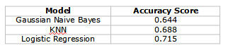
In this report, we have discussed the effectiveness of GNB, KNN and LR in classifying recipe cooking times with a focus on slow cooking times. The final version for each of the three models involved using all features, except for GNB, and KNN used 11 neighbours and inverse distance voting. Figure 5 displays their accuracy scores using unseen test data to reduce overfitting. Since classifying class 3 remained a problem for these models using another one such as neural networks may be better.
Figure 4 – Final results for each model.

7. References

Majumder, B. P., Li, S., Ni, J. & McAuley, J. Generating personalized recipes from historical user preferences. Proceedings of the 2019 Conference on Empirical Methods in Natural Language Processing and the 9th International Joint Conference on Natural Language Processing (EMNLP-IJCNLP), 2019.

Ma, E (2018). Understand how to transfer your paragraph to vector by doc2vec.
https://towardsdatascience.com/understand-how-to-transfer-your-paragraph-to-vector-by-doc2vec-1e225ccf102

Shperber, G (2017). A gentle introduction to Doc2Vec.
https://medium.com/wisio/a-gentle-introduction-to-doc2vec-db3e8c0cce5e

Y. Ng, A & I. Jordan, M (2001). On Discriminative vs. Generative Classifiers: A comparison of logistic regression and naive Bayes.
https://ai.stanford.edu/~ang/papers/nips01-discriminativegenerative.pdf

Deb, S (2016). Naive Bayes vs Logistic Regression.
https://medium.com/@sangha_deb/naive-bayes-vs-logistic-regression-a319b07a5d4c

Shindo, H & Yamada, I (2019). Neural Attentive Bag-of-Entities Model for Text Classification.
https://arxiv.org/pdf/1909.01259.pdf

Huilgol, P (2020). Top 6 Open Source Pretrained Models for Text Classification you should use.
https://www.analyticsvidhya.com/blog/2020/03/6-pretrained-models-text-classification/

Ehinger, K (2021). Machine Learning COMP30027 Lecture 19 (Neural networks II: Deep learning) Semester 1 – 2021 [Lecture notes].
https://canvas.lms.unimelb.edu.au/courses/102017/pages/week-10-neural-networks?module_item_id=2524369

Luo, L (2021). Machine Learning COMP30027 Lecture 15 (Model Evaluation 2) Semester 1 – 2021 [Lecture notes].
https://canvas.lms.unimelb.edu.au/courses/102017/pages/week-8-2-model-evaluation-2?module_item_id=2524366

Ottesen, C (2017). Comparison between Naive Bayes and Logistic Regression.
https://dataespresso.com/en/2017/10/24/comparison-between-naive-bayes-and-logistic-regression/

