V-Exam

Online Examination System

Verscend Technologies

Contents

1. Introduction 2

2. Objectives 2

3. Scope and Limitations 2

4. System Requirement Specification 3

I. Functional System Requirement 3

5. System Design 5

a) Context Diagram 5

b) DFD-0 (Admin perspective) 5

c) DFD-0 (Interviewee perspective) 6

d) Flow chart 6

e) Use case diagram 8

6. Technical Details 9

# Introduction

Verscend Technologies is Nepal’s leading software development company. Yearly it has been hiring more than XXX employees. Interviewees have to go through a series of processes to get hired. One of the most important processes is written examination. Till date Verscend has been conducting paper based written examination. With the implementation of V-Exam, Verscend is planning to digitalize the written examination making it online (hosted in internal server). Interviewees can login into the system and attend the examination from Exam Hall at Verscend.

# Objectives

* 1. The core objectives of V-Exam are as following.
  2. Digitalization of written examination process.
  3. Easy Interview Session and Examination management.
  4. Easy Examset assignment for job vacancy.
  5. Conduct Examination for multiple job vacancies at a time.
  6. Easy to check answers and publish results.

# Scope and Limitations

* 1. V-Exam is designed for Verscend Technologies’ employee hiring process.
  2. Operates in Verscend’s intranet system only.
  3. Two types of questions
     1. Subjective questions
     2. Objective questions (multiple choice)
  4. Admin to create examset with predefined exam duration for given set.
  5. Automatically check objective answers
  6. Manually check subjective answers
  7. Publish results.

# System Requirement Specification

## Functional System Requirement

This section gives functional requirements that are applicable to V-Exam.

1. **V-Exam consists of two types of users**

* **Interviewee**

Interviewee will login to the system and take his/her examination. The email address and contact number provided in CV will be the username and password for him/her. Once the interviewee logs into the system he/she will not be allowed to re-login and re-attend the exam in given interview session.

* **Administrator**

The following features will be available to the admin.

* + - * 1. **Setup**

**Department**

Admin can add, edit and delete departments.

**Job Vacancy Titles**

Admin can add, edit and delete most common job vacancies that Verscend hires. Eg. Software Engineer (Asp.net mvc), Database Administrator, IT support etc.

**Question Complexities**

Interview questions in an Exam set may be of different complexity level. Questions will be marked as per its complexity.

E.g. Simple question will be of 2 marks, medium question of 5 marks and complex question of 10 marks.

**Question Categories**

Exam set may include multiple questions from different categories. Admin can create, edit and delete question categories.

E.g. Asp.net, javascript, database, I.Q etc.

A exam set may have 10 questions from “Asp.net”, 5 questions from javascript, 2 questions from database and 3 questions from I.Q.

* + - * 1. **Question Bank**

Question bank is the collection of all the questions. Admin can add questions of different categories.

* + - * 1. **Exam Sets**

Exam set is a set of question interviewee gets when logged in. Admin can create exam set and add questions from question bank.

* + - * 1. **Job Vacancies**

Admin can add the jobs that Verscend announces vacancies for.

* + - * 1. **Interviewees**

Once admin (HR) gets CV of candidates, he/she adds the candidate as interviewee with basic details for current interview session. Interviewee’s email address and contact number provided in cv will be the username and password for him/her to log into the system and attend the exam.

* + - * 1. **Interview Session**

Interview Sessions are the employee hiring period. In a session there may be vacancies for multiple jobs. Admin creates a session with start date and end date. Interview Session gets expired after the end date of session. Admin adds job vacancies and interviewees for the session.

* + - * 1. **Result**

After Interviewee attends the exam, admin gets the list of interviewees who attended the exam in the current interview session. Admin selects the interview to check the answer sheet. Subjective answers will be checked and marked by admin/examiner manually while the objective questions are checked and marked automatically by the system. Admin gets the interviewees list in descending order of total marks obtained.

1. **Authentication**

To access this system user must log in. Admin can log into the system with the email and password while Interviewees can log into the system with the email and contact number provided in interviewee’s CV. Once interviewee logs into the system he/she will not be allowed to re-login and re-attend the same exam in the same interview session.

1. **Authorization**

V-Exam has two types of users, interviewee and admin. Interviewee will only be allowed to attend the exam and submit the answer while the admin will have full access of the backend where he/she will be allowed to configure the settings, create exam sets, create interview sessions and add interviewees, and publish result.

# System Design

## Context Diagram

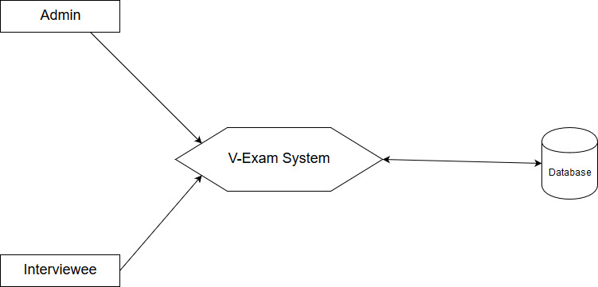

Fig: Context Diagram

## DFD-0 (Admin perspective)

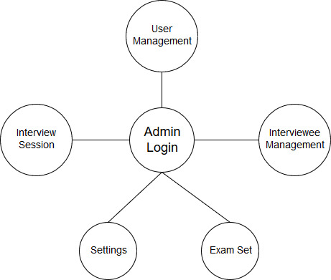

Fig: DFD-0

## DFD-0 (Interviewee perspective)

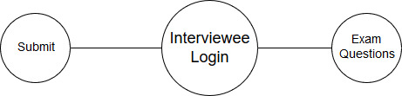

Fig: DFD-0

## Flow chart

* + 1. Interviewee



Fig: Interviewee Flow

* + 1. Admin



Fig: Admin Flow

## Use case diagram

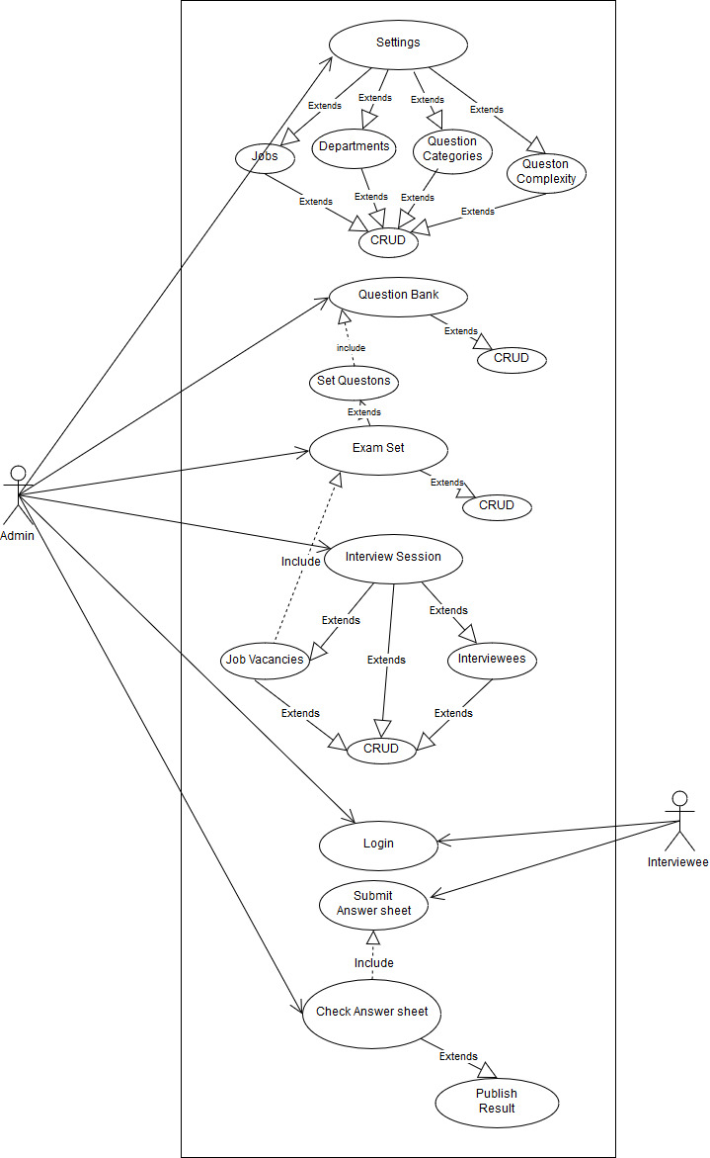

Fig: Use Case Diagram

# Technical Details

**Development Platforms Used**

* MS Sql Server for database
* Dot net core for web api
* React and Redux for frontend

**Authentication**

JWT token based authentication with claim identity is used for user authentication.

**Password Encryption**

Admin’s password is secured with “BCrypt” encryption algorithm.

# Further Enhancements

This release is the first version of V-Exam system. After successful implementation and reviews it’s second version will be developed with following enhancements and improvements.

Separate current admin’s role into two, admin and examiner, with role based

* Add new user role, Examiner, who will be allowed to perform following operations.
  + Add questions in question bank
  + Create Exam set
  + Check and mark answersheet submitted by interviewees
  + Publish results
  + Shortlist top interviewees
* Admin to perform following operations
  + Create interview session
  + Add Job vacancies
  + Add Interviewees
  + Manage admin users and examiner users