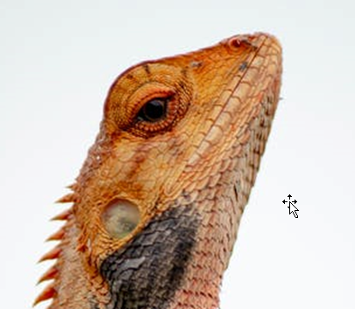

hh  
02545  
bbjkb

# Work experoence

nknb

# Work experience

**kl:** *kll->l*kl

# Mores experiences

# Skills