Switch#show ip interface brief

Switch(config)#interface vlan 1

Switch(config-if)#ip address 192.168.1.100 255.255.255.0

Switch(config-if)#no shut

Switch(config-if)#no shutdown

Switch(config)#line vty 0 15

Switch(config-line)#password sales

Switch(config-line)#login

---------------------------------------------------------

acket Tracer PC Command Line 1.0

C:\>telnet 192.168.1.100

Trying 192.168.1.100 ...Open

User Access Verification

Password:

Switch>

-------------------------------------------------------

Switch(config)#enable password sales2

---------------------------------------------------------

Packet Tracer PC Command Line 1.0

C:\>telnet 192.168.1.100

Trying 192.168.1.100 ...Open

User Access Verification

Password:

Switch>enable

Password:

Switch#

**18/09/2018**

**---------------------------------------------------------------------**

Cammand Prompt

tracert cisco.com

ping cisco.com

nslookup cisco.com

ping -#

tracert cisco.com -d

**Home work**

* Password implementation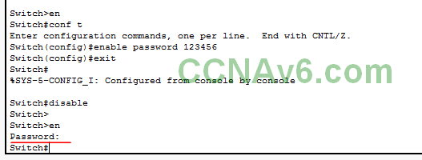
* Service encryption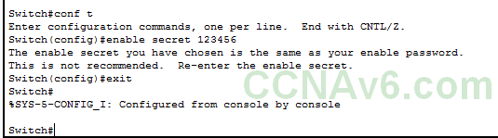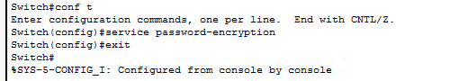
* Motd-description
  + message-of-the-day (MOTD) 
* Login synchronous
  + unsolicited messages that are routed to your console are to be displayed at the terminal.
  + Router(config-line)#logging synchronous