The answers of question 5

1. x = seq(1,100)
2. w = 2 + 0.5 * x
3. sample1 = rnorm(n=100,mean = 0,sd = 5)

mean_sample1 = mean(sample1)

variance_sample1 = var(sample1)

hist(sample1)

Mean_sample1 is -0.50822

Variance_sample1 is 24.6893

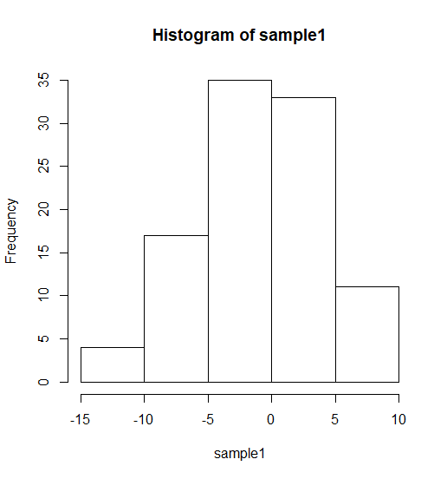

I observed that most of values concentrate near the 0 value.

1. y = w + sample1
2. 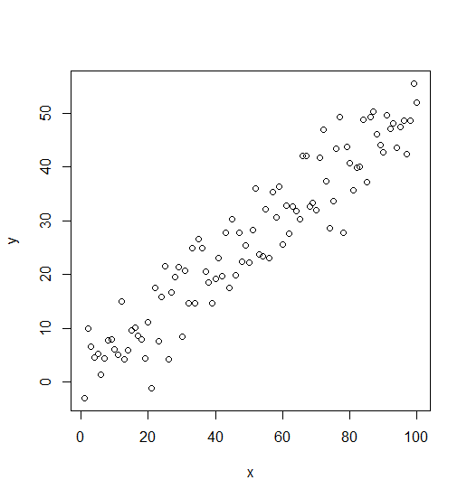
3. beta1 = sum((x - mean(x)) * (y - mean(y))) / sum((x - mean(x))^2)

beta0 = mean(y) - beat1 * mean(x)

plot(x = x , y = y)

abline(lm(y~x), lwd=1, col="red")

Beta1 is 0.4963

Beta0 is 1.6822

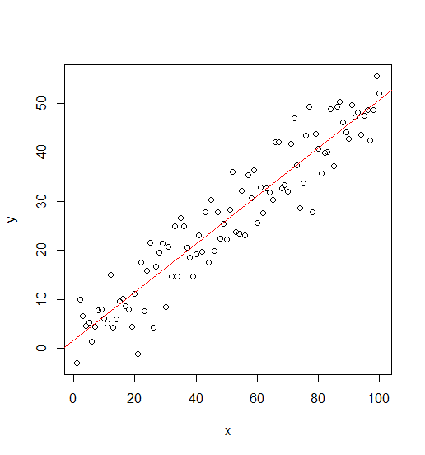

I observed that the line is in the middle of those points.

1. residual_sample1 = residuals(lm(y~x))

plot(x,residual_sample1)

MSE = sum(residual_sample1^2) / (100 - 2)

MSE is 24.929

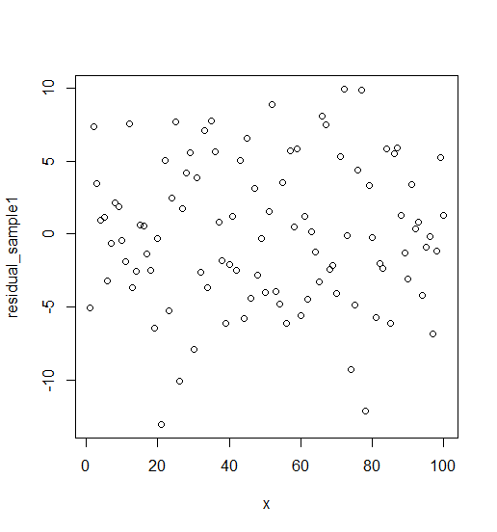

I observed that those points are approximated symmetry. The axis of symmetry is 0.

1. I observed that those results approximate the same.

hw = function(){

x = seq(1,100)

w = 2 + 0.5 * x

sample1 = rnorm(n=100,mean = 0,sd = 5)

mean_sample1 = mean(sample1)

variance_sample1 = var(sample1)

#hist(sample1)

y = w + sample1

#plot(x = x , y = y)

beta1 = sum((x - mean(x)) * (y - mean(y))) / sum((x - mean(x))^2)

beta0 = mean(y) - beta1 * mean(x)

#plot(x = x , y = y)

#abline(lm(y~x), lwd=1, col="red")

residual_sample1 = residuals(lm(y~x))

#plot(x,residual_sample1)

MSE = sum(residual_sample1^2) / (100 - 2)

print(c(beta0,beta1,MSE,mean_sample1,variance_sample1))

return(c(beta0,beta1,MSE,mean_sample1,variance_sample1))

}

beta0_list = c()

beta1_list = c()

mse_list = c()

mean_sample1_list = c()

variance_sample1_list = c()

for (i in c(1:1000)){

results = hw()

beta0_list[i] = results[1]

beta1_list[i] = results[2]

mse_list[i] = results[3]

mean_sample1_list[i] = results[4]

variance_sample1_list[i] = results[5]

}

mean_beta0 = mean(beta0_list)

mean_beta1 = mean(beta1_list)

mean_mse = mean(mse_list)

Mean_beta0 is 1.98635

Mean_beta1 is 0.500145

Mean_mse is 24.87754

Beta0 histogram

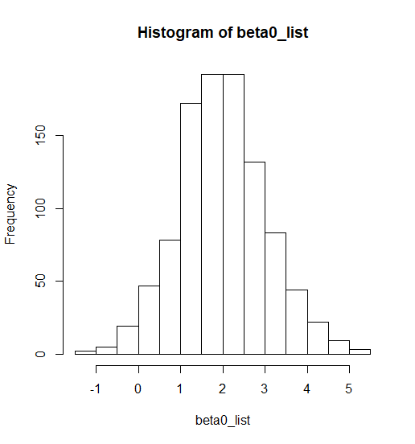

Beat1 histogram

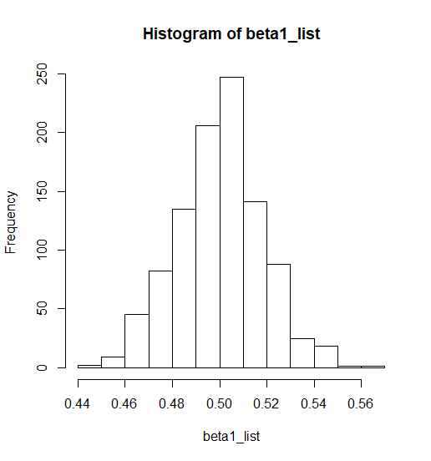

MSE histogram

