**Instruction of Stroke Star**

1. **Read this instruction before get started**
2. **Map (Sky)**
   1. Choose a completed map or a template (ivory paper)
      1. **If you choose a template, you need to put the template on the top of another paper like a mold, draw the contour of the template along its edge on the bottom paper, and mark two starting dots and the star sign at the same place on bottom paper as they are on the template.**
   2. Two dots for players to start with
   3. One star sign to reach
3. **2 Players**
   1. Each player chooses a pencil (allow to choose same pencil, but be careful to track your stroke path)
   2. Players decide who goes first and which dot to start with
   3. Players cannot start with the same dot
4. **Stroke** 
   1. Learn the way to launch (flick) a stroke
   2. Each player is only allowed to launch **one stroke** every turn
   3. Player launches a stroke from the last ending dot on the path
   4. The end of first continuous and visible line becomes the last ending dot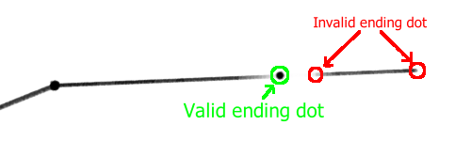
5. **Obstacle Line (you may need a rule for it)**
   1. Each player only has **3 chances** to draw obstacles in total
   2. Obstacle line is a straight line with **length** **no more than 2 cm**
   3. The **distance** from the last ending dot to the obstacle line should **not be less than 1 cm**
6. **Blocking**
   1. If the valid ending dot on a new stroke cross over the obstacle, the ending dot should be placed on the intersection of the stroke and the obstacle

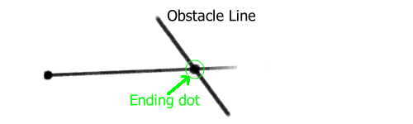

* 1. Path **cannot** cross over the obstacle

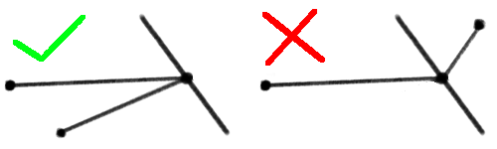

1. **Cutting**
   1. Player’s stroke can cut opponent’s path so that opponent’s ending dot will be placed on the intersection of paths (**Don’t forget to erase rest part of path**)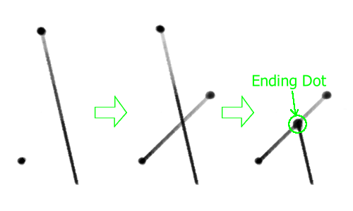
2. **Game’s turn**
   1. **Player 1** draws an **obstacle** (Player 1 can choose not to draw obstacle at this turn)
   2. **Player 2** launches a **stroke**
   3. **Player 1** launches a **stroke**
   4. **Player 2** draws an **obstacle** (Player 2 can choose not to draw obstacle at this turn)
   5. Repeat until one player win
3. **Winning/Losing Condition**
   1. If your path reaches the star sign, you win
   2. The last player who totally blocks out star sign from his/her opponent using obstacle line lose (for example)



* 1. If opponent breaks pencil or paper, you win

1. **Constellation**
   1. After someone win, look at the stroke path on the map (sky), if it looks like constellation, **name it**
   2. Create a new map (sky) if you get some wonderful thoughts.