INTRODUCTION TO MACHINE LEARNING
(NPFL054)
A template for Homework #2

Name: Vilém Zouhar
School year: 2nd

- Provide answers for the exercises.
- For each exercise, your answer cannot exceed one sheet of paper.

1.1 Multiple linear regression

(Intercept) cylinders displacement horsepower weight
-17.95460 -0.48971 0.02398 -0.01818 -0.00671
acceleration year is_european is_japanese
0.07910 0.77703 2.63000 2.85323

Model interpretation (from highest to lowest numbers)
is_european, is_japanese
We created dummy variables (is_european, is_japanese) from input variable origin (from the ISLR package: 1. American, 2. European, 3. Japanese). We used is_american as base class, because if included, it would be detected as a linearly dependent variable. We can interpret it as: the more American the car, the less mpg it has, with Japanese cars having slightly more mpg.
year
The newer the car is, the higher mpg it has.
cylinders
The more cylinders the car has, the less mpg it achieves. This is presumably because higher number of cylinders indicate a sports car, not an economical car.
engine displacement
Higher engine volume results in more mpg.
horsepower/weight
Higher horsepower/weight implies somewhat less mpg. Probably the same reason as with cylinders.
acceleration
Acceleration in this case is the time it takes the car to accelerate from 0 to 60 mpg (in sec.). Hence less agile cars have higher mpg. Same reason as above.
intercept
Base mpg, if all features were zero. This will naturally not be the case in reality (zero acceleration, weight, etc..).

The features were unscaled and hence we don’t know which feature is the most important one. (eg. cylinders seems quite significant, but this number spans from 2 to 8)
1.2 Polynomial regression

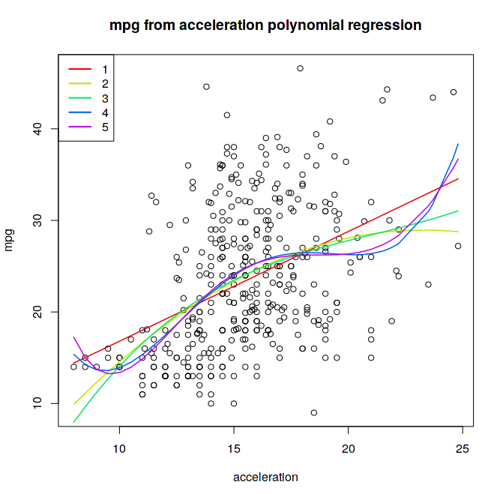
Degree 1 R^2: 0.179207050156255
Degree 2 R^2: 0.193964011032176
Degree 3 R^2: 0.195508000328506
Degree 4 R^2: 0.213597901585262
Degree 5 R^2: 0.214801832251011
2.1 Binary attribute mpg01 and its entropy

Since there is no example of a car with mpg equal to the global median (even number of examples with two different middle values), it does not matter where we categorize these mpg median cars.

H[mpg01] = 1
This should be obvious, because half of the cars will have mpg01 equal to 1, the other equal to 0 (even number of examples). Then P[mpg01 = 1] = P[mpg01 = 0] = 0.5. From this follows:
- H[mpg01] = P[mpg01 = 1]*log_2(P[mpg01 = 1]) + P[mpg01 = 0]*log_2(P[mpg01 = 0])
- H[mpg01] = 0.5 * log_2(0.5) + 0.5 * log_2(0.5) = log_2(0.5) = -1

Computation in R gives the same result.
2.3 Trivial classifier accuracy

MFC accuracy: 46.84%
2.4 Logistic regression – training and test error rate, confusion matrix, interpretation

Logistic regression test error rate: 11.39%
Logistic regression train error rate: 7.67%

true test values
predicted test values 0 1
0 37 4
1 5 33

Model:
(Intercept) cylinders displacement horsepower weight
-20.844548 -0.496219 0.023211 -0.045976 -0.005976
acceleration year is_european is_japanese
0.060631 0.511699 2.313537 1.514192

The model values are somewhat similar to the simple linear regression model (predicting raw mpg) and thus interpretation the same. There are some minor differences between the two: is_japanese and year. They can both be explained due to different fitting function (logistic regression transforms the output using the sigmoid function) and splitting the mpg into two classes. Thus we can conclude, that for above median mpg it doesn’t make much difference whether the car is European or Japanese.

2.5 Decision tree algorithm – training and test error rate, cp parameter

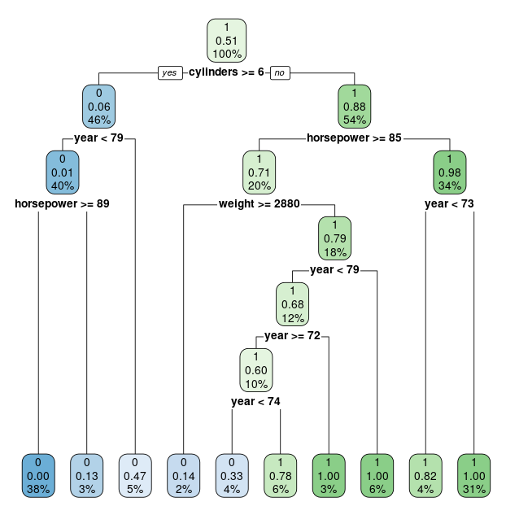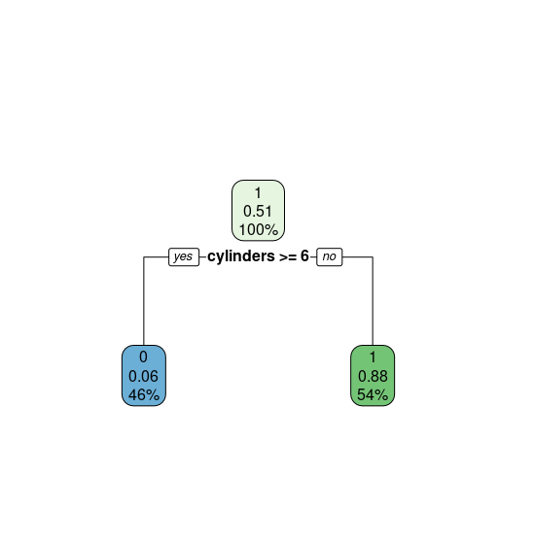
max decision tree vs optimally pruned decision tree

Decision tree (min cp) train error rate: 6.39%
Decision tree (min cp) test error rate: 13.92%
Decision tree (optimal cp) train error rate: 9.27%
Decision tree (optimal cp) test error rate: 11.4%
CP xerror
1 0.811688312 1.1428571 Optimal cp: 0.016233766
2 0.016233766 0.2077922
3 0.008658009 0.2077922
4 0.000000000 0.1883117
Above is the cptable from the max decision tree. The minimum is 0.1883117 and the sd is 0.4708688. The first cp associated with an xerror lower or equal to computed min + sd (0.6591805) is 0.016233766. Hence this is the optimal cp parameter. (It is optimal, because it is in sd range of min and produces the simplest decision tree with this property.) It would be more apparent from a cp graph, but there’s no space left on this page.
The above computation can be done with this R code:
trm.cpt = trm.default$cptable[, c(1,4)]
trm.o_cp = trm.cpt[trm.cpt[,2] <= min(trm.cpt[,2]) + sd(trm.cpt[,2])][[1]]
Different samplings would produce vastly different trees, so this method should be wrapped in cross validation.
2.6 Naive Bayes algorithm – precision and recall

Naive Bayes test error rate: 10.13%
Naive Bayes train error rate: 9.27%
true test values
predicted test values 0 1
0 37 3
1 5 34
Naive Bayes precision: 88.1%
Naive Bayes recall: 92.5%
2.7 k-NN -- cross validation error rate

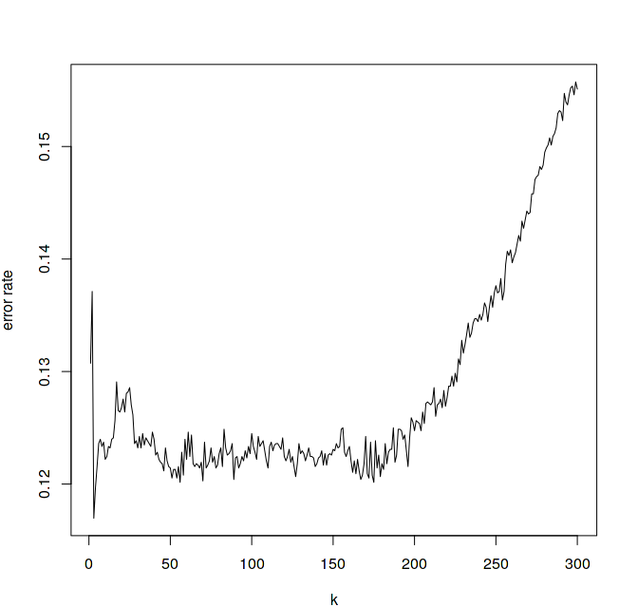
The graph shows, that the best value for k is around 50 (error rate 12%). K closing to 343 is equivalent to MFC (all training examples are taken into account without distance weights).

