Maximum likelihood:

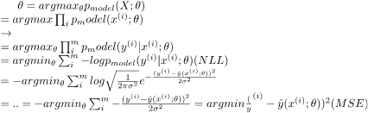

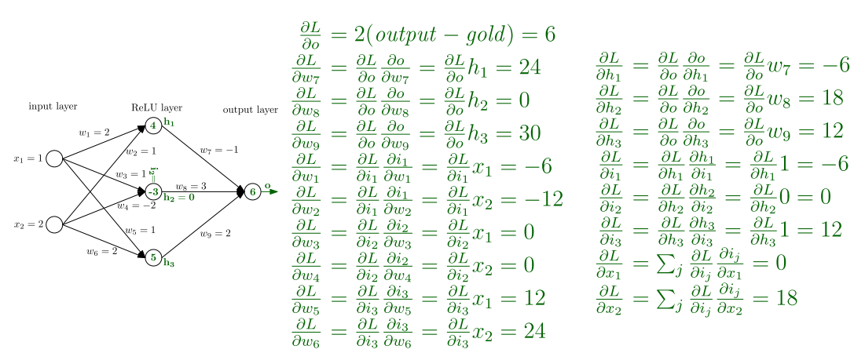

(sgm(x))’ = sgm(x)*(1-sgm(x)) (sgm(x) = 1/(1+e^(-x)) )
(tanh(x))’ = 1-tanh(x) (tanh(x) = (e^(2x)-1)/(e^(2x)+1)
(relu(x))’ = {1, NaN, 0}
(softmax(x))’ = (softmax(x) = e^(z_i)/(sum e^(z_j)))

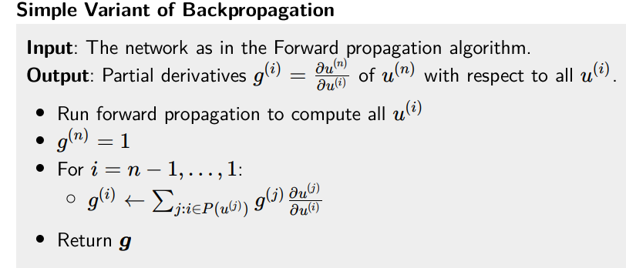
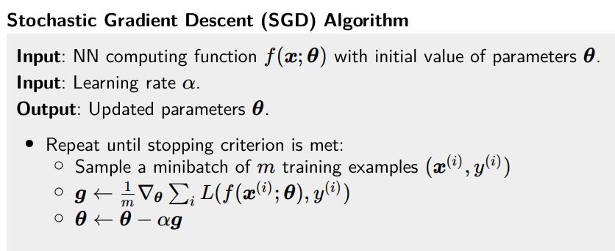
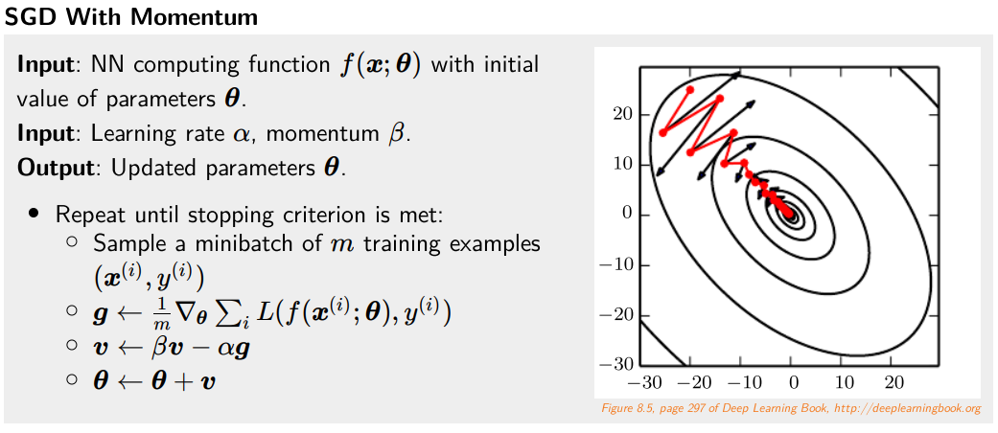
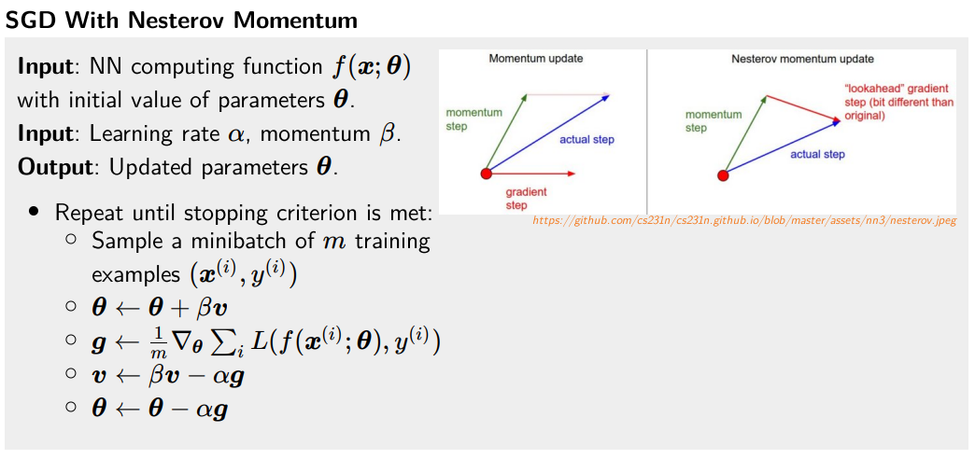
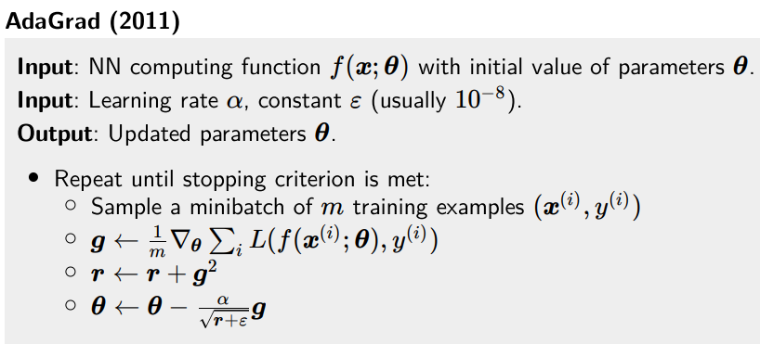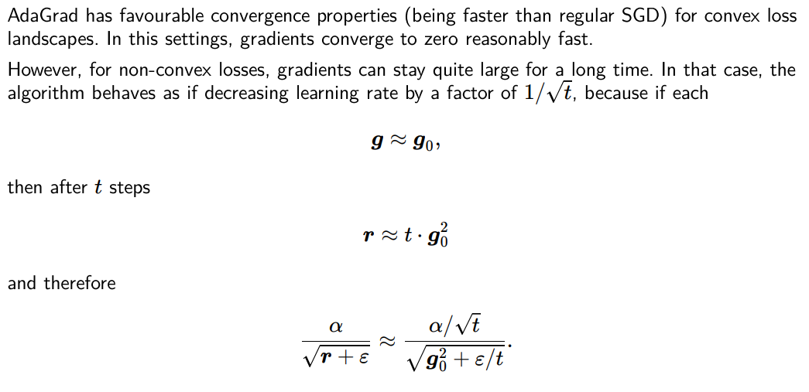
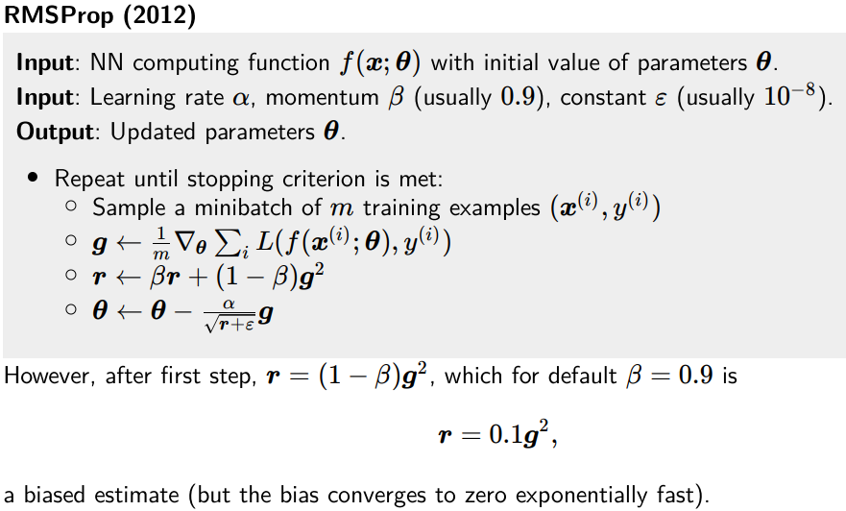

Regularization

Early stopping:
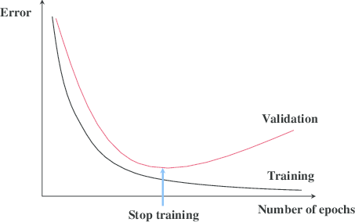

L2 regularization: Instead of minimizing we optimize
and each weight is updated as:

L1 regularization: Instead of minimizing we optimize
and each weight is updated as:

Dataset augmentation: For some tasks it is easy to generate slightly modified examples. Problematic for texts though.

Ensembling: Reducing generalization error by combining several models. The models are usually combined by averaging their outputs. If models have uncorrelated (independent) errors, then by averaging model outputs the errors will cancel out. However, ensembling usually has high performance requirements

Label smoothing: Uniformly allocate some probability to all possible classes.
Dropout

Ideally to every densely connected layer. Usually 0.5, but 0.3 if underfitting. During inference we scale the activations down to (1-p) to account for more neurons than usual.
It sort of works as ensembling.

Doesn’t work on RNN because it messes up the long term dependencies.

Variational dropout: Same mask on all time steps.

Zoneout: Randomly preserve hidden activations instead of dropping them. Random residual connection.

Recurrent dropout: Drop connection that adds new information to the state. Dropping out on the “state highway” is nonsense.

Layer normalization

Works for RNNs instead of Batch normalization.

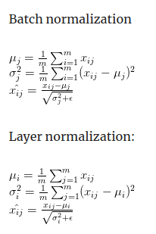

Convergence

Best way to initialize matrix is 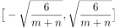.
Gradient clipping:
We can clip each gradient separately per weight, or gradient as a whole.
g = {g if ||g|| < c, c * g/||g|| otherwise}

Saturating non-linearities:
A saturating activation function squeezes the input.
Convolution

One dimension:
Two dimensions:
Here the kernel/filter (matrix) is multiplied element-wise with the underlying image. Image with C channels, then convolution layer of F filters of width W and H and stride S is parametrized by kernel of size W*H*C*F and
The F kernels are independent.
Padding either valid (only valid pixels) or same (pad with zero pixels).

Batch normalization:

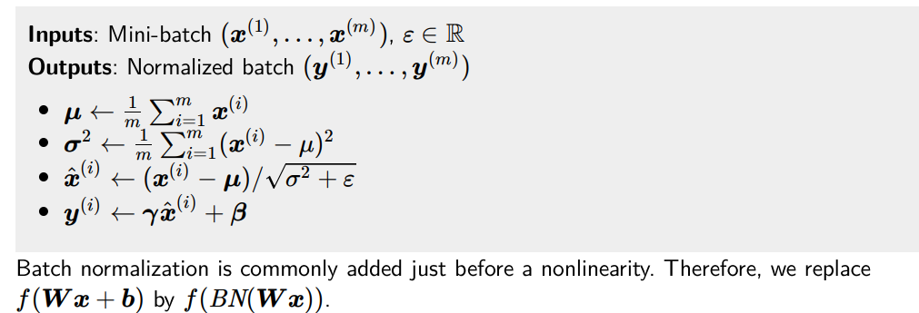

When a batch normalization is used on a fully connected layer, each neuron is normalized individually across the minibatch.

For convolutional networks we would like the normalization to honor their properties, most notably the shift invariance. We therefore normalize each channel across not only the minibatch, but also across all corresponding spacial/temporal locations.
VGG/ResNet
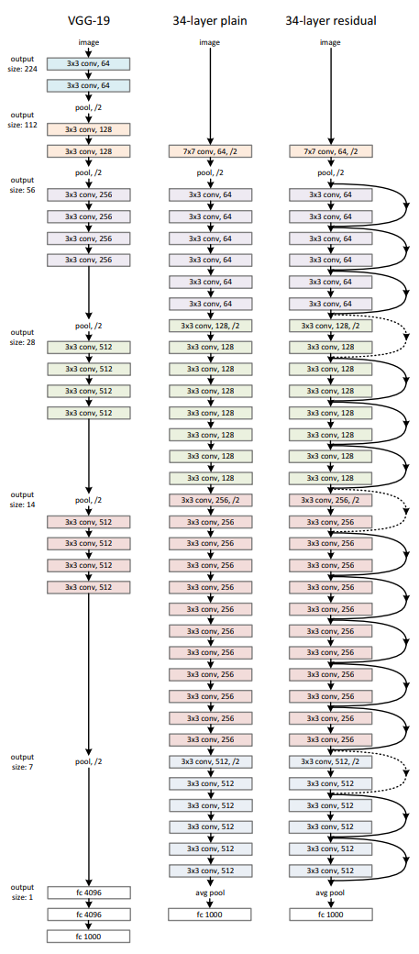
DenseNet

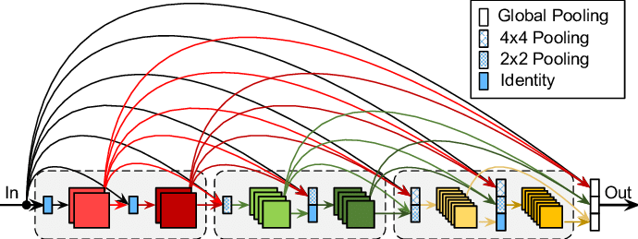
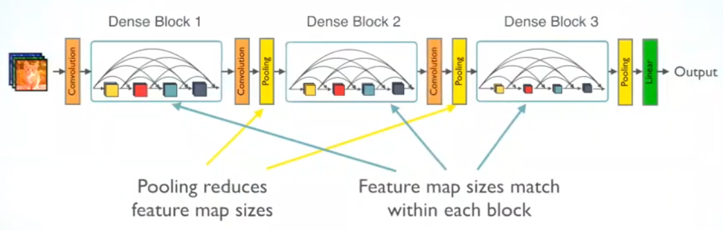
PyramidNet

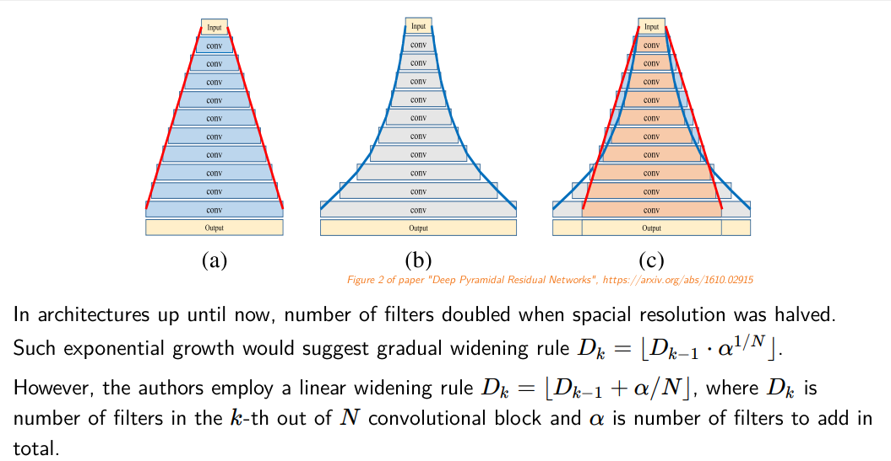
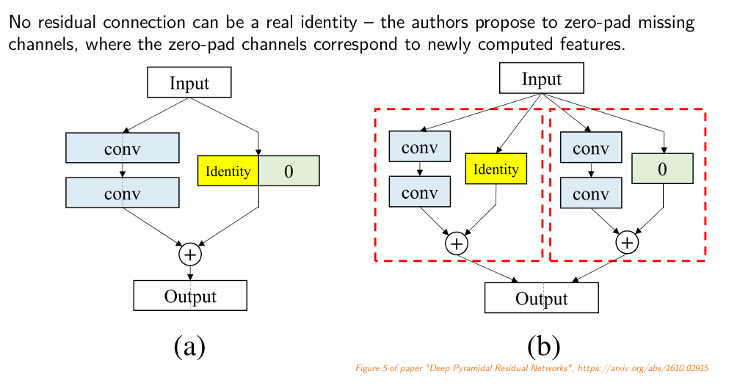
Object detection

Fast-RCNN: Each Region of Interest (RoI). Last layer of VGG is replaced with RoI-pooling layer. Then each RoI goes through classification layer (number of classes + 1 for no object). Then another part of the network generates bounding box. Loss for bounding boxes is calculates as Intersection Over Union.
If single objects are in multiple RoI we use non-maximum supression.
RoI-pooling: For each pixel in RoI it max-pools intersecting pixels in the underlying area.
Faster-RCNN: Adds a RoI proposal system to the neural network. It uses a sliding window of size 3x3 and at each step it proposes a RoI of different size centered at this window (also with different aspect ratios).
Mask-RCNN: For each class the mask is predicted separatedly (using convolutions).
RNN

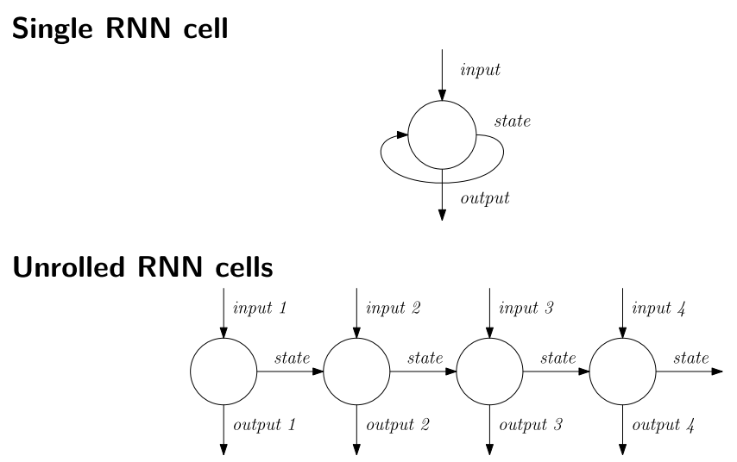
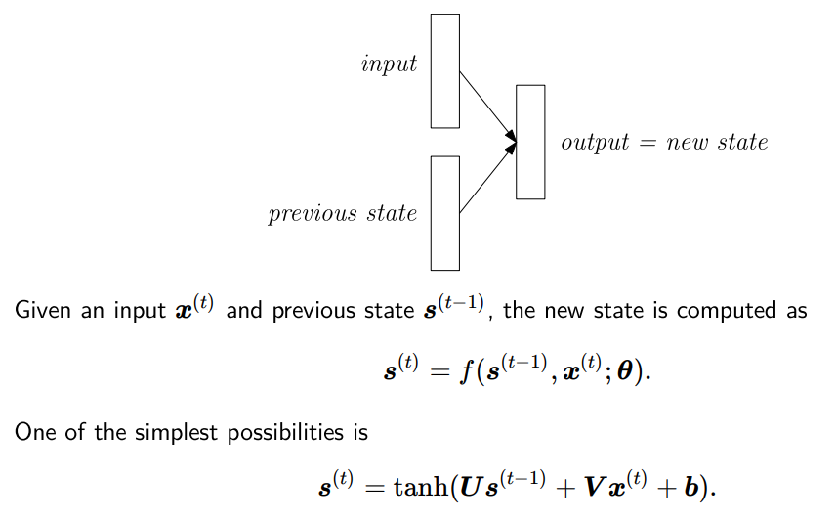
Problem is exploding gradients problem (the challenge of long term dependencies) because of the eigenvalue decomposition (as if it were linear).
LSTM (Long Short Term Memory)

Constant error carousel
Input gate which determines how much will be stored in the memory cell

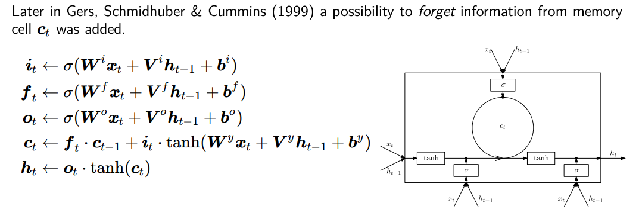
Without the upper gate this would serve only as a residual connection.

GRU (Gated Recurrent Unit)

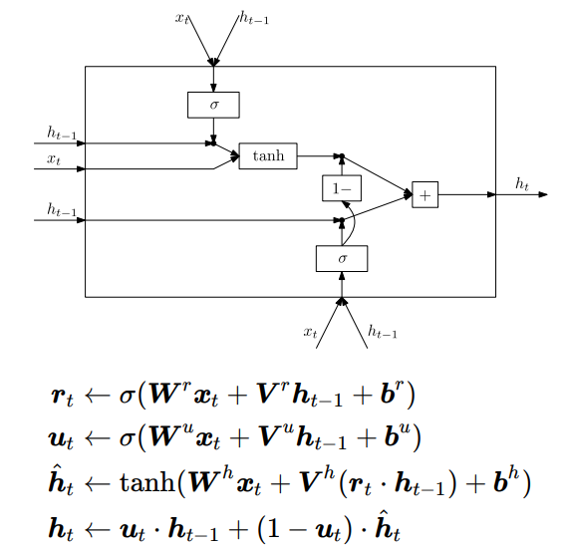

Simpler than LSTM. Forgetting and input merged together.
Highway networks

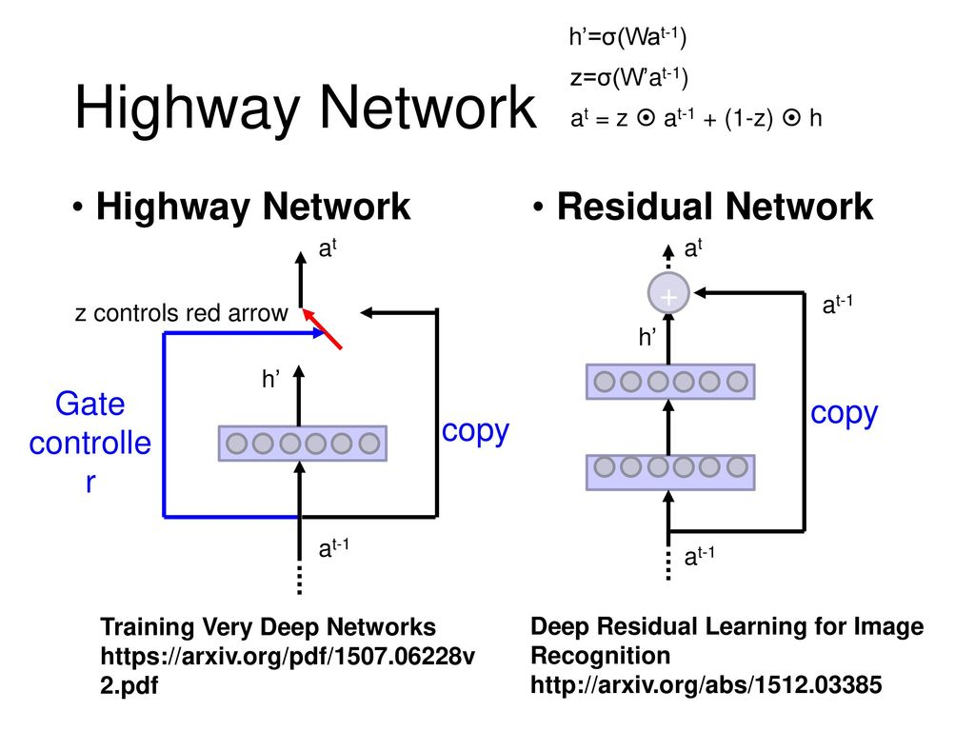

Gradually improves the representation.
Multilayer RNN

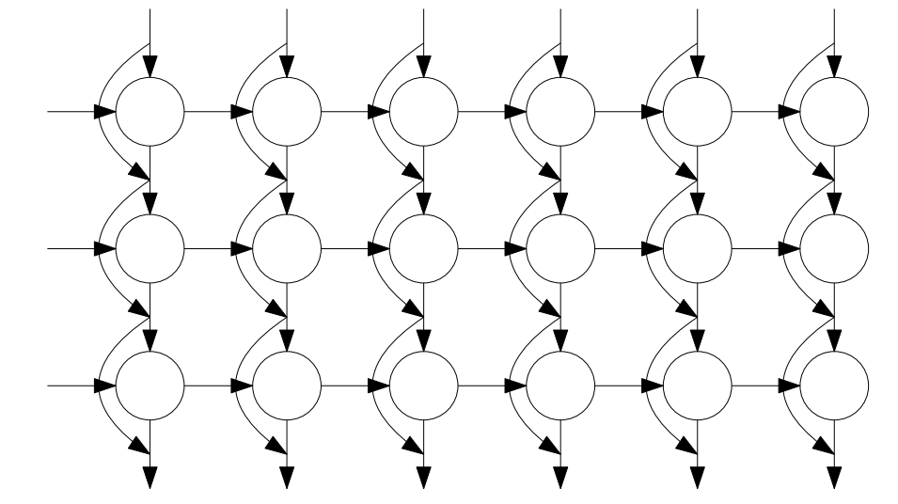
We have to add residual connections because otherwise the information degrades.

Sequence to sequence architecture

Teacher forcing: Gold outputs are used as inputs even though the network outputs may differ (in decoder).

TODO: Attention

TODO: Subword units
Byte pair encoding (BPE): Greedy method for creating subword units. We again and again find two most neighbouring symbols which occur most in the data and merge them. End of the word symbol is just a regular symbol.

Wordpieces: Similar joining, but based on maximum likelihood of unigram language model.

