Question 1A

1. Does the noun carry inflection in your language?
Yes.

2. If yes, for which inflectional categories?
Nominals carry:
- number (singular, dual, plural)
- case (nominativ, accusative, genitive, dative, locative, ablative, prolative)
- posessive forms for all numbers, persons and cases; some forms are homomorphs

3. If there are any paradigms given, please include an example.
Example of paradigms given in the language:
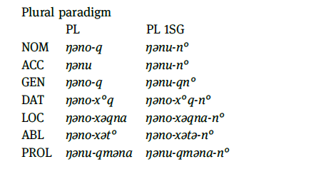
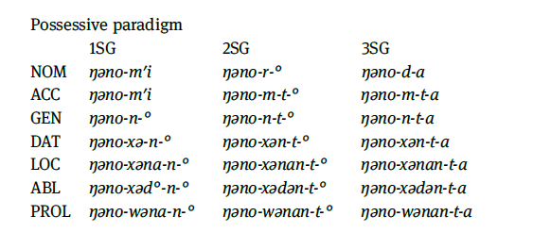

4. How many cells does the paradigm have?
The paradigm for case declension has 7 cells for every number/person, 35 in total. When treated separately, the plural paradigm has 14 and the possesive paradigm 21 cells.

Question 1B

1. Make a list of the inflectional categories that may be marked on the verb.
Verbs are inflected by:
- agreement
  - in person and number
- tense
  - present, past, future, habitual, future in the past / conjunctive
- mood
  - imperative, hortative, jussive / optative, conjunctive, necessitative, interrogative, probabilitative, obligative, potential, and inferential

2. How many inflectional categories are marked on the verb of your language?
3 (4, if person and number are treated separately)

3. How does your language compare with the typology of the WALS chapter mentioned above?
According to WALS, the categories are treated somewhat differently.
- agreement (number/person)
- tense/aspect/mood
- illocution (interrogative,declarative, imperative)
There are in total 3 categories per verb. In comparison with other languages, this is lower than the average.

Question 1C
Attested morphological patterns in the language:

a. Affixation
Our language has suffixes and no prefixes. A suffix can mark number (dual/plural), case or verb conjugation.
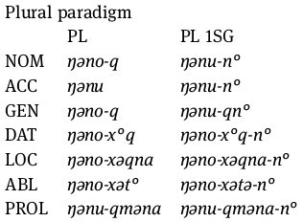
Examples:
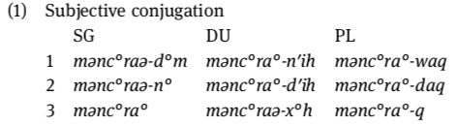
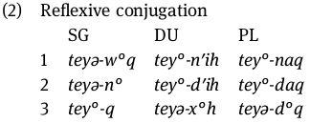

b. Compounding (endocentrically)
There is compounding present in nouns and numbers. Examples are shown below:
Numeral
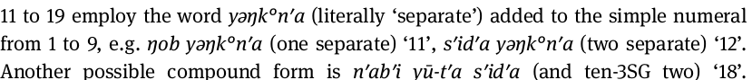
Noun
Note: “boy” is a compound of words “man” and “child”.

d. Reduplication
not typical

Question 1D
The language has following morphological typological framework:
SYNTHESIS | Synthetic
FUSION | Concatenative
FLEXIVITY | Flexive (possess allomorph but of small degree)
EXPONENCE | Separative

Question 2
a. inflection
b. derivation
c. compounding
d. suppletion
e. conversion
f. cliping
g. conversion (synecdoche, capitalization)

Question 3
a. (im:aff + possible:adj):adj
b. (un:aff + (friend:noun + ly:aff):adj):adj, ((un:aff + friend:noun):verb + ly:aff):adj
c. ((act:verb + ive:aff):adj + ity:aff):noun
d. (un:aff + (zip:noun + pable:aff):adj):adj, ((un:aff-zip:noun):verb + pable):adj
* p is added to the -able morpheme for phonological reasons

Question 4

 | number of morphemes | root | derivational? | inflectional?
only | 1 | only | - | -
unpacked | 3 | pack | x | -
bookshops | 3 | shop | x | x
healthier | 2 | healthy | - | x
disappearing | 3 | appear | x | x
coldest | 2 | cold | - | x
pinkish | 2 | pink | x | -
mispronounces | 3 | pronounce | x | x
uglification | 2 | uglify | - | x
reenergizabilities | 6 | energy | x | x

Question 5

a.

b.

c.

d.

