
Task 1.1

Example 1 (source):
Indonesian village living in shadow of palm oil.

Literal interpratation:
There exists an object (indonesian village), which continuously lies in the shadow (from the light) of another object (palm oil).

Inferences:
- indonesian village refers to the people living there and the local conditions
- palm oil is not any volume of the palm oil product, but rather the industry
- to lie in the shadow of X means to be hurt by the presence of X

Background knowledge:
- villages can’t live and this and similar terms (cities, states) usually refer to the inhabitants and conditions
- palm oil is also an industry, which is known for being environmentaly destructive
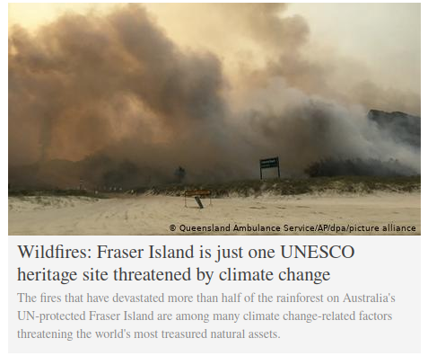

Example 2 (source):
Fraser Island is just one UNESCO heritage site threatened by climate change

Literal interpretation:
Fraser Island is only one (not two or more) UNESCO heritage sites and is threatened by climate change.

Inferences:
- there are many more UNESCO heritage sites that are threatened by climate change

Background knowledge:
- phrase just one in journalism implies that it is not an isolated incident

Task 1.2

Example 1
Context:
Me: [showing the assignment to my friend] Do you have any idea of contexts in which non-standard interpratation of this sentence would be used?
My friend: Yes, [explains Example 2]
Me: Thank you, that would never have occurred to me. [P]
Implicature:
The provided example is good [Q], I did not come up with it and I acknowledge my friend’s help.
Calculation:
- M said P
- M tries to be brief, informative and his goal is to finish this assignment. Therefore he tries to be at most cooperative.
- M thought Q and expressed P, because it is a standard way dialog phrase and briefly covers the intentions.
- M knows that both M and F are fluent English speakers and assumes the counterpart has knowledge of this phrase.
- M did not cancel any implied properties of the utterance.
- Therefore M intended for F to think Q and in saying P he implied Q.

Example 2
Context:
Me: I failed the exam.
My friend: Well that would have never occured to me. [P] (stress on that)
Implicature:
To fail an exam is a common thing [Q], I have past and expect to have future experience with it.
Calculation:
- F said P
- F tries to be friendly, it is a colloquial setting
- F thought and expressed Q, trying to be casual and slightly funny
- F knows that both M and F are fluent English speakers and are capable of registering intonation changes.
- F cancelled the original meaning with a prosodical stress on the word that.
- Therefore F intended for M to think Q and in saying P they implied Q.

Task 1.3

Trump disappears during last days of term. [P]
Implicature:
The current president of USA, Donald Trump is still present, but during the last days of term is less public and communicates less on social media.
Calculation:
- Writer of the title heading says P
- It is the work of W to be informative.
- W has to be brief in order to fit the heading format, but also informative.
- W assumes that readers of this newspaper have sufficient political and world knowledge.
- W did not express anything else, that would cancel the meaning implication.
- Therefore W intended R to think Q and in saying P they implied Q.

Cancelling context:
Trump disappears during last days of term. The White House staff has been looking for him the whole night, yet he is nowhere to be found.

