Question 1
i I think it's a disgrace.
ii The guy in that house over there works for the city.
iii Most of the mistakes he made were very minor.
iv The thing that puzzles me is why no one called the police.
v One of her daughters is training to be a pilot.

Question 2
There was a horrible smell in the kitchen next morning when Harry went in for breakfast. It seemed to be coming from a large metal tub in the sink. He went to have a look. The tub was full of what looked like dirty rags swimming in grey water.
‘What’s this?’ he asked Aunt Petunia. Her lips tightened as they always did if he dared to ask a question.
‘Your new school uniform,’ she said.
Harry looked in the bowl again.
‘Oh,’ he said. ‘I didn’t realise it had to be so wet.’
‘Don’t be stupid,’ snapped Aunt Petunia. ‘I’m dyeing some of Dudley’s old things grey for you. It’ll look just like everyone else’s when I’ve finished.’
Harry seriously doubted this, but thought it best not to argue. He sat down at the table and tried not to think about how he was going to look on his first day at Stonewall High – like he was wearing bits of old elephant skin, probably.

Notes:
- distinguishing noun and adjective modifiers, e.g. in large metal tub
- I marked the infinitive participle to as part of the verb
- I split don’t into do and n’t
- I joined the possesive marking with the noun
- everyone else

Question 3.
Clause (remember that modifiers on the clausal level are (traditionally) called adjuncts; and that the head of a simple clause is the verb phrase)
  - [I] worked last week. C
  - [She] seemed very annoyed. C
  - [The longhorned beetle] seemed to [hug its rival]. C C
  - [The pirates] laughed [heartily]. C M
Nominal phrase
  - [the] furnace [black with soot] M M
  - [an] understanding [of C++, Java, and other programming languages] M M(C?)
  - [the] [very young] child M M
  - [my] [German] class M M
  - [her] criticism [of my decision] M M
  - [the] treasure chest [in my room] M M
  - [the] work [I did yesterday] M M
Prepositional phrase (ignore the parts within brackets)
  - (That was) nearly [two weeks ago]. C
  - (I stayed) until [after dinner]. C
  - (The student body elected her) as [student prefect]. C
  - (We went) [directly] to [my room]. M C

Question 4
- clause – phrase headed by a finite verb (the whole sentence)
- subject – main agent the phrase is about / who performs the action (father)
- predicate – phrase describing action / process in the sentence (VP)
- predicator – predicate head (fed)
- object – non-active entity to which the action / process applies (direct object: mashed carrots, indirect object: the baby)
- complement – dependent, which is mandatory to fill some frame, otherwise the sentence is ungrammatical or has vastly different meaning (e.g. to feed requires two complements: subject and an object)
- adjunct – loosely attached phrase, which could be omitted (e.g. modifiers)
- NP – a phrase whose head is a noun (the father)
- VP – a phrase whose head is a verb (fed the baby mashed carrots for lunch)
- PP – a phrase whose head is a preposition (for lunch)
- adverb – modifier of verbs

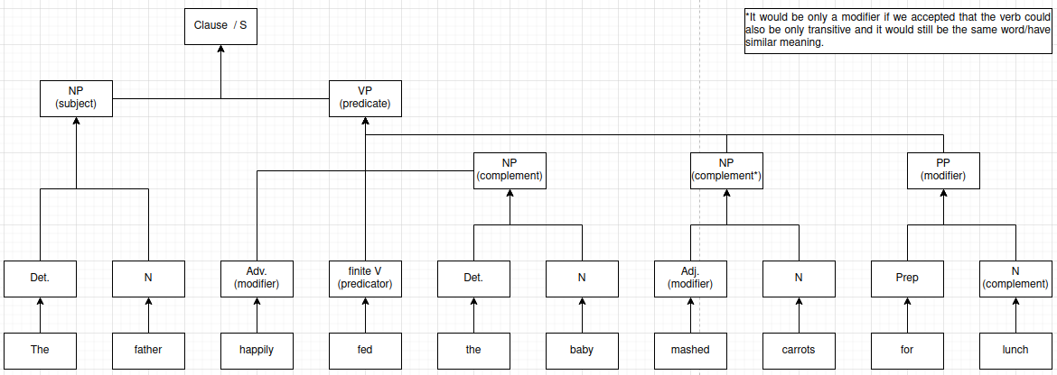
Question 5
- There does not appear to be any case marking for subject/object in transitive verbs (examples don’t list intransitive ones). mi means I/me and the grammatical relation is signalized by relation to the verb.
- From a and b it appears that this language is SVO. d to h appear to be basically the same sentences, only with changing subjects. The same applies to c, i and j.

Question 6
1a echo question test
Q: At what/whom did Kim glance?
A: At [the actor with a wig].
A: At [the actor].
A: *At [the actor with a].
1b coordination
Kim glanced at [[the actor with a wig] and [the director]].
Kim glanced at [[the actor] and [the director]] with a wig. (This also appers to be grammatical, if we assumed that a wig would be some instrument one could look with.)
2a echo question test
Q: At what/whom did Kim glance?
A: At the actor.
A: *At the actor through.
A: *At the actor through her binoculars.
2b coordination
Kim glanced at [[the actor] and [the director]] through her binoculars.
*Kim glanced at [the actor through her binoculars and the director].
