Foundations of Linguistics
WiSe 20/21
Take-home exam 1

Hand-out of exam: Friday the 12th of February 2021; 23.59
Hand-in of exam: Friday the 19th of February 2021; 23.59

Hand-in form: PDF. Attached to the exam is a .docx answer file which lists the questions numbers. Please use it to answer the questions, convert it to PDF, and upload it to MS Teams. You are not required to use Word, those of you that use Open Office, LaTeX, whatever, will know how to convert the .docx file. The final product, your exam, should have just your answers, appropriately numbered, in PDF form.

In case there are any technical problems you can reach Annemarie Verkerk at:
annemarie.verkerk@uni-saarland.de

You will receive a confirmation message from Annemarie Verkerk when the exam has been successfully received.

Note: this exam is intended to reflect your individual knowledge and skills. Working together and copying each other’s work in any way is NOT ALLOWED. Using published work without citing it fully is plagiarism and is NOT ALLOWED. Reframing in your own words published or unpublished work without citing it fully is plagiarism and is NOT ALLOWED. Along with this document (the exam) you will find the "Erklärung über Eigenständigkeit" that relates these issues in more detail. Please hand in a signed version of this document along with your exam.

Part I: Morphology and Syntax

1.1.
- mice catch|er
- stick|-on labell|ing
- over|slept
- un|abbreviat|able
- back|trans|form|ation
- ping|-pong table|s
- self|-de|struct
- UNESCO phone
- North Americ|an Sci|-Fi Mini|-Conven|tion
- single|-mind|ed|ness

1.2.
Ordering: root, derivation, inflection. Parts of speech are indicated in the parentheses, because sometimes the form may be ambiguous.

- mice (mouse*), mousy, mice (**)
catch (verb), catcher, catches
*The root is formed by base modification of mouse, therefore derivational and inflectional morphology is included from this word.
**mice is derived from mouse
- stick (verb), sticker, sticks (verb)
label (noun), label (verb), labels
- slept, sleeper, sleeps (verb)
- abbreviate, abreviation, abbreviated
- form (verb), forms (noun, conversion), formed
- ping-pong, ping pong (verb, conversion), ping-pongs (noun)
table (noun), table (verb, archaic), tables
- struct (structure*), structure (noun - bulding), structured
*The root is formed by the clipping of the verb structure, therefore derivational and inflectional morphology is included from this word.
- UNESCO, -*, -*
phone (noun), phone (verb), phones (noun)
*There’s no inflected nor derived word from UNESCO (common with initialization words). In Czech, one would be able to create an inflected form of UNESCO, e.g. peníze UNESCA = the money of UNESCO (gen.). It is however present mostly in the spoken form and the usage is controversial.
- north, northerner (noun), northern (adj.)
America, American (noun), Americas
Sci (science*), scientist, sciences (noun)
Fi (fiction*), fictional, fictions (noun)
convene (verb), convener (person attending a convention), convenes (verb)
*Sci-Fi is created by clipping of the words science and fiction, therefore derivational and inflectional morphology is included from these words.
- single, singular, -*
mind (noun), mindless, minds (noun)
*There are no words related to the adjective single, that would still count as inflectional morphology. The closest could be singly, which is, however, an adverb, and changing the grammatical category is not common in inflectional morphology.

1.3.
- mice - base modification (phonologically motivated)
catcher - concatenation/affixation
- stick-on - compounding
labelling – concatenation/affixation, insertion of l (phonologically motivated)
- overslept - compounding (over), base modification (sleep → slept)
- unabbreviatable - compounding (un, able), base modification (abbreviate → abbreviat)
- backtransformation - compounding (back, trans), affixation (ation)
- ping-pong – compounding (artificial)
tables - concatenation/affixation (s)
- clipping (structure → struct), affixation (de)
- UNESCO - alphabet-based abbreviation
clipping (telephone → phone)
- north - no change
american - concatenation/affixation
sci-fi - clipping (science → sci, fiction → fi), compounding
mini-convention - base modification (convene → conven), concatenation/affixation (tion)
- single-mindedness - concatenation/affixation (mind → minded), affixation (minded → mindedness), compounding

1.4.
labelling, overslept, tables

2.1.
nouns
kuȴpir kangaroo
wati man
miɲma woman
ŋura camp
yuṇʈal daughter
ţiţi child
papa dog
paṇa ground

verbs*
ɲin-aɲu, ɲina-kat-iŋu sat
ŋaλa-kat-iŋu brought
ŋaλakulp-aŋu returned
ŋaλapiţ-aŋu came
paţ-aṇu bit
yul-aŋu cried
kul-inu heard
want-iŋu left
kuȴʈ-uṇu speared
pir-inu scratched
manţ-inu picked up
ɲ-aŋu saw
waţ-aṇu told
mirpaṇar-iŋu was/become angry
ilur-iŋu died
mapiţ-aŋu went away
makat-iŋu took/carried away
yaλʈ-iŋu called
paka-ṇu got up
ţap-inu asked
wan-aṇu followed
p-uŋu hit (past)

pronouns
ŋay- I/me (not marked whether subject or object)
pal- he/him (not marked whether subject or object)
Ŋanaṇa we (plural)
Ŋali we (two)
Ɲura / Ŋura you (singular, subject)
Ţana they (plural)

markings
-pa object, subject for intransitive verbs (dropped for woman, dog)
-ŋku, -tu, -lu subject
-ŋka locative case
-uɲa object marking for pronouns and names (me, him)
the original exam version used -uṇa in example 12, which could
perhaps have been a phonologically motivated allomorph)
-ŋa object marking for names and pronouns
also subject for intransitive verbs
-ɲa object marking for we (plural) and we (two)
also subject for intransitive verbs
-tu subject marking for names and nouns for transitive verbs
-ulu subject marking for pronouns and names (I, Nunu (sub.))
-uúu subject marking for he
-muka plural marking of you

others
-kat- verb marking; at first appears to mark plural in the verb (sat),
though this is not in correspondence with brought
it also always appears with took / carried away
-uŋu, -iŋu, inu, -aṇu, -aŋu, -aŋu
verb markings; do not correspond to gender, number, person
nor verb transitivity
possibly allomorphes for past tense

*The verbs may possibly bear a marking of the past tense. We would need to see contrastive examples of verbs in other tenses to make such a claim.

2.2.
synthesis:
synthetic (words are composed of multiple morphemes)

fusion:
agglutinative (most morphemes have a single meaning, do not modify roots)

flexivity:
rather non-flexive (low degree of alomorphy)

exponence:
separative (one morpheme usually contains just one grammatical categorym, slight exceptions)

2.3.
subject - object - verb

2.4.
dependent marking (subjects and objects take affixes based on their case) + constituent order

2.5.
ergative alignment (objects and subjects take the same morphemes to mark the case)

Mystery Language X
1 Wati-ŋku kuȴpir-pa ŋaλa-kat-iŋu. The man brought the kangaroo.
2 Ţiţi ŋura-ŋka ɲin-aɲu. The child sat in camp.
3 Papa paṇa-ŋka ɲin-aṇu. The dog sat on the ground.
4 Papa-ŋku ţiţi paţ-aṇu. The dog bit the child.
5 Ţiţi yul-aŋu. The child cried.
6 Ŋay-ulu ţiţi kul-inu. I heard the child.
7 Wati-ŋku ŋura want-iŋu. The man left the camp.
8 Wati-ŋku kuȴpir-pa kuȴʈ-uṇu. The man speared the kangaroo.
9 Kuȴpir-tu wati pir-inu. The kangaroo scratched the man.
10 Yuṇʈal-tu ţiʈi manţ-inu. The daughter picked up the child.
11 Miɲma ŋaλakulp-aŋu. The woman returned.
12 Miɲma-ŋku ŋay-uɲa ṇ-aŋu. The woman saw me.
13 Ŋay-ulu miɲma waţ-aṇu. I told the woman.
14 Ŋay-ulu mirpaṇar-iŋu. I became angry.
15 Ɲura ŋay-uɲa ɲ-aŋu. You saw me.
16 Miɲma-ŋku ɲuraɲa ɲ-aŋu. The woman saw you.
17 Yuṇʈal-pa ŋaλapiţ-aŋu. The daughter came.
18 Kuȴpir-pa ilur-iŋu. The kangaroo died.
19 Miɲma mapiţ-aŋu. The woman went away.
20 Ŋay-ulu ţiţi ma-kat-iŋu. I carried the child away.
21 Ṇuṇ-ulu ŋay-uɲa ɲ-aŋu. Nunu saw me.
22 Pal-uúu wati waţ-aṇu. He told the man.
23 Wati-ŋku pal-uɲa kul-inu. The man heard him.
24 Watiŋku ampin-ŋa yaλʈ-iŋu. The man called Ampin.
25 Ampin-ŋa pak-aṇu. Ampin got up.
26 Pal-uúu mapiţ-aŋu. He went away.
27 Ŋura ŋaλapiţ-aŋu. You came.
28 Ampin-tu ɲuraɲa ɲ-aŋu. Ampin saw you.
29 Ŋanaṇa ɲina-kat-iŋu. We (pl) sat down.
30 Ŋanaṇa yuṇʈal-pa yaλʈ-iŋu. We called the daughter.
31 Ŋali yuṇʈal-pa ţap-inu. We (2) asked the daughter.
32 Wati-ŋku ŋanaṇa-ɲa wan-aṇu. The man followed us (pl).
33 Ampin-tu ŋali-ɲa yaλʈ-iŋu. Ampin called us (2).
34 Ɲura-muka ţiʈi kul-inu. You (pl) heard the child.
35 Pili-lu ɲura-muka-ɲa ɲ-aŋu. Pili saw you (pl).
36 Ţana ţiʈi ma-kat-iŋu. They (pl) took the child away.
37 Ţiţi-ŋku ţanaɲa pir-inu. The child scratched them (pl).
38 Ţana ţiʈi-ŋka ɲin-aŋu. They (pl) sat on the child.
39 Ţana pak-aṇu. They (pl) got up (arose).
40 Pili-ɲa mirpaṇar-iŋu. Pili was angry.
41 Wati-ŋku pili-ɲa p-uŋu. The man hit Pili.

3.1

The trees may be hard to read because of their width, but it is possible to zoom in.

3.1.a.

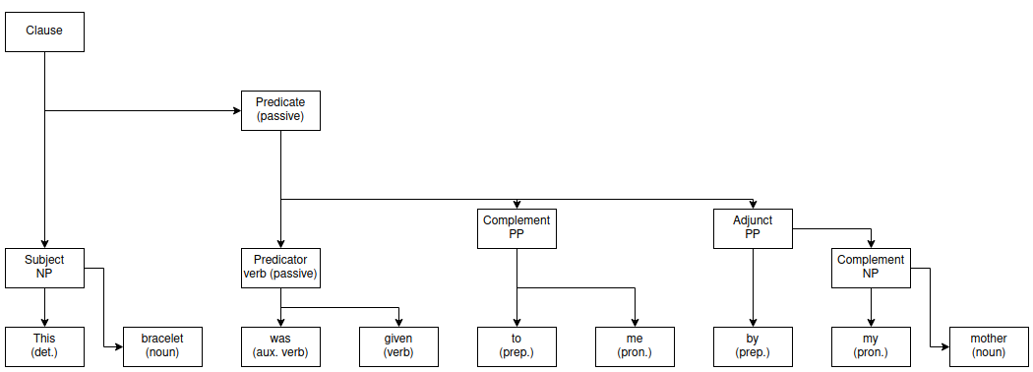
3.1.b.
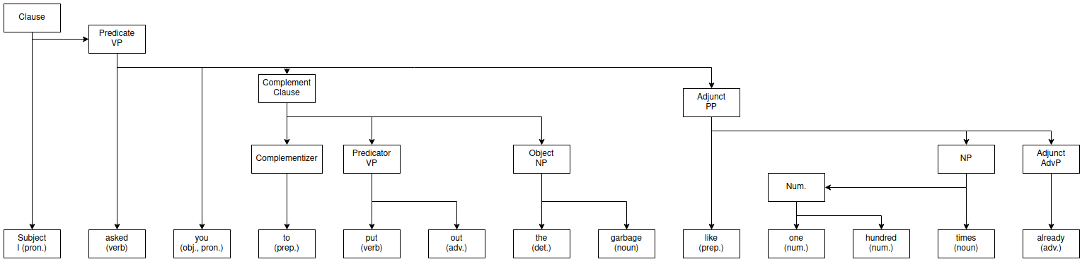

3.1.c.

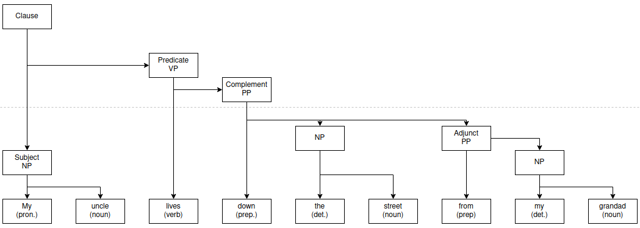
3.1.d.

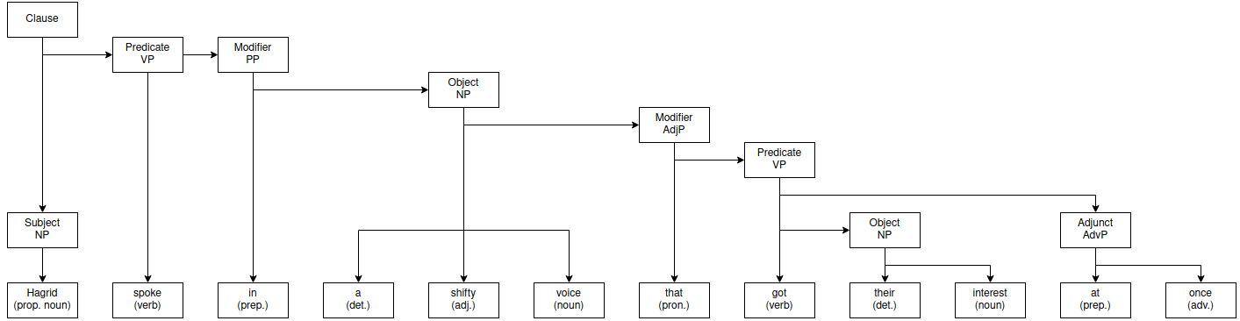

3.1.e.
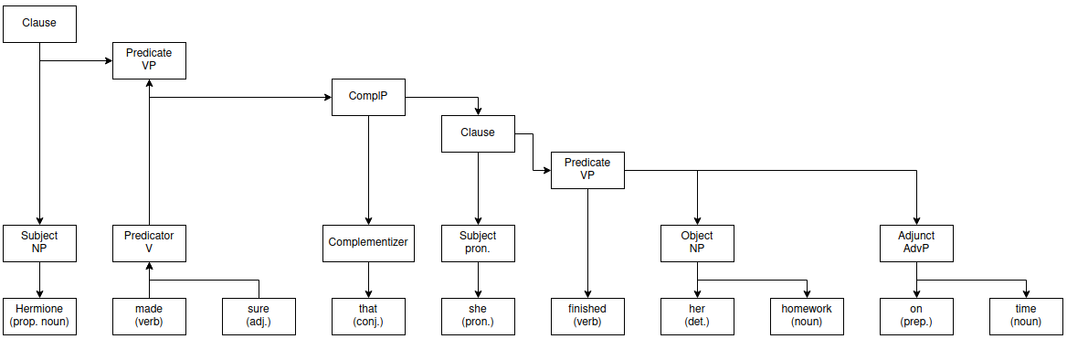

3.1.f.

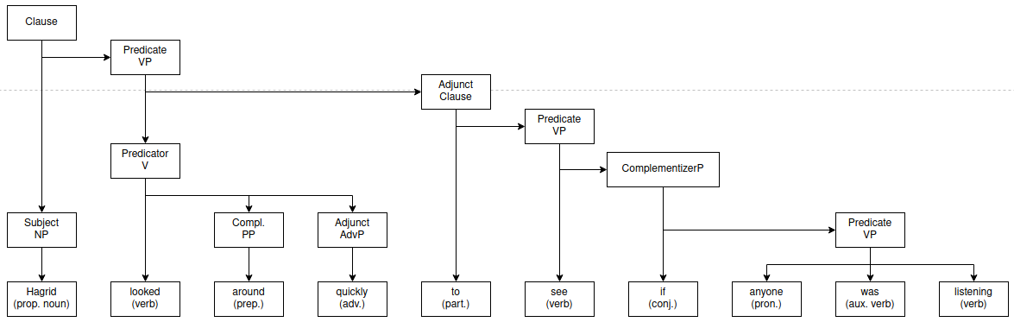

3.1.g.

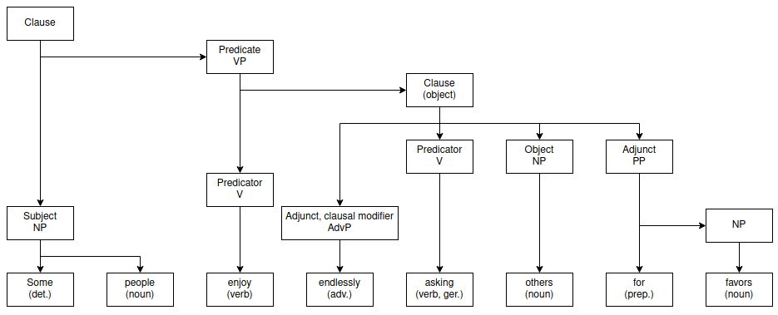

3.1.h.

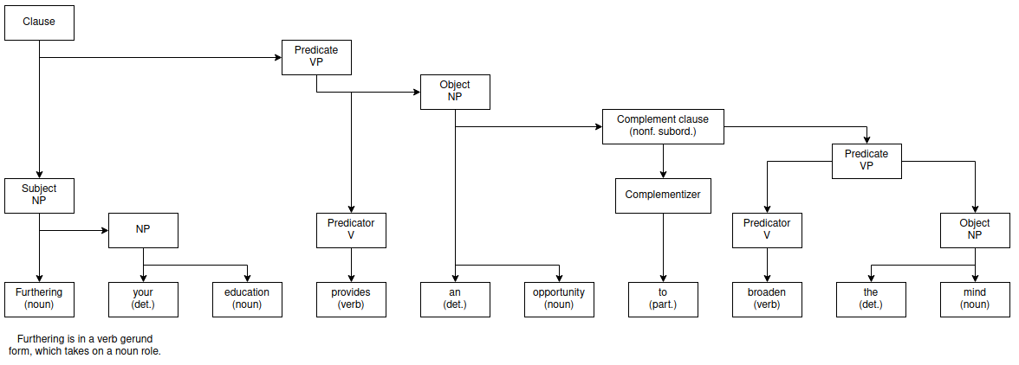

3.2.i.

a)
Clefting: *It was [???] who has given the bracelet to me by my mother.
The verb is in passive form, therefore subject constituency tests fail. (no direct subject)
However there is a verb agreement between “this bracelet” and “was given”. From this we may conclude that “this bracelet” is the subject.

h)
Clefting: It is [furthering your education] that provides an opportunity to broaden the mind.
Standard position: subject - verb - … .
Subject-verb agreement (-s ending).

3.2.ii.

b)
Object movement: I asked you to put the garbage out like one hundred times already.
Prepositional verbs can’t be separated (preposition may be placed after the object NP [2]), this must be a phrasal verb.
Sentence fragment: What did I ask you to put like one hundred times already? *Out the garbage.

c)
Object movement: *My uncle lives the street down from my grandad.
Prepositional verbs can’t be separated, which is the case here, therefore this must be a prepositional verb.
Sentence fragment: Where exactly does your uncle live? Down the street from my grandad.

d)
Object movement: *Hagrid spoke a shifty voice that got their interest at once in.
Prepositional verb for the same reason.
Sentence fragment: In what voice did Hagrid speak that got their interest at once? In a shifty voice.

3.2.iii.

We can use clause omission: Hagrid spoke in a shifty voice. Since majority of the information defining the noun voice is missing, we may conclude that it was a defining relative clause. This is supported by the lack of commas, which usually mark non-defining relative clauses.

3.2.iv.

Finiteness can be recognized by the verb markings and presence of auxiliary verbs in English. The test from the slides [1]:
- If the verb is a primary form, the clause is finite.
- If the verb is a gerund-participle or a past participle, the clause is non-finite.
- If the verb is a plain form, the clause may be finite or non-finite:
  - imperative and subjunctive clauses are finite
  - infinitival clauses are non-finite

Generally, nonfinite verbs can’t create self-standing clauses.

e) [she finished her homework on time] is a valid sentence. The verb is in primary form. Therefore finished here is finite.
f) [to see if anyone was listening] is not a complete sentence. The verb is in an infinitival form (auxiliary to). Therefore to see here is nonfinite.
g) [endlessly asking others for favors] is not a complete sentence. The verb is a gerund-participle. Therefore asking here is nonfinite.
h) [to broaden the mind] is not a complete sentence. The verb is in an infinitival form (auxiliary to). Therefore to broaden is nonfinite. (furthering is verb in gerund form, serving as a noun)

3.2.v.

Adjuncts are optional and therefore can be left out. The verb meaning has to stay the same.

- This bracelet was given to me [by my mother].
- I asked you to put out the garbage [like one hundred times [already]].
- My uncle lives down the street [from my grandad].
- Hagrid spoke in a shifty voice [that got their attention [at once]].
- Hermione made sure *[that she finished her homework on time].
Hermione made sure that she finished her homework [on time].
- Hagrid looked around [quickly] [to see if anyone was listening].
- Some people enjoy [endlessly] asking others {for favors}.
Here the distinction is less clear, since omitting for favors leads to a slightly different meaning in the verb, so it’s not classified as an adjunct.
- Furthering your education provides an opportunity {to broaden the mind}.
to broaden the mind is a complement of the noun

4. Bonus question.
4.a.

Assign each word to one of the following classes: nouns, pronouns, verbs, adjectives, adverbs, determinatives, prepositions, coordinators, subordinators, interjections. Use the colours given to each word class.

Hagrid shuffled into view, hiding something behind his back. He looked very out of place in his moleskin overcoat.
‘Jus’ lookin’,’ he said, in a shifty voice that got their interest at once. ‘An’ what’re you lot up ter?’ He looked suddenly suspicious. ‘Yer not still lookin’ fer Nicolas Flamel, are yeh?’
‘Oh, we found out who he is ages ago,’ said Ron impressively. ‘And we know what that dog’s guarding, it’s a Philosopher’s St–’
‘Shhhh!’ Hagrid looked around quickly to see if anyone was listening. ‘Don’ go shoutin’ about it, what’s the matter with yeh?’
‘There are a few things we wanted to ask you, as a matter of fact,’ said Harry, ‘about what’s guarding the Stone apart from Fluffy –’
‘SHHHH!’ said Hagrid again. ‘Listen – come an’ see me later, I’m not promisin’ I’ll tell yeh anythin’, mind, but don’ go rabbitin’ about it in here, students aren’ s’pposed ter know. They’ll think I’ve told yeh –’
‘See you later, then,’ said Harry.
Hagrid shuffled off.

4.b.

just – hard to distinguish between it being an adjective and an adverb
to/ter – can be a particle, a preposition, an adverb. The first case is a preposition what are you up to. In the second case, I would classify it as a particle, but since this class is not provided, I included it in verbs .
that – can be both a conjunction and a determinative

Part II: Semantics

5.1.

A: Bert has white hair
B: Elmo has brown hair.

Bert and Elmo are real world entities. There exists a model (M) world in which Bert has white hair and Elmo does not. Therefore we may conclude, that these two sentences have different meanings. If they had the same meaning, every model would assign both of them the same truth values.

5.2.

A: The statement X is true and X is not true.. (contradiction, always false).
B: Either the statement X is true or X is not true. (tautology, always true)

No. The following sentences have different meanings (because there exists a model in which their truth values differ), though A is never true and B is never false.

6.1.

6.2.

Monotone decreasing iff(closed under subsets)

6.3.

For monotone increasing quantifiers, we may infer the base property from a more specific one: All men are hairy raptiles. All men are raptiles.

For monotone decreasing quantifiers, we may infer more specific properties from the base one: No man is a raptile. No man is a hairy raptile.

In both examples we assume that . The fact that hairy reptiles do not exist is not important, may as well be nonempty. In general, for a quantifier to be monotone, it has to be closed under subsets (decreasing) or supersets (increasing).

7.1.a.

The implicit assumption in the sentence that there exist an entity with the name of Harry has been made explicit in the formula. For brevity, this could simply be replace by a constant harry:

Explicit translation: The fact that harry can do magic is the reason why he is a wizard.
can_do_magic(x): entity x is able to do magic.
is_wizard(x): entity x is a wizard (belongs to the set of wizards)

7.1.b.

Here magic and hogwarts are constants. learns_at is a ternary relation (<who>, <what>, <where>). learns_at could be rewritten with neo-davidsonian events. This is more complex to write, but easier to depict in a graphical form (binary relation as an arrow/edge, while ternary and higher order relations require a hypergraph structure).

Explicit translation: If someone is a wizard, then there exists a learn event, of which that person is the agent, magic is the object and hogwarts are the location.
Alternatively: If someone is a wizard, then they learn magic at hogwarts.
learns(e): event e means to learn
agent, object, location: standard thematic roles

7.1.c.

knows is a binary relation (<who>, <whom>). It is not necessarily symmetric, though it is rational to assume reflexivity. The unary relation is_muggle could be perhaps rewritten as, which would decrease the number of used relations (assuming we would already have to use is_human). On the other hand, I never read Harry Potter and am not sure whether anyone who isn’t a wizard but is human is necessarily a muggle, therefore is_muggle is safer to use.

Normally with two exisential quantifiers, we would perhaps need to include non-equality between the variable (), which is a hidden assumption in natural language. Here it is not needed, because the relation can_do_magic would discriminate the same x, who is a muggle and can’t do magic.

Explicit translation: If someone is a muggle, then they can’t do magic and if someone else can do magic, then they don’t know them. The or in the original sentence becomes a logical and here.
is_muggle(x): entity x is a muggle (belongs to the set of muggles)
knows(x,y): entity x knows entity y, reflexive

7.2.a
In this model, there are no muggles, which trivially fulfills the last statement.
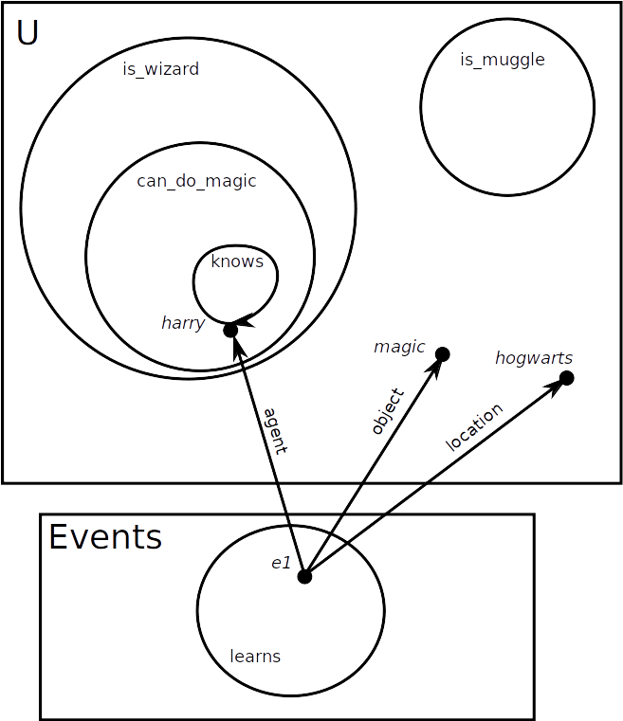
Graphical representation:
7.2.b.a

7.2.b.b

7.2.b.c

8. Bonus question.

Soudness is a property that ensures that every statement that is derived by the system is true. Completeness property ensures that every statement that is true can be derived by the system.

Both properties can be “cheated” by a system that does not prove anything (soudness) and a system that claims every statement is correct (completeness). Apart from these degenerate corner cases, we are usually interested in a system that is both sound () and complete ().

Part III: Pragmatics

9.1.

Centering theory is used for modeling coherence on a local level. It operates on entity mentions (referring expressions generally) in a sequence of utterances (usually sentences) and observes how the attention/focus and overall mentionss change. Higher changes are interpreted as a sign of a less coherent text.

For every utterance U_{t} we define the following sets:
- Forward looking centers C_{f} (U_{t})
  - Ordered set of referencable expressions in the current utterance
  - Ordering is provided by the “salience” of the given entity
    - Commonly subject < object < other classes
- Prefered center C_{p} (U_{t}) = C_{f} (U_{t})¹ (highest ranking element in C_{f} (U_{t}))
  - We expect this element to be referenced in the next utterance
- Backward looking center C_{b} (U_{t}) = C_{p} (U_{t-1})
  - Prefered center of the previous utterance
  - Starts as NULL

We may then examine the transitions with respect to the introduced sets. From the prefered (highest local coherence) to the least prefered (changes in focus, least local coherence):

- C_{b} (U_{t}) = C_{b} (U_{t-1}) and C_{b} (U_{t}) = C_{p} (U_{t})
- C_{b} (U_{t}) = C_{b} (U_{t-1}) and C_{b} (U_{t}) != C_{p} (U_{t})
- C_{b} (U_{t}) != C_{b} (U_{t-1}) and C_{b} (U_{t}) = C_{p} (U_{t})
- C_{b} (U_{t}) != C_{b} (U_{t-1}) and C_{b} (U_{t}) != C_{p} (U_{t})

This provides us with a coarse algorithm that we can use to estimate coherence of a text by just looking at the referring expressions. Notation and description based on the lecture [5].

9.2.

A rule that is often observed by the speakers is that if C_{f}(U_{t}) is expressed as a pronoun in an utterance U_{t+1}, then C_{b}(U_{t+1}) must also be a pronoun [5]. This makes the usage of pronouns somewhat more consistent and easier for the listener (though it can be violated). The following example illustrates such a violation (with 3a) and fix that satisfies this rule (3b).

- Subject: A
- Subject: A (pronominalized), Object: B

  - Subject: B (pronominalized), Object: A
  - Subject: B (pronominalized), Object: A (pronominalized)

For the pronoun disambiguation, we will act as if this rule is always satisfied (whenever possible). Given a sequence of utterances, we first have to determine the refering expressions. The next step is to create all possible C_{b}(U_{t}) – C_{f}(U_{t}) combinations. From these, the connections with mismatching agreement (e.g. she + masculine entity) are removed. Transitions violating the aforementioned rule are also removed. Pairs are then ordered so that the text is maximally coherent (given the ordering in 9.1).
In case of a tie, the assignment which mentions an entity in the previous sentence is considered.

9.3.

The centering theory makes a very strong assumption about the way people use refering expressions in their utterances. It takes into account the grammatical roles very coarsly. Importantly, entity grid models the transition patterns statistically instead of specifying which transitions as good (e.g. continue) or bad (e.g. rough shift). In more general terms, the entity grid allows for a data-driven approach in which we may estimate mention distribution for coherent and incoherent texts.

For every refering expression in annotated data we mark its occurrence together with its grammatical role* and then aggregate of these occurences+roles. At the end we get a generative (joint probability) description of the transitions with respect to the grammatical roles. This way we may find out, that e.g. the transition from entity being mentioned as a subject twice in a row is higher than first being a subject than an object.

*This could be generalized in such a way that instead of aggregating over grammatical roles, other features are used (e.g. position in the sentence or relation to other entities).

9.4.

The neural entity grid model trains a neural network in a supervised way to predict the coherence of a document.

Grammatical roles (of mentions in segments – same initial step as in entity grid model) are encoded as feature vectors using a trainable embedding (can be pre-trained for different tasks). This is followed by a convolutional layer, which apply the same filters at multiple positions at once, therefore learning position-invariant structures. The perceptive fields of this convolutions are able to capture the transitions of a given entity (e.g. SS-O-X in a coherent text [6]) The output of this is a variable length tensor, so max pooling (extracts the maximum from each feature map) is applied to reduce the dimensions into a fixed size vector representation. This last layer is multiplied by a weight matrix with a bias added (linear regression). The output is a real value from which we can compute the loss (we know the coherence scorings of the documents) and backpropagate the gradient to update the weights.

The main advantage is representation learning of the feature vectors (entities and their roles). Secondly, this allows for the model to be optimized by just specifying the gold outputs and the loss function.

10.

- O-quality:
  - Benjamin Lee Whorf was an American linguist and fire prevention engineer.
  - Derivation:
    - We assume that the Wikipedia editor followed the maxims and tried to be cooperative.
    - We assume that the editor believes the information shared (no reason to not think this) and has adequate evidence for it.
  - Source: https://en.wikipedia.org/wiki/Benjamin_Lee_Whorf
- O-quantity:
  - Some of them [manuscripts] were published in the years after his death by another of Whorf's friends, Harry Hoijer.
  - Derivation:
    - We again assume that the Wikipedia editor followed the maxims and tried to be cooperative.
    - Semantically, it could be true that in fact all manuscripts were published in the years after Whorf’s death. However, if this was true, then the editor (following the maximum of quantity) would have used the word all and not some.
    - Therefore we can conclude that there are some manuscripts, that weren’t published in the years after Whorf’s death.
  - Source: https://en.wikipedia.org/wiki/Benjamin_Lee_Whorf
- O-manner:
  - Idaho police say they shot and killed an armed man in his own yard after mistaking him for a suspect.
  - Derivation:
    - We assume that the author is trying to give an accurate description of the events.
    - In this context, there is no reason to believe they are not adhering to the conversational maxims or are not trying to be cooperative.
    - Nothing suggests that a maxim has been violated.
    - Therefore we may conclude, that when the police shot, they shot into the armed man, which resulted in his death (happened after the shooting). (Another possible reading would be that the police shot into the air, and then beheaded the otherwise healthy man on e.g. a guillotine.)
  - Source: https://edition.cnn.com/2021/02/09/us/idaho-man-shot-suspect-search/index.html
- F-manner:
  - Meghan Markle, Prince Harry expecting baby No. 2
  - Derivation:
    - The term baby No. 2 is obscure.
    - The author of the headline knows that it is obscure, knows that we find it obscure and knows that we understand that it roughly means second baby.
    - In order to make the headline more interesting, the author chose baby No. 2 over second baby.
    - The meaning of baby No. 2 and second baby is almost identical, though the first one is perhaps a bit deragatory and may express the author’s views of the royal pair.
  - Source: https://www.foxnews.com/entertainment/meghan-markle-prince-harry-expecting-baby-no-2
- F-quality:
  - mountains of waste are sometimes set alight to save money
    - The author of the article tries (1) to communicate a factual message and (2) tries to make the text enjoyable to read. This means, that they are cooperative in this effort.
    - The author knows about our knowledge of the world and that mountains can’t be artificially created.
    - We know that the author knows this about us, therefore we can establish that the usage of mountains was an exaggeration for stylistic purposes.
    - The true meaning is that huge piles of waste are sometimes set alight to save money.
  - Source: https://www.dw.com/en/polands-growing-problem-with-illegal-european-waste/a-55957224
11.1

The literal listener interprets utterances from semantic point of view. They do not take the options of the speaker into consideration. Therefore, smiling in this case would refer to the second, the third and the fourth face all at once, because they all have the properties of smiling faces.

The interpretation function is composed of a “gate” (property in utterance u matching (1) or not matching (0) to an object s) and apriori belief (distribution).

11.2

The pragmatic speaker has a conception of the literal listener and tries to make them successfully recognize the given object in question. Therefore, a pragmatic speaker would not use the term smiling to refer to the third picture, because they know, that a literal listener could not distinguish this from the other two faces.
The pragmatic speaker could then use the term glasses, because this is unambiguous from the position of the literal listener.

The pragmatic speaker could be overly specific, which would ensure that the literal listener would always recognize the object, though this also has the cost of having to always formulate long utterance. Because of that, the distribution of the rational speaker is composed of two components surprisal of the L₀ speaker and the cost of the utterance.

11.3

The pragmatic listener would interpret the term smiling as the last face. They have a conception of the options of the pragmatic speaker. If the pragmatic speaker wanted to refer to the second face, they would have probably used the utterance halo (or angelic). If they wanted to refer to the third face, they would have used glasses. Lastly, smiling can’t refer to the first face, because it’s simply not smiling.
Since the last face does not have any distinctive features that could be used to identify it and the two other semantically alowed faces could be refered to in an unambigous ways (halo, glasses), the utterance smiling refers to the last face.

Formally, the pragmatic listener combines the utility function of the pragmatic speaker and apriori beliefs over possible objects. Source [7]

12. Bonus question.

- Classification/ontology of discourse relations.
  - The reasoning for boundaries in definitions of discourse relations are not clear.
  - Two different annotation schemas may arrive at concepts, which may overlap, but not necessarily correspond 1:1. E.g. one class in PDTB could be a subset of another class in RST, or they could overlap but not be in any subset relation.
  - This obscures the goal of universal discourse relation analysis.
- Modeling real-world context.
  - To make decisions regarding the author intentions and transitively e.g. nuclearity, knowledge and understanding of the real world is neede.
  - This may be very hard to capture automatically with ML models.
  - Explicit knowledge-bases and hybrid models attempt to make progress in this area, although there is a meaning which goes beyond information stored in knowledge-bases.
- Optimal shape of the discourse representation.
  - So far the discourse was modelled as a tree (in RST strictly projective) with single relation between two spans.
  - This is a strong assumption and limit to what we can express with the current description.
  - The best representation could perhaps be a multi-/hyper-graph (multiple edges, sets of verticies), which would allow for relations between any spans, more than one relation per two objects and more than two objects in an edge.
  - This is however makes it much harder to model, since there are much fewer restrictions.
- Although not an inherent challenge of discourse relation classification, [3] reports lack of consistency in evaluation and presenting results. (This is eerily comparable to [4] in MT).

Part IV: Phonetics

13.

Phonetics tries to capture more physical aspects regarding the sounds humans produce for communication. The main goal is to describe the way the given sounds are produced (e.g. properties of larynx, pharnx, mouth and nose cavity, palate, lips) and perceived on a physical level (acoustics) and how this can be observed, measured and quantified. Units are universal across languages (e.g. categorized by IPA). Human pronunciations is measured and modelled mathematically. Phonetics tries to be as detailed as possible.

On the other hand, phonology tries to interpret these sounds usually with a relation to a specific language (sound system of a language) and the patterns and their meanings. This is done by an abstraction over the physical properties of the sound. The smallest meaningful unit in phonology is a phoneme. Furthermore, allomorphy and the distribution of phonemes in the language is also studied here. Phonology usually follows after phonetics.

The figure is an illustration of the fact, that phonology tries to be more abstractive to reach conclusions and generalizations, while the goal of phonetics is to capture the true state of the world as detailed as possible.

14.

- The articulation of some words may be different to fit the context better (e.g. /ˈeɪ/ vs /ə/).
- Words may blend together e.g. in case the first ends with a consonant and the other begins with a vowel.
- Speakers also have to manage their breath. This leads to an effect in which some words are pronounced faster as the breath capacity comes to an end. In cases of words spoken separately, the speakers may take care to breathe in before every word, therefore mitigating this effect.
- There’s also a higher level aspect and that is sentence intonation (rising with questions). Finally, assuming the continuous speech is part of some larger discourse, the pronounciation also has prosody markings. Words may have different meanings/interpretation depending on which part of the sentence is stressed.
- From psycholinguistic point of view, it is easier to listen to a sentence, because of anticipatory cues.

We invite you to have a great time in Paris.

- In connected speech a would be pronouncend probably as /ə/, while when spoken separatedly, it would be pronounced as /ˈeɪ/, to be more distinctive. Generally the words spoken individually will be longer than in continuous speech.
- invite ends with a consonant (/t/), while you starts with a vowel (/j/). In connected speech (without stressing the word you), there wouldn’t be a space (or a small one) between these two words.
- In this case the sentence is too short for breath effects to be visible (the speaker won’t run out of air).
- Based on the information the speaker is trying to convey, they may stress different words: we, invite, you, great, Paris.

15.

Words are alwas consonant initial, vowel final and consonants and vowels form a regular pattern CVCVCV…

Phoneme | Observed contexts | Generalization
ch | a_i, i_i | _i
f | #_u, h_u | _u
h | #_a, o_e, #_i, #_o | not _u
sh | a_i, u_i, #_i | _i
t | u_a, i_a, o_o, #_a, a_e | not _i, not _u
ts | a_u | a_u
s | u_e, i_u, #_o, #_u, u_a | not _i

Notation: replace _ with the given phoneme, # marks the beginning of a word, not X are all contexts which do not match X.

There are no contrastive minimal pairs (words differing in just one phoneme). Some of the pairs (e.g. h-sh) occur in overlaping (analogous) environments, from which we can conclude, that they all belong to different phonemes.

The pairs ch-t, ch-s, sh-t, sh-s (_i / not _i), f-h, ts-h, f-t (_u / not _u) occur in complementary distributions, but they are however phonetically distant and therefore their allophony is improbable. Other pairs with non-overlaping contexts include ch-f, ch-ts, sh-f, sh-ts (_i / _u), but we do not conclude allophony for the same reason as before.

There two candidates for allophony (motivated by the complementary contexts):
- t-ts (not _u / a_u), which bear some phonetic similarity (esp. in production). ts could be selected in _u contexts.
- s-ts (not _i / a_u), these are more phonetically similar, though the selection for ts would be restricted to just the context of a_u (and perhaps also e_u, i_u, u_u, for this we would need more examples) and not just _u, becaue s was already observed in i_u.

16.

The source-filter model tries to model the production of speech (output wave/energy spectrum). It decomposes the signal into two parts Source-Filter (lungs included for completeness).

- Power: a stream of air from the lungs
- Source (excitation):
  - vocal folds vibrate in the air flow, which creates a periodic wave
  - vibrations in the larynx
  - fundamental frequency F0 originates here
- Filter (acoustic filter, sound formation):
  - modulates the input source wave
  - happens in vocal tract, which can be very roughly approximated with a half-open tube
  - intentional (by the speaker) changes in the properties of the mouth modulate the glottal pulses

The excitation / source produces repeated harmonics (with diminishing intensities). See the sketch (top left). The filter is a theoretical function (top right), that modulates the source, producing the output signal (bottom). The output energy signal still shows the repeated harmonics, which are, however, modulated by the filter. Should the excitation change, the samples would be differently positioned, though the overall output signal shape would remain similar.

Sketch based on figures from [9]

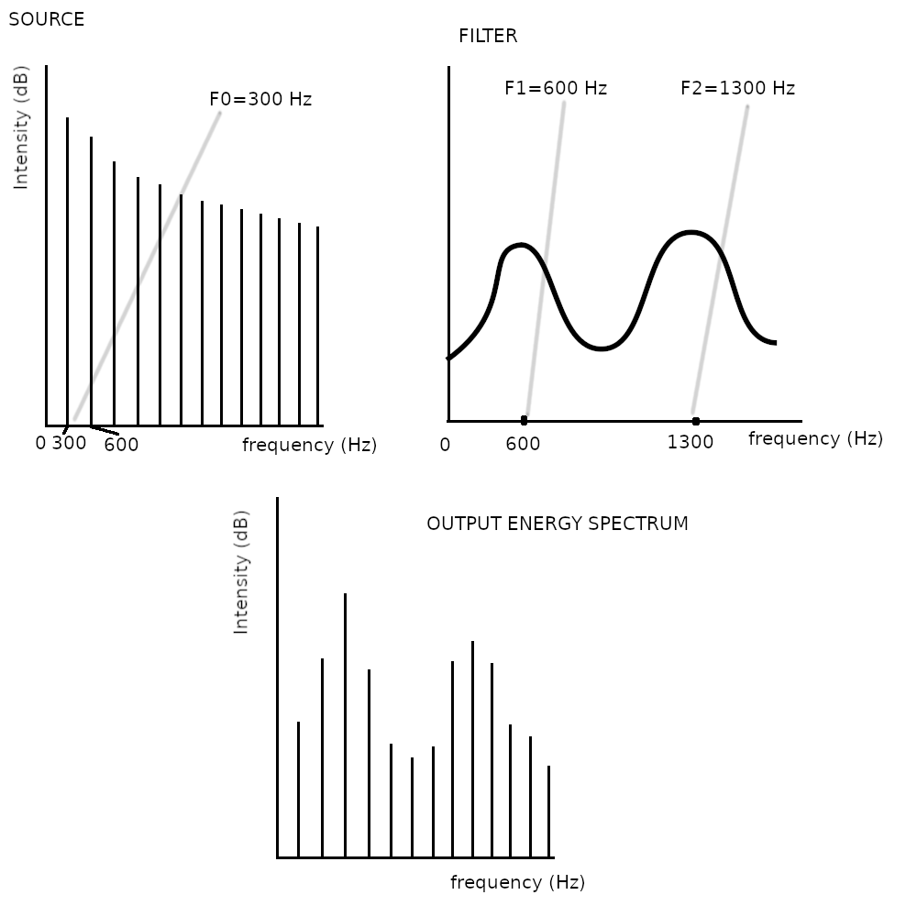

Formants are peaks of energy in the spectral decomposition (resonant frequencies). We distinguish F1, F2, … (top right). They are the reinforcement of certrain frequencies and are formed by the deliberate shapes in the vocal tract (i.e. speaker willingly changes the F1, F2, .. formants to produce different sounds and be understood).

The recognition of e.g. vowels depends largely on the formants (F1, F2, … ), which are independent of the excitation signal (they are created by a filter), given that it’s in a reasonable range for speaking. When singing, the F0 can be moved by the singer to higher values (for artistic purposes), which may make further recognition of the individual formants difficult (harmonic peaks present at multiples of F0). Because of this, singers have learn to produce phonemes differently for them to be also understandable with high F0.

17. Bonus question.

The y-axis in the chart represents the jaw opening but also tongue height in the mouth (close – chart top – tongue close to the palate, open – chart bottom – tongue at the bottom). The x-axis is also tongue position along the tract (front – chart left – tongue close to front, back – chart right – tongue further back).

The chart is not a square, but rather a trapezoid with the bottom left position “missing”. This is because it’s impossible to have tongue in the front and also high. This creates a correlation, because the higher the tongue is, the more in back it has to be.

Image edited, source [8]

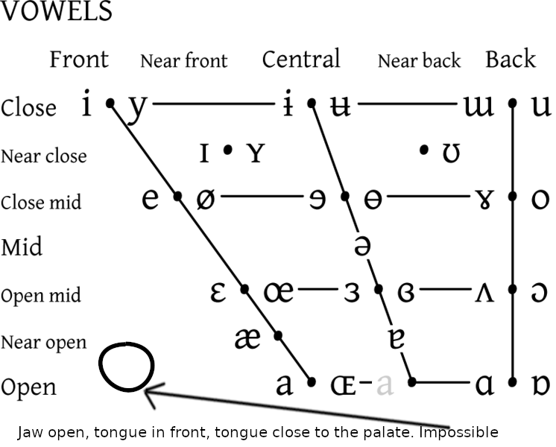

References

- Lecture slides Morphology & Syntax/Found_Ling_3SyntaxI.pdf
- Lecture slides Morphology & Syntax/Found_Ling_4SyntaxII.pdf
- https://www.aclweb.org/anthology/2020.acl-main.480.pdf
- https://www.aclweb.org/anthology/W18-6319.pdf
- Lecture slides Pragmatics/Cohesion.pdf
- https://www.aclweb.org/anthology/P17-1121.pdf
- http://www.problang.org/chapters/01-introduction.html
- https://en.wikipedia.org/wiki/File:IPA_vowel_chart_2005.png
- Lecture slides Phonetics/FoundLing_acoustic-phonetics_2020.pdf

