January 4 2021
IBM Data Science Capstone
Battle of Neighborhoods – Paris
Mini Report

Zouheir Couyed
Introduction
The instructions relative to this project are “to leverage the Foursquare API to solve a problem of your choice using location data.”
Business Problem
The problem I have chosen to solve for this capstone is the following:
Based on the user's input of venue categories, return candidate neighborhoods that contain venues belonging to the categories of interest entered by the user.
It is easy to search on the web for a specific venue, a venue category or a certain neighborhood and obtain information.
However, what if a person wants to eat Chinese for lunch, watch a movie, go to a café, browse for music at a store, have Italian for dinner and finish the night at a bar, all in the same neighborhood so as to minimize distance traveled?
The objective of this project is to attempt and solve this problem by leveraging the Foursquare API, so as to obtain suggested candidate neighborhoods that contain venue categories of interest to the user.
The following users may be interested in this type of solution:
- tourists that may want to book a hotel next to certain venue categories
- a person who would like to buy an appartment in the city of Paris in poximity of specific venue categories (a gym and a cafe for example)
- a local Parisien who wants to minimize the distance traveled and visit all venue categories of interest, all in the same neighborhood

But first, out of curiosity, I would like to cluster the neighborhoods in Paris using k-means (part of section 3 and section 4 of the jupyter notebook are dedicated to clustering the neighborhoods).

The Dataset
The starting dataset will be obtained from https://opendata.paris.fr/explore/dataset/quartier_paris/information/ and is composed of the neighborhoods in Paris and certain characteristics such as their geographical coordinates, the surface area, and the district to which they belong.
As specified, Foursquare.com shall also be leveraged to obtain location data mainly concerning the venues in Paris.

Methodology
This section presents the methodology followed during this project that was perfomed on a jupyter notebook on IBM’s tool available in Skills Network Lab.
Reading & cleaning data
After downloading the python libraries and dependencies needed on this project, the first step was to import the dataset to the jupyter notebook for cleaning. The first 2 rows of the original dataset are shown below.
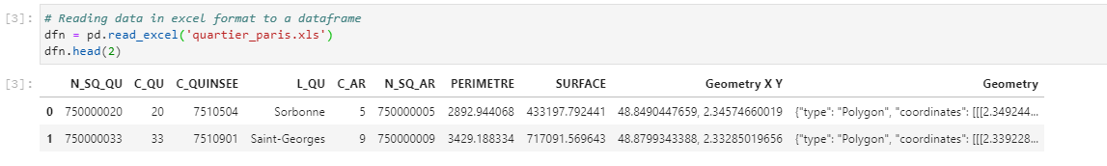
The latitude and longitude values, which were the variables of interest, were found in the column 'Geometry X Y' as one value. This column was separated into 2 distinct columns in the new dataframe. Certain columns that were not going to be used were dropped and the last step was to rename the columns into more meaningful terms, as shown below.
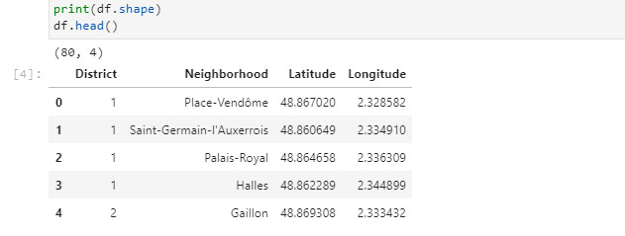

Visualizing the data on a map
The next step was to leverage Folium to visualize this data on a map. The red markers in the map shown below correspond to the 80 neighborhoods that compose Paris.
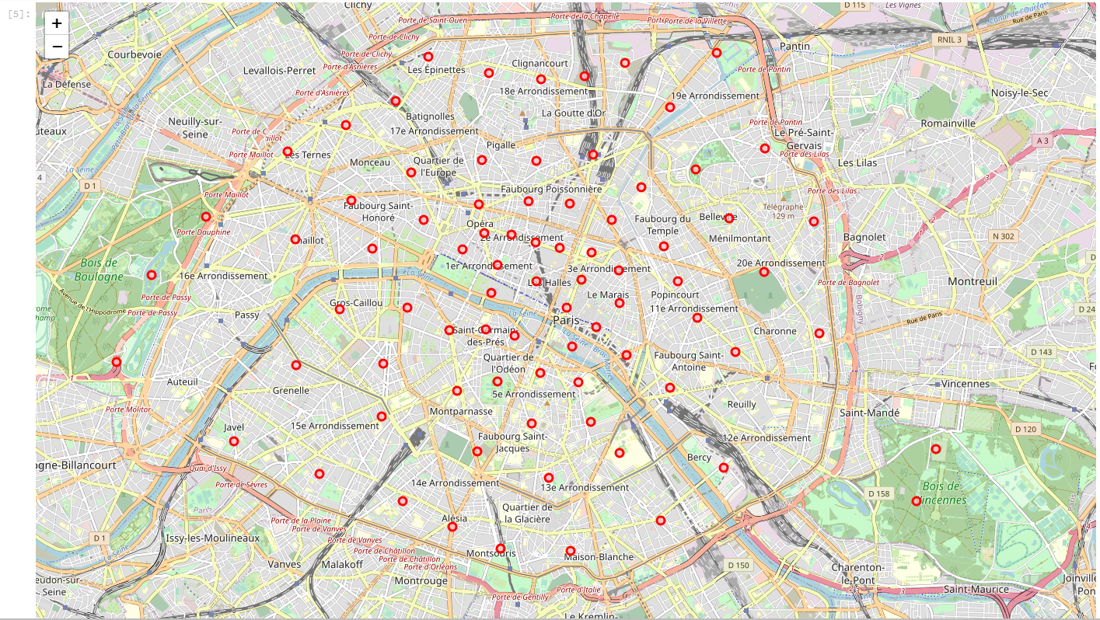
While the markers for certain locations (circled in black on the map) corresponded to the geographic centers of their respective neighborhoods; they were not satisfactory as these points were offset by large parks that make up these neighborhoods. For example, Auteuil's marker is offset towards Bois de Boulogne (bottom left of the map). No people live in Bois de Boulogne and Bois de Boulogne could be considered itself a venue. It makes more sense to focus on a point that corresponds more closely to the center of the 'neighborhood where people live', not necessarily the geographic center of the neighborhood.
For this reason, a geolocator instance was used to obtain new coordinates for certain neighborhoods that seemed offset for one reason or another.
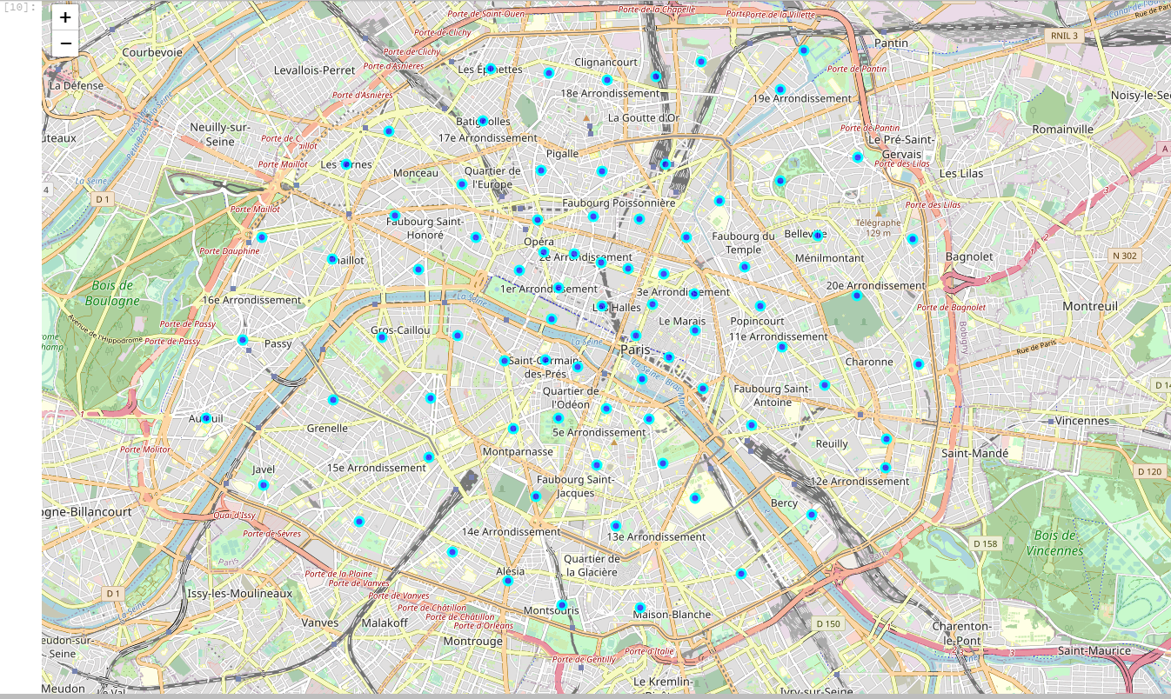
The map above shows that the all the points are inside the boulevard peripherique, and correspond better to areas where people live. They were used for the rest of the project.

Obtaining the venues in Paris

The function used in lab 3 to generate venues for the city of Manhattan through an API call to Foursquare was borrowed to generate venues for Paris, as shown in the dataframe below . The radius used in the API call is 500 meters.

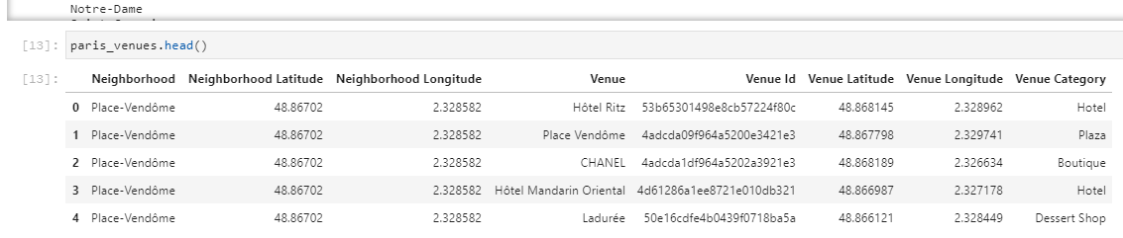
The resulting dataframe paris_venues contains 5291 venues returned by Foursquare, of which 299 unique venue categories. This dataframe shall be the basis for the next and final part of the project, consisting of returning candidate neighborhoods, based on venue categories entered by the user.

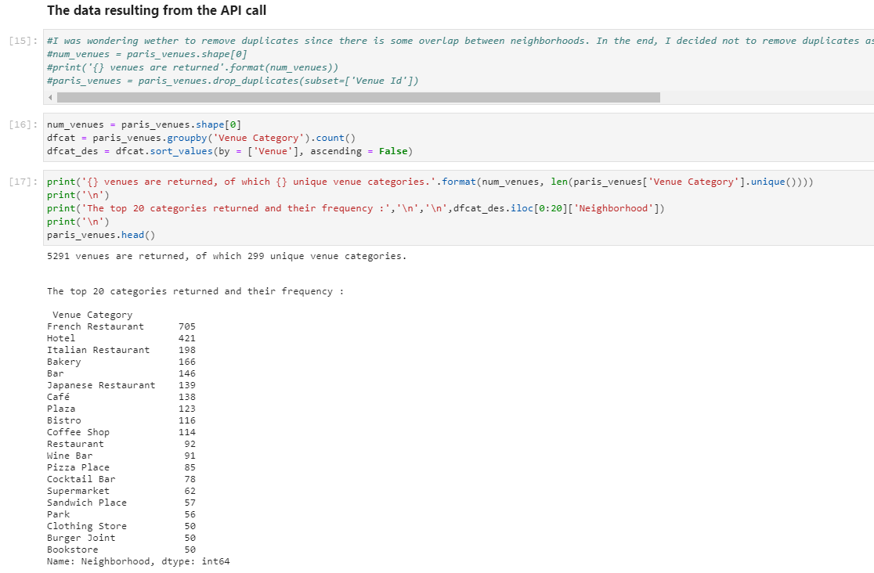
This dataframe contains duplicates, due to overlap of venues created by the fact that certain neighborhoods are close to each other, and by a radius of 500m applicable to all neighborhoods. In the end, it was decided not to remove duplicates as the radius that is taken into consideration through the API call defines the notion of neighborhood. Said otherwise, removing duplicates in this case means removing a characteristic of that said neighborhood.
The last part consists of asking the user for input, it is described in the Results section.

Results
First, the user is asked the number of venue categories desired in the neighborhood of interest. Then the user is prompted to list each category.
The previous dataframe was then searched and trimmed to return neighborhoods which contained the venue categories of interest to the user.
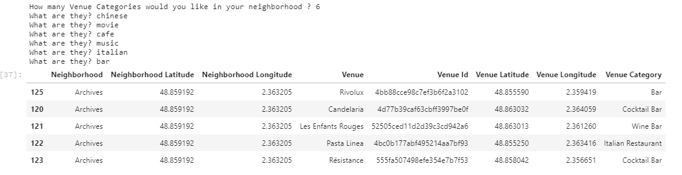
In the introduction, a case was given where a person wants to eat Chinese for lunch, watch a movie, go to a café, browse for music at a store, have Italian for dinner and finish the night at a bar, all in the same neighborhood so as to minimize distance traveled?
What is returned is the list of neighborhoods containing these categories and the number of venues per category.
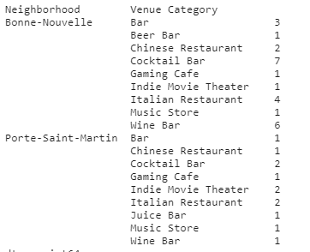

Finally, a map is used to visualize the neighborhoods (grey circles) as well as the venues (red markers) that may interest the user, as shown below.
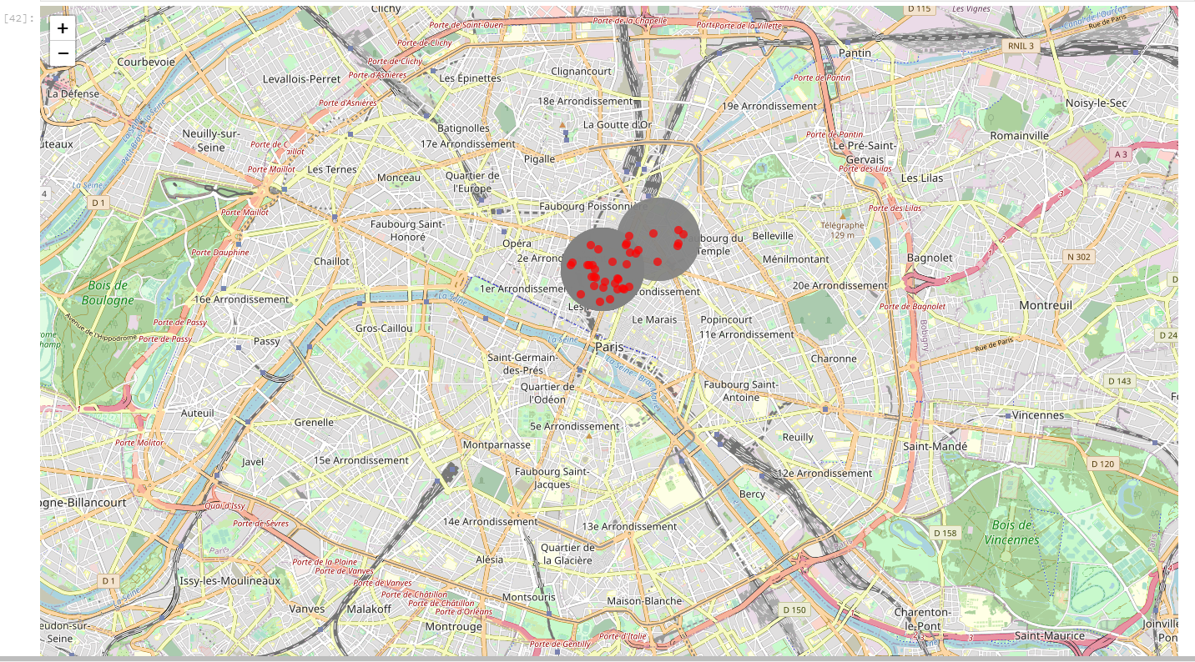
Discussion
This project yielded good results, and a working solution to the problem. Nevertheless it could be improved as using neighborhoods may not be as ideal as creating a grid on top of the map of Paris. The reason is that not only do districts vary in surface/size, but also neighborhoods. Since their shapes are variable, some are close to each other, some are very spaced out compared to others; the value of the radius used to make the Foursquare API call is either too large (overlapping venues) or too small (missing venues) in many cases. Using a grid with evenly spaced locations would not only result in better coverage of the surface (we would get more venues), but also would prevent from creating any overlap (2 or more neighborhoods sharing the same venue).
One important question relating to this tool is “What happens if no neighborhoods are returned because not all venue categories exist in that neighborhood”? In this case, and in the context of this project, the user will not obtain any answer, however, it is definitely a question to take into consideration.
Conclusion and further studies
While it did take some time to build, in retrospect, a tool that could be useful to people was built leveraging Foursquare location data. Going further, one may want to use a grid as mentioned in the Discussion section, maybe use both Foursquare, Google maps and other API’s to obtain as many venues as possible.
What may also be interesting is to obtain a rating for every venue and make it available on the map when a user clicks on a marker.

