Adjust subcomponent crossover rate for differential evolution (ScrDE)
- 数据驱动
- 统计特性，与sort_JADE对比（特例）
- 不用子函数的评估，与CRAsDE对比
As the most widely used crossover scheme in DE literatures, ScrDE offers three main advantages:
- Data driven algorithm: adjust subcomponent crossover rate according to the data, so that the algorithm has adaptability to different problems and different stages of the problem.
- Compare to CRAsDE, there is no need to find to local fitness function to represent the quality of the jth subcomponent. And ScrDE can fit to more numerical optimization problem.
- Compare to sort_JADE, it’s more general.

abstract

Introduction

background

classical DE algorithm

initialization

mutation

crossover(binomial, exponential)

selection

Related work
Sort_JADE

Proposed ScrDE algorithm
- Overview

The aim of the proposed new crossover strategy is to
As the most widely used crossover scheme in DE literatures
Besides the above features, the new strategy is expected to overcome the limitations of existing crossover operators in handling different subcomponents.
Fig. 1 illustrates the limitations of the two traditional crossover operators.
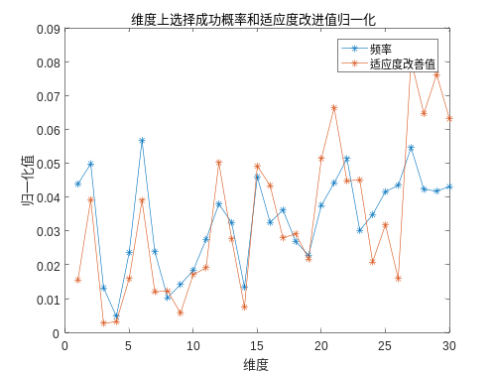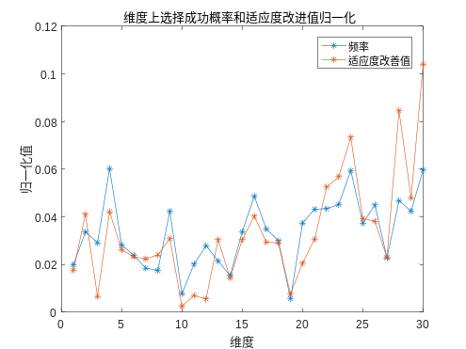
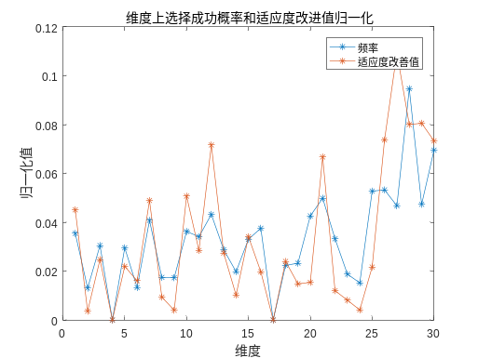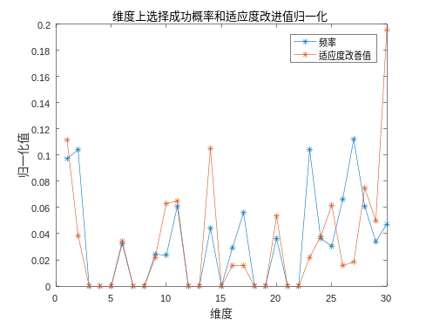
Fig. 1. Limitations of binomial recombination. Different subcomponent with different successful frequency should have different crossover rate.

- Algorithmic Structure
The main idea of the proposed strategy is…Fig. 2 and Algorithm 1 demonstrate the standard procedure of Adjusting subcomponent crossover rate for differential evolution.
success rate

sub(1) |  | sub(2) |  | sub(3) |  | … | sub(D-1) |  | sub(D)
CR(1) |  | CR(2) |  | CR(3) |  | … | CR (D-1) |  | CR(D)
CR

Fig.2. Description of CR sorting mechanism

special case: sort_JADE

EXPERIMENTAL RESULTS
The 25-benchmark functions are used to test the effectiveness of the proposed JADE_sort algorithm. These functions are presented for CEC-2005 competition. The detail description of functions can be found in [34].
30次独立运行的均值和方差。30维、50维
Compare with DE/rand/bin/1,DE/best/bin/1
Compare with sort_JADE（DE）
Compare with sort_JADE（JADE）

cONCLUSION

