# 

# **Abstract Code - ERMS main menu**

Find the current User using the username;

Display user’s name, population size, jurisdiction or headquarters depending on user type;

Display menu options;

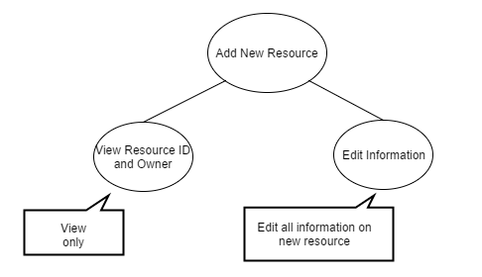

# **Abstract Code - Add New Resource**

View auto assigned Resource ID, Owner Name;

While no buttons are pushed, do nothing;

While a button is pushed, then do the following:

{If Save:

Validate all fields

if all fields are valid:

{Update attributes of Resource (name, ESF, model, capabilities, home Location, cost);

Go back to the ERMS main menu of user;}

else:

{Show invalid fields and ask for new valid inputs;

Wait for another button push;}

If Cancel:

{Void the auto assigned ID;

Go to ERMS main menu of user;}}

# 

# **Abstract Code - Add Emergency Incident**

Display auto assigned Incident ID;

While no buttons are pushed, do nothing;

While a button is pushed, then do the following:

{If Save:

Validate all fields

if all field are valid:

{Update attributes of Incident (Date, Description, Location);

Go back to the ERMS main menu of user;}

else:

{Show invalid fields and ask for new inputs;

Wait for another button push;}

If Cancel:

Go back to the ERMS main menu of user;}

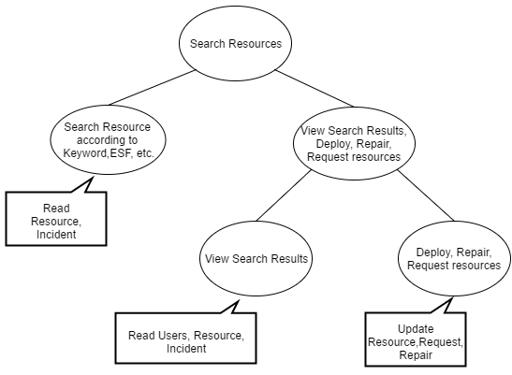

# **Abstract Code - Search Resource**

While no buttons are pushed, do nothing;

While a button is pushed, then do the following:

{If Search: Display Search Result table according to search conditions;

If Cancel: Go to ERMS main menu of user;};

**Search Result**

Find the Incident according to search conditions;

Display the name and ID of incident;

Find the resources according to search conditions;

Display the resources and their attributes, sorted by distance, then availability and then name;

While no buttons are pushed, do nothing;

While a button is pushed, then do the following:

{If Deploy: Update resource; Input expected return time;

else if Repair: Update resource; update repair; Display repair form;

else if Request: Update resource; update request; Display the resource status;

If Close: Go to ERMS main menu of user;}

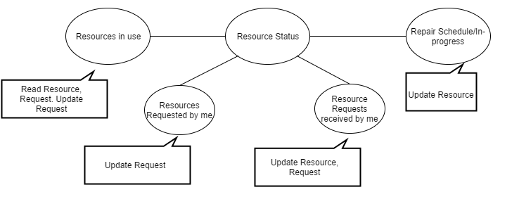

# **Abstract Code - Resource Status**

# **Resources in use**

Find all resources in use of current user;

Display the resources attributes sorted by resource ID;

While no buttons are pushed, do nothing;

While Return button is pushed, then do the following:

{Update resource;

update request;}

# **Resources requested by me**

Find all resources requested by me;

Display the resources requested by me attributes sorted by resource ID;

While no buttons are pushed, do nothing;

While Cancel is pushed, then do the following:

{Cancel request;}

# **Resources Requests received by me**

Find all resources requests received by me;

Display the attributes of resources requests received by me, sorted by return by date;

If the resource is available, do following:

{display Deploy button;}

Display Reject button;

While no buttons are pushed, do nothing;

While a button is pushed, then do the following:

{If Deploy: Update resource; update request;

else if Reject: Cancel request;}

# **Repairs Schedule/ In-Progress**

Find all resources being or has been repaired;

Display the ID, name, and start/ready date of these resources;

While no buttons are pushed, do nothing;

While Cancel is pushed, then do the following:

{Cancel repair;}

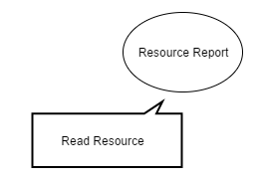

# **Abstract Code - Resource Report**

Find all resources of current user;

Calculate the total number of resources and resources in use according to ESF number;

Display the ESF number, ESF description, total source number and number of sources in use;