Portfolio Documentation
Excel Data Analysis & Automation Project

Name: Vezinduna Mbekezeli Ndlovu

Part 1 — Data Preparation & Cleaning

Step 1: Consolidate Sales Data
Copy the entire Sales_Q1 sheet (including headers) to a new sheet named Sales_All, then appended only the data rows from Sales_Q2 and Sales_Q3 below it.

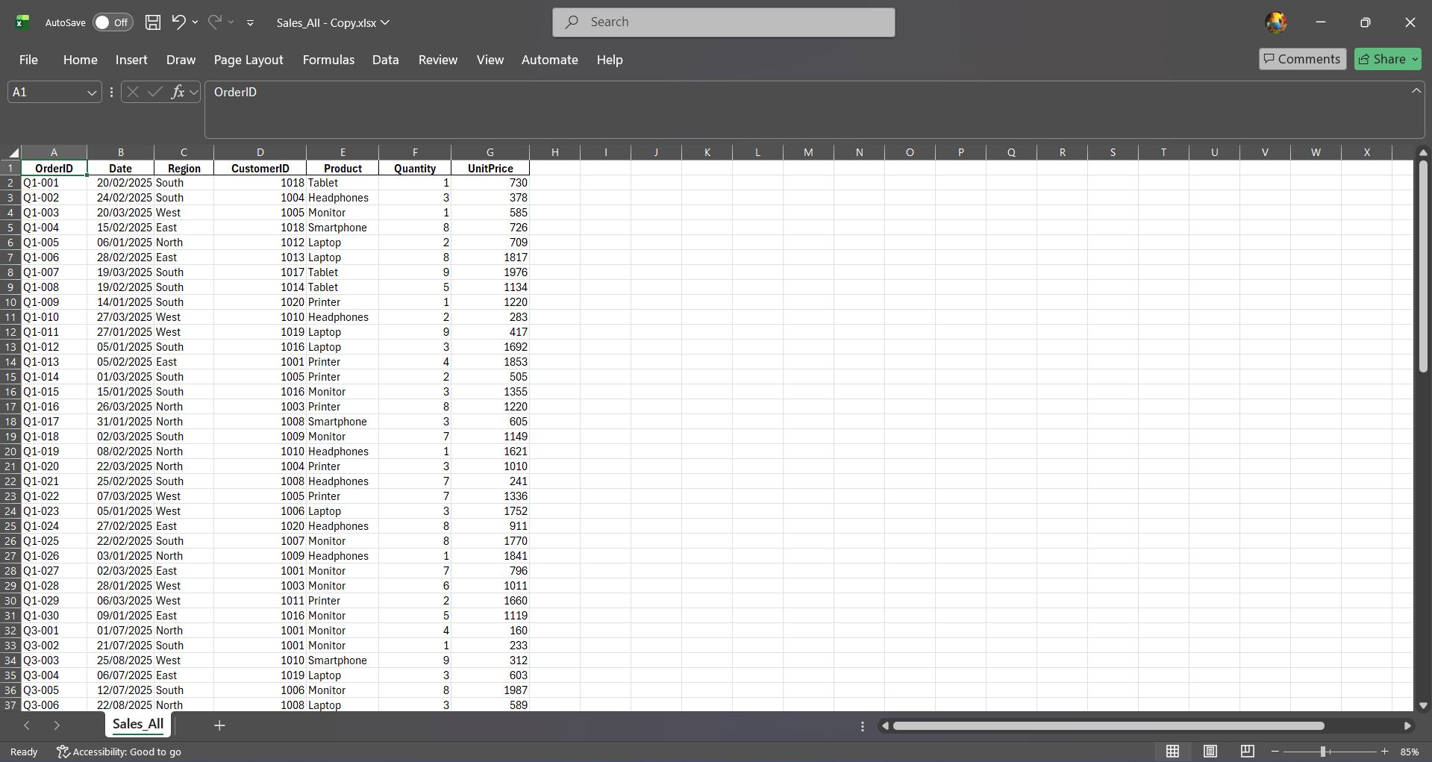

Step 2: Standardize Date Format
Locale: English (United Kingdom).

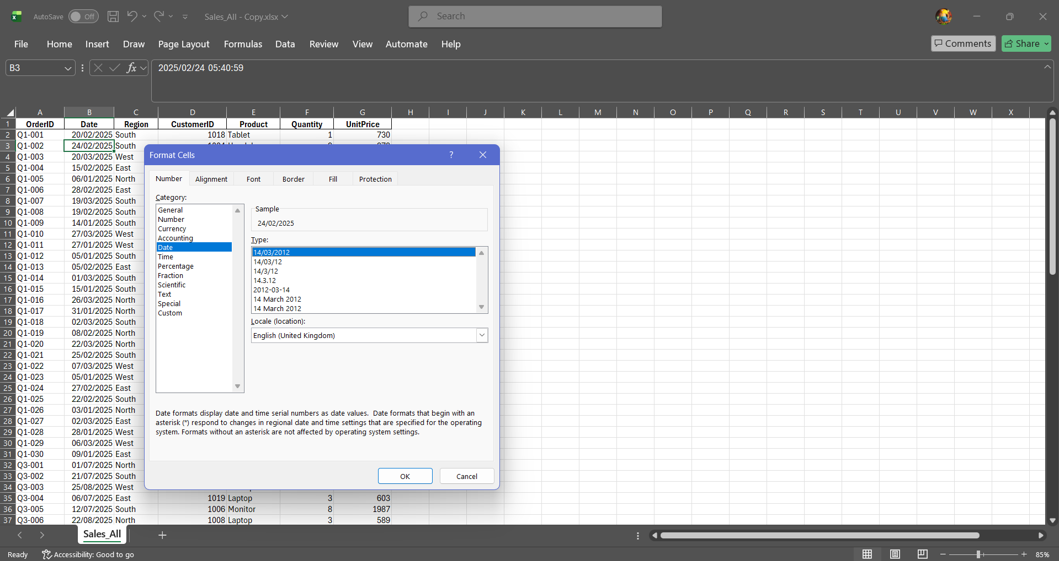

Step 3: Remove Duplicate Orders
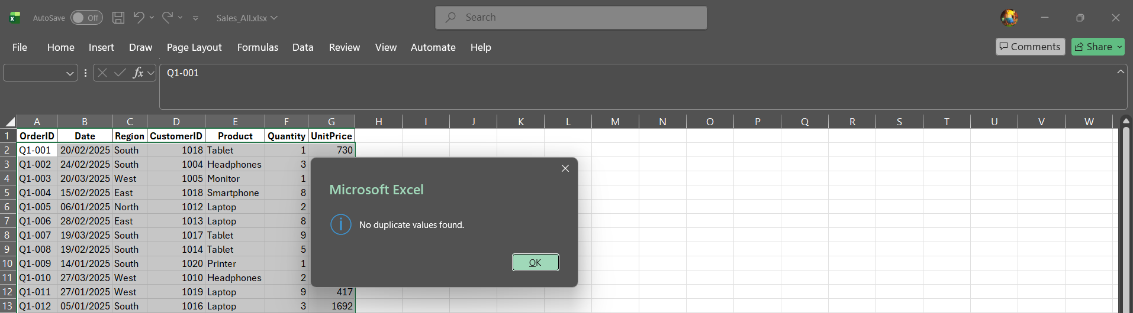

Step 4: Customer Data Cleanup
=PROPER(B2) 'For FirstName
=PROPER(C2) 'For LastName

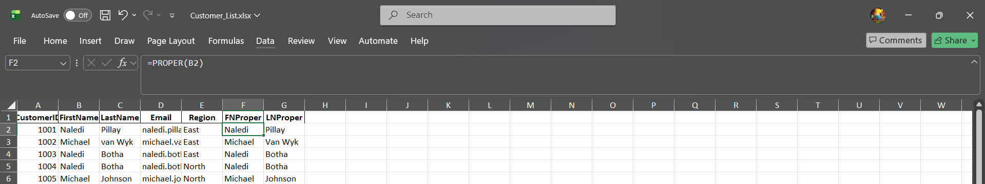

Step 5: Customer Data Cleanup – Extract Email Domain
=RIGHT(D2, LEN(D2) - FIND("@", D2))



Step 6: Flag Duplicate Customers
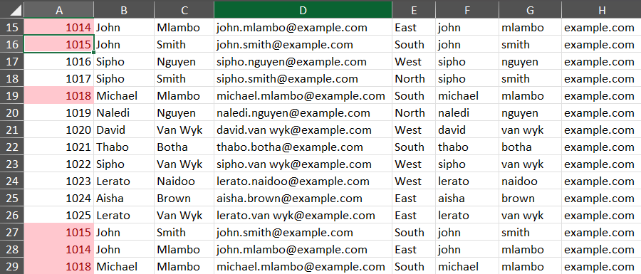

Step 7: Merge Product Details with XLOOKUP
Category (H2): =XLOOKUP(E2, Product_List!$A:$A, Product_List!$B:$B, "Not Found")
UnitCost (I2): =XLOOKUP(E2, Product_List!$A:$A, Product_List!$D:$D, 0)
Discount (J2): =XLOOKUP(E2, Product_List!$A:$A, Product_List!$E:$E, 0)

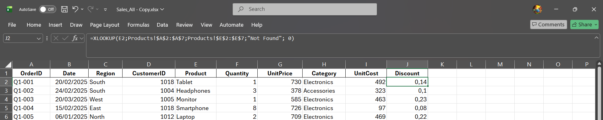

Step 8: Add Month Helper Column
=EOMONTH(B2,0)
Retrieves the last day of the order month (e.g., in column M).

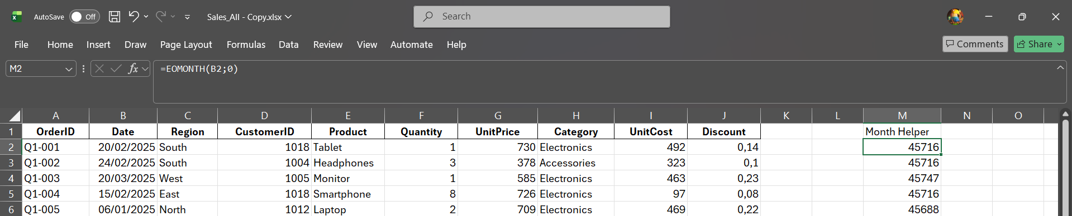

Step 9: Link Operations Data
DeliveryDays (N2): =XLOOKUP(A2, Operations_Data!$A:$A, Operations_Data!$B:$B, 0)
ReturnRate (O2): =XLOOKUP(A2, Operations_Data!$A:$A, Operations_Data!$C:$C, 0)
Linked via the OrderID (column A).

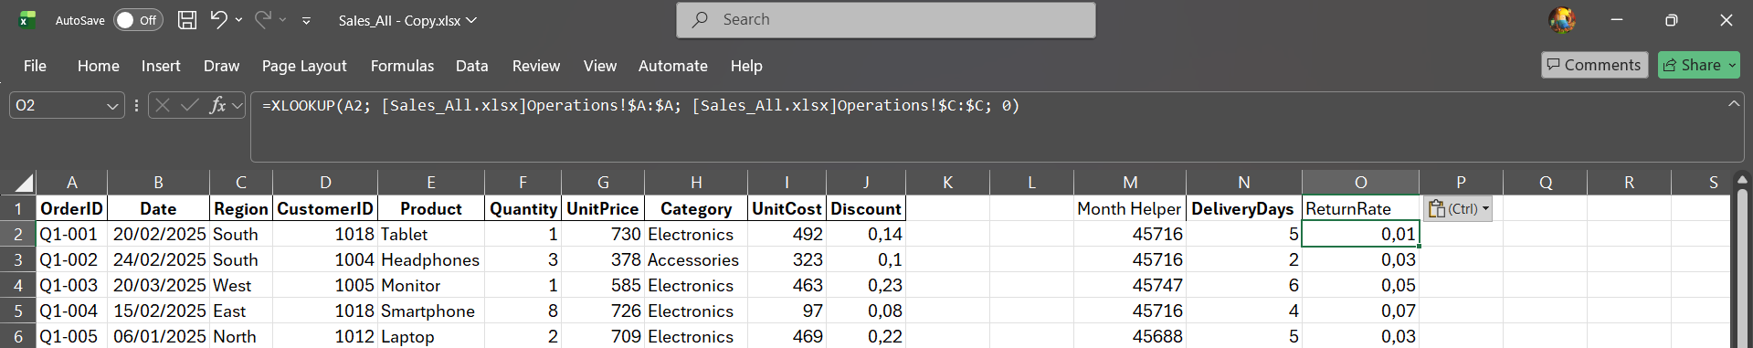

Step 10: Link Finance Data
MonthlyOverhead (P2): =XLOOKUP(M2, Finance_Data!$A:$A, Finance_Data!$B:$B, 0)
MonthlySalary (Q2): =XLOOKUP(M2, Finance_Data!$A:$A, Finance_Data!$C:$C, 0)
MonthlyOther (R2): =XLOOKUP(M2, Finance_Data!$A:$A, Finance_Data!$D:$D, 0)
Linked via the Month helper column (M2). These represent total monthly amounts to be allocated next.

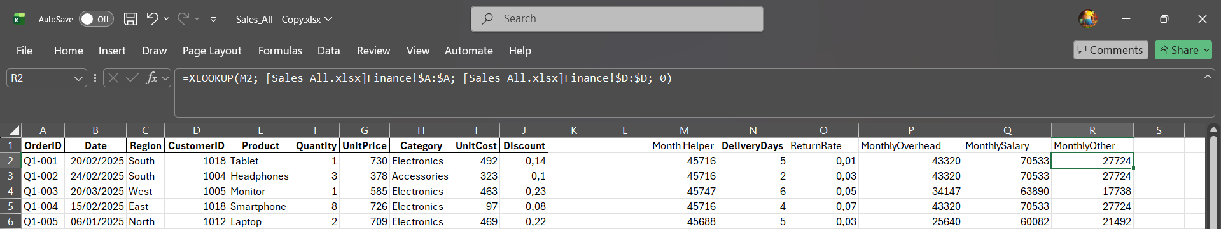

Part 2 — Advanced Calculations & Functions

Step 11: Calculate Revenue & Discounted Revenue
Revenue (S2): =F2*G2
Discounted Revenue (T2): =S2*(1-J2)

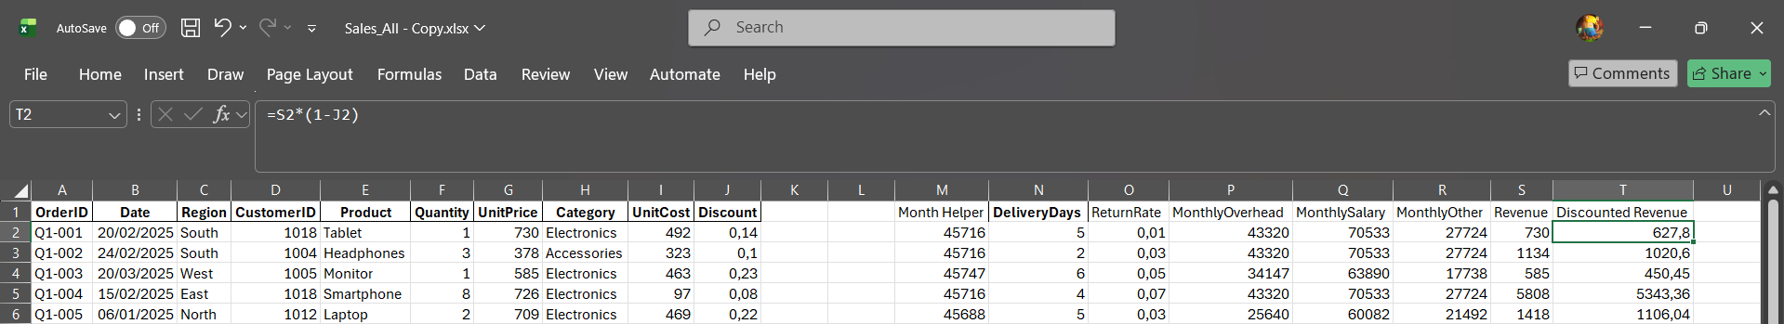

Step 12: Count Orders Per Month
=COUNTIF($M$2:$M$97, M2)

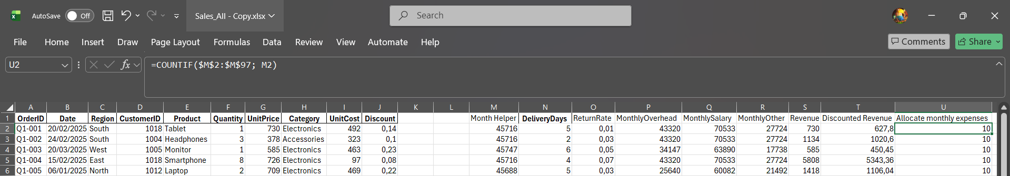

Step 13: Allocate Monthly Expenses Per Order
Allocated Overhead (V2): =P2/U2
Allocated Salary (W2): =Q2/U2
Allocated Other (X2): =R2/U2

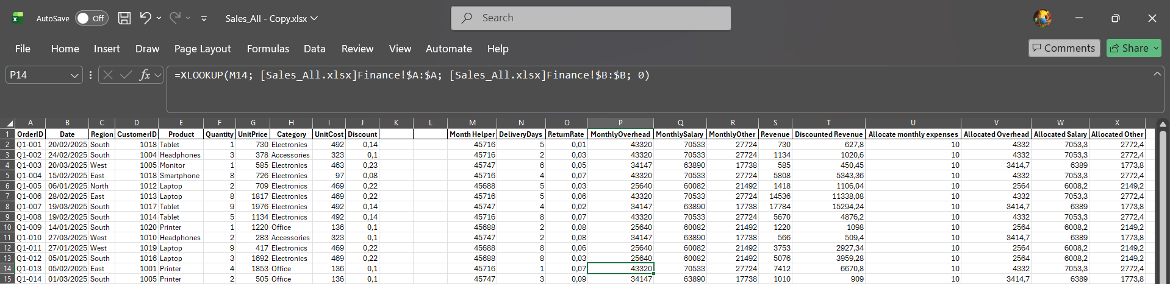

Step 14: Calculate Net Profit
=S2 - (F2*I2) - V2 - W2 - X2
This corrected formula subtracts (Quantity * UnitCost) and all allocated expenses from Gross Revenue (S2).

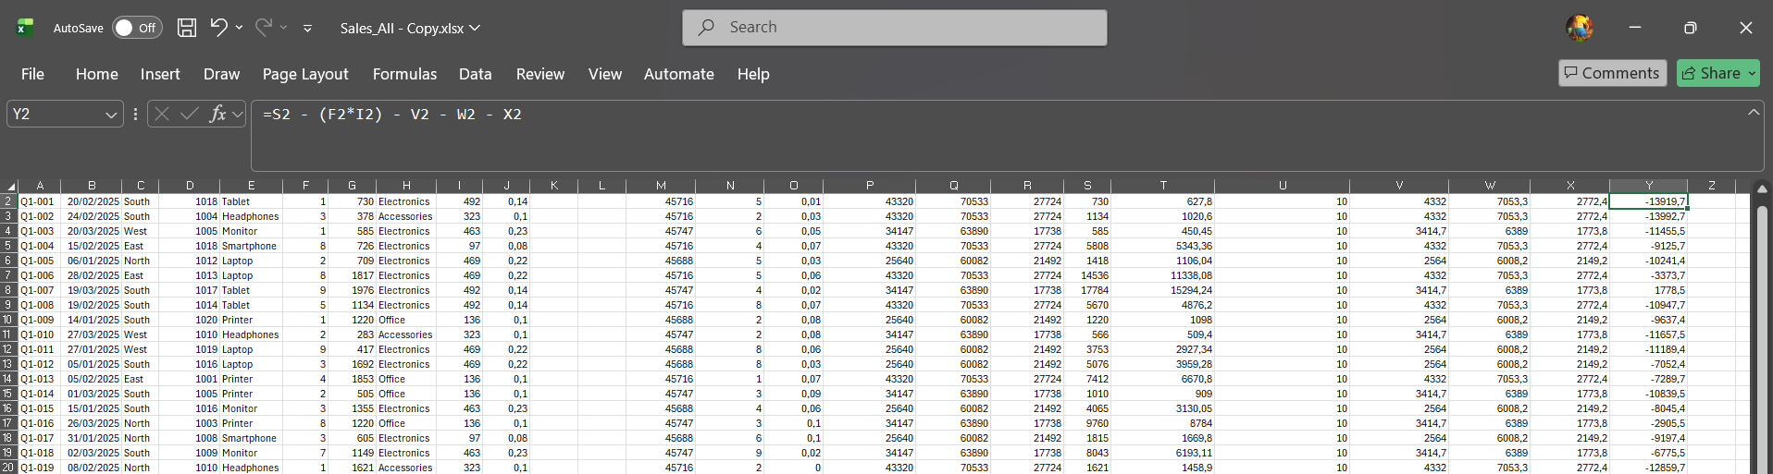

Step 15: Classify Customers with IFS
Customer Total Revenue (Z2): =SUMIF($D$2:$D$97, D2, $S$2:$S$97)
Classification (AA2): =IFS(Z2>50000, "VIP", Z2>=20000, "Regular", TRUE, "Low Value")

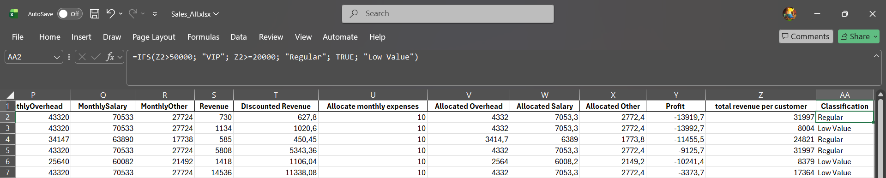

Step 16: Alternative Lookup: INDEX-MATCH
=INDEX(Product_List!$B:$B, MATCH(E2, Product_List!$A:$A, 0))

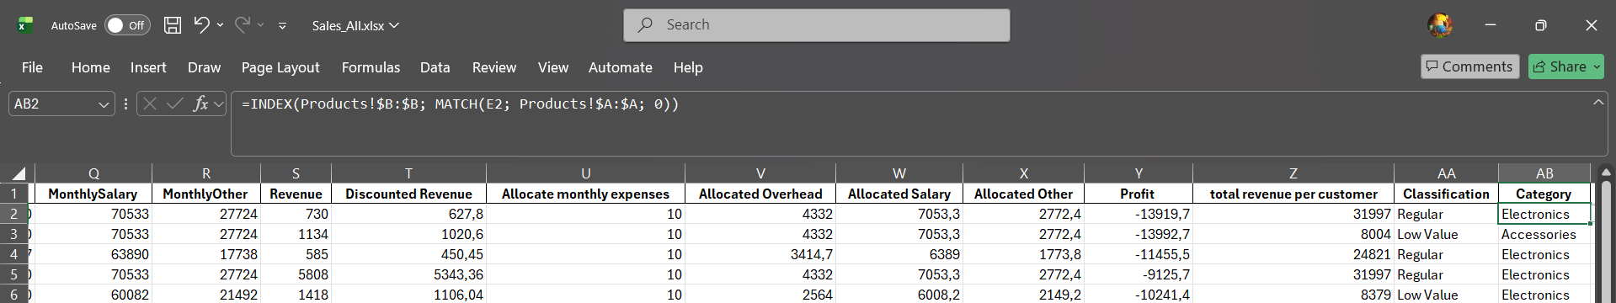

Step 17: Dynamic Named Range for Categories
Name: ProductCategories
Refers to: =OFFSET(Product_List!$B$1,1,0,COUNTA(Product_List!$B:$B)-1,1)

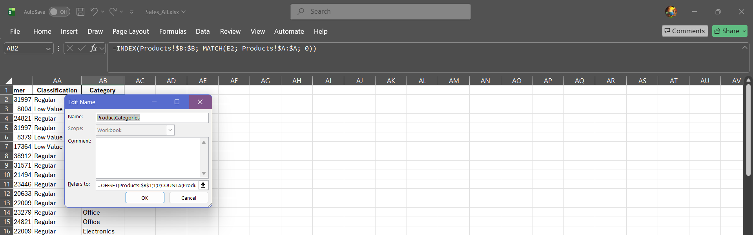

Step 18: Dynamic Arrays for Region Summary
Unique Regions (A2): =UNIQUE(Sales_All!$C$2:$C$97)
Orders per Region (B2): =COUNTIF(Sales_All!$C$2:$C$97, A2#)
Avg Delivery Days (C2): =AVERAGEIF(Sales_All!$C$2:$C$97, A2#, Sales_All!$N$2:$N$97)
Placed on a new sheet named 'Region_Summary'.

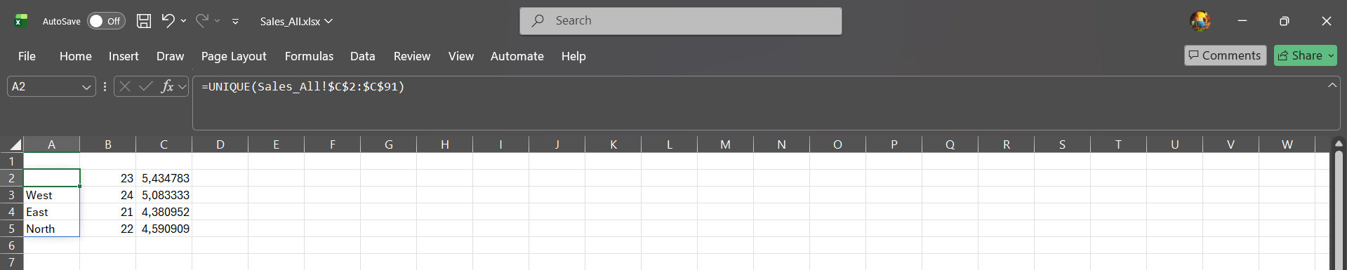

Step 19: List Purchased Products via TEXTJOIN
=TEXTJOIN(", ", TRUE, IF(Sales_All!$D$2:$D$97 = A2, Sales_All!$E$2:$E$97, ""))

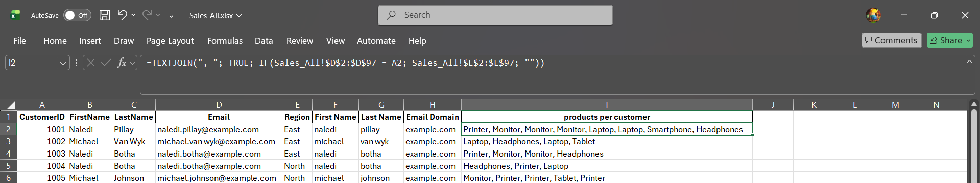

Part 3 — Data Management & Validation

Step 20: Data Validation Drop-downs
For Region Source: East,West,North,South
For Category Source: =ProductCategories

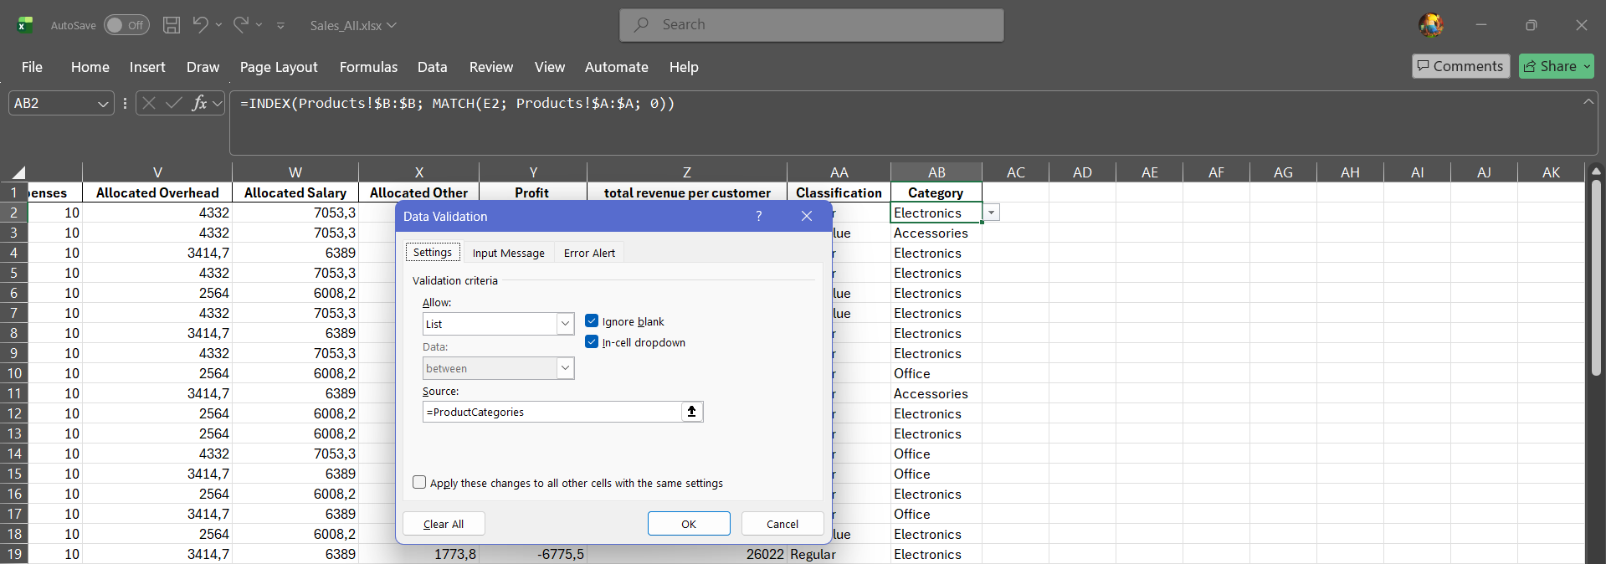

Step 21: Dependent Drop-down Lists
=INDIRECT(cell_reference)
Created named ranges for each category (e.g., 'Electronics'), then reference the cell where the Category is selected.

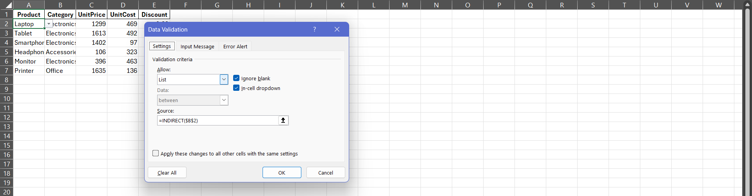

Step 22: Protect Sheets
Selected all cells, untick Locked. Select formula cells and tick Locked. Go to Review > Protect Sheet, allowing only 'Select unlocked cells'.

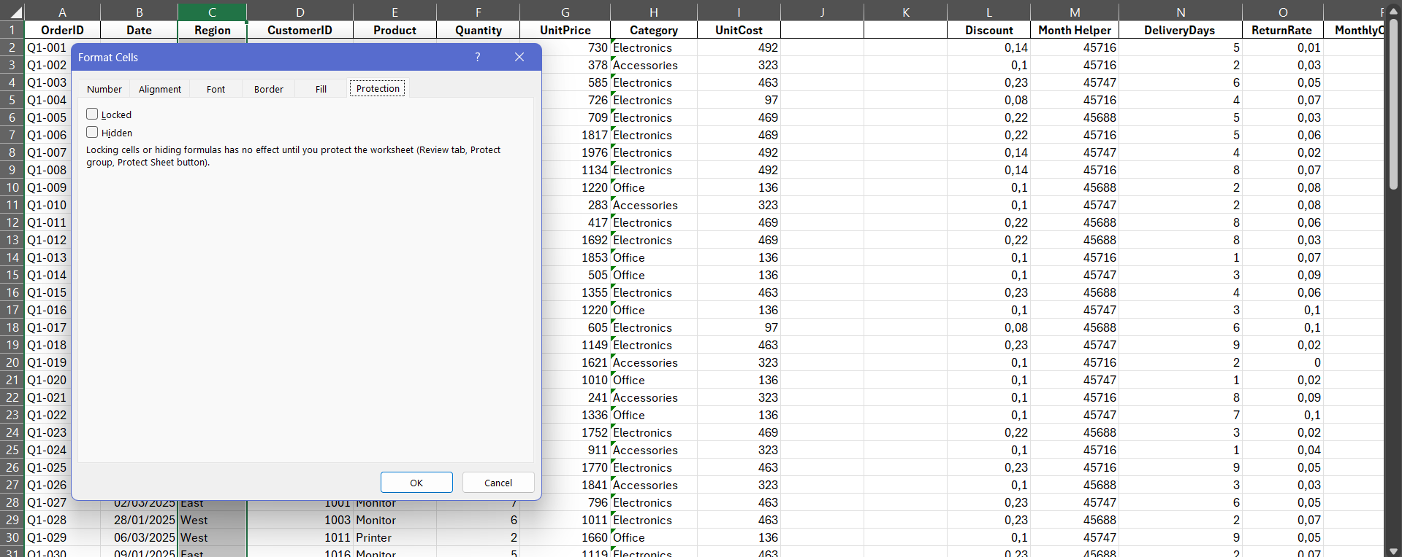

Part 4 — Conditional Formatting

Step 24: Highlight Top 10 Customers
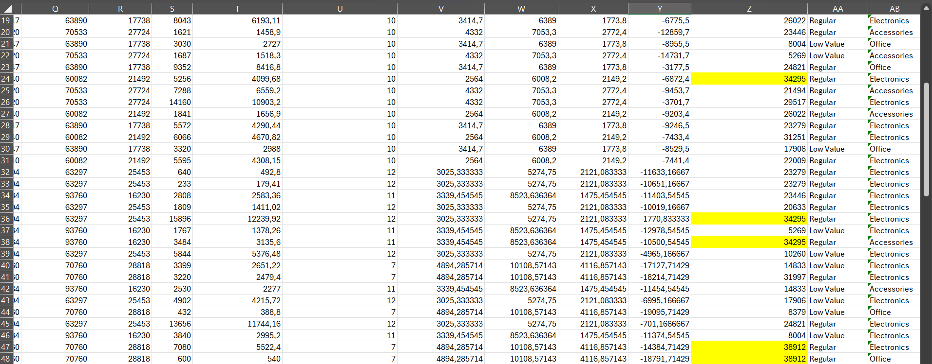

Step 25: Formula Rule: High Revenue & High Return Risk
=AND($Z2>25000, $O2>0.05)
Applied this New Rule using a formula across the data range, setting a distinct format like an orange fill.

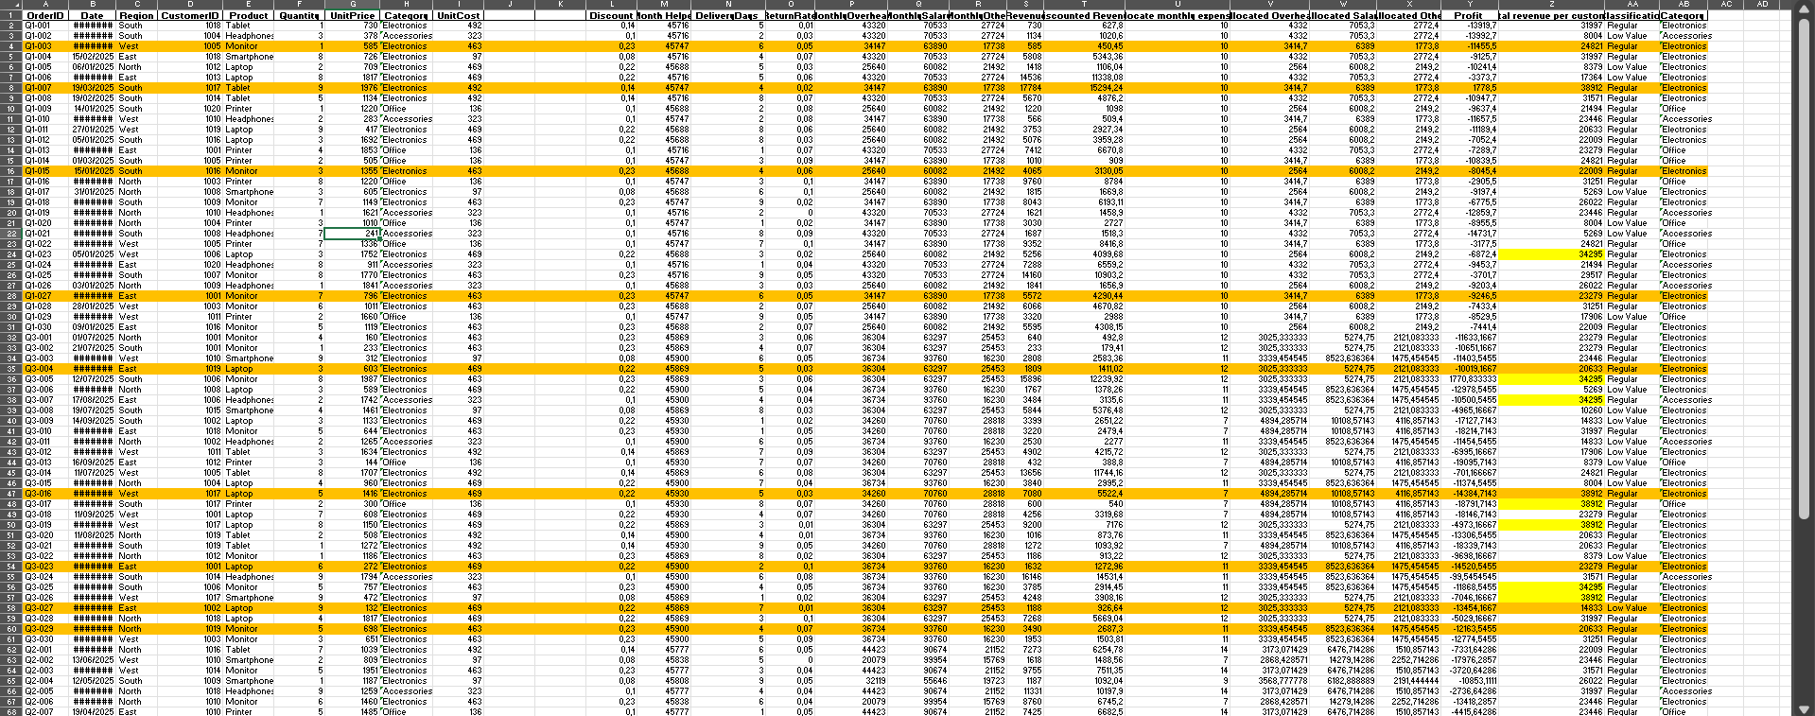

Step 26: Icon Sets for Delivery Performance
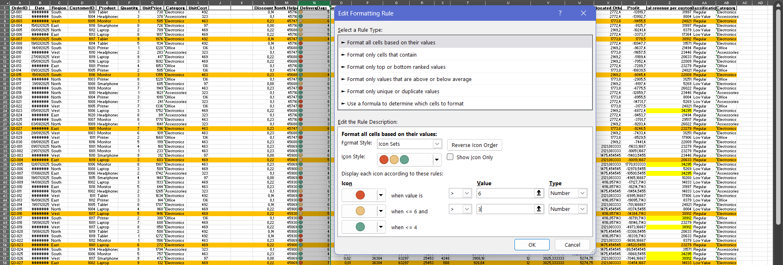

Step 27: 3-Colour Scale on Expenses
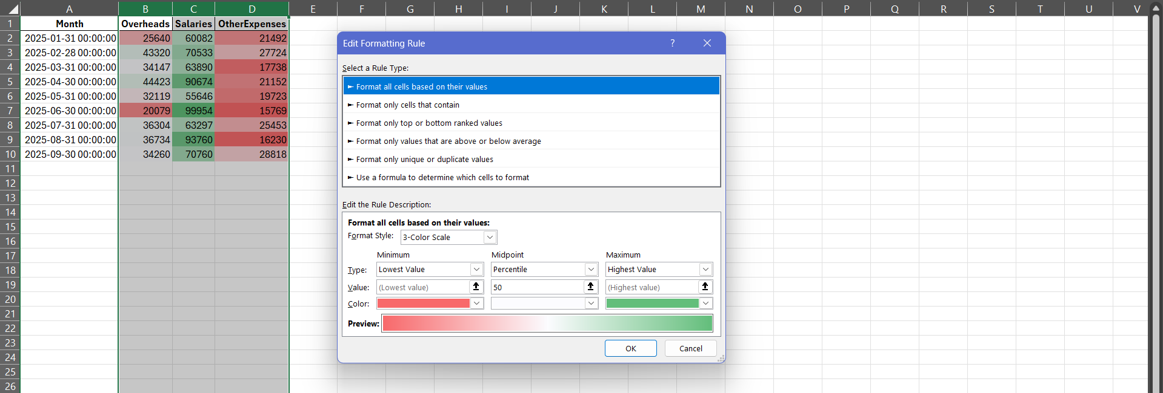

Part 5 — Advanced PivotTables & Analysis

Step 28-31: PivotTable
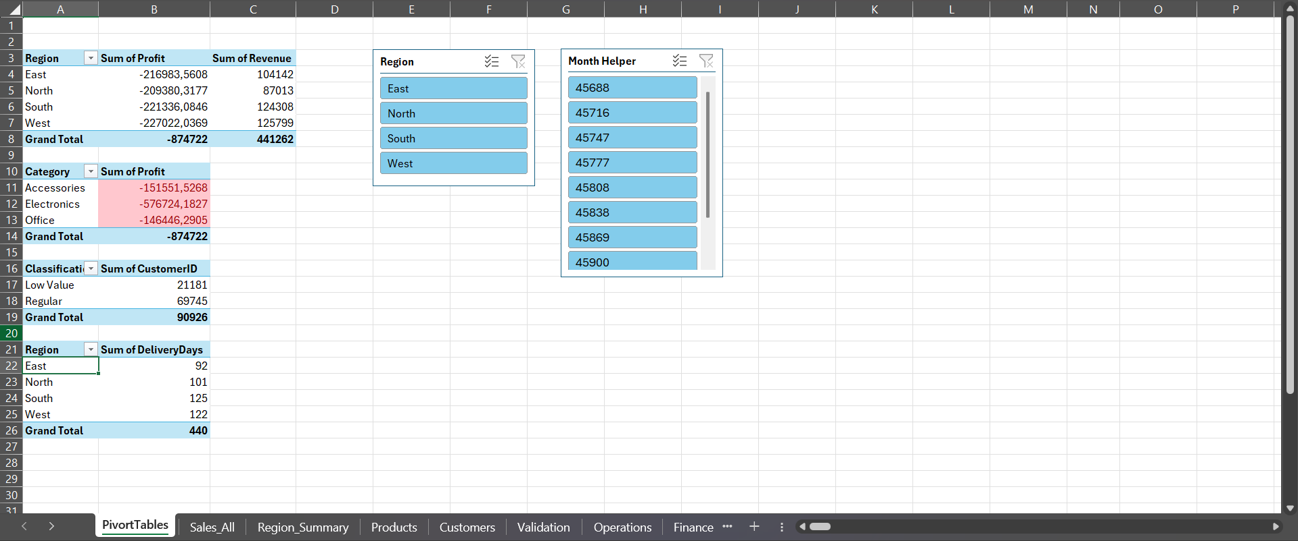

Step 32: Insert PivotTable Calculated Fields
Profit Margin % Formula: =Profit / Revenue

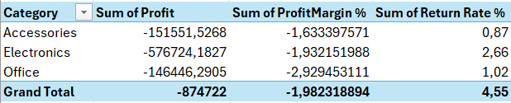

Step 33: Connect Slicers & Timeline
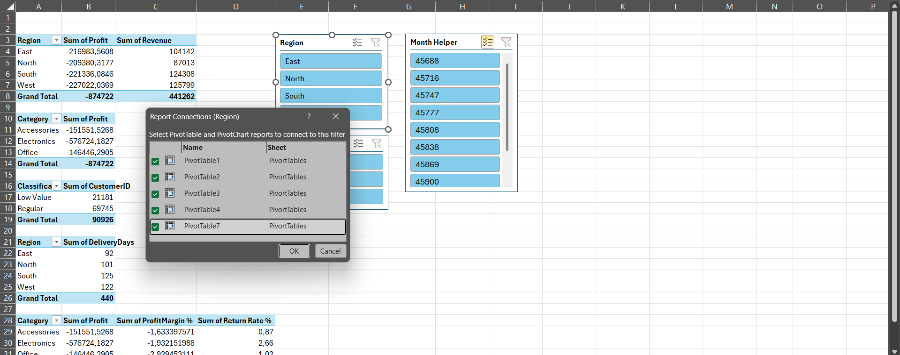

Step 34: Top 5 Products by Revenue
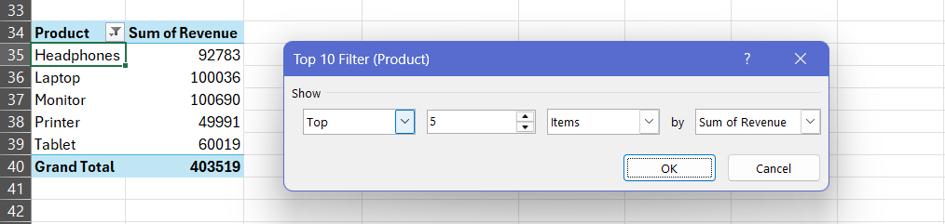

Part 6 — Charts & Dashboard

Step 35: Create Core Charts
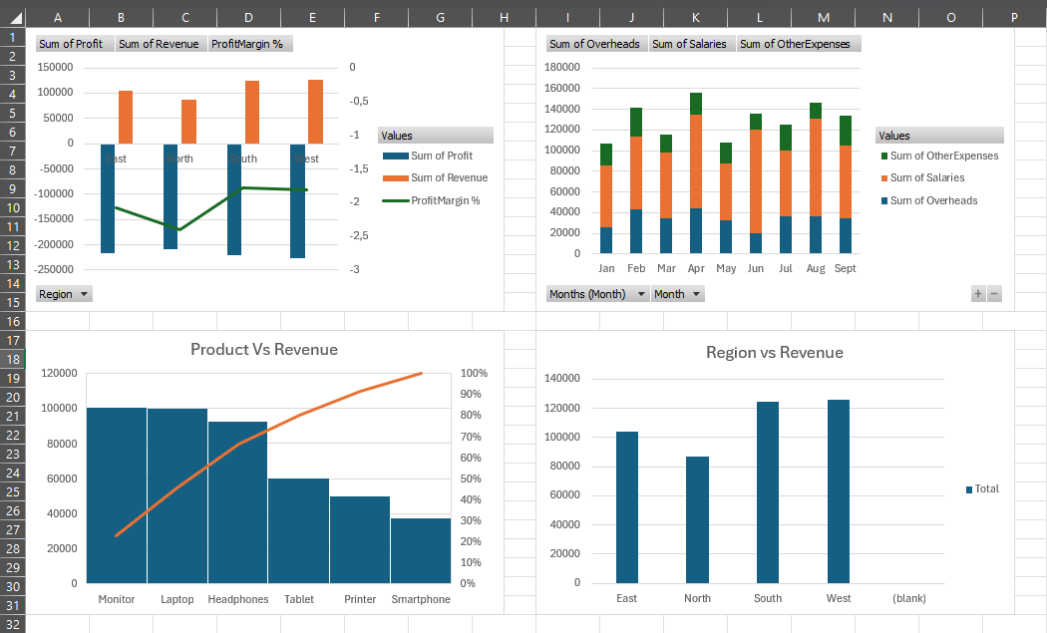

Step 36: Map Chart Alternative
IMPORTANT EXCEL BEHAVIOR: Filled Map charts may fail or render blank with generic names like 'East'. Use a Clustered Column chart as a reliable substitute.

Step 37: Build Dashboard KPI Cards
Total Revenue: =SUM(Sales_All!S:S)
Total Profit: =SUM(Sales_All!Y:Y)
Top Customer: =INDEX(Sales_All!D:D, MATCH(MAX(Sales_All!Z:Z), Sales_All!Z:Z, 0))
On‑Time Delivery %: =COUNTIF(Sales_All!N:N,"<=3") / COUNTA(Sales_All!N:N)

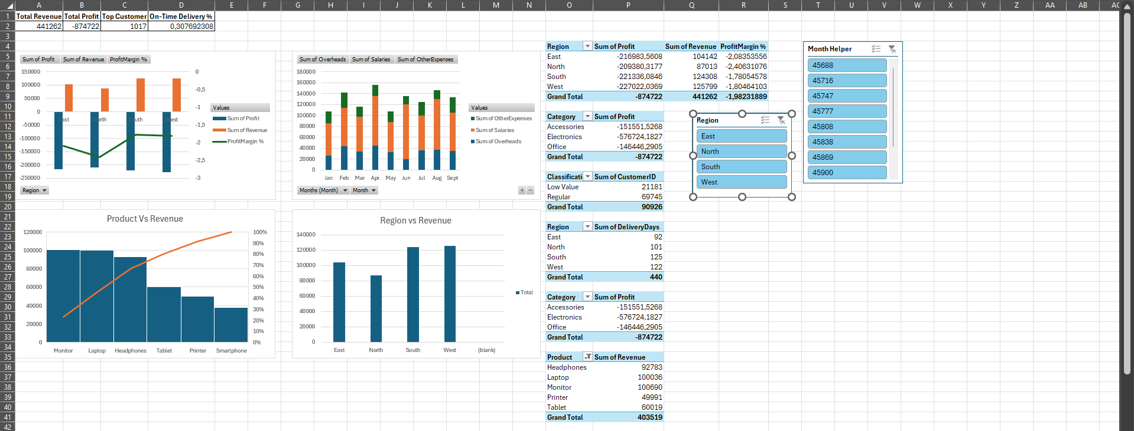

Step 38: Dynamic Dashboard Heading
= "Dashboard for " & IF(RegionSlicerCell="", "All Regions", RegionSlicerCell)

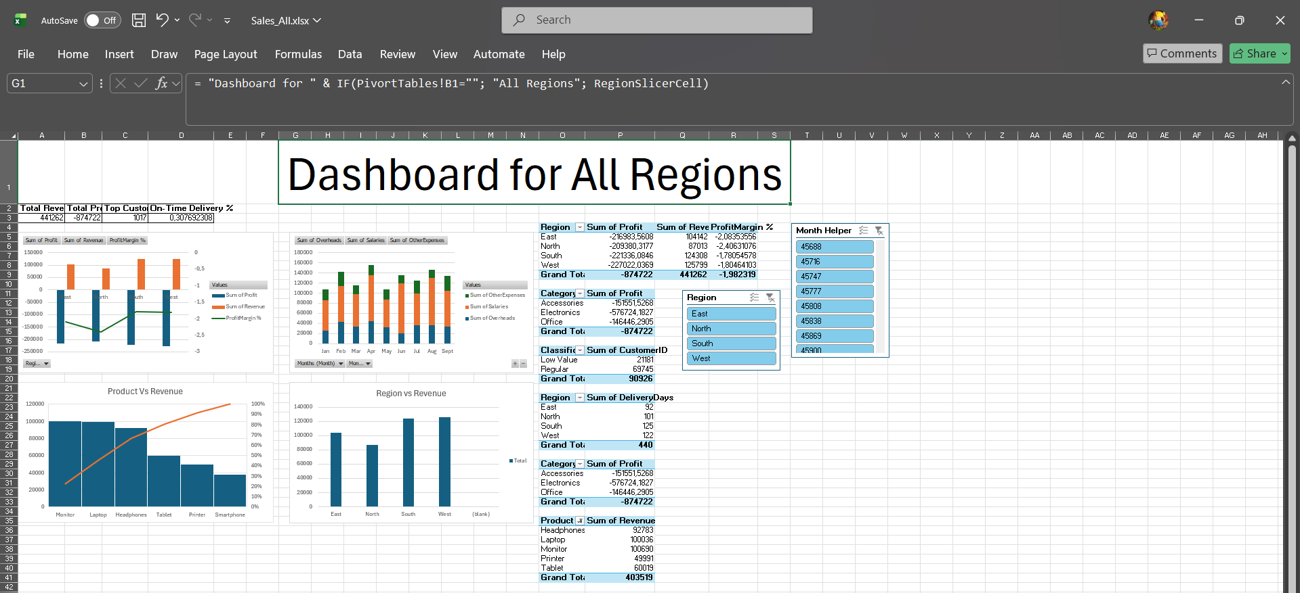

Part 7 — Automation & Extras (Optional)

Step 39: VBA Macro – Refresh All PivotTables
Sub RefreshAll()
Dim pt As PivotTable, ws As Worksheet
For Each ws In ThisWorkbook.Worksheets
For Each pt In ws.PivotTables
pt.RefreshTable
Next pt
Next ws
MsgBox "All PivotTables refreshed."
End Sub

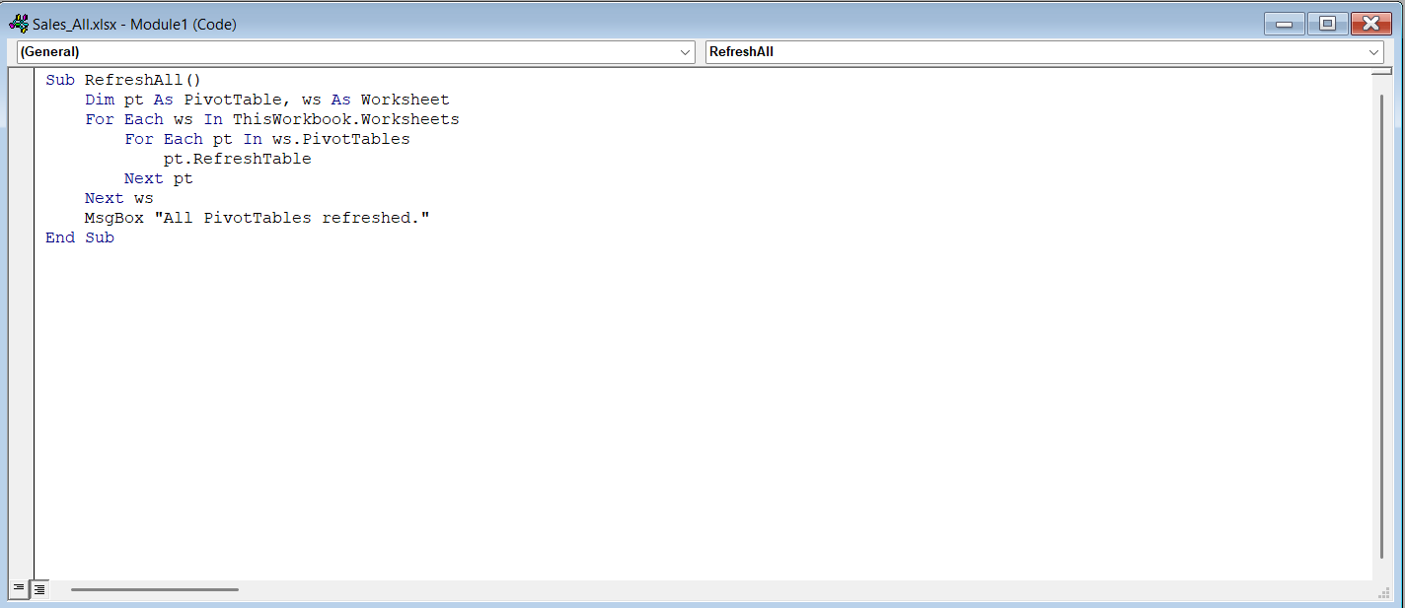

Step 40: VBA Macro – Export Dashboard as PDF
Sub ExportDashboardPDF()
Sheets("Dashboard").ExportAsFixedFormat Type:=xlTypePDF, _
Filename:=ThisWorkbook.Path & "\Dashboard_Report.pdf", _
Quality:=xlQualityStandard, OpenAfterPublish:=True
End Sub

